FEA analysis of modified pressure seat of I2map camera port

  - François Cazenave
  - November 3, 2015

Modification are made to the glass port to reach a depth rating of 1500m. Modifications include:
- bevelled and polished inside edge
- polished pressure seat, paint removed
- thicker gasket
- possible dome support modification
This report contains the results of a finite element analysis performed on the proposed modified dome support, and a description of the proposed pressure test.

Von Misses stress
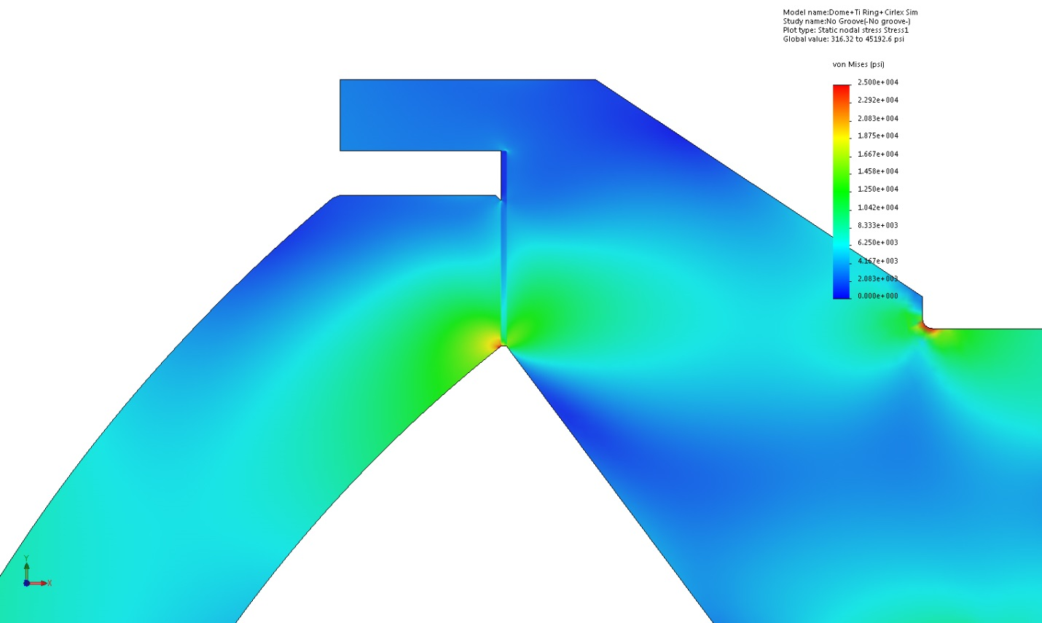

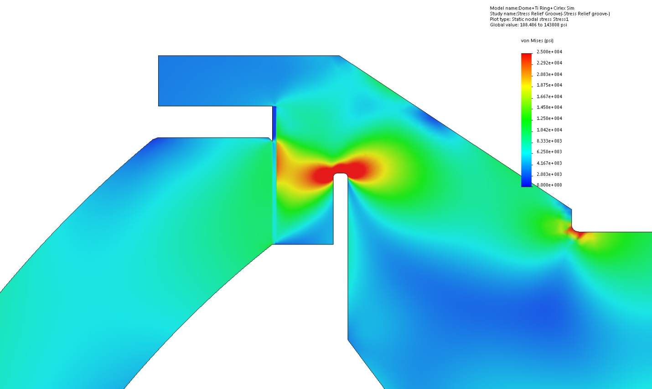

Displacement
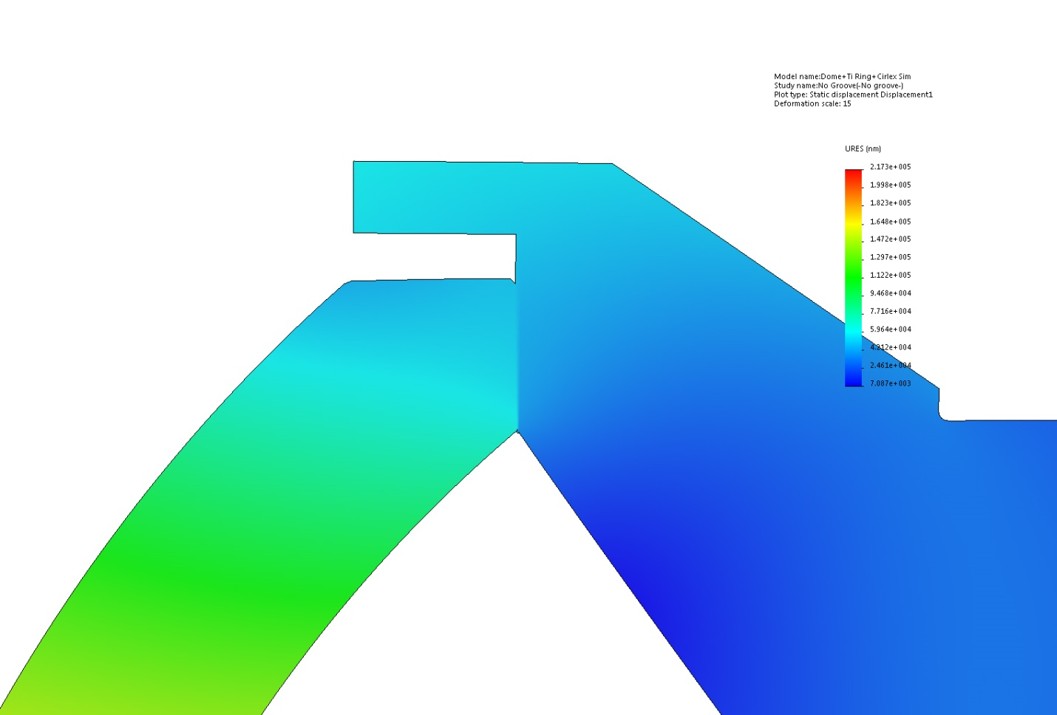

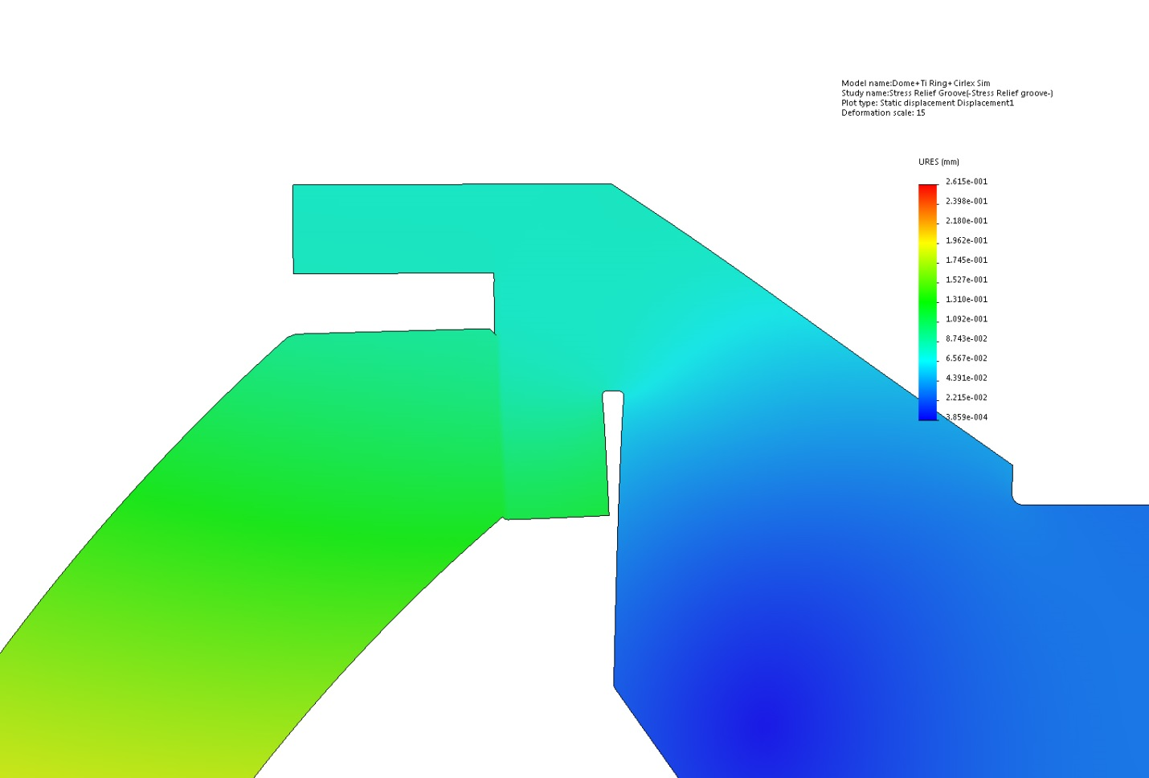

First principal stress
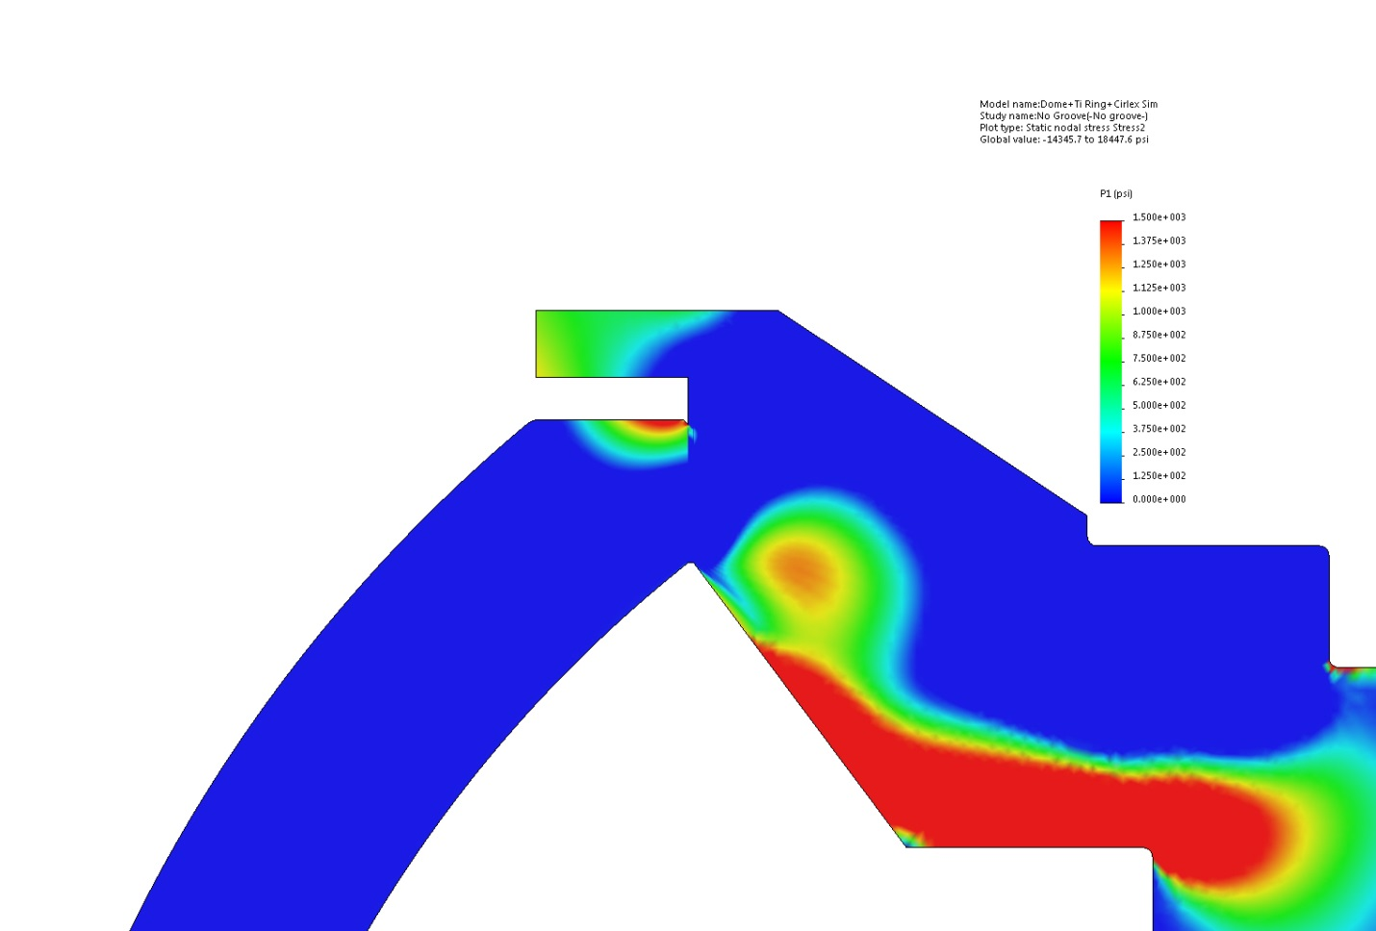

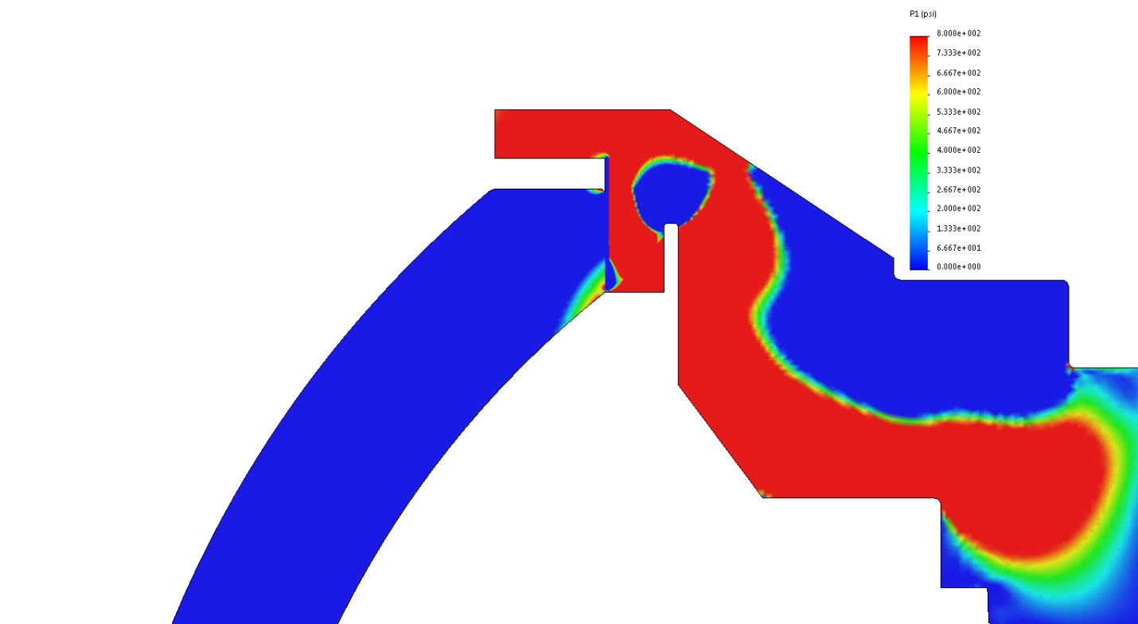

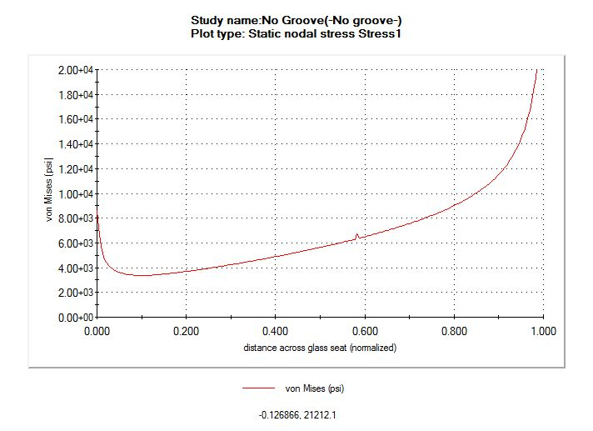
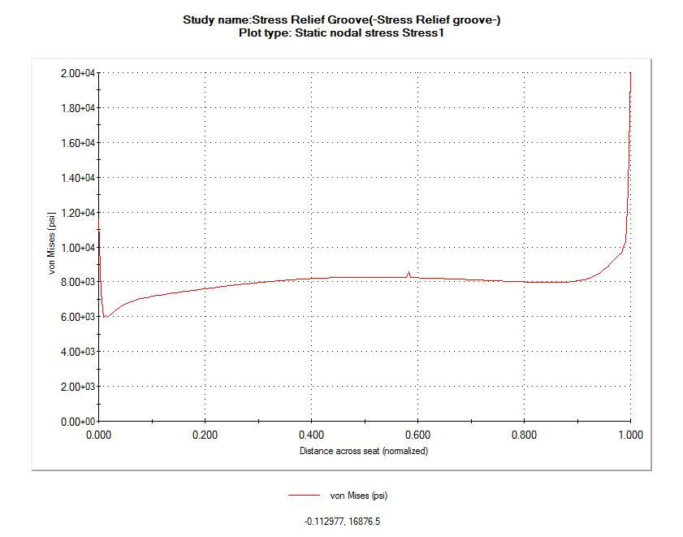

Gasket material

0.020” thick Cirlex.
Cirlex is laminated kapton, manufactured by Fralock in San Carlos.
Offers the benefits of kapton (strength, compliance) in greater thickness. Can be ordered cut to size (waiting for quote).
Thicker gasket helps distribute stress.
Fiber reinforced neoprene of the proper thickness could not be found (it’s possibly no longer manufactured).

Instrumented test

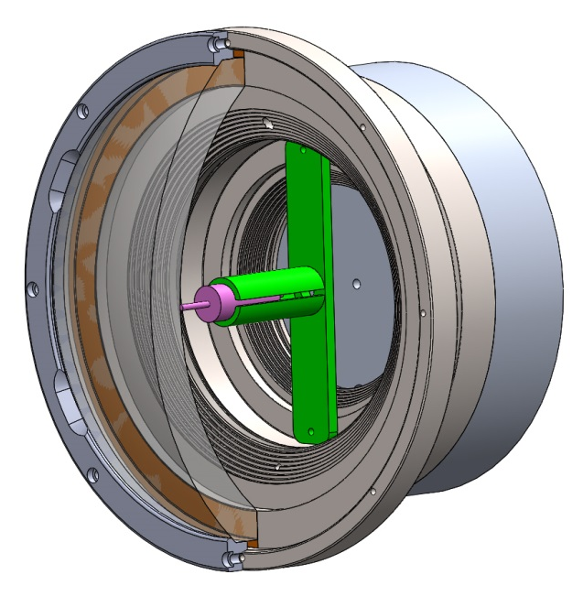
Test will be performed at Port Hueneme Navy facility, free of charge.
- LVDT to measure deformation of dome. Data will be logged during the entire test. Hardware has been ordered (LVDT and signal conditioner).
- Pressure and temperature will be logged
Proposed test: 60 cycles, 60 hours. Rated pressure +25%.
Two domes have been purchased, and will be delivered early December. The test can be performed in December. If the test is successful, the second dome can be mounted on the titanium seat with optical elements. Assembly can be performed by Myriad Fiber imaging or at MBARI. Proof test can be performed at Maripro.

