Finite element analysis of glass port for I2map camera housing.
By François Cazenave, October 14 2015.
Finite element analysis was performed on the glass dome, titanium support ring, and dome seat gasket of the I2map camera housing. The purpose of this analysis is to estimate the stresses in the components when they are subjected to a pressure equivalent to the target depth (2200PSI, 1500m sea water depth). Two cased were studied. The first case is based on the current design. In the second case, a groove was made in the titanium to help relieve the stress.
The plots below show the results of the analysis. Von Misses stress, first principal stress and displacement plots are shown. For the first principal stress plots, the color scale was adjusted to range from 0 PSI to the greatest positive value in the glass. The first principal stress plots are used to determine if any areas of the glass are under significant tension (tension in glass can lead to failure).
The material properties of the glass (BK-7 equivalent) and the titanium (grade 5) were provided by the vendors. The material properties of the fiber reinforced gasket are unknown. Due to the nature of the material, the properties cannot be modeled accurately anyway. For the analysis, the following properties were used: E=400000 PSI, Poisson’s ratio: 0.3 (equivalent to Kapton, which was used previously).
The element size of the mesh used was 0.06”. Near the dome seat and gasket, the mesh size was reduced to 0.005”. The components contacts are set to ‘bonded’ because it is assumed that there is no relative displacement at the component contact. Also, studies with unbonded contacts have yielded unrealistic results.
The gasket thickness is 0.022”, based on the sample given by Glenn McDonald.
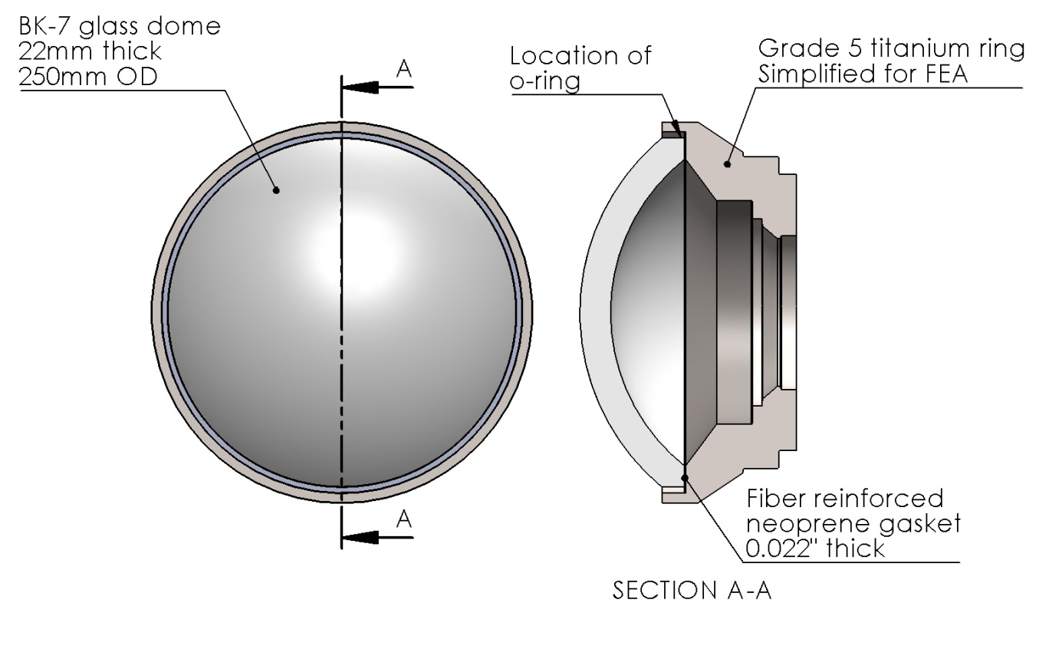
Figure 1: Model used for analysis

For reference, the theoretical average normal stress at the dome seat is calculated below:
Area of the dome seat = 16.5 in²,
OD of the dome seat = 9.8 in
Normal force applied on dome at 2200PSI = (pi*9.8²/4)*2200 = 165945 lbs
Normal stress in dome seat at 2200 PSI = 165945/16.5 = 10057 PSI

Case 1, displacement plot
The plot below shows the displacement when 2200 PSI is applied to the assembly. The maximum displacement is 2.2mm. The OD of the glass is displaced toward the titanium more than the OD, which causes a stress concentration. Note that the deformation scale is 71.

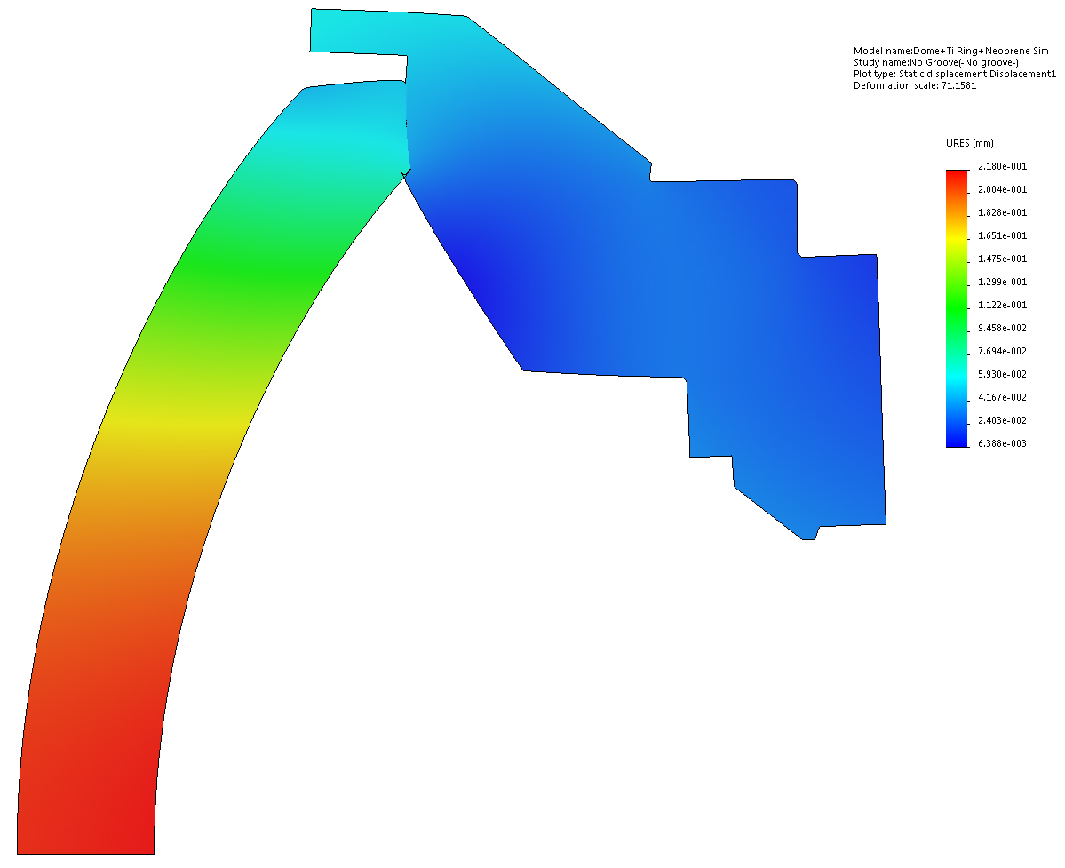

Case 1, Von Misses stress plot
The plot below shows V.M. stresses. There is a stress concentration on the inner edge. The stress on the ID of the glass is 40000 PSI. This value is not accurate: with a coarser mesh it became smaller and with a finer mesh, it increased. The stress at the inner edge cannot be determined accurately because it depends on the size of the bevel and other factors that cannot be modeled (for example, the gasket is likely to yield there, which cannot be modeled realistically). After running multiple studies, using a range of values for the gasket’s modulus of elasticity, if was found that lower values resulted in a reduced stress concentration (for example with E=50000PSI, the maximum stress in the glass dropped to 25000PSI). This suggests that using a neoprene ring (material used on deep sea ceramic spheres) instead of kapton will yield better results. Also, several studies were performed using a range of thickness values for the gasket. A thinner gasket resulted in higher stress. This was expected: a thicker gasket has more ‘give’ and can distribute the stress more evenly.
The stress away from the inner edge of the glass is realistic. The stress in the glass near the axis is about 8000PSI.

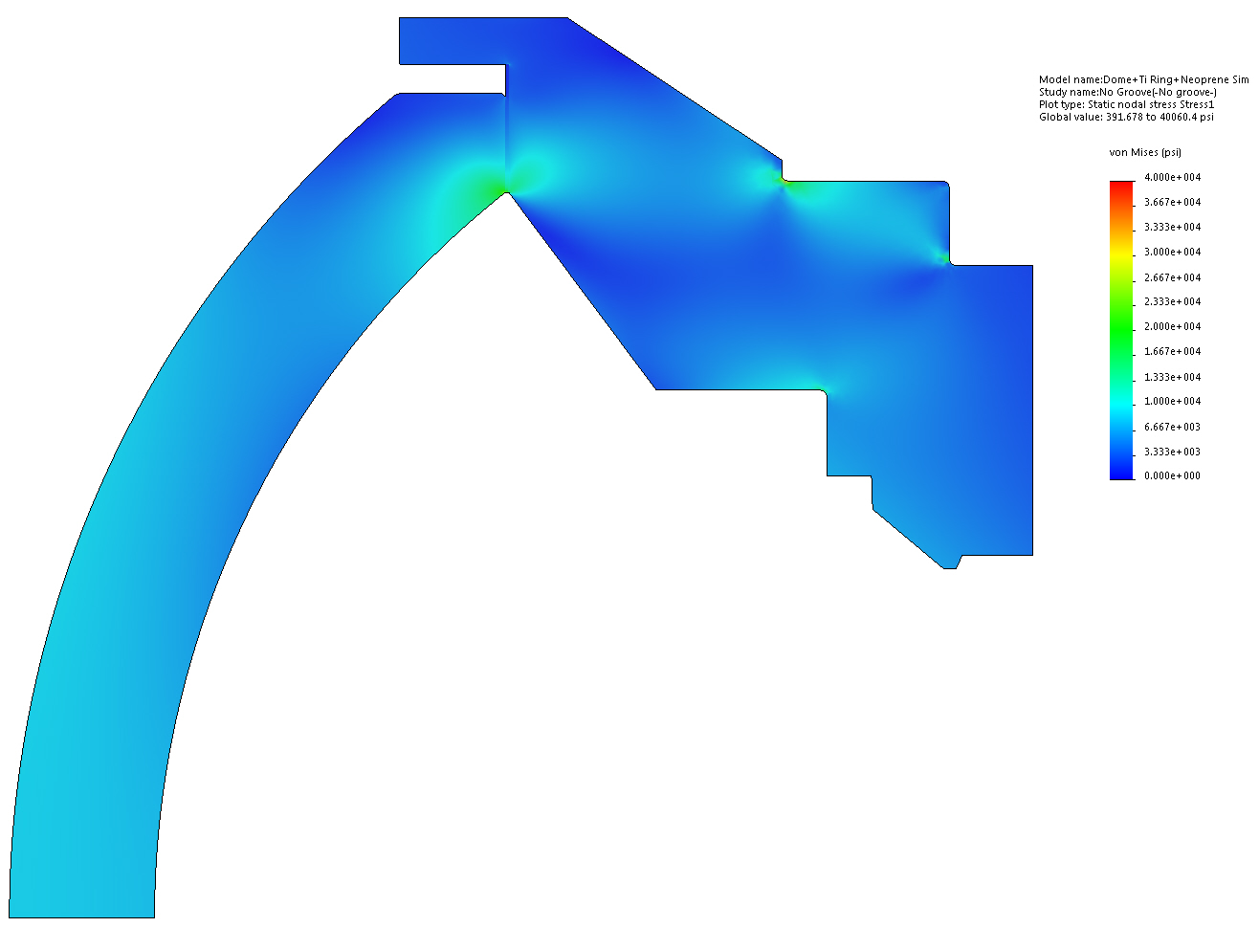

Case 1, First principal stress
The plot below shows the first principal stress. The scale is adjusted to range from 0 to the highest value in the glass (1600PSI). Values in the glass are generally very low. Values in the titanium are very low and can be ignored.

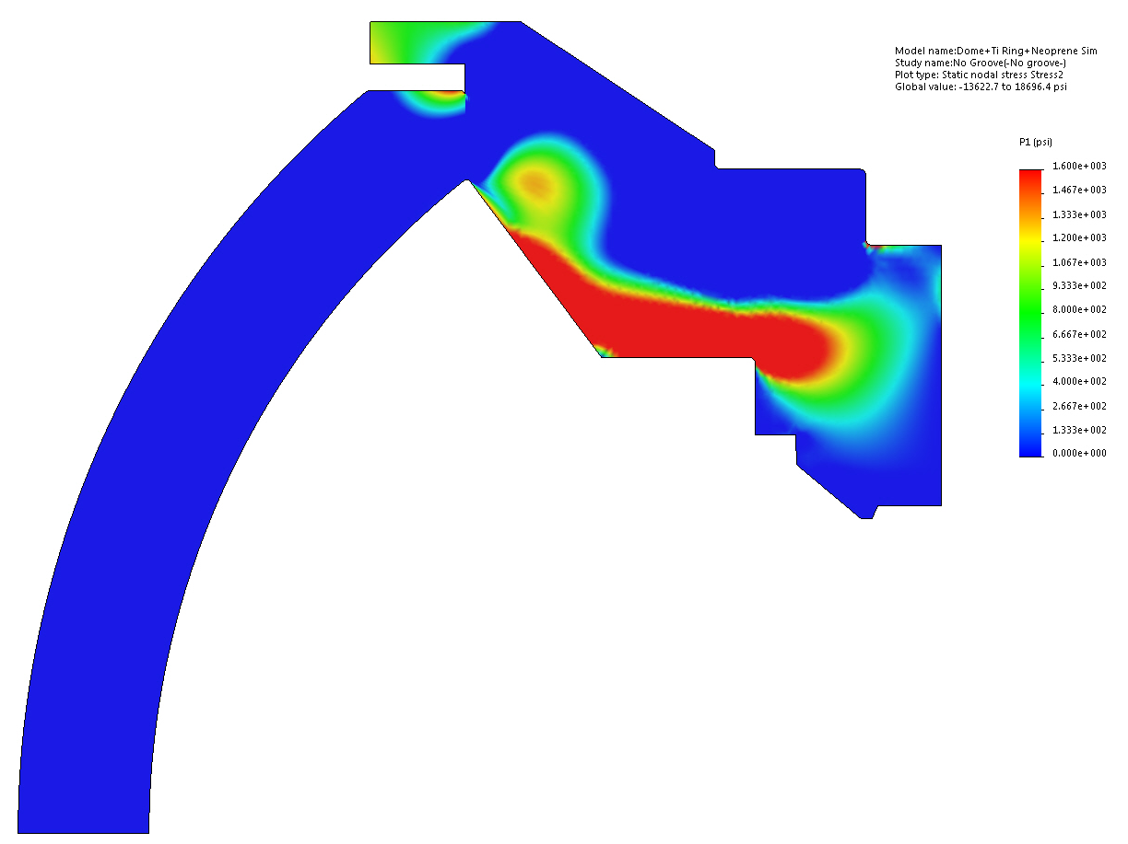

Notes on analysis above
The FEA shows reasonable Von Misses stress values in most of the glass (around 7500psi) and no tension. However, there is a stress concentration near the inner edge of the dome. This problem was exacerbated by the absence of a chamfer and the use of a thin (0.005”), relatively hard kapton gasket and most likely caused the failure during the pressure test. The exact stress value in the region cannot be determined, due to limitations of FEA analysis, and to the unknown properties of the gasket and the glass.
The kapton gasket will be replaced by a fiber-reinforced neoprene gasket and a bevel will be machined on the inner edge of the dome. This will help even the stress across the dome seat and most likely prevent cracking.

Should the dome still fail during testing after these changes are made, another solution is proposed. A groove could be machined in the titanium near the inner edge of the gasket to help center the high stress point near the center of the dome seat, and reduce its intensity. See the drawing below.

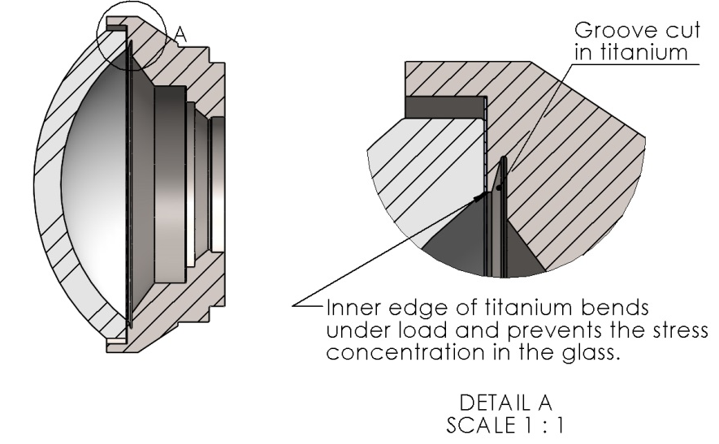

Case 2 (Stress centering groove in titanium), displacement plot
The plot below shows the displacement when 2200 PSI is applied to the assembly. The maximum displacement is 2.5mm, a slight increase compared to case 1. The inner edge of the titanium is displaced significantly, allowing the glass to move without causing a stress concentration.
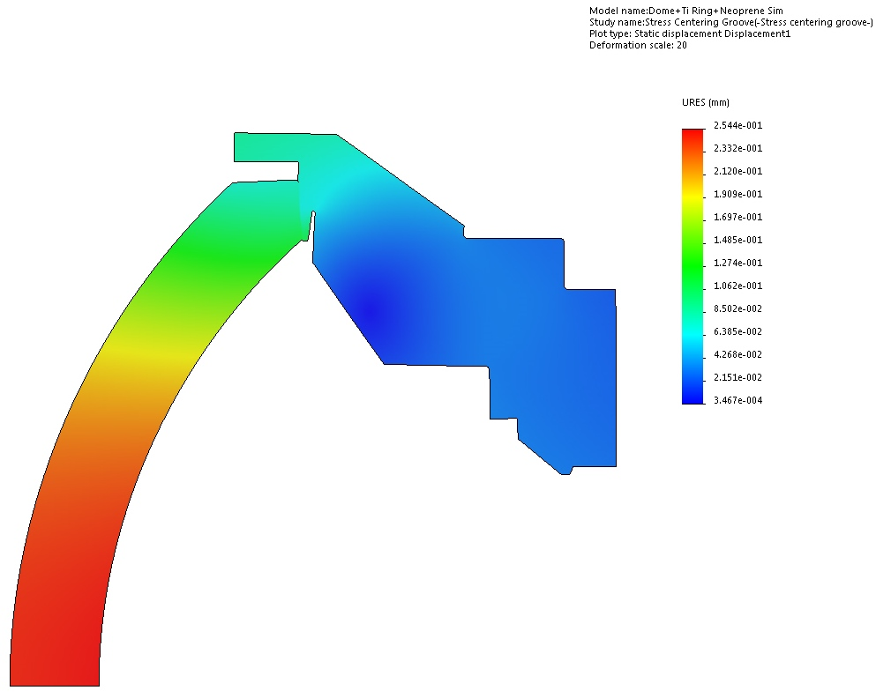

Case 2 (Stress centering groove in titanium), Von Misses stress
The plot below shows V.M. stresses. Please note the scale, adjusted to show stress in the glass. The maximum stress in the glass is about 14000PSI. There is no longer a stress concentration on the inner edge. The stress in the glass near the axis is about 8000PSI (same as case 1).
There is a high stress region in the titanium near the groove, but it is much more predictable and manageable due to the nature of the material.

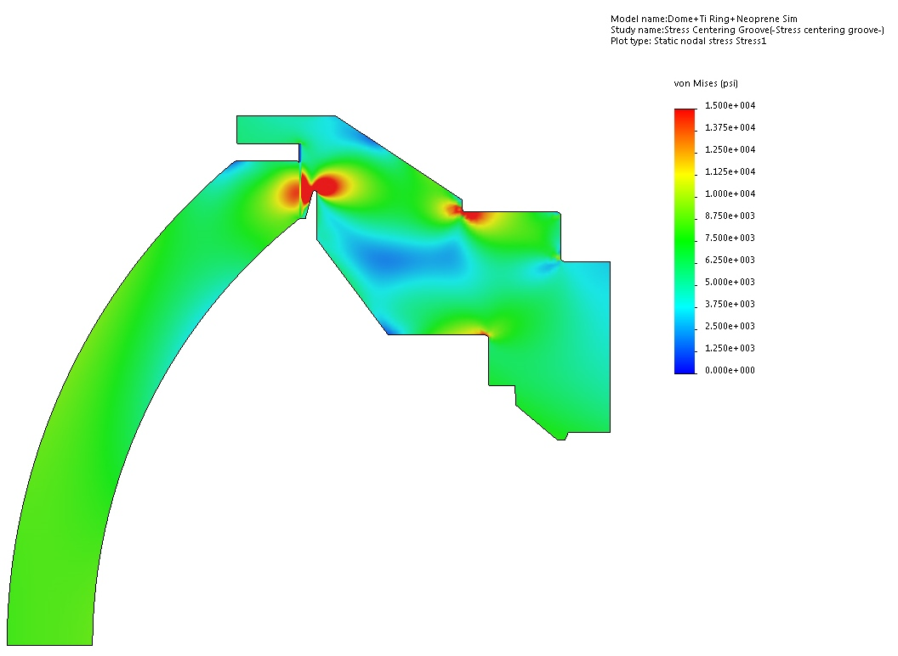

Case 2 (Stress centering groove in titanium), First principal stress
The plot below shows the first principal stress. The scale is adjusted to range from 0 to the highest value in the glass (2828PSI). Values in the glass are generally very low. The f. p. s. near the dome seat is increased compared to case 1, but values are still low. In the titanium they are very low and can be ignored

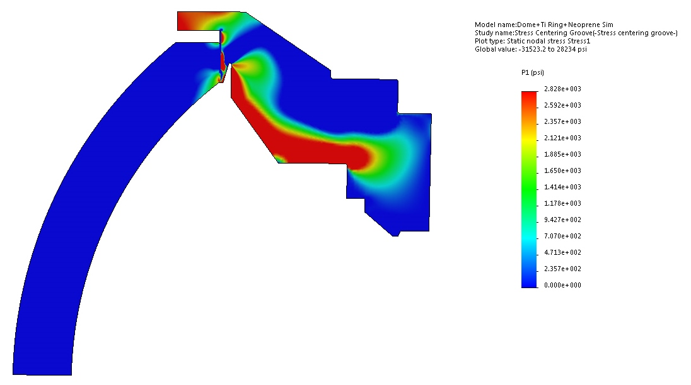

Conclusion:
The first study shows that high stresses are present near the inner edge of glass dome. It’s very likely that it caused the failure that occurred during the pressure test. Numerous studies were done using various thicknesses and material properties for the gasket. A lower compressive modulus and greater thickness result is more even stress. A fiber-reinforced neoprene gasket would meet these properties.
So, we suggest the following improvements:
- Use fiber-neoprene gasket
- Machine bevel on ID of glass dome
- Optical polish of dome seat to increase strength

If a failure occurs again during testing, a small groove can be cut in the titanium near the glass seat to help center the stress in the glass and reduce the chances of failure.

