Quinn’s Contributions to paper

Info for Experimental Procedure
The two domes were examined using standard fractographic procedures as described in References Q1.and Q2. The breakage patterns were observed along with an examination of the fracture surfaces to assess the directions of crack propagation of each major crack. Curved Wallner lines, occasional arrest lines, and hackle lines on the fracture surfaces facilitated the interpretation. In this manner, it was possible to back track the cracks to their origins, and for the instances where multiple origins and crack systems were operative, the intersections of cracks could led to a determination of which crack came first. The fracture surface markings and the fracture origins themselves were examined with a Wild M5 stereo optical microscope at magnifications up to 125 power to the eyes. Directional illumination was critical in highlighting the key features, as escribed in Refs Q1 and Q2.
A digital camera was used to record the images.

Refs:
Q1. G. D. Quinn, Guide to Practice for Fractography of Ceramics and Glasses, NIST Special Publication SP 960-16, May 2007.
Q2. G. D. Quinn, Guide to Practice for Fractography of Ceramics and Glasses, 2nd edition, NIST Special Publication SP 960-16e2, May 2016.

Results
Dome #1 had four crack systems and four fracture origins as shown in Figure A. All four fracture origins were located near (but not exactly at) the outer rim. The cracks all propagated perpendicular to the rim. This indicates that the driving stresses were hoop, circumferential tension stresses. Figure B shows a slightly curved arrest line on the fracture surface of crack #1, at location a few centimeters in from the rim. The fact that it is an arrest line means that the crack popped in and stopped for some time before propagating further. The gentle arch means that the tension stresses were fairly-uniform through the dome thickness. Further along, more toward the middle of the dome, another curved arrest line was detected as shown in Figure B. The very strong arc, with the leading edge of the crack on the inside surface of the dome, indicated that the stresses had changed to were bending stresses well away from the rim. Similar markings were observed on the other 3 cracks. The cracks did not branch as they propagated into the dome, indicating that the tension stresses were not very large. The fracture origins were all contact damage cracks, located not at the very edge of the domes, but along the bottom ground surface of the glass dome, about 1 to 3 mm in from the inner edge of the dome. This was a key observation, and it corresponded to the location of the edge of the metal supporting structure. Figure C shows an example.

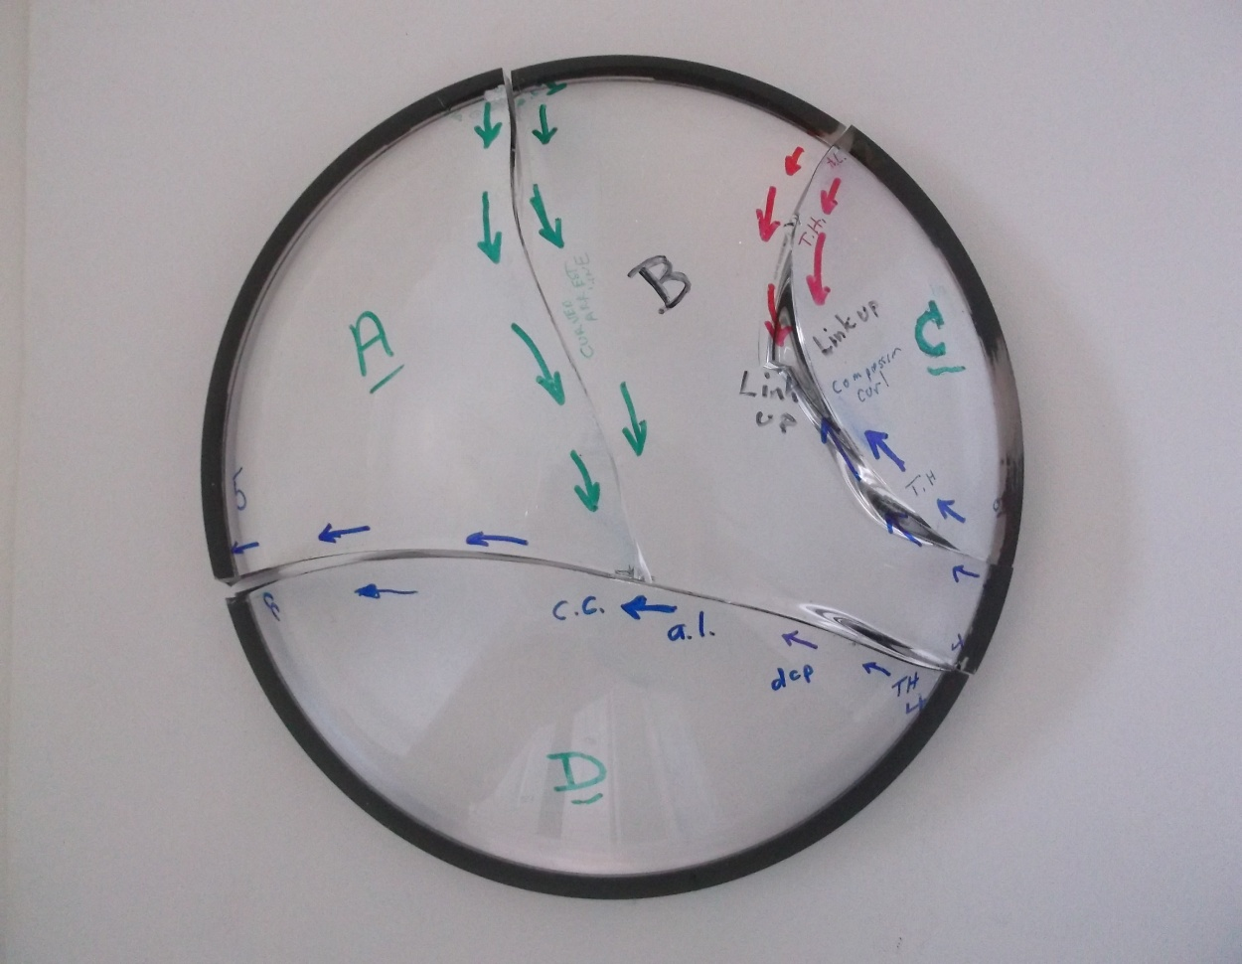
4
1
2
3

Figure A Top view of dome #1 showing four crack systems that started at origin sites labelled 1-4. The arrows are markers put on during the analysis, showing the directions of crack propagation. Origin #4 probably was the first break, although #2 and #3 are possibilities. These two cracks curved and intersected each other and then stopped. The crack that started at origin #1 ran until it intersected crack system 4, which was already there.

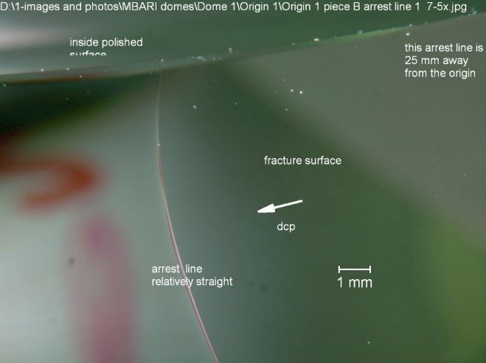
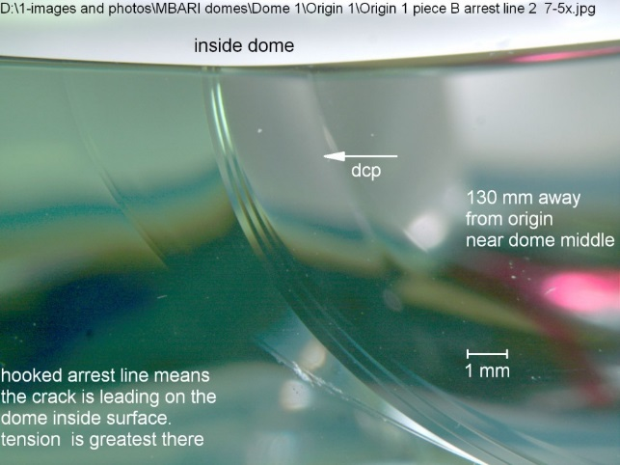

(a) (b)

Figure B. Fracture surface views. (a) shows a gently curved arrest line from a location a few cm in from the rim. (b) shows another arrest line from a location nearer the dome middle.

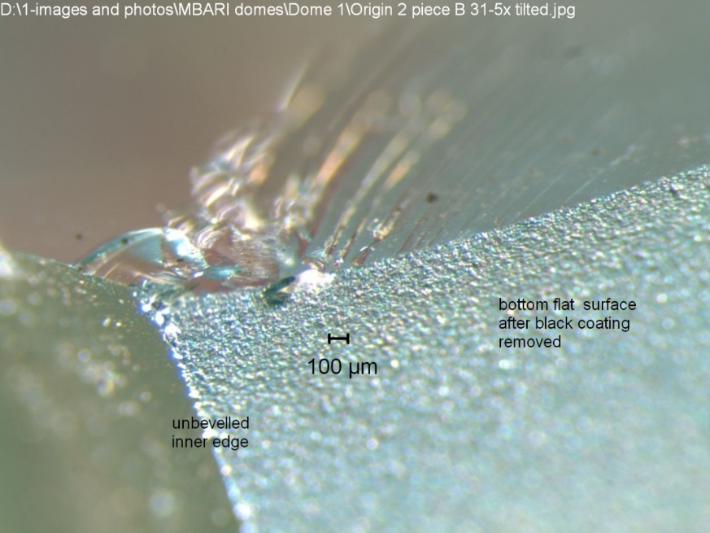
Bottom flat base of the dome
Fracture surface
Inside polished dome surface

Figure C. A contact damage crack that was the fracture origin of Dome 1, crack #2. It is about 1 mm to the right of the unbeveled inner edge of the dome. The ground surface of the flat bottom of the dome was very good. None of the fractures started from polishing or grinding damage.
Dome #2 is shown in Figure D. All the cracks radiated from a single origin site on the right side. Several curved around and exited through the rim, but a few fan shaped cracks ran toward the middle and stopped, presumably because the hoop tensile stresses diminished rapidly towards the dome middle. This multiple arc pattern of breakage is not unusual in pressure loaded disk or plate test specimens if the origin is at the edge and hoop stresses drive the initial crack growth. The insert shows an example of a ring-on-ring biaxial disk strength test fracture pattern from Reference. The fracture origin in this dome was located in the center of a beautiful fracture mirror (Figure E-a) on the outer dome edge. The origin was a contact crack or a grinding crack at the beveled edge of the dome as shown in Figure E-b. A fracture mirror analysis using the mirror/mist and mist/hackle constants and actual data of J. B. Quinn (Ref Q3) for a very similar borosilicate glass (Schott BK-7), produced hoop tensile stress estimates of between 40 to 47 MPa. A fracture mechanics analysis of the semielliptical crack itself gave hoop stress estimates of 39 to 46 MPa, in superb agreement with the estimates form the mirror size analysis.

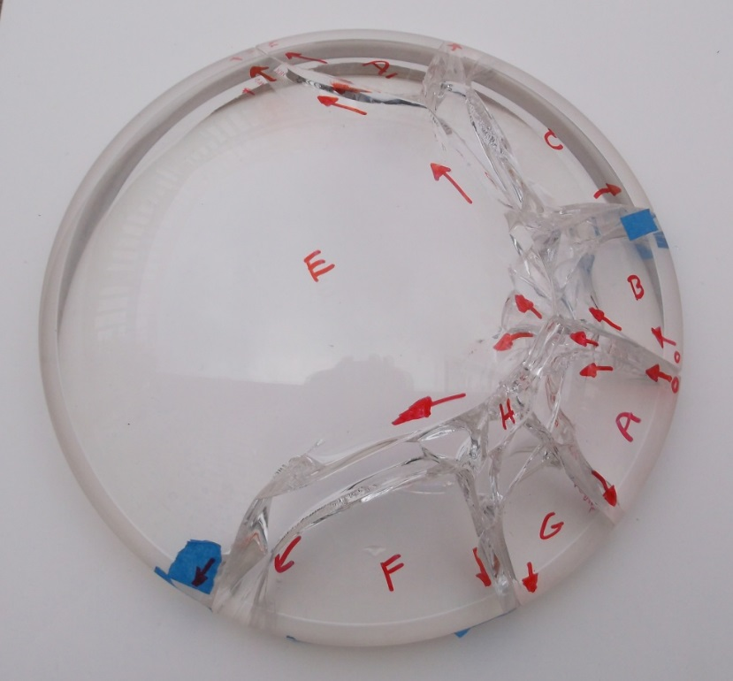

Figure D. Fractured dome 2. The origin is on the right side (black arrow). The sketch shows a fracture pattern in a biaxially loaded disk with an outer edge fracture origin from Refs Q1 and Q2.

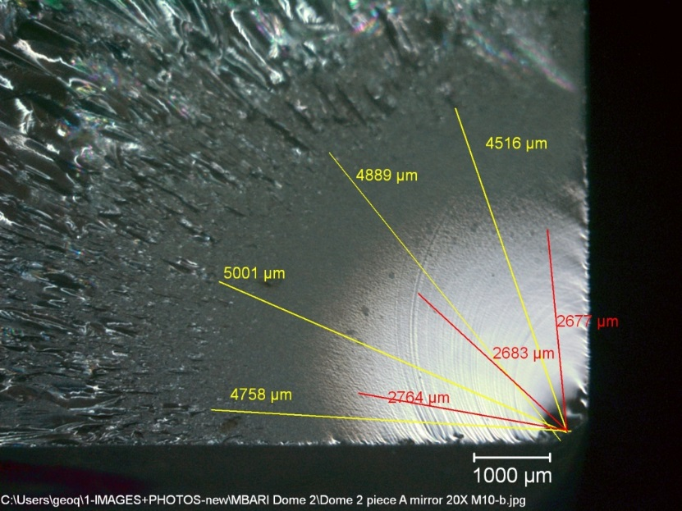
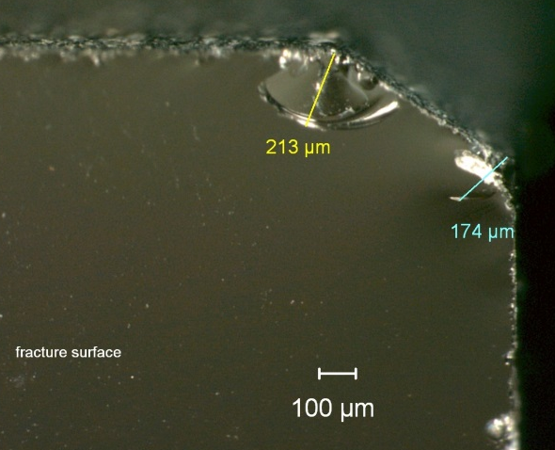

(a) (b)

Figure E shows the fracture origin at the outer edge of dome 2. (a) is a fracture mirror and (b) shows the origin flaw, a contact or grinding crack located on the outer edge bevel.

Ref Q3
J. B. Quinn, “Extrapolation of Fracture Mirror and Crack-Branch Sizes to Large Dimensions in Biaxial Strength Tests of Glass,” J. Amer. Ceram. Soc., 82 [8] (1999) pp. 2126-32.

END

