Elastic constants, fracture strength, and slow crack growth were determined by testing disks in accordance with ASTM International test methods C1259, C1368, and C1499.
Elastic modulus and Poisson’s ratio of HK9-L and BK-7 were 80±0.6 GPa and 0.22, and 80±0.3 GPa and 0.22 respectively. Strength distributions in un-strengthened and strengthened states are shown in Figure 1. Strengthening more than doubled the characteristic strength (382 to 786 MPa for BK-7 and 326 to 769 for HK-9L), and appears to have greatly increased the Weibull modulus for BK-7, however, the specimens were not prepared at the same time (?) and the conclusion is only tentative. Although strengthened HK-9L exhibited similar characteristic strength to BK-7, the Weibull modulus was substantially lower (19.7 vs. 7.9), as shown in Figure 1.

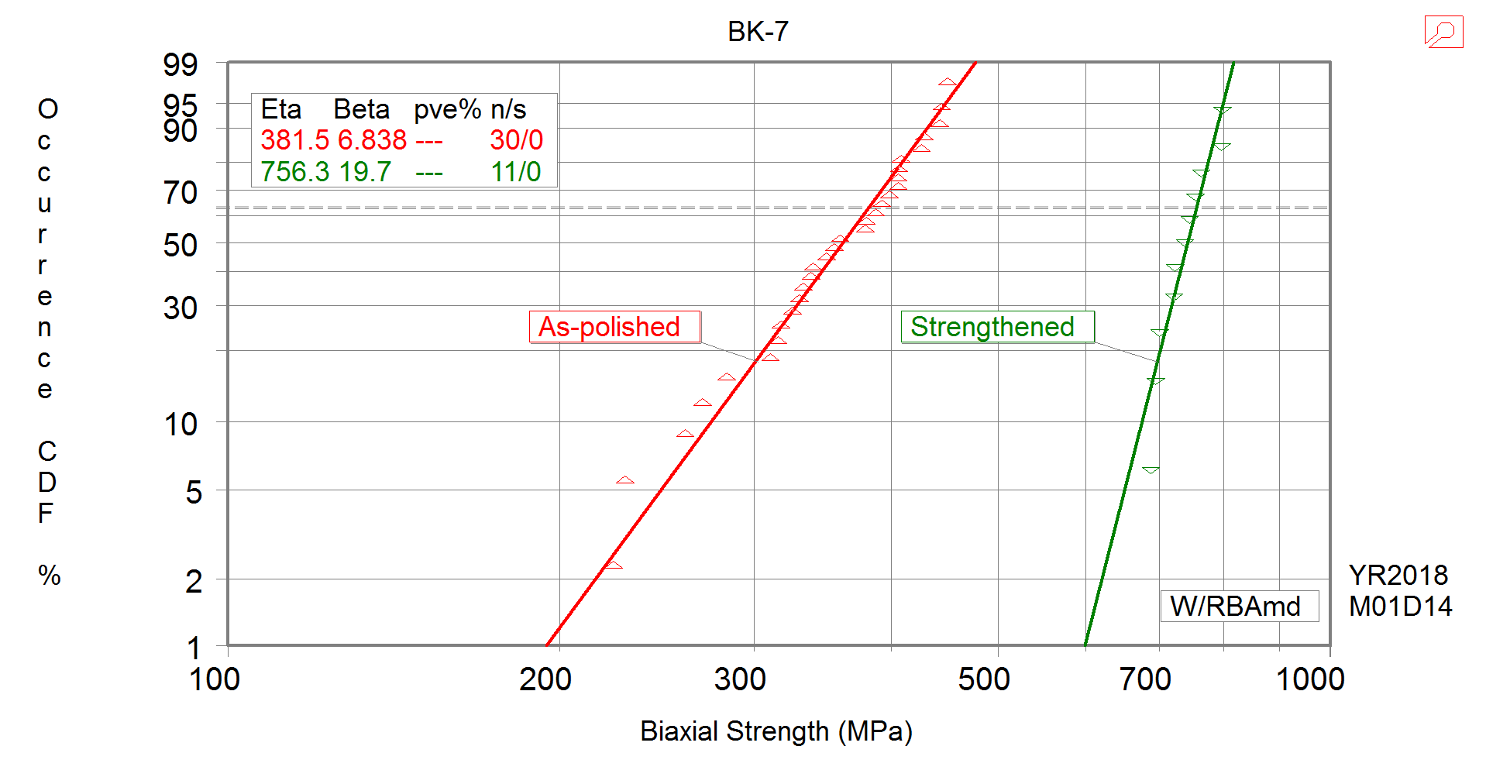

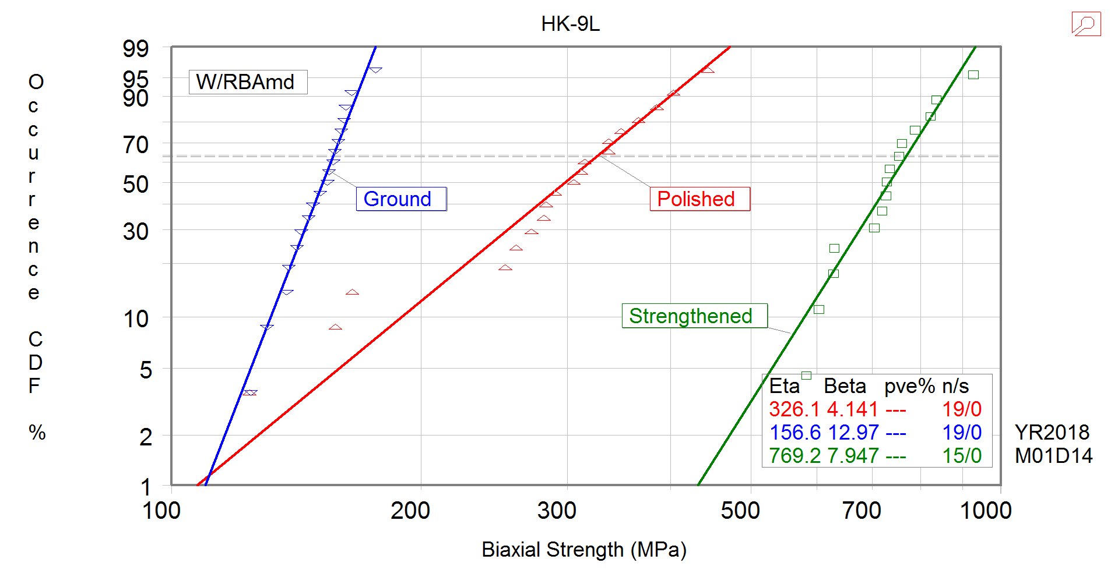
Figure 1. – Weibull distributions.

Slow crack growth parameters for HK-9L were determined by using constant stress rate testing in water per ASTM C1368. The resultant crack velocity curve is shown in Figure 2. The materials exhibit similar crack growth behavior.
Figure 2. – Crack velocity as a function of stress intensity.

Fracture toughness was determined in accordance with C1421 by using the chevron notch configuration in nitrogen, Figure 2. For HK9-L and BK-7, the fracture toughness in N₂ were 0.92±0.02 and 0.98±0.04 MPa√m respectively.
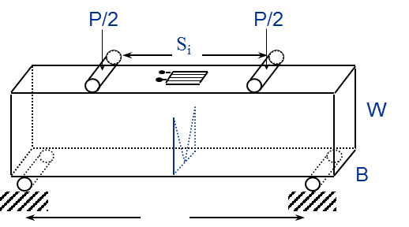
Figure 3. – Chevron-notched beam test configuration.

