Results of FEA simulation of glass port and titanium support ring
The strength of the glass is unknown. It depends on many factors (type of glass used, micro structure of surface of the glass, area of surface exposed, rate of stress increase, environmental media)and cannot be calculated. An acceptable stress value of 18000 PSI was determined by reverse engineering two proven designs (Sony HDTV housing, DSPL housing).

Pressure used for FEA: 2200 PSI

Displacement:
Maximum displacement on axis: 0.2mm
Maximum radial displacement: 0.008mm

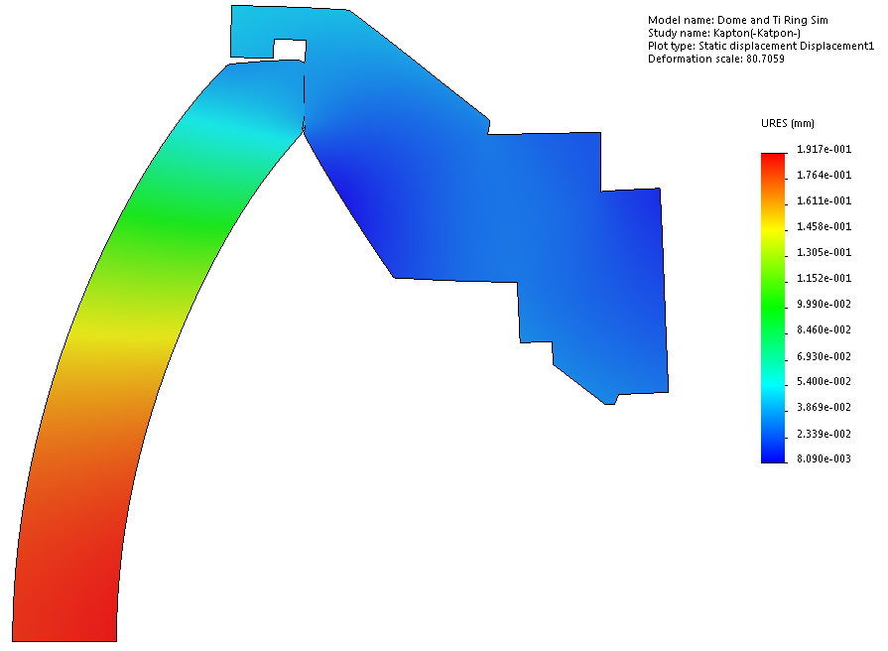

Stress

Maximum stress on axis: 8600 PSI
Maximum stress on contact edge: 32100 PSI (uncertain)
Average stress on contact face: 10500 PSI

