Project Number: | 901209

Project Start: Jan. 1, | 2013 | Project Duration (in years): | 4 ¹

Please indicate if proposal includes requests for any of the following (mark all that apply).

 | X |  |  | X |  |  | X
Ship Time |  |  | ROV |  |  | AUV |  |  | Wave Glider |  |  | Mini ROV

Please indicate what type of project is being proposed (mark only one).

 |  |  |  | X
Feasibility/Scoping  [Less than 100 days effort] |  |  | Development |  |  | Research |  |  | Infrastructure² |  |  | Education
 |  |  | Time Series |  |  | Institute Initiative
Project Manager: Kim Reisenbichler
Principal Investigator: Bruce Robison
Lead Scientist: Kim Reisenbichler
Lead Engineer: Mark Chaffee

Project Title: Investigations of Imaging for Midwater Autonomous Platforms (i²MAP)

- ABSTRACT

The i2MAP project was conceived as an effort to develop an AUV imaging system capable of taking over the task of midwater time series surveys currently conducted with ROVs. Thus, the i2MAP project proceeded to develop an AUV camera system that has a minimum requirement of producing video comparable to that currently provided by MBARI’s ROVs. Progress was initially slow, primarily due to competing engineering staff priorities, but the last 12 months have been very productive, culminating in the project’s first AUV vs. ROV video comparison dives on June 25th of this year. Initial inspection of the AUV video has the project team confident that we are well on our way to surpassing minimum project goals. However, we have exhausted our resources for this year, and we were directed to de-scope our 2015 efforts during the last proposal cycle due to limited local ship time. This step will delay further AUV/ROV video comparison dives beyond our single remaining dive in September of this year, until 2016.

Furthermore, there is additional engineering and comparative work that needed to field a fully operational i2MAP AUV imaging system for routine missions. The primary engineering challenge that remains is to determine the limitations of the glass dome design and, if needed, modify the design to achieve the 1500 meter depth rating specified in the design requirement. In addition, there remains work to refine some of the software functions and work path for video transfer to the VARS annotation system. We expect this project to be completed by the end of 2016.

We believe that this application of an AUV equipped with a state-of-the-art camera system both promises to provide Midwater Time Series researchers with a more complete census of the midwater community due to its enhanced video capabilities, stealth and increased transect speeds, and will do so more cost effectively by allowing MBARI to multitask midwater shipboard operations by deploying ROV and AUV simultaneously. Further, this effort will enable the midwater transecting component of the Integrated Time Series project.

- PROPOSAL

  - New Projects

Statement of the problem, why it is important

MBARI’s 22-year time series survey of the mesopelagic community in Monterey Bay is the only one of its kind. It is an invaluable resource for revealing the structure of the deep pelagic community and the changes taking place as a result of normal oceanic cycles, as well as climate change. However, there are limitations to this time series. First, the ROV platforms used to collect the images are large, slow, noisy and obtrusive, thus biasing these surveys towards animals that lack the ability to quickly move out of the way, or who are attracted to the lights. And second, competition for MBARI ship/ROV time is increasing, as available operational days diminish and our ability to maintain the frequency of these time-series surveys to the statistically required standard is diminishing. Therefore, developing less obtrusive methods for imaging the water column while minimizing the unit effort of ship/ROV time required to maintain the time series are in MBARI’s best interests. This applies both scientifically, by maintaining the frequency and increasing the quality of the midwater time series, and economically, by reducing the cost to collect the data. In addition, by adapting our survey methods to other platforms (moorings and AUVs), we optimize the potential for these techniques to be adopted by other institutions that do not operate ROVs.

How does it relate/contribute to MBARI’s mission and strategic plan?

This project aims to develop innovative technology that will provide a unique perspective on midwater ecology. It offers the potential to visualize the ocean’s interior for investigations of ecosystem dynamics, and to do so in a new way.

How does it relate/contribute to the Packard Foundation’s Ocean Visions Grantmaking policies? (See http://mww.mbari.org/oed/OED_Documents.htm#Packard for documents.)

This project addresses the Foundation’s core goal of restoring the world’s oceans and coasts, by developing new technology to measure and monitor pelagic animal populations. This approach provides a new perspective -- unobtrusive imaging – as a counterpart to trawling, acoustics, and ROV surveys. This approach holds promise for automating our successful ROV-based methods to make midwater surveys more economical for MBARI, and also more broadly available to other potential users. Data generated from such a system have applications in coastal management and fisheries restoration as well as probing the structure and function of the pelagic ecosystem

Does it relate to the Technology Roadmap? If so, please describe how.
(See http://www.mbari.org/about/TechnologyRoadmap.pdf.)

The i2MAP Midwater Imaging Module development effort clearly relates to MBARI’s Technical Roadmap as a tool to address the themes of Ecosystem processes and Ocean visualization. As the eventual primary video acquisition tool for the Midwater Time-Series project, it will be used to monitor long-term ecosystem trends within the mesopelagic community. The enhance stealth, speed and image quality it will provide promises a more complete picture of that community than what we have seen before. In addition, the relatively reduced cost of an AUV based imaging system will make it attractive to other institutions which might otherwise not be able to afford these types of operations. In addition, this effort will enable the midwater transecting component of the Integrated Time Series project.

Approach to the problem

The ultimate goal of the i2MAP project was to develop a camera system (controller, digital recorder and camera(s)) and platform interfaces that can be readily adapted for deployment in three modes, in order of priority: 1) on MBARI’s Dorado class AUV for time-series video transecting to produce survey imagery equal to, or better then we currently gather using MBARI’s ROVs. Ultimately, we intend to scale the system down for smaller AUVs; 2) on MRS moorings or from a ships wire for passive observations and; 3) as part of a vertically profiling optical/acoustic platform integrated into the MARS observatory.

It quickly became apparent that the Dorado i2MAP imaging AUV would provide the most immediate benefit and the focus of this project has been to develop an midwater transect imaging module that can acquire imagery of at least the quality of that recorded by MBARI’s ROVs. As will become apparent as you read this proposal, we are well on our way to meeting and, we believe, exceeding that goal by a good margin. The work remaining to complete this project requires that we request to extend the project by one year to tie up loose ends and provide a fully functional and documented module to the Operations group. The work remaining for 2016 includes the following:
- Test the existing dome design to determine if it is adequate to achieve the 1500 m depth rating it was designed to.
- Should the existing dome design fail its rating, design, purchase and test one that will meet the depth requirement.
- Work with the ITD and the Video TAG to help develop a digital video ingest pathway into VARS.
- Modify the camera and AUV control software to refine missions and functionality.
- Build an API (application programming interface) that will index the AUV ancillary data so that it can be searched, retrieve and integrated with other software, such as VARS.
- Conduct comparative, concurrent transects with Ventana to assess the performance of the i2MAP imaging module and validate the methodology.
- Make minor modifications, as needed to control electronics, as needed.
- Document the imaging module so that it can be readily operated and maintained by the DMO AUV group and Midwater scientific group.
- Optimize camera performance by upgrading firmware and adjusting camera setting for the best image under transecting conditions.
Publications (from other projects over the last 5 years)

See Midwater Time-Series proposal.

  - Continuing Projects

If the proposed project includes multiple individual projects, please list each of these projects as a subheading in the proposal. For each subheading, please address the following:

Current status of project and results to date

The following are short bullet items for the work performed on the i2MAP project between 2012 and 2014. For the detail of these tasks, see the 2015 i2MAP proposal.
- Scientific Requirements (2012 feasibility study) - See Appendix 1 for details.
- Evaluation of Current MBARI Imaging Systems (2012 feasibility study.) Found that no other in-house project had requirements that matched those of the i2MAP project.
- Light Field Evaluation (2012 feasibility study). Found that 4 DSPL SeaLite Sphere LED lights provide enough light to illuminate a volume similar to that used in the ROV transects.
- Digital Video Compression Evaluation (2012 feasibility study). Showed that Apple ProRes 422 (HQ) video codec provided digitally recorded video that is comparable to that recorded on HD tape.
- Dorado Midwater Imaging Module Power Budget (2013). Found that Dorado can provide enough power to run the i2MAP imaging module at full power for over 15 hrs at 2 knots.
- Dorado Low-Speed Stability Testing (2013-14). Showed that Dorado can be adequately at speeds as low as 1 knot with the addition of fixed reduced buoyancy, fixed wings, duct winglets, or a combination thereof.
- Optimized Camera and Lighting Design Evaluations (2013-2014). Found that the previously identified lighting and Sony F5 camera enable us to record transect video of equal or superior quality to that currently recorded by the ROVs. The F5, in combination with the light the SeaLite Spheres provide, is also capable of shooting at a higher frame rate and faster shutter speed than those used on the ROVs. This allows the transect speeds to be increased from 1 to 2 knots. Increasing the transect speed both eliminates the need for wings or ducts on the vehicle to maintain stability and allows us to observe some of the animals that can evaded the vehicle at lower speeds. In addition, this camera is capable of producing UltraHD (4K) video, a capability that can be implemented when a recorder becomes available that can handle the data rate required to do so.
The following are project achievements for 2015:
Camera/Recorder/Electronic Integration and Pressure Housing Assembly and Testing
The Sony F5 camera and AJA video recorder chosen in 2014, along with the control electronics designed this year were packed efficiently into a chassis designed to fit into a surplus titanium pressure housing (Fig. 1). The pressure housing was fitted with a new dome ring designed to accommodate the corrective optics and low-distortion glass dome that was specifically designed for this application.
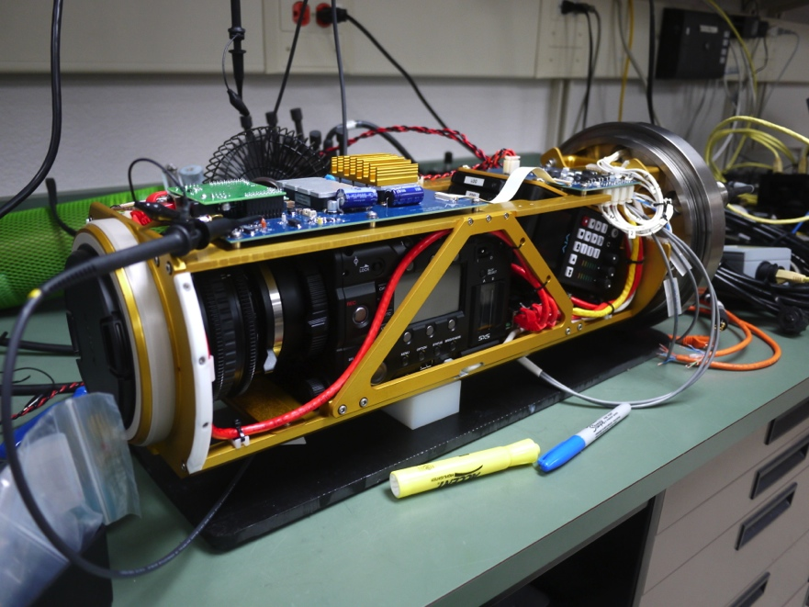
Figure 1. The complete i2MAP cameras/recorder/controller assembly during bench testing.
The glass dome for the camera was designed for a depth rating of 1500m. Three domes were ordered from a Chinese manufacturer. The first dome was mounted on the camera housing and pressure tested. The pressure was cycled to 2750PSI (equivalent to a depth of 1875m) 10 times. The dome was then inspected; there was no damage. The dome was then pressurized to 2750PSI and left at that pressure during 4 days. At the end of this period, the dome was found to have cracked.
Upon inspection of the broken dome, several problems were found:
- A small chamfer that was meant to relieve stress on the inside edge of the mating face had not been machined because of an error during the translation of the drawings to Chinese. This may have increased the likelihood of failure.
- The kapton ring that sits between the glass and the titanium seat was slightly undersized, causing the glass to overlap. According to an expert in the field, this can increase the likelihood of failure.
- Paint had been applied to the mating face of the dome, as recommended by the optical engineer. The paint was found to be of uneven thickness, possibly increasing stress in some regions of the dome.
Following the failure, one of the spare domes was assembled with the housing and successfully pressure tested to 1250m (20 cycles, 3 day hold). The unit was used for the AUV’s test dives, to a depth of 300m.
Sensor Integration
Along with a video data, continuation of current transect experiments requires addition environmental data sets to be available. The design of the new nose section includes a small suite of environmental sensors. As much as possible selected sensors are those already included in Dorado class AUVs to reduce costs associated with asset sparing and to reduce needs for extensive software integration on the AUV. Using previously integrated sensors also allows us to utilize the existing AUV CTD data architecture. Sensors identified include: conductivity (SBE 4C), temperature (SBE 3F), oxygen (2x SBE-43) from Sea-Bird Electronics. A 25 cm WET Labs C-Star transmissometer is also installed. The sensors are connected to a Sea-Bird SBE 25plus CTD, which is common with the one used on the Iceberg AUV and similar to the board set integrated into the CTD AUV. These sensors will be mounted inside the imaging module, to the port and starboard side of the imaging housing (Fig. 2).

Figure 2. Views of the open i2MAP imaging module. a) Stern view with the camera housing in the top center, SBE 25plus is in the lower center and environmental sensors mounted on each side. b) Bow view with the camera housing dominating and sensors on both sides.

i2MAP Camera Recorder and Logger (CARL) Software
In 2015 we developed the interface software for controlling the components in the i2MAP Dorado AUV section. This software is made up of 3 modules working together. The first module is an interface to the AJA Ki Pro video recorder that controls when and how the video from the Sony F55 camera is captured. The second module interfaces to a Modtronix micro controller board used to switch power to the i2MAP components, channel CTD data streams to the AUV, and measure environmental data.The third module is the CARL behavior that is used in AUV mission scripts. The behavior module exposes all of the functionality in the AJA and Modtronix modules that is needed by AUV mission designers such as turning on the camera, starting and stopping video recording, and turning on the LED lights.

Vehicle Controls Work
Controls work during 2015 was mostly focused on improving vehicle control at 1.0 m/s (2 knots). The vehicle with the nose in the final configuration performed very well during the first sea trail. After achieving steady-state, depth control error was on the order of tens of centimeters for each transit depth.
Figure 3. Plots of a) speed maintained at ~ 1.0 m/sec during a transect and, b) depth maintained during the transect. The transects ran from 2500 to 3300 seconds.

Dorado simulation in real-time mode is used to test the new camera and recorder drivers associated with software. This is done by simulating vehicle flight with all sensors simulated as usual other than the camera. The camera was connected to the simulator over the Ethernet, and was receiving commands as if the vehicle was operating. This was thus a complete test of the relevant software operating during flight. This approach found several bugs, and facilitated their correction ahead of time in the lab, without consuming valuable sea-trial time.

Initial AUV/ROV Open Water Testing and Video Comparison
The complete i2MAP Imaging AUV made it’s first test deployment on June 15th, 2015 (Fig. 4), which was followed by the first concurrent AUV/ROV video comparison dive with Ventana on June 25th. Due to the dome de-rating, we were only able to make comparative transects at 100, 200 and 300 m depths. The ROV transects were run at ~1 knot (55 cm/sec) for 10 minutes each to be compared to the AUV running at ~2 knots (100 cm/sec) for 5 minutes.

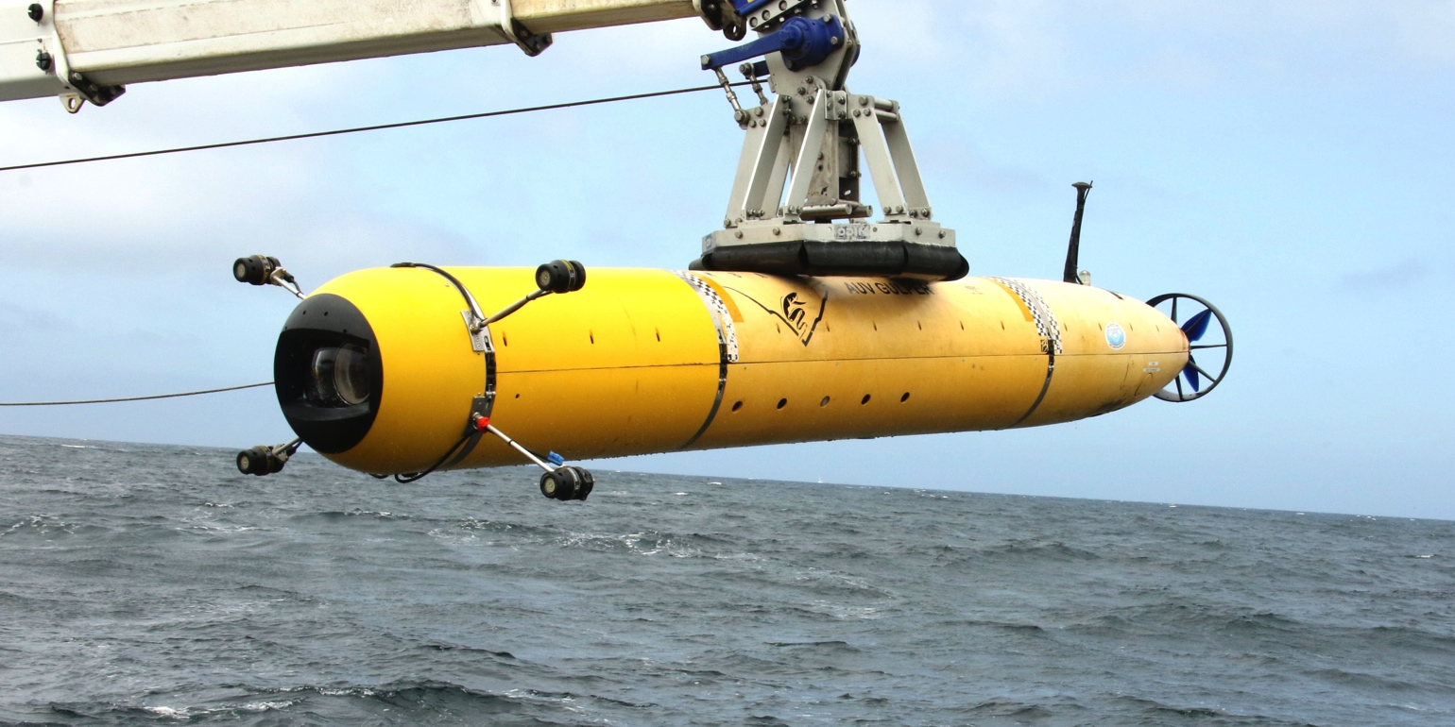
Figure 4. The Dorado i2MAP Midwater Imaging AUV being launched for its initial sea trials.
Initial impressions by all who observed the AUV video were positive. Despite running at twice the speed of the ROV, the video from the AUV is less smeared around the edges, where motion most affects the quality of the image. When compared frame-by-frame, one can see that the i2MAP image is sharper around the edges (Fig. 5).
Annotation and analysis of the date from the 100 and 300 m transects, which had the largest concentrations of animals in them (Fig. 6), indicates that for most taxa, the i2MAP imagery revealed numbers comparable to or greater than the ROV images at both depths. Remarkable, the exceptions to this where two relatively large and easily identifiable animals, Sergestes similis and Nanomia bijuga. This may be do to the difference in location in the canyon (i.e., North wall vs. South wall) or, by the i2MAP light field requiring adjustment to better illuminate the outer edges if the field of view. The latter issue would cause the annotator to not see animals that can normally be identified at a distance along the distant periphery of the image where lighting is less intense. Continued testing during our September, 2015 cruise further improve lighting structure and camera settings.

Figure 5. Frame grabs taken from: a) Ventana transecting at 55 cm/sec and, b) i2MAP AUV transecting at 100 cm/sec.

Figure 6. Chart showing the relative abundance of taxa observed during ROV and i2MAP AUV video transects at a) 100 m depth and b) 300 m depth.

Significant changes from previous project proposal

There are no significant changes to what we propose in our 2015 proposal other than that further engineering effort is required to qualify the dome port to the specified depth (1500 msw) and that the i2MAP AUV vs. ROV video comparisons will take place a year later than previously proposed (i.e., 2016).

Publications based on the results of this project only

A presentation of our progress to date is being made in early September of this year at the 14th Deep-Sea Biology Symposium in Aveiro, Portugal.

We are planning on submitting a paper describing the imaging module and the results of the quantitative video comparisons with that collected by ROV in Limnology and Oceanography Methods in early 2017.

  - New and Continuing Projects: Plans for 2016

Research Activities
Following the completion of the dome port qualification to 1500 m early in 2016, the focus of the project will changing from engineering development to scientific evaluation of the engineering product. Evaluation of the AUV imagery will take place via two different methods. Quantitative analysis of the AUV-obtained video in comparison to that taken with Ventana, will be conducted to validate this new methodology during 5 dives in 2016. Concurrent AUV and ROV transects will be run at similar depths and at similar times within a close, but safe, proximity to each other for video transecting comparisons. Additional, AUV transects will also be conducted to determine if we can reduce vehicle avoidance by altering our transecting procedure. For example, we will conducting five, one minute illuminated transects intermingled with one minute dark periods vs. one continuous 10 minute transect at a given depth to determine how that effects the number and types of animals observe.
Engineering/technology development

Camera Dome Evaluation and Redesign (as necessary)
Our goal is now to increase the depth rating of the glass dome to 1500m. We have consulted with two engineers who are highly experienced in the design of glass ports (Mark Olsson, of DSPL, and Glenn McDonald, of WHOI) to discuss the failure. Based on their recommendations and our careful judgment we are proposing to:
- Order two modified domes from the manufacturer. The modifications will include a 0.5mm chamfer on the inner edge, an optical polish of the mating face (to increase strength), and no paint. The units have already been manufactured and can be ordered for a cost of $1350 each, excluding freight and customs charges.
- Replace the kapton ring with fiber reinforced neoprene. This material is used on WHOI’s 11km rated glass domes. Its greater thickness and compliance will help distribute the load more evenly. A new method, still to be determined, will be used to cut the neoprene to the proper size.
Glenn McDonald, recommended a slightly different approach to the finite element analysis of the dome, to get a better estimate of stress and deformation under pressure. In this approach, the neoprene ring is included in the model, and the friction between the components is assumed to be infinite. François will apply this alternate method to verify the design and get an accurate estimate of stress and deformation.
One of the modified domes will be pressure tested to 1500m, plus a 25% safety margin and a number of cycles and hours under pressure equivalent to the lifetime of the dome (5 years, 60 dives to 1500m, assuming 1 hour at or deeper than 1000m for each dive, a conservative estimate). The test will be performed using a computer controlled pressure chamber. The duration of the test will be approximately 4 days.
The test article will be instrumented with a digital linear gauge, a microphone and a thermistor, whose data will be recorded during the test. The sensor will be placed inside the housing and will be connected to a data recorder. The linear gauge will be used to measure the deformation of the dome and to verify the results of the finite element analysis. If the measured deformation does not match the calculated deformation, the model can be modified to match reality and thereby obtain a more accurate estimate of stress. The microphone will be used to listen to cracking sounds that are likely to occur during the first cycle, when stress can be relieved in the glass. Cracking sounds during subsequent cycles will show that the glass continues to degrade over time. No sounds will indicate that the dome is stable (more research will need to be made on the subject). The thermistor will be used to verify that temperature is constant throughout the test. In the event of a failure of the dome, the data recorded during the test may help determine its cause.
Strain gauges will not be used during pressure testing. They would be of little use because they can only measure surface strain and the failure stresses and associated strains and crack growth are within the bulk of the glass. Moreover, the strain gauge couldn't be used to measure the strain at the glass to metal interface, which is the most critical part of the dome.
The pressure test can be performed using the existing dome mount ring. A dummy cap may need to be manufactured to accommodate the sensors and connector.
If the test is successful, an additional cycle to 1500m + 50% may be performed to increase our confidence in the dome’s ability to withstand pressure. After the test, the dome can be discarded. The spare dome can be used for operations at sea, and spares can be ordered from the manufacturer. A test protocol will have to be determined and applied to each unit before use in the field. Also, an inspection program will be put in place to verify the condition of the dome during its lifetime.
If funds and labor remain available in 2015, we would prefer to do this work as soon as possible. Associated labor is listed under Milestone 1 and we estimated the total cost to perform these tests to be $9000
In the event that the dome fails during the test, the design will need to be modified in 2016. Several modifications can be performed (shown in order of cost and difficulty):
- Plan A. Increase dome thickness
  - $7500 est. cost
  - 60 hrs of ME time
  - 40 hrs of Machine Shop time
- Plan B. Angle dome seat to better distribute stress (requires new dome, and new dome mount ring)
  - $12,000 est. cost
  - 100 hrs of ME time
  - 80 hrs of Machine Shop time
- Plan C. Decrease dome OD (reduce field of view or modify optical design altogether). Requires new dome, new titanium optical mount ring, and possibly new corrector lenses.
  - $17,000 est. cost
  - 120 hrs of ME time
  - 120 hrs of Machine Shop time
We will use the mid-price option (Plan B) for the purposes of budgeting for this proposal.

i2MAP Camera Recorder and Logger (CARL) Software
For 2016, we propose to work on refining all 3 software modules, as needed, while focusing most of the effort on the CARL behavior module. This effort will include providing more of the precise methods needed by mission designers, automatic adjustment of the camera aperture and F-Stop setting to match ambient light levels, and greatly improving the reliability of the entire system.

AUV Controls Software
For next year, we will probably need to refine the time-series transect mission(s), and test them in simulation. We need to continue to monitor the new vehicle (new nose shape, shorter in length) for any recurrence of unwanted oscillations, and have the resources to make controls adjustments if necessary.

Video Annotation and Archival Workflow
An important design requirement described in the 2014 proposal is that the video acquired by the AUV midwater imaging system be compatible with the existing video lab annotation and archival system. In order to accomplish this, we acquire video at 1080 P60 (1080x1920 pixels progressively scanned at 60 frames per second) and record on a one terabyte (TB) solid state field recorder, the AJA Ki Pro Quad. The data is compressed at the time of recording using the Apple ProRes 422(HQ) standard. See Digital Video Compression Evaluation section above. Post mission, the video records will be moved from the AUV by downloading using Gigabit Ethernet to a portable drive and transferred immediately to the MBARI Atlas server. For the remainder of 2015 the .mov files will be batch converted to H.264 format files and annotated using existing VARS capabilities. In the future, the workflow will use the file based video format selected as the standard by the Video TAG and we offer our video as a test case for this selection. The maximum data anticipated for 2016 is 15 hours of video (~4 TB), for which storage space is being requested through the MDUC Core Annotation/data management project (500055)
Contextual Data Ingestion
It is vital that the ancillary data (CTDOT, ADCP and navigation data) be linked to the video imagery produced by the i2MAP module. Fortunately, a path already exists for the CTD AUV data stream that will allow us to off-load, process and QC these data with little modification.
Raw, binary log files from each instrument (CTDO, ADCP) are recorded on the vehicle’s main computer. After a mission, the full set of logs is zipped onboard the vehicle and transferred to a server (Atlas). On shore, mission data are uncompressed and stored as raw, converted to netcdf, and processed with Matlab to apply instrument calibration(s). Then standard products are generated: 5 types of plots for quality control or quick viewing or the various data can be accessed for further analyses, and processed data in multiple formats (matlab, netcdf, odv, kml). An API (application programming interface - Schlining) will be built to index the AUV data so that they can be searched, retrieved and integrated with other software like VARS. See Figure 7 for an illustration of the data flow path
Figure 7. Flow chart of AUV ancillary data processing required to make it accessible by end user queries.

Other Remaining Tasks
The few remaining task to wrap up the project include: refining the integration of the camera system operations into the Dorado mission script (McEwen and Henthorn); modifying the PCB electronics for independent camera and recorder power switching (Chaffee); camera firmware upgrade and picture optimization (Chaffee); and refining the user documentation and field checklist (all).

Field programs (detail ship requirements/deployments/diver requirements)

We will require five Carson/Dorado/Ventana ship days in 2016 i2MAP AUV vs. ROV video transect comparisons. The first day will be scheduled in May, followed by five more days distributed throughout the latter half of the year.

Specific deliverables

1) A transecting camera and recording system for the AUV Dorado capable of completing the midwater transects currently conducted by MBARI’s ROVs. The system will also be compatible with the current annotation process and image archival systems at MBARI.
2) A paper describing the i2MAP Imaging Module and the results of the video comparisons will be submitted to the Limnology and Oceanography Methods for publication in 2017.

Milestones (see personnel classification list)

2016 Project Start Date:  01/04/2016 | Milestone 1 | Milestone 2 | Milestone 3 | Milestone 4 | Milestone 5 | Total Resources for each resource category for all milestones listed here
Milestone Date | 2/28/16 | 4/30/15/15 | 5/20/15 | 11/20/15 | 12/31/15
Milestone Description | Complete dome testing | Complete electronics and firmware upgrades | Complete dome redesign | Complete AUV controls and CARL upgrades | Complete ROV/AUV transect comparisons
EE | Chaffey-24 | Chaffey-85 | Chaffey-56 |  | Chaffey-120 | Chaffey-285
SE |  |  |  | Henthorn-200  McEwen-120 |  | Henthorn-200  McEwen-120
ME | Cazenave-120 |  | Cazenave-100 |  | Cazenave-40 | Cazenave-260
EE Tech
SE Tech
ME Tech
Machine Shop | 36 |  | 80 |  |  | 116
ITD Video Tech |  |  |  |  | 121 | 121
Divers

Budget justification

Line Item | Price | Justification
Pressure test cost – Milestone 1 | $3,000 | Required to test existing dome design to determine if it can meet the 1500 m requirement
Foreign Freight Charges - Milestone 1 | $300 | Required to test existing dome design to determine if it can meet the 1500 m requirement
Domestic shipping – Milestone 1 | $200 | Required to test existing dome design to determine if it can meet the 1500 m requirement
Modified domes – Milestone 1 | $3000 | Required to test existing dome design to determine if it can meet the 1500 m requirement
Sensors for dome testing – Milestone 1 | $1050 | Required to test existing dome design to determine if it can meet the 1500 m requirement
Materials for dummy cap and sensor mount – Milestone 1 | $500 | Required to test existing dome design to determine if it can meet the 1500 m requirement
Waterproof connectors and cables – Milestone 1 | $200 | Required to test existing dome design to determine if it can meet the 1500 m requirement
Travel to testing facility – Milestone 1 | $750 | Required to test existing dome design to determine if it can meet the 1500 m requirement
Optical Engineer (OS) – Plan B | $1500 | Required to engineer, test and build a new dome seat if the original design proves defective.
Pressure testing – Plan B | $2,000 | Required to engineer, test and build a new dome seat if the original design proves defective
New Dome (3 ea.) – Plan B | $6000 | Required to engineer, test and build a new dome seat if the original design proves defective
Materials for fabrication of new titanium dome fixture – Plan B | $2500 | Required to engineer, test and build a new dome seat if the original design proves defective
Travel to pressure test facility – Plan B | $750 | Required to engineer, test and build a new dome seat if the original design proves defective
Spare Sealite Sphere | $2,300 | Spare light in case one is damage during launch or recovery.
SBE 43 Dissolved O2 sensor (redundant) | $5,362 | Redundant O2 sensors are required to be assured of O2 data quality.
Spare cables and connectors | $1,000 | Spare cables and connectors for imaging module
Shore power/data cable | $800 | Required for testing module in test tank and lab while in housing.

Project team

Bruce Robison, Principal Investigator (80 hrs. requested)
Will oversee the development of scientific requirements and review the capabilities of the systems to meet those requirements.
Kim Reisenbichler, Project Manager and Lead Scientist (240 hrs. requested)
Will manage project time and resources, providing scientific guidance to the engineering team, participate in developing the lab testing procedure and helping evaluate the test results.
Mark Chaffey, Lead Engineer and Electrical Engineer (285 hrs. requested)
Mark will oversee project engineering. He will also be working with Francois on dome testing and re-design, as well as, revising and electronics board, upgrade camera firmware, and precruise preparation and testing.
Francois Cazenave, Mechanical Engineer (100 hrs. requested)
Francois has been responsible for the mechanical engineering for the project, including: pressure/camera housing design and light frame design and build. His main efforts for 2016 will be to resolve the issues with the camera dome and any other mechanical issues which become apparent during testing.
Rich Henthorn, Software Engineer (200 hrs. requested)
Rich will be continue developing the camera/recorder control software.
Rob McEwen, Software Engineer (120 hrs. requested)
Rob is responsible for AUV stability testing and control software.
Brian Schlining, Software Engineer (80 hrs. requested)
Brian will be responsible for building the API to facilitate transfer and storage of the ancillary data for later query by users
Rich Schramm, Software Engineer (80 hrs. requested)
Rich will be working with Brian Schlining to develop the API interface
Rob Sherlock, Science Technician (160 hrs. requested)
Rob will utilize his wealth of experience processing time series video to help develop the protocol for testing candidate systems to ensure that they are capable of delivering video survey records comparable to what we can currently extract from the ROV video.
DMO AUV Group
Participation in this project by the AUV group is greatly valued. While we have budgeted engineering resources to accomplish all project goals, their continued participation in project planning, as well as work on system integration are necessary to produce the best results possible for the project.
ITD Video Support Technician (121 hrs)
With the loss of Kris Walz expertise at the end of 2015, we now require Video Lab Technician support to perform our AUV/ROV video transect comparisons. The time required is calculated by estimating that it takes 8 hours to hyper-annotate every 1 hour of standard ROV video and 0.5 hrs of i2MAP AUV video, respectively.

Project lab and office space requirements

We are currently occupying the NW corner of Lab A244 and would like to retain that space through June of 2016

Data storage requirements (see Todd Ruston for assistance)

Our project data storage requirement of 4 TB for 2016 are being handled under the MDUC Core Annotation/data management project (500055)

Data availability outside project team, uniqueness

The data extracted from video produced by the imaging module will be adding to MBARI’s unique 20 year midwater time-series and will be available to MBARI researchers and collaborators. The resulting publications will be available to all. Engineering information produced by this project will be shared via publications and, we hope, used at other institutions to facilitate the initiation of long-term midwater surveys elsewhere.

Export Regulation
Does the project team anticipate any foreign collaborations or international travel? If so, please identify collaborators by name, institution, and country.

Not at this time.

Does the project team plan or anticipate export controlled purchases, shipments, or transfers of items (e.g., research instruments, proprietary data, hand-carried tools or samples) outside the U.S. temporarily or permanently? If yes, please identify country or countries and indicate whether these items will remain under MBARI control while abroad or controlled by others. Will the items be exported to more than one country? Please include foreign collaborator information as described above.

Not at this time.

Monterey Bay National Marine Sanctuary SESAs (General map)
Projects will need to indicate whether or not work will be conducted within one of the Monterey Bay National Marine Sanctuary's Ecologically Significant Areas (SESAs). An interactive map can be found on the Sanctuary's SIMoN webpages at http://sanctuarysimon.org/maps/sesa/. (Note: It may take a moment for the page to load, so please be patient. Also, if prompted for a login, hit “Cancel” and then you will be able to access page.) To determine if your work will occur in a SESA, specific coordinates can be entered using the locator function (click on the red "target" button in the toolbar at the top of the map). If your work will be conducted in one of these areas, please indicate which area, by number.

[Click here to enter SESA number, if applicable, or enter "None"]

Risk matrix (development and infrastructure projects only)

 | Technical Risk | Organizational Risk | Tech Transfer Risk | Labor Estimate Risk
High
Medium | X | X | X | X
Low

This date and number should remain the same for the duration of the project. If your project start date for 2016 is not January 1, please indicate the start date in the first cell of the milestone chart.
Development and infrastructure projects must complete the risk matrix (see item #5 at the end of the proposal form).
Not all projects will require all four titles to be filled in. Please indicate individuals only for those titles that are appropriate for your project.
This number should be the same number you entered on the resource requests for this particular resource.

