Automating MBARI’s midwater time-series video surveys: the transition from ROV to AUV

Kim R Reisenbichler, Mark R. Chaffey, Francois Cazenave, Robert S. McEwen, Richard G. Henthorn, Robert E. Sherlock and Bruce H. Robison
Monterey Bay Aquarium Research Institute
7700 Sandholdt Rd.
Moss Landing, CA 95039
reki@mbari.org

Abstract— MBARI has been conducting remotely operated vehicle (ROV)-based video surveys of the upper 1000 meters of the water column in Monterey Bay, California for over 23 years. These surveys have produced a unique midwater time-series data set that has enabled MBARI scientists to observe changes in mesopelagic animal distribution and community structure in Monterey Bay over that time period. These changes can generally be associated with both short and long term changes in water mass structure, including some now being associated with climate change. This historical data set is becoming even more important as we begin to observe the effects of climate change on community structure and ecology in the midwater environment and try to predict the impact of future change. However, this data set comes at a high cost in ROV and support ship time required to conduct the surveys. In order to sustain these surveys into the future, a more cost effective approach is required. In an effort to reduce cost, improve methodology and develop a system that has the potential to be exported to other institutions, MBARI has developed a high definition video module to be deployed on its Dorado class autonomous underwater vehicle (AUV). This paper explores the challenges of this development, the chosen solutions, and presents early data derived from our initial inter-comparisons of video collected concurrently with MBARI’s ROV and midwater imaging AUV.
Keywords—component; formatting; style; styling; insert (key words)
I. INTRODUCTION

In the context of history, it is sometimes said that to know where you’re going, you must know where you’ve been. This concept also rings true in the realm of the marine sciences on both short-term (months to decades) and long-term (decades to centuries) scales. Unfortunately, detailed historical data of pelagic animal distributions throughout the oceans as a whole are relatively sparse, with few extended data sets of animal distributions and associated hydrographic conditions, collected in the same area over an extended period of time. In 1993, the Midwater Ecology Group at the Monterey Bay Aquarium Research Institute (MBARI) began the first extended time-series study of its kind, monitoring the upper 1000 m of water in Monterey Canyon, via high quality Remotely Operated Vehicle (ROV) video on a monthly basis to monitor how the population dynamics at this site change with varying hydrographic conditions such as those associated with El Niño-Southern Oscillation (ENSO) and decadal oscillation events. The ensuing 23 years of observations and resultant data, also serve as a unique baseline to assess further changes that appear to be linked to climate change. In order to fully realize the increasing value of these data, the surveys must be continued into the future.
ROV-based video surveys have significant advantages over those conducted using nets, particularly in regard to determining the density of gelatinous organisms, many of which are too fragile to be collected intact by nets. However, there are limitations. First, from a survey perspective, ROV platforms used to collect the images are large, slow and noisy, thus biasing these surveys towards animals that lack the ability to quickly move out of the way, or that are attracted to the high intensity lights. And second, from an operational standpoint, ship/ROV time is expensive and competitive. It is difficult to support a program that requires this amount of resources on a perpetual basis. Therefore, developing a less obtrusive method for imaging the water column while minimizing operating costs is the logical path forward. Also, by adapting our survey methods to an Autonomous Underwater Vehicle (AUV) platform, there is the potential for this technique to be adopted by other institutions that do not operate ROVs.
Consequently, the Investigations of Imaging for Midwater Autonomous Platforms (i2MAP) project has developed a high–definition, imaging module nose section that is mated to one of MBARI’s Dorado class AUV tail and mid-sections that are otherwise used for seafloor mapping [Kirkwood, et al.] and hydrographic surveys (Ryan, et al.). The minimum requirement for this system was to capture video and ancillary hydrographic data of at least the quality of that which we previously attained using MBARI’s ROVs. However, the higher goal was to improve the quality of the imagery in such a way that it will enhance the quality of our surveys.

II. MESOPELAGIC SURVEYS WITH MBARI’S ROVS

Midwater Time-Series surveys have been conducted at the Midwater 1 site (36° 42’ N, 122° 03’ W), over approximately 1400 m of water in Monterey Bay, California, beginning in 1993 (Fig 1.). The primary vehicle used for the surveys has been the ROV Ventana (Fig 2.), with supplementary surveys
over the years being conducted by the ROVs Tiburon and Doc Ricketts. The surveys are conducted at 11 depths between 50 and 1000 m. Each transect is run at a speed of ~0.55 m/sec (~1 knot), for 10 minutes, resulting in an average transect distance of 330 m at each depth. The high definition video (1080i/30fps) is recorded on tape and returned to shore where it is annotated in detail using MBARI’s Video Annotation and Reference System (VARS) {Schlining 2006}and the resultant data are stored in MBARI’s Expedition Database along with concurrently collected hydrographic data (i.e., temperature, depth, salinity, dissolved oxygen and light transmission).
One example of how these data can be used is illustrated in Fig. 3, which consists of a plot of water column oxygen content overlaid with a plot of the mean depth distribution of a six species of commonly occurring midwater animals over a 14 year period. The oxygen plot shows a trend of a broadening Oxygen minimum layer followed by a corresponding decrease in average mean depth for 4 of the 6 species populations plotted. Another example can be found in the Midwater Ecology group’s publication on the extraordinary contribution that Giant larvaceans make to the carbon flux from the epipelagic zone to the benthos [Robison, et al.]

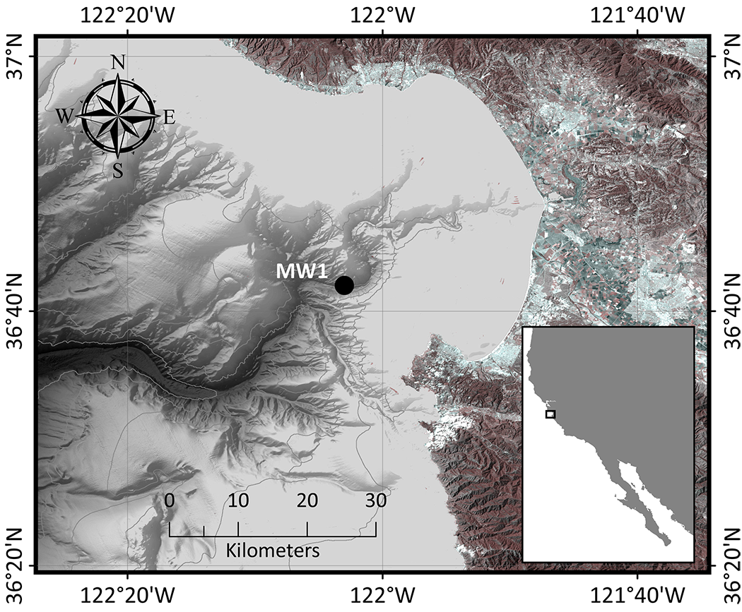
Figure 1. Google map of Monterey Bay, California, USA showing the Midwater 1 site in the axis of the Monterey Submarine Canyon.

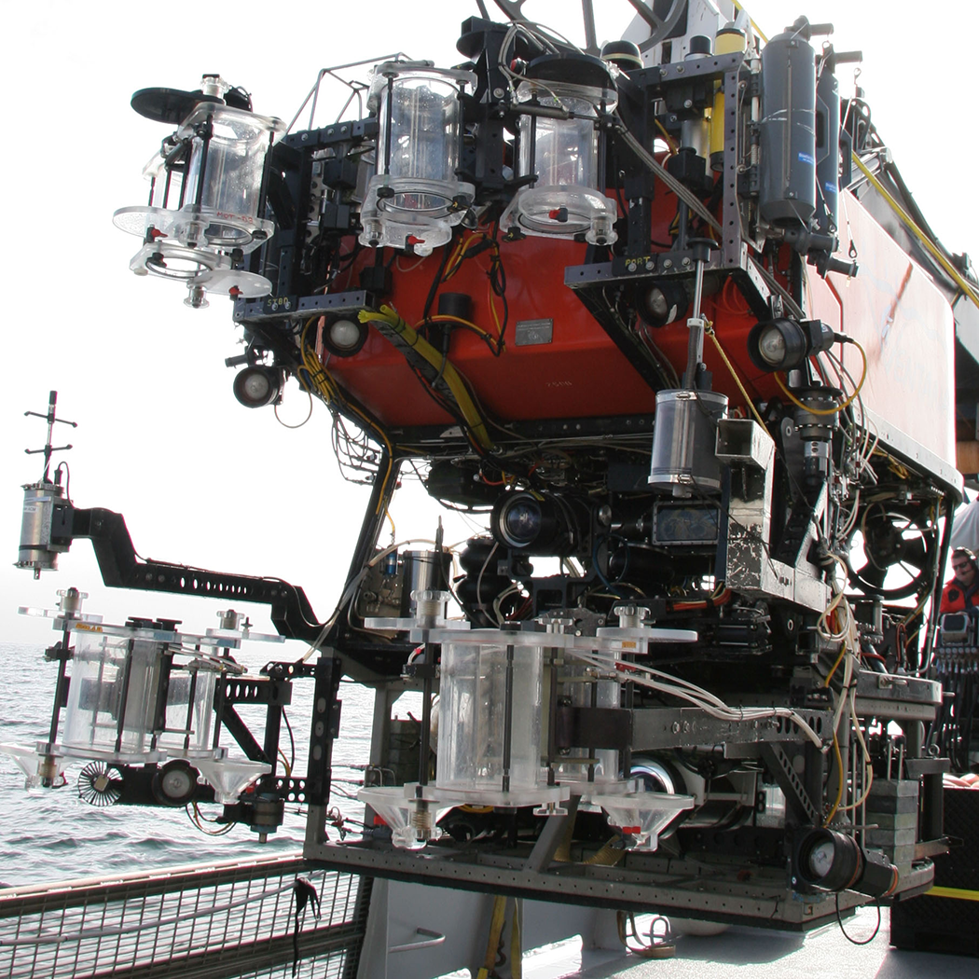
Figure 2. The ROV Ventana equipped for midwater surveys and animal collections.

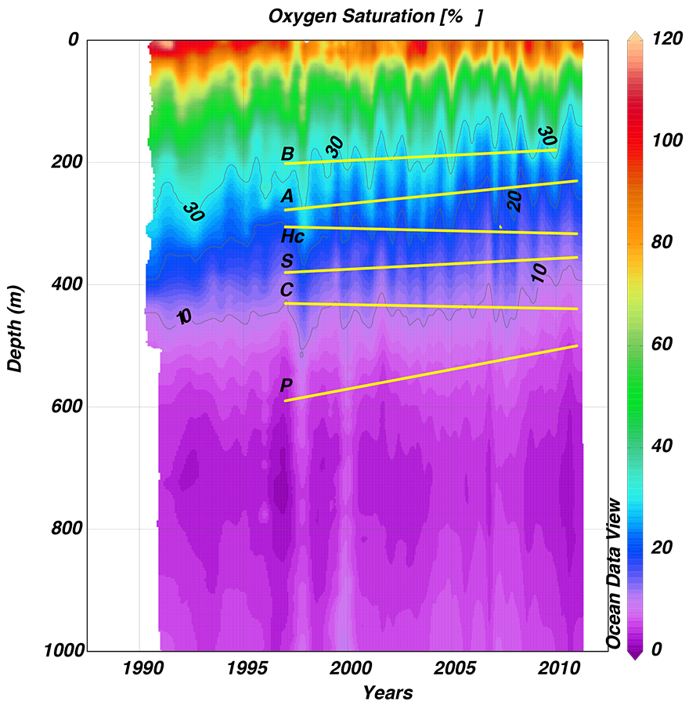

Figure 3 illustrates an example of plotting the average depth distribution of a number of animals over a plot of the average oxygen concentration at the study site

III. THE DORADO CLASS AUTONOMOUS VEHICLES.

The Dorado AUV is a modular, 0.534 m (21”) diameter, torpedo-shaped platform that has previously been described [Sibanec, et al.; Podder, et al.]. The depth rating of the main propulsion module and battery packs is 4500 m, while that of each vehicle configuration is dependent upon the maximum rating of each mission-specific module included in the configuration. It was designed operate at speeds of 0.5 to 2.0 m/sec, but in practice has been optimized to operate at ≥1.2 m/sec. Power is currently provided by Li-Ion battery packs housed in Benthos glass spheres (3.7 kWhr ea.). The maximum power available to the mission package is ~ 420 W @ 24VDC, with the limiting factor being the single power connection between the battery pack(s) and payload. More power can be made available by adding an additional battery pack to mission package connector.

IV. PRIMARY CHALLENGES FOR AUV VIDEO IMAGING

Three primary issues required investigation to determine if transitioning to AUV-based transecting using the Dorado vehicle would be practical. These were: 1) Lighting – is there sufficient power available for current light technology to supply adequate illumination for high quality video for the duration of the survey? 2) Vehicle control – can the Dorado vehicle be reliably controlled at a reduced operating speed of 0.50 m/sec (~1 knot), if needed? And, 3) Video storage format compatibility – is there a digital video storage format that maintains image quality comparable to that stored on High Definition tape.

A. Light Field Evaluation
We evaluated the light fields successfully used for ROV transecting by the Doc Ricketts, which carried four 400 Watt DeepSea Power and Light (DSPL) HID lights, and by Ventana, with six 400 Watt DSPL HMI lights. We found that we could produce comparable illumination with four purposefully directed DSPL Model 5100 SeaLite 80 Watt LED lights. Initial lighting configuration tests were conducted in MBARI’s test tank using the 4 LED lights arranged in a 0.5 x 1.2 meter (H x W) pattern, with an Insite Pacific Zeus HD camera located in the center of the rectangular layout. Field tests of this lighting configuration mounted on the Doc Ricketts showed that we were getting as good or better video with LED illumination as with the vehicle’s HID lights. We also found that the constant light output from LED lights eliminated the image artifacts caused by HID lights interacting with the camera shutter at high speeds (> 1/100th s).

B. Vehicle Control
The typical operating speed of the Dorado class AUV is 2 to 3 times faster than that of the ROV based transects. Low-speed stability testing of the Dorado vehicle was undertaken where the vehicle was transiting at low-speed (~0.5 – 0.75 m/sec) in a variety of configurations, including: basic vehicle only, adding mid-body wings, the addition of streamlined light bars with LED lights on the bow, and the addition of horizontal planes to the thruster duct. All of these configurations were tested under normal ballasting of 3.2-4.5 kilograms floatation (kgf) positive buoyancy.
These tests revealed differences in controllability between configurations. In configurations with the basic vehicle with only light bars, and with the vehicle additionally equipped with mid-body and duct wings, the vehicle was able to maintain the initial commanded depth, however when a stepped depth change was commanded, the wingless vehicle was unable to maintain depth within tolerance. The winged vehicle successfully responded to both steps, although with some delay.
Further testing of the winged vehicle utilizing round (cross section) light bars designed to increase low-speed stability; modified gain controls designed specifically for low speed; and reduced positive buoyancy (~1.8 kgf) was performed. All of these changes contributed to improved low-speed performance. Fig. 4a shows a depth-step test at sea that illustrates these improvements. Testing of the basic vehicle with round light bars and reduced flotation (~1.8 kgf) at 1.0 m/sec shows a stable vehicle capable of controlled depth changes (Fig. 4b)

Figure 4. The Dorado AUVs response to depth step commands when traveling at: a) 0.5-0.6 m/s with body and duct wings, b). 1.0 m/s with no additional control surfaces. There were two depth steps; a 1 meter step followed by a 10 meter step. The red trace is the commanded depth, and the blue is the actual. The vehicle had lights and round light-bars in both cases, and was ballasted normally, at 1.8 kgf. The initial descent for both traces were made at a higher vehicle speed.
These tests led us to conclude that the Dorado vehicle can be controlled at survey speeds as low as 0.5 m/sec or greater, and therefore meets the minimum speed control requirements for the AUV imaging system.

C. Digital Video Compression Evaluation
Recording video images on an AUV requires file-based digital recording onto high-data-rate hard drives or flash memory. Various compression schemes are typically employed to maximize the amount of video that can be recorded onto these media. Depending on the storage format selected, there can be significant image quality loss, and it is necessary to determine how much compression can be applied before it affects the ability of the annotators to correctly identify the animals.
The current ROV-based video transects are recorded on Panasonic HD D5 tape which utilizes a relatively mild 4:1 compression and is considered essentially lossless in image quality. High-definition footage, unaltered from the HD D5 tape was compared to the same footage digitized to Apple ProRes 422 (HQ), a common intermediate level video compression codec (coder/decoder). Apple ProRes 422 (HQ) results in a video record that is about 20% of the file size of the original 1080i/60 HD footage and would allow an entire transect series (50 – 1000 m) to be recorded on a single 512 GB solid-state drive. At full HD quality we would currently require two solid-state drives. The ability to compress the data is important if we are to record progressive video at 60 frames per second.
Using the two video formats, we compared the 20 most abundant animal taxa from 12 transects made at our Midwater 1 study site (Fig. 5). These transects were run at depths of 100, 200, 300 and 400 m (the most populous depths) over the course of 3 dives and were subsequently annotated in the video lab. About 7% fewer organisms (n=2582) were annotated from the HD D5 tape footage than in the Apple ProRes 422 (HQ) (n=2798). This discrepancy was attributed to human variation between annotators as opposed to resolution differences. We concluded that the Apple ProRes 422 (HQ) compression scheme provides us with sufficient video quality to record our time-series transects on an AUV platform without compromising the integrity of the long-term data set.

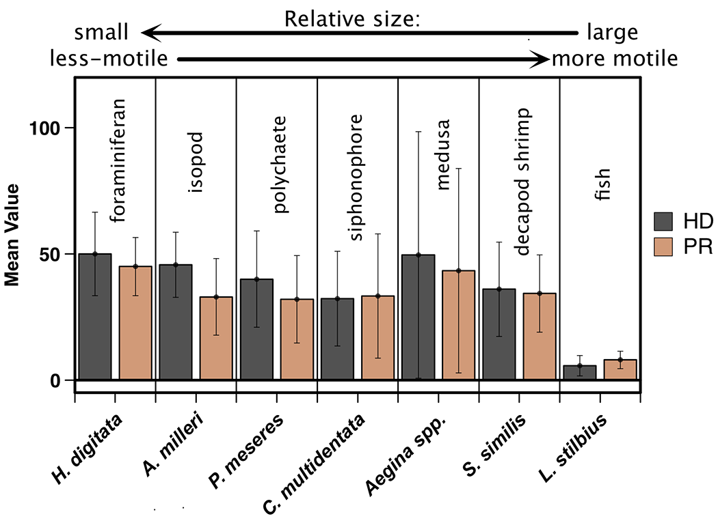
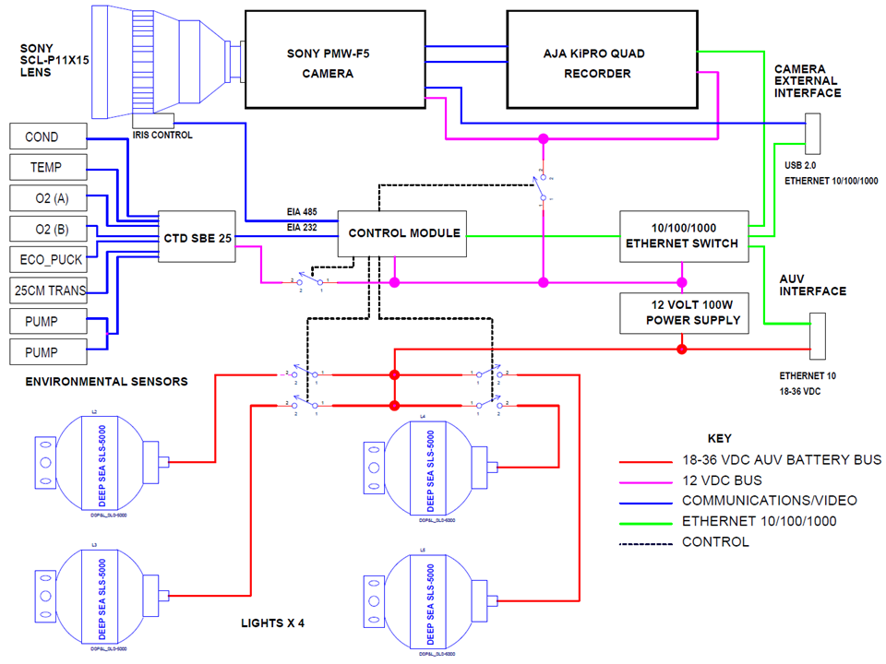

Figure 6. Camera System Block Diagram.
Figure 5. A comparison of numbers of animals identified from transect video recorded on High Definition D5 tape (HD) vs. the same video compressed to Apple ProRes 422 (HQ) standard and recorded on a digital hard drive.

V. REQUIREMENTS FOR AUTONOMOUS VEHICLE CAMERA SYSTEM

In order to duplicate the ROV-based video transects with the Dorado class AUV, the AUV camera system must meet more stringent requirements. The two major differences between the two platforms are the vehicle transit speed during the surveys and, as an untethered vehicle, the AUV system must be completely self-contained, including the energy available for lighting and storage space for the video and data acquired on the mission.
The ROV is inherently stable and the video transect speed has been established at 0.55 meters per second. This speed was determined by balancing a number of factors including ROV tether dynamics and video quality. Tether dynamic influence the speed at which the vehicle can move at a constant rate through the water for the duration of the transect, without being slowed by the tether due to water drag and ship/ROV relative orientation. The speed of passage of animals and particles through the video field is a major factor in determining video quality, particularly on the periphery of the image. Camera characteristics (i.e., video format, light sensitivity, frame rate and shutter speed) determine how fast the vehicle can move through the water while retaining a high quality image suitable for accurate annotation. For our ROVs the optimum speed was determined to be 55 cm/sec. In comparison the AUV typically requires a minimum transit speed of around 0.75 to 1 meter per second to provide enough control authority to stay at the commanded depth during the transect. The higher AUV transit speeds increase the angular velocities of objects that are off the camera axis as they approach, causing increased motion blur, the “Star Wars” effect. This greatly reduces the effective volume that is being sampled by making species identification more difficult as you move further away from the camera axis.

VI. OVERALL CAMERA SYSTEM ARCHITECTURE.

The camera system is designed as a self-contained payload for the AUV with a simple mechanical and electrical interface that allows for easy installation and removal on a per-mission schedule. The camera, data (digital video) recorder, and light control are all contained within one pressure housing (Fig. 6) which allows the electrical interface to the AUV to be a single connector that contains pins for power and 10BaseT Ethernet. For downloading image files, a separate direct wire Gigabit Ethernet (1000BASE-T or IEEE 802.3ab) connection to the camera housing is made while the AUV is on the ship’s deck post-mission. This high speed data connection is necessary to allow the collected image files, which contain up to one terabyte of data, to be downloaded in a reasonable period of time. Two custom electronics modules within the camera housing, the Power module and the Control module, manage the power distribution, internal environmental monitoring and all hardware control functions.

To determine the overall energy budget, the 80 Watt demand of each of the four SLS-5100 Sealites® selected during the light field evaluation were summed with the camera and recorder loads. The energy for lighting is about 75% of the overall camera system energy expenditure. The resulting overall camera system energy budget of to 420 Watts is well within the battery capacity for the Dorado AUV given the short duration of video recording portion of the mission (Fig. 7).
A. Camera, Lens and Recorder Selection.
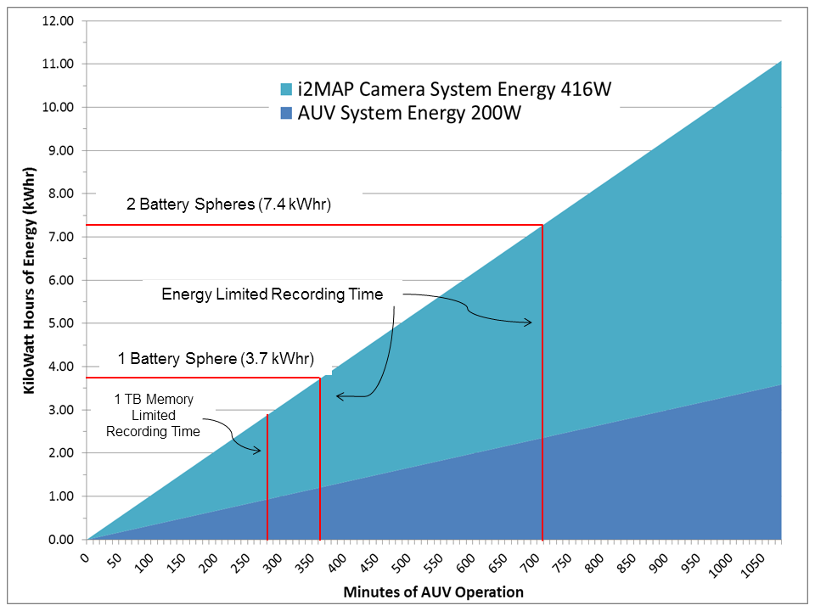Figure 7. AUV and camera system energy use at 1 meter per second transect speed. Even with the minimum one battery sphere the video recording limit is the file storage space.

Prior to committing to a significant camera system development effort it was necessary to prove that high quality images could be collected at the higher transect speeds necessary for AUV control stability. Three questions needed to be answered: 1. Could the camera system capture high quality images at the required AUV transit speeds? 2. Would there be a loss of detail information in images compressed for file-based storage? 3. What is the optimal camera and lens combination?
To test the camera and recording system’s ability to capture images at high transect speeds, the rotating test pattern shown in figure 8 was used to simulate the angular motion of approaching off-axis camera targets (targets close or on the camera axis only appear to move closer in the image, not also radially as off-axis targets do). For an accurate test, we first determined the translation of a targets radial velocity in the camera image to the targets radial velocity on the camera focal plane as the AUV moves forward. The targets calculated velocity on the focal plane was then translated back to angular motion on a circular test target rotating about the camera axis. The calculated result showed that a test image disk that was 50 cm from the camera dome and was spinning at 12 RPM would simulate the off-axis motion of targets at 50cm with the AUV transecting at 1 meter per second. For comparison, we also simulated the historical 0.5 m per second ROV transecting speeds at the same distance by spinning the disk at 6 RPM.
Using the spinning disk protocol, we tested multiple cameras and video recording formats. The results of these dynamic tests showed that to preserve the current ROV-based image quality, higher AUV transit speeds required three adjustments to the camera system. First, the camera framerate must be increased from the ROV high definition video format of 1080i 29.97 frames per second (fps) format to at least 1080p 59.94 fps to allow for smooth slow speed playback during human annotation. Second, the camera shutter speed must be increased from 1/60th s to 1/250th s to reduce off-axis motion blur. Third, to provide the proper exposure under these conditions, the camera gain and lighting intensity must be increased.
We also used the rotating target to compare the quality of full resolution uncompressed recorded images and images that were compressed using Apple ProRes 422(HQ) and SONY XVAC formats. Even with rapidly moving targets, there was no detectable loss of image quality with Apple ProRes 422(HQ). This confirmed the results of the annotation tests on actual underwater transect recordings, described above, that showed that there was no significant difference in the species counts between recordings on D5 tape and file based recordings in the ProRes 422(HQ) format.

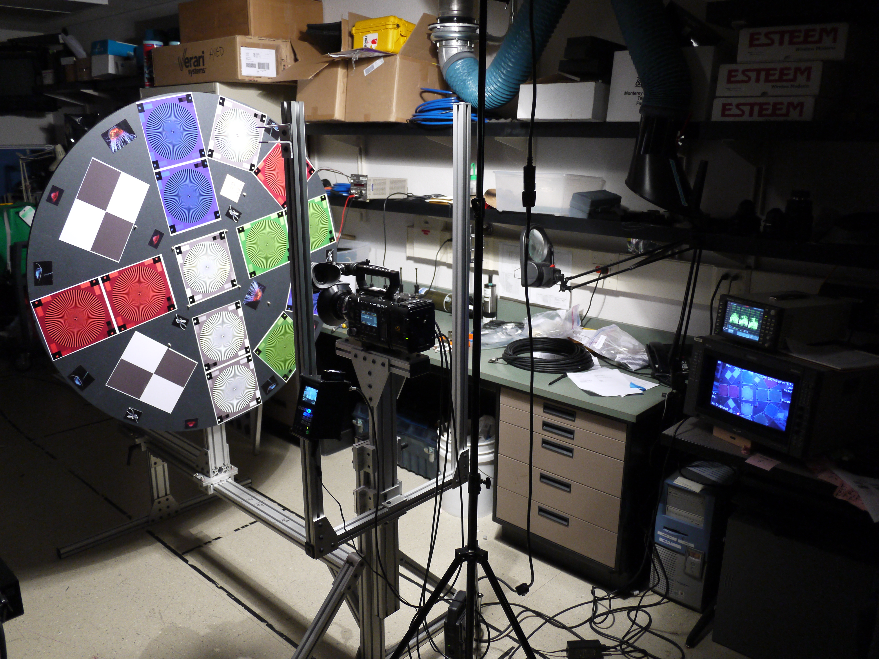
Figure 8. Camera test stand with the rotating target image. Rotation at 12 revolutions per minute simulates AUV transect speed of 1 meter per second

To determine the required visual depth of field (DOF), previous transect data was analyzed to determine the distance from the camera dome at which organisms were first identifiable. These data were used to set the DOF requirement from 10 cm to 250 cm from the camera dome in water as shown in Fig. 9.

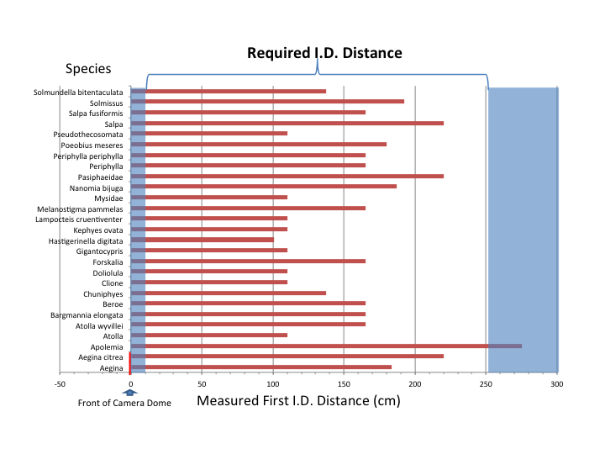
Figure 9. Measured first identification distance of an assortment of common taxa logged in the time-series annotations. The blue bands in the near and far fields define the limits of the calculated depth of field at F 5.6. . Need to enlarge figure so text can be read

Our requirements also specified a 16:9 picture ratio and horizontal field of view in water of between 80 and 100°.
To select the optimal camera and companion lens we tested four different cameras and five compatible lenses using resolution test charts. The cameras fell into two major groups. Traditional “three-chip” prism cameras with 2/3” image sizes, requiring a B4 mount 5 mm focal length lens, and large format Bayer array single-chip cameras with DIN super 35 imagers requiring a PL mount lens with a focal length in the range of 10 mm to 15 mm. The criteria for selection were a combination of image quality, cost, size and upgrade potential. We selected the Sony PMW-F5 large format camera and a Sony SCL-P11X15 wide angle zoom lens (the zoom is from 11 mm to 15 mm). This camera and lens combination had nearly identical resolution to the other top choices and met the size criteria, but the capital cost was significantly less. The PMW-F5 camera also offered a clear upgrade path from the current “2K” (2048×1080 pixels) video format to the “4K” (4096×2160 pixels) format, should future missions require more detailed imagery.

B. Data Recording and Post-Mission Recovery.

The selection of an appropriate file based video recorder was based on the requirement of recording at least 120 minutes of video in the 2K progressive 59.94 format, having the appropriate form factor and most importantly, allowing image file downloads over a remote copper wire connection. The remote download ability was required so that the camera system housing did not have to be opened to recover the image recordings after each AUV mission. The AJA KiPro Quad was the only available data recorder that met all of these criteria. Data is recorded on two proprietary 512 gigabyte media cards with transparent rollover and can store nearly 5 hours of video. The control for the recorder is via HTML over Ethernet, which interfaces directly with our overall system architecture. To download the video image files after a mission, a Gigabit Ethernet connection is made between a laptop computer and the camera systems internal Gigabit Ethernet network using a metal shell connector. The ratio of recording duration to download time is approximately 1:1 when transferring Apple ProRes 422(HQ) files over Gigabit Ethernet.

VII MECHANICAL DEVELOPMENT

A. The Camera Housing

The camera housing is a titanium housing, 0.61 m in length and 0.22 m in diameter. The back endcap supports all the connectors, while the front end is fitted with the dome port and optical elements (Fig. 10, 11). Particular care was given to the design of the optical elements support pieces. A ring was machined to support all three corrective optical elements from a solid billet of grade 5 titanium. Titanium was chosen for its good corrosion resistance and its coefficient of thermal expansion and, modulus of elasticity that are relatively close to those of glass. Threaded retainers and spacers are used to hold the lenses at the distances specified by the optical prescription. Once the lenses and dome are assembled, a vacuum is pulled on the assembly to hold the lenses firmly in place and to prevent fog from forming. The inside of the support ring was painted using ultra flat black Krylon paint to reduce unwanted light reflections.
The camera and the electronics are mounted on an aluminum chassis, itself attached to the back endcap. A fan circulates air in the housing to help transfer heat to the outside.

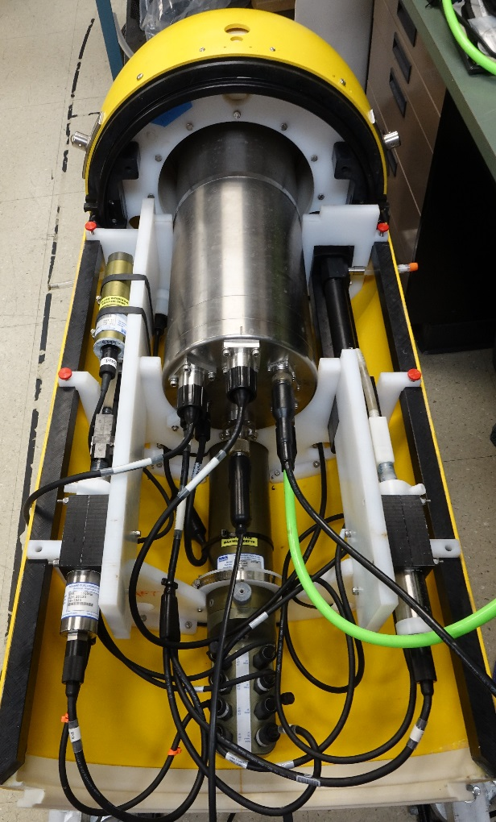
Figure 10. The vehicle payload includes the camera housing, 2 Seabird CTDO sensors, 1 Seabird data logger, and 1 Wetlabs transmissometer.

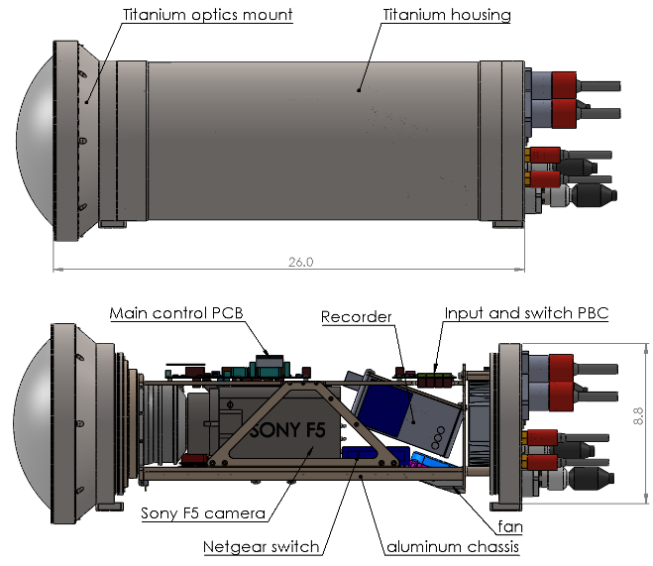
Figure 11. A custom housing designed for the camera, recorder and optical elements.

B. Optical Path Design

High resolution cameras and lens systems originally designed for in-air use require carefully designed dome port adapters to achieve optimal performance in seawater.
We hired Dr. Paul Remijan, of Fathom Imaging, inc, to design the dome port and adaptor lenses. Dr. Remijan is a leading expert in the field with extensive experience in designing underwater camera adapters.
The typical small, hemispherical dome ports used on most deep water cameras have poor optical performance when used with large image sensors. Small dome ports generate aberration requiring compensation and they can limit the operating field of view. We took advantage of the fact that the AUV-based i2MAP camera system is less size-constrained than typical ROV-mounted cameras (pan and tilt it not needed), and chose to maximize the quality of the optical image by using a large dome port.
The design uses a 250mm outside diameter, 22mm thick, flattened dome port. The corrector group consists of three lenses. The main design features include:
- Extremely high resolution over entire the entire filed of view. Chromatic correction over the entire visual spectrum.
- Large field of view (up to 100 deg).
- Relatively easy optical component fabrication requirements (standard optical tolerances and standard glass materials).
- Simple optical assembly with reasonable mechanical tolerances.
- Compatibility with most camera lens.
C. The Glass Dome

Most deep-water camera ports are hemi-spherical and are relatively small in diameter, which is ideal for resisting hydrostatic pressure because the stress in the glass is evenly distributed. When designing the dome port, we sought the highest optical quality, which resulted in a shape that is far from ideal in terms of mechanical properties: the diameter is large (250 mm) and the shape is not hemispherical (Fig. 12). As a result the stress in the dome is not evenly distributed. This is acceptable because the targeted depth of operation is only 1500 m. The dome was made by Biomedical Optic LLC, a US company with factories in China. It was made using H-K9L, a form of borosilicate crown glass equivalent to BK7.

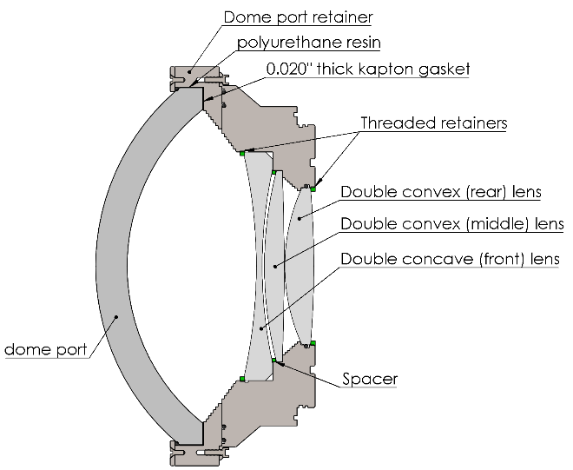
Figure 12: Cross section of the optical elements and titanium support rings.

The dome support was carefully engineered to reduce point loading and tensile stress in the glass. A first design was pressure-tested and failed after over 10 hours and 12 pressure cycles at 2750 PSI (targeted operating depth + 25%). We deemed the safety margin to be too small so we made several improvements to the design: the seat was polished and beveled to increase the strength, a thick (0.508 mm) polyimide gasket was placed under the dome seat to help distribute the load, and the side of the dome was bonded with polyurethane resin to a titanium ring, to prevent radial displacement and tensile stress. According to a finite element analysis, the tensile stress was reduced from about 6000 PSI to 1000PSI. The new design was pressure tested to 1600 PSI and deployed to 500 m. We have hired a consultant to determine a proper proof test protocol to certify the dome to 1500 m depth.

D. Vehicle Layout and Operational Considerations

The camera, recorder, lights and scientific instruments occupy the fore section of a DORADO AUV. This section can easily be separated from the rest of the vehicle when it is not in use. The section is 1.25 m length, weighs 145.2 kg and is nearly neutrally buoyant (Fig 10, 11).
The camera port faces forward, at the front of the vehicle. This is obviously risky because in case of a frontal collision (for example with the ship during recovery or with the seafloor), the glass port is exposed. A very sturdy plastic shield surrounding the port, outside the field of view, was designed to protect the glass port in case of an impact. The lights protrude about 0.3 m outside the fairing. Aluminum bars that hold the lights are designed to bend in case of an impact in order to prevent severe damage to the lights or the AUV’s fairing. The bars are inexpensive and easily replaceable. Entanglement of the light bars with fishing lines or kelp is a possibility but the region of operation is usually free of these objects so the danger is minimal.

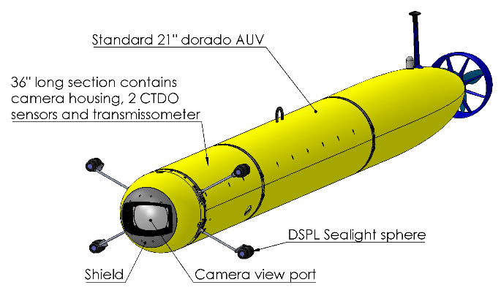
Figure 13: Midwater imaging vehicle. Camera viewport and lights are located in the nose of the vehicle and face forward.

VIII. POWER AND CONTROL FUNCTIONS

The control software developed for the i2MAP system is called the Camera Recorder and Logger (CARL). CARL consists of three software modules that interface through a local embedded Modtronix Corporation micro-processor subsystem, to the AJA KiPro Quad digital video recorder, the power switching module, and the stepper motor controller used to adjust the camera iris.
The local processor also measures the internal housing temperature, humidity, video levels and water alarms, which are all logged by CARL. The Modtronix subsystem utilizes the PIC18F6627 CPU and has the advantage of including a TCP/IP stack and embedded firmware that allows configuration and control through a simple HTML interface, greatly reducing the software and hardware development effort.
The power switching module allows individual power control for all components by the main vehicle control system (VCS) through the CARL interface using a simple scripting language. The hardware includes noise filtering and over-current protection for the camera, lights, and video recorder. The hardware also includes an automatic over-temperature shutdown function that removes power to the camera and recorder if the housing internal temperature reaches 40° C. This is necessary to protect the electronics from inadvertent over-temperature damage during deck operations. When the housing is in seawater heat dissipation is not a concern.

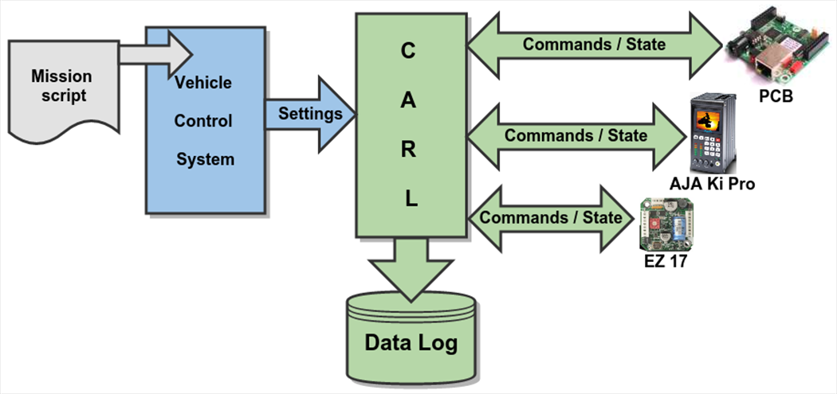
Figure 14. The CARL block diagram illustrates the primary interfaces in the i2MAP software system. The timing and quality of the video is directed by user statements in the AUV mission script that are converted to the desired hardware settings by the Vehicle Control System and the CARL software module.

Using the CARL interface built into the mission scripting language, our scientists and engineers can control the settings of the i2MAP system for many different situations. For example, a mission may be scripted for three, 5-minute transects at depths of 50, 75, and 100 meters. Given that the ambient light at those depths will differ significantly, the mission designer can use CARL to adjust the intensity of the lights as well as the f-stop of the camera to maximize the quality of the video at each of those depths.

IX. MISSION PLANNING
Dorado real-time simulation mode is routinely used to thoroughly test new camera and recorder drivers associated with CARL software. This is accomplished by running a vehicle mission while executing simulated interfaces for all sensors and subsystems except for CARL. The CARL components are connected to the simulator over the network and receive commands as if the vehicle is operating in the ocean. This provides a complete test of the relevant CARL software that will execute during a planned mission. The real-time simulations have enabled us to find several errors, and facilitated their correction in the lab, while conserving valuable sea-trial time.

X. RESULTS

The complete i2MAP Imaging AUV made its first test deployment on June 15th, 2015, which was followed by the first concurrent AUV/ROV video comparison dive with the ROV Ventana on June 25th, and a second on June 6th, 2016. The comparative transects were conducted at 100 m intervals to 300 m, and 500 m depths on those dates, respectively. The ROV transects were run at ~1 knot (55 cm/sec) for 10 minutes each to be compared to the AUV running at ~2 knots (100 cm/sec) for 5 minutes.
Initial impressions by experienced tape annotators who observed the AUV video were very positive. Despite running at twice the speed of the ROV, the AUV video was less smeared along the periphery, where motion most affects the quality of the image. When compared frame-by-frame, one can see that the i2MAP images are much sharper around the edges, which allows for easier and more accurate identification of animals observed in those regions of the image. The AUV image was very steady, with no observable vertical or lateral motion that would be an artifact of frequent vehicle depth or course corrections.
Annotation and analysis of the data derived from the transects made at 100, 200 and 300 m on the June 15th, 2015 dive, as well as, the 500 m June 6th, 2016 dive were made. The combined data between 100 through 300 m, which had the largest concentrations of animals (Fig. 16), indicate that for most taxa, the i2MAP imagery revealed numbers comparable to or greater than the ROV images at both depths. Care must be taken when interpreting these limited data, as the midwater environment is not uniform and many of the animals found there are not uniformly distributed. There were three exceptions to this trend. During the 100 through 300 m transects (Fig. 16a), remarkably higher numbers of Actinopteri (fish), Chaetognaths (Arrow worms) and Euphausia (krill) were seen by the AUV in comparison to the ROV. A similar pattern was seen for the fish in the 500 m transect (Fig. 16b). A closer look at the data between 100 and 300 m showed that the large number of Arrow worms and krill seen were due to dense patches seen at one depth, 200 m, and otherwise the numbers were comparable between vehicles. However, the higher numbers of fish were consistently observed at all depths surveyed. This suggests that the AUV surveys may indeed be superior for surveying the more mobile midwater species.

Figure 16. Chart showing the relative abundance of taxa observed during ROV and i2MAP AUV video transects at: a) combine 100, 200 and 300 m depths; and b) 500 m depth.

XI. CONCLUSIONS

MBARI has reached the final stages of developing and testing the i2MAP AUV Midwater Video Imaging System. Although this paper presents only preliminary comparative data between MBARI ROV-based and AUV-based midwater transect surveys, we believe this system to be a significant advancement in automating the technology required to make an accurate census of the midwater pelagic community. The comparative data that we present indicates that we see comparable numbers of the less mobile species and higher relative numbers of the more mobile animals with the AUV. We believe these results are due to a combination of factors including: a quiet, streamlined vehicle; increased transect speed, enabled by a video camera shooting at high shutter speed and superior format; and a smaller, more directed light envelope. The technology required to make these improvements continues to evolve with better cameras, more efficient lighting and higher power density batteries already on the horizon, if not on the shelf. While we continue to develop the i2MAP system for work from the Dorado vehicle at MBARI, we hope that others will build on our work to make similar, smaller systems that may be more readily deployed on smaller AUVs.
The remaining work for this project is to complete optical dome qualifications, after which we will make a series of transect comparisons throughout the upper 1000 m of the water column to validate this methodology. In addition, we will also be exploring upgrading the camera to acquire more detailed 4K video.

REFERENCES.

Acknowledgment
We thank the David and Lucile Packard Foundation for providing support for the i2MAP project. We also thank the MBARI AUV Group for their support throughout this development project and the crew of the R/V Rachel Carson and ROV Ventana pilots.

References
{bibliography}
The template will number citations consecutively within brackets [1]. The sentence punctuation follows the bracket [2]. Refer simply to the reference number, as in [3]—do not use “Ref. [3]” or “reference [3]” except at the beginning of a sentence: “Reference [3] was the first ...”
Number footnotes separately in superscripts. Place the actual footnote at the bottom of the column in which it was cited. Do not put footnotes in the reference list. Use letters for table footnotes.
Unless there are six authors or more give all authors’ names; do not use “et al.”. Papers that have not been published, even if they have been submitted for publication, should be cited as “unpublished” [4]. Papers that have been accepted for publication should be cited as “in press” [5]. Capitalize only the first word in a paper title, except for proper nouns and element symbols.
For papers published in translation journals, please give the English citation first, followed by the original foreign-language citation [6].

- G. Eason, B. Noble, and I. N. Sneddon, “On certain integrals of Lipschitz-Hankel type involving products of Bessel functions,” Phil. Trans. Roy. Soc. London, vol. A247, pp. 529–551, April 1955. (references)
We suggest that you use a text box to insert a graphic (which is ideally a 300 dpi TIFF or EPS file, with all fonts embedded) because, in an MSW document, this method is somewhat more stable than directly inserting a picture.
To have non-visible rules on your frame, use the MSWord “Format” pull-down menu, select Text Box > Colors and Lines to choose No Fill and No Line.
- J. Clerk Maxwell, A Treatise on Electricity and Magnetism, 3rd ed., vol. 2. Oxford: Clarendon, 1892, pp.68–73.
- I. S. Jacobs and C. P. Bean, “Fine particles, thin films and exchange anisotropy,” in Magnetism, vol. III, G. T. Rado and H. Suhl, Eds. New York: Academic, 1963, pp. 271–350.
- K. Elissa, “Title of paper if known,” unpublished.
- R. Nicole, “Title of paper with only first word capitalized,” J. Name Stand. Abbrev., in press.
- Y. Yorozu, M. Hirano, K. Oka, and Y. Tagawa, “Electron spectroscopy studies on magneto-optical media and plastic substrate interface,” IEEE Transl. J. Magn. Japan, vol. 2, pp. 740–741, August 1987 [Digests 9th Annual Conf. Magnetics Japan, p. 301, 1982].
- M. Young, The Technical Writer’s Handbook. Mill Valley, CA: University Science, 1989.

