Gateway Node Cape System Board Modifications

Initial Configuration Modifications
These are changes which were part of the initial design process.

DC-DC Converter Cape

- Logic Power to Capes

Description
The DC-DC Converter Cape generates the logic power for the BeagleBone as well as all of the other cape boards. Because the BeagleBone can also supply logic power to capes, the removal of those pins on the bus isolates the two supplies.

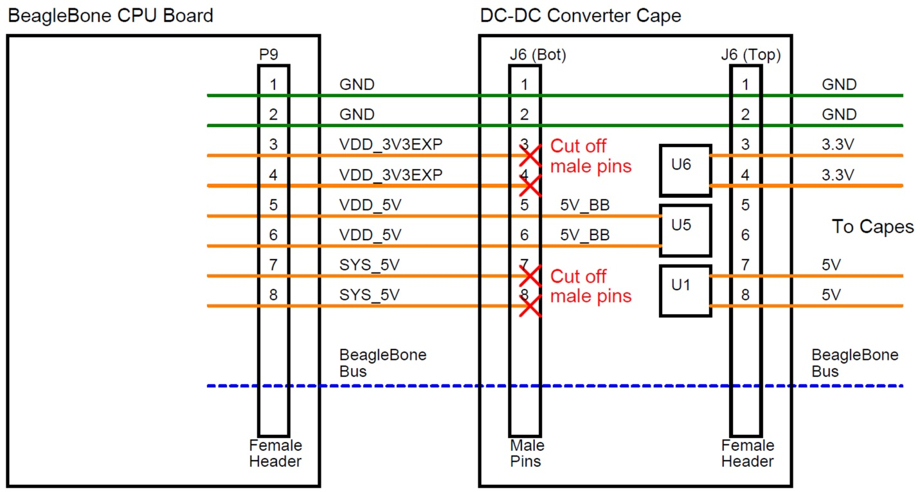
Figure 1: Routing of logic power in the Gateway Node Cape System
Procedure
On the rear side of the DC-DC Converter Cape, clip out the male pins J6-3, J6-4, J6-7, and J6-8. It is best to use a pair of clippers with narrow jaws.

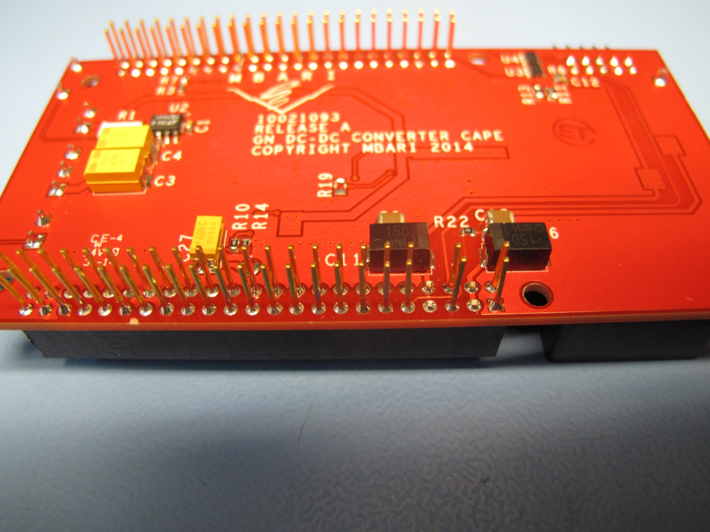
Figure 2: DC-DC Converter Cape with J6-3, J6-4, J6-7, and J6-8 removed.

Sensor Node Switching Cape

- Removal of Boot Isolation Jumper

Ground Fault and Environmental Sensing Cape

- Removal of Boot Isolation Jumper

Engineering Change Orders (ECOs)
These are changes made due to design or layout mistakes.

DC-DC Converter Cape

- Logic Power Swap
- Current Sense Circuit

Sensor Node Switching Cape

- Current Sense Circuit
- NODE_3_OFF Pin Change
- Relay On & Off Signal Name Swap

Ground Fault and Environmental Sensing Cape

- NODE_3_OFF Pin Change
- Relay On & Off Name Swap

