Gateway Node Cape System Board Modifications
Chad Kecy
03-25-2015

Engineering Change Orders (ECOs)
This document covers all of the modifications made to the GN capes. Because the capes share a common bus, some of the changes affect multiple capes.

DC-DC Converter Cape (PN# 10021093)

- New Headers for J5 and J6
Description
When mounting the DC-DC Converter Cape to other capes, there needs to be enough clearance for the power inductors. The original headers, J5 and J6, on the DC-DC Converter cape did not allow enough clearance.

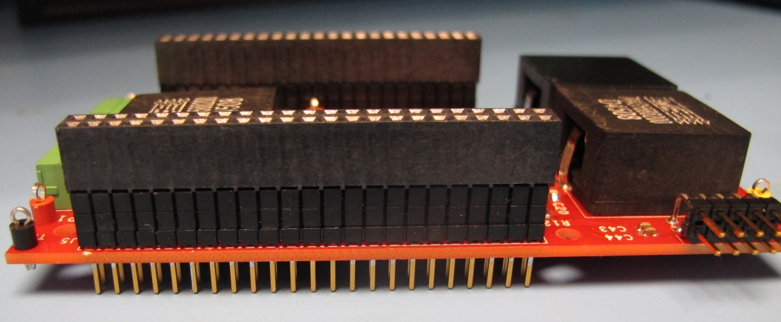
Figure 1: DC-DC Converter with new header installed

New Part
Manufacturer PN# ESQ-123-34-G-D (Samtec)

Procedure
If performing an initial board population, simply solder in the new headers. If modifying an existing board, the old headers will need to be unsoldered and removed.

B. Logic Power to Capes
Description
The DC-DC Converter Cape generates the logic power for the BeagleBone as well as all of the other cape boards. Because the BeagleBone can also supply logic power to capes, the removal of those pins on the bus isolates the two supplies.

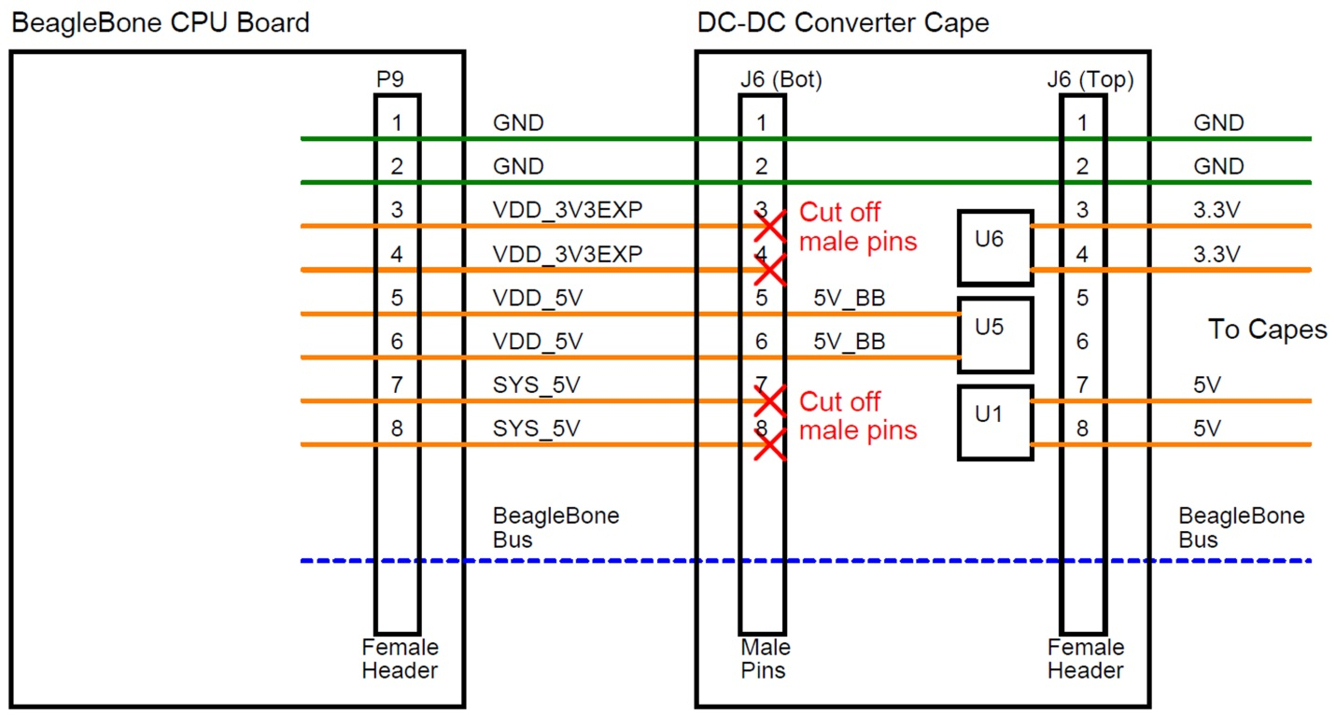
Figure 2: Routing of logic power in the Gateway Node Cape System

Procedure
On the rear side of the DC-DC Converter Cape, clip out the male pins J6-3, J6-4, J6-7, and J6-8. It is best to use a pair of clippers with narrow jaws.

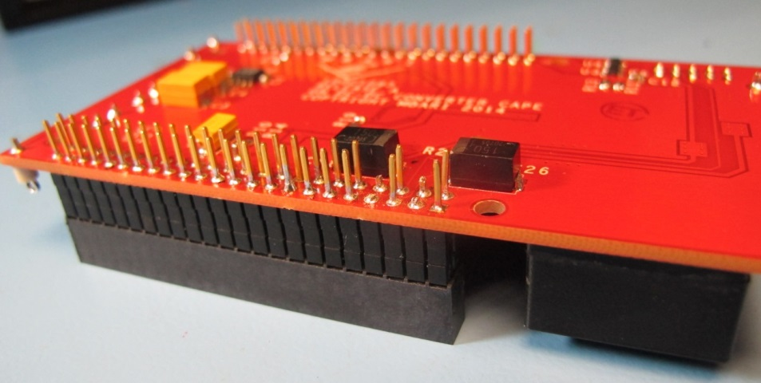
Figure 3: Rear side of DC-DC Converter Cape showing the clipped pins from J6-3, J6-4, J6-6, and J6-7.

- Logic Power Swap
Description
The two nearly identical power supply circuits for generating the logic power for the cape boards have the incorrect feedback resistors. U1 should generate 5V but is programmed for 3.3V while U6 should generate 3.3V but is programmed for 5V.

Fix
Swap the two programming resistors

Procedure
Replace R5 with a 1.62kohm, 1%, 0.25W resistor.
Replace R13 with a 2.94kohm, 1%, 0.25W resistor.

- Current Sense Circuit Modification
Description
The current sense amplifier, U2, was laid out incorrectly. The Bias pin (pin 6) of U2 should be tied to ground, not Vout.

Procedure
Cut the trace that goes from U2-6 to the via closest to it.
Pin 5 should remain connected to the via.
Connect U2-6 to a ground connection. (the backside layer is all ground).

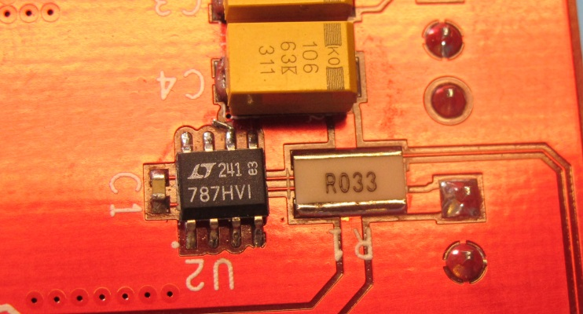
Figure 4: DC-DC Converter Current Sense Modification

Sensor Node Switching Cape (PN# 10021094)

- Modification of Boot Isolation Circuit
Description
For the BeagleBone to properly boot up with attached capes, 16 shared boot pins must be held in isolation during the boot cycle. They can be used normally once the boot process is complete. Two octal tri-state buffers are used to hold these 16 pins in a high impedance state during the boot up time. The SYS_RESETn line was designed to control the tri-state buffer, however, the steady state polarity of SYS_RESETn keeps these 16 signals in isolation after the boot is complete.

Fix
Modify the circuit to use a standard gpio signal to control the state of the tri-state buffer. Gpio1_16 must be muxed via software after the boot process, and then it is held high. This causes a transistor to pull the output enable signal low, allowing access to the 16 shared boot signals.

New Parts
2N3904 (TO-92 package) Suggested part: PN# 2N3904BU (Fairchild Semiconductor)
10kohm resistor (0603 package) Suggest part: PN# CRCW060310K0FKEA (Vishay)

Procedure
Remove header JP1
Install the transistor as follows
JP1-6 Base
JP1-9 Emitter
JP1-10 Collector
Install the 10k resistor between JP1-6 and JP1-8.
Install a blue wire (30awg) between J12-15 and solder pad V1.

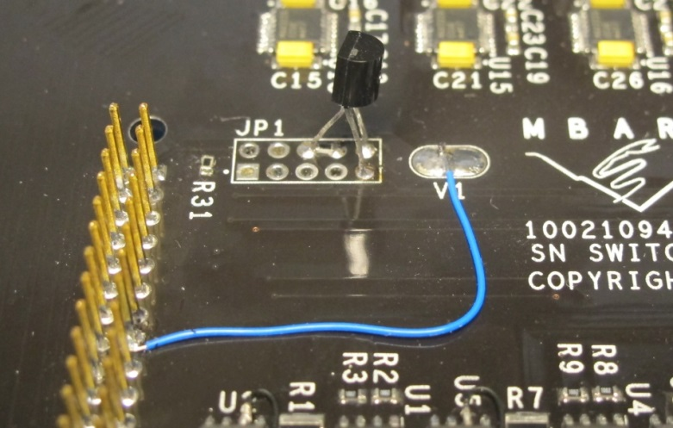
Figure 5: Modification to the Boot Signal Circuit
- Current Sense Circuit Modification

Description
The current sense amplifiers, U2, U5, U8, and U11 were laid out incorrectly. The Bias pin (pin 6) of the amplifiers should be tied to ground, not Vout.

Procedure (repeat for U2, U5, U8, and U11)
Cut the trace that goes from Ux-6 to the via closest to it.
Pin 5 should remain connected to the via.
Add a jumper wire from Ux-6 to Ux-4.

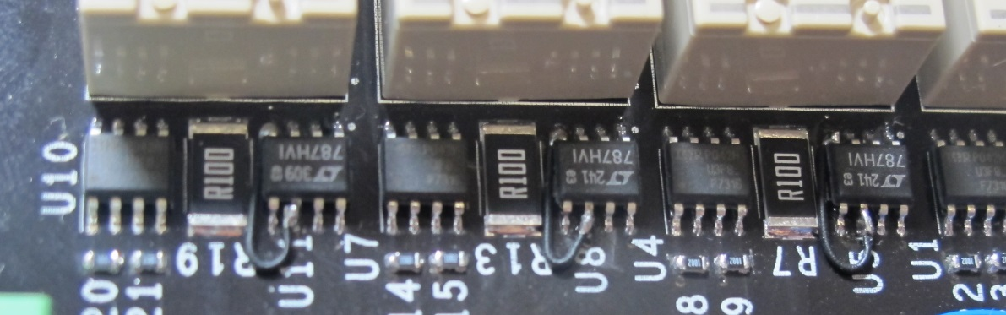
Figure 6: SN Current Sense Modification

- NODE_3_OFF Pin Change

Description
During initial testing it was found that GPIO1_3 has an undocumented function on the BeagleBone board and is not available for users. We had initially planned to use GPIO1_3 as the control signal, NODE_3_OFF. We subsequently switched NODE_3_OFF to GPIO1_28

Procedure
On the rear side of the board, cut the trace that extends from J11-5 (Figure xx).
Add a jumper wire from J14-8 to J16-5.

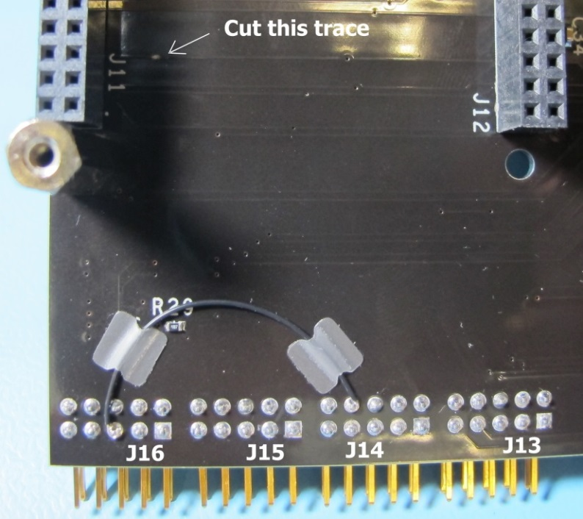
Figure 7: NODE_3_ON Signal Modification

- Relay Modification

Description
The switching of power from the Gateway Node to the Sensor Nodes was causing power glitches which were destroying the serial transceivers on both nodes. A series of modifications to both nodes were implemented to prevent this.

Fix
Bypass the switching of ground (DC return) to the Sensor Node by shorting together the relay poles which pass return. To help reduce the counter EMF signal generated by the input inductance of the Sensor Node, add a snubber circuit across the relay poles which switch the DC power.

New Parts
2.2uF, 100V ceramic capacitor (1206 package) Suggested part: C1210C225K1RACTU
10 ohm resistor (1206 package) Suggested part: CRCW120610R0FKEA

Procedure
Solder a 22AWG section of bus wire between pins 5 and 6 of K1, K3, K5, and K7.
Solder a series combination of the above C and R between pins 3 and 4 of K1, K3, K5, and K7.

- Serial Transceiver Protection
Description
The switching of power from the Gateway Node to the Sensor Nodes was causing power glitches which were destroying the serial transceivers on both nodes. A series of modifications to both nodes were implemented to prevent this.

Fix
Add bi-directional Transient Voltage Suppression (TVS) Diodes to the RXD and TXD lines of each serial transceiver.

New Parts
20V TVS Diode (DO-214AB package) Suggested part: SMDJ22CA

Procedure
Solder the TVS diodes from pin 13 to gnd and pin 8 to gnd on U13, U15, U16, and U17.

Ground Fault and Environmental Sensing Cape (PN# 10021095)

- Modification of Boot Isolation Circuit

Description
For the BeagleBone to properly boot up with attached capes, 16 shared boot pins must be held in isolation during the boot cycle. They can be used normally once the boot process is complete. Two octal tri-state buffers are used to hold these 16 pins in a high impedance state during the boot up time. The SYS_RESETn line was designed to control the tri-state buffer, however, the steady state polarity of SYS_RESETn keeps these 16 signals in isolation after the boot is complete.

Fix
Modify the circuit to use a standard gpio signal to control the state of the tri-state buffer. Gpio1_16 must be muxed via software after the boot process, and then it is held high. This causes a transistor to pull the output enable signal low, allowing access to the 16 shared boot signals.

New Parts
2N3904 (TO-92 package) Suggested part: PN# 2N3904BU (Fairchild Semiconductor)
10kohm resistor (0603 package) Suggest part: PN# CRCW060310K0FKEA (Vishay)

Procedure
Remove header JP1
Install the transistor as follows
JP1-6 Base
JP1-9 Emitter
JP1-10 Collector
Install the 10k resistor between JP1-6 and JP1-8.
Install a blue wire (30awg) between J12-15 and solder pad V1.

