Shallow Water FOCE Gateway Node Control System
Hardware Interface Document, v0.1

Chad Kecy
Monterey Bay Aquarium Research Institute

June 23, 2014



Table of Contents
Overview 5
System Level Description 5
BeagleBone Computer Board 6
Functional Description 7
Serial Communication 7
Analog Signals 7
Digital Signals 8
SPI Signals 8
Expansion Headers 8
DC-DC Converter Cape 8
Functional Description 9
DC-DC Conversion 9
Optional Auxiliary DC Power Supply 9
Source Voltage and Current Monitoring 9
Scaled Voltage 9
Measured Current 10
Test Connector 10
Sensor Node Switching Cape 10
Functional Description 11
Load Switching and Monitoring 11
Serial Interface 12
Boot Isolation Pins 12
Cape EEPROM 12
Test Connectors 12
Ground Fault Detection and Environmental Sensor Cape 12
Functional Description 13
Ground Fault Detection 14
Environmental Sensing 14
Boot Isolation Pins 14
Cape EEPROM 14
Test Connectors 14
Board Level Signal Descriptions 16
Digital Output Signals 16
Digital Input Signals 21
Analog Input Signals 22
SPI Bus Signals 25
I2C Signals 25
Serial Signals 25
Appendicies 26

Figure 1: Possible Gateway Node configuration on swFOCE 5
Figure 2: Block Diagram of the Gateway Node System 6
Figure 3: BeagleBone Computer Board 7
Figure 4: DC-DC Converter Cape 8
Figure 5: Gateway Node DC-DC Conveter Cape Block Diagram 9
Figure 6: Sensor Node Switching Cape 10
Figure 7: Gateway Node SN Switching Cape Block Diagram 11
Figure 8: Ground Fault Detection and Environmental Sensing Cape 13
Figure 9: Gateway Node Ground Fault Detection and Environmental Sensing Cape Block Diagram 14

Overview

The Gateway Node is an open source computer system which can be used to control a wide range of oceanographic experiments. It is a series of stackable circuit boards based around the BeagleBone computer board. The daughter boards, or capes, have each been designed with a specific function. These include a DC-DC Converter cape, a Sensor Node Switching Cape, and a Ground Fault Detection and Environmental Sensing Cape. Because this is a modular system, the end-user can customize their Gateway Node system to meet their specific needs. Additional boards can also be fabricated using the BeagleBone cape design specification.

System Level Description

The Gateway Node serves two primary purposes in the swFOCE experiment: it collects data from all of the instrumentation and acts as the main computer in the control loop. It provides power (48Vdc) and serial communication to a maximum of four Sensor Nodes.

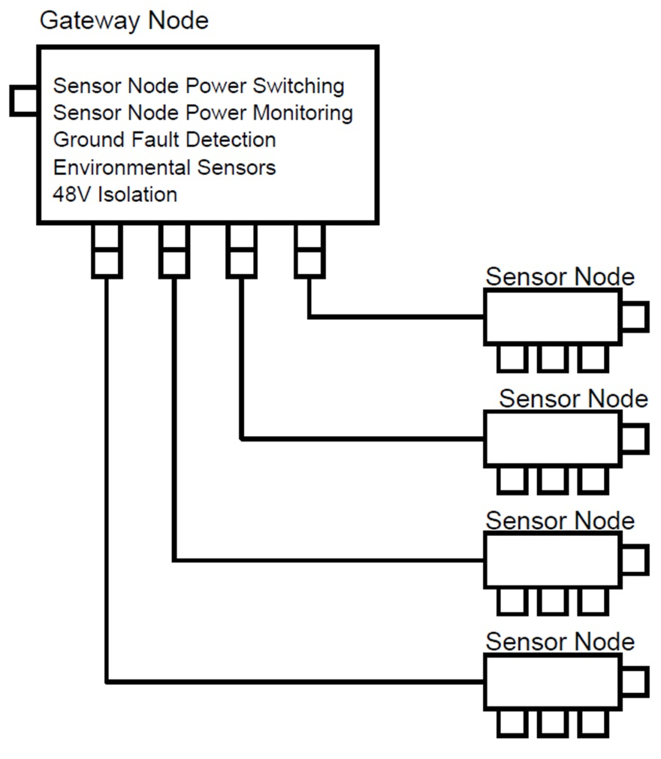
Figure 1: Gateway Node and Sensor Nodes

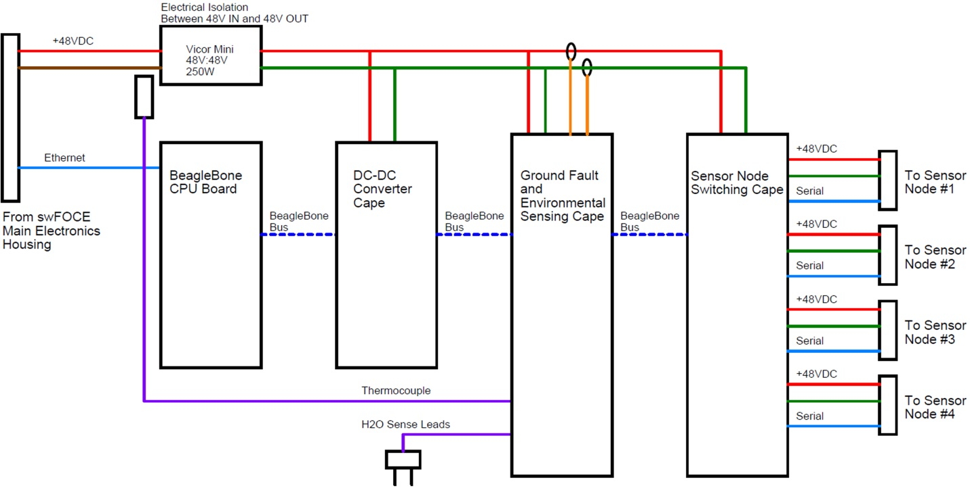
Figure 2: Block Diagram of the Gateway Node System

Vicor Supply
The Gateway Node housing contains a single 250W 48V:48V Vicor Mini DC-DC Converter module. The Vicor supplies power to the Gateway Node as well as to the attached Sensor Nodes. It is an isolating DC-DC converter; being on a separate DC power bus aids in ground fault detection.

BeagleBone Computer Board

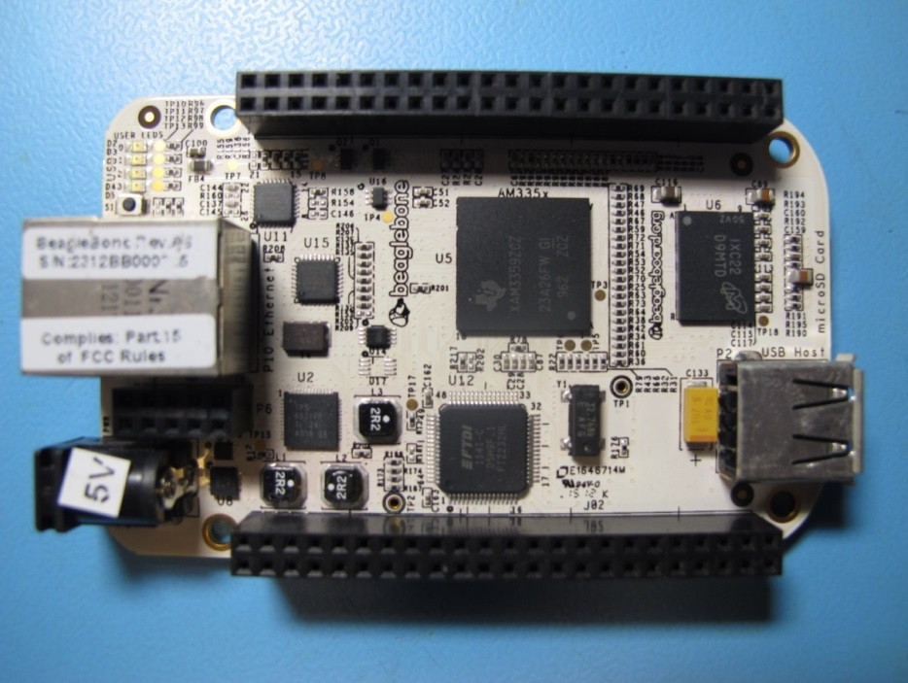
Figure 3: BeagleBone Computer Board

Functional Description
The heart of the GN is the BeagleBone computer board; it contains a TI AM3358 720MHz ARM Cortex-A8 based microprocessor and 256MB of DDR2 memory. Among its features are an Ethernet interface, USB port, microSD card slot, 7 analog inputs, 4 serial ports and 65 GPIO lines. There are also 2 46-pin expansion headers which allow for custom cape boards to be interfaced. Up to 4 cape boards can be individually addressed via onboard EEPROMs.

Serial Communication
The four available serial ports from the BeagleBone are used to communicate with the attached Sensor Nodes. Separate one-channel transceivers are used in the event of a failure only affecting one channel.

Analog Signals
The BeagleBone has seven 12-bit analog inputs which are read at 100K samples per second. The analog signals cannot exceed 1.8V; use a voltage divider for signals that exceed this range. The measured analog signals are the four Sensor Node output currents, the voltage and current of the input 48Vdc, and the measured ground fault current.

Digital Signals

SPI Signals

Expansion Headers

DC-DC Converter Cape

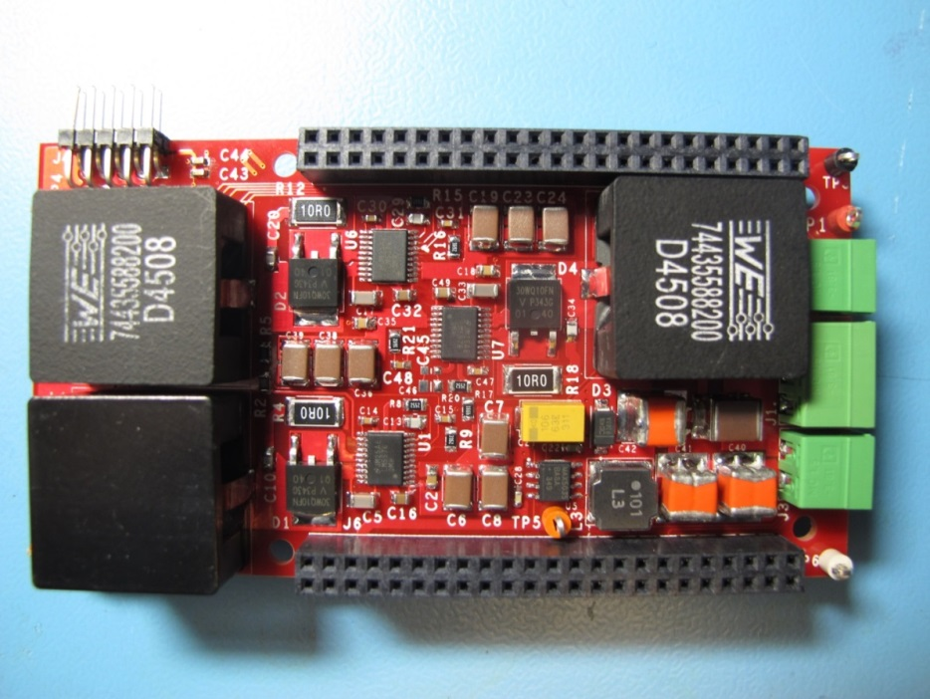
Figure 4: DC-DC Converter Cape

Functional Description
The role of the DC-DC converter cape is to generate all of the lower voltages needed by the BeagleBone and the attached capes. Dedicated switching regulators provide 3 amps of 3.3Vdc and 5.0Vdc to the attached capes. An optional adjustable regulator can be used provide power to additional hardware or sensors.

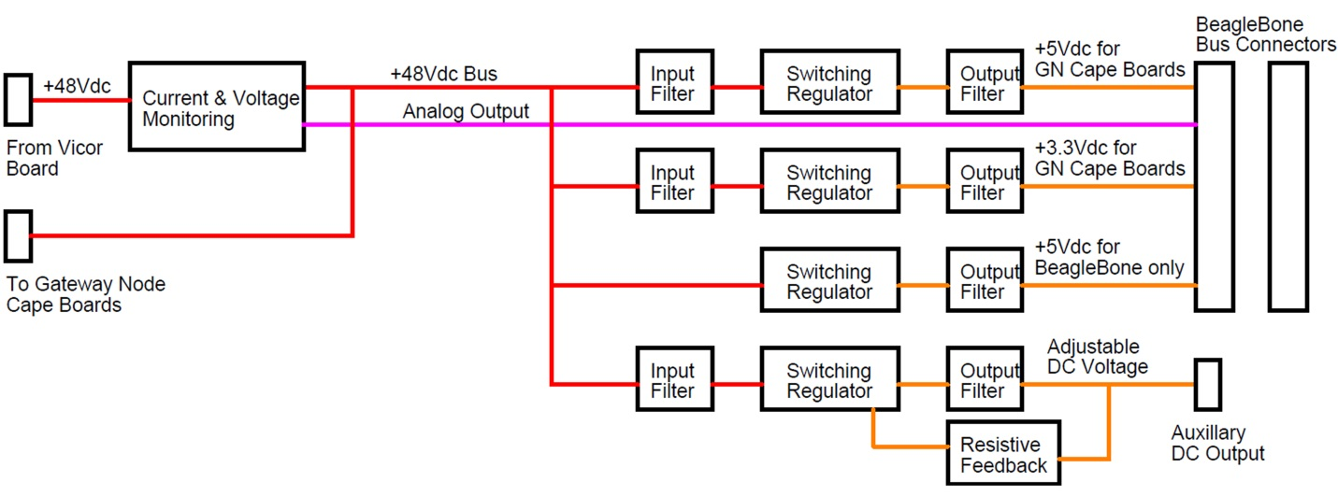
Figure 5: Gateway Node DC-DC Converter Cape Block Diagram

Logic Power
A pair of LM5576 buck regulators are used to generate the 3.3Vdc and 5.0Vdc used by the attached cape boards. These switchers contain an integrated 170m ohm N-Channel MOSFET and are capable of supplying a continuous output of 3 amps. The output filters were designed to limit the output ripple at less than 1%.

A 1 amp switching regulator (MAX5035) generates the 5V dedicated to the BeagleBone. All DC voltages share a common return.

While the BeagleBone can supply logic power to attached capes, the DC buses are limited to one amp. As part of the board population, the male pins are removed (cut off) to prevent two separate regulators from supplying the logic power to the capes.

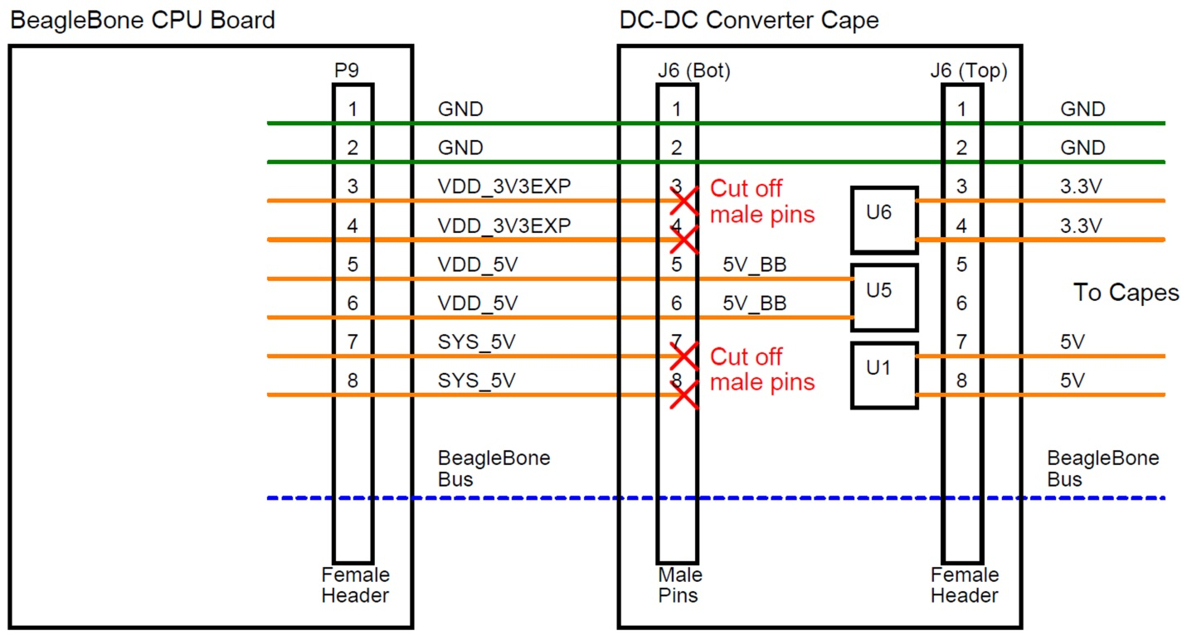
Figure 6: Block diagram of the logic power routing on the Gateway Node cape stack

Optional Auxiliary DC Power Supply
A spare LM5576 switching regulator allows the user to generate a specific voltage for optional circuitry or hardware at J3. The output voltage is determined by the selection of two feedback resistors and can be any value between 1.22Vdc and 48Vdc. The regulator is rated at 3 amps.

If R17 is set at 4.99Kohm, insert the desired voltage into the following equation and solve for R19:

R19 = 4999 / (Vout/1.225) – 1)

Source Voltage and Current Monitoring
The voltage level and current usage of the source 48Vdc is measured and read by the BeagleBone computer board. The maximum allowed analog input voltage for the ADC on the BeagleBone is 1.8V.

Scaled Voltage
U4, R3, and R7 are used to scale the incoming 48Vdc to an appropriate level for the ADC onboard the BeagleBone. For 48Vdc, the scaled voltage should be 1.58Vdc. This is the signal 48V_VOLT on the cape bus.

Vout = 0.0329 * Vin

Measured Current
U2, U3, R6, and C12 are used to measure the current drawn by the 48Vdc loads. The circuit outputs a scaled voltage which is representative of the load current. The maximum measured current is 6 amps. This is the signal 48V_CURR on the cape bus.

Vout = 0.264 * ILoad [voltage to ADC]

I = Vout/0.264 [actual load current based on measured voltage]

Test Connector
A test connector, J4, with signals of interest is available to assist with calibration and/or troubleshooting.

Sensor Node Switching Cape

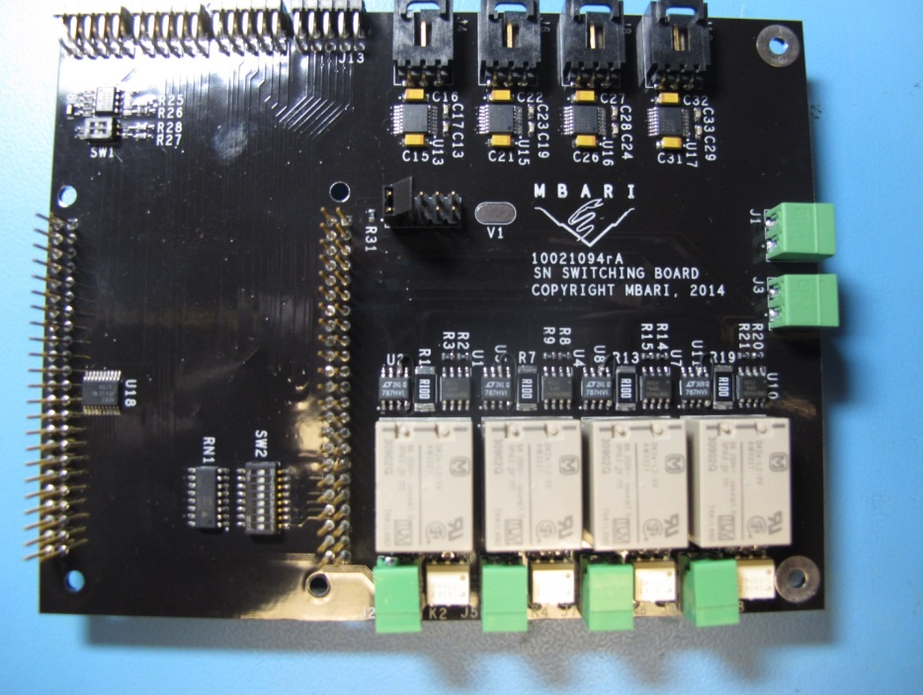
Figure 7: Sensor Node Switching Cape

Functional Description
The Sensor Node Switching Cape provides two primary functions: switching power to and communicating with four Sensor Nodes.

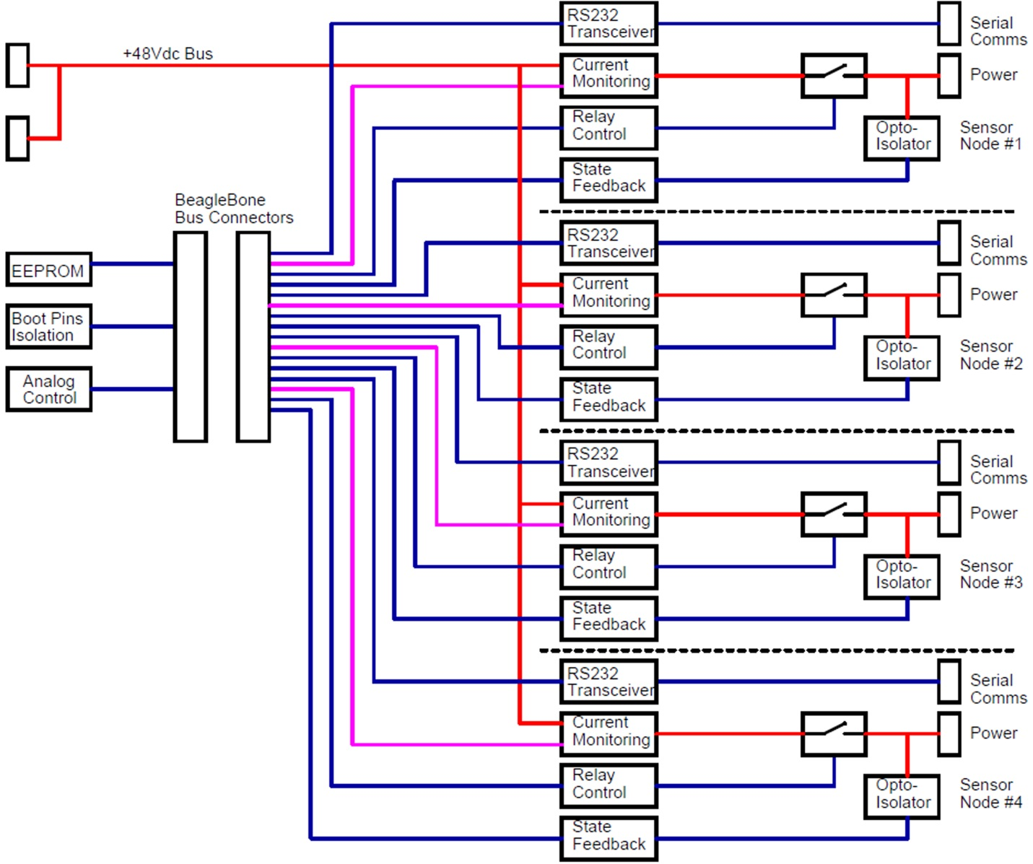
Figure 8: Gateway Node Sensor Node Switching Cape Block Diagram

Load Switching and Monitoring
Four separate load paths are used to switch power (48Vdc) and monitor the current used by each Sensor Node. The DK series relays from Panasonic PEWA are pc mounted dual coil latching 2 Form C relays; electromechanical relays are used to provide complete galvanic isolation in the event of a ground fault. Separate on and off pulses from the BeagleBone drive P-channel MOSFETs for coil activation. The use of latching relays cuts down on the quiescent current draw of the system. Relay state feedback is provided by opto-isolated relays.

Current sense amplifiers (LT1787) are used to measure the current delivered to each Sensor Node. A proportional voltage output is sent through a first order low pass filter prior to being sent to an analog in port on the BeagleBone. The maximum current per load path is 2 amps.

Each current sense amplifier uses a 0.100 ohm sensing resistor and has an internal gain of 8. The voltage proportional to the load current is calculated by:

Vout = ILoad x 0.100 ohms x 8

Serial Interface
The TTL level serial lines from the BeagleBone are routed through the cape bus to the Sensor Node Switching cape. Individual serial transceivers translate the signals to EIA levels before being routed to the Sensor Nodes.

Boot Isolation Pins
The BeagleBone gives the users the ability to change the boot order by setting the state of 16 reserved digital input/output pins during the boot cycle. Once the boot cycle is complete, these 16 lines are then available for general use. This makes it necessary for these 16 pins to be held in a high impedance state during the boot cycle if one wishes to use the default boot order. Two octal tri-state buffers on the Sensor Node Switching cape are used to keep the 16 pins in a high impedance state during boot up.

Cape EEPROM
Each cape in a BeagleBone stack must have a unique ID number associated with it if it intends to interface with other commercially available cape boards. An EEPROM was added to keep the Sensor Node Switching cape compatible with the BeagleBone format. If using only boards dedicated to the Gateway Node, then no IDs need to be used. Consult the BeagleBoard User’s Manual for more detailed information.

Test Connectors
Four test connectors were added allowing easy access to signals of interest. See table xx for a listing of the signals.

Ground Fault Detection and Environmental Sensor Cape

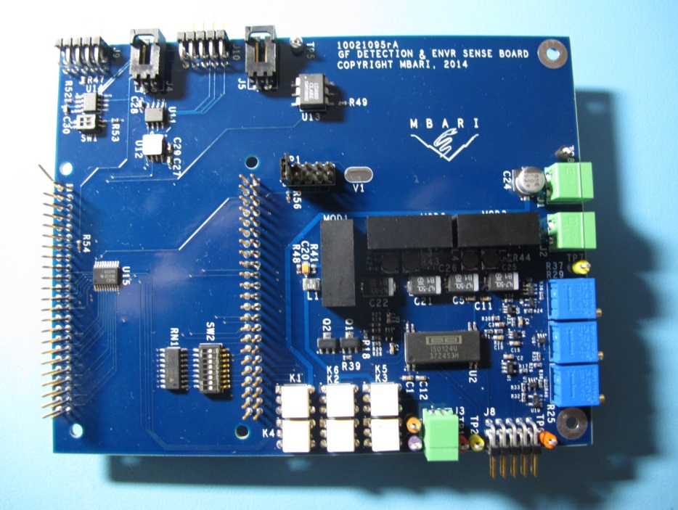
Figure 9: Ground Fault Detection and Environmental Sensing Cape

Functional Description

Text of functional Description

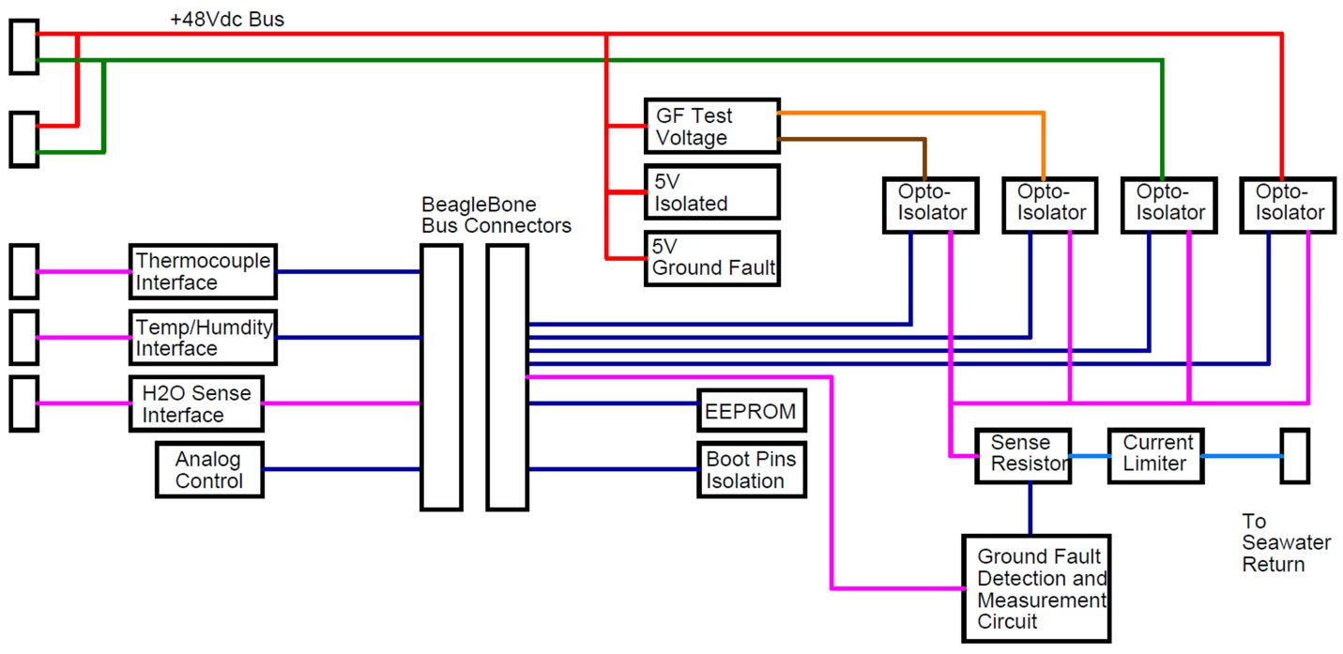
Figure 10: Gateway Node Ground Fault Detection and Environmental Sensing Cape Block Diagram

Ground Fault Detection

The GN Carrier board has the ability to check for ground faults on the +48Vdc line and Return that go to the SNs. Digital signals from the BB test the positive and negative rails of the 48Vdc against a seawater reference return. The analog signal GF_CURR will register a fault in either direction. There is also a test channel that places a known intentional short to ground on an isolated voltage source in order to test and calibrate the GF circuitry.

Environmental Sensing

The GN Carrier board will eventually be housed in a PVC housing and placed underwater, therefore standard sensors are included. These include ambient temperature, humidity, and a water presence detection circuit. There is also a thermocouple conditioning circuit for monitoring the temperature of the Vicor Mini module (type K).

Boot Isolation Pins

Cape EEPROM

Test Connectors

Name | Signal Type | Dir (w/r to BB) | BB Expan Signal | BB Expan Port | BB Mode | Active (Outputs)
NODE_1_ON | Digital | Out | GPIO1_14 | P8-16 | 7 | Low Pulse
NODE_1_OFF | Digital | Out | GPIO1_15 | P8-15 | 7 | Low Pulse
NODE_1_STATE | Digital | In | GPIO2_22 | P8-27 | 7
NODE_1_CURR | Analog | In | AIN0 | P9-39
NODE_2_ON | Digital | Out | GPIO1_12 | P8-12 | 7 | Low Pulse
NODE_2_OFF | Digital | Out | GPIO1_13 | P8-11 | 7 | Low Pulse
NODE_2_STATE | Digital | In | GPIO2_23 | P8-29 | 7
NODE_2_CURR | Analog | In | AIN1 | P9-40
NODE_3_ON | Digital | Out | GPIO1_28 | P9-12 |  | Low Pulse
NODE_3_OFF | Digital | Out | GPIO1_2 | P8-5 | 7 | Low Pulse
NODE_3_STATE | Digital | In | GPIO2_24 | P8-28 | 7
NODE_3_CURR | Analog | In | AIN2 | P9-37
NODE_4_ON | Digital | Out | GPIO1_7 | P8-4 | 7 | Low Pulse
NODE_4_OFF | Digital | Out | GPIO1_6 | P8-3 | 7 | Low Pulse
NODE_4_STATE | Digital | In | GPIO2_25 | P8-30 | 7
NODE_4_CURR | Analog | In | AIN3 | P9-38
UART_1_TTL_TXD | Digital | Out | UART1_TXD | P9-24
UART_1_TTL_RXD | Digital | In | UART1_RXD | P9-26
UART_2_TTL_TXD | Digital | Out | UART2_TXD | P9-21
UART_2_TTL_RXD | Digital | In | UART2_RXD | P9-22
UART_4_TTL_TXD | Digital | Out | UART4_TXD | P9-13
UART_4_TTL_RXD | Digital | In | UART4_RXD | P9-11
UART_5_TTL_TXD | Digital | Out | UART5_TXD | P8-37
UART_5_TTL_RXD | Digital | In | UART5_RXD | P8-38
48V_RET_GF | Digital | Out | GPIO1_4 | P8-23 |  | High SS
48V_GF | Digital | Out | GPIO1_0 | P8-25 |  | High SS
TEST_RET_GF | Digital | Out | GPIO1_1 | P8-24 |  | High SS
TEST_GF | Digital | Out | GPIO1_29 | P8-26 |  | High SS
GF_CURR | Analog | In | AIN4 | P9-33
H2O_ALARM | Digital | In | GPIO1_5 | P8-22
48V_VOLT | Analog | In | AIN5 | P9-36
48V_CURR | Analog | In | AIN6 | P9-35
ENVR_ALARM | Digital | In | GPIO1_31 | P8-20
EEPROM_WP1 | Digital | Out | GPIO0_26 | P8-14 |  | High SS
EEPROM_WP2 | Digital | Out | GPIO0_27 | P8-17 |  | High SS
EEPROM_WP3 | Digital | Out | GPIO2_1 | P8-18 |  | High SS
EEPROM_WP4 | Digital | Out | GPIO1_30 | P8-21 |  | High SS

Chip | Pin | Addr | Dir | Act | Val | Signal
1 | 15 | 47 | Out | Low | High | NODE_1_OFF
1 | 14 | 46 | Out | Low | High | NODE_1_ON
2 | 22 | 86 | In | Low | N/A | NODE_1_STATE
1 | 13 | 45 | Out | Low | High | NODE_2_OFF
1 | 12 | 44 | Out | Low | High | NODE_2_ON
2 | 23 | 87 | In | Low | N/A | NODE_2_STATE
1 | 2 | 34 | Out | High | Low | NODE_3_OFF
1 | 28 | 60 | Out | High | Low | NODE_3_ON
2 | 24 | 88 | In | Low | N/A | NODE_3_STATE
1 | 6 | 38 | Out | High | Low | NODE_4_OFF
1 | 7 | 39 | Out | High | Low | NODE_4_ON
2 | 25 | 89 | In | Low | N/A | NODE_4_STATE
1 | 4 | 36 | Out | High | Low | 48V_RET_GF
1 | 0 | 32 | Out | High | Low | 48_GF
1 | 1 | 33 | Out | Low | Low | TEST_RET_GF
1 | 28 | 60 | Out | Low | Low | GPIO1_28
1 | 29 | 61 | Out | Low | Low | TEST_GF
1 | 5 | 37 | In | Low | N/A | H2O_ALARM
1 | 31 | 63 | In | Low | N/A | ENVR_ALARM
1 | 30 | 62 | Out | High | Low | EEPROM_WP

Board Level Signal Descriptions

Digital Output Signals

All digital output signals originate on the BeagleBone board and are used on one or more of the attached cape boards. They use +3.3Vdc logic. The default (boot up) state and active levels are assigned in the BeagleBone firmware.

NODE_1_ON

GPIO1_14
Addr = 46
P8-16
Sensor Node Switching Cape

NODE_1_ON is used to apply power to Sensor Node #1; it does this by activating the reset coil of relay K1. The default state is high and its active level is a negative going pulse 5 msec in duration.

NODE_1_OFF

GPIO1_15
Addr = 47
P8-15
Sensor Node Switching Cape

NODE_1_OFF is used to remove power from Sensor Node #1; it does this by activating the set coil of relay K1. The default state is high and its active level is a negative going pulse 5 msec in duration.

NODE_2_ON

GPIO1_12
Addr = 44
P8-12
Sensor Node Switching Cape

NODE_2_ON is used to apply power to Sensor Node #2; it does this by activating the reset coil of relay K3. The default state is high and its active level is a negative going pulse 5 msec in duration.

NODE_2_OFF

GPIO1_13
Addr = 45
P8-11
Sensor Node Switching Cape

NODE_2_OFF is used to remove power from Sensor Node #2; it does this by activating the set coil of relay K3. The default state is high and its active level is a negative going pulse 5 msec in duration.

NODE_3_ON

GPIO1_28
Addr = 60
P9-12
Sensor Node Switching Cape

NODE_3_ON is used to apply power to Sensor Node #3; it does this by activating the reset coil of relay K5. The default state is high and its active level is a negative going pulse 5 msec in duration.

NODE_3_OFF

GPIO1_5
Addr = 37
P8-5
Sensor Node Switching Cape

NODE_3_OFF is used to remove power from Sensor Node #3; it does this by activating the set coil of relay K5. The default state is high and its active level is a negative going pulse 5 msec in duration.

NODE_4_ON

GPIO1_7
Addr = 39
P8-4
Sensor Node Switching Cape

NODE_4_ON is used to apply power to Sensor Node #4; it does this by activating the reset coil of relay K7. The default state is high and its active level is a negative going pulse 5 msec in duration.

NODE_4_OFF

GPIO1_6
Addr = 38
P8-3
Sensor Node Switching Cape

NODE_4_OFF is used to remove power from Sensor Node #4; it does this by activating the set coil of relay K7. The default state is high and its active level is a negative going pulse 5 msec in duration.

48V_GF

GPIO1_0
Addr = 32
P8-25
Ground Fault and Environmental Sensing Cape

48V_GF is used to test the source 48Vdc for conductivity to the seawater reference; it does this by activating opto-relay K4. The default state is low and its active level is a steady state high.

48V_RET_GF

GPIO1_4
Addr = 36
P8-23
Ground Fault and Environmental Sensing Cape

48V_RET_GF is used to test the source 48Vdc Return for conductivity to the seawater reference; it does this by activating opto-relay K1. The default state is low and its active level is a steady state high.

TEST_GF

GPIO1_29
Addr = 61
P8-26
Ground Fault and Environmental Sensing Cape

TEST_GF is used to test a reference voltage for conductivity to the seawater reference; it does this by activating opto-relays K3 and K6. This signal allows for the calibration and verification of the ground fault detection circuitry. The default state is low and its active level is a steady state high.

TEST_RET_GF

GPIO1_1
Addr = 33
P8-24
Ground Fault and Environmental Sensing Cape

TEST_RET_GF is used to test a reference voltage return for conductivity to the seawater reference; it does this by activating opto-relays K2 and K5. This signal allows for the calibration and verification of the ground fault detection circuitry. The default state is low and its active level is a steady state high.

EEPROM_WP1

GPIO0_26
Addr = 26
P8-14
Ground Fault and Environmental Sensing Cape

EEPROM_WP1 is a write protect signal for the CAT24C256WI-GT3 EEPROM, U14. When high, the memory of U14 is protected against write operations, but can still be read back. When low, write operations may be performed.

EEPROM_WP2

GPIO0_27
Addr = 27
P8-17
Sensor Node Switching Cape

EEPROM_WP2 is a write protect signal for the CAT24C256WI-GT3 EEPROM, U14. When high, the memory of U14 is protected against write operations, but can still be read back. When low, write operations may be performed.

EEPROM_WP3

GPIO2_1
Addr = 65
P8-18
[future cape board]

EEPROM_WP3 is a write protect signal for the CAT24C256WI-GT3 EEPROM. When high, the memory is protected against write operations, but can still be read back. When low, write operations may be performed.

EEPROM_WP4

GPIO1_30
Addr = 62
P8-21
[future cape board]

EEPROM_WP4 is a write protect signal for the CAT24C256WI-GT3 EEPROM. When high, the memory is protected against write operations, but can still be read back. When low, write operations may be performed.

Digital Input Signals

All digital inputs signals originate on the attached cape boards and are read by the BeagleBone computer board. They use +3.3Vdc logic. The active level is assigned in the BeagleBone firmware.

NODE_1_STATE

GPIO2_22
Addr = 86
P8-27
Sensor Node Switching Cape

NODE_1_STATE indicates the power state of Sensor Node #1. Opto relay K2 drives this signal high when Sensor Node #1 is energized. It is low when Sensor Node #1 is off.

NODE_2_STATE

GPIO2_23
Addr = 87
P8-29
Sensor Node Switching Cape

NODE_2_STATE indicates the power state of Sensor Node #2. Opto relay K4 drives this signal high when Sensor Node #2 is energized. It is low when Sensor Node #2 is off.

NODE_3_STATE

GPIO2_24
Addr = 88
P8-28
Sensor Node Switching Cape

NODE_3_STATE indicates the power state of Sensor Node #3. Opto relay K6 drives this signal high when Sensor Node #3 is energized. It is low when Sensor Node #3 is off.

NODE_4_STATE

GPIO2_25
Addr = 89
P8-30
Sensor Node Switching Cape

NODE_4_STATE indicates the power state of Sensor Node #4. Opto relay K8 drives this signal high when Sensor Node #4 is energized. It is low when Sensor Node #4 is off.

H2O_ALARM

GPIO1_5
Addr = 37
P8-22
Ground Fault and Environmental Sensing Cape

H2O_ALARM indicates the presence of seawater in the Gateway Node subsea housing; it does this by driving an opto-isolator, U13, high if seawater is detected. A high reading indicates water in the housing while a low indicates a dry interior.

ENVR_ALARM

GPIO1_31
Addr = 63
P8-20
Ground Fault and Environmental Sensing Cape

ENVR_ALARM indicates the either the ambient temperature or humidity has gone out of the programmed range. Its default state is high; a low indicates an alarm. The actual values can then be read back over the SPI bus.

Analog Input Signals

All analog input signals originate on the attached cape boards and are read by the onboard ADC on the BeagleBone computer board. The maximum voltage level on all analog input signals is 1.8V.

NODE_1_CURR

AIN0
P9-39
Sensor Node Switching Cape

NODE_1_CURR is a voltage which is representative of the current drawn by Sensor Node #1. The maximum current drawn and measured is 2 amps, which corresponds to an output of 1.6Vdc.

NODE_1_CURR (volts) = ILoad (amps) * 0.1 (ohms) * 8

Once this value is read by the ADC on the BeagleBone, the actual current may be found:

ILoad = NODE_1_CURR (volts) / 0.8 (ohms)

NODE_2_CURR

AIN1
P9-40
Sensor Node Switching Cape

NODE_2_CURR is a voltage which is representative of the current drawn by Sensor Node #2. The maximum current drawn and measured is 2 amps, which corresponds to an output of 1.6Vdc.

NODE_2_CURR (volts) = ILoad (amps) * 0.1 (ohms) * 8

Once this value is read by the ADC on the BeagleBone, the actual current may be found:

ILoad = NODE_2_CURR (volts) / 0.8 (ohms)

NODE_3_CURR

AIN2
P9-37
Sensor Node Switching Cape

NODE_3_CURR is a voltage which is representative of the current drawn by Sensor Node #3. The maximum current drawn and measured is 2 amps, which corresponds to an output of 1.6Vdc.

NODE_3_CURR (volts) = ILoad (amps) * 0.1 (ohms) * 8

Once this value is read by the ADC on the BeagleBone, the actual current may be found:

ILoad = NODE_3_CURR (volts) / 0.8 (ohms)

NODE_4_CURR

AIN3
P9-38
Sensor Node Switching Cape

NODE_4_CURR is a voltage which is representative of the current drawn by Sensor Node #4. The maximum current drawn and measured is 2 amps, which corresponds to an output of 1.6Vdc.

NODE_4_CURR (volts) = ILoad (amps) * 0.1 (ohms) * 8

Once this value is read by the ADC on the BeagleBone, the actual current may be found:

ILoad = NODE_4_CURR (volts) / 0.8 (ohms)

GF_CURR

AIN4
P9-33
Ground Fault and Environmental Sensing Cape

GF_CURR is a voltage which is representative of the electrical current between seawater reference and the ground fault channel under test.

[add more after GF circuit is calibrated and tested – CDK 08/21/2014]

48V_VOLT

AIN5
P9-36
DC-DC Converter Cape

48V_VOLT is a scaled voltage representative of the actual 48Vdc source. For 48Vdc, the scaled voltage should be 1.58Vdc.

48V_VOLT = 0.0329 * Vin

Once this value is read by the ADC on the BeagleBone, the actual voltage may be found:

V = 30.4 * 48V_VOLT

48V_CURR

AIN6
P9-35
DC-DC Converter Cape

48V_CURR is a voltage which is representative of the current drawn by the entire load of the 48Vdc source. The maximum current drawn and measured is 6 amps, which corresponds to an output of 1.6Vdc.

48V_CURR (volts) = ILoad (amps) * 0.033 (ohms) * 8

Once this value is read by the ADC on the BeagleBone, the actual current may be found:

ILoad = NODE_4_CURR (volts) / 0.264 (ohms)

** Add in AMB_HUM, AMB_TEMP, and VICOR_TEMP **

SPI Bus Signals

SPI1_MOSI

SP1_MISO

SPI1_SCLK

SPI1_CS0

SPI1_CS1

I2C Signals

I2C2_SDA

I2C2_SCL

Serial Signals

UART_1_TTL_TXD

UART_1_TTL_RXD

UART_2_TTL_TXD

UART_2_TTL_RXD

UART_4_TTL_TXD

UART_4_TTL_RXD

UART_5_TTL_TXD

UART_5_TTL_RXD

Appendicies

