Kelp Forest Array Overview
Chad Kecy
12-11-2013

System Overview

The Kelp Forest Array (KFA) is a subsea cabled array located just off of Hopkins Marine Station. It is approximately 200 meters from shore at a depth of 15 meters. It has a total of eight low voltage output ports which support a wide range of experiments. The KFA operates from +300Vdc and has a background power usage of 60 watts. The KFA actually consists of two housings: a small micro node and a larger central node. The tether is potted to the micro node, which is connected to the central node via two subconn high voltage GigE rated cables. One of the cables carries the KFA power and Ethernet while the second cable is dedicated to the swFOCE experiment.

The KFA and the swFOCE experiment have no shared power or Ethernet communication in the tether. The two systems are powered independently and have their own ground fault detection systems. The swFOCE power and Ethernet simply pass through the KFA micro node and central node. The KFA and swFOCE do share a common conductor in the tether as a seawater reference.

The tether is a custom from South Bay; it has 5x14 AWG and 8 MM fibers. It runs from the KFA along the sea floor to the beach, where it is buried until it reaches a drainage pipe. The tether runs through the pipe and connects to a newly installed underground PVC tube which connects to the pump house. The tether enters the pump house and from there it is connected to the shore side electrical system.

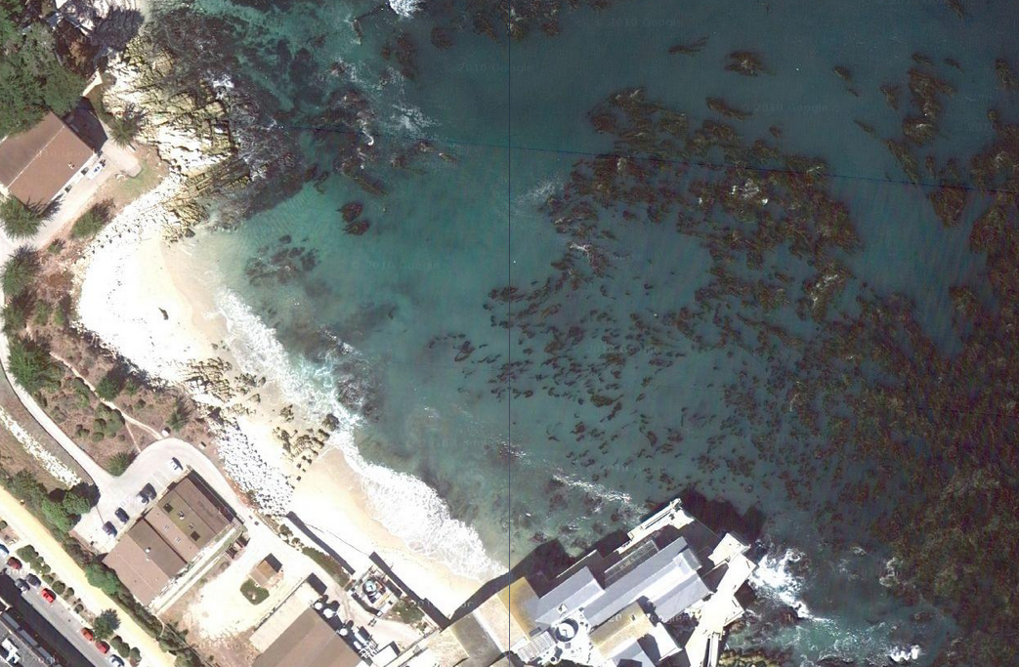
Figure One: Location of the Kelp Forest Array (KFA)

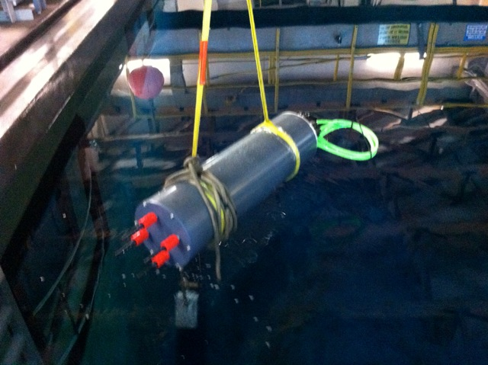
Figure Two: The KFA Central Node in the test tank. The four connectors in the foreground are the high voltage ports while the the green cables in the rear are the low voltage outputs.

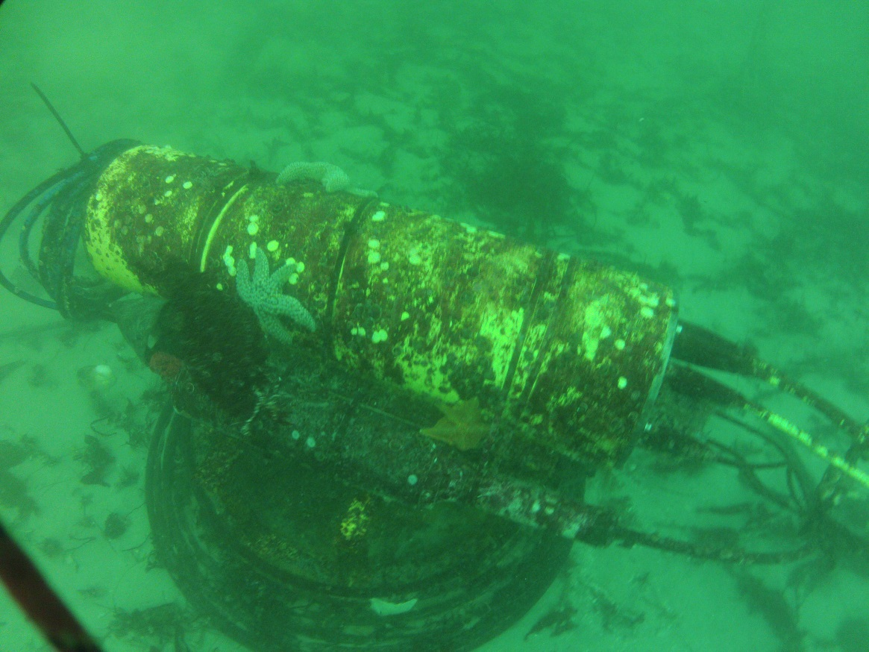
Figure Three: The deployed KFA in its cradle. The micro node is strapped to the side of the central node.

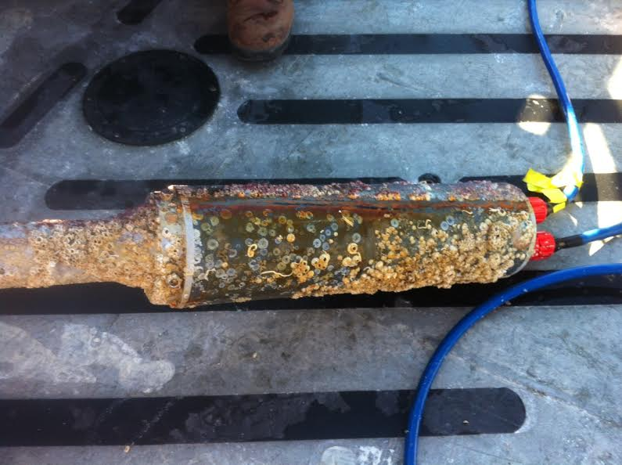
Figure Four: The micro node. This picture was taken onboard the R/V Sheila B on Dec. 5, 2013.

