Kelp Forest Array Internal Electronics Frame

Requested resources: Mech Tech (preferrable Paul Coenen due to familarity with project)
Estimated job time: 2-3 days

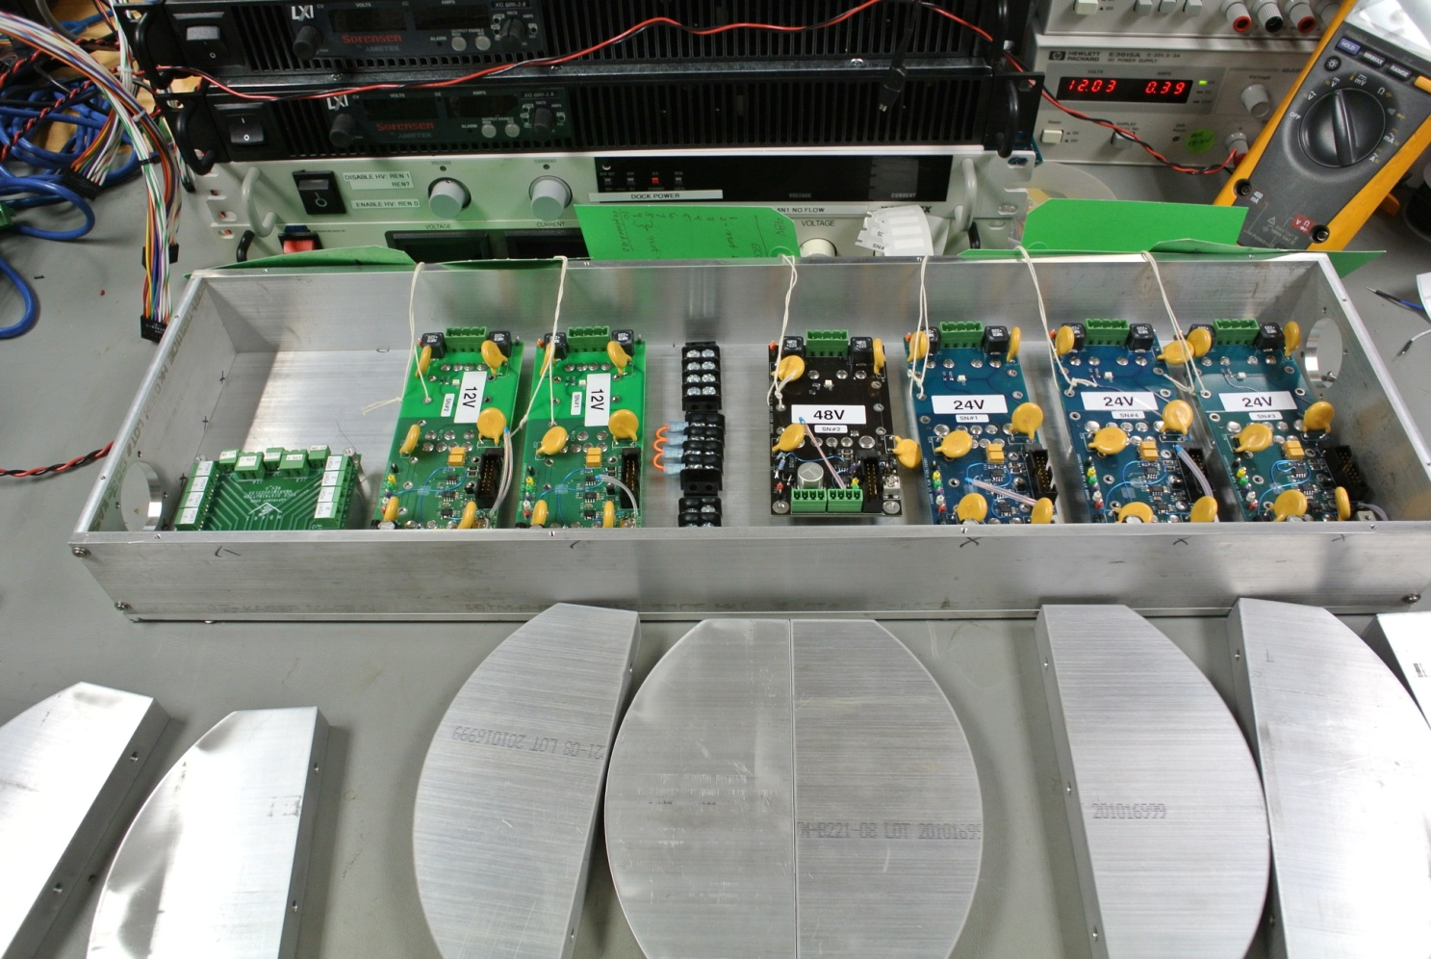
Figure One: Layout of the 300V-LVdc Vicor boards

1. Aluminum frame side plates: Each need a 1" diameter circular hole drilled.

2. Aluminum bottom plate: Need 24 beveled holes (non-threaded) for mounting the 8 heatsink fins.
Need threaded mounting holes for the Vicor boards and other modules.

3. Need all boards mounted to aluminum plate.

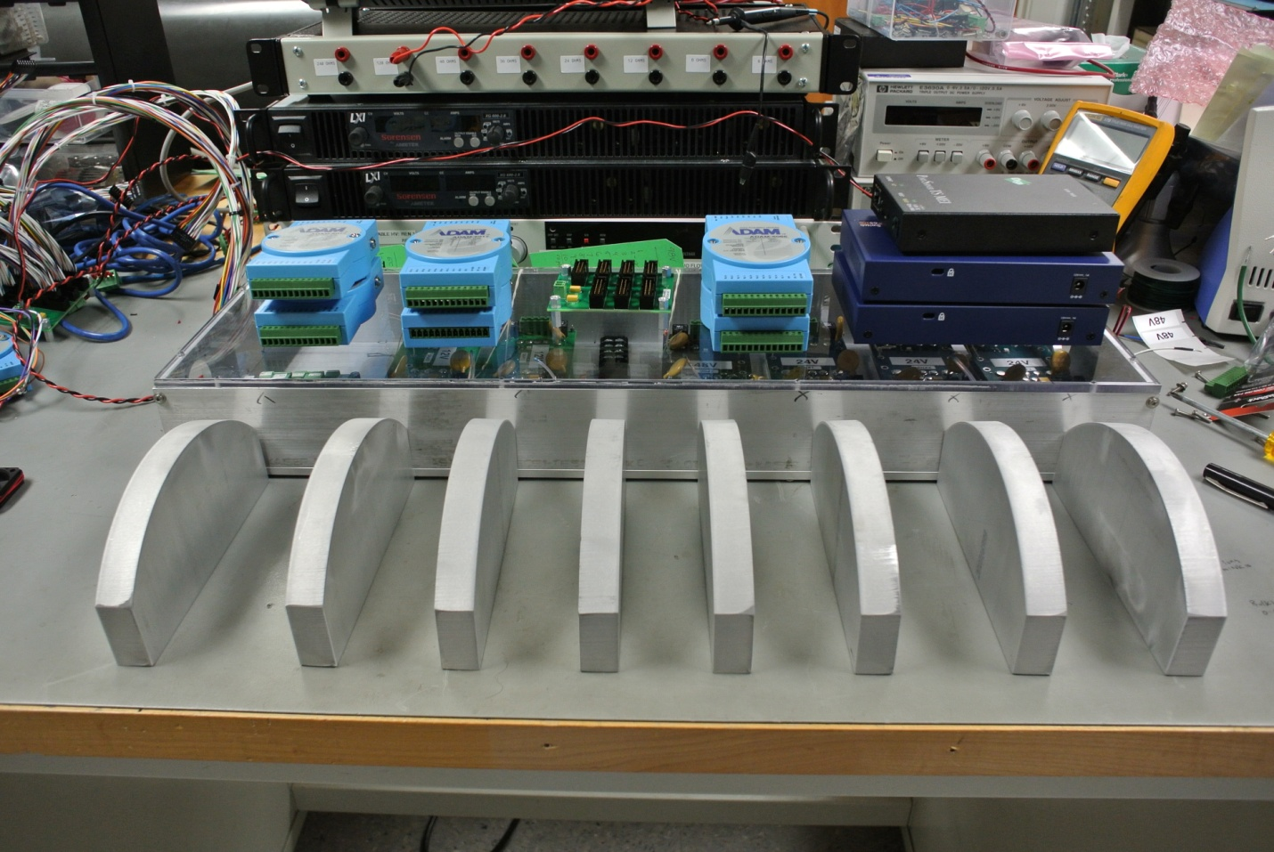
Figure Two: Layout of the ADAM modules and Ethernet switches.

4. Lexan plate: Need (3) 1"x5" notches cut out (for wire routing)
Need threaded mounting holes for the ADAM modules and patch boards.

5. Need all electronic modules mounted to lexan plate.

6. Heatsink fins: Need (2) 1/2" diameter circular holes drilled in each (for air circulation).
Need (2) 1/4"-20 threaded mounting holes (1/2" deep) on each flat side (for side bar).

7. Side bars (not pictured): Need (2) 1/4" holes (non-threaded) drilled at specified interval.

