FOCE Instrument Chassis System Software Overview v1.0
Chad Kecy

System Description

The Instrument Chassis is a backplane based modular circuit board housing. The core components are a 44-pin backplane board, a power supply board, and a CPU board. The PS and CPU boards have dedicated slots; the remaining eight slots may be occupied by a variety of other functional cards. Currently, these include an environmental board (done), a low-voltage load switcher (3rd version of proto), a medium-voltage load switcher (completed design), and a ground fault detection board (conceptual).

The CPU board interfaces a higher level computer via ethernet using a Lantronix XPort DS ethernet-to-serial converter. Communication to the daughter boards is controlled by the CPU board using SPI as the protocol. Each board has two SPI busses; one for backplane comms and one for internal data acquisition and control.

Each board has a PIC24 microcontroller, although they may be of different varieties. Each daughter board will collect and process its own specific data. The CPU will routinely poll the daughter boards for their data, store it, and make it available to the higher level computer.

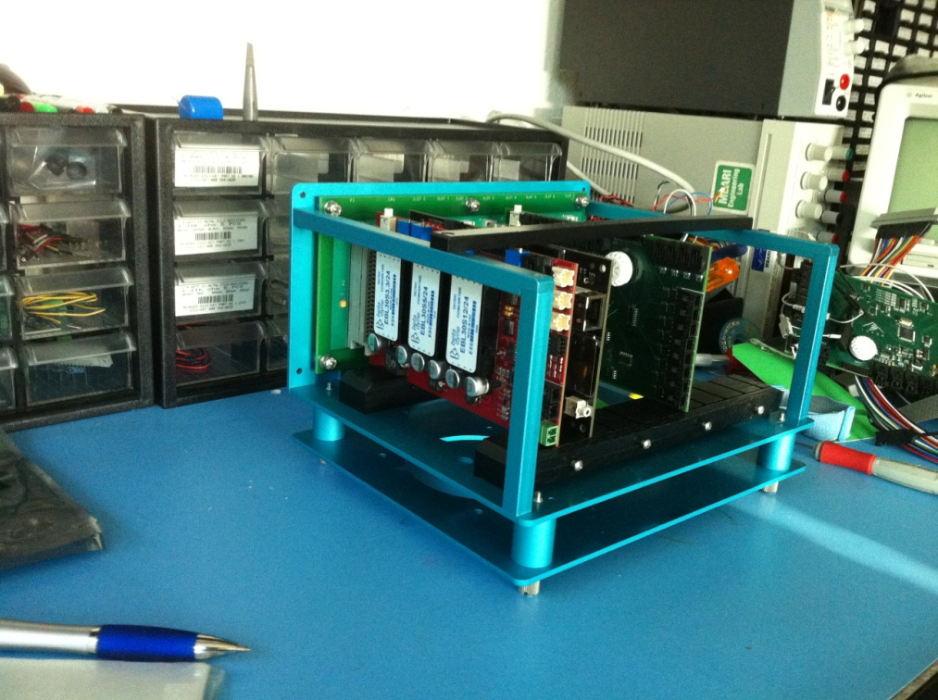
Figure 1: FOCE Instrument Chassis System

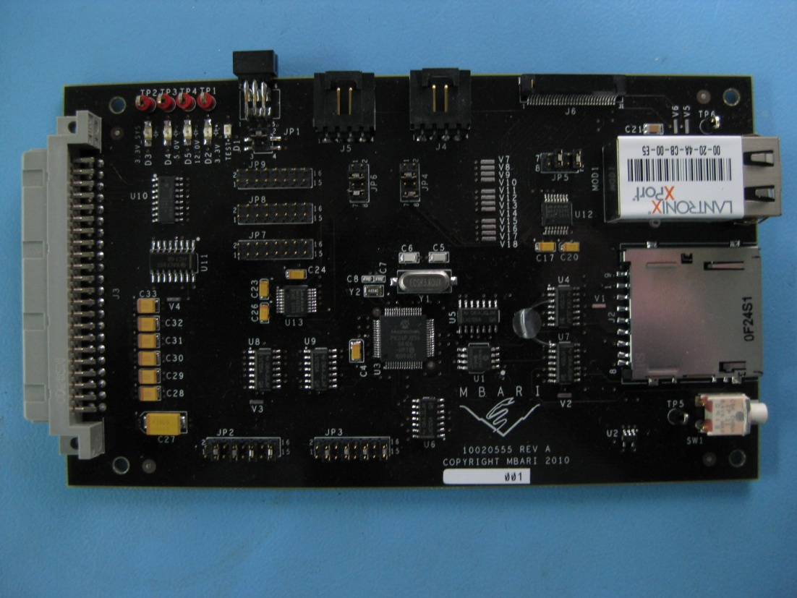
Figure 2: CPU Board

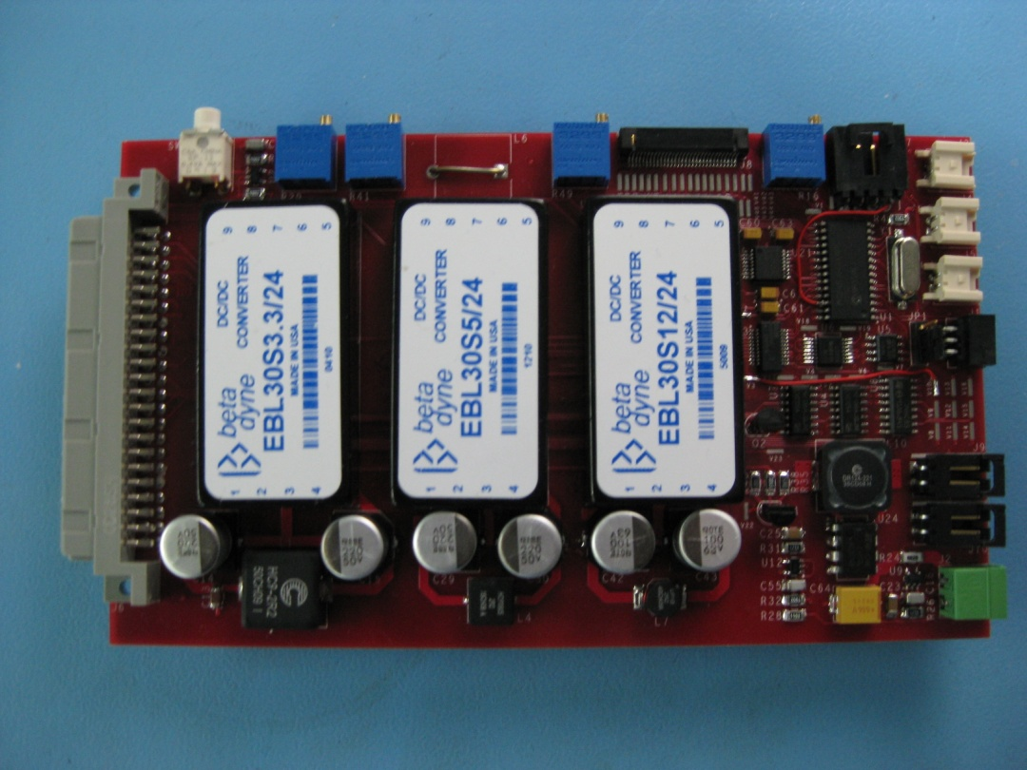
Figure 3: Power Supply Board

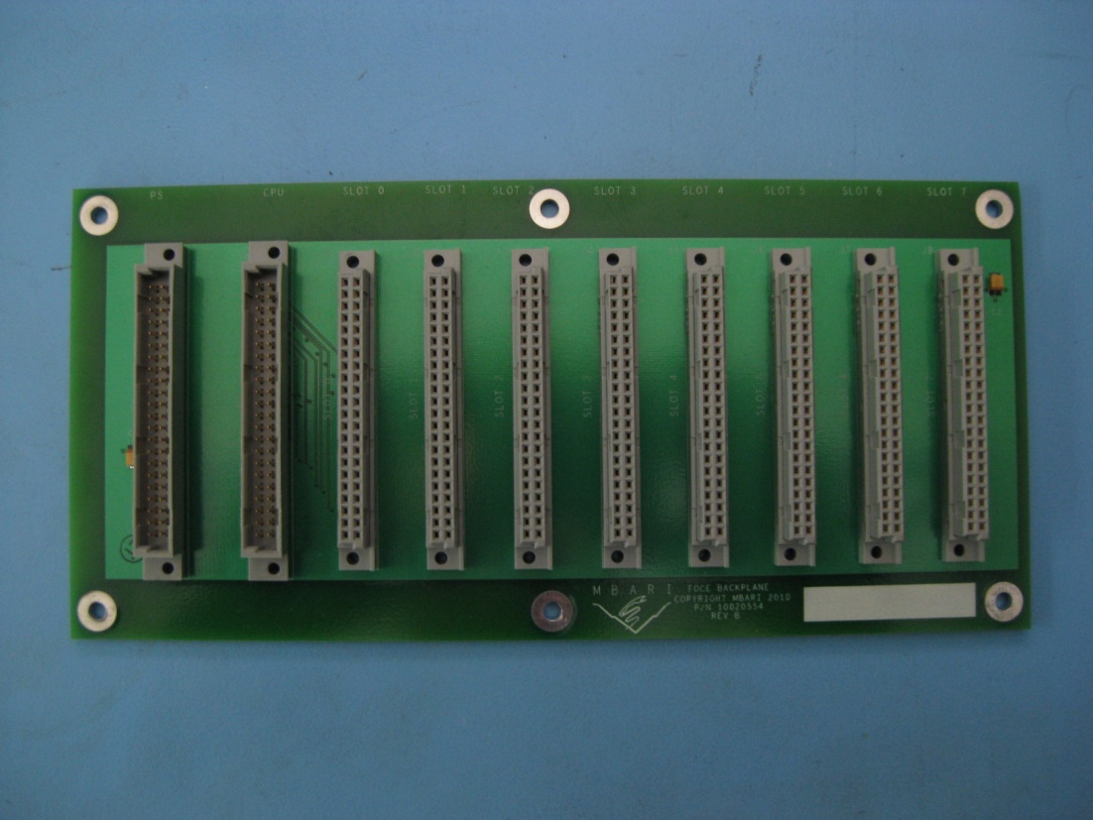
Figure 4: Backplane Board

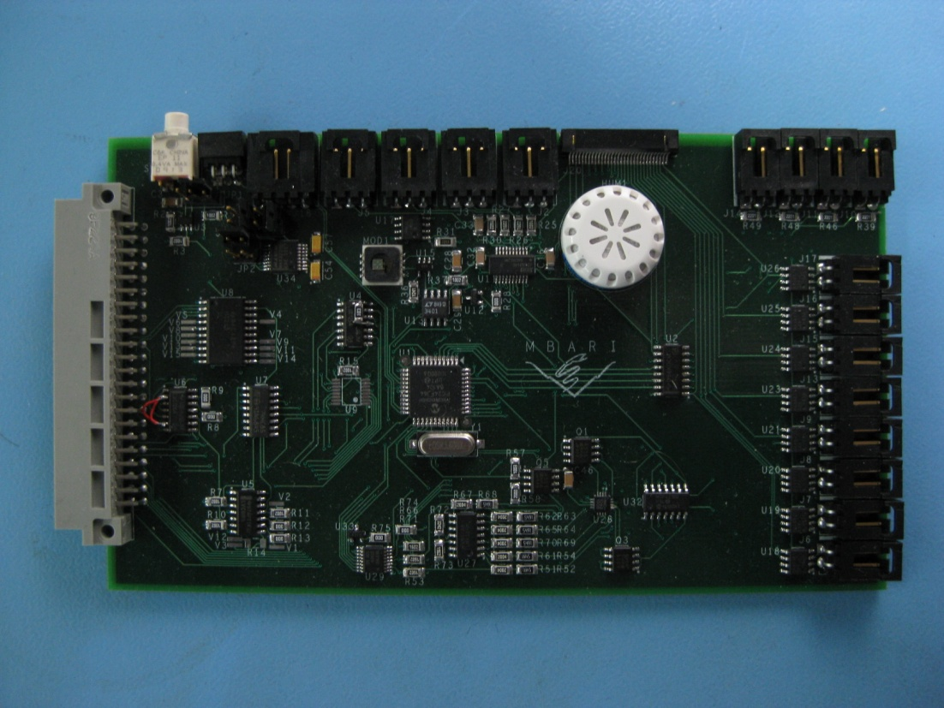
Figure 5: Environmental Board

