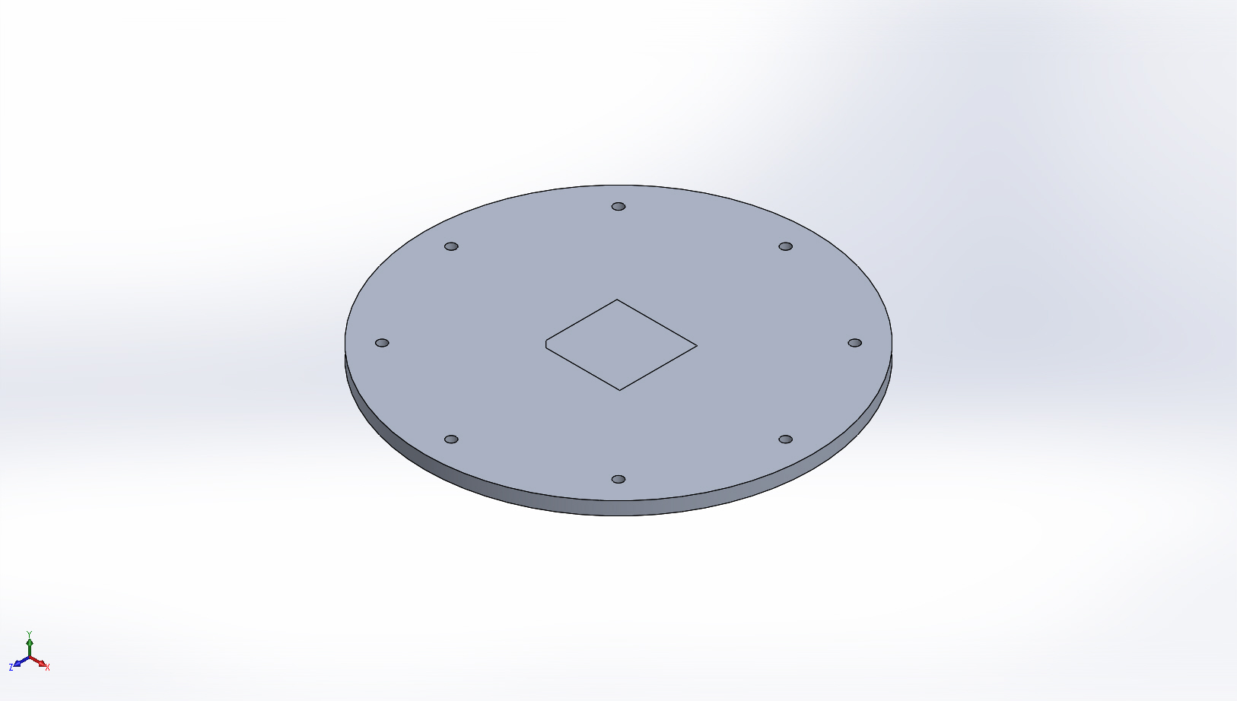
  Simulation of Gateway Node Aluminum Cap
  Date: Thursday, November 13, 2014
  Designer: Farley Shane
  Study name: Gateway Node Thermal Conductivity
  Analysis type: Thermal(Steady state)
  Table of Contents
  Description 1
  Assumptions 2
  Model Information 2
  Study Properties 3
  Units 3
  Material Properties 3
  Thermal Loads 4
  Contact Information 4
  Mesh Information 5
  Sensor Details 6
  Study Results 7
  Conclusion 7

Description
3/8" 6061-T6 Aluminum Plate as part of the Gateway Node Endcap

Assumptions

Model Information

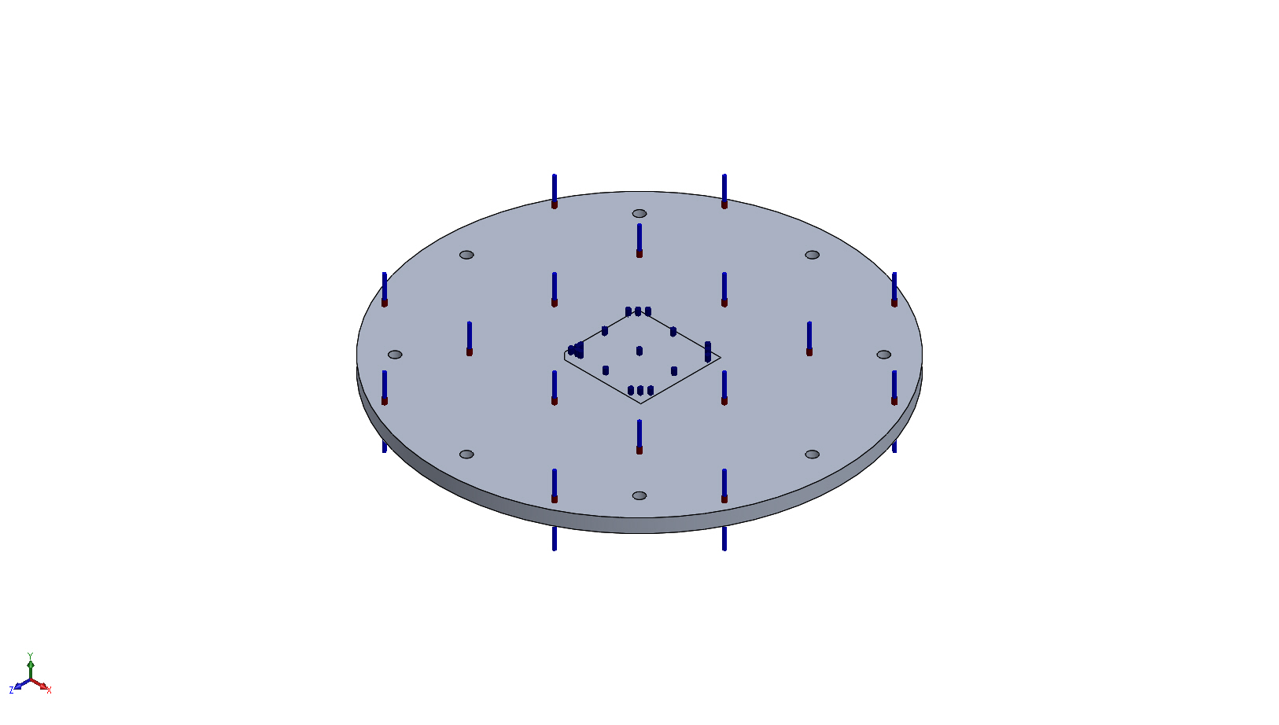
Model name: Gateway Node Aluminum Cap
Current Configuration: Default
Solid Bodies
Document Name and Reference | Treated As | Volumetric Properties | Document Path/Date Modified
Split Line2  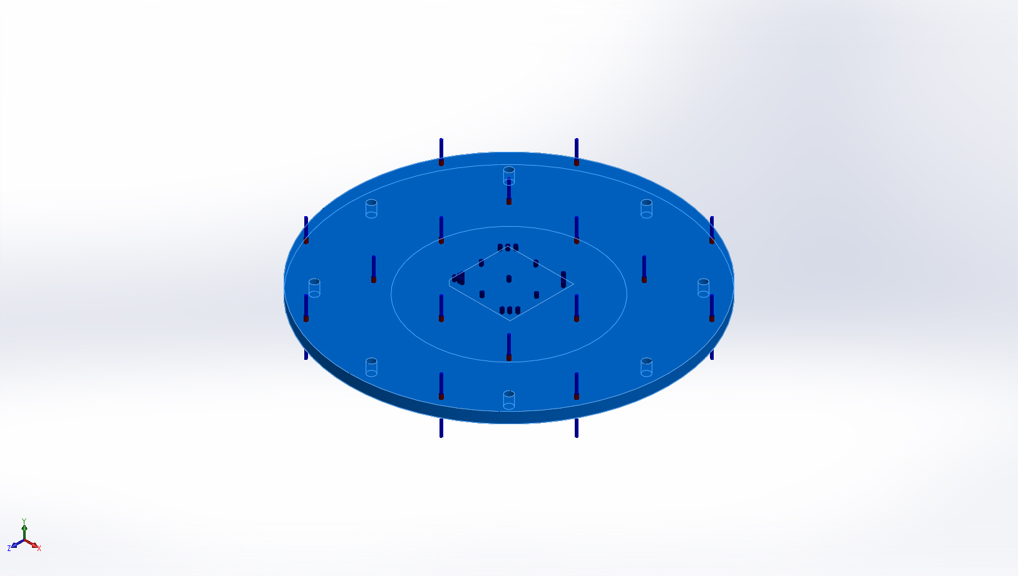 | Solid Body | Mass:1.56943 kg  Volume:0.000581269 m^3  Density:2700 kg/m^3  Weight:15.3804 N | X:\901219.SW-FOCE\MECHANICAL\Gateway Electronics Housing\Gateway Node Aluminum Cap.SLDPRT  Nov 12 11:17:59 2014

Study Properties
Study name | Gateway Node Thermal Conductivity
Analysis type | Thermal(Steady state)
Mesh type | Solid Mesh
Solver type | FFEPlus
Solution type | Steady state
Contact resistance defined? | No
Result folder | SolidWorks document (X:\901219.SW-FOCE\MECHANICAL\Gateway Electronics Housing)

Units
Unit system: | SI (MKS)
Length/Displacement | mm
Temperature | Kelvin
Angular velocity | Rad/sec
Pressure/Stress | N/m^2

Material Properties
Model Reference | Properties | Components
 |  | SolidBody 1(Split Line2)(Gateway Node Aluminum Cap)
  Name: | 6061-T6 (SS)
  Model type: | Linear Elastic Isotropic
  Default failure criterion: | Max von Mises Stress
  Thermal conductivity: | 166.9 W/(m.K)
  Specific heat: | 896 J/(kg.K)
  Mass density: | 2700 kg/m^3
Curve Data:N/A

Thermal Loads

Load name | Load Image | Load Details
Temperature-1 | 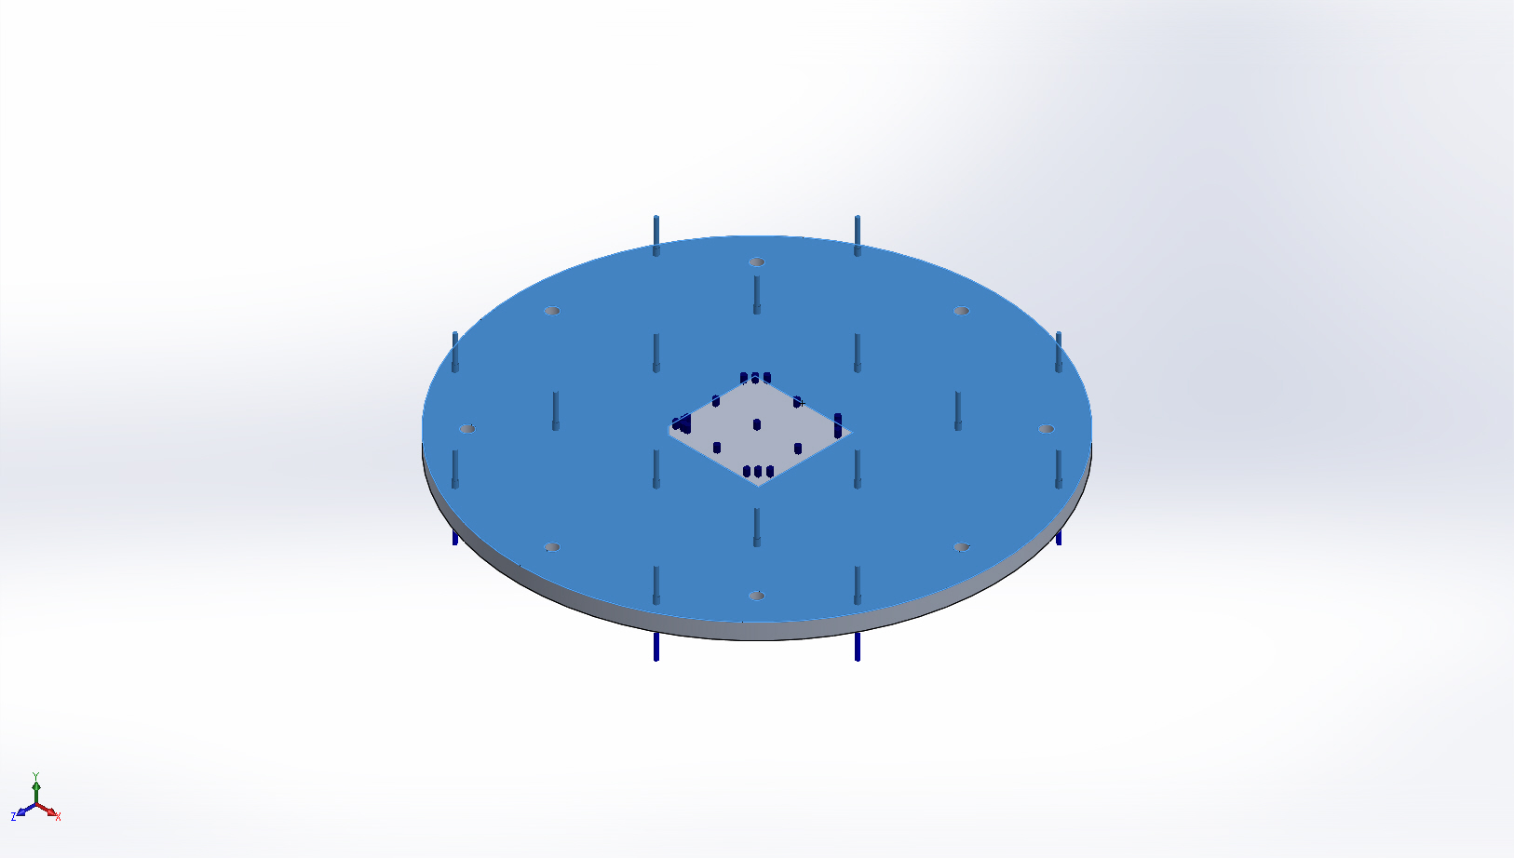
  Entities: | 1 face(s)
  Temperature: | 48 Fahrenheit
Heat Power-1 | 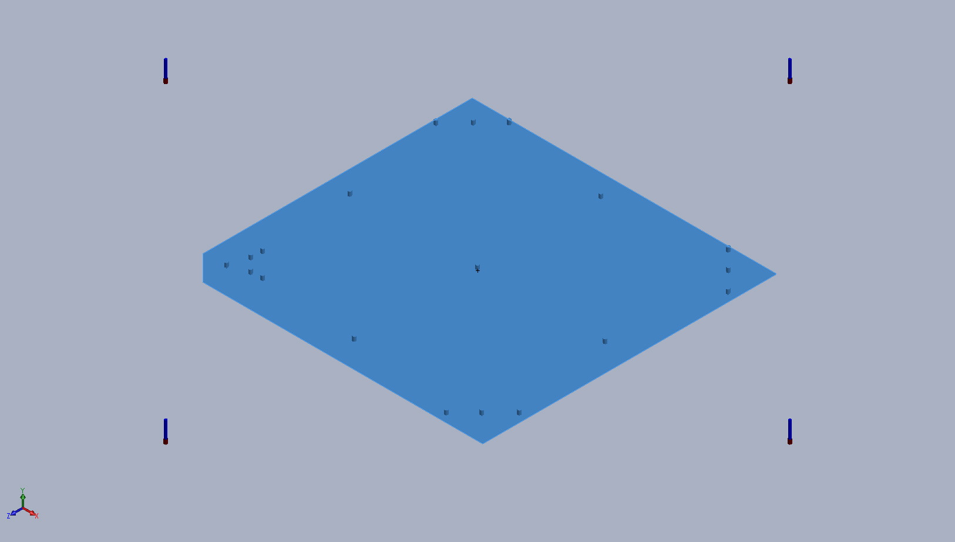
  Entities: | 1 face(s)
  Heat Power Value: | 250 W
Temperature-2 | 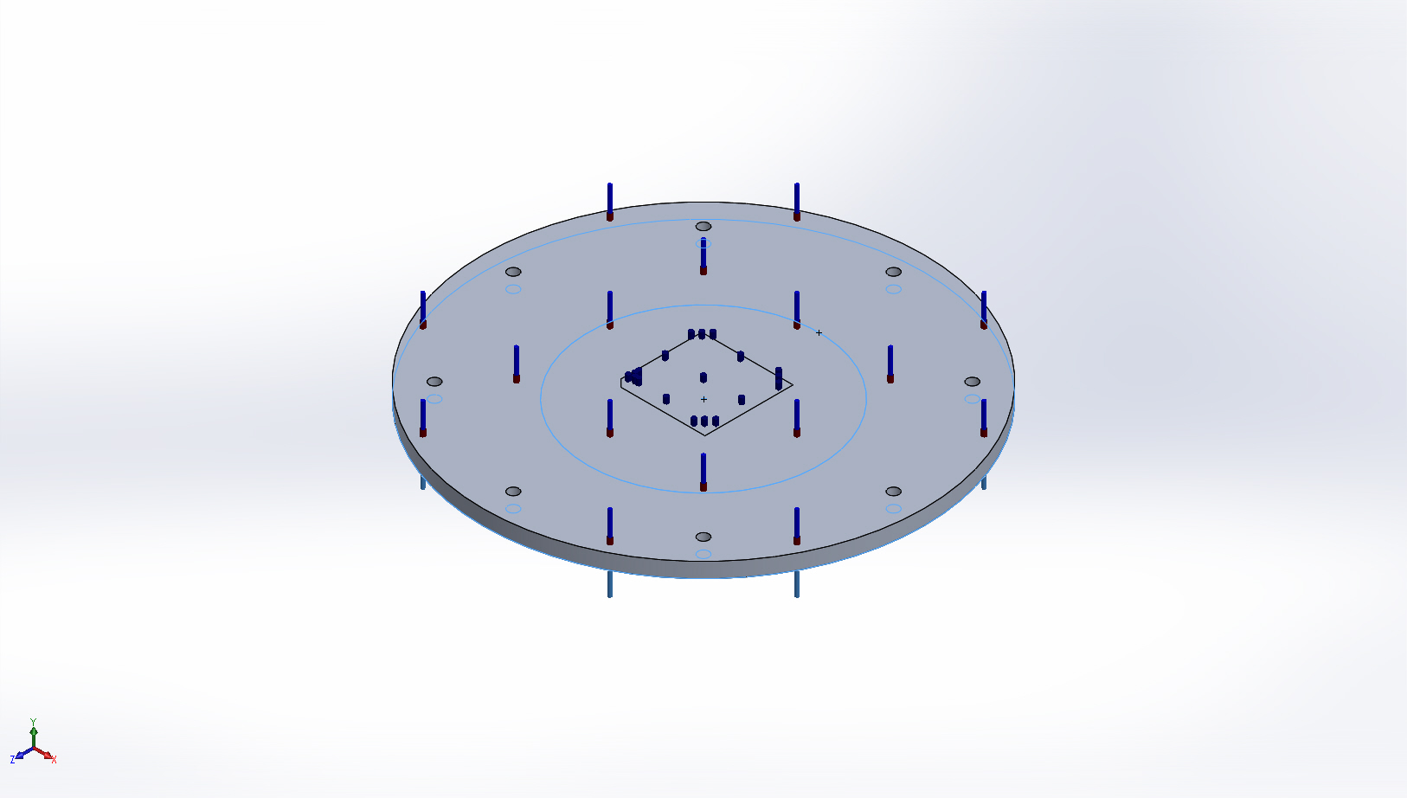
  Entities: | 2 face(s)
  Temperature: | 48 Fahrenheit

Contact Information
No Data

Mesh Information
Mesh type | Solid Mesh
Mesher Used: | Standard mesh
Automatic Transition: | Off
Include Mesh Auto Loops: | Off
Jacobian points | 4 Points
Element Size | 0.242379 in
Tolerance | 0.012119 in
Mesh Quality | High

Mesh Information - Details
Total Nodes | 35111
Total Elements | 20506
Maximum Aspect Ratio | 12.591
% of elements with Aspect Ratio < 3 | 99.8
% of elements with Aspect Ratio > 10 | 0.00488
% of distorted elements(Jacobian) | 0
Time to complete mesh(hh;mm;ss): | 00:00:04
Computer name: | ENIGMA
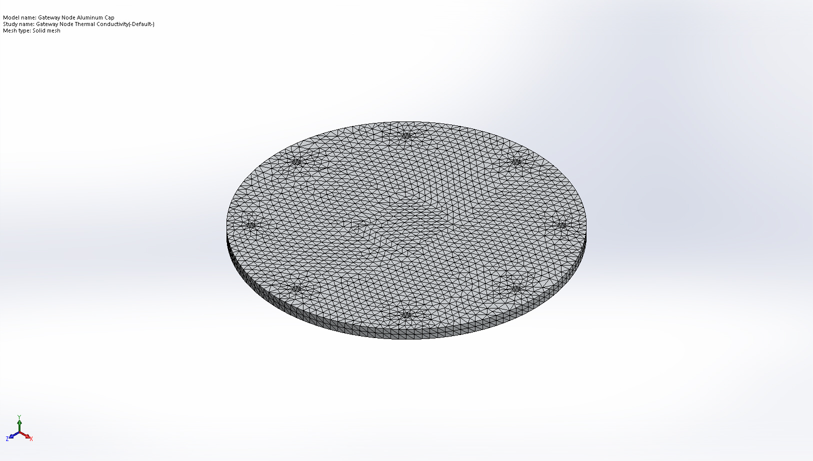

Sensor Details
No Data

Study Results

Name | Type | Min | Max
Thermal1 | TEMP: Temperature | 48 Fahrenheit  Node: 1 | 55.763 Fahrenheit  Node: 3239
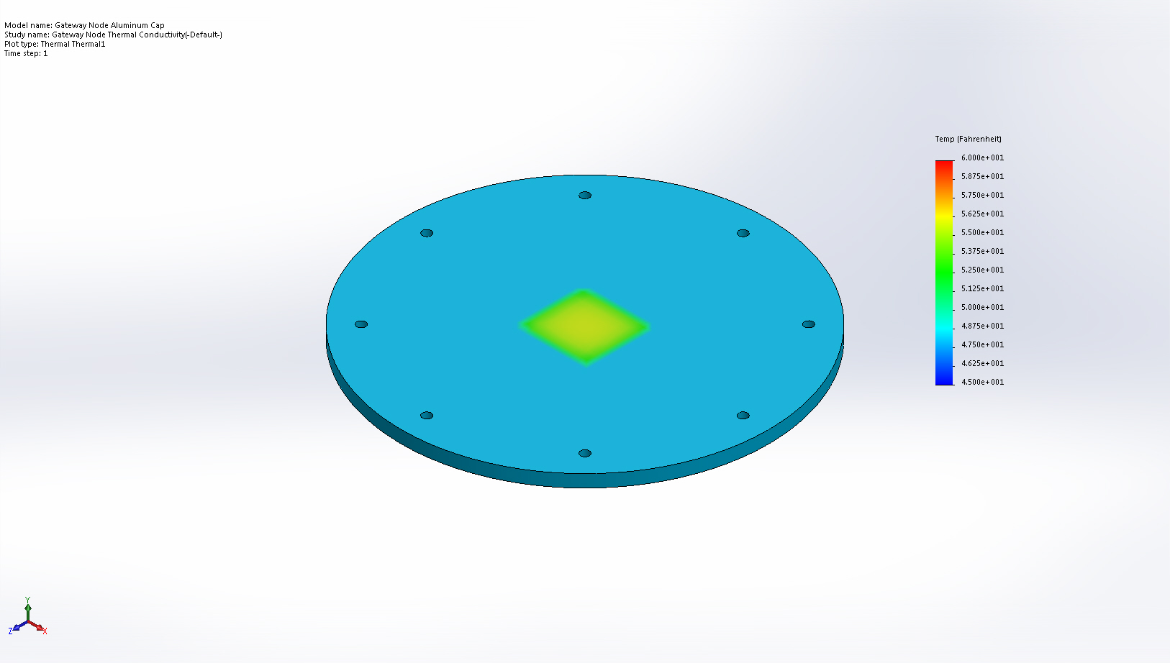
Gateway Node Aluminum Cap-Gateway Node Thermal Conductivity-Thermal-Thermal1

Conclusion

