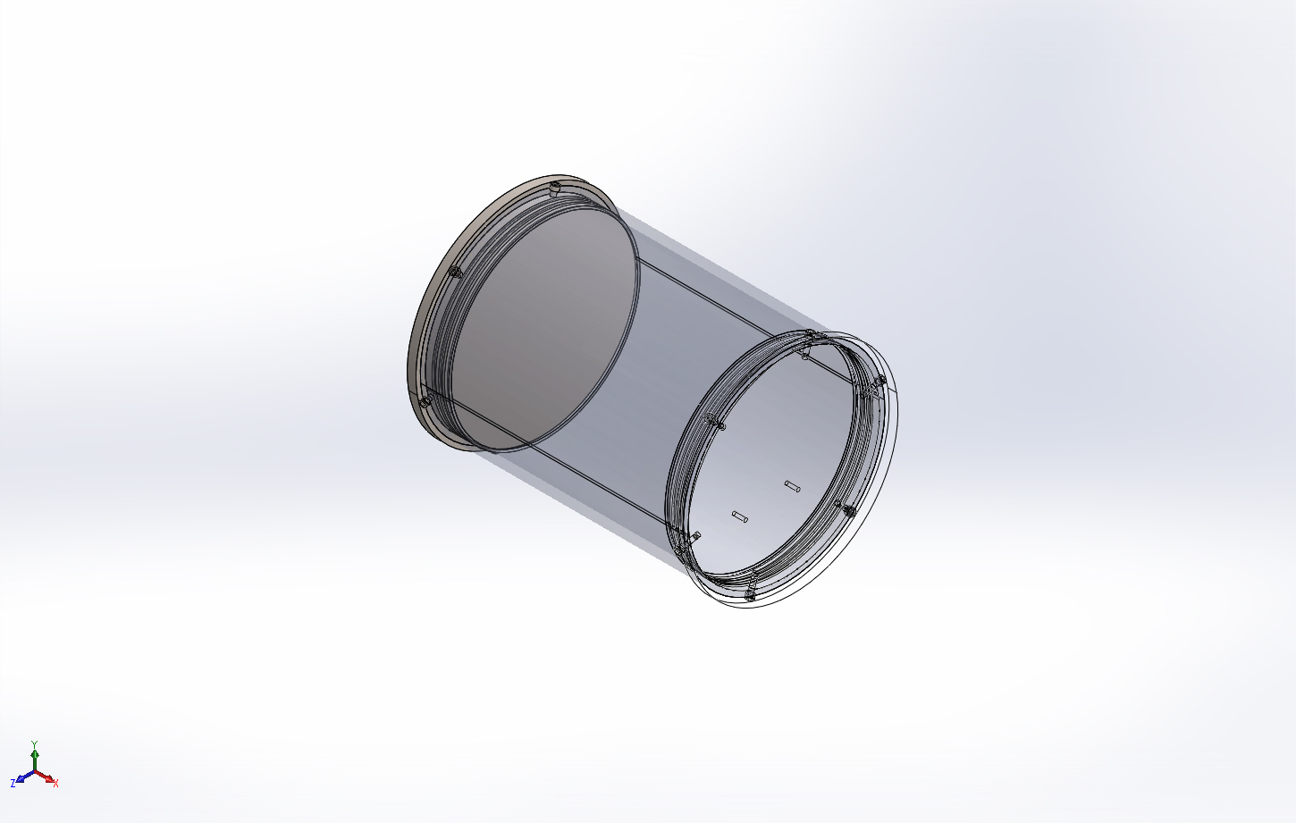
  Simulation of swFOCE Valve Manifold Assy
  Date: Tuesday, June 23, 2015
  Designer: F. Shane
  Study name: 22June2015 Valve Manifold Housing Static 1
  Analysis type: Static
  Table of Contents
  Description 1
  Assumptions 2
  Model Information 2
  Study Properties 6
  Units 6
  Material Properties 7
  Loads and Fixtures 8
  Connector Definitions 8
  Contact Information 9
  Mesh information 10
  Sensor Details 11
  Resultant Forces 12
  Beams 12
  Study Results 13
  Conclusion 16

Description
Static FEA for swFOCE
Valve Manifold Housing

Assumptions

Model Information

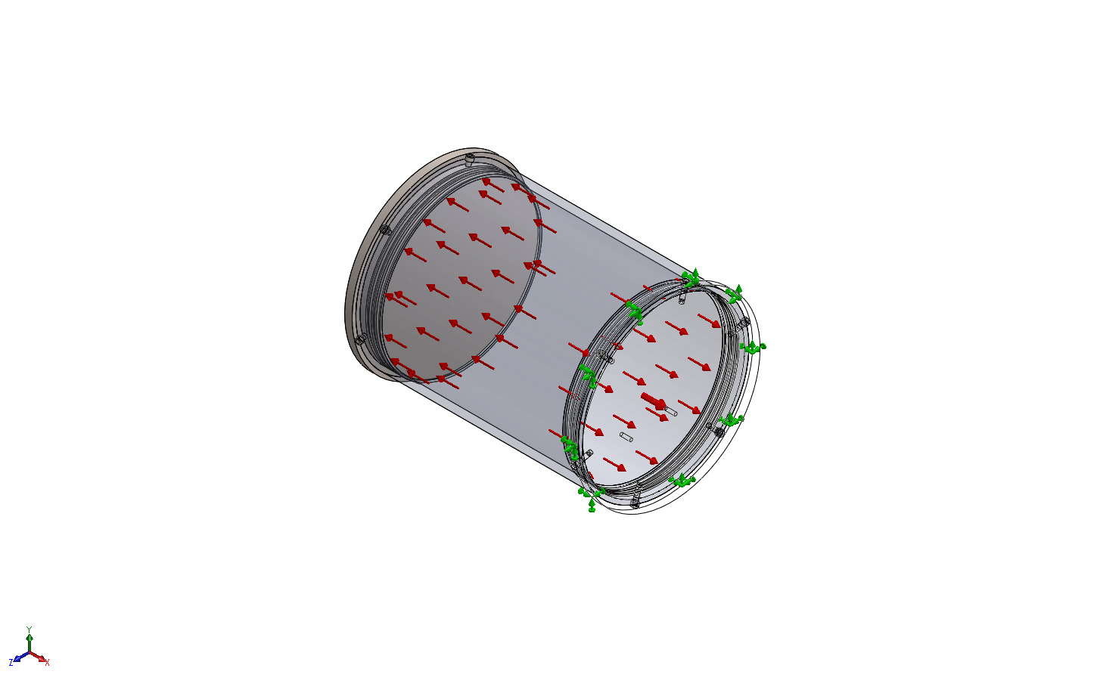
Model name: swFOCE Valve Manifold Assy
Current Configuration: Default
Solid Bodies
Document Name and Reference | Treated As | Volumetric Properties | Document Path/Date Modified
Cut-Extrude3  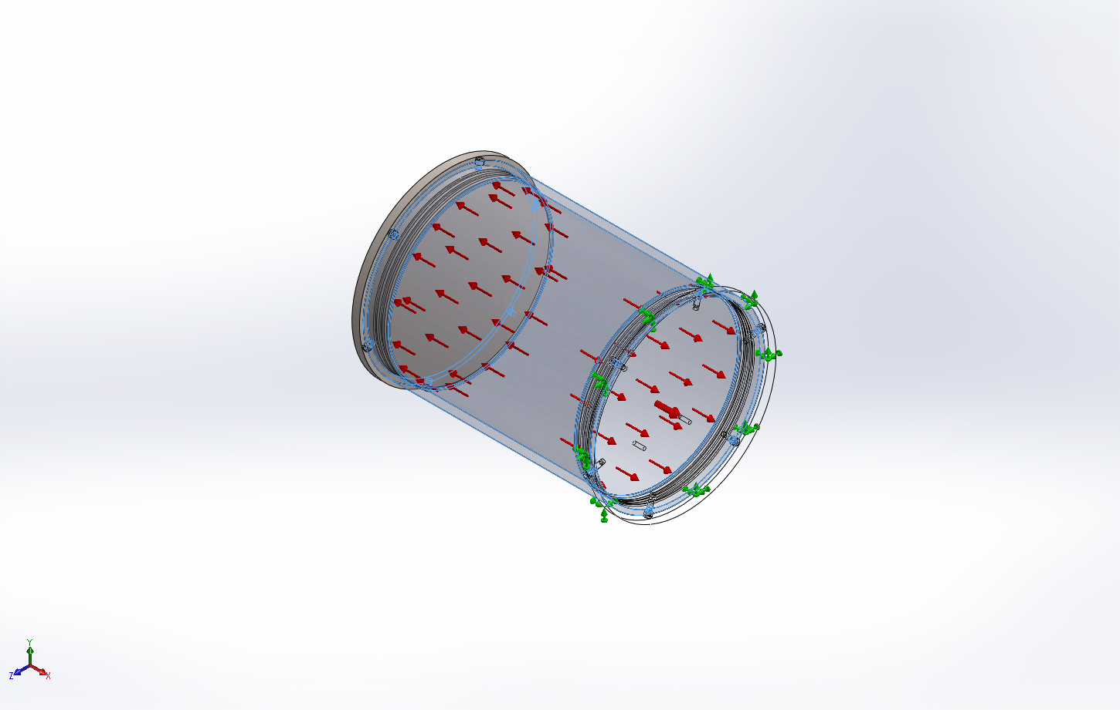 | Solid Body | Mass:11.6706 kg  Volume:0.00145883 m^3  Density:8000 kg/m^3  Weight:114.372 N | X:\901219.SW-FOCE\MECHANICAL\Valve Manifold\8 in. Sched. 40 Clear PVC Pipe.SLDPRT  Mar 23 14:57:33 2015
#10-24 Tapped Hole1  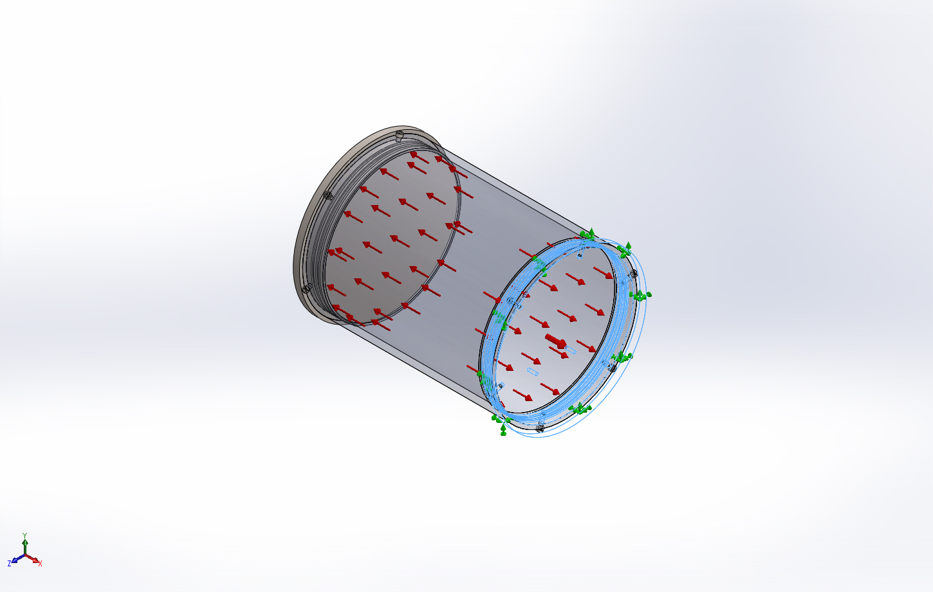 | Solid Body | Mass:9.06576 kg  Volume:0.00113322 m^3  Density:8000 kg/m^3  Weight:88.8444 N | X:\901219.SW-FOCE\MECHANICAL\Valve Manifold\Valve Manifold Circular Bottom Cap.SLDPRT  Feb 02 10:29:27 2015
Cut-Extrude2  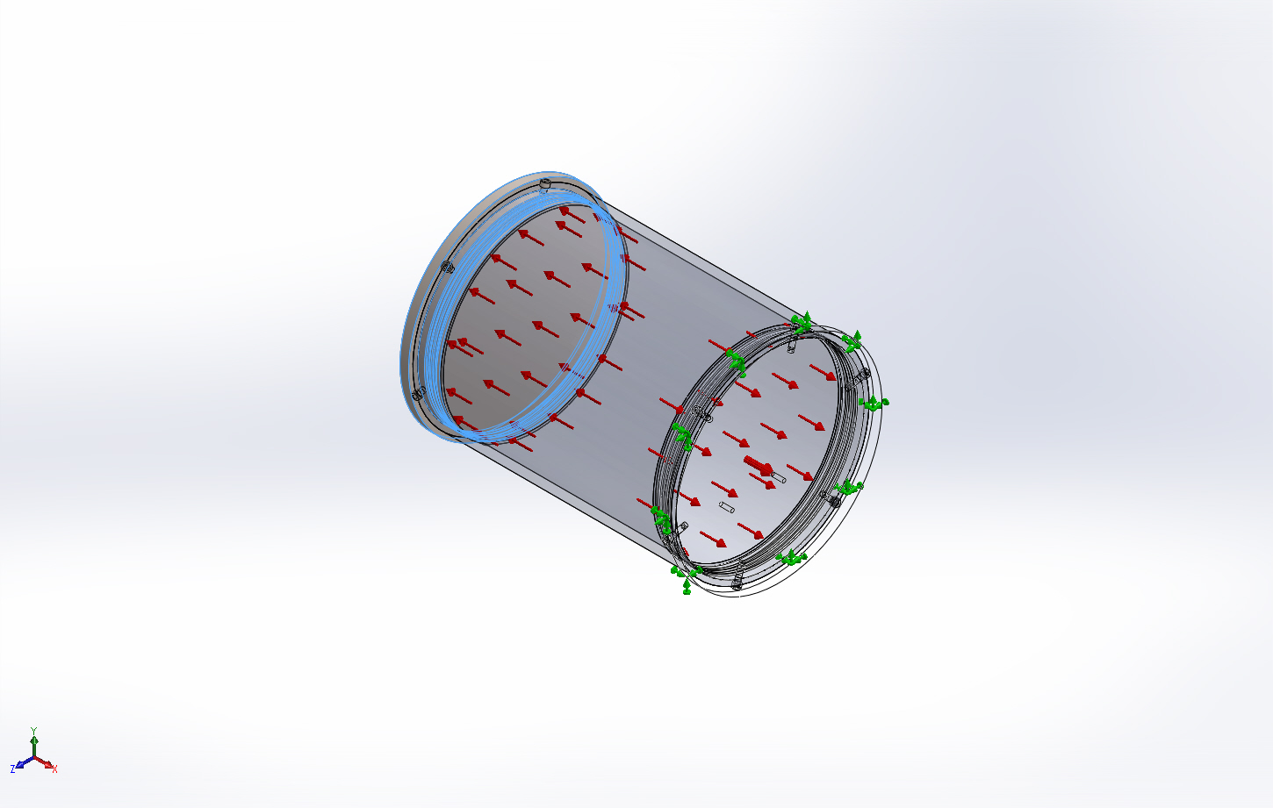 | Solid Body | Mass:9.07734 kg  Volume:0.00113467 m^3  Density:8000 kg/m^3  Weight:88.9579 N | X:\901219.SW-FOCE\MECHANICAL\Valve Manifold\Valve Manifold Circular Top Cap.SLDPRT  Mar 11 10:55:23 2015
Hex  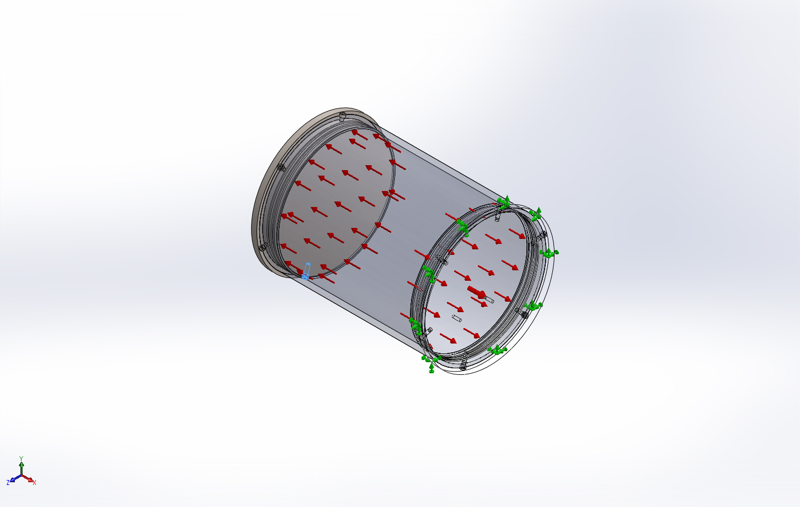 | Solid Body | Mass:0.00390524 kg  Volume:4.88154e-007 m^3  Density:8000 kg/m^3  Weight:0.0382713 N | C:\SOLIDWORKS Data (6)\browser\Ansi Inch\bolts and screws\socket head screws\socket head cap screw_ai.sldprt  Jun 17 15:05:22 2015
Hex  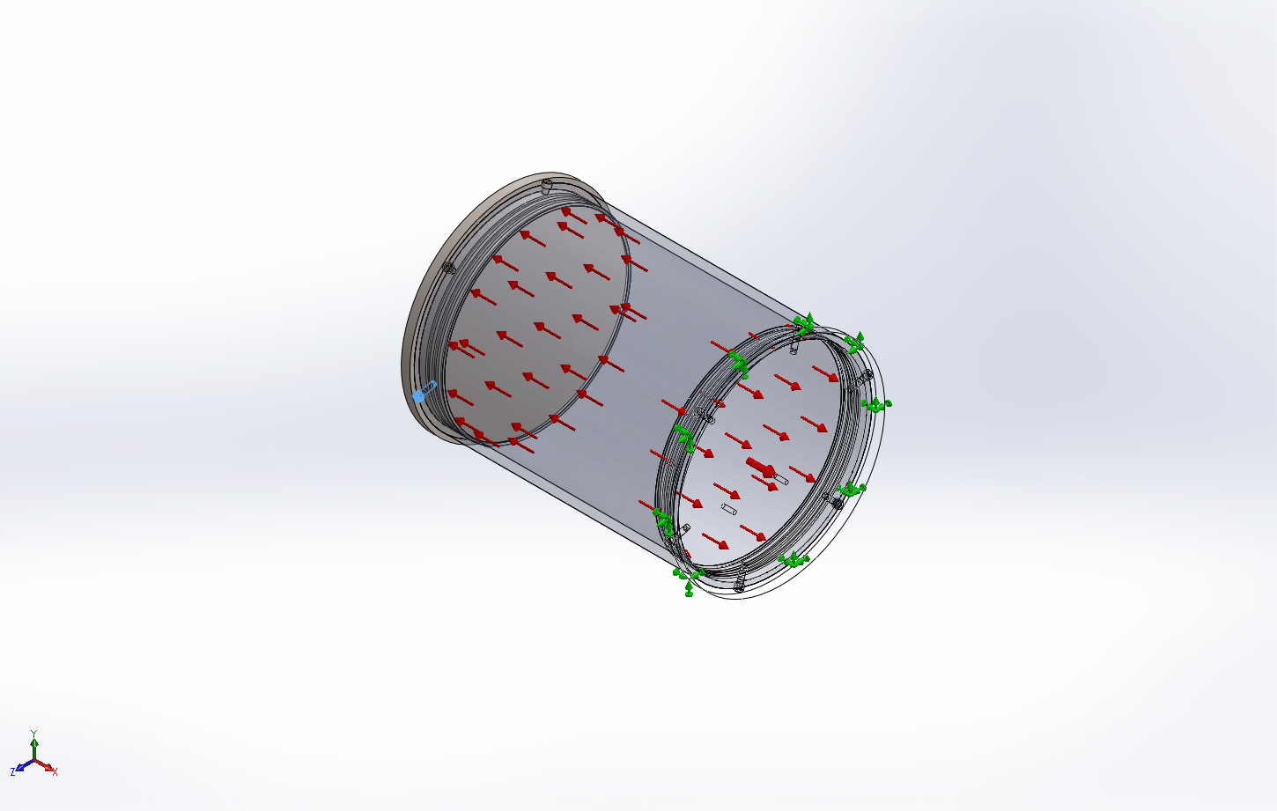 | Solid Body | Mass:0.00390524 kg  Volume:4.88154e-007 m^3  Density:8000 kg/m^3  Weight:0.0382713 N | C:\SOLIDWORKS Data (6)\browser\Ansi Inch\bolts and screws\socket head screws\socket head cap screw_ai.sldprt  Jun 17 15:05:22 2015
Hex  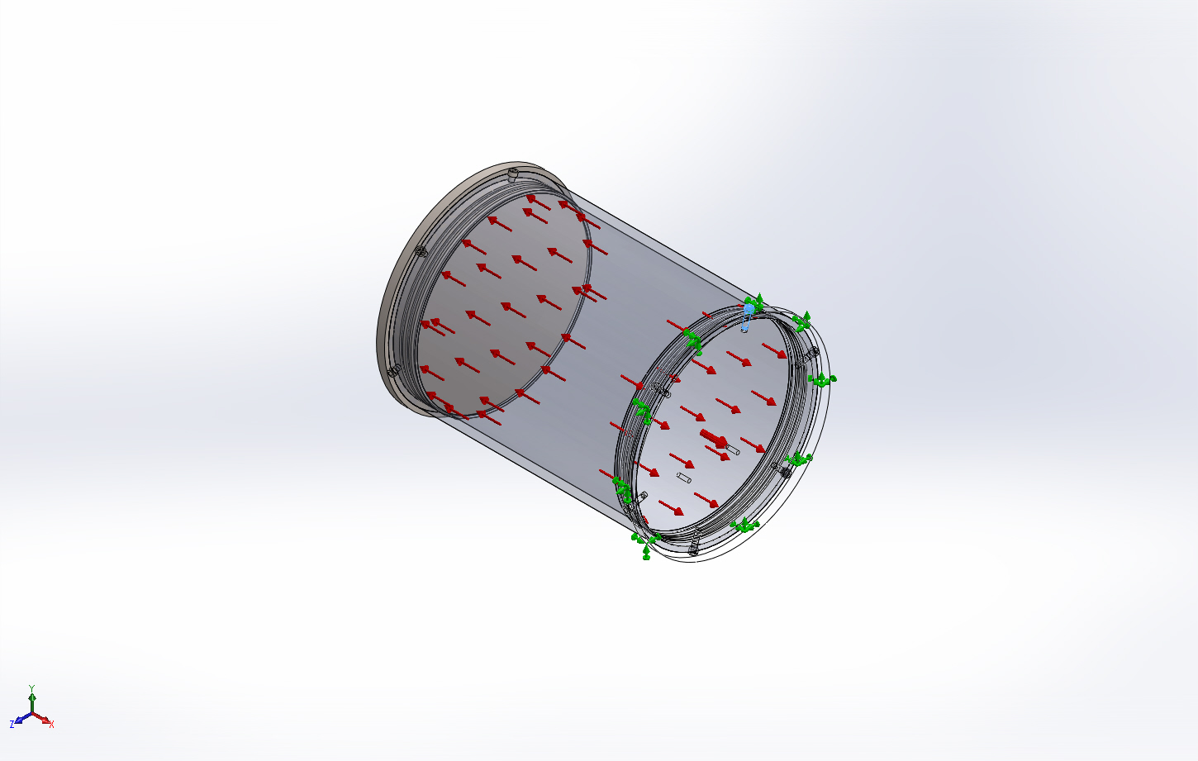 | Solid Body | Mass:0.00390524 kg  Volume:4.88154e-007 m^3  Density:8000 kg/m^3  Weight:0.0382713 N | C:\SOLIDWORKS Data (6)\browser\Ansi Inch\bolts and screws\socket head screws\socket head cap screw_ai.sldprt  Jun 17 15:05:22 2015
Hex  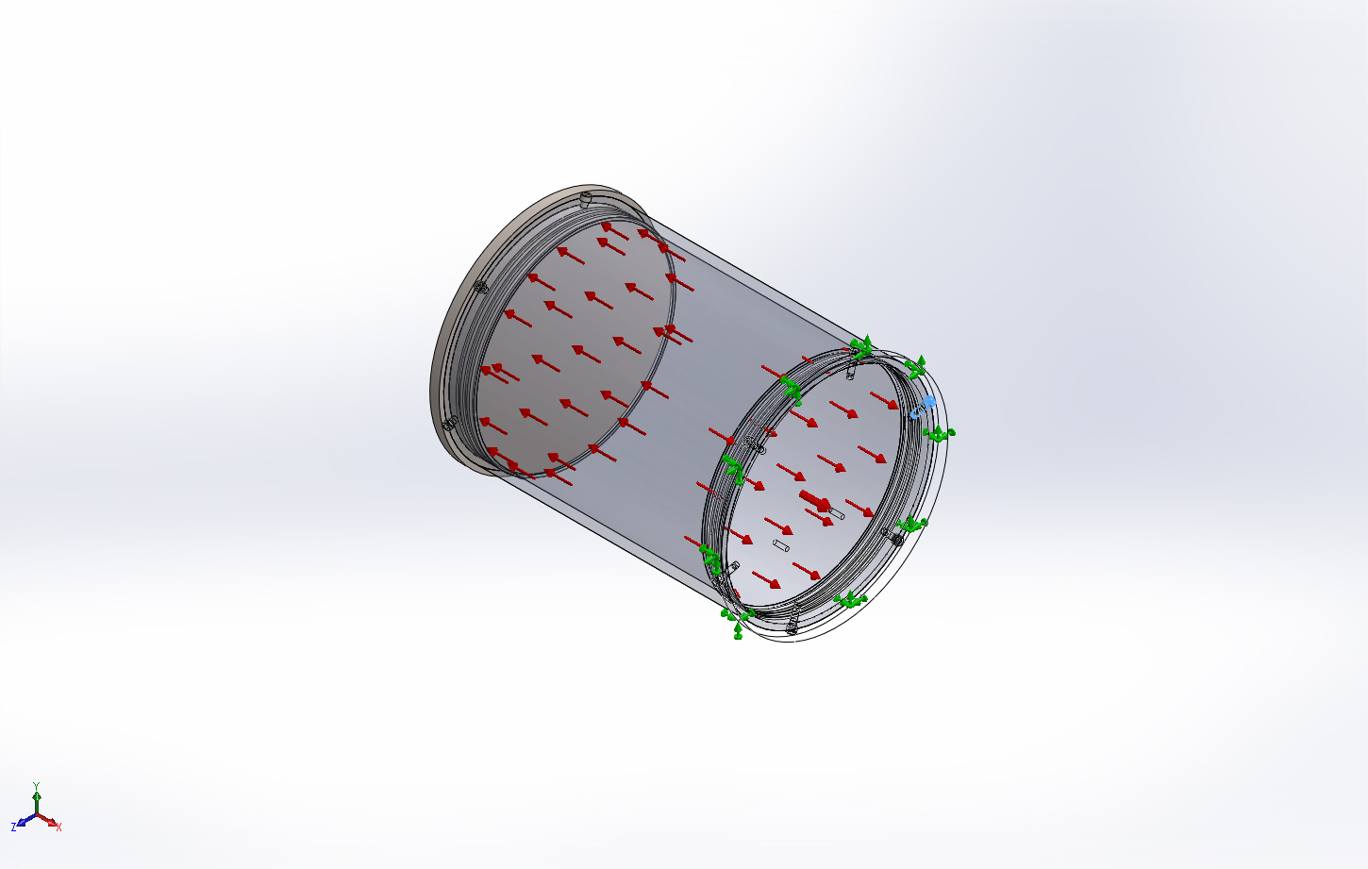 | Solid Body | Mass:0.00390524 kg  Volume:4.88154e-007 m^3  Density:8000 kg/m^3  Weight:0.0382713 N | C:\SOLIDWORKS Data (6)\browser\Ansi Inch\bolts and screws\socket head screws\socket head cap screw_ai.sldprt  Jun 17 15:05:22 2015
Hex  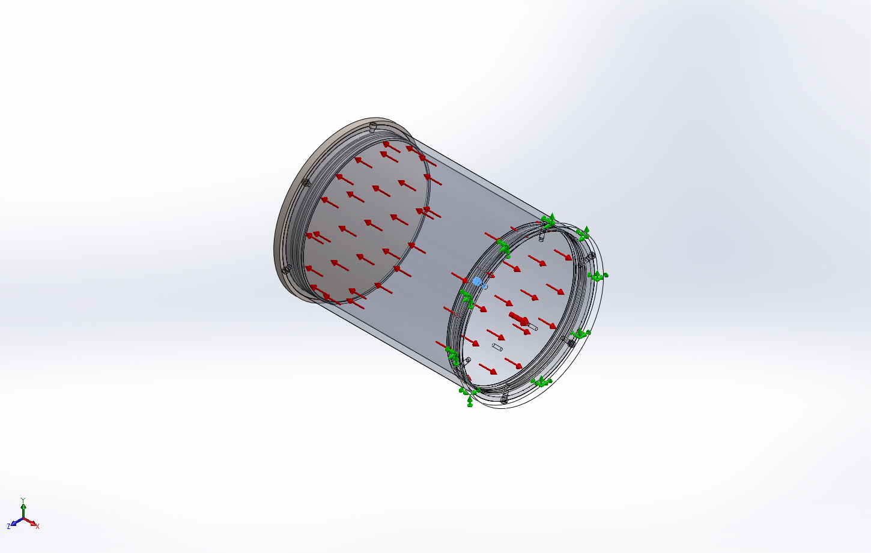 | Solid Body | Mass:0.00390524 kg  Volume:4.88154e-007 m^3  Density:8000 kg/m^3  Weight:0.0382713 N | C:\SOLIDWORKS Data (6)\browser\Ansi Inch\bolts and screws\socket head screws\socket head cap screw_ai.sldprt  Jun 17 15:05:22 2015
Hex  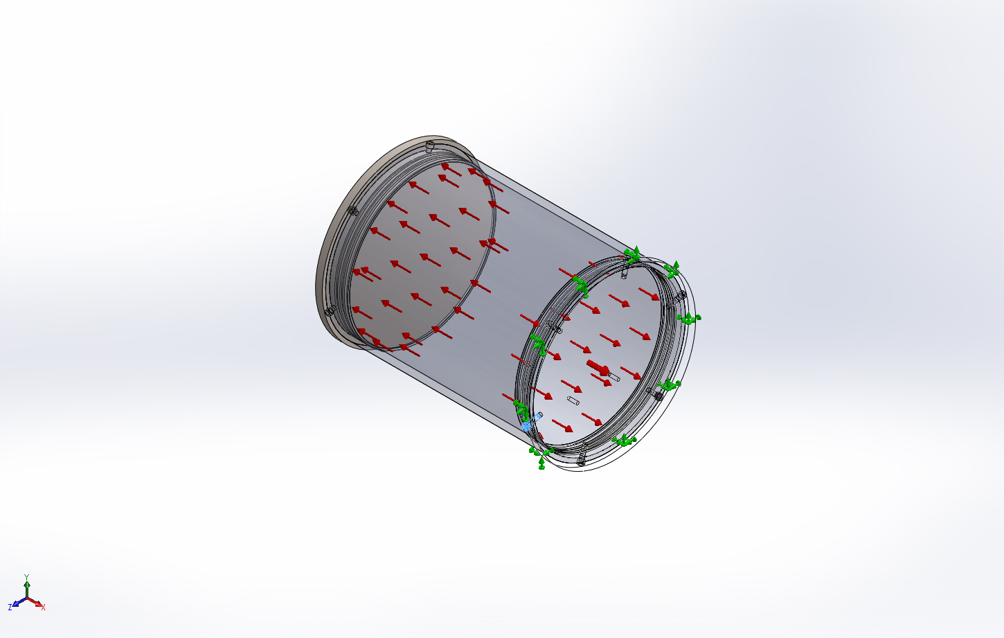 | Solid Body | Mass:0.00390524 kg  Volume:4.88154e-007 m^3  Density:8000 kg/m^3  Weight:0.0382713 N | C:\SOLIDWORKS Data (6)\browser\Ansi Inch\bolts and screws\socket head screws\socket head cap screw_ai.sldprt  Jun 17 15:05:22 2015
Hex  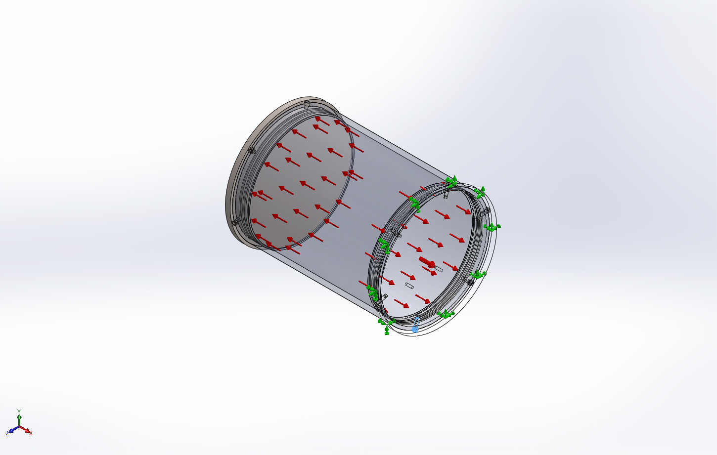 | Solid Body | Mass:0.00390524 kg  Volume:4.88154e-007 m^3  Density:8000 kg/m^3  Weight:0.0382713 N | C:\SOLIDWORKS Data (6)\browser\Ansi Inch\bolts and screws\socket head screws\socket head cap screw_ai.sldprt  Jun 17 15:05:22 2015
Hex  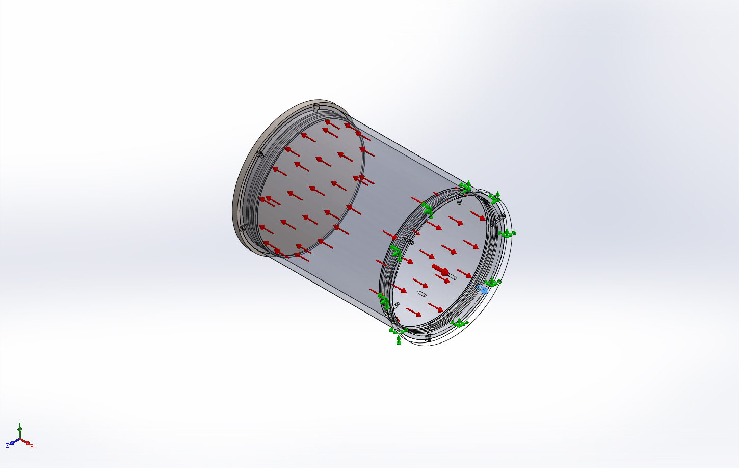 | Solid Body | Mass:0.00390524 kg  Volume:4.88154e-007 m^3  Density:8000 kg/m^3  Weight:0.0382713 N | C:\SOLIDWORKS Data (6)\browser\Ansi Inch\bolts and screws\socket head screws\socket head cap screw_ai.sldprt  Jun 17 15:05:22 2015
Hex  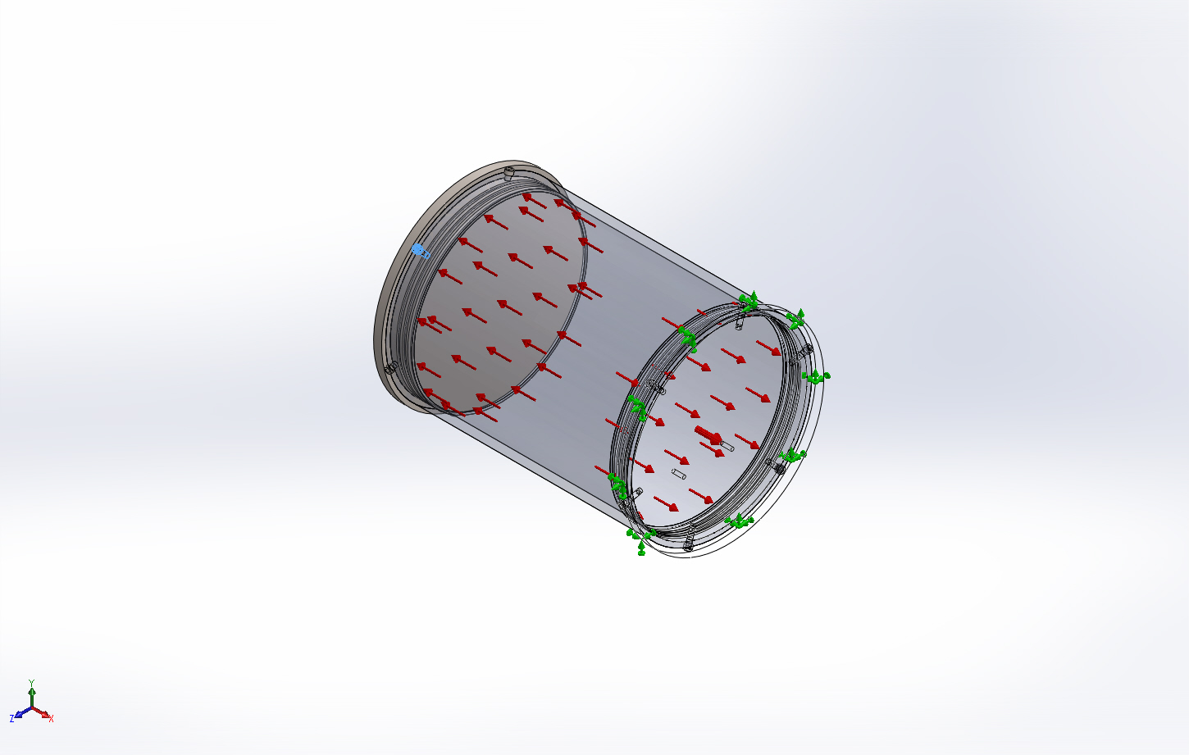 | Solid Body | Mass:0.00390524 kg  Volume:4.88154e-007 m^3  Density:8000 kg/m^3  Weight:0.0382713 N | C:\SOLIDWORKS Data (6)\browser\Ansi Inch\bolts and screws\socket head screws\socket head cap screw_ai.sldprt  Jun 17 15:05:22 2015
Hex  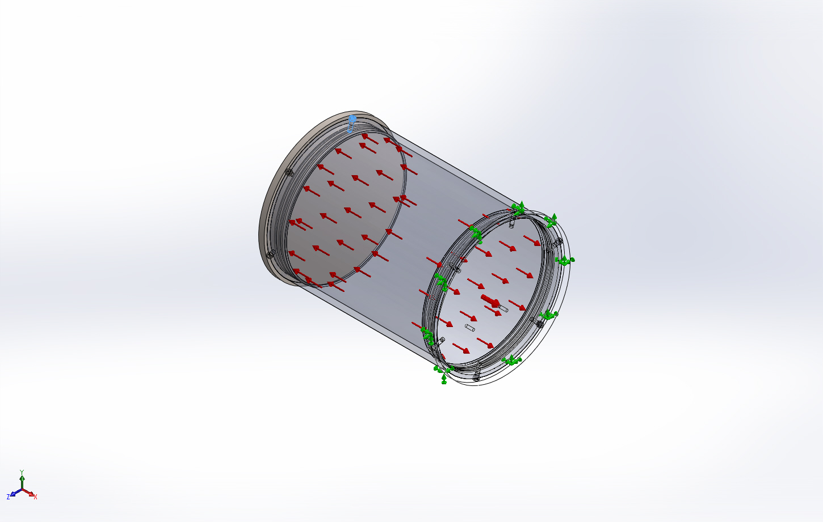 | Solid Body | Mass:0.00390524 kg  Volume:4.88154e-007 m^3  Density:8000 kg/m^3  Weight:0.0382713 N | C:\SOLIDWORKS Data (6)\browser\Ansi Inch\bolts and screws\socket head screws\socket head cap screw_ai.sldprt  Jun 17 15:05:22 2015
Hex  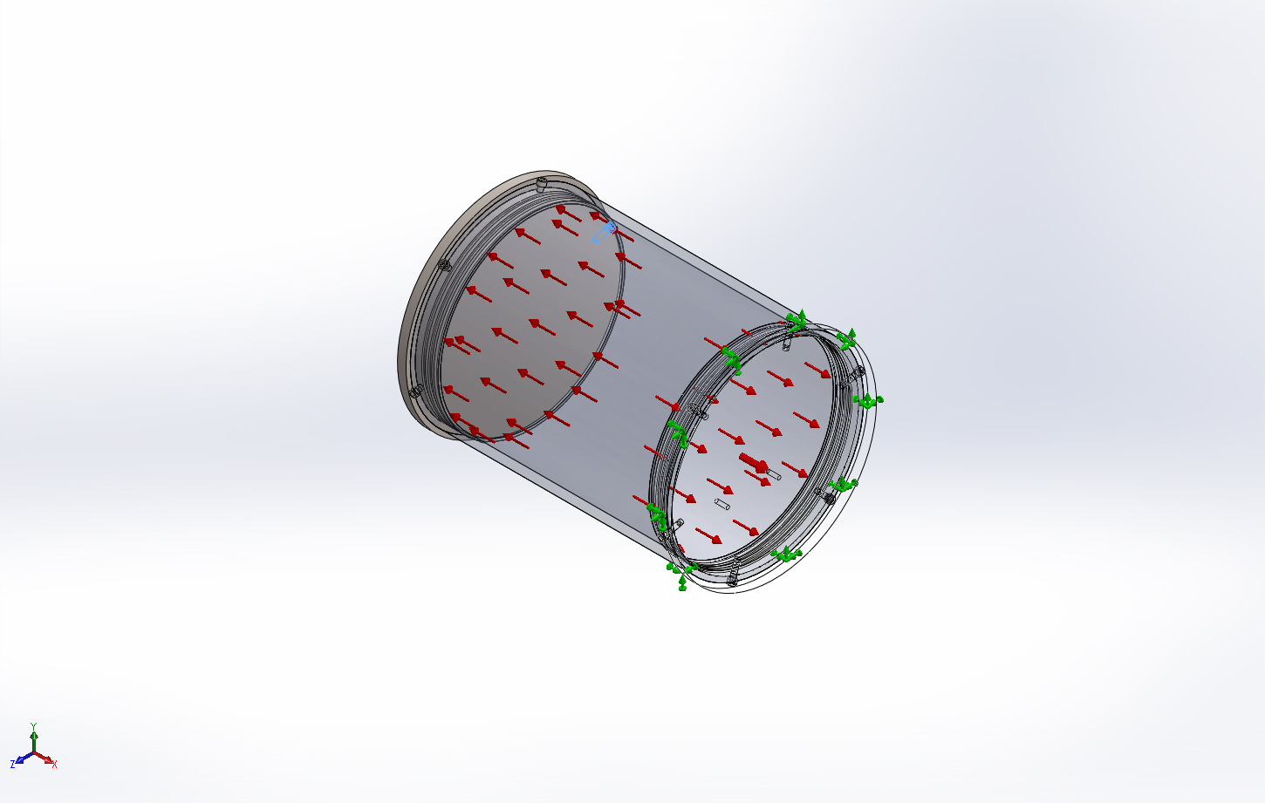 | Solid Body | Mass:0.00390524 kg  Volume:4.88154e-007 m^3  Density:8000 kg/m^3  Weight:0.0382713 N | C:\SOLIDWORKS Data (6)\browser\Ansi Inch\bolts and screws\socket head screws\socket head cap screw_ai.sldprt  Jun 17 15:05:22 2015
Hex  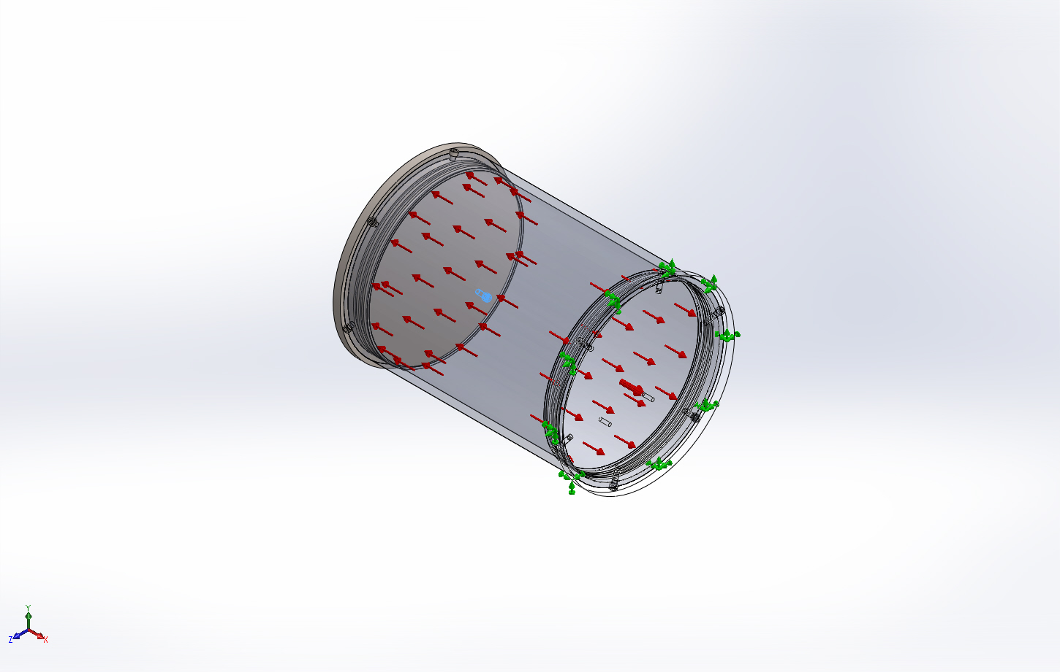 | Solid Body | Mass:0.00390524 kg  Volume:4.88154e-007 m^3  Density:8000 kg/m^3  Weight:0.0382713 N | C:\SOLIDWORKS Data (6)\browser\Ansi Inch\bolts and screws\socket head screws\socket head cap screw_ai.sldprt  Jun 17 15:05:22 2015

Study Properties
Study name | 22June2015 Valve Manifold Housing Static 1
Analysis type | Static
Mesh type | Solid Mesh
Thermal Effect: | On
Thermal option | Include temperature loads
Zero strain temperature | 298 Kelvin
Include fluid pressure effects from SOLIDWORKS Flow Simulation | Off
Solver type | Direct sparse solver
Inplane Effect: | Off
Soft Spring: | On
Inertial Relief: | Off
Incompatible bonding options | Automatic
Large displacement | Off
Compute free body forces | On
Friction | Off
Use Adaptive Method: | Off
Result folder | SOLIDWORKS document (X:\901219.SW-FOCE\MECHANICAL\Valve Manifold)

Units
Unit system: | SI (MKS)
Length/Displacement | mm
Temperature | Kelvin
Angular velocity | Rad/sec
Pressure/Stress | N/m^2

Material Properties
Model Reference | Properties | Components
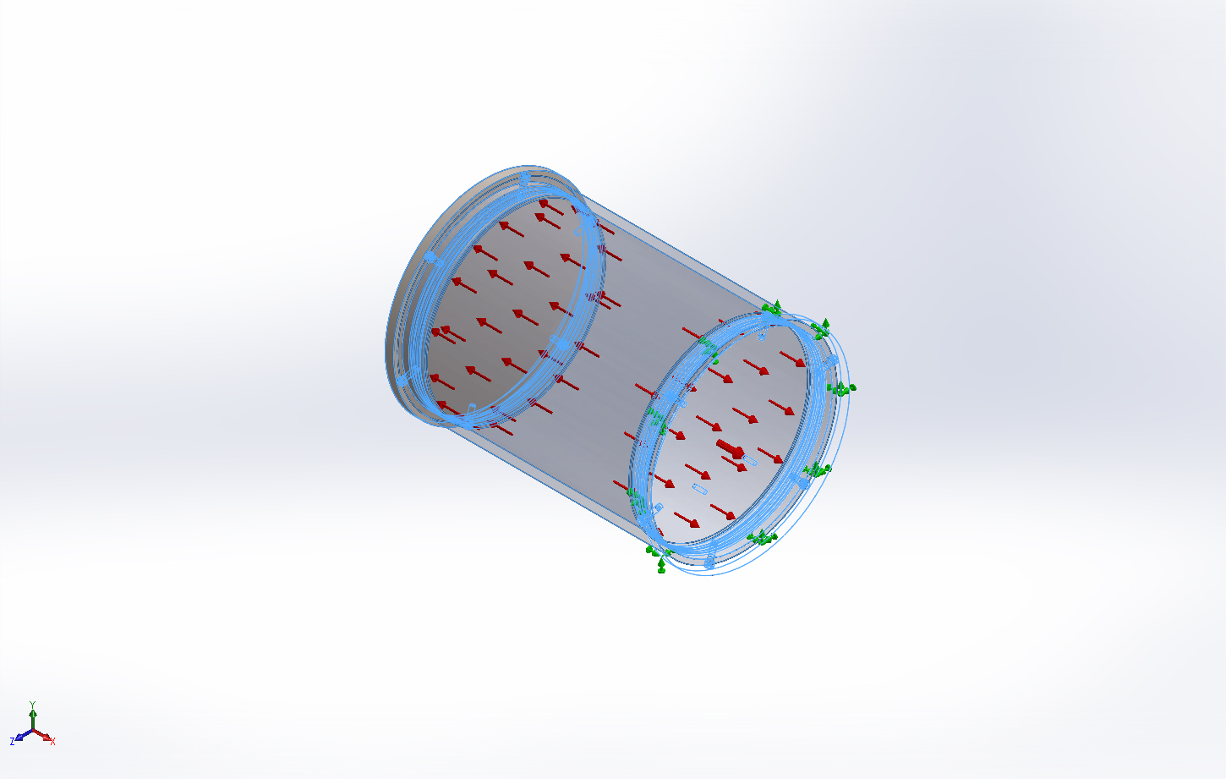 |  | SolidBody 1(Cut-Extrude3)(8 in. Sched. 40 Clear PVC Pipe-1),  SolidBody 1(#10-24 Tapped Hole1)(Valve Manifold Circular Bottom Cap-2),  SolidBody 1(Cut-Extrude2)(Valve Manifold Circular Top Cap-3),  SolidBody 1(Hex)(socket head cap screw_ai-10),  SolidBody 1(Hex)(socket head cap screw_ai-11),  SolidBody 1(Hex)(socket head cap screw_ai-40),  SolidBody 1(Hex)(socket head cap screw_ai-41),  SolidBody 1(Hex)(socket head cap screw_ai-42),  SolidBody 1(Hex)(socket head cap screw_ai-43),  SolidBody 1(Hex)(socket head cap screw_ai-44),  SolidBody 1(Hex)(socket head cap screw_ai-45),  SolidBody 1(Hex)(socket head cap screw_ai-5),  SolidBody 1(Hex)(socket head cap screw_ai-6),  SolidBody 1(Hex)(socket head cap screw_ai-7),  SolidBody 1(Hex)(socket head cap screw_ai-8)
  Name: | AISI 316 Annealed Stainless Steel Bar (SS)
  Model type: | Linear Elastic Isotropic
  Default failure criterion: | Max von Mises Stress
  Yield strength: | 1.37895e+008 N/m^2
  Tensile strength: | 5.5e+008 N/m^2
  Elastic modulus: | 1.93e+011 N/m^2
  Poisson's ratio: | 0.3
  Mass density: | 8000 kg/m^3
  Thermal expansion coefficient: | 1.6e-005 /Kelvin
Curve Data:N/A

Loads and Fixtures
Fixture name | Fixture Image | Fixture Details
Fixed-1 | 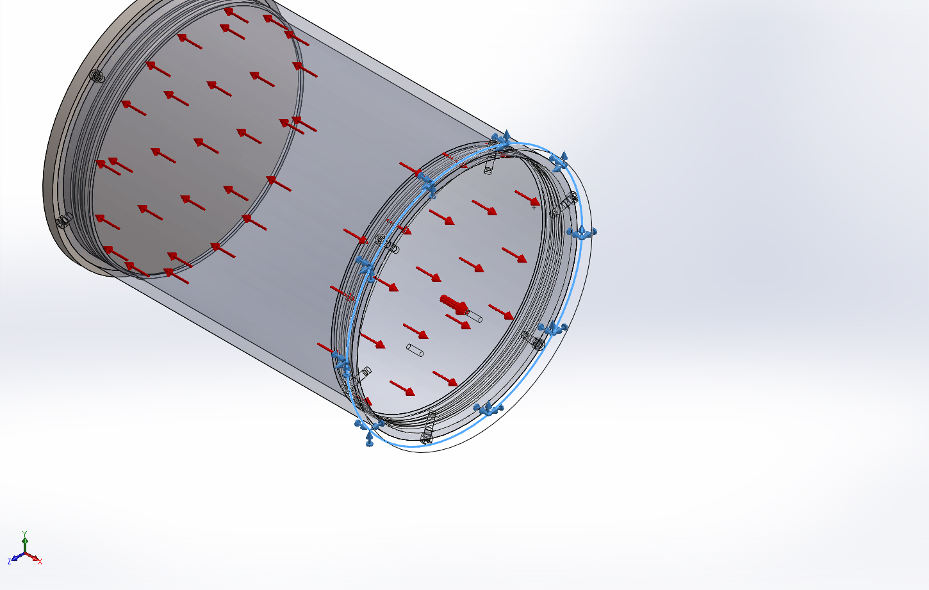
  Entities: | 1 edge(s)
  Type: | Fixed Geometry
Resultant Forces
Components | X | Y | Z | Resultant
Reaction force(N) | 1.56092 | 4.3869e-005 | -2.57492e-005 | 1.56092
Reaction Moment(N.m) | 0 | 0 | 0 | 0

Load name | Load Image | Load Details
Pressure-1 | 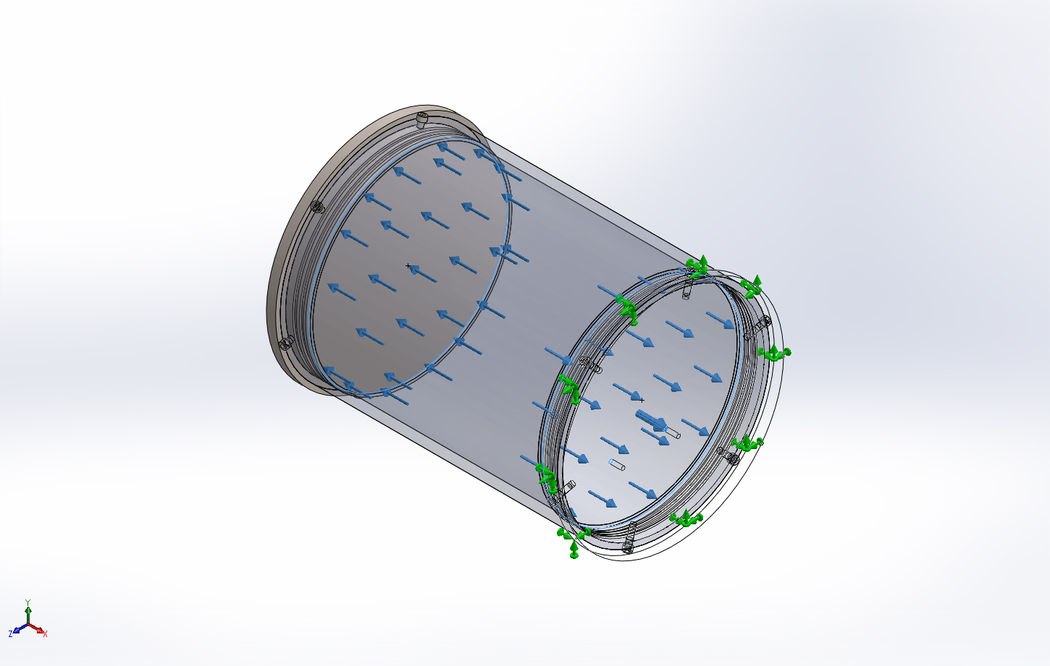
  Entities: | 2 face(s)
  Type: | Normal to selected face
  Value: | 10
  Units: | psi
  Phase Angle: | 0
  Units: | deg

Connector Definitions
No Data

Contact Information

Contact | Contact Image | Contact Properties
Global Contact | 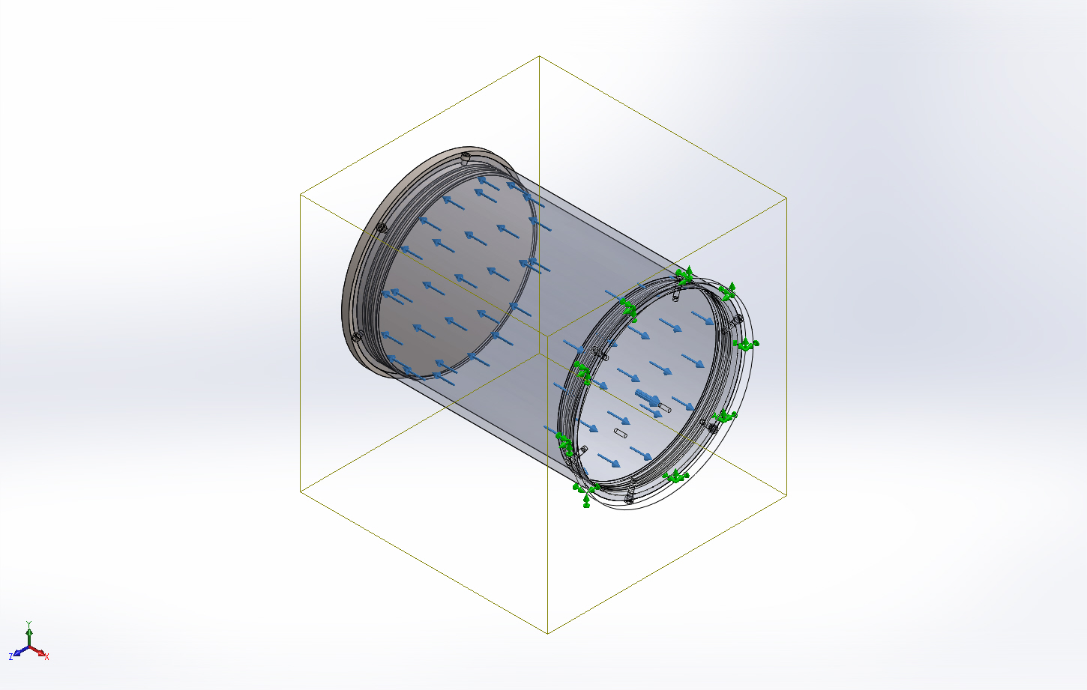
  Type: | Bonded
  Components: | 1 component(s)
  Options: | Incompatible mesh
Component Contact-1 | 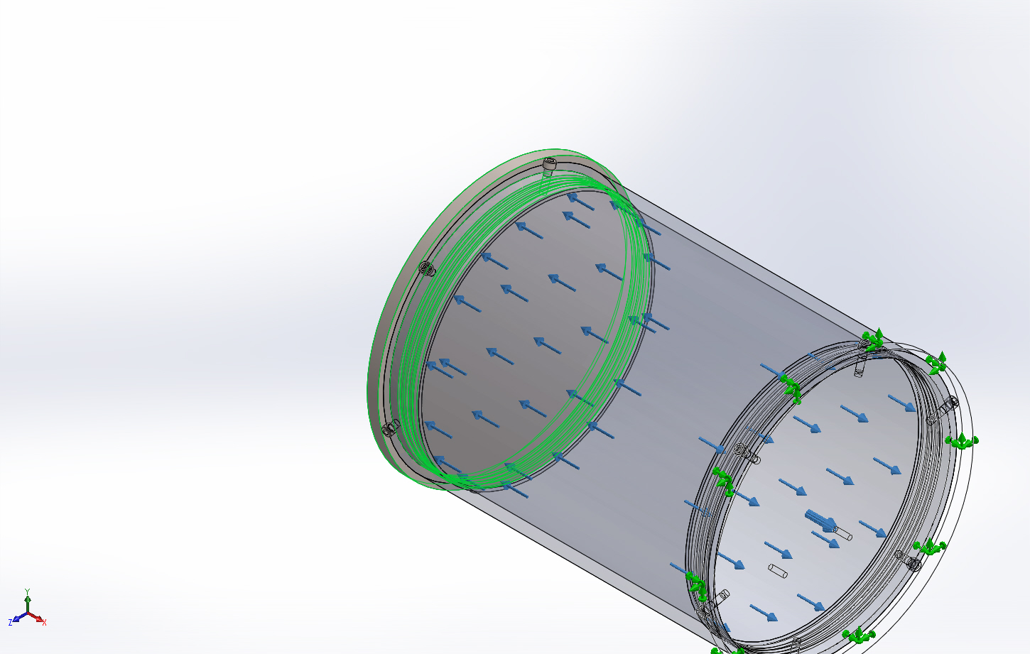
  Type: | Bonded
  Components: | 1 Solid Body (s)
  Options: | Incompatible mesh

Mesh information
Mesh type | Solid Mesh
Mesher Used: | Standard mesh
Automatic Transition: | Off
Include Mesh Auto Loops: | Off
Jacobian points | 4 Points
Element Size | 0.25 in
Tolerance | 0.0125 in
Mesh Quality | High
Remesh failed parts with incompatible mesh | Off

Mesh information - Details
Total Nodes | 216548
Total Elements | 134680
Maximum Aspect Ratio | 13.805
% of elements with Aspect Ratio < 3 | 96.5
% of elements with Aspect Ratio > 10 | 0.00371
% of distorted elements(Jacobian) | 0
Time to complete mesh(hh;mm;ss): | 00:00:43
Computer name: | ENIGMA
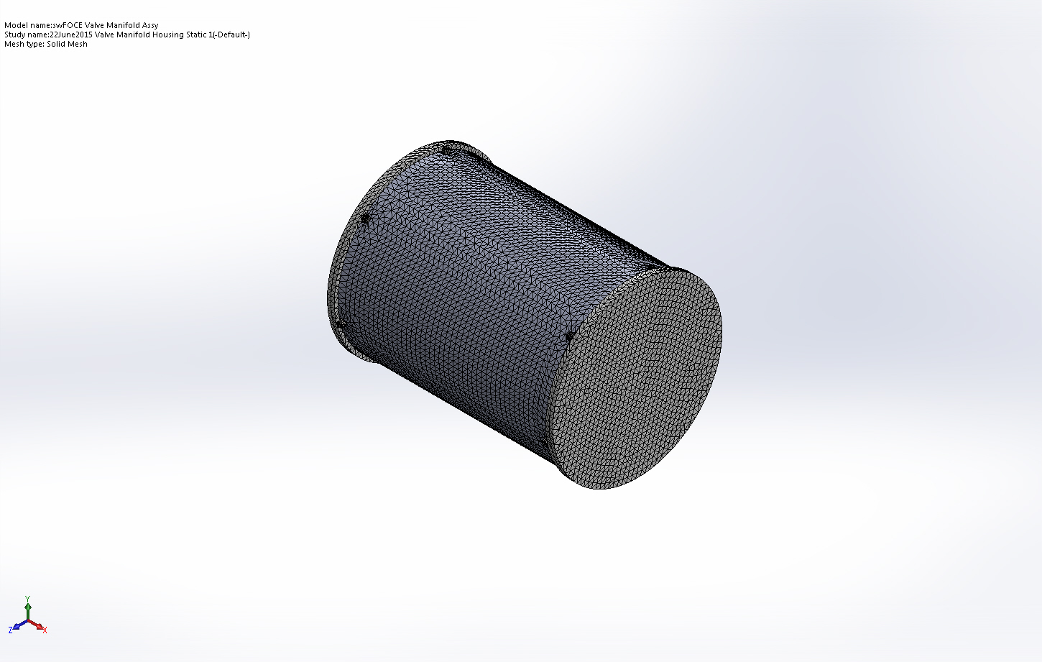

Sensor Details
No Data

Resultant Forces

Reaction forces
Selection set | Units | Sum X | Sum Y | Sum Z | Resultant
Entire Model | N | 1.56092 | 4.3869e-005 | -2.57492e-005 | 1.56092

Reaction Moments
Selection set | Units | Sum X | Sum Y | Sum Z | Resultant
Entire Model | N.m | 0 | 0 | 0 | 0

Beams
No Data

Study Results

Name | Type | Min | Max
Stress1 | VON: von Mises Stress | 0 psi  Node: 206823 | 375.369 psi  Node: 88576
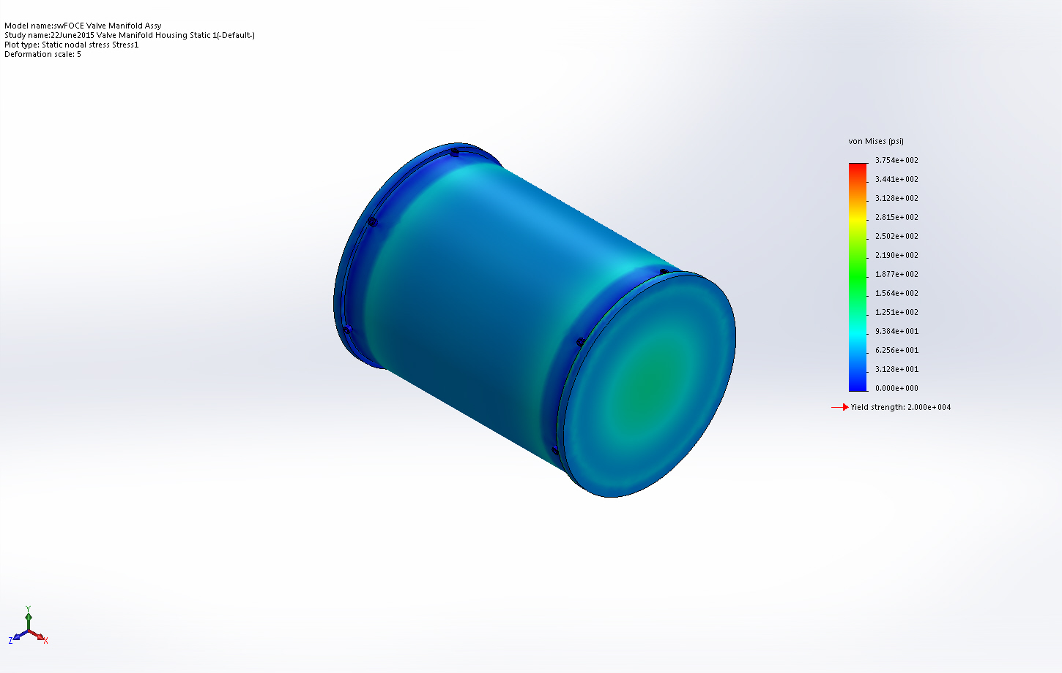
swFOCE Valve Manifold Assy-22June2015 Valve Manifold Housing Static 1-Stress-Stress1

Name | Type | Min | Max
Displacement1 | URES: Resultant Displacement | 0 in  Node: 89478 | 6.41991e-005 in  Node: 172887
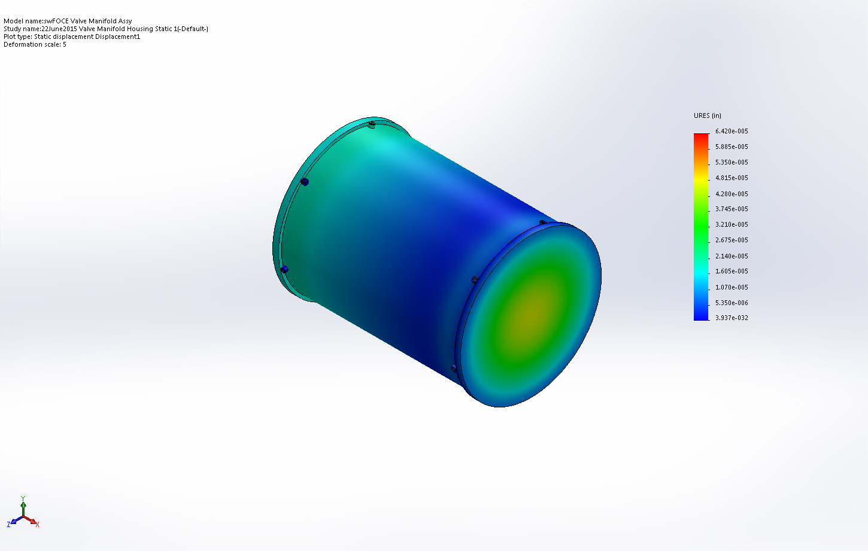
swFOCE Valve Manifold Assy-22June2015 Valve Manifold Housing Static 1-Displacement-Displacement1

Name | Type | Min | Max
Strain1 | ESTRN: Equivalent Strain | 0  Element: 129521 | 6.91654e-006  Element: 16449
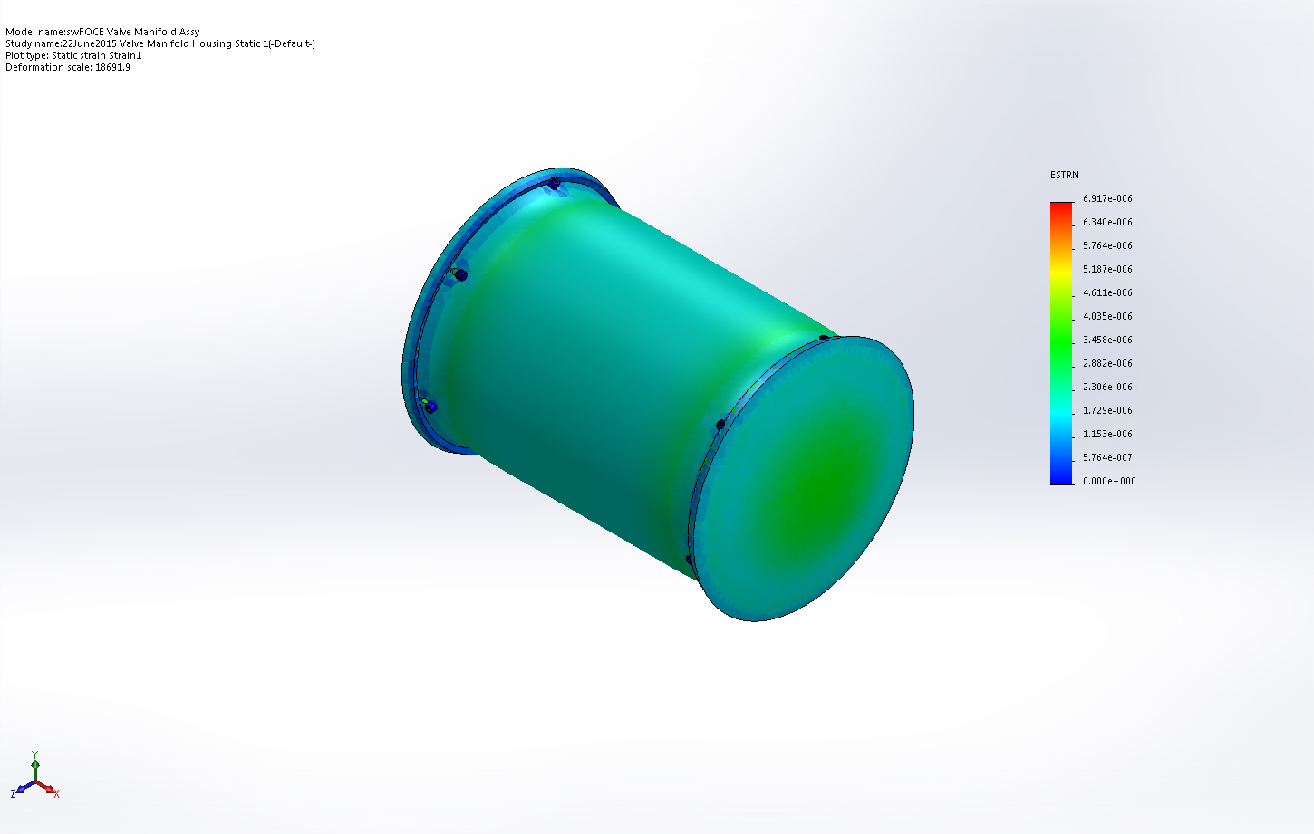
swFOCE Valve Manifold Assy-22June2015 Valve Manifold Housing Static 1-Strain-Strain1

Name | Type
Displacement1{1} | URES: Resultant Displacement
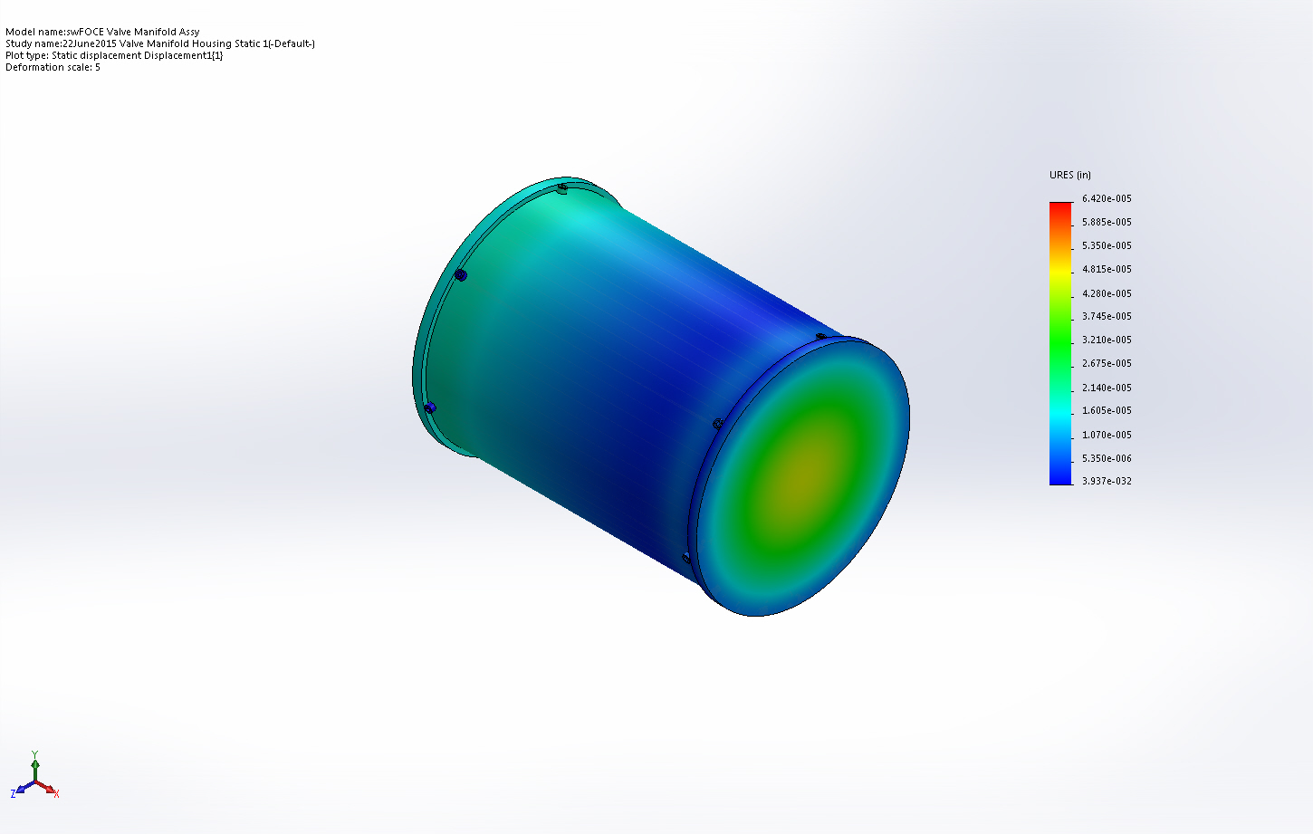
swFOCE Valve Manifold Assy-22June2015 Valve Manifold Housing Static 1-Displacement-Displacement1{1}

Conclusion

