Notes on Setup and Testing of the Medium Voltage Converter Board

Project: SW-FOCE – Project 901219
Revision – 1.1
Date: 4/22/2015

The Medium Voltage Converter Board is part of the FOCE Central Node – see \\ProjectLibrary\901219.SW-FOCE\Electrical\SystemLevel\Schematics\System Level Power Distribution.pdf and Networking.pdf
It is upstream from any gateway node, and so is intended to be controlled from shore, most likely from kelpbed, the Linux computer at the pump house. Its control interface, then, is not a serial port but a Lantronix Matchport NR, which is a dual ethernet-to-serial device. This device interfaces to the on-board PIC via two serial ports.

Setup and Connections
All board orientations referenced in this document are with the board oriented so the ethernet and serial connectors at the top, and the big 450V electrolytic capacitor is at the bottom right-hand coner.

Power
In situ, the board is powered via a 375-to-24 volt Vicor which is external to the board. In the lab, you can directly power the board with a 24VDC (9-36 accepted) power supply. Connect the power to J24, which is at the top left-hand side.

Ethernet, Serial, PIC ICSP
The Ethernet (J31) and debug serial (J29) ports are at the top center of the board. The debug serial port is RS-232 at 9600N81.
If you need to reprogram the firmware, the PIC ICSP port is J26, a 6-pin connector at the top right-hand side of the board. Normally, the blue wire from the ICD is at the top corner of the connector.

MatchPort Setup
With the Ethernet, serial, and power cables attached, apply 24VDC to the board. You should see the config/debug menu on the serial port (see below). But first, you need to set up the MatchPort. If you haven’t previously set up the MatchPort, it will default to DHCP. To find it, you need to load the MatchPort DeviceInstall software onto your PC. There is a copy in this directory, under dox/MatchPort/DeviceInstaller/setup.exe. Install it. When you then run it, it will search for all Lantronix devices on your local subnet – it may take several seconds. Look for the “MatchPort NR” entry with a “Hardware Address” that matches the MAC address printed on the MatchPort (the six hex numbers separated by hyphens).
Once you know the IP address, you can use any web browser to browse to that address. When it asks for User Name and Password, just hit return, and it should let you into the Configuration Manager page.
The left-hand side of that page contains several links for various configuration options. You only need 3: Network, Channel 1 Serial Settings, and Channel 2 Serial Settings.
The Network page should look familiar to anyone who has configured a network device. Normally, you would set it up as a static address (“Use the following IP configuration”), as follows:
IP Address | 134.89.91.7
Subnet Mask | 255.255.255.0
Default Gateway | 134.89.91.1
DNS Server | 134.89.10.10

The Channel 1 Serial Settings should look like this:
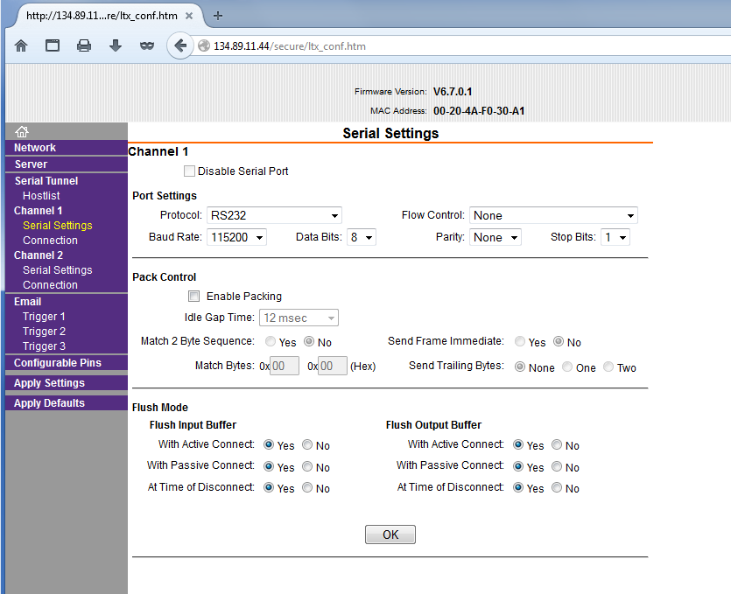
The Channel 2 Serial Settings should look the same, except the Baud Rate should be 9600.

Testing
The MV Converter Board has 3 serial ports: 2 via the MatchPort, and one direct serial connection at J29. These serial ports are used as follows:
Serial Port | MatchPort TCP Port | PIC Serial Port | Used for:
MatchPort Channel 1 | 10001 | 1 | Modbus port
MatchPort Channel 2 | 10002 | 2 | Alternate config/debug port
Native at J29 |  | 3 | Config/debug port

In order to control the MV Converter from a host computer, you need some software on that computer that can map an IP Address : IP port to a serial port. For Windows, it’s probably best to use the Lantronix Com Port Redirector, available from the Lantronix web site or on MBARI’s Project Library FOCE directory under Software/Lantronix. On Linux, socat is a useful port mapping tool.
For configuration and debugging, you can connect to either config/debug port. For the main debug port, connect to a spare serial port on your host and use a terminal emulator such as Hyperterminal, minicom, etc.
For the alternate debug port, you can use telnet, PuTTY, or on a Windows machine, you can use Hyperterminal configured for TCP/IP. In any case, you’ll want to connect to
134.89.91.7 port 10002 - or whatever IP address you have configured into the board.
When connected to either debug port, you should see something that looks like this:
Medium Voltage Converter SW Rev 1.05 Apr 22 2015, 10:05:06
Type ? for menu
SLAVE ID: 1
BAUD RATE: 115200
BLINKY DEBUG: ON
RESET POWER: 0x00 ( None )
GF CTRL: 0x00
SERIAL NUM: 1
0 - Save config changes and reset
1 - Show build date and config
2 - Set Slave ID
3 - Set Modbus baudrate
4 - Set blinky debug state
5 - Set power reset state
6 - Set board serial number
7 - Set default GF channels sampled
D - Debug Menu

Debugging and Calibration

Modes of Operation
It’s useful to know that the MV Converter board has two modes of operation:
- Configuration and debug mode
- Operation Mode
It comes up in config/debug mode. It is only in this mode that the config/debug port is active. The board stays in config/debug mode until it receives the first valid Modbus message on the Modbus port, at which point it goes into operational mode. When in operational mode, the config/debug ports are inactive and will not respond to input. There are two ways to get back to config/debug mode:
- Board reset or power cycle
- Set Modbus coil #9. This can be done from the mvTest program via command “cm”, which was chosen to denote “configuration mode”
When in config mode, the board is responsive to Modbus input, at which point it will go into operational mode. The exception is when it’s in the Debug menu, reachable via the D menu option above. This was an intentional design choice, as the debug menu allows you to control and calibrate individual ground fault channels. This would conflict with operational mode, which does ground fault scanning in the background.

mvTest Program
The mvTest program is available in directory Software/MVConv/mvLib/test in ProjectLibrary. It allows you to test various board functions by sending Modbus messages to the board to invoke those functions: turning on and off Vicors, relays, and fans, reading analog channels, testing ground fault channels, etc. Note that as soon as you invoke any such function, you are by definition in Operational Mode. Or, stated differently, this tests the board in operational mode. You can return to config/debug mode with the “cm” command.
Conversely, you can test low-level board functions in config/debug mode via the config/debug serial ports. As noted above, if you go into the Debug menu, no external program (including mvTest) can talk to the board in operational mode until you exit the Debug menu.
In summary:
- If you’re in mvTest and want to enable the config/debug ports, use command cm
- If you’re connected to a config/debug port and are in the Debug menu, and you want to enable the use of mvTest or other operational software, exit the Debug menu with X

