Shallow Water FOCE Sensor Node Board
Hardware Interface Document, v0.6

Chad Kecy
Monterey Bay Aquarium Research Institute

June 6, 2014



Table of Contents
Overview 5
System Level Description 5
Functional Description 8
DC-DC Conversion 8
Load Paths 8
PIC and Instrument Communication 9
Configuration Bits 9
Analog Signals 9
Board Population Options 11
DC-DC Converter Selection 11
Bus Voltage Trim Up/Down 12
Logic Power LED 12
Port #3 Configuration 13
Port #4 Feedback Resistor 13
Heartbeat LED 13
ADC Calibration 14
Connector Population 15
Programming and Serial Debugging 15
Board Configuration Feedback 15
Board Level Signal Descriptions 18
Analog Signals 18
SPI Bus Signals 19
Digital Output Signals 19
Digital Inputs 20
Appendices 21

Table 1: Default and user configuration options 11
Table 2: List of available DC-DC converter 12
Table 3: Jumper selection for instrument port #3 13
Table 4: Current limiting resistors for U17 13
Table 5: User configuration settings for SW1 17
Table 6: Software settings for user configuration settings 18

Figure 1: Possible Sensor Node configuration on swFOCE 6
Figure 2: Front side of Sensor Node board 7
Figure 3: Rear side of Sensor Node board 8
Figure 4: Sensor Node block diagram 11
Figure 5: PYB series (left) and the higher power VHB series (right) DC-DC converters 12
Figure 6: Output relays and connectors with trim circuit on far left (configured for trim up) 14
Figure 7: Serial transceiver circuits and connectors 15
Figure 8: User settable dip switch (SW1) and the microcontroller (U18) 16

Appendix 1: Electrical Specifications 21
Appendix 2: Mechanical Specifications 22
Appendix 3: PIC pin assignment for SN board 22
Appendix 4: PIC pin software assignment 23
Appendix 5: Bill of Materials for Sensor Node Board 24

Overview

The Sensor Node (SN) is an open source board which is used to interface a wide range of oceanographic instruments. The SN provides individual power switching and communication to three instruments; a fourth high-current power only port can be used to drive simple devices, such as underwater lights. The SN can be configured to output 12Vdc to 48Vdc and can provide up to 75 watts of total power. The input and output communication protocol is RS-232 serial, at a maximum baud rate of 1Mbps. One of the instrument ports may also be configured to accept data from 4-20ma instruments. An onboard PIC24 microcontroller can be programmed in any manner to meet the user’s needs.

System Level Description

The role of the SN as part of the Shallow Water Free Ocean Carbon Enrichment (swFOCE) experiment is to interface various underwater instruments such as pH probes, CTDs, PAR sensors, and ADCPs among others. The Gateway Node (GN) provides power and communication to four SNs; this configuration allows up to sixteen instruments to be attached to swFOCE. Data from the individual instruments are requested by the GN using Modbus protocol. The SN parses the requests to the appropriate instruments and routes the data back to the GN.
Figure 1: Possible Sensor Node configuration on swFOCE
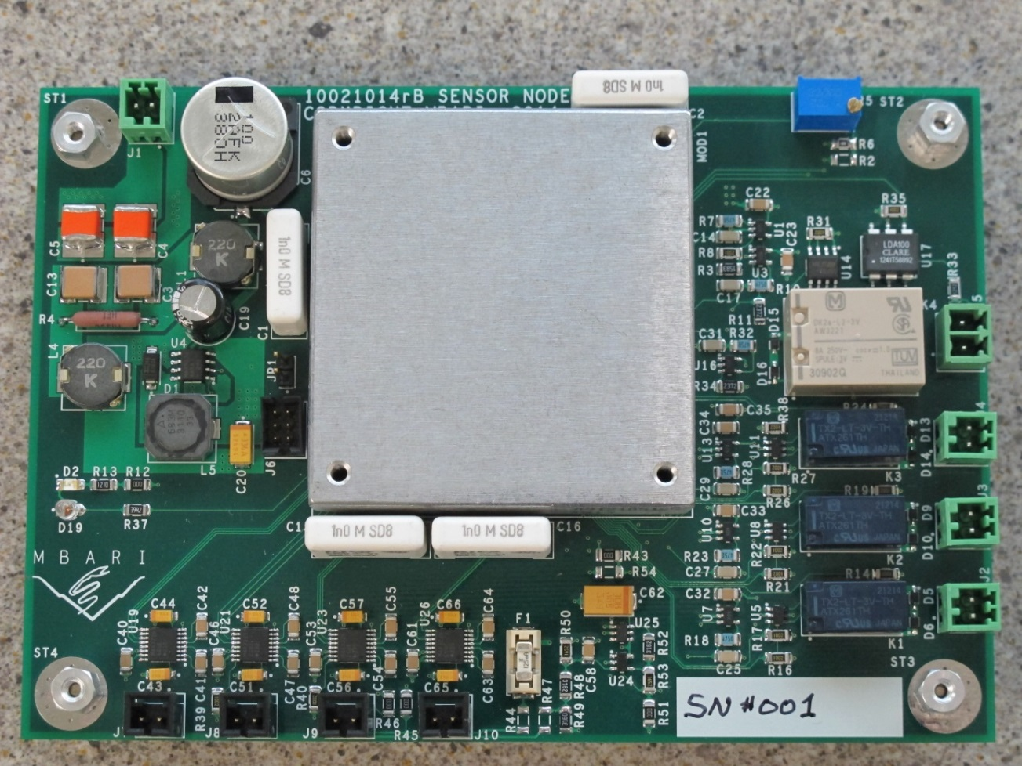
Figure 2: Front side of Sensor Node board
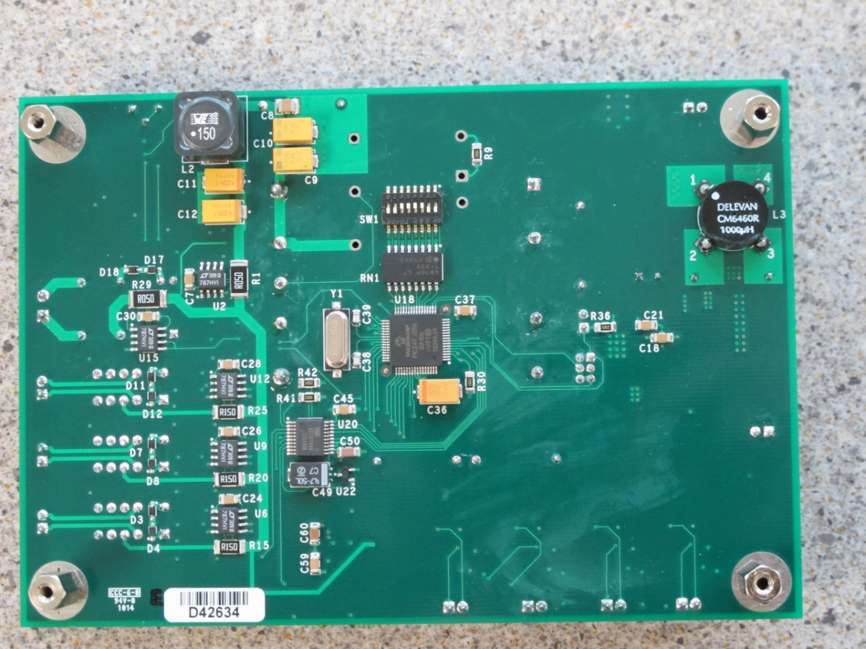
Figure 3: Rear side of Sensor Node board

Functional Description

DC-DC Conversion
The SN contains a single DC-DC converter which provides a common DC voltage for the attached instruments. The board has been designed to accept two families of converters which allow the user to determine the output voltage and the maximum output power (for greater system efficiency). The input and output filters were designed to accommodate all of the available converters. A jumper selectable trim up/down potentiometer is also included. The current and voltage level of the instrument bus voltage (BUS_VOLT) are monitored and recorded. A digital signal from the PIC can disable the DC-DC converter in the event power to all of the instruments needs to be removed quickly. The logic power is provided by a separate voltage regulator which is supplied directly by the input 48Vdc.

Load Paths
The instrument bus voltage is split into four paths: three standard instrument ports and one high-current power port. The standard instrument ports are limited to 2A of current, regardless of bus voltage. The high-current port can provide up to the maximum of 6A. The current usages of all four ports are monitored individually. Load switching to each port is accomplished via dual coil latching relays. Separate on and off pulses are used to change the relay states. Digital signals indicating the states of the individual relays are sent back to the PIC for independent confirmation. The high-current port has a different family of relay that allows for higher current usage; it can handle the maximum current at 75W for any of the chosen DC-DC converters.

The total power consumption of the four output ports should not exceed the rated power level of the installed DC-DC converter. There is no hardware monitoring of this power usage; this will need to be monitored in software.

PIC and Instrument Communication
The SN board contains a PIC24F microcontroller with four serial UARTs. Three are used for communication to the instruments, and the fourth is for communication back to the GN. Separate one-channel transceivers are used in the event of a failure only affecting one channel. The three instrument serial transceivers may be placed into a sleep mode to reduce overhead power consumption. The third port may be configured to accept 4-20ma instruments. In this case, serial port #3 is inactive and the 4-20ma data is read through the ADC. The PIC handles all of the digital input and output signals, the four UARTs, and the spi bus. An onboard boot loader allows the operating program to be loaded remotely.

Configuration Bits
Due to all of the possible hardware configurations of the Sensor Node board, and the fact that the board may be in a potted housing, there are eight bits which may be read back to confirm the hardware configuration. These are set by eight dip switches prior to potting.

Analog Signals
A SPI bus based 16-bit Analog-to-Digital Converter (ADC) is used to measure the various analog signals on board. All of the voltages are scaled to 3.0 volts. The signals measured are the bus voltage and current, the individual instrument currents, and the 4-20ma signal, if used.

Figure 4: Sensor Node block diagram

Board Population Options

The Sensor Node can be configured in a number of ways to suit the needs of the end user. The board is initially populated in a default configuration; the user can modify it accordingly. Table one displays the default population of the Sensor Node board as well as a convenient form for the user to fill out. Each of the options are described below.

 | Default | User
DC-DC Converter | Open
Trim Up/Down | None
R2 | Open
R6 | Open
Logic Power LED | On
R12 | Installed
Port #3 Config | Serial
R44 | Open
R45 | 0 ohms
R46 | 0 ohms
R47 | Open
R51 | 0 ohms
Port #4 Feedback
R33 | Open
Hearbeat LED
D19 | Open
ADC Calibration
R43 | 0 ohms
R54 | Open
Table 1: Default and user configuration options

DC-DC Converter Selection
There are two families of CUI Inc. DC-DC converters, PYB and VHB, which can be used on the SN board. External filtering and control components have been selected to accommodate any voltage/power combination.

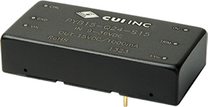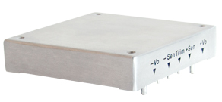
Figure 5: PYB series (left) and the higher power VHB series (right) DC-DC converters

 |  |  | Power | Input | Output | Current
Manuf | Series | Manufacturer PN# | (Watts) | (Volts) | (Volts) | (Amps)
CUI Inc | PYB10 | PYB10-Q48-S12 | 10 | 18-75 | 12 | 0.833
CUI Inc | PYB10 | PYB10-Q48-S15 | 10 | 18-75 | 15 | 0.667
CUI Inc | PYB15 | PYB15-Q48-S12 | 15 | 18-75 | 12 | 1.250
CUI Inc | PYB15 | PYB15-Q48-S15 | 15 | 18-75 | 15 | 1.000
CUI Inc | PYB20 | PYB20-Q48-S12 | 20 | 18-75 | 12 | 1.667
CUI Inc | PYB20 | PYB20-Q48-S15 | 20 | 18-75 | 15 | 1.333
CUI Inc | PYB20 | PYB20-Q48-S24 | 20 | 18-75 | 24 | 0.834
CUI Inc | VHB50W | VHB50W-Q48-S12 | 50 | 18-75 | 12 | 4.160
CUI Inc | VHB50W | VHB50W-Q48-S15 | 50 | 18-75 | 15 | 3.330
CUI Inc | VHB50W | VHB50W-Q48-S24 | 50 | 18-75 | 24 | 2.080
CUI Inc | VHB50W | VHB50W-Q48-S28 | 50 | 18-75 | 28 | 1.780
CUI Inc | VHB50W | VHB50W-Q48-S48 | 50 | 18-75 | 48 | 1.040
CUI Inc | VHB75W | VHB75W-Q48-S12 | 75 | 18-75 | 12 | 6.250
CUI Inc | VHB75W | VHB75W-Q48-S15 | 75 | 18-75 | 15 | 5.000
CUI Inc | VHB75W | VHB75W-Q48-S24 | 75 | 18-75 | 24 | 3.120
CUI Inc | VHB75W | VHB75W-Q48-S48 | 75 | 18-75 | 48 | 1.560
Table 2: List of available DC-DC converter

Bus Voltage Trim Up/Down
The main bus voltage may be trimmed up or down based on the needs of the user. To trim up, populate R6 with a zero ohm resistor, leaving R2 open. To trim down, populate R2 with a zero ohm resistor and leave R6 open. In both cases, the potentiometer R5 adjusts the bus voltage.

Logic Power LED
During the bench top test and debug phase it may be useful to have a power on indication. When R12 is populated with a zero ohm resistor, LED D2 indicates the presence of +3.3Vdc. Removing R12 reduces the power consumption by approximately 9mW.

Port #3 Configuration
In place of serial communication, instrument port #3 can be configured to accept 4-20ma devices. Resistors R44-R47, and R51 are used to select between serial communication and 4-20ma signals.

 | R44 | R45 | R46 | R47 | R51
Serial | OPEN | 0 OHMS | 0 OHMS | OPEN | 0 OHMS
4-20ma | 0 OHMS | OPEN | OPEN | 0 OHMS | OPEN
Table 3: Jumper selection for instrument port #3
In addition, the user has the option of not populating certain components if one or the other port #3 options will not be used.

If the user plans on using serial communication only and never 4-20ma, the following components can be considered No Stuff: F1, R44, R47, R48, R49, R50, R52, R53, C58, C59, C60, C62, U24, and U25.

If the user plans on using 4-20ma on port #3 and never serial communication, the following components can be considered No Stuff: R45, R46, C53, C54, C55, C56, C57, and U23.

Note on R51: Special attention must be made with respect to R51. If using serial communication, it needs to be populated with a zero ohm resistor. This prevents electrical noise from interfering with the ADC (U20). If using 4-20ma, R51 needs to be No Stuff in order to present the 4-20ma signal to the ADC.

Port #4 Feedback Resistor
Due to the switching relay on port #4 not having a second set of poles, an opto-isolator is used to read the relay state feedback. In order to keep the forward diode current in the nominal operating range, the current limiting resistor has to match the bus voltage.

BUS_VOLT | R33 | Watts
12 Vdc | 12k | 0.250 W
15 Vdc | 12k | 0.250 W
24 Vdc | 24k | 0.250 W
28Vdc | 24k | 0.250 W
48 Vdc | 47k | 0.250 W
Table 4: Current limiting resistors for U17

Heartbeat LED
D19 is a through-hole LED on extended legs. This allows the user to mount the LED in such a way that it is visible through any potting compound. D19 can be used during initial test, final deployment, or both.

ADC Calibration
Channel 7 of the ADC (U20) is unused and by default is tied to ground via a zero ohm resistor. The user has the option of creating a voltage divider via R54 and R43 to calibrate the analog-to-digital hardware and software. If Vmeas is the voltage to be measured by the ADC, then:

R54 = R43 * (3.0V – Vmeas) / Vmeas))

Vmeas = 3.0V * (R43 / (R43 + R54))

For optimal use of the voltage reference, U22, the current draw should be between 100uA and 1mA. For example, R43 = 10k and R54 = 20k results in Vmeas = 1.0V and the current drawn is 100uA.

If no calibration is desired, install a zero ohm resistor for R43 and leave R54 open.
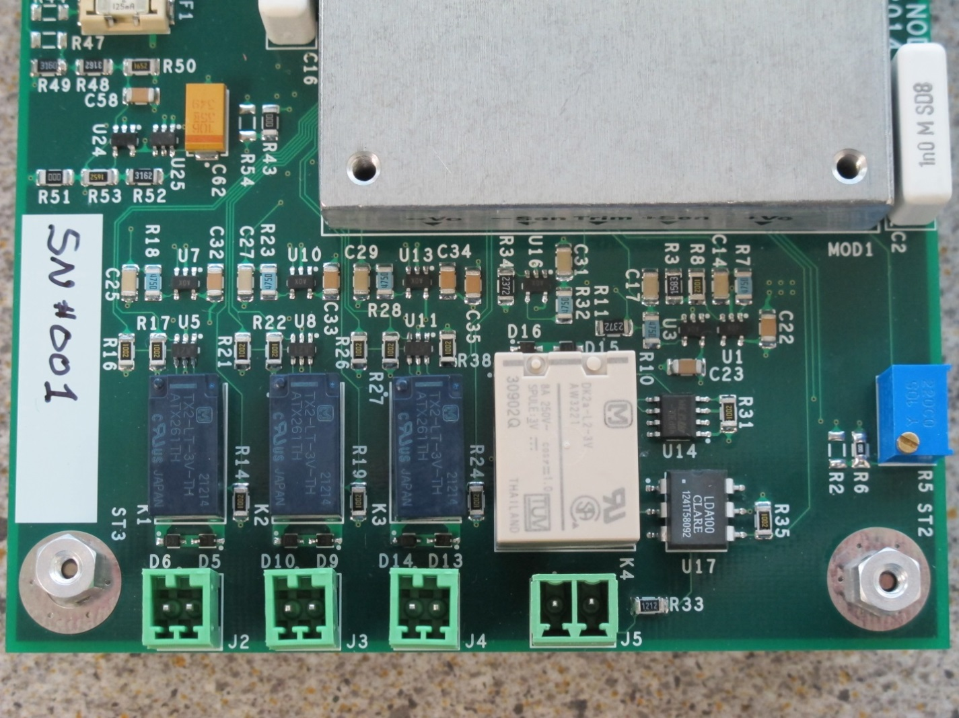
Figure 6: Output relays and connectors with trim circuit on far left (configured for trim up)

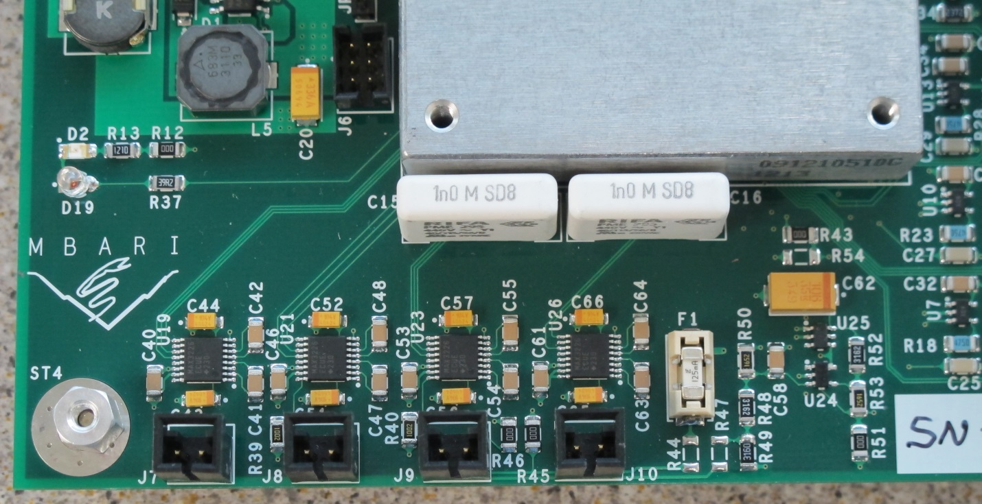
Figure 7: Serial transceiver circuits and connectors

Connector Population
The power and signal connectors for the SN board should be populated during initial testing; this facilitates easier bench testing. If ultimately potting the SN board in an underwater housing, the connectors can be removed and the whips can be directly soldered to the board. However, depending on the user’s final deployment method, the power and signal connectors can remain populated. The power connectors (J1, J2, J3, J4, and J5) were designed to accommodate 18AWG wire. The communication connectors (J7, J8, J9, and J10) were designed to accommodate 24AWG wire. In addition, the programming connector, J6, may be removed prior to deployment, if desired.

Programming and Serial Debugging

The PIC is programmed through J6; these signals are compatible with Microchip’s ICD programmers. See the Sensor Node PIC Test Code document for details on programming. Jumper JP1 allows the user to manually reset the PIC in the event of a programmer lockup or malfunction. Serial port #4 (J10) can be used a debug port during the testing phase.

Board Configuration Feedback

The user configuration settings can be set into memory by using the 8 position dip switch, SW1, as indicated in table five. The 8-bit word can be read back using CONFIG_BIT_0 through CONFIG_BIT_7; these correspond to digital port B, signals 8 through 15. See table six.

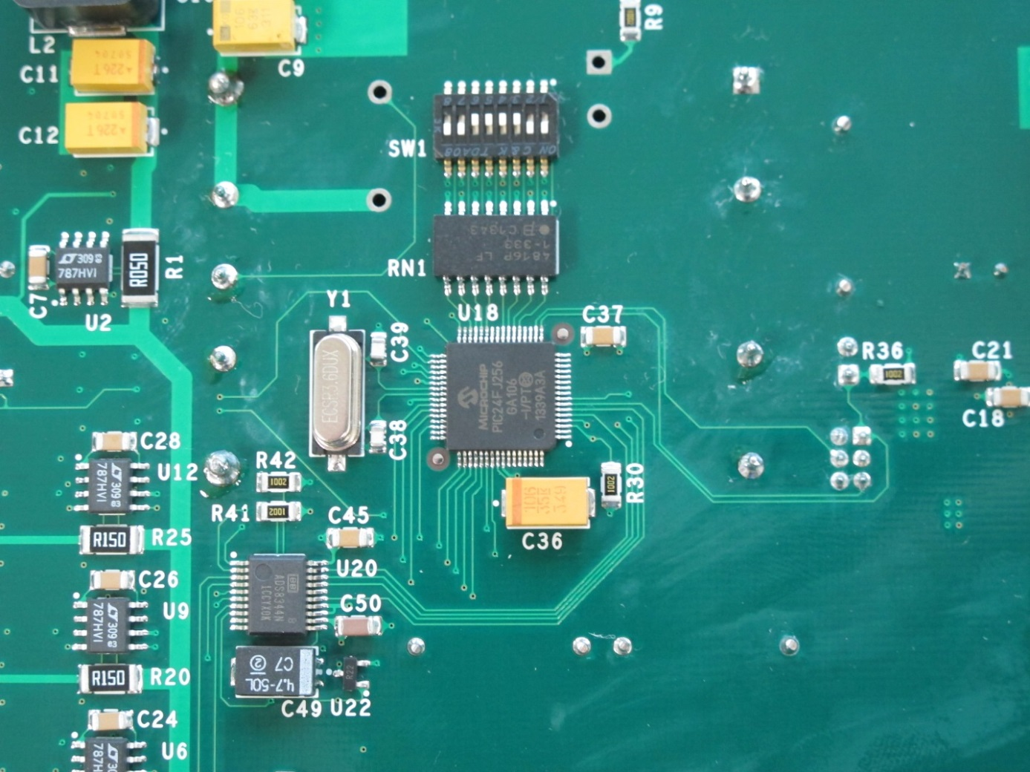
Figure 8: User settable dip switch (SW1) and the microcontroller (U18)

Watts | Voltage | Port #3 | SW1-1 | SW1-2 | SW1-3 | SW1-4 | SW1-5 | SW1-6 | SW1-7 | SW1-8
75 | 48 | Serial | OFF | OFF | OFF | OFF | OFF | OFF | ON | ON
75 | 24 | Serial | ON | OFF | OFF | OFF | OFF | OFF | ON | ON
75 | 15 | Serial | OFF | ON | OFF | OFF | OFF | OFF | ON | ON
75 | 12 | Serial | ON | ON | OFF | OFF | OFF | OFF | ON | ON
50 | 48 | Serial | OFF | OFF | ON | OFF | OFF | OFF | ON | ON
50 | 28 | Serial | ON | OFF | ON | OFF | OFF | OFF | ON | ON
50 | 24 | Serial | OFF | ON | ON | OFF | OFF | OFF | ON | ON
50 | 15 | Serial | ON | ON | ON | OFF | OFF | OFF | ON | ON
50 | 12 | Serial | OFF | OFF | OFF | ON | OFF | OFF | ON | ON
20 | 24 | Serial | ON | OFF | OFF | ON | OFF | OFF | ON | ON
20 | 15 | Serial | OFF | ON | OFF | ON | OFF | OFF | ON | ON
20 | 12 | Serial | ON | ON | OFF | ON | OFF | OFF | ON | ON
15 | 15 | Serial | OFF | OFF | ON | ON | OFF | OFF | ON | ON
15 | 12 | Serial | ON | OFF | ON | ON | OFF | OFF | ON | ON
10 | 15 | Serial | OFF | ON | ON | ON | OFF | OFF | ON | ON
10 | 12 | Serial | ON | ON | ON | ON | OFF | OFF | ON | ON
75 | 48 | 4-20ma | OFF | OFF | OFF | OFF | ON | OFF | ON | ON
75 | 24 | 4-20ma | ON | OFF | OFF | OFF | ON | OFF | ON | ON
75 | 15 | 4-20ma | OFF | ON | OFF | OFF | ON | OFF | ON | ON
75 | 12 | 4-20ma | ON | ON | OFF | OFF | ON | OFF | ON | ON
50 | 48 | 4-20ma | OFF | OFF | ON | OFF | ON | OFF | ON | ON
50 | 28 | 4-20ma | ON | OFF | ON | OFF | ON | OFF | ON | ON
50 | 24 | 4-20ma | OFF | ON | ON | OFF | ON | OFF | ON | ON
50 | 15 | 4-20ma | ON | ON | ON | OFF | ON | OFF | ON | ON
50 | 12 | 4-20ma | OFF | OFF | OFF | ON | ON | OFF | ON | ON
20 | 24 | 4-20ma | ON | OFF | OFF | ON | ON | OFF | ON | ON
20 | 15 | 4-20ma | OFF | ON | OFF | ON | ON | OFF | ON | ON
20 | 12 | 4-20ma | ON | ON | OFF | ON | ON | OFF | ON | ON
15 | 15 | 4-20ma | OFF | OFF | ON | ON | ON | OFF | ON | ON
15 | 12 | 4-20ma | ON | OFF | ON | ON | ON | OFF | ON | ON
10 | 15 | 4-20ma | OFF | ON | ON | ON | ON | OFF | ON | ON
10 | 12 | 4-20ma | ON | ON | ON | ON | ON | OFF | ON | ON
Table 5: User configuration settings for SW1

 |  |  | B8 | B9 | B10 | B11 | B12 | B13 | B14 | B15 | Dec
Watts | Voltage | Port #3 | 0 | 1 | 2 | 3 | 4 | 5 | 6 | 7
75 | 48 | Serial | 1 | 1 | 1 | 1 | 1 | 1 | 0 | 0 | 63
75 | 24 | Serial | 0 | 1 | 1 | 1 | 1 | 1 | 0 | 0 | 62
75 | 15 | Serial | 1 | 0 | 1 | 1 | 1 | 1 | 0 | 0 | 61
75 | 12 | Serial | 0 | 0 | 1 | 1 | 1 | 1 | 0 | 0 | 60
50 | 48 | Serial | 1 | 1 | 0 | 1 | 1 | 1 | 0 | 0 | 59
50 | 28 | Serial | 0 | 1 | 0 | 1 | 1 | 1 | 0 | 0 | 58
50 | 24 | Serial | 1 | 0 | 0 | 1 | 1 | 1 | 0 | 0 | 57
50 | 15 | Serial | 0 | 0 | 0 | 1 | 1 | 1 | 0 | 0 | 56
50 | 12 | Serial | 1 | 1 | 1 | 0 | 1 | 1 | 0 | 0 | 55
20 | 24 | Serial | 0 | 1 | 1 | 0 | 1 | 1 | 0 | 0 | 54
20 | 15 | Serial | 1 | 0 | 1 | 0 | 1 | 1 | 0 | 0 | 53
20 | 12 | Serial | 0 | 0 | 1 | 0 | 1 | 1 | 0 | 0 | 52
15 | 15 | Serial | 1 | 1 | 0 | 0 | 1 | 1 | 0 | 0 | 51
15 | 12 | Serial | 0 | 1 | 0 | 0 | 1 | 1 | 0 | 0 | 50
10 | 15 | Serial | 1 | 0 | 0 | 0 | 1 | 1 | 0 | 0 | 49
10 | 12 | Serial | 0 | 0 | 0 | 0 | 1 | 1 | 0 | 0 | 48
75 | 48 | 4-20ma | 1 | 1 | 1 | 1 | 0 | 1 | 0 | 0 | 47
75 | 24 | 4-20ma | 0 | 1 | 1 | 1 | 0 | 1 | 0 | 0 | 46
75 | 15 | 4-20ma | 1 | 0 | 1 | 1 | 0 | 1 | 0 | 0 | 45
75 | 12 | 4-20ma | 0 | 0 | 1 | 1 | 0 | 1 | 0 | 0 | 44
50 | 48 | 4-20ma | 1 | 1 | 0 | 1 | 0 | 1 | 0 | 0 | 43
50 | 28 | 4-20ma | 0 | 1 | 0 | 1 | 0 | 1 | 0 | 0 | 42
50 | 24 | 4-20ma | 1 | 0 | 0 | 1 | 0 | 1 | 0 | 0 | 41
50 | 15 | 4-20ma | 0 | 0 | 0 | 1 | 0 | 1 | 0 | 0 | 40
50 | 12 | 4-20ma | 1 | 1 | 1 | 0 | 0 | 1 | 0 | 0 | 39
20 | 24 | 4-20ma | 0 | 1 | 1 | 0 | 0 | 1 | 0 | 0 | 38
20 | 15 | 4-20ma | 1 | 0 | 1 | 0 | 0 | 1 | 0 | 0 | 37
20 | 12 | 4-20ma | 0 | 0 | 1 | 0 | 0 | 1 | 0 | 0 | 36
15 | 15 | 4-20ma | 1 | 1 | 0 | 0 | 0 | 1 | 0 | 0 | 35
15 | 12 | 4-20ma | 0 | 1 | 0 | 0 | 0 | 1 | 0 | 0 | 34
10 | 15 | 4-20ma | 1 | 0 | 0 | 0 | 0 | 1 | 0 | 0 | 33
10 | 12 | 4-20ma | 0 | 0 | 0 | 0 | 0 | 1 | 0 | 0 | 32
Table 6: Software settings for user configuration settings

Board Level Signal Descriptions

Analog Signals

INSTR_CURR
This is a 0-3V analog voltage signal which corresponds to the total current usage of the DC-DC converter. The conversion factor is Y(amps) = 2.0 x INSTR_CURR.

INSTR_VOLT
This is a 0-3V analog voltage signal which corresponds to the output voltage of the DC-DC converter. The conversion factor is Y(volts) = 16.0 x INSTR_VOLT.

INSTR_1_CURR
This is a 0-3V analog voltage signal which corresponds to the current usage of the instrument being monitored on port #1. The conversion factor is Y(amps) = 0.667 x INST_1_CURR.

INSTR_2_CURR
This is a 0-3V analog voltage signal which corresponds to the current usage of the instrument being monitored on port #2. The conversion factor is Y(amps) = 0.667 x INST_2_CURR.

INSTR_3_CURR
This is a 0-3V analog voltage signal which corresponds to the current usage of the instrument being monitored on port #3. The conversion factor is Y(amps) = 0.667 x INST_3_CURR.

INSTR_4_CURR
This is a 0-3V analog voltage signal which corresponds to the current usage of the instrument being monitored on port #4. The conversion factor is Y(amps) = 2.0 x INST_4_CURR.

4_20MA_VOLT
This is a 0-3V analog voltage signal which corresponds to the 4-20ma circuit, if used. The conversion factor is Y(milliamps) = 6.1 x 4_20MA_VOLT + 4.0. The scaling for 4 to 20mA ends at 2.62V. A reading of 2.97 volts (22.1ma) indicates an error in the measurement.

SPI Bus Signals

SPI_SCLK
The clock input for the SPI bus; it can also be used to control the ADC conversion steps.

SPI_MISO
The SPI data output of the ADS8344.

SPI_MOSI
The SPI data input to the ADS8344.

SPI_*CS
This is the active low SPI chip select signal.

Digital Output Signals

ADC_*SHDN
This is an active low input to the ADS8344 ADC. Pulling this line low puts the ADS8344 in a low power shutdown mode.

UART_1_*SHDN
This is a logic low digital signal which puts the serial transceiver for port #1 into a low power shutdown mode.

UART_2_*SHDN
This is a logic low digital signal which puts the serial transceiver for port #2 into a low power shutdown mode.

UART_3_*SHDN
This is a logic low digital signal which puts the serial transceiver for port #3 into a low power shutdown mode.

INSTR_1_ON
This is a logic high level positive going pulse which turns on the power relay to the instrument on port #1. The minimum pulse width is 10msec and should not exceed 50msec.

INSTR_1_OFF
This is a logic high level positive going pulse which turns off the power relay to the instrument on port #1. The minimum pulse width is 10msec and should not exceed 50msec.

INSTR_2_ON
This is a logic high level positive going pulse which turns on the power relay to the instrument on port #2. The minimum pulse width is 10msec and should not exceed 50msec.

INSTR_2_OFF
This is a logic high level positive going pulse which turns off the power relay to the instrument on port #2. The minimum pulse width is 10msec and should not exceed 50msec.

INSTR_3_ON
This is a logic high level positive going pulse which turns on the power relay to the instrument on port #3. The minimum pulse width is 10msec and should not exceed 50msec.

INSTR_3_OFF
This is a logic high level positive going pulse which turns off the power relay to the instrument on port #3. The minimum pulse width is 10msec and should not exceed 50msec.

INSTR_4_ON
This is a logic low level positive going pulse which turns on the power relay to the instrument on port #4. The minimum pulse width is 10msec and should not exceed 50msec.

INSTR_4_OFF
This is a logic low level positive going pulse which turns off the power relay to the instrument on port #4. The minimum pulse width is 10msec and should not exceed 50msec.

DC-DC_CNTL
This is an active low control signal which disables the onboard DC-DC converter. This removes power to all of the attached instruments simultaneously.

Digital Inputs

INSTR_1_STATE
This is a logic level feedback signal which corresponds to the state of the relay on port #1. Logic level high indicates the relay is on.

INSTR_2_STATE
This is a logic level feedback signal which corresponds to the state of the relay on port #2. Logic level high indicates the relay is on.

INSTR_3_STATE
This is a logic level feedback signal which corresponds to the state of the relay on port #3. Logic level high indicates the relay is on.

INSTR_4_STATE
This is a logic level feedback signal which corresponds to the state of the relay on port #4. Logic level high indicates the relay is on.

ADC_BUSY
This is an output of the ADS8344 that indicates the operating status of the ADC. Its operation is different depending on whether using internal or external clocking. It is in a high impedance state when *CS is high.

CONFIG_BIT_x (0-7)
These are 8 digital bits which can be read back by the user to verify the hardware configuration of the SN module. CONFIG_BIT_7 is the MSB. See tables four and five for the exact codes.

Appendices

Appendix 1: Electrical Specifications
Input Voltage | 48Vdc
No Load Conditions
Nominal Current | 29ma
Power Usage | 1.4W
Max Current Out
Channel 1-3 | 2A
Channel 4 | 6A
Max Power Out | 75W
Converter Effiiciency (max) | 83%

Appendix 2: Mechanical Specifications
Length | 5.75 in
Width | 4.0 in
Height | 1.0 in
Operating Temperature
Min | 32 degF
Max | 70 degF
Operating Depth | 300m

Appendix 3: PIC pin assignment for SN board
PIC24FJ256GA106 Pinout for swFOCE Sensor Node Board
Pin # | Func1 | Func2 | Func3 | Func4 | Func5 | Func6 | Func7 | Functional Description
1 | CN63 | PMD5 | RE5 |  |  |  |  | INSTR_3_OFF
2 | SCL3 | CN64 | PMD6 | RE6 |  |  |  | INSTR_4_OFF
3 | SDA3 | CN65 | PMD7 | RE7 |  |  |  | INSTR_4_ON
4 | PMA5 | RP21 | C1IND | CN8 | RG6 |  |  | SPI_*CS
5 | C1INC | RP26 | CN9 | PMA4 | RG7 |  |  | SPI_SCLK
6 | C2IND | RP19 | CN10 | PMA3 | RG8 |  |  | SPI_MISO
7 | *MCLR |  |  |  |  |  |  | *MCLR
8 | C2INC | RP27 | CN11 | PMA2 | RG9 |  |  | SPI_MOSI
9 | Vss |  |  |  |  |  |  | Vss
10 | Vdd |  |  |  |  |  |  | Vdd
11 | PGEC3 | AN5 | C1INA | RP18 | CN7 | RB5 |  | OPEN
12 | PGED3 | AN4 | C1IN | RP28 | CN6 | RB4 |  | OPEN
13 | AN3 | C2INA | CN5 | RB3 |  |  |  | OPEN
14 | AN2 | C2INB | RP13 | CN4 | RB2 |  |  | OPEN
15 | PGEC1 | AN1 | Vref- | RP1 | CN3 | RB1 |  | OPEN
16 | PGED1 | AN0 | Vref+ | RP0 | CN2 | PMA6 | RB0 | OPEN
17 | PGEC2 | AN6 | RP6 | CN24 | RB6 |  |  | PROG_CLK
18 | PGED2 | AN7 | RP7 | CN25 | RB7 |  |  | PROG_DATA
19 | AVdd |  |  |  |  |  |  | AVdd
20 | AVss |  |  |  |  |  |  | AVss
21 | AN8 | RP8 | CN26 | RB8 |  |  |  | CONFIG_BIT_0
22 | AN9 | RP9 | CN27 | PMA7 | RB9 |  |  | CONFIG_BIT_1
23 | TMS | AN10 | CVref | CN28 | PMA13 | RB10 |  | CONFIG_BIT_2
24 | TDO | AN11 | CN29 | PMA12 | RB11 |  |  | CONFIG_BIT_3
25 | Vss |  |  |  |  |  |  | Vss
26 | Vdd |  |  |  |  |  |  | Vdd
27 | TCK | AN12 | CTED2 | CN30 | PMA11 | RB12 |  | CONFIG_BIT_4
28 | TDI | PMA10 | AN13 | CTED1 | CN31 | RB13 |  | CONFIG_BIT_5
29 | AN14 | CTPLS | RP14 | CN32 | PMA1 | RB14 |  | CONFIG_BIT_6
30 | AN15 | REFO | RP29 | CN12 | PMA0 | RB15 |  | CONFIG_BIT_7
31 | SDA2 | RP10 | CN17 | PMA9 | RF4 |  |  | OPEN
32 | SCL2 | RP17 | CN18 | PMA8 | RF5 |  |  | "Test LED"
33 | RP16 | CN71 | RF3 |  |  |  |  | INSTR_4_STATE
34 | RP30 | CN70 | RF2 |  |  |  |  | INSTR_3_STATE
35 | ASCK1 | RPI45 | INT0 | CN72 | RF6 |  |  | DC-DC_CNTL
36 | SDA1 | CN84 | RG3 |  |  |  |  | ADC_BUSY
37 | SCL1 | CN83 | RG2 |  |  |  |  | ADC_*SHDN
38 | Vdd |  |  |  |  |  |  | Vdd
39 | OSCI | CLKI | CN32 | RC12 |  |  |  | OSCI
40 | OSCO | CLKO | CN22 | RC15 |  |  |  | OSCO
41 | Vss |  |  |  |  |  |  | Vss
42 | RTCC | RP2 | CN53 | RD8 |  |  |  | UART_3_*SHDN
43 | RP4 | CN54 | RD9 |  |  |  |  | UART4_TTL_TXD
44 | RP3 | CN55 | PMCS2 | RD10 |  |  |  | UART4_TTL_RXD
45 | RP12 | CN56 | PMCS1 | RD11 |  |  |  | OPEN
46 | RP11 | CN49 | RD0 |  |  |  |  | UART1_TTL_TXD
47 | SOSCI | C3IND | CN1 | RC13 |  |  |  | OPEN
48 | SOSCO | C3INC | RPI37 | CN0 | RC14 |  |  | OPEN
49 | RP24 | CN50 | RD1 |  |  |  |  | UART1_TTL_RXD
50 | RP23 | CN51 | RD2 |  |  |  |  | UART2_TTL_TXD
51 | RP22 | CN52 | PMBE | RD3 |  |  |  | UART2_TTL_RXD
52 | RP25 | CN13 | PMWR | RD4 |  |  |  | UART3_TTL_TXD
53 | RP20 | CN14 | PMRD | RD5 |  |  |  | UART3_TTL_RXD
54 | C3INB | CN15 | RD6 |  |  |  |  | UART_1_*SHDN
55 | C3INA | CN16 | RD7 |  |  |  |  | UART_2_*SHDN
56 | Vcap | Vddcore |  |  |  |  |  | Vcap
57 | ENVREG |  |  |  |  |  |  | ENVREG
58 | CN68 | RF0 |  |  |  |  |  | INSTR_1_STATE
59 | CN69 | RF1 |  |  |  |  |  | INSTR_2_STATE
60 | CN58 | PMD0 | RE0 |  |  |  |  | INSTR_1_ON
61 | CN59 | PMD1 | RE1 |  |  |  |  | INSTR_1_OFF
62 | CN60 | PMD2 | RE2 |  |  |  |  | INSTR_2_ON
63 | CN61 | PMD3 | RE3 |  |  |  |  | INSTR_2_OFF
64 | CN62 | PMD4 | RE4 |  |  |  |  | INSTR_3_ON
Appendix 4: PIC pin software assignment
PIC24FJ256GA106 Pin and Coding Assignments
Pin # | Func1 | Signal Type | Default State | Schematic Name
1 | RE5 | Digital Output | LOW | INSTR_3_OFF
2 | RE6 | Digital Output | HIGH | INSTR_4_OFF
3 | RE7 | Digital Output | HIGH | INSTR_4_ON
4 | RG6 | SPI | HIGH | SPI_*CS
5 | RP26 | SPI |  | SPI_SCLK
6 | RP19 | SPI |  | SPI_MISO
7 | *MCLR | Programming |  | *MCLR
8 | RP27 | SPI |  | SPI_MOSI
9 | Vss |  |  | Vss
10 | Vdd |  |  | Vdd
11 | RB5 | Digital Output | HIGH | OPEN
12 | RB4 | Digital Output | HIGH | OPEN
13 | RB3 | Digital Output | HIGH | OPEN
14 | RB2 | Digital Output | HIGH | OPEN
15 | RB1 | Digital Output | HIGH | OPEN
16 | RB0 | Digital Output | HIGH | OPEN
17 | PGEC2 | Programming |  | PROG_CLOCK
18 | PGED2 | Programming |  | PROG_DATA
19 | AVdd |  |  | AVdd
20 | AVss |  |  | AVss
21 | RB8 | Digital Input |  | CONFIG_BIT_0
22 | RB9 | Digital Input |  | CONFIG_BIT_1
23 | RB10 | Digital Input |  | CONFIG_BIT_2
24 | RB11 | Digital Input |  | CONFIG_BIT_3
25 | Vss |  |  | Vss
26 | Vdd |  |  | Vdd
27 | RB12 | Digital Input |  | CONFIG_BIT_4
28 | RB13 | Digital Input |  | CONFIG_BIT_5
29 | RB14 | Digital Input |  | CONFIG_BIT_6
30 | RB15 | Digital Input |  | CONFIG_BIT_7
31 | RF4 | Digital Output | HIGH | OPEN
32 | RF5 | Digital Output | LOW | "Test LED"
33 | RF3 | Digital Input |  | INSTR_4_STATE
34 | RF2 | Digital Input |  | INSTR_3_STATE
35 | RF6 | Digital Output | HIGH | DC-DC_CNTL
36 | RG3 | Digital Input |  | ADC_BUSY
37 | RG2 | Digital Output | HIGH | ADC_*SHDN
38 | Vdd |  |  | Vdd
39 | OSCI | Clock |  | OSCI
40 | OSCO | Clock |  | OSCO
41 | Vss |  |  | Vss
42 | RD8 | Digital Output | HIGH | UART_3_*SHDN
43 | RP4 | Serial |  | UART4_TTL_TXD
44 | RP3 | Serial |  | UART4_TTL_RXD
45 | RD11 | Serial | HIGH | OPEN
46 | RP11 | Serial |  | UART1_TTL_TXD
47 | RC13 | Digital Output | HIGH | OPEN
48 | RC14 | Digital Output | HIGH | OPEN
49 | RP24 | Serial |  | UART1_TTL_RXD
50 | RP23 | Serial |  | UART2_TTL_TXD
51 | RP22 | Serial |  | UART2_TTL_RXD
52 | RP25 | Serial |  | UART3_TTL_TXD
53 | RP20 | Serial |  | UART3_TTL_RXD
54 | RD6 | Digital Output | HIGH | UART_1_*SHDN
55 | RD7 | Digital Output | HIGH | UART_2_*SHDN
56 | Vcap |  |  | Vcap
57 | ENVREG |  |  | ENVREG
58 | RF0 | Digital Input |  | INSTR_1_STATE
59 | RF1 | Digital Input |  | INSTR_2_STATE
60 | RE0 | Digital Output | LOW | INSTR_1_ON
61 | RE1 | Digital Output | LOW | INSTR_1_OFF
62 | RE2 | Digital Output | LOW | INSTR_2_ON
63 | RE3 | Digital Output | LOW | INSTR_2_OFF
64 | RE4 | Digital Output | LOW | INSTR_3_ON
Appendix 5: Bill of Materials for Sensor Node Board

Ref | Value | Manufacturer | Manufacturer PN | Description
C1 | 1000pF | Kemet | PME295RB4100MR30 | CAP FILM 1000PF 480VAC RADIAL
C2 | 1000pF | Kemet | PME295RB4100MR30 | CAP FILM 1000PF 480VAC RADIAL
C3 | 1.0uF | TDK Corporation | CKG57KX7R2A105M | CAP CER 1UF 100V 20% X7R SMD
C4 | 22uF | Vishay Sprague | 597D226X9063F2T | CAP TANT 22UF 63V 10% 2924
C5 | 22uF | Vishay Sprague | 597D226X9063F2T | CAP TANT 22UF 63V 10% 2924
C6 | 100uF | Panasonic | EEV-FK2A101M | CAP ALUM 100UF 100V 20% SMD
C7 | 0.1uF | Kemet | C1206F104K3RACTU | CAP CER .1UF 25V X7R 1206 FO
C8 | 1.0uF | TDK Corporation | CKG32KX7R1H105M335AH | CAP CER 1UF 50V 20% X7R SMD
C9 | 10uF | Kemet | T521X106M063ATE050 | CAP TANT 10UF 63V 20% 2917
C10 | 10uF | Kemet | T521X106M063ATE050 | CAP TANT 10UF 63V 20% 2917
C11 | 22uF | AVX Corporation | TPME226K050R0075 | CAP TANT 22UF 50V 10% 2917
C12 | 22uF | AVX Corporation | TPME226K050R0075 | CAP TANT 22UF 50V 10% 2917
C13 | 1.0uF | TDK Corporation | CKG57KX7R2A105M | CAP CER 1UF 100V 20% X7R SMD
C14 | 0.033uF | Yageo | CC1206KRX7R9BB333 | CAP CER 0.033UF 50V 10% X7R 1206
C15 | 1000pF | Kemet | PME295RB4100MR30 | CAP FILM 1000PF 480VAC RADIAL
C16 | 1000pF | Kemet | PME295RB4100MR30 | CAP FILM 1000PF 480VAC RADIAL
C17 | 0.033uF | Yageo | CC1206KRX7R9BB333 | CAP CER 0.033UF 50V 10% X7R 1206
C18 | 0.1uF | Kemet | C1206F104K3RACTU | CAP CER .1UF 25V X7R 1206 FO
C19 | 47uF | Panasonic | EEU-EB1J470S | CAP ALUM 47UF 63V 20% RADIAL
C20 | 33uF | AVX Corporation | TPSC336K010R0150 | CAP TANT 33UF 10V 10% 2312
C21 | 0.1uF | Kemet | C1206F104K3RACTU | CAP CER .1UF 25V X7R 1206 FO
C22 | 0.1uF | Kemet | C1206F104K3RACTU | CAP CER .1UF 25V X7R 1206 FO
C23 | 0.1uF | Kemet | C1206F104K3RACTU | CAP CER .1UF 25V X7R 1206 FO
C24 | 0.1uF | Kemet | C1206F104K3RACTU | CAP CER .1UF 25V X7R 1206 FO
C25 | 0.033uF | Yageo | CC1206KRX7R9BB333 | CAP CER 0.033UF 50V 10% X7R 1206
C26 | 0.1uF | Kemet | C1206F104K3RACTU | CAP CER .1UF 25V X7R 1206 FO
C27 | 0.033uF | Yageo | CC1206KRX7R9BB333 | CAP CER 0.033UF 50V 10% X7R 1206
C28 | 0.1uF | Kemet | C1206F104K3RACTU | CAP CER .1UF 25V X7R 1206 FO
C29 | 0.033uF | Yageo | CC1206KRX7R9BB333 | CAP CER 0.033UF 50V 10% X7R 1206
C30 | 0.1uF | Kemet | C1206F104K3RACTU | CAP CER .1UF 25V X7R 1206 FO
C31 | 0.033uF | Yageo | CC1206KRX7R9BB333 | CAP CER 0.033UF 50V 10% X7R 1206
C32 | 0.1uF | Kemet | C1206F104K3RACTU | CAP CER .1UF 25V X7R 1206 FO
C33 | 0.1uF | Kemet | C1206F104K3RACTU | CAP CER .1UF 25V X7R 1206 FO
C34 | 0.1uF | Kemet | C1206F104K3RACTU | CAP CER .1UF 25V X7R 1206 FO
C35 | 0.1uF | Kemet | C1206F104K3RACTU | CAP CER .1UF 25V X7R 1206 FO
C36 | 10uF | AVX Corp | TPSD106K035R0125 | CAP TANT LOESR 10UF 35V 10% SMD
C37 | 0.1uF | Kemet | C1206F104K3RACTU | CAP CER .1UF 25V X7R 1206 FO
C38 | 15pF | Kemet | C0805C150J5GACTU | CAP CERAMIC 15PF 50V NP0 0805
C39 | 15pF | Kemet | C0805C150J5GACTU | CAP CERAMIC 15PF 50V NP0 0805
C40 | 0.1uF | Kemet | C1206F104K3RACTU | CAP CER .1UF 25V X7R 1206 FO
C41 | 0.1uF | Kemet | C1206F104K3RACTU | CAP CER .1UF 25V X7R 1206 FO
C42 | 0.1uF | Kemet | C1206F104K3RACTU | CAP CER .1UF 25V X7R 1206 FO
C43 | 0.1uF | AVX Corp | TAJA104K035RNJ | CAP TANTALUM .10UF 35V 10% SMD
C44 | 0.1uF | AVX Corp | TAJA104K035RNJ | CAP TANTALUM .10UF 35V 10% SMD
C45 | 0.1uF | Kemet | C1206F104K3RACTU | CAP CER .1UF 25V X7R 1206 FO
C46 | 0.1uF | Kemet | C1206F104K3RACTU | CAP CER .1UF 25V X7R 1206 FO
C47 | 0.1uF | Kemet | C1206F104K3RACTU | CAP CER .1UF 25V X7R 1206 FO
C48 | 0.1uF | Kemet | C1206F104K3RACTU | CAP CER .1UF 25V X7R 1206 FO
C49 | 4.7uF | Vishay Sprague | 593D475X9050D2TE3 | CAP TANT 4.7UF 50V 10% 2917
C50 | 1.0uF | TDK Corporation | C3216X7R2A105K | CAP CER 1.0UF 100V X7R 1206
C51 | 0.1uF | AVX Corp | TAJA104K035RNJ | CAP TANTALUM .10UF 35V 10% SMD
C52 | 0.1uF | AVX Corp | TAJA104K035RNJ | CAP TANTALUM .10UF 35V 10% SMD
C53 | 0.1uF | Kemet | C1206F104K3RACTU | CAP CER .1UF 25V X7R 1206 FO
C54 | 0.1uF | Kemet | C1206F104K3RACTU | CAP CER .1UF 25V X7R 1206 FO
C55 | 0.1uF | Kemet | C1206F104K3RACTU | CAP CER .1UF 25V X7R 1206 FO
C56 | 0.1uF | AVX Corp | TAJA104K035RNJ | CAP TANTALUM .10UF 35V 10% SMD
C57 | 0.1uF | AVX Corp | TAJA104K035RNJ | CAP TANTALUM .10UF 35V 10% SMD
C58 | 0.1uF | Kemet | C1206F104K3RACTU | CAP CER .1UF 25V X7R 1206 FO
C59 | 0.1uF | Kemet | C1206F104K3RACTU | CAP CER .1UF 25V X7R 1206 FO
C60 | 1.0uF | Kemet | C1206C105K3RAC | CAP, CER, 1.0uF, 25V, 10%, X7R, 1206
C61 | 0.1uF | Kemet | C1206F104K3RACTU | CAP CER .1UF 25V X7R 1206 FO
C62 | 10uF | AVX Corp | TPSD106K035R0125 | CAP TANT LOESR 10UF 35V 10% SMD
C63 | 0.1uF | Kemet | C1206F104K3RACTU | CAP CER .1UF 25V X7R 1206 FO
Ref | Value | Manufacturer | Manufacturer PN | Description
C64 | 0.1uF | Kemet | C1206F104K3RACTU | CAP CER .1UF 25V X7R 1206 FO
C65 | 0.1uF | AVX Corp | TAJA104K035RNJ | CAP TANTALUM .10UF 35V 10% SMD
C66 | 0.1uF | AVX Corp | TAJA104K035RNJ | CAP TANTALUM .10UF 35V 10% SMD
D1 | B360A-13-F | Diodes Inc | B360A-13-F | DIODE SCHOTTKY 60V 3A SMA
D2 | LTST-C150GKT | Lite-On Inc | LTST-C150GKT | LED GREEN CLEAR 1206 SMD
D3 | BZX384 | NXP | BZX384-C3V3,115 | DIODE ZENER 3.3V 300MW SOD323
D4 | DB2J31700L | Panasonic | DB2J31700L | DIODE 30V 1A SMINI2
D5 | BZX384 | NXP | BZX384-C3V3,115 | DIODE ZENER 3.3V 300MW SOD323
D6 | DB2J31700L | Panasonic | DB2J31700L | DIODE 30V 1A SMINI2
D7 | BZX384 | NXP | BZX384-C3V3,115 | DIODE ZENER 3.3V 300MW SOD323
D8 | DB2J31700L | Panasonic | DB2J31700L | DIODE 30V 1A SMINI2
D9 | BZX384 | NXP | BZX384-C3V3,115 | DIODE ZENER 3.3V 300MW SOD323
D10 | DB2J31700L | Panasonic | DB2J31700L | DIODE 30V 1A SMINI2
D11 | BZX384 | NXP | BZX384-C3V3,115 | DIODE ZENER 3.3V 300MW SOD323
D12 | DB2J31700L | Panasonic | DB2J31700L | DIODE 30V 1A SMINI2
D13 | BZX384 | NXP | BZX384-C3V3,115 | DIODE ZENER 3.3V 300MW SOD323
D14 | DB2J31700L | Panasonic | DB2J31700L | DIODE 30V 1A SMINI2
D15 | DB2J31700L | Panasonic | DB2J31700L | DIODE 30V 1A SMINI2
D16 | BZX384 | NXP | BZX384-C3V3,115 | DIODE ZENER 3.3V 300MW SOD323
D17 | DB2J31700L | Panasonic | DB2J31700L | DIODE 30V 1A SMINI2
D18 | BZX384 | NXP | BZX384-C3V3,115 | DIODE ZENER 3.3V 300MW SOD323
D19 | WP710A10 | Kingbright | WP710A10SEC/J4 | 3MM ORANGE LED ROUND
F1 | 0154.125DR | Littelfuse Inc | 0154.125DR | FUSEBLOCK W/.125A FUSE SMD FST
J1 | 1881558 | Phoenix Contact | 1881558 | CONN TERM BLK HDR 2.5MM 2POS
J2 | 1881558 | Phoenix Contact | 1881558 | CONN TERM BLK HDR 2.5MM 2POS
J3 | 1881558 | Phoenix Contact | 1881558 | CONN TERM BLK HDR 2.5MM 2POS
J4 | 1881558 | Phoenix Contact | 1881558 | CONN TERM BLK HDR 2.5MM 2POS
J5 | 1803426 | Phoenix Contact | 1803426 | CONN HEADER VERT 2POS 3.81MM
J6 | 87831-0620 | Molex | 87831-0620 | CONN HEADER 6POS 2MM VERT GOLD
J7 | 70543-0001 | Molex Inc | 70543-0001 | CONN HEADER 2POS .100 VERT GOLD
J8 | 70543-0001 | Molex Inc | 70543-0001 | CONN HEADER 2POS .100 VERT GOLD
J9 | 70543-0001 | Molex Inc | 70543-0001 | CONN HEADER 2POS .100 VERT GOLD
J10 | 70543-0001 | Molex Inc | 70543-0001 | CONN HEADER 2POS .100 VERT GOLD
JP1 | 87224-2 | Tyco Electronics | 87224-2 | CONN HEADER VERT .100 2POS 15AU
K1 | TX2-LT-3V-TH | Panasonic | TX2-LT-3V-TH | RELAY GENERAL PURPOSE DPDT 2A 3V
K2 | TX2-LT-3V-TH | Panasonic | TX2-LT-3V-TH | RELAY GENERAL PURPOSE DPDT 2A 3V
K3 | TX2-LT-3V-TH | Panasonic | TX2-LT-3V-TH | RELAY GENERAL PURPOSE DPDT 2A 3V
K4 | DK2a-L2-3V | Panasonic | DK2a-L2-3V | 2 Form A, 3VDC 2 Form A 10A 250VAC
L1 | 22uH | Taiyo Yuden | NR10050T220M | INDUCTOR 22UH 2.6A 20% SMD
L2 | 15uH | Wurth | 7447709150 | INDUCTOR POWER 15UH 6.5A SMD
L3 | 1mH | API Delevan Inc | CM6460R-105 | CHOKE COMMON MODE 1000.0UH SMD
L4 | 22uH | Taiyo Yuden | NR10050T220M | INDUCTOR 22UH 2.6A 20% SMD
L5 | 68uH | EPCOS Inc | B82464G4683M | INDUCTOR POWER 68UH 1.3A SMD
MOD1 | VHB | CUI Inc |  | CONVERTER DC/DC 50W, 75W
MOD2 | PYB | CUI Inc |  | CONVERTER DC/DC 10W, 15W, 20W
R1 | 0.05 | Stackpole | CSRN2512FK50L0 | RES .05 OHM 2W 1% 2512 SMD
R2 | TBD |  |  | TO BE DETERMINED, HEIGHT 0.6mm
R3 | 158.0K | Vishay | CRCW1206158KFKEA | RES 158K OHM 1/4W 1206 SMD
R4 | 5k | Vishay Dale | ALSR015K000JE12 | RES 5.0K OHM 5% WW AXIAL
R5 | 1M | Bourns Inc. | 3299Y-1-105LF | TRIMMER 1M OHM 0.5W PC PIN
R6 | TBD |  |  | TO BE DETERMINED, HEIGHT 0.6mm
R7 | 475 | Vishay | CRCW1206475RFKEA | RES 475 OHM 1/4W 1206 SMD
R8 | 10.0K | Vishay | CRCW120610K0FKEA | RES 10K OHM 1/4W 1206 SMD
R9 | 10.0K | Vishay | CRCW120610K0FKEA | RES 10K OHM 1/4W 1206 SMD
R10 | 475 | Vishay | CRCW1206475RFKEA | RES 475 OHM 1/4W 1206 SMD
R11 | 23.7K | Vishay | CRCW120623K7FKEA | RES 23.7K OHM 1/4W 1206 SMD
R12 | 0 | Vishay/Dale | CRCW12060000Z0EA | RES 0.0 OHM 1/4W 1206 SMD
R13 | 120 | Vishay | CRCW1206120RJNEA | RES 120 OHM 1/4W 1206 SMD
R14 | 10.0K | Vishay | CRCW120610K0FKEA | RES 10K OHM 1/4W 1206 SMD
R15 | 0.15 | Stackpole | CSRN2010FKR150 | RES .15OHM 1W 1% 2010 SMD
R16 | 10.0K | Vishay | CRCW120610K0FKEA | RES 10K OHM 1/4W 1206 SMD
R17 | 10.0K | Vishay | CRCW120610K0FKEA | RES 10K OHM 1/4W 1206 SMD
R18 | 475 | Vishay | CRCW1206475RFKEA | RES 475 OHM 1/4W 1206 SMD
R19 | 10.0K | Vishay | CRCW120610K0FKEA | RES 10K OHM 1/4W 1206 SMD
R20 | 0.15 | Stackpole | CSRN2010FKR150 | RES .15OHM 1W 1% 2010 SMD
R21 | 10.0K | Vishay | CRCW120610K0FKEA | RES 10K OHM 1/4W 1206 SMD
Ref | Value | Manufacturer | Manufacturer PN | Description
R22 | 10.0K | Vishay | CRCW120610K0FKEA | RES 10K OHM 1/4W 1206 SMD
R23 | 475 | Vishay | CRCW1206475RFKEA | RES 475 OHM 1/4W 1206 SMD
R24 | 10.0K | Vishay | CRCW120610K0FKEA | RES 10K OHM 1/4W 1206 SMD
R25 | 0.15 | Stackpole | CSRN2010FKR150 | RES .15OHM 1W 1% 2010 SMD
R26 | 10.0K | Vishay | CRCW120610K0FKEA | RES 10K OHM 1/4W 1206 SMD
R27 | 10.0K | Vishay | CRCW120610K0FKEA | RES 10K OHM 1/4W 1206 SMD
R28 | 475 | Vishay | CRCW1206475RFKEA | RES 475 OHM 1/4W 1206 SMD
R29 | 0.05 | Stackpole | CSRN2512FK50L0 | RES .05 OHM 2W 1% 2512 SMD
R30 | 10.0K | Vishay | CRCW120610K0FKEA | RES 10K OHM 1/4W 1206 SMD
R31 | 10.0K | Vishay | CRCW120610K0FKEA | RES 10K OHM 1/4W 1206 SMD
R32 | 475 | Vishay | CRCW1206475RFKEA | RES 475 OHM 1/4W 1206 SMD
R33 | TBD |  |  | TO BE DETERMINED, HEIGHT 0.6mm
R34 | 23.7K | Vishay | CRCW120623K7FKEA | RES 23.7K OHM 1/4W 1206 SMD
R35 | 10.0K | Vishay | CRCW120610K0FKEA | RES 10K OHM 1/4W 1206 SMD
R36 | 10.0K | Vishay | CRCW120610K0FKEA | RES 10K OHM 1/4W 1206 SMD
R37 | 39 | Vishay | CRCW120639R0JNEA | RES 39 OHM 1/4W 1206 SMD
R38 | 10.0K | Vishay | CRCW120610K0FKEA | RES 10K OHM 1/4W 1206 SMD
R39 | 10.0K | Vishay | CRCW120610K0FKEA | RES 10K OHM 1/4W 1206 SMD
R40 | 10.0K | Vishay | CRCW120610K0FKEA | RES 10K OHM 1/4W 1206 SMD
R41 | 10.0K | Vishay | CRCW120610K0FKEA | RES 10K OHM 1/4W 1206 SMD
R42 | 10.0K | Vishay | CRCW120610K0FKEA | RES 10K OHM 1/4W 1206 SMD
R43 | 0 | Vishay/Dale | CRCW12060000Z0EA | RES 0.0 OHM 1/4W 1206 SMD
R44 | TBD |  |  | TO BE DETERMINED, HEIGHT 0.6mm
R45 | TBD |  |  | TO BE DETERMINED, HEIGHT 0.6mm
R46 | TBD |  |  | TO BE DETERMINED, HEIGHT 0.6mm
R47 | TBD |  |  | TO BE DETERMINED, HEIGHT 0.6mm
R48 | 31.6K | Vishay | CRCW120631K6FKEA | RES 31.6K OHM 1/4W 1206 SMD
R49 | 316 | Vishay | CRCW1206316RFKEA | RES 316 OHM 1/4W 1206 SMD
R50 | 16.5K | Vishay | CRCW120616K5FKEA | RES 16.5K OHM 1/4W 1206 SMD
R51 | TBD |  |  | TO BE DETERMINED, HEIGHT 0.6mm
R52 | 31.6K | Vishay | CRCW120631K6FKEA | RES 31.6K OHM 1/4W 1206 SMD
R53 | 16.5K | Vishay | CRCW120616K5FKEA | RES 16.5K OHM 1/4W 1206 SMD
R54 | TBD |  |  | TO BE DETERMINED, HEIGHT 0.6mm
RN1 | 33k | Bourns Inc. | 4816P-T01-333LF | RES ARRAY 33K OHM 8 RES 16SOIC
ST1 | #4 Screw |  |  | #4 SCREW TERMINAL W/ WASHER
ST2 | #4 Screw |  |  | #4 SCREW TERMINAL W/ WASHER
ST3 | #4 Screw |  |  | #4 SCREW TERMINAL W/ WASHER
ST4 | #4 Screw |  |  | #4 SCREW TERMINAL W/ WASHER
SW1 | TDA08 | C&K | TDA08H0SB1 | SWITCH DIP 8POS HALF PITCH SMD
U1 | AD8603 | Analog Devices | AD8603AUJZ-REEL7 | IC OPAMP GP R-R CMOS TSOT23-5
U2 | LT1787 | Linear Technology | LT1787HVIS8#PBF | IC AMP PREC CURR SENSE HV 8-SOIC
U3 | AD8603 | Analog Devices | AD8603AUJZ-REEL7 | IC OPAMP GP R-R CMOS TSOT23-5
U4 | MAX5033 | Maxim IC | MAX5033AASA+ | IC BUCK 3.3V 0.5A 8SOIC
U5 | QS6K21TR | Rohm | QS6K21TR | MOSFET N-CH 45V 1A TSMT6
U6 | LT1787 | Linear Technology | LT1787HVIS8#PBF | IC AMP PREC CURR SENSE HV 8-SOIC
U7 | AD8603 | Analog Devices | AD8603AUJZ-REEL7 | IC OPAMP GP R-R CMOS TSOT23-5
U8 | QS6K21TR | Rohm | QS6K21TR | MOSFET N-CH 45V 1A TSMT6
U9 | LT1787 | Linear Technology | LT1787HVIS8#PBF | IC AMP PREC CURR SENSE HV 8-SOIC
U10 | AD8603 | Analog Devices | AD8603AUJZ-REEL7 | IC OPAMP GP R-R CMOS TSOT23-5
U11 | QS6K21TR | Rohm | QS6K21TR | MOSFET N-CH 45V 1A TSMT6
U12 | LT1787 | Linear Technology | LT1787HVIS8#PBF | IC AMP PREC CURR SENSE HV 8-SOIC
U13 | AD8603 | Analog Devices | AD8603AUJZ-REEL7 | IC OPAMP GP R-R CMOS TSOT23-5
U14 | STS4DPF30L | STMicroelectronics | STS4DPF30L | MOSFET 2P-CH 30V 4A 8-SOIC
U15 | LT1787 | Linear Technology | LT1787HVIS8#PBF | IC AMP PREC CURR SENSE HV 8-SOIC
U16 | AD8603 | Analog Devices | AD8603AUJZ-REEL7 | IC OPAMP GP R-R CMOS TSOT23-5
U17 | LDA100STR | IXYS | LDA100STR | OPTOCOUPLER SGL TRANS-OUT 6-SMD
U18 | PIC24FJ256GA106 | Microchip | PIC24FJ256GA106-I/PT | IC PIC MCU FLASH 256K 64TQFP
U19 | MAX3226E | Maxim IC | MAX3226ECUE+ | IC TXRX RS232 250KBPS SD 16TSSOP
U20 | ADS8344 | Analog Devices | ADS8344NB | IC 16-BIT 8-CH A/D CONV 20-SSOP
U21 | MAX3226E | Maxim IC | MAX3226ECUE+ | IC TXRX RS232 250KBPS SD 16TSSOP
U22 | AD1583 | Analog Devices | AD1583ARTZ-REEL7 | IC VREF SERIES PREC 3V SOT-23-3
U23 | MAX3226E | Maxim IC | MAX3226ECUE+ | IC TXRX RS232 250KBPS SD 16TSSOP
U24 | AD8603 | Analog Devices | AD8603AUJZ-REEL7 | IC OPAMP GP R-R CMOS TSOT23-5
U25 | LT1790-1.25 | Linear Technology | LT1790BCS6-1.25#TRMPBF | IC VREF SERIES 1.25V SOT-23-6
U26 | MAX3226E | Maxim IC | MAX3226ECUE+ | IC TXRX RS232 250KBPS SD 16TSSOP
Y1 | 3.6864MHz | ECS Inc | ECS-36-20-5PXDU-TR | CRYSTAL 3.6864 MHZ 20PF SMD

