Programming the SensorNode Board

Project: SW-FOCE – Project 901219
Revision – 1.0
Date: 11/26/2014

- Power the SensorNode with 14-48 VDC for 12V board, or 26-48 VDC for a 24V board. Power is applied via J1, which is in the upper left hand corner when you’re looking at the board in its normal orientation (all printing seen in normal face-up order, MBARI logo in lower left hand corner).
- The four serial connections are across the bottom left hand corner: J7 to J10.
J7 is instrument serial port 1
J8 is instrument serial port 2
J9 is instrument serial port 3
J10 is normally the ModBus serial port, which runs at 115200 baud, N81
- Note that all 4 serial port connectors (J7-J10) are lacking a ground connection. To use them, you must externally connect RS-232 ground to power ground (J1).
- J7, which is normally instrument serial port 1, is also used for:
  - User configuration (slave ID, baud rate, configuration, etc). This port is usable for these purposes until the first ModBus message is received. After that, this port is disabled for user configuration, and is only usable as an instrument serial port
  - The boot loader port (see below).

Firmware Setup
There are two pieces of firmware for this board: the boot loader and the application firmware. The procedure is to first install the boot loader, then use it to install the application firmware.

Boot Loader
Obtain the SensorNode code, either from Mercurial or the Project Library. I’ll assume it’s loaded to a directory named SensorNode. The boot loader, then, is in directory SensorNode/bootloader. This code must be blown directly into the PIC on the Sensor Node, using one of Microchip’s debug tools, most likely the ICD3. Plug the ICD target connector into J6, with the blue wire at the upper left hand corner. Using MPLabX, download the bootloader code into the chip.
Note that you’ll see no external indication that anything is running, other than the fact that the LED will light up. The chip will initially be in boot mode, waiting for a connection from the boot programmer.

Building the SensorNodeMain Application
The application code is in SensorNode/SensorNodeMain. Using MPLabX, open the project file you find there (normally named SensorNodeMainBootable.X), and build it.

Boot Programmer
The boot loader client is a Windows/PC based GUI client located in directory SensorNode/bootloader/pic24BootloaderGUI, and is called P24QP.exe. When running, it will look as follows:
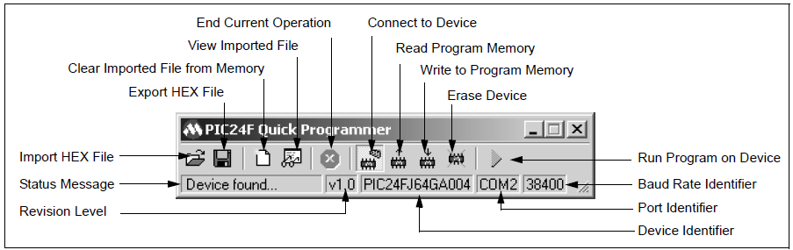
- Right-click on the Port Identifier to set the COM port that is connected to J7 on the SensorNode board.
- Right-click on the Baud Rate Identifier to set it to 38400 baud. This is the baud rate that’s built into the boot loader. Note that the User Configuration that normally runs on this port, runs at 9600 baud. This difference is slightly annoying; but it’s desirable to run the boot loader at 38400 baud, because the code can take a while to download.
- Click on the Import HEX File icon (the folder icon). Point it to SensorNode/SensorNodeMain/SensorNodeMainBootable.X/dist/default/production, and click on the .hex file you find there.
- Click on Connect To Device. If you’ve built and loaded the boot loader correctly, have the correct serial port and baud rate, and it’s running, you should see the status bar say “connecting” and then “Device found”. It should show the device as a PIC24FJ256GA106.
- Click on Erase Device, the little icon with the green X through it.
- Click on Write to Program Memory, the icon with a down arrow above it. It may take a couple of minutes to program the device. If no errors are shown, the device has programmed correctly.
- Click on Run Program on Device, the green right arrow. Or, alternatively, power-cycle the SensorNode.
- Close P24QP, and re-connect your terminal emulator (Hyperterm or equivalent) at 9600 baud.
The SensorNode should now be running the application code.

Running the SensorNode Application
As noted above, the first serial port (J7) is used as the user interface / configuration port until the first ModBus message is received. After that time, it is simply an instrument serial port.
Connect J7 (with appropriate ground, as noted) to a PC serial port, and run Hyperterm or other terminal emulator on that port at 9600 baud, N81. When you boot or apply power, you’ll see something like:
SensorNode I/O SW Rev 1.00 Dec 15 2014, 14:41:54
CVS tag "$Name: $"
Type ? for menu
SLAVE ID: 1
BAUD RATE: 115200
BLINKY DEBUG: ON
CONFIG XMIT: ON
RESET POWER: OFF
SERIAL NUM: 1
CONFIG REG: 0 (hex)
HW CFG BITS: c3 (hex)
You may type ‘?’ to get a menu, which will display as:
0 - Save config changes and reset
1 - Show build date and config
2 - Set slave address
3 - Set Modbus baudrate
4 - Set blinky debug state
5 - Set config xmit reset state
6 - Set power reset state
7 - Set board serial number
8 - Set board configuration register
9 - Set bootloader flag and reset
Most of these are self-explanatory, but here are some notes.
0: Whenever you make changes that you want saved, use option 0 to save those changes and reset the board. You should see the signon as above, but reflecting your new changes.
4: Blinky debug state – normally the LED is on solidly at startup. When the board receives its first Modbus message, the LED will blink (and the config port will be disabled). This is “Blinky Debug” state. But you may disable this behavior.
5: Set config xmit reset state – Some instruments may object to the boot messages that appear on instrument port 1. This menu item allows you to disable the transmitter on this port at boot time. To talk to an instrument, then, the software needs to re-enable it. Note that if this is set and you want to use this port for configuration, you’ll see no boot messages until you first send at least one character to this port. At that point, the port transmitter will again be enabled.
6 Set power reset state – allows you to specify that, at boot-up, the power relays are either switched off, or left in their previous state.
7: Board Serial Number – This is intended to be a unique serial number, settable via this menu item. But in reality the user may enter any number here. The results are displayed in the signon screen, and also are retrievable via the software library snLib.
8: Board Config Register – note that there are two methods of noting/saving the board configuration. There are the hardware configuration bits (HW CFG BITS), set via SW1 on the back side of the board. The software can read and display these bits, but cannot change them. But there is also a software configuration register. The user can change this register via this menu item. The result is show on the signon screen, and is also retrievable via the software library snLib.
9: Set boot flag and reset. This item allows you to load new code into the SensorNode. The software will request confirmation. If confirmed, the board will then be permanently in the boot loader, waiting for new code. To use the board normally, load new code (or reload the old).

Loading new code into an operational board
- Connect a terminal emulator (Hyperterm or equivalent) to J7 (with ground connection). Set to 9600 N81.
- Power-cycle the SensorNode. This is necessary to get it into configuration mode
- Choose menu option ‘9’. Confirm it.
- Hang up terminal emulator, and run P24QP.exe at 38400 baud.
- Follow the directions under “Boot Programmer” above.

