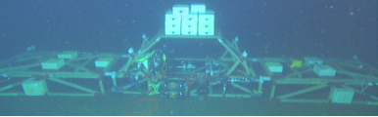
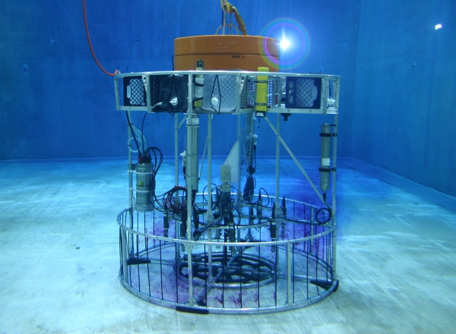

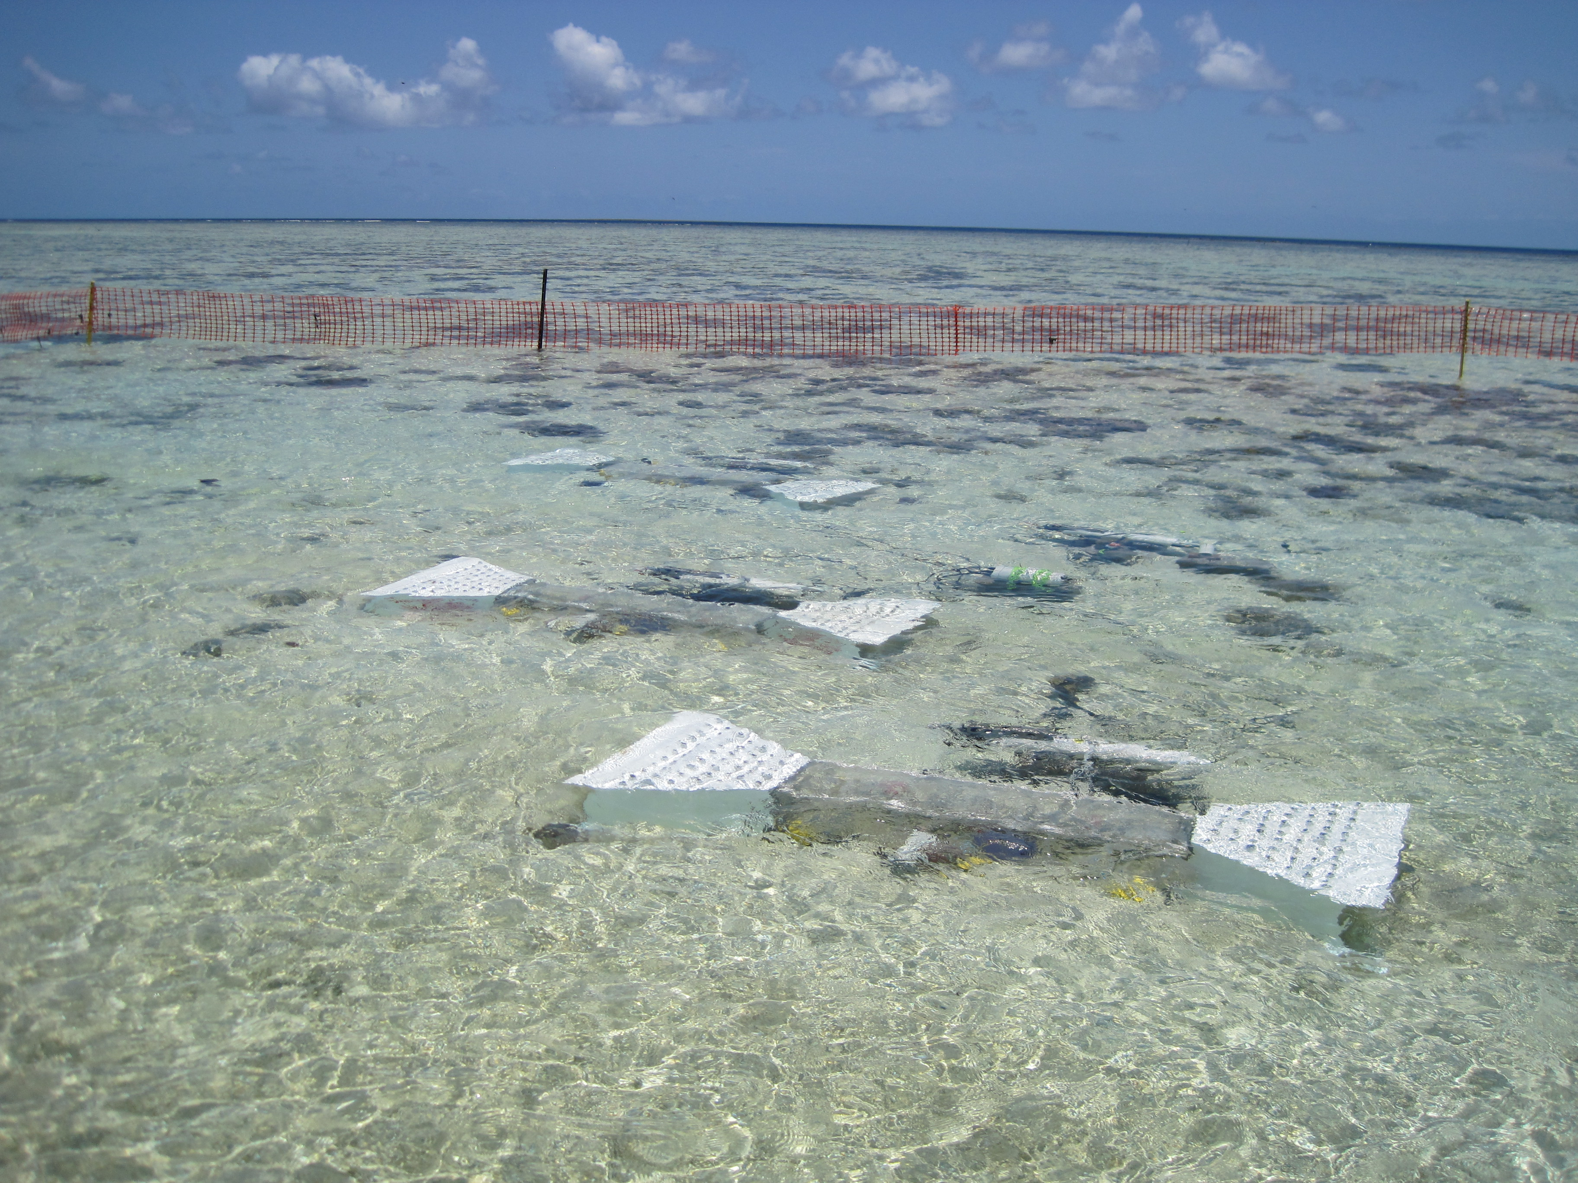
MBARI FOCE
Ocean Acidification Research Tool

The MBARI FOCE (Free Ocean Carbon Experiment) is technology for studying the effects of ocean acidification. FOCE takes the experimental concept of the terrestrial Free Air Carbon Experiments into the ocean, making it possible to perform in situ experiments in a pH-controlled environment.

FOCE may be implemented for shallow water or deep, and the flexible design provides many options for optimizing cost and performance.

Features
- Maintain pH offset relative to reference sensor
- Maintain specified constant pH
- Manual or small-boat deployable
- Diver serviceable
- Real-time telemetry and system monitoring
- Automatic data logging
- Wide range of operating depths
- Scalable, customizable architecture

Specifications

 | Min | Max | Typical
pH operating range | 7.0 | 8.0
pH tracking |  |  | ±0.01
pH resolution |  |  | ±0.001
Instrument suite |  |  | CTD (2)  pH (2)  DO (2)  Water flow (2)  Video Camera (1)
Data storage |  |  | 128 GB
Sample rates |  | 2 Hz
Device inputs |  |  | 16x RS-232  10/100Base-T Ethernet
Supply Voltage |  |  | 12, 24, 48, 400 VDC

 | basic | Better | Best
Self-contained | ○ | ○ | ○
CTD | 2 | 2 | 2
DO | 2 | 2 | 2
pH | 2 | 4 | 4
Velocity/Flow | 2 | 3 | 3
ESW Pump | 1 | 1 | 1
ESW Diverter | 1 | 1 | 2
Thrusters | 1 | 1 | 2
Light Panel | 1 | 2 | 3
Timelapse Cam | ✔ | ○ | ○
Video Cam | ✗ | 2 | 3
Bidirectional Flow | ✗ | ✔ | ✔

✔ | Included
✗ | Not Included
○ | Optional

Options
Energy Source | Diesel/Gas/etc.  Wind/Solar  Shore Utility  Batteries
Power Generation | Wind Turbine  PV Panels  Diesel Generator  Shore Utility  Air Compressor  HPU
Power Distribution | Cabled  Self-contained
Power Storage | Batteries
CO₂ Source | Bottled Gas  Diesel Gen
ESW Storage | Shore ESW Reservoir  In-situ ESW Reservoir  In-situ liquid CO₂ Reservoir
ESW Distribution | Electric Pump  Hydraulic Pump  Pneumatic Pump
Telemetry PHY | RF  Cell  Satellite  Cable  Inductive
Telemetry Protocols | TCP/IP  Serial  802.11  SBD
Com PHY | Inductive  Twisted pair  Coax  Fiber-optic  Acoustic
Com  Protocols | TCP/IP  RS422  RS232  CAN  RS485

