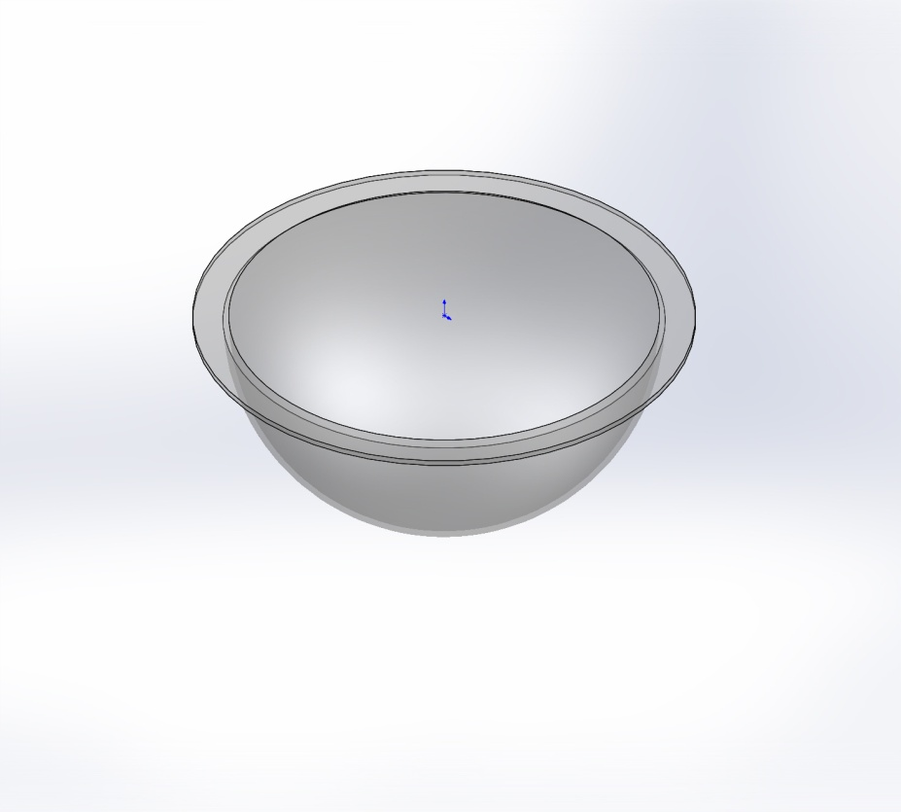
  Simulation of Criterion Dome -0600-MA-LL
  Date: Wednesday, March 13, 2013
  Designer: Farley F. Shane
  Study name: Dome Study 1
  Analysis type: Static
  Table of Contents
  Description 1
  Assumptions 2
  Model Information 2
  Study Properties 4
  Units 5
  Material Properties 5
  Loads and Fixtures 6
  Connector Definitions 7
  Contact Information 7
  Mesh Information 8
  Sensor Details 9
  Resultant Forces 10
  Beams 10
  Study Results 11
  Conclusion 15

Description
Shallow Water Foce
Sony PZT Camera Dome Analysis

Assumptions

Model Information

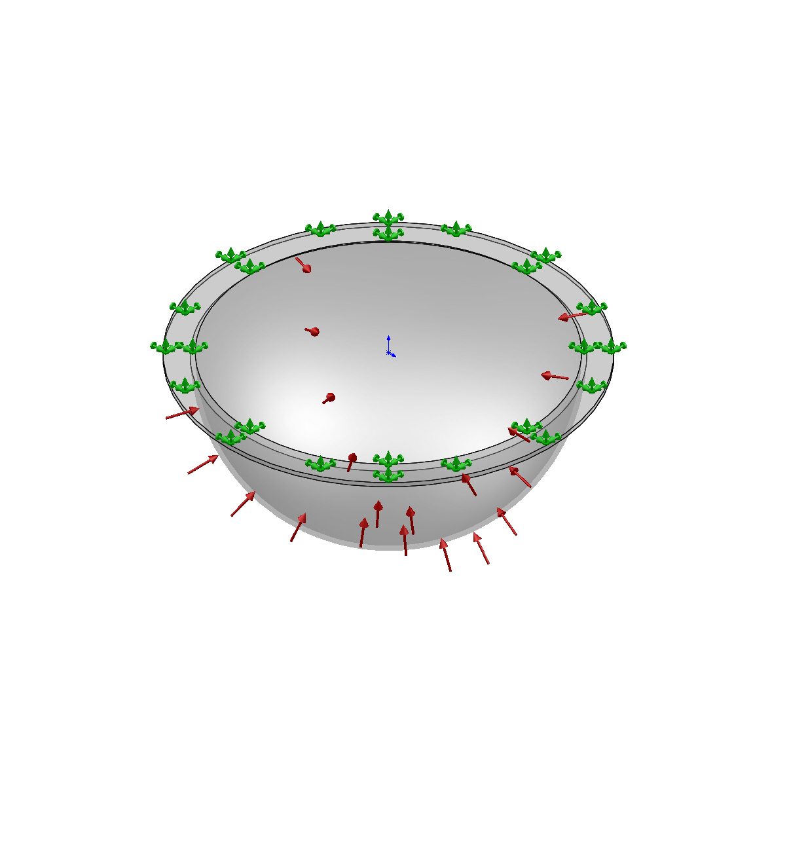
Model name: Criterion Dome -0600-MA-LL
Current Configuration: Default
Solid Bodies
Document Name and Reference | Treated As | Volumetric Properties | Document Path/Date Modified
Revolve1  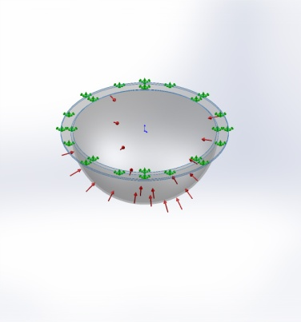 | Solid Body | Mass:0.103511 kg  Volume:8.69839e-005 m^3  Density:1190 kg/m^3  Weight:1.01441 N | X:\901219 SW-FOCE\Test Encl+Frame\Criterion Dome -0600-MA-LL.SLDPRT  Mar 13 15:18:02 2013

Study Properties
Study name | Dome Study 1
Analysis type | Static
Mesh type | Solid Mesh
Thermal Effect: | On
Thermal option | Include temperature loads
Zero strain temperature | 298 Kelvin
Include fluid pressure effects from SolidWorks Flow Simulation | Off
Solver type | FFEPlus
Inplane Effect: | Off
Soft Spring: | Off
Inertial Relief: | Off
Incompatible bonding options | Automatic
Large displacement | Off
Compute free body forces | On
Friction | Off
Use Adaptive Method: | Off
Result folder | SolidWorks document (X:\901219 SW-FOCE\Test Encl+Frame)

Units
Unit system: | SI (MKS)
Length/Displacement | mm
Temperature | Kelvin
Angular velocity | Rad/sec
Pressure/Stress | N/m^2

Material Properties
Model Reference | Properties | Components
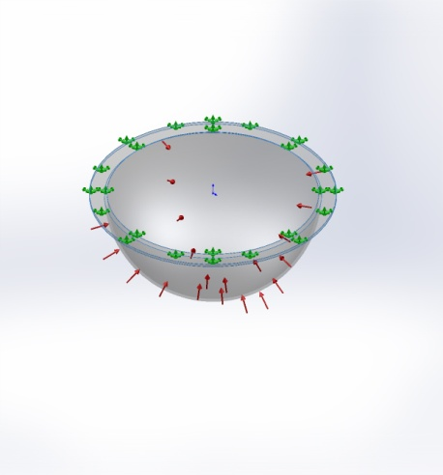 |  | SolidBody 1(Revolve1)(Criterion Dome -0600-MA-LL)
  Name: | PC High Viscosity
  Model type: | Linear Elastic Isotropic
  Default failure criterion: | Unknown
  Tensile strength: | 6.27e+007 N/m^2
  Elastic modulus: | 2.32e+009 N/m^2
  Poisson's ratio: | 0.3912
  Mass density: | 1190 kg/m^3
  Shear modulus: | 8.291e+008 N/m^2
Curve Data:N/A

Loads and Fixtures
Fixture name | Fixture Image | Fixture Details
Fixed-1 | 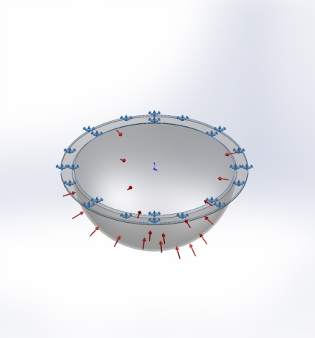
  Entities: | 1 face(s)
  Type: | Fixed Geometry
Resultant Forces
Components | X | Y | Z | Resultant
Reaction force(N) | 0.0122389 | -4606.87 | 0.0184584 | 4606.87
Reaction Moment(N-m) | 0 | 0 | 0 | 0

Load name | Load Image | Load Details
Pressure-1 | 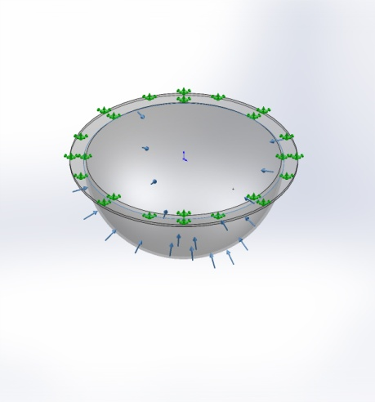
  Entities: | 1 face(s)
  Type: | Normal to selected face
  Value: | 35
  Units: | psi

Connector Definitions
No Data

Contact Information
No Data

Mesh Information
Mesh type | Solid Mesh
Mesher Used: | Standard mesh
Automatic Transition: | Off
Include Mesh Auto Loops: | Off
Jacobian points | 4 Points
Element Size | 0.231911 in
Tolerance | 0.0115955 in
Mesh Quality | High

Mesh Information - Details
Total Nodes | 15376
Total Elements | 7602
Maximum Aspect Ratio | 11.591
% of elements with Aspect Ratio < 3 | 50.6
% of elements with Aspect Ratio > 10 | 0.0526
% of distorted elements(Jacobian) | 0
Time to complete mesh(hh;mm;ss): | 00:00:04
Computer name: | ENIGMA
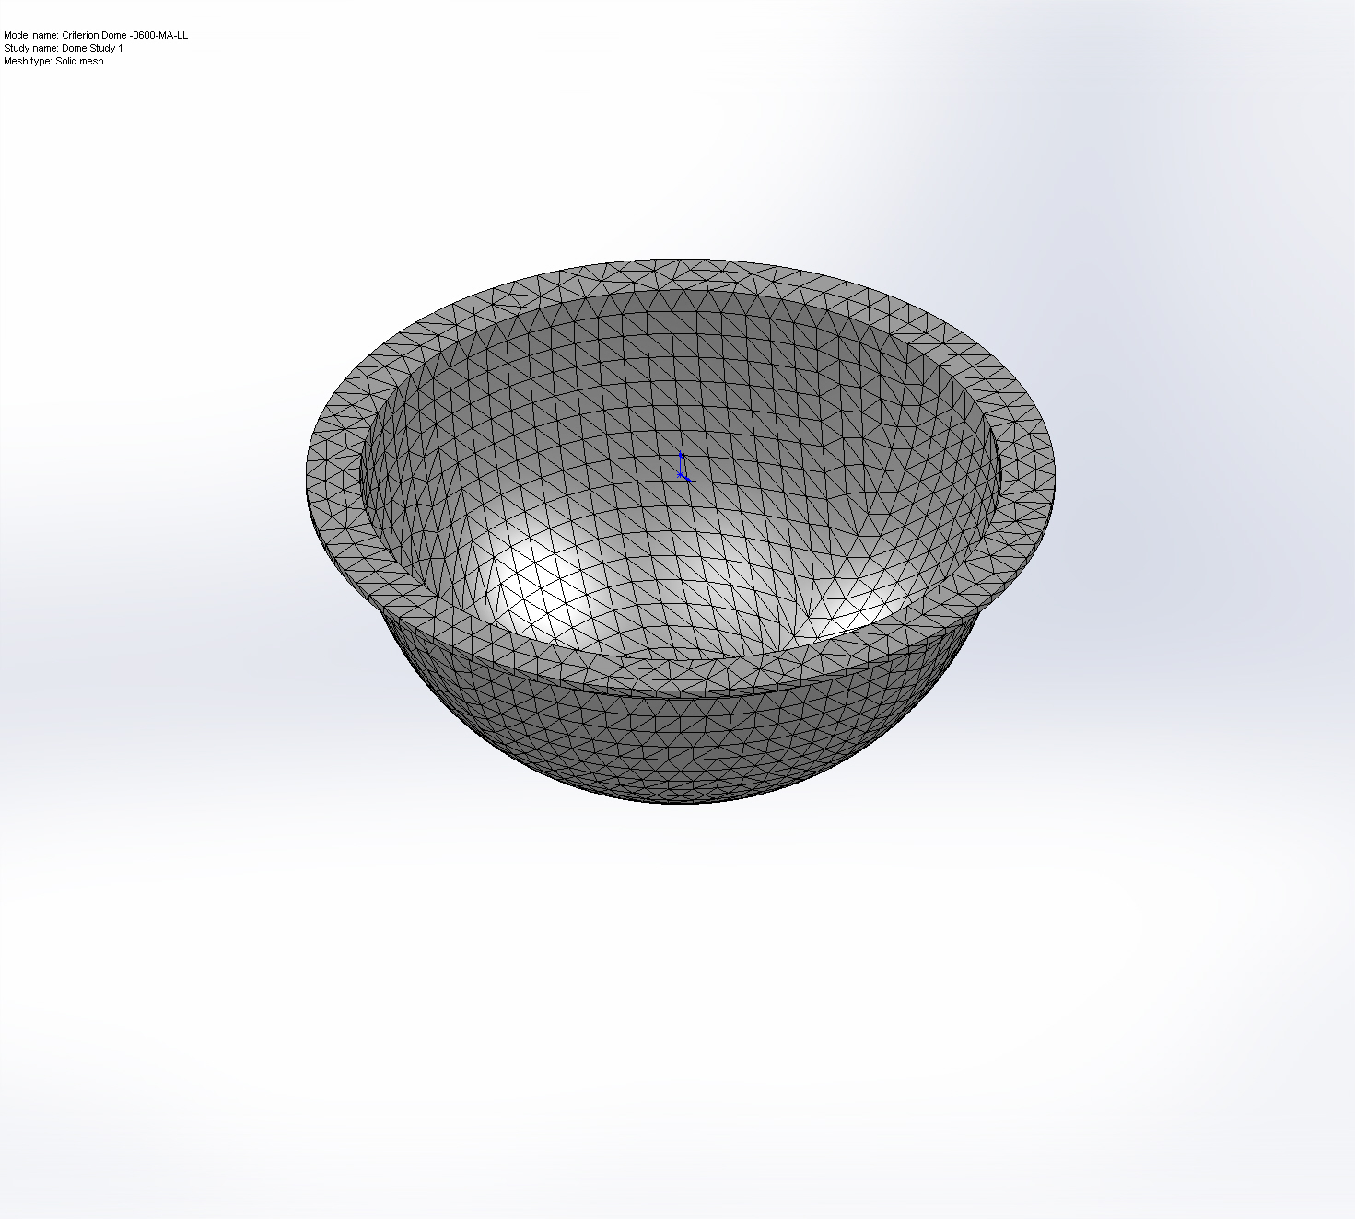

Sensor Details
No Data

Resultant Forces

Reaction Forces
Selection set | Units | Sum X | Sum Y | Sum Z | Resultant
Entire Model | N | 0.0122389 | -4606.87 | 0.0184584 | 4606.87

Reaction Moments
Selection set | Units | Sum X | Sum Y | Sum Z | Resultant
Entire Model | N-m | 0 | 0 | 0 | 0

Beams
No Data

Study Results

Name | Type | Min | Max
Stress1 | VON: von Mises Stress | 0.137087 psi  Node: 4613 | 951.111 psi  Node: 5645
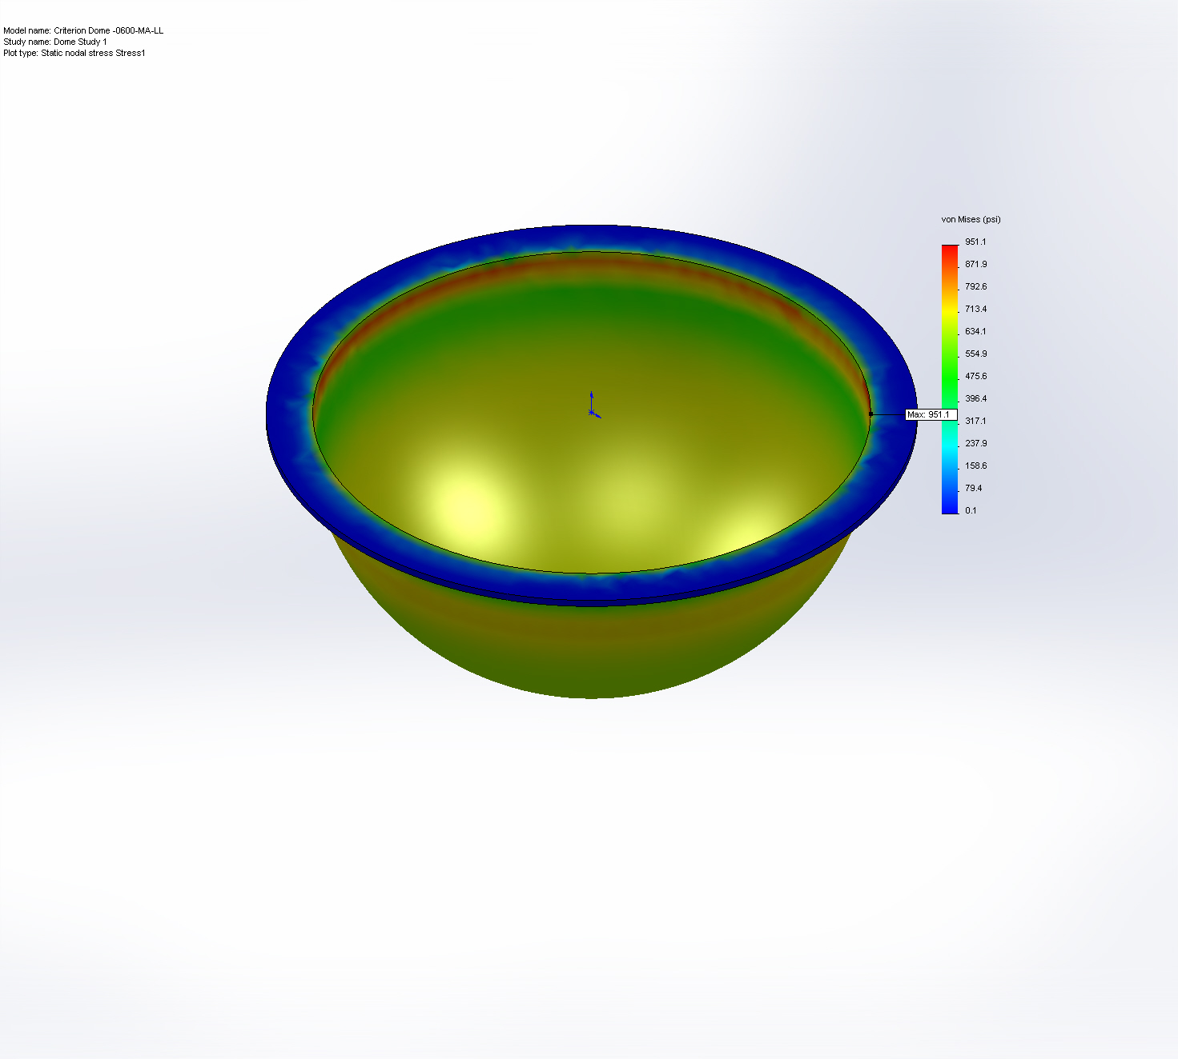
Criterion Dome -0600-MA-LL-Dome Study 1-Stress-Stress1

Name | Type | Min | Max
Displacement1 | URES: Resultant Displacement | 0 in  Node: 952 | 0.00443561 in  Node: 994
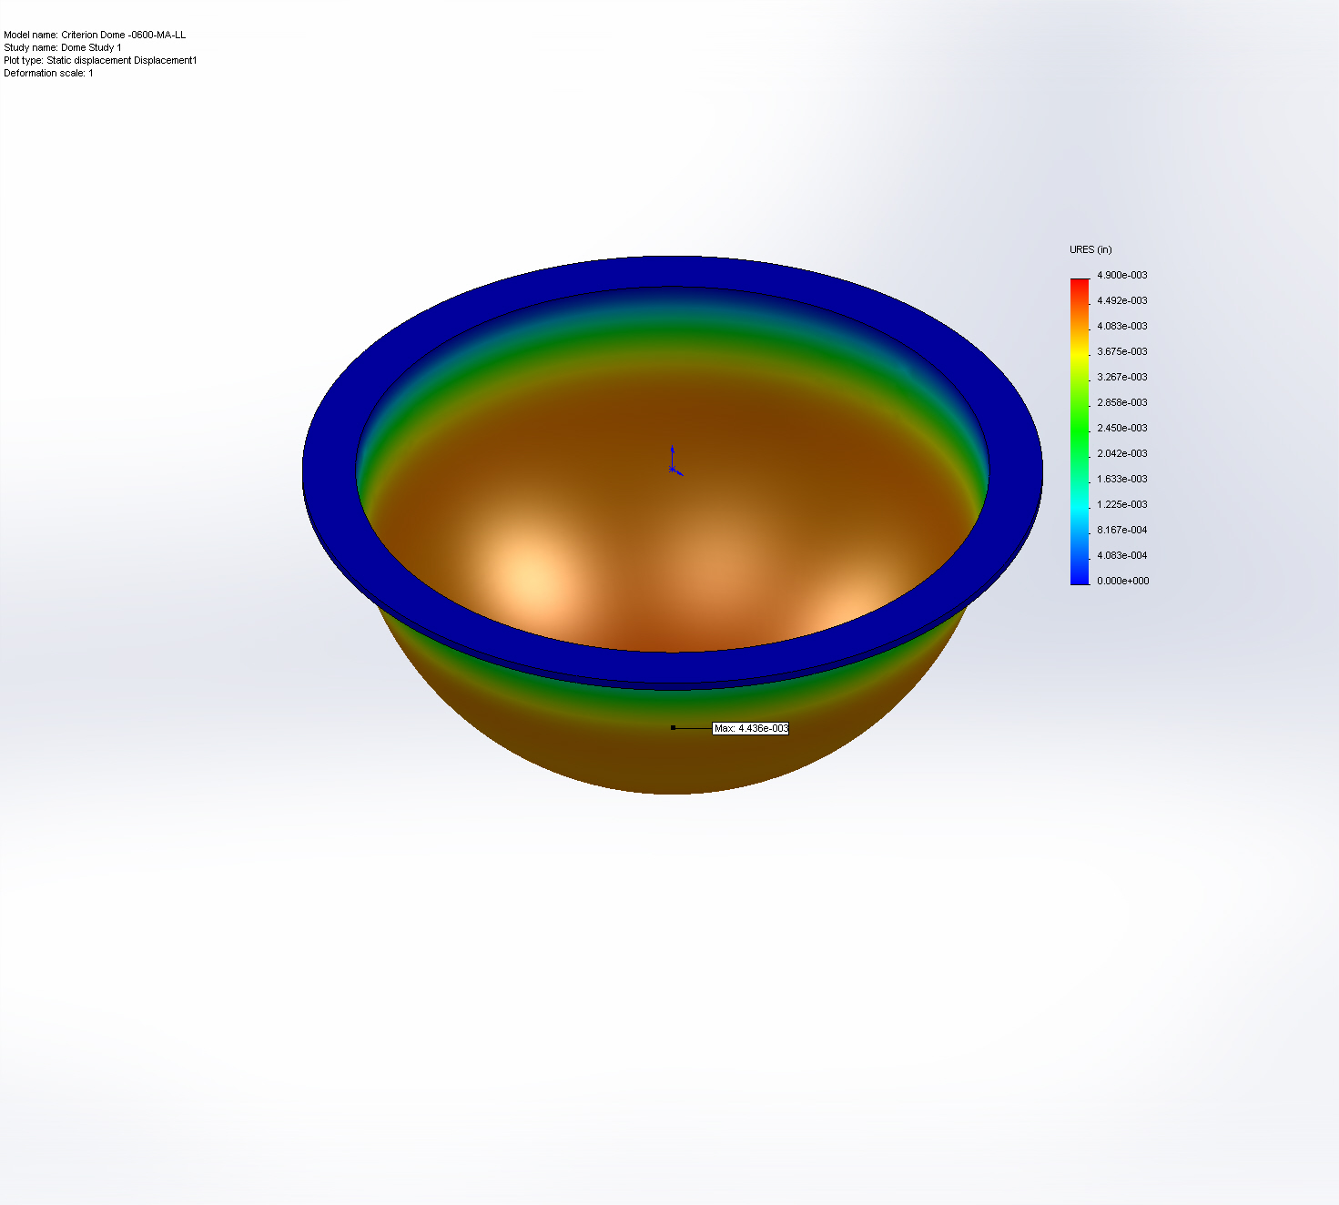
Criterion Dome -0600-MA-LL-Dome Study 1-Displacement-Displacement1

Name | Type | Min | Max
Strain1 | ESTRN: Equivalent Strain | 4.95199e-007  Element: 5442 | 0.00232956  Element: 5970
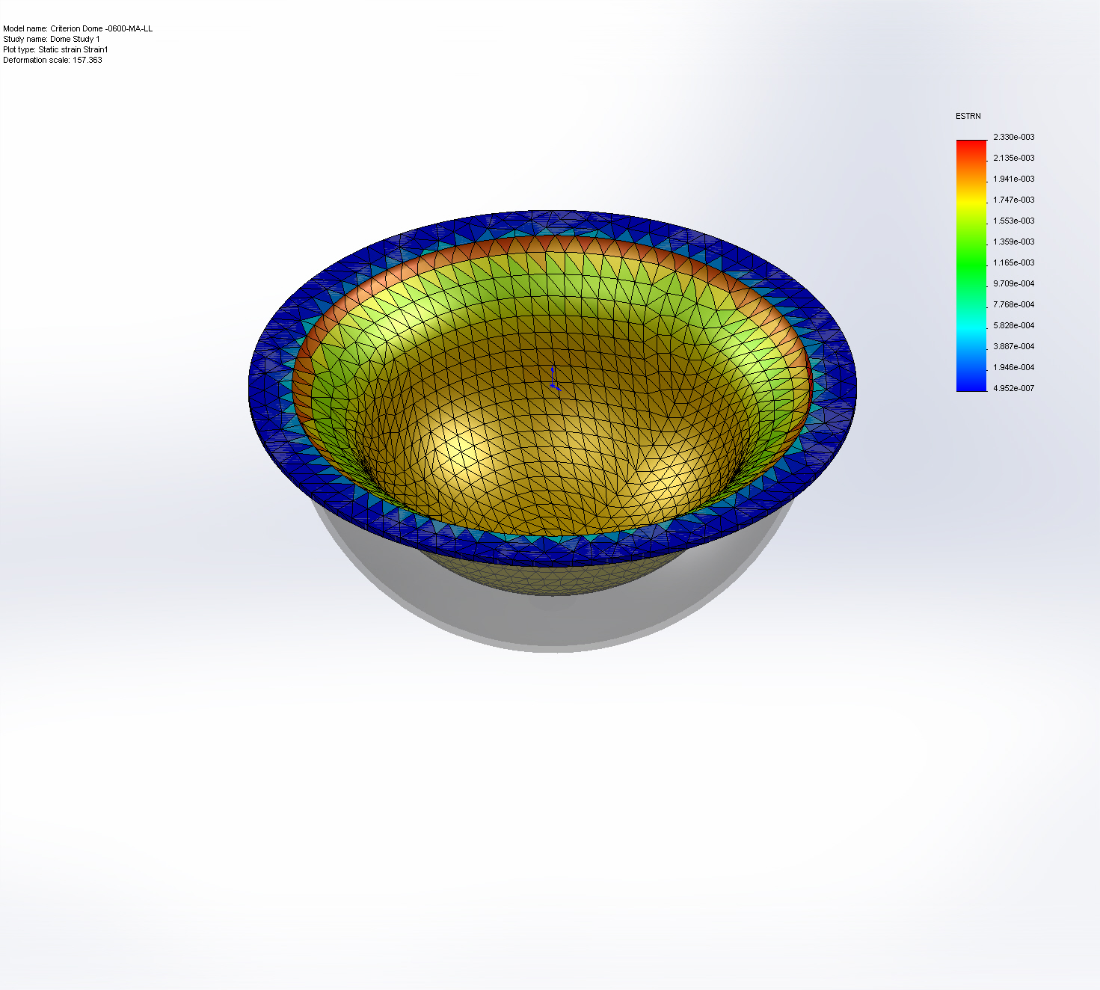
Criterion Dome -0600-MA-LL-Dome Study 1-Strain-Strain1

Name | Type
Displacement1{1} | Deformed Shape
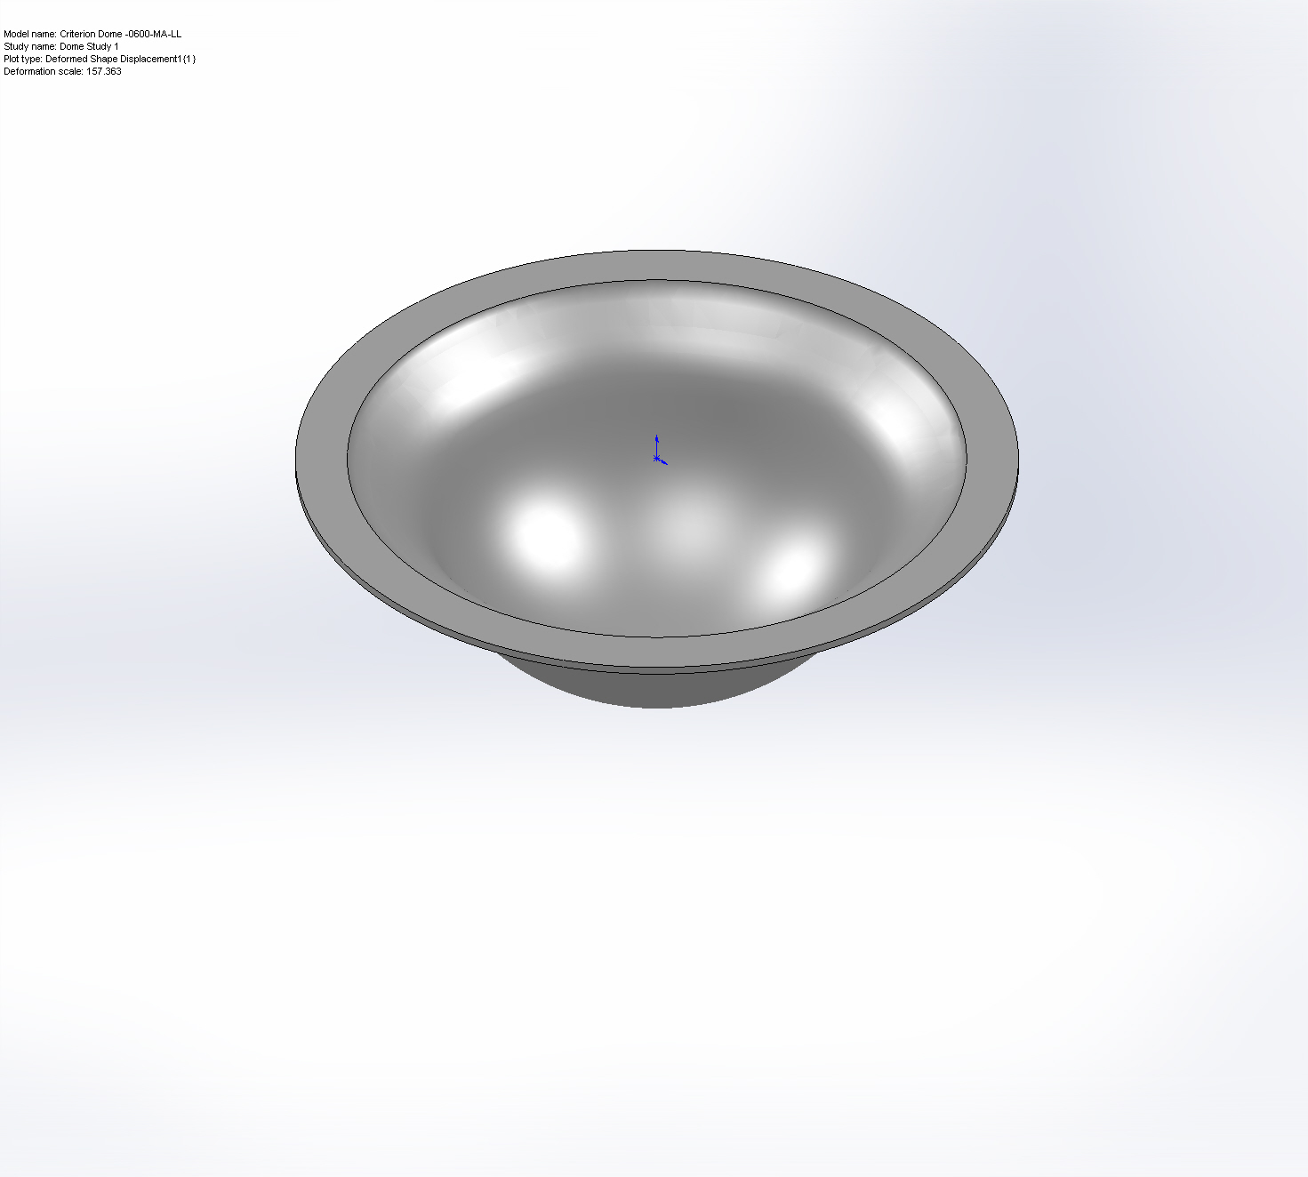
Criterion Dome -0600-MA-LL-Dome Study 1-Displacement-Displacement1{1}

Conclusion

