Directions:

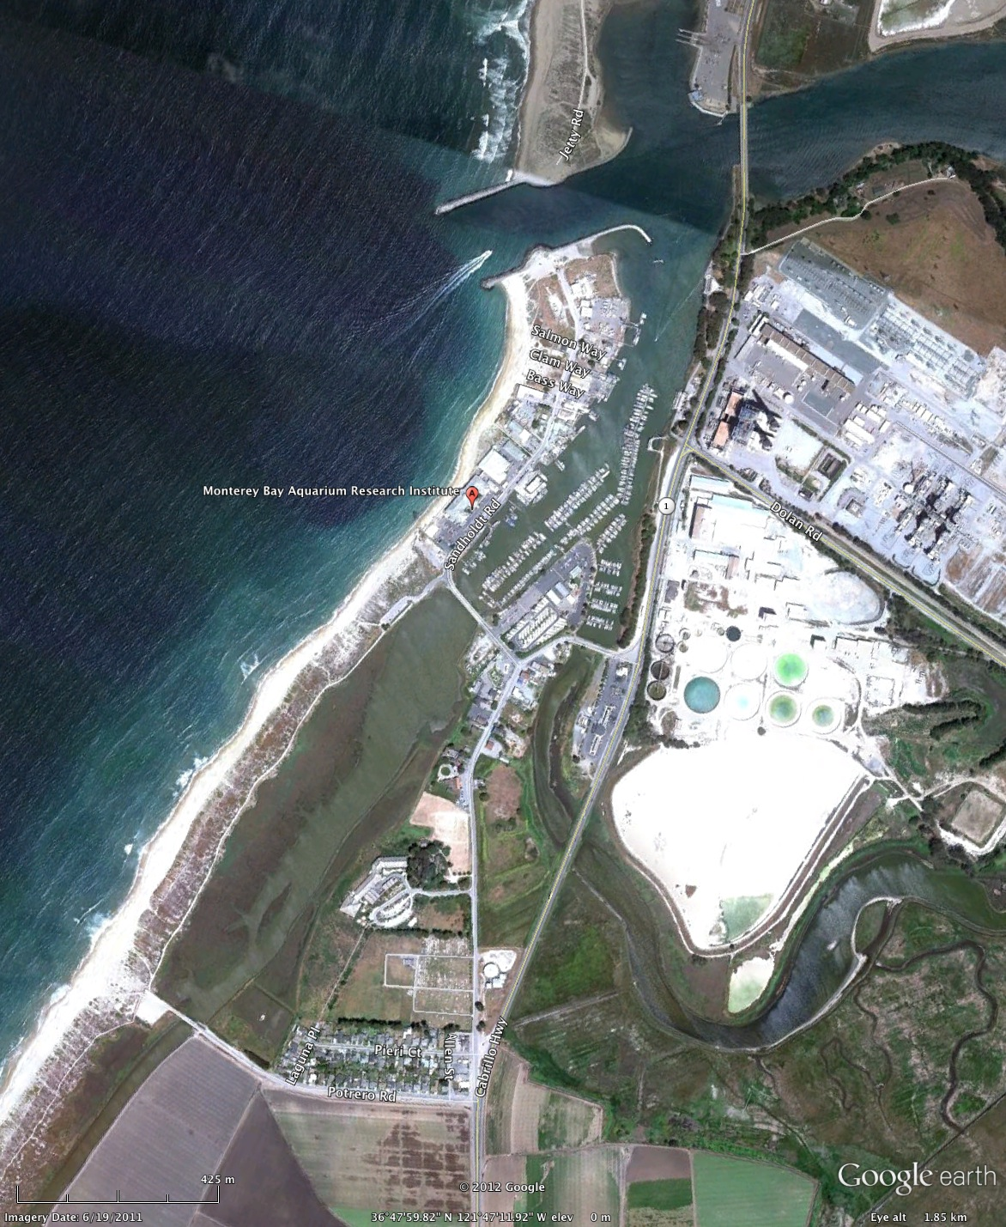

Parking
Enter through main gate at 7700 Sandholdt Road
Park in visitor parking, enter through main door
Sign in at reception
Proceed to Pacific Forum Auditorium upstairs
Pacific Forum
(Upstairs)

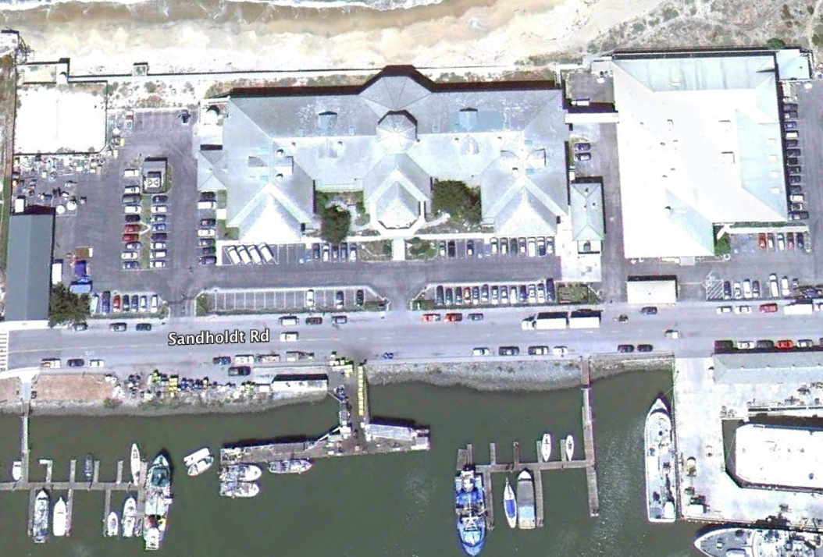
Main
Entrance

