12/10/13
LARGE DIAMETER PVC PIPE ENCLOSURE ASSEMBLY
Electronic Housings: Off The Shelf- PVC 8” and 10” pipe and fittings.

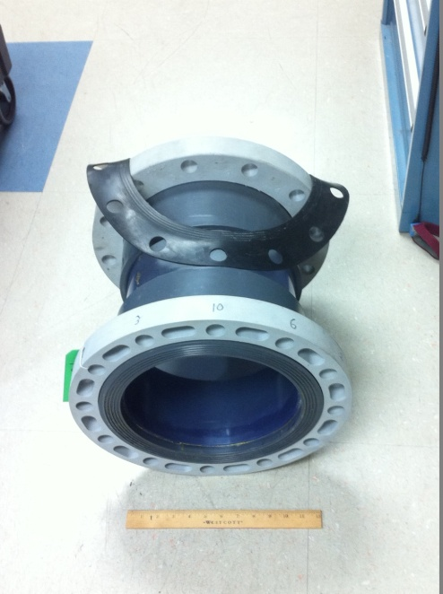
These Housings are inexpensive, relatively easy to assemble, and extremely robust.
Components are available at various prices and accessibility.
Most are Sch. 40 with pressure ratings varying from 70psi (clear pvc pipe) to 150 psi( gray or white pvc).
Some of the flanges are Sch. 80. Pressure ratings are published for the INTERNAL pressure if the proper bolts are installed and torqued as stated on the van stone flanges. ( For the 10”flanges---12 x 7/8” bolts Torqued to 65 ft-lbs. )
HOWEVER, Since we are using these components as 1 atm. Housings in SHALLOW WATER, we can install much smaller bolts. We have installed 3/8” hardware, torqued to 16 ft-lbs successfully on 10” flanges. Since PVC is slightly stronger in compression than in tension, It can safely be used as a 1 atm. Housing to 70 psi (clear PVC pipe) 45 meters depth or 140 psi(gray or white (PVC Type 1)) 95 meters depth with about 3x factor of safety.
The 8” components are half to a third the price and are much easier to locate and assemble. Sometimes even available at a local agricultural or industrial plumbing supply store.
NOTE: Large diameter PVC pipes need to be carefully glued with heavy duty PVC cement, with proper procedures and pressed completely together. This instructional video about Solvent Welding Large Diameter PVC pipe was very helpful-http://www.weldon.com/howtovideo#.

PREPARE THE PARTS- P2
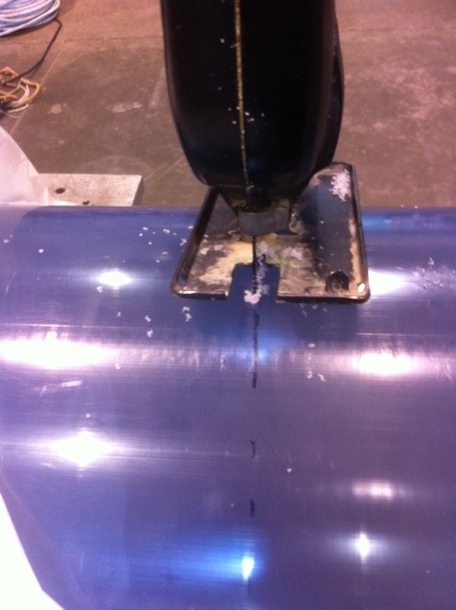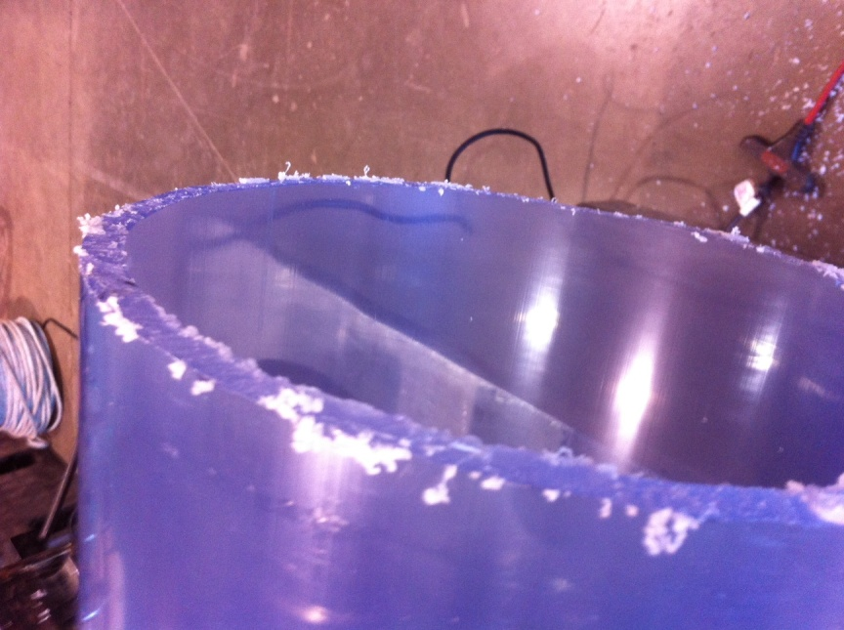
The pipe sections are cut to length square as possible and the edges beveled, sanded and cleaned.

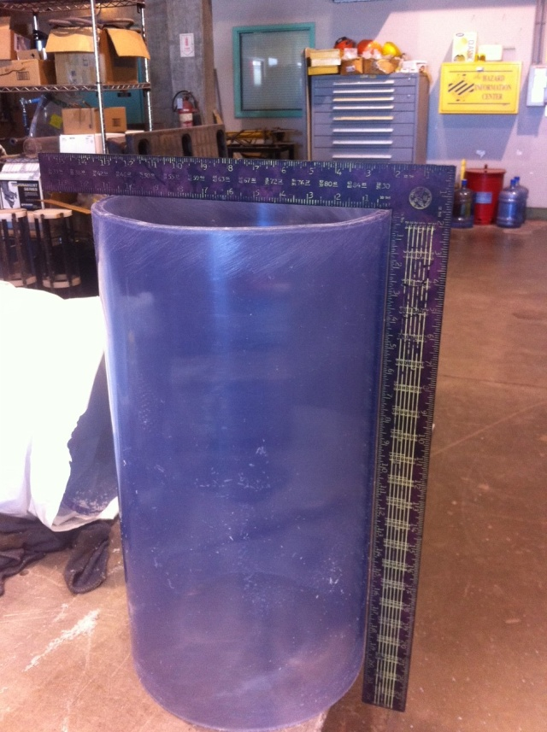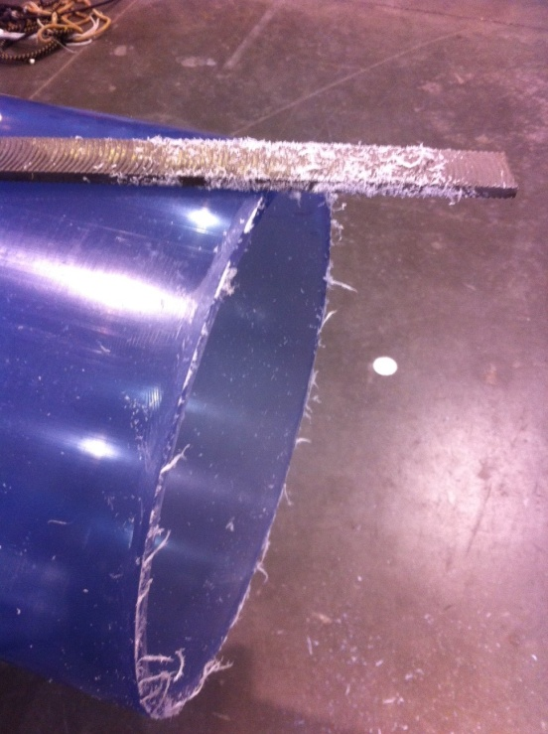

P3
The Van Stone Flange inside bonding area has to be sanded and cleaned as well.
Heavy duty cement, Primer, and large brushes are assembled. Follow the vendor’s instructions for cleaning, sanding, prefitting of parts. Mark on the pipe the full insertion depth. Cement only needs to thoroughly cover bottom half of flange socket and pipe.

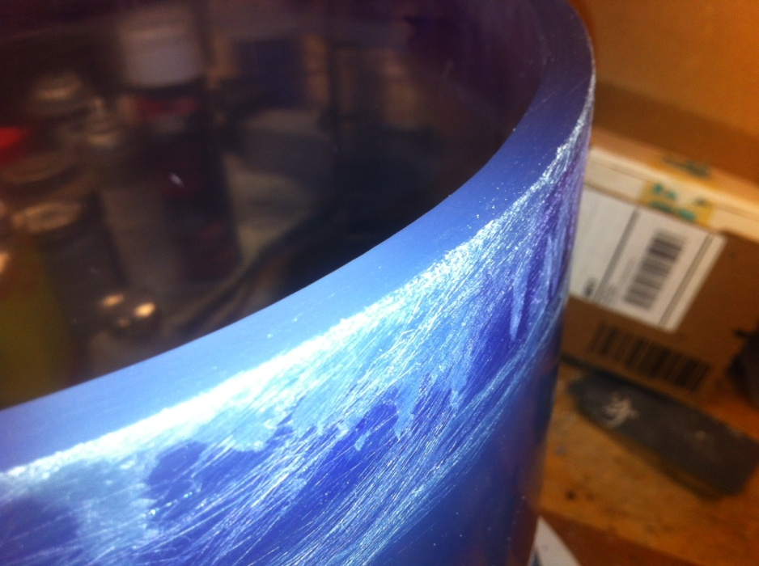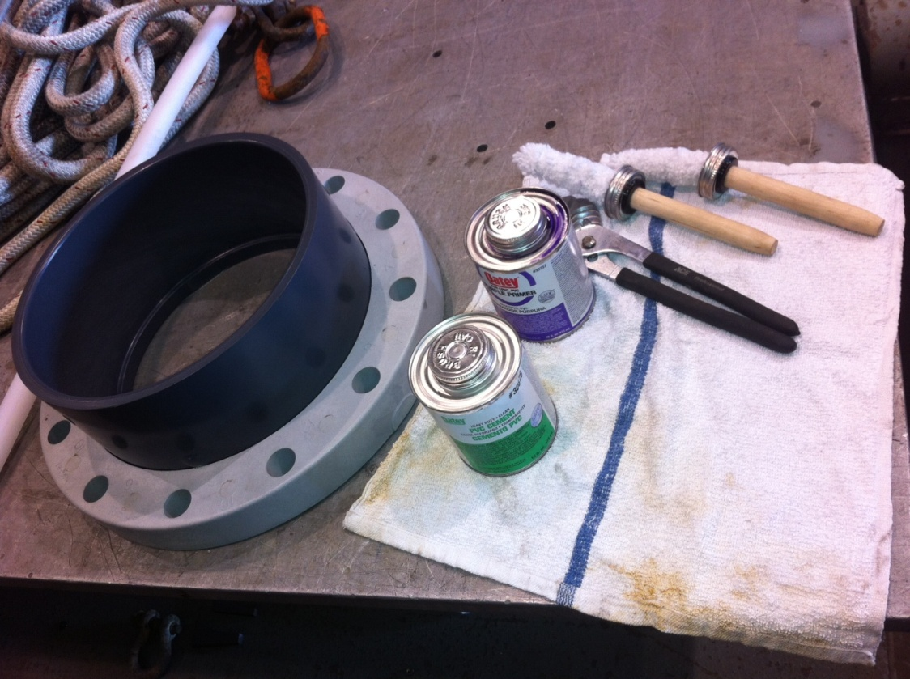

Part assembly has to be done quickly once the cement is applied so have two people ready to stand on a plate across the upper end. Following 1st image shows pipe fully engaged when assembled. A press (photo) is handy but not necessary.

P4
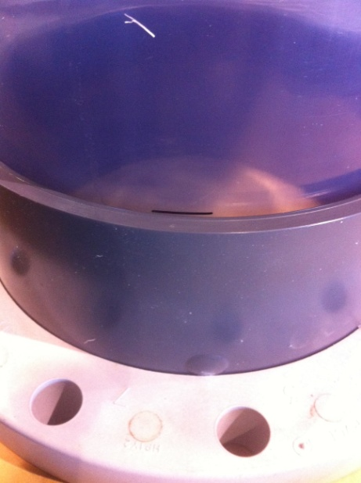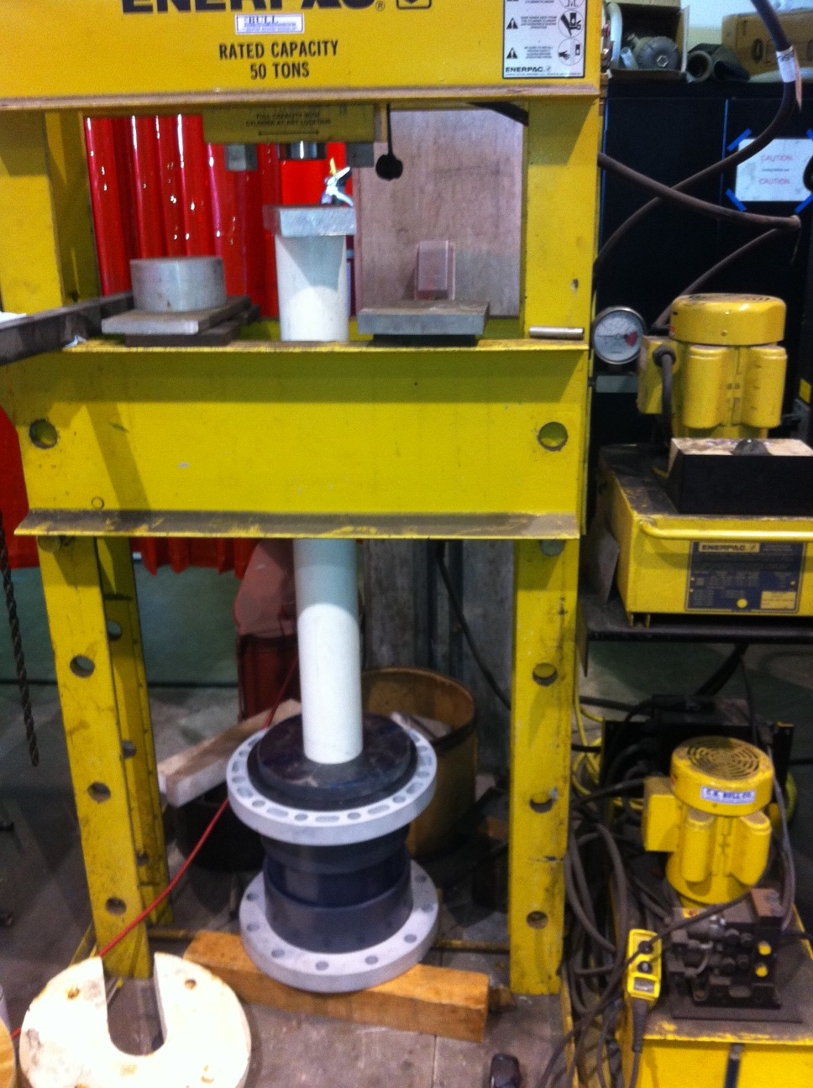
At least 300lb of force was required for the 10” assemblies. It can be done with 2 people standing on the end cap. 8” would be much easier.
NOTE: The flanges were done separately, with several hours between them.

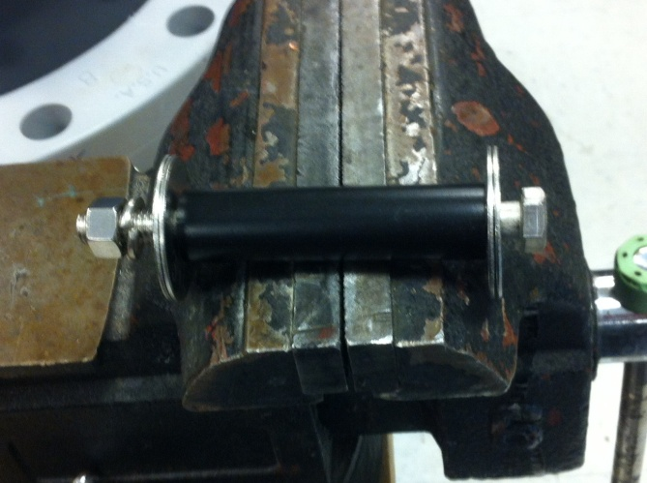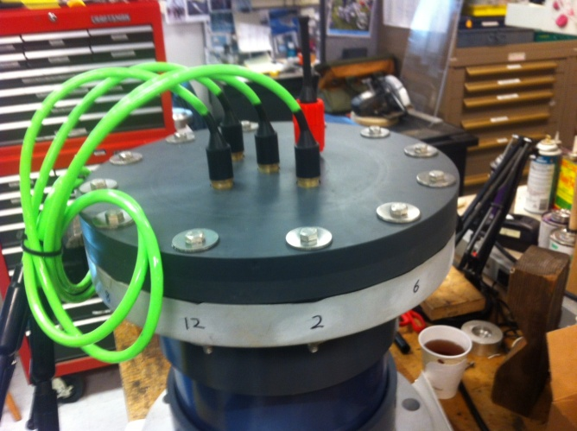
¾” spacers and Bolted ass’y with 3/8” 316SS hardware, washers are doubled up for strength.
ADDITIONAL NOTE: Heat dissipation is a big issue with plastic housings, please see info in the swFOCE Library about MBARI designed Cu/Ni Alloy heat transfer rod arrangements for Heat Dissipation thru the end caps.
P5
PVC Housing Component Prices

All parts Sch 40 exc. McM-C flanges and Spears Blind End Caps
PART 8” 10” SOURCE

Pipe clear PVC $50/ft $81/ft McMaster Carr
Pipe gray PVC $23/ft $31/ft
Gasket-Full Face, nitrile $14 $21 AllState Gasket
Gasket-FF, viton $53 $70
VanSTone, adj.flange, socket $41 not avail. McMaster-Carr
VanSTone, adj.flange, socket $167 $217 Spears
VanSTone, adj.flange, socket --- $115 United Eqpt & Fab
VanStone, blind endcap $282 $471 Spears
VanStone, blind endcap(CPVC) --- $236 KSCDirect

As a reference, here is a link to a Price list from Spears mfg. Co., a major supplier.
http://www.spearsmfg.com/super_sourcebook/SSB-1%20Part%201%20List%20Price%20Catalog/015%20Pipe%20Flanges%20Schedule%2040.pdf
It pays to shop around as prices varied. Check local Agricultural/Irrigation Suppliers as well.
Our experience is to recommend 8” max. if at all possible.

