shFOCE Enclosure and Ducting as an xFOCE implementation by MBARI 7/7/14

Herein are some images of the 0.5m x 0.5m x 2m experimental and control chambers, subsea frame, 25 cm. ducting and filters MBARI is deploying for shFOCE. Sandy bottom, 15m deep, moderate wave and currents. The chambers were fabricated primarily with hand and common shop tools, 316 SS fasteners and latches. The chambers are 3/8” Acrylic, 3/16” clear PVC angle (outside), ¾ x ¾” UHMW bars (inside) and EDPM bottom rubber seals. The frame is FRP, PVC angle, and 3/16” Polycarbonate vertical sealing skirt. A device for providing wave driven oscillatory flow inside the chambers is in some images, (perturbulator).
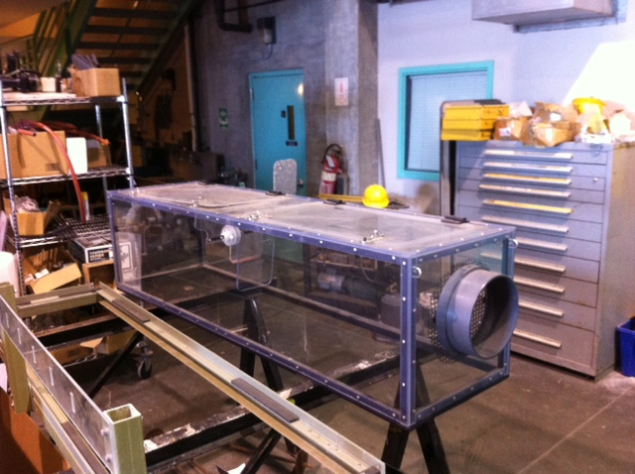
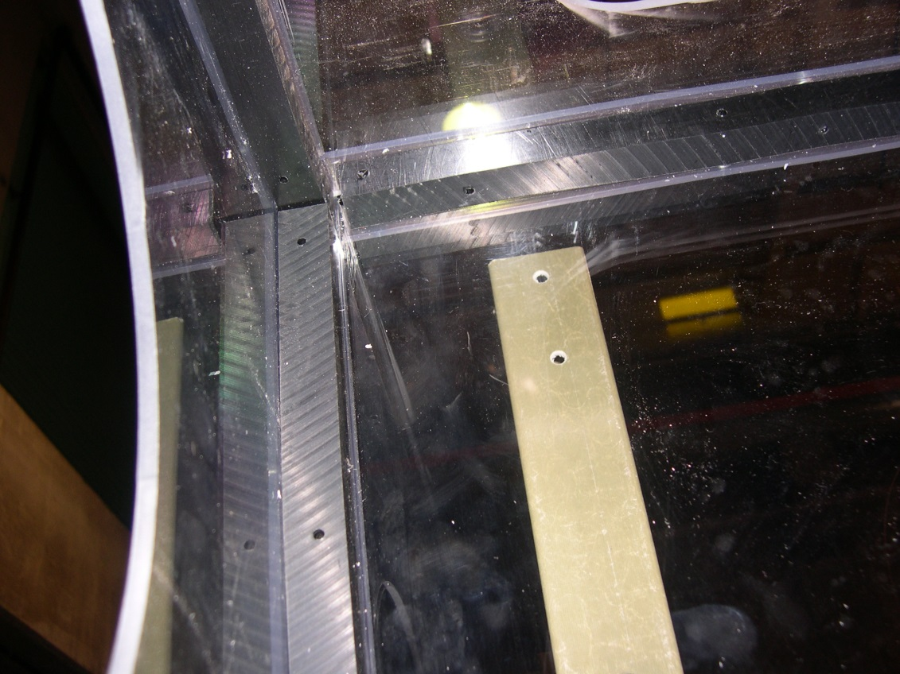
UHMW inside reinforcing
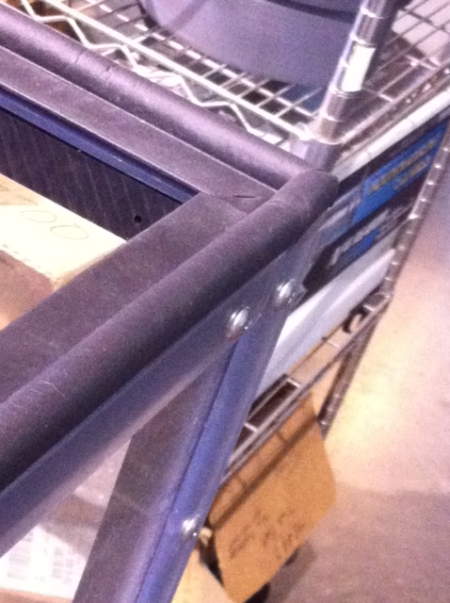
EDPM seal w/Acrylic adhesive on bottom edge

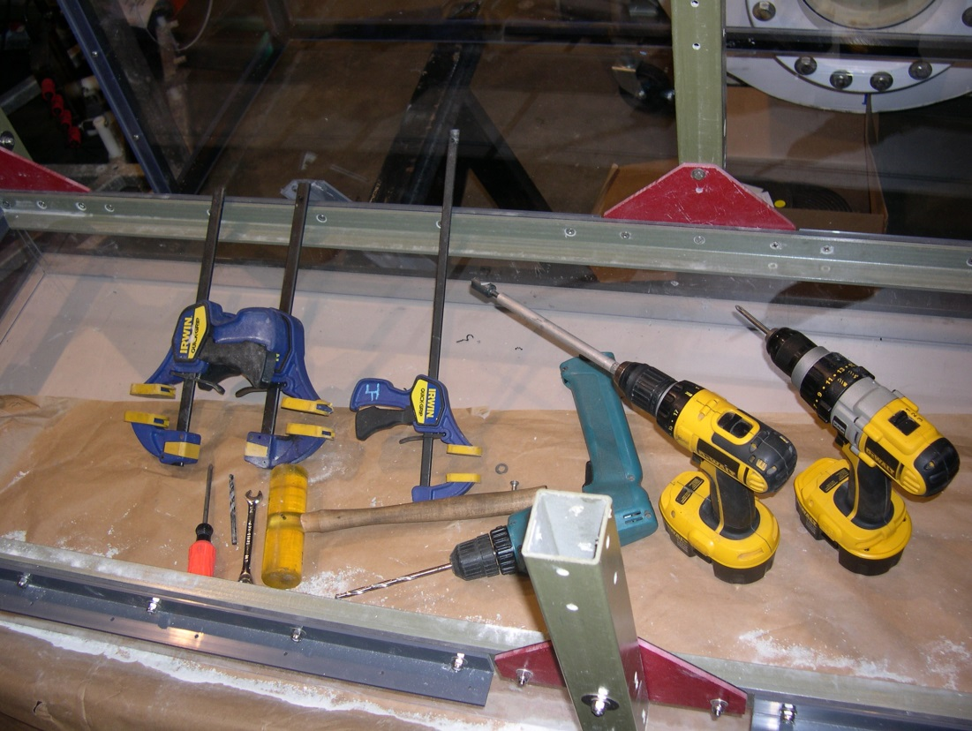
Frame-when anchored to the seafloor, allows chamber replacement as necessary

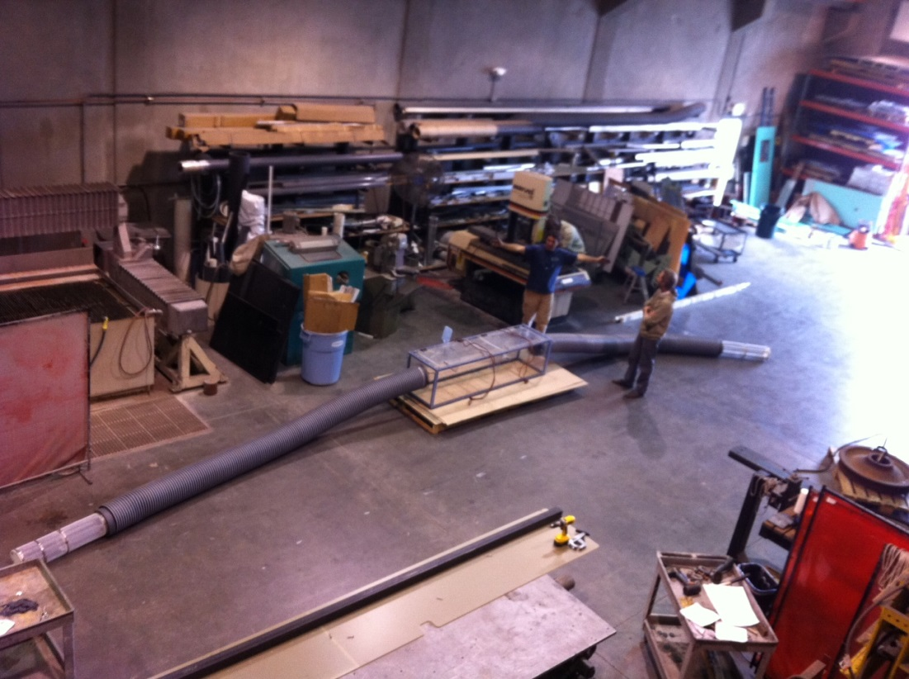
Control enclosure with 10” ducting and filters

