ANCHORS / Anchoring

- Plow anchors:
C.Q.R. anchor, 240 percent
Danforth and Bruce, 250 percent
Delta, 270 percent
- Pivoting fluke anchors:
Danforth Standard and Dan-forth Deepset (standard version), 520 percent
Danforth Deepset (high-tensile version), 540 percent
Danforth Hi-Tensile, 550 percent
Fortress, 560 percent
Be aware, however, that holding power is not the only criterion for an anchor. Stowage, handling, and (especially) penetrating power also are important.
Read more: http://www.answers.com/topic/holding-power#ixzz1pDjwmpTU

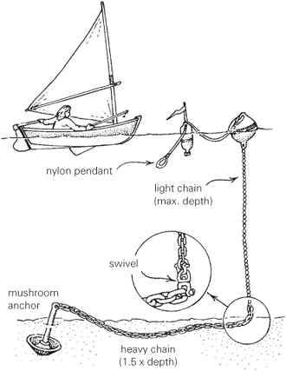

All anchors are compared with a traditional fisherman’s anchor, which is given an arbitrary holding power of 100 percent.
- Plow anchors:
C.Q.R. anchor, 240 percent
Danforth and Bruce, 250 percent
Delta, 270 percent
- Pivoting fluke anchors:
Danforth Standard and Dan-forth Deepset (standard version), 520 percent
Danforth Deepset (high-tensile version), 540 percent
Danforth Hi-Tensile, 550 percent
Fortress, 560 percent
Be aware, however, that holding power is not the only criterion for an anchor. Stowage, handling, and (especially) penetrating power also are important.
Read more: http://www.answers.com/topic/holding-power#ixzz1pDmlLLhG

Sizing of Anchors  Helix anchors can be sized according to your holding requirements. Typically, the soil and holding requirements dictate the number of helices and length of the anchor. Each helix plate acts as a separate anchor, using the soil above it to achieve holding power. With our specialized equipment, we can determine the holding achieved by each anchor while it's being turned into the substrate. | 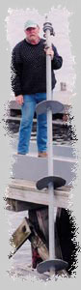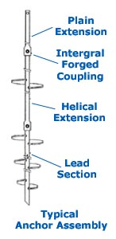

How Do Helix Anchors Compare?
Following is a chart produced by BoatUS Insurance. They conducted an independent test on the various types of permanent mooring anchors on the market and found the helix anchor to offer the greatest holding. The cost of the helix anchor and installation per pound of holding power was clearly the most favorable. See chart below.

Mooring Type | Helix | Dor-Mor  anchor  650 lbs | mushroom  500 lbs | single  block  2k lbs | double  block  8k lbs
Resisting Force  (lbs.) | 12,000 | 4,500 | 1,200 | 800 | 4,000
Water Depth | 20 | 18 | 15 | 14 | 35
Scope | 4:1 | 3:1 | 3.5:1 | 3:1 | 3:1
Est. Cost | $850 | $1,125 | $1,100 | $350 | $550

Additional Holding with Less Scope  In cases where more holding power is required, a three point system can be installed to triple the holding of what the single helix offers. Bridled together and sized accordingly, these systems can be engineered to securely moor very large vessels.  This type of mooring also offers the advantage of cutting down on the size of the swing radius of the vessel by lessening the amount of scope required.  Flotation can be added to keep the ground tackle off the bottom, causing far less damage than the conventional long scope chain. | 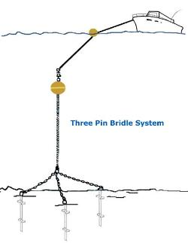
For additional information about Helix Anchors and Helix Anchoring Systems go to: www.helixanchors.com

Why Helix?

Helix mooring anchors are far superior to all other mooring anchors on the market. BoatUS Insurance and Cruising World Magazine have conducted pull tests to compare the holding power of the typical anchors used to moor boats. Their findings have proven that helix anchors have 4 to 5 time the holding power compared to all the alternatives. A single helix anchor, properly installed, can withstand the pulling force of a 800 hp Tug boat. Many different test pulls, with strain gauges in the line have registered in excess of 20,000 lbs of holding.  Embedment Anchor Benefits  - Higher holding power  - Shorter scoping  - Allow for suspended ground tackle  - Longer lifespan  - Virtually no bottom disturbance  Attributes  - Made with high grade steel  - Drop-forged connections  - Hot-dipped galvanizing  - Major USA manufacturer  - Wide variety of sizes and lengths  - Tension capacities of 100,000 lbs.  - All welding done prior to galvanizing  - US- Crosby shackles  - Anchors are easily transported | 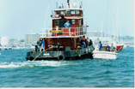
 | 

Holding Power  These anchors have far greater holding power than conventional mooring anchors, allowing vessels both large and small to use them. | 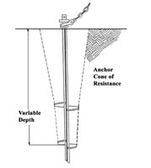
Mooring Type | Helix | Dor-Mor  anchor  650 lbs | mushroom  500 lbs | single  block  2k lbs | double  block  8k lbs
Resisting Force  (lbs.) | 12,000 | 4,500 | 1,200 | 800 | 4,000
Water Depth | 20 | 18 | 15 | 14 | 35
Scope | 4:1 | 3:1 | 3.5:1 | 3:1 | 3:1
Est. Cost | $850 | $1,125 | $1,100 | $350 | $550

Solid Substrate Anchoring

When we hit solid substrate, we use embedment pins/reef pins...
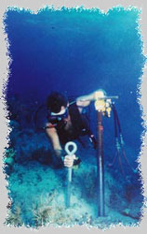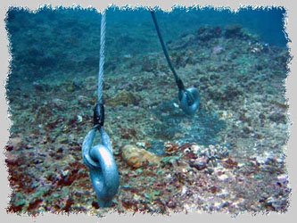

Dor-Mor Anchors
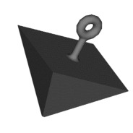The Dor-Mor anchor is a patented, pyramidal-shaped anchor that is designed to penetrate the bottom and prevent dragging. The one-piece cast iron anchor is used to moor boats, large and small buoys, docks, oceanographic equipment, containment booms, nets, aquaculture pens, and much more. These anchors have proven so effective that the US Coast Guard is replacing their concrete sinkers with Dor-Mors!
Dor-Mor anchors are most appropriate for:
- Moving water sites such as rivers and coastal areas
- Where the moorings will be frequently moved
- Mooring scopes of 3:1
Here is how the Dor-Mor anchor compares to two other popular types of anchors in a 3:1 scope mooring
- Approximately 10 times the holding power of a concrete anchor of similar weight
- Approximately 2 times the holding power of a mushroom anchor of similar weight
Here are some of the design attributes that make the Dor-Mor anchor work so well:
- Cast Iron design loses only 14% of its weight in water vs. 45% for concrete
- Large surface area of the pyramid shape has a high suction effect when dragged
- Chain wrap is minimized by the short shank design (as opposed to the long shank of mushroom anchors)
- The large diameter size is designed to accommodate the proper sized shackle for the mooring weight
The Dor-Mor anchor is available in sizes ranging from 15 lbs to 4,000 lbs. For our Watermark buoys we make the following recommendations:
 | Lake Mooring | Slow River | Fast River/Coastal Area
WNS-1060 | 15 lbs | NA | NA
WNS-6000 | 15 lbs | 15 lbs | 35 lbs
WNS-7000 | 35 lbs | 35 lbs | 70 lbs
Dor-Mor anchors may not be the best option when:
- Using extremely short scopes (<2:1)
- The bottom is very rocky
- Concrete anchors are sufficient for applications in small lakes or ponds

West Marine 2006 (SAIL / Yachting Monthly)
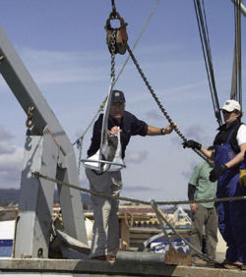
West Marine 2006 testing
In 2006, West Marine conducted a major series of anchor testing in California on sand seabeds. Their testing involved 14 anchor types in the 15 kg / 35 lb size range, three different real world underwater locations (with varying bottom types), and a real world rode connecting the anchors to the test boat.
In their 2007 and 2008 catalogs, they published a brief summary of this testing, including some very brief summary comments relating to each anchor. These are quoted in the table below, together with the details of each anchor tested.

Methodology

Sizes and types
The anchors chosen were as above in the small to mid-sized range, around 15 kg / 35 lb. An unfortunately common mistake was made by the inclusion of varying materials, i.e. mixing aluminium with steel anchors, with the Fortress and the Hydrobubble. The aluminium Fortress FX-37 tested is massive, and would weigh over 25 kg / 55 lb if it were built from steel. This is not to say that aluminium anchors are inherently more efficient – steel is used by most anchor types for reasons relating to durability and strength. Indeed, the Fortress was damaged during the testing! The two material types are not easily comparable, as they have different purposes and applications.
There was a significant variation in sizing with some of the other anchors also. Below, the results are shown in both their raw form, and scaled on a size-for-size basis.
The rode used was 1" (25mm) nylon rope with a 20' (6m) leader of 5/16" (8mm) chain, deployed at three different scopes of 3:1, 5:1, and 7:1. Anchors were pulled from a powerful motorboat capable of pulling all anchors to the force cap of 5,000 lb (2,270 kgf).

Locations and seabeds
Three locations with varying types of seabeds were chosen. This is fortunate and is an element missing from much testing. While an anchor might perform well in one or two pulls at a particular location, its consistency and reliability is not tested at all unless the same test is repeated at other locations. Some of the contenders did manage to record high pulls at least once or twice, but their average results are greatly damaged by failures to perform at other locations.
All seabed types were sand, generally firm and hard. This is one of the reasons that some of the old generation anchors could not be made to set reliably, and this makes a good testbed from which a harsh light is shone on those anchors which are not good all round types. Versatility is closely examined in this test.

Summary comments
Company | Anchor | Material | Weight (lb) | Comments verbatim from West Marine
Noteco | Bulwagga 27 | Steel | 28.6 | Held up to 3,000lb., engaged each attempt. Released and failed to reset at higher loads.
Lewmar | Claw 33 | Steel | 36.3 | Failed to set during this test. Maximum tension under 700lb., briefly.
Lewmar | CQR 35 | Steel | 38.5 | One promising set to 2,000lb., but little else. Would not engage bottom.
Lewmar | Delta 35 | Steel | 36 | Variable results ranging from around 1,500lb. to 4,500lb. Drags at limit.
NavX Corp | Fortress FX-37 | Aluminium | 21.9 | Generally held as much tension as we could throw at it. Was slightly damaged when pulled over 5,000lb. Excellent performance.
Anchor Concepts | Hydrobubble 45 SA | Alu & stainless steel | 16 | Surprise performer based on small size and weight. Held over 5,000lb. twice, also held to 1,600lb twice and released.
Manson Marine | Manson Supreme 35 | Stainless steel | 35.9 | In six pulls never held less than 2,300lb, and held over 5,000lb three times. Seemed to engage the bottom immediately.
SPADE | Océane 35 | Steel | 38.2 | Highly variable results. After four disappointing results, the Océane held over 5,000lb on the last two pulls. Puzzling.
Rocna Anchors | Rocna 15 | Steel | 32 | Superb, consistent performance. Held a minimum of 4,500lb and engaged immediately.
Anchor Right | SARCA #5 | Steel | 33 | Medium performer that held in the 2,000lb range and either released or dragged. One pull to 5,000lb.
SPADE | Spade S80 | Steel & lead | 34.4 | Somewhat mixed results with three OK pulls, and three maximum pulls. Set immediately each time.
WASI | WASI 35 SS | Stainless steel | 32 | Varied results from 1,300lb to maximum tension. Failure mode was generally dragging.
West Marine | West Marine Performance 20 | Steel | 26.3 | Disappointing results considering previous tests. Held 200 to 1,500lb, but could not get a secure grip.
XYZ Marine | XYZ | Stainless steel | 10.6 | Could not get anchor to work. One pull at 900lb, but mostly dragged on the bottom.

Helix anchors will not penetrate solid rock or coral. When we encounter these substrates, we drill a hole with hydraulic equipment and use a two-part epoxy to secure our galvanized steel pin. This method can achieve optimum loading.
When higher loads of holding are required, we can engineer the mooring tackle to suit the situation.
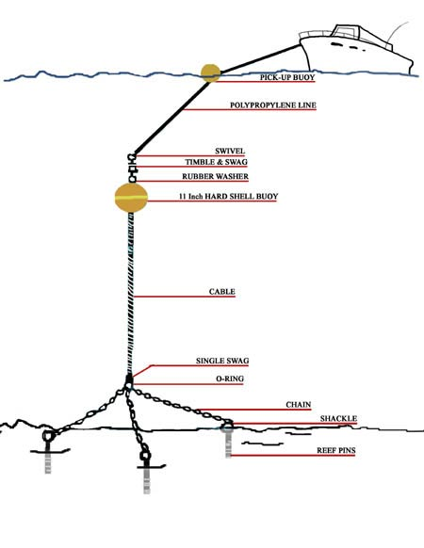
ANCHORS & MOORING
There are three general categories of anchors: the lunch hook, the working anchor and the storm anchor. A lunch hook is an light anchor that is set for short stops when the crew remains alert. The working anchor is used for standard anchoring. A storm anchor is used in heavy weather and can be of any type, as long as it is very heavy.
Anchors can be further defined as burying and non-burying. Non-burying anchors hook onto rock or thick grass and weeds, and must re-hook if the boat swings (Grapnel and Fisherman). Burying anchors dig into soft bottoms and well designed ones hold if the boat changes position (Mushroom, CQR, Danforth). These are usually lighter than non-burying anchors because they dig into the seabed. Many modern designs have characteristics of each (Bruce and Delta).
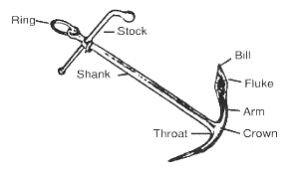
It is important to understand what anchors do for you on the bottom. A good anchor should be able to (1) gain a hold in the bottom below you, (2) it must be able to provide holding power sufficient to keep the boat from dragging it, and (3) it should be able to either maintain or regain its hold when the wind or current changes the direction of pull.
The last point is critical because the wind and the current frequently change, and it is nearly impossible for an anchor to be effective in a full 360 degrees circle. Your anchor should be able to break-free and re-set itself securely. Not all anchors will do this. A fisherman's anchor, for example, will frequently foul its rode on its fluke or stock with a change in direction, a CQR may not get a bite if being dragged slowly, and a Danforth style is likely to be caked with mud or clay when it breaks-free and may take some time to reset. Note that some anchors have moving parts, which if jammed will not re-set.
It is hard to find an anchor that does not have at least a few limitations. Seek a primary anchor that fits your routine needs and can be used in a range of bottoms. Secondary and storm anchors can be selected to compliment the primary anchor with varying bottoms and conditions in mind. It is a good idea to have two working anchors one designed for hard bottoms and one designed for soft bottoms.
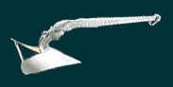
Plow-Type (CRQ): The plow is a seasoned design from the early 1930's, with characteristics of a hooking anchor and plow-shaped flukes for holding in soft sand and mud. The hinged shank allows a wide degree of effectiveness, but it may not reset well if it does break free. It performs well at a scope of 5-to-1 of all chain or 7-to-1 of a nylon rode with a chain leader. The more scope the better. This anchor relies on weight to penetrate the bottom; the heavier it is, the more firmly it will set. The CQR, manufactured in Scotland by Lewmar, is widely recognized; however, there are other version of the anchor type, with varying quality. Lewmar recommends a 35# CQR for a 40 - 50 foot boat. The CQR Anchor
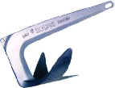
Claw or Bruce: Originally developed in the early 1970's, this is a one-piece cast steel anchor that is both strong and versatile. Large versions are used to secure giant drilling platforms in the North Sea. With it's three-pronged hooking design, this anchor will grab coral and ledge very well. Additionally, it's wide shape helps it to bury itself in the sand or mud. It's design makes it easy to set and it will hold at its maximum loading on quite short scope, 4-to 1 or even 3-to-1. Because it sets easily and quickly, it also resets easily when the wind or current changes. The limitation is low holding power, relative to its size and weight. For boats from 40 to 46 feet, Bruce recommends a 44# anchor. Bruce Anchors
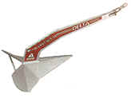
Delta: This relatively new design from the late 1980's, is a hybrid of the best of the CQR design and the Bruce. A one-piece steel casting (eliminating the hinge of the CQR), it is a hooking anchor in many ways similar to the Bruce, with superior holding statistics. Yet, it has a weighted point for penetrating mud, hard sand bottoms, and kelp that give it more versatility than it's three-pronged cousin. Like the CQR, it has flukes for holding in sand and mud, but the Delta's flukes are more obliquely angled and therefore present a broader, flatter surface than does the CQR providing greater potential holding for the same size and weight. However, this anchor has problems setting and resetting in soft bottoms. The Delta is rapidly developing a following among experienced cruisers. The manufacturer's sizing tables suggest that a 35# Delta is appropriate for boats from 40 to 50 feet in length, which is lighter weight than most other modern designs except for aluminum anchors (see Spade and Fortress below). The Delta Anchor
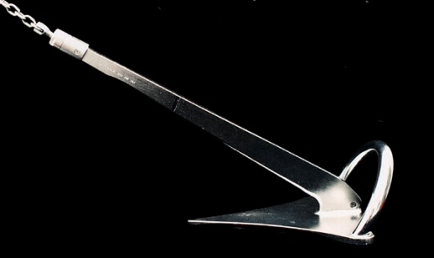
Buegel Anchor: This anchor has been very popular in Europe for some time and is gaining favor among US cruisers. The design is like a flat fluked Delta with a roll-bar to prevent dragging on it's side. It is suggested that the single flat fluke prevents a "plowing" action which allows the CQR and Delta anchors to plow through the bottom limiting their holding potential in sand and soft mud; following that logic the next better step might be the concave fluke (see below). The sizing chart suggests a 44# anchor to 10 tons and a 54# to 15 tons. Buegel Anchors

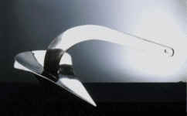
Spade Anchor: This is a recent anchor from the late 1990's which has only one tip like the CQR, Delta and Buegel, but the concavity is inverted to be spoonlike. As the concave profile moves through the bottom, it is designed to compact the sea floor material within its form, rather than sliding through it like a plow. Nearly 50 % of the anchor's total weight is applied onto the tip when the rode pulls on the shank. The goal of the design is to penetrate the sea floor, even into hard sand and through weeds. Spade recommends a slightly heavier anchor per boat length than Delta, but offers an aluminum version at less than half the weight of their steel offering -- the model 100 is 44# in steel and 20# in aluminum. Spade suggests a 44# steel anchor for boats from 36 to 52 feet with weights from 5 - 12 tons. Spade Anchor
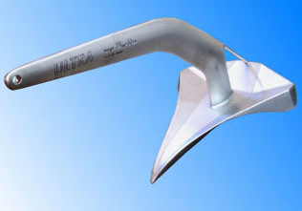
Ultra Anchor: This is a new century anchor which appears to incorporate the better features of the Delta and the Spade, offering the concavity of the Spade for holding power, a weighted tip like a Delta, with potentially superior penetration ability from its sharp hooked tip and contoured bottom. Ultra's tables recommend a 35# anchor for a 7 - 11 ton boat. My 39 foot 10 ton boat falls at the top of the Ultra range for a 35# anchor. Ultra seems to suggest an anchor weight to boat size ratio similar to the Bruce and Spade anchors; for my boat I would probably pick a 44# in any of these and the Ultra. Ultra Anchor
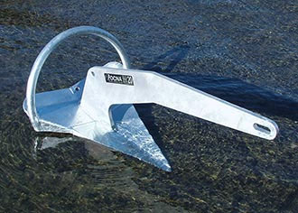
Rocna Anchor: This is another new century anchor offering the best features of the Delta and the Spade. Like the Ultra, this design offers concavity for holding power and superior penetration ability from its contoured bottom. A roll bar similar to the Buegel prevents the anchor from dragging on its side or upside-down. Rocna Anchors
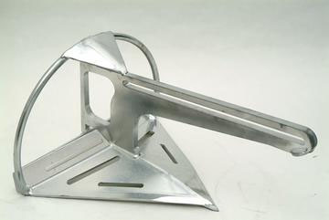
Sarca Anchor: This anchor offers the roll bar of the Buegel, a hooked tip like the Ultra, but a plow shaped convex fluke, with the ability for the rode to slide along most of the shank for easier recovery from rocky bottoms. SARCA stands for Sand and Rock Combination Anchor. I have not seen these available in the US. The manufacturer recommends a 48# anchor for boats from 5 - 11 tons, and a 55# anchor for boats from 11 - 17 tons. Sarca Anchors
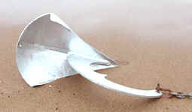
Oceane Anchor (modified Spade): It is modified from the Spade (above) for better performance on smaller boats, with the shank positioned farther toward the point, presenting a higher proportion of the effort on the point. It also has a "spike" on the shank designed to assists the shank's positioning on the bow roller. Océane Anchor
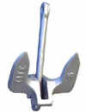
Navy Anchor: Inexpensive, and heavily-built double-fluke anchor. It relies heavily on weight for its performance. This is of the type known as the stockless anchors originating in the 1820's.
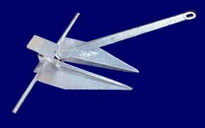
Danforth or Standard Lightweight: It is a light-weight more sophisticated version of the Navy double-fluked concept with a stock in the head, designed in the late 1930's. Danforth manufactures a substantial portion of these steel anchors in North America, with the name originating from one of the inventors. This double-fluke anchor gains its strength from its ability to bury itself quickly in soft sand and mud. The buried flukes then present a broad flat surface which prevents the anchor from dragging. Theoretically, in deep soft mud the anchor will continue to bury itself until it is many feet below the bottom level. A criticism is lack of ability to re-set, especially if fouled with mud and weeds. Danforth recommends a 43# anchor for boats from 40 -45 feet in winds to 20 mph, for their standard product although they offer several high-performance models with higher holding power in lighter weights. Danforth Anchors
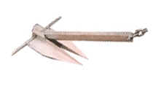
Fortress (ultra lightweight Danforth style): A relatively new light-weight anchor made of aluminum magnesium alloy, the Fortress has made it's name as a well crafted and reliable burying anchor. It is notable for its incredibly high weight to holding ratios. The newer models have adjustable flukes enabling you to either set it for sand and shell bottoms or for soft mud bottoms. In the latter conditions, ooze and swamp mud the Fortress may have no equal. This anchor disassembles and folds for storage. The manufacturer also offers the lighter-duty Guardian line of similar design. The manufacturer's tables suggest that a 15# Model FX 23 anchor is sufficient for a 39 - 45 foot boat, but separately suggests a 21# Model FX 37 to replace the holding power of a 33 to 50 pound steel anchor; is this a contradiction? Fortress Anchors
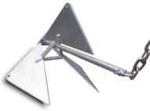
Bulwagga Anchor: This is a new design from the late 1990's. This anchor seems to have immense holding power in both sand and mud. In weeds, it is designed to straddle the weeds, only entangling the few it hits on the edge of its flukes. In addition it is designed to work like a grappling hook, holding onto rocks and ledges. Another unique feature is a sliding shank, which allows the shank to fully retract when pulled 180 degrees from the angle of set, making retrieval of a fouled anchor much easier. Bulwagga Anchors
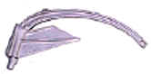
Barnacle Anchor: This is a single fluke design from the late 1930's which seems to have excellent holding power, especially in mud, but it has marginal setting and hooking characteristics. It is not popular and hard to find in North America. An advantage is that it stores relatively flat compared to most modern anchors.
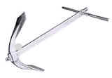
Fisherman's (Yachtman's or Herreshoff) Anchor: This venerable design has been used by sailors for hundreds of years and was perfected in England in the 18th Century, similar Greek designs in bronze date back to 800 BC. Until the advent of the plow and the Danforth-type in the 1930's, the fisherman's anchor was the common choice for yachtsmen and commercial sailors alike. Today, few cruising sailors carry the fisherman type because it is unwieldy, prone to fouling when the wind or current changes and it is difficult to stow (see Luke 3 piece below). Yet, as a hooking anchor with the ability to penetrate weed and kelp, the anchor is useful in some regions of the country, Northern New England and the Pacific Northwest, in particular. Also, there are some offshore sailors who believe that a fisherman's anchor of great weight is the best storm anchor, in rocky and kelp strewn waters.
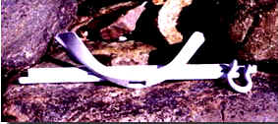
Luke Storm Anchor (3 piece Fisherman): As described above in a convenient storable form. Luke Storm Anchor
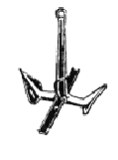
Northill: A specialty anchor, the Northill is constructed of welded stainless steel. It is a hooking-type anchor that derives its basic design from the Fisherman's anchor, with the stock (cross-bar) moved to the throat (base of the shank). Like the Fisherman, it is prone to fouling when the wind or current change. But, unlike the fisherman's anchor, the Northill is lighter and can be folded for storage.
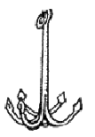
Grapnel Anchor: This anchor is well suited to rocky bottoms. The hooks will hook under rocks. It is inherently likely to reset well in it's preferred environment, if it does not snag its rode.
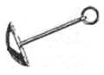
Mushroom Anchor: This is the anchor frequently used in permanent moorings. Over time, this anchor digs deeply into the bottom. Once embedded, it has tremendous holding power in all directions. Small versions of this anchor are used by fisherman as it holds well in mud or sand in calm, protected waters. This anchor does not work well in grassy or rocky bottoms.
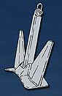
Poole Anchor: Mainly used for large vessels, it is a refined version of the Navy anchor, like a stout Danforth. In some circles it is referred to as a Kedge Anchor, but that term is most commonly applied to the Fisherman/Herreshoff Anchor. Manson Marine

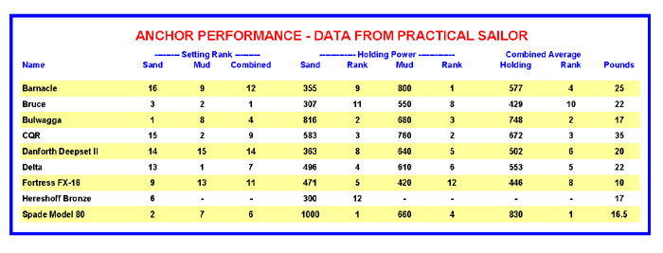
densities. For example, Marion, Massachusetts
calculates the required deadweight by multiplying
the vessel length by the beam, then by a factor of
four. Marble-head, on the other hand, has
developed a very good standard for deadweight
size based upon the vessel length and its location
and exposure in the harbor, i.e., sheltered,
moderate, or severe.
In water, concrete loses almost one-half its
weight; granite loses almost one-third, and iron
loses only an eighth. This is significant. If a
mooring is designed to withstand a 4,000-lb. pull,
one needs 8,000 lbs. of concrete, 6,000 lbs. of
granite, or 4,500 lbs. of iron. At a minimum, over
one ton is needed for even a small, 25’ yacht. To
handle weights of this magnitude, a barge crane is
needed. As long as this equipment is used to place
the anchor, one might as well err on the side of
excessive weight when placing it.
Anchor Alternatives
Pilings are not commonly found, but are very
effective. They can be driven into the bottom, and
in shallow harbors, extend above the surface for
mooring vessels bow-to-stern. In moderate to
shallow depths, steel pilings of pipe or “I” beam
may be driven flush into the bottom with traditional
ground tackle attached. Because a barge/pile
driver is necessary to set the pilings, size should
be generous, either a 6” diameter pipe, or a 6” “I”
beam and larger.
Helical Piles or sea screws are not common,
but are exceptionally effective. These are long
shafts of high tensile steel with an attachment eye
at the top and large threads at the lower end.
These “screw anchors” are screwed into the bottom.
Common lengths are 8’ with threads of 10” to 14”
in diameter. When embedded into the bottom with
the top eye flush or into the bottom soil attached
to traditional ground tackle, their holding power is
exceptional. Recent tests have shown that their
holding power is vastly greater than any traditional
without spinning the anchor. Once multiple
anchors are set at equal angles and connected to a
common point, the riding or top chain is also
connected to that point. Also, anchors may be set
for specific wind direction or sea exposure. If the
harbor is long and narrow, or a vessel is moored
in a river, two anchors may be set – one up
harbor, and one down harbor. In the design of this
system, the bottom chain between the center point
and the anchors should be equal to, or greater than
the bottom chain requirement of a single mooring
anchor system

. Mushroom Anchor “Spin Out”
Mushroom anchors, not embedded in the bottom,
will get “spun out” and lose what little holding
power they have when partially buried. All too
often, mushroom moorings are pulled for the
winter, or for inspection and maintenance of worn
components. When replaced, they are often just
dropped and then pulled to make sure they are not
standing upright. The problem is that the mushroom
never gets a chance to bury itself in the bottom.
In New England, prevailing winds set the
anchors in the westerly direction. Along comes a
roaring northeaster, or hurricane opposite the
westerly set and the mushroom gets spun around
180° and rolls out of the bottom. Away goes the
vessel, mooring and all.
When the mushroom is not buried in the
bottom or standing up, the chain will often wrap
around the anchor, consuming valuable scope.
This commonly occurs with the vessel following
the tide, pulling the chain from one side to the
other of the mooring, wrapping around the stock.
To correct this situation, mushroom anchors
should be left in and allowed to set. Inspection
and maintenance should be done in the water. If
the mooring is pulled, the anchor should be jetted
(using a stream of water to blow a hole in the
bottom for the anchor) into the bottom.
A common method to protect against multiple
wind direction is to use a three-point mooring
system allowing a vessel to swing in any direction
5
densities. For example, Marion, Massachusetts
calculates the required deadweight by multiplying
the vessel length by the beam, then by a factor of
four. Marble-head, on the other hand, has
developed a very good standard for deadweight
size based upon the vessel length and its location
and exposure in the harbor, i.e., sheltered,
moderate, or severe.
In water, concrete loses almost one-half its
weight; granite loses almost one-third, and iron
loses only an eighth. This is significant. If a
mooring is designed to withstand a 4,000-lb. pull,
one needs 8,000 lbs. of concrete, 6,000 lbs. of
granite, or 4,500 lbs. of iron. At a minimum, over
one ton is needed for even a small, 25’ yacht. To
handle weights of this magnitude, a barge crane is
needed. As long as this equipment is used to place
the anchor, one might as well err on the side of
excessive weight when placing it.
Anchor Alternatives
Pilings are not commonly found, but are very
effective. They can be driven into the bottom, and
in shallow harbors, extend above the surface for
mooring vessels bow-to-stern. In moderate to
shallow depths, steel pilings of pipe or “I” beam
may be driven flush into the bottom with traditional
ground tackle attached. Because a barge/pile
driver is necessary to set the pilings, size should
be generous, either a 6” diameter pipe, or a 6” “I”
beam and larger.
Helical Piles or sea screws are not common,
but are exceptionally effective. These are long
shafts of high tensile steel with an attachment eye
at the top and large threads at the lower end.
These “screw anchors” are screwed into the bottom.
Common lengths are 8’ with threads of 10” to 14”
in diameter. When embedded into the bottom with
the top eye flush or into the bottom soil attached
to traditional ground tackle, their holding power is
exceptional. Recent tests have shown that their
holding power is vastly greater than any traditional
without spinning the anchor. Once multiple
anchors are set at equal angles and connected to a
common point, the riding or top chain is also
connected to that point. Also, anchors may be set
for specific wind direction or sea exposure. If the
harbor is long and narrow, or a vessel is moored
in a river, two anchors may be set – one up
harbor, and one down harbor. In the design of this
system, the bottom chain between the center point
and the anchors should be equal to, or greater than
the bottom chain requirement of a single mooring
anchor system.

Dor-Mor Anchors
The Dor-Mor anchor is a patented, pyramidal-shaped anchor that is designed to penetrate the bottom and prevent dragging. The one-piece cast iron anchor is used to moor boats, large and small buoys, docks, oceanographic equipment, containment booms, nets, aquaculture pens, and much more. These anchors have proven so effective that the US Coast Guard is replacing their concrete sinkers with Dor-Mors!
Dor-Mor anchors are most appropriate for:
- Moving water sites such as rivers and coastal areas
- Where the moorings will be frequently moved
- Mooring scopes of 3:1
Here is how the Dor-Mor anchor compares to two other popular types of anchors in a 3:1 scope mooring
- Approximately 10 times the holding power of a concrete anchor of similar weight
- Approximately 2 times the holding power of a mushroom anchor of similar weight
Here are some of the design attributes that make the Dor-Mor anchor work so well:
- Cast Iron design loses only 14% of its weight in water vs. 45% for concrete
- Large surface area of the pyramid shape has a high suction effect when dragged
- Chain wrap is minimized by the short shank design (as opposed to the long shank of mushroom anchors)
- The large diameter size is designed to accommodate the proper sized shackle for the mooring weight
The Dor-Mor anchor is available in sizes ranging from 15 lbs to 4,000 lbs. For our Watermark buoys we make the following recommendations:
 | Lake Mooring | Slow River | Fast River/Coastal Area
WNS-1060 | 15 lbs | NA | NA
WNS-6000 | 15 lbs | 15 lbs | 35 lbs
WNS-7000 | 35 lbs | 35 lbs | 70 lbs
Dor-Mor anchors may not be the best option when:
- Using extremely short scopes (<2:1)
- The bottom is very rocky
- Concrete anchors are sufficient for applications in small lakes or ponds
If you need to deploy a mooring where a Dor-Mor anchor is not suited, check out Concrete and Helical Anchors, or contact us for more assistance.

Concrete Anchors
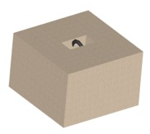For many applications, simple concrete anchors are the most cost-effective option. They are most appropriate for applications:
- In still water such as lakes
- Where the buoy and mooring will be in place year-round
- Where the bottom is very rocky, preventing the use of other types of anchors
- For mooring scopes less than 2
- When heavy moorings can be set with ease (crane barge, etc...)
Watermark offers prefabricated anchors with 3/8" stainless steel mooring eyes in 70, 150, and 250 lb sizes. Larger sizes available.
Soil classification Undrained Shear Strength (kPa)
Consistency ASTM BS
of Clay D-2488 CP-2004
Very soft 0 - 13 0 - 20
Soft 13 - 25 20 - 40
Firm 25 - 50 40 - 75
Stiff 50 - 100 75 - 150
Very stiff 100 - 200 150 - 300
Hard 200 - 400 300 - 600
Very hard > 400 > 600
table B
Soil strength is generally expressed in terms of the shear strength parameters
of the soil. The soil type is classified mainly by grain size distribution.
Grain size Soil descrip tion
< - 2 μm Clay
2 - 6 μm Fine Silt
6 - 20 μm Medium Silt
20 - 60 μm Coarse Silt
60 - 200 μm Fine Sand
200 - 600 μm Medium Sand
0.6 - 2 mm Coarse Sand
2 - 6 mm Fine Gravel
6 - 20 mm Medium Gravel
20 - 60 mm Coarse Gravel
60 - 200 mm Cobbles
> - 200 mm Boulders
IIn general, the soil types encountered in anchor design are sand and clay
(Grain diameter from 0.1 μm to 2 mm). However, mooring locations consisting
of soils with grain sizes above 2 mm, such as gravel, cobbles, boulders,
rock and such, also occur. Clay type soils are generally characterised by the
undrained shear strength, the submerged unit weight, the water content
and the plasticity parameters. The consistency of clays is related to the
undrained shear strength. However, American (ASTM) and British (BS) standards
do not use identical values (table B).
The undrained shear strength values Su can be derived in the laboratory
from unconfined unconsolidated tests (UU).
Su UU SPT CPT
kPa kPa N MPa
0 - 13 0 - 25 0 - 2 0.0 - 0.2
13 - 25 25 - 50 2 - 4 0.2 - 0.4
25 - 50 50 - 100 4 - 8 0.4 - 0.7
50 - 100 100 - 200 6 - 15 0.7 - 1.5
100 - 200 200 - 400 15 - 30 1.5 - 3.0
> 200 > 400 >-30 >3.0
table C
Descriptive Relative Angle SPT CPT
term Density ϕ N MPa
Very loose < 0.15 < 30 0- 4 0 - 5
Loose 0.15 - 0.35 30 - 32 4 - 10 5 - 10
Medi um dense 0.35 - 0.65 32 - 35 10 - 30 10 - 15
Dense 0.65 - 0.85 35 - 38 30 - 50 15 - 20
Very dense > 0.85 > 38 > 50 > 20
Descriptive term Compressive
strength qu [MPa]
Very weak < 1.25
Weak 1.25– 5
Moderately weak 5 – 12.5
Moderately strong 12.5 – 50
Strong 50 – 100
Very strong 100 – 200
Extremely strong > 200
table D
table E

Soil classification 31
On site the values can be estimated from the results of the Standard
Penetration Test (SPT) or Cone Penetrometer Test (CPT). An approximate
relation between shear strength and the test values are shown in table C.
The mechanical resistance of sandy soils is predominantly characterised by
the submerged unit weight and the angle of internal friction, ϕ. These
parameters are established in the laboratory. An approxim-ate correlation
between the angle ϕ and the relative density of fine to medium sand is given
in table D. The undrained shear strength of clayey soil can also be estimated
based on manual tests.
• In soft clay the thumb will easily penetrate several inches, indicating an
undrained shear strength smaller than 25 kPa.
• In firm (medium) clay the thumb will penetrate several inches with moderate
effort, indicating an undrained shear strength between 25 kPa and
50 kPa.
• Stiff clay will be easily indented with the thumb but penetration will
require great effort, indicating an undrained shear strength between 50
kPa and 100 kPa.
• Very stiff clay is easily indented with the thumbnail, indicating an
undrained shear strength between 100 kPa and 200 kPa.
• Hard clay is indented with difficulty with the thumbnail, indicating an
undrained shear strength larger than 200 kPa.
The rock strength can generally be described by its compressive strength
(table E).
A classification system for soil based on the carbonate content and grain
size of the soil (Clark and Walker), is shown on the laste page of this chapter.

