Project Number: | 901303

Project Start: Jan. 1, | 2013 | Project Duration (in years): | 3

Please indicate what type of project is being proposed (mark only one).

 |  |  |  | X
Feasibility/Scoping  [Less than 100 days effort] |  |  | Development |  |  | Research |  |  | Infrastructure¹ |  |  | Education
 |  |  | Time Series |  |  | Institute Initiative

Project Manager: Thomas C O'Reilly
Principal Investigator: Alexandra Z Worden
Lead Scientist: Alexandra Z Worden
Lead Engineer: James G Bellingham

Project Title: CytoAUV

- ABSTRACT (new projects only)
We propose that MBARI engineers miniaturize cytometer technology developed by the University of Washington and integrate the resulting instrument with LRAUV. This effort will result in a revolutionary vehicle that we call CytoAUV, combining unique capabilities of UW (cytometry, genomics) with MBARI (low-power instrument design, LRAUV, autonomous adaptive sampling). This project addresses the “exploration and discovery” and “observing ecosystem dynamics” strategic themes.
The Armbrust lab at UW has developed a unique flow cytometer called SeaFlow. Conventional cytometers must inject cells into the core of expendable “sheath fluid” and physically align the fluid stream so that cells flow through the measurement system in single-file. SeaFlow utilizes UW-patented “virtual core” technology that eliminates complex plumbing and expendable sheath fluid, instead sampling a seawater stream directly. SeaFlow measures up to 24000 cells per second in the 0.5-20 micron size range, which includes marine bacteria such as the important open ocean Prochlorococcus species. The Armbrust lab is now adding automated staining capability to the instrument, further widening the bacterial species that can be detected. SeaFlow’s integrated PC automates data acquisition, optical alignment correction, and data summarization. Thanks to its relatively simple fluidic design and automation, SeaFlow can be operated unattended for many days at a time. SeaFlow[j1] has participated in two CANON Western Flyer cruises in collaboration with the Worden lab. In October 2011 the instrument detected a coastal eddy on the outbound leg along CALCOFI line 67, and was able to relocate the eddy 5 days later on the inbound leg based on the coastal signature of microbes in the water
SeaFlow is designed to operate aboard ship, is about the size of a microwave oven, and consumes 250W. We propose that MBARI license the technology from UW, then design and build a smaller low-power version that can be integrated with LRAUV. LRAUV provides a robust long duration mobile platform, three-dimensional round-the-clock sampling, instrument data logging, command-and-control, and telemetry. Onboard LRAUV software can modify the vehicle's mission plan based on data from the cytometer and other onboard sensors, and can send summarized cytometer data to shore via satellite in near-real-time. These capabilities will be especially useful for CANON, providing invaluable science data sets as well as near-real time microbial data that can be incorporated into multi-platform supervised autonomy missions.
We propose a three-year project. In the first year, we will build a UW cytometer from components and develop prototypes that address the highest risk aspects of fluid handling, power reduction and miniaturization. By January 2014 we will hold a review and recommend whether to proceed with implementation. If MBARI decides to proceed, instrument implementation, integration, sea trials and data validation would occur in years 2 and 3. We anticipate that the resulting CytoAUV vehicle would quickly be integrated with the CANON initiative.
During the first year, we will consult with UW's Jarred Swalwell on cytometer construction and approaches to power reduction and miniaturization. Mutually beneficial IP arrangements between MBARI, UW, and Swalwell are key to a successful outcome of this project, and are currently under discussion between these parties. MBARI and UW agree in principle that each side will have a non-exclusive royalty-free research license to use the other's technology, If MBARI decides to proceed beyond year 1, we will develop a complete collaborative framework with UW, emphasizing science missions and data validation.

- PROPOSAL

  - New Projects

Statement of the problem, why it is important

Populations of nano- and picoplankton are highly diverse, and their distributions are known to be spatially and temporally heterogeneous, yet traditional ship-based sampling of these organisms is limited in spatial and temporal resolution. In a recent workshop sponsored by the MBARI CANON initiative, oceanographers that work in open-ocean environments made a plea for integration of autonomous platform sampling with process studies to measure organism rates and activities. The ideal scenario put forward by this group was that mapping AUVs could provide advanced contextual information, allowing interrogation of specific features and comparison to a reference water zone (e.g. an eddy with comparison to a standard stratified water column). Currently these types of studies are extremely difficult to perform as they rely on satellite data, which can be patchy, and only reveals surface ocean features. Globally there are several institutions that recognize these limitations to traditional oceanography and have sought to develop both continuously sampling moorings as well as AUV fleets capable of measuring different physical, chemical and biotic (e.g. fluorescence) features in the water. We propose to examine and explore feasibility of a technology that could be deployed on an AUV, mooring, or other autonomous platform that would result in the highest resolution biotic data to date. Lack of appropriate sampling resolution is an issue that MBARI has been addressing intensively over the last several years and is a major feature in the strategic plan. Our goals are to participate in global carbon cycling research, to develop biogeochemical models and understand how both natural and anthropogenic perturbations rely on the development of more appropriate spatial and temporal sampling, and more refined placement and execution of process studies.

How does it relate/contribute to MBARI’s mission and strategic plan?

This project couples to two themes in MBARI’s strategic plan: Ecosystem Dynamics and Ocean Biogeochemistry. Both of these research thrusts are intimately dependent on our ability to sense the microbial components of marine ecosystems – in effect the first theme revolves around observing and understanding marine microbial systems, while the second addresses fundamental chemical cycles which are largely mediated by microbial ecosystems. Both problems are challenged by the high cost and consequent under-sampling of the microbial ocean. This proposal directly addresses this foundational challenge, focusing on creating an AUV-compatible flow cytometer capable of discriminating organisms based on size and optical and fluorescent characteristics.

This proposal is also consistent with strategic plan objectives and strategies. This proposal clearly fosters technological innovation through development of truly revolutionary capability, and our strategy of a one-year feasibility phase potentially followed by two-year implementation phase is consistent with strategies 1.3 and 1.4. CytoAUV enhances collaborations by combining unique strengths of UW (cytometer technology, genomics) and MBARI (low-power design, LRAUV, autonomous adaptive sampling). CytoAUV will be made available to our UW colleagues (strategy 3.3). Development of MBARI cytometer engineering expertise is a project goal, consistent with the strategic objective of increasing institutional flexibility; we will use the expertise of SeaFlow inventor Jarred Swalwell to advise and train MBARI engineers (strategy 2.2).

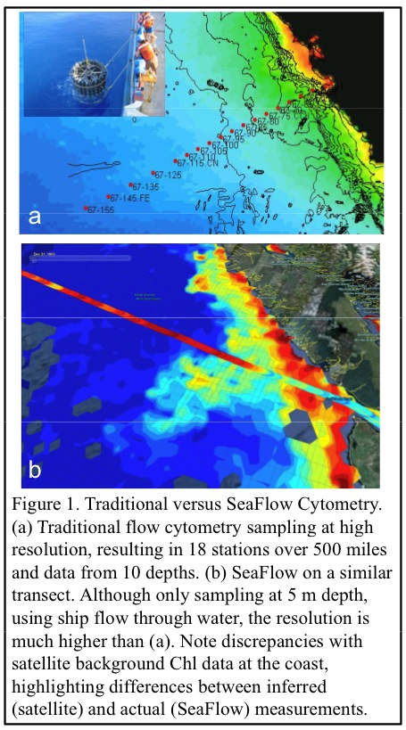One of the principle challenges in any technological/engineering activity at MBARI revolves around finding and nurturing technology transfer to ensure use of MBARI innovations by the broader community. This is the primary metric for intermediate term impacts in the strategic plan. This project is particularly well positioned in this regard because of the collaborative nature of the development with the UW group, and their commitment to enabling broader use of their flow cytometry technology.

How does it relate/contribute to the Packard Foundation’s Ocean Visions Grantmaking policies? (See http://mww.mbari.org/oed/OED_Documents3.htm#Packard for documents.)

[Click here to enter text]

Approach to the problem
We propose a three-year project to redesign UW’s SeaFlow cytometer, such that the resulting instrument is compatible with LRAUV payload dimensions and electrical, mechanical and software interfaces. We will integrate the instrument with an LRAUV, and conduct preliminary science missions with the resulting CytoAUV in Monterey Bay. MBARI will obtain a royalty-free research license to SeaFlow technology from UW, giving us access to instrument design documents and details. Virtually all engineering work will be performed by MBARI personnel, with a limited amount of consulting help from SeaFlow inventor Swalwell. In the process, MBARI will develop in-house expertise in cytometer design, fabrication and operation.
This project carries considerable technical and programmatic risks. To mitigate these, we divide the project into a one-year feasibility phase potentially followed by a two-year implementation phase. During the feasibility phase in year 1 we'll evaluate, analyze, and prototype the highest risk aspects of the CytoAUV instrument. We will hold a review at the end of year 1, and recommend "Go" or "No-go" toward the implementation phase based on our findings. We will recommend “Go” only if we believe that technical and programmatic risk have been reduced to acceptable levels. In either case, we will present a detailed rationale for our recommendation based on analyses and prototype activities. If we recommend implementation, this review will include a preliminary design of the instrument and its interfaces to LRAUV.
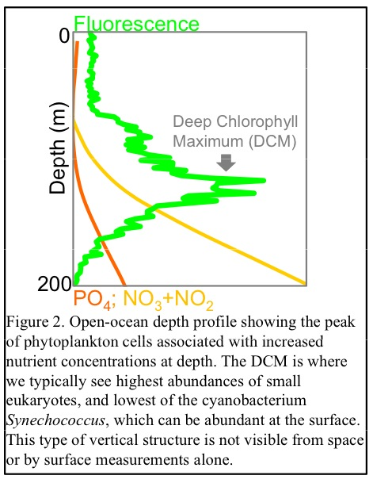Flow cytometry is a tool that has been used in marine systems since the early 1990’s and is responsible for the discovery of the most abundant photosynthetic organism on the planet (the cyanobacterium Prochlorococcus, [1]). Several flow cytometers that can be deployed on moorings exist, including the commercial CytoBuoy and WHOI’s CytoBot. Design components make these instruments power intensive and structurally large; for example some require filtration of a sheath fluid through which samples are injected. A novel development at the University of Washington is the SeaFlow system, which has one of the smallest platforms available while also having the resolution to interrogate small phytoplankton. The SeaFlow instrument developers are also well versed in phytoplankton ecology and are developing approaches to high-throughput data analysis employing hidden Markov models. The combination of the instrument and a knowledgeable phytoplankton team working on data processing (UW and Worden lab) are invaluable to the MBARI goal of integrating such an instrument on autonomous platforms. SeaFlow is a continuous flow cytometer utilizing position-sensitive optics for increased reliability and reduced maintenance. The current level of data acquisition by SeaFlow is leagues ahead of what has been possible until now. For example in a high resolution transect performed by the Worden lab in 2009, 10 depths at each of 18 discrete cast stations were sampled (Fig. 1a). This was a massive effort and represents some of the best resolution data available for these phytoplankton communities. In contrast, SeaFlow is automated, requires minimal operator input, and continually samples the ship’s intake water, resulting in spatial resolution that is orders of magnitude better (Fig. 1b). Still, the water column is not homogenous (Fig. 2), and integrating SeaFlow with a small size AUV or a profiling float would add the necessary dimension: depth. Most autonomous platforms provide a near-real-time satellite telemetry link. The SeaFlow instrument produces data that could probably be summarized by onboard software to indicate the presence and diversity of microbial communities. If this information could be telemetered to shore via satellite, the sampling strategy of other assets (sensors, ships, other vehicles) can be modified based on the information. We believe that this “adaptive sampling” capability could result in high-value science data.

LRAUV is an ideal target platform for this instrument because it provides extended range and endurance, and can potentially be deployed by research groups with minimal operations support. The system will be capable of missions ranging from days to weeks in duration, will have onboard species classification capability, and will telemeter results to shore via Iridium satellite link. CytoAUV will enable more advanced mapping of phytoplankton communities, similar to SeaFlow’s current capabilities for measuring surface waters, but for the entire water column. This will in turn facilitate process studies that are not currently possible, in which rates and activities of different phytoplankton communities are measured. Specifically this will allow research teams to more sensitively pick target regions for such studies, by using mapping-in-advance capabilities of CytoAUV.
Programmatic risk: This project carries significant programmatic risk, including the following:
- This project is dependent on patented technology developed at the University of Washington, and it is crucial that IP issues are clearly understood and worked out by MBARI and UW. We are in active discussion with IP attorneys and UW to craft a detailed agreement satisfactory to both sides (see IP Agreement, below).
- It is vital that MBARI and UW have a smooth working relationship. Worden has known the instrument developer since 1998 and hence there is a strong working relationship already in place with the UW team, whose sole focus is marine microbiology; Worden collaborates frequently with the University of Washington’s Armbrust lab, a leader in phytoplankton genomics and sensing. Worden, O’Reilly and Bellingham have several years experience working with the UW team to propose CytoAUV to MBARI as well as NASA, and Chaffey is now interacting with Jarred Swalwell to identify technical issues.
- MBARI engineering knowledge of cytometry is clearly at the “novice” stage. But while MBARI currently does not have experience in building cytometers, the Worden and Bellingham labs are committed to building the necessary in-house expertise. Moreover MBARI engineers have very significant expertise in lasers, optics, fluid handling, low-power design and packaging, all of which are critical to this project.
Technical risk: We have identified the fluid handling subsystem as the highest technical risk element. Note that SeaFlow utilizes a stream-in-air measurement, which is impractical within the LRAUV instrument's pressure vessel (30 atmosphere pressure differential at 300 meters). Instead we will design a closed system flow cell, in which the seawater flows through the system at outside ambient pressure. The advantage of this closed system is that no energy needs to be expended to de-pressurize and re-pressurize the injection stream. Many cytometers utilize a closed system flow cell. Our system must have restart capability, must be pressure-safe (particularly where the flow sample line passes through the instrument pressure vessel), and must be resistant to clogs and bio-fouling. Jarred Swalwell is currently designing a closed system flow cell for the SeaLabel cytometer (see below); while SeaLabel operates onboard ship at one atmosphere, we expect that his design will inform our design for the LRAUV instrument.
Feasibility phase: We believe it is essential to have a functional SeaFlow on hand in order to understand its principles of operation and to provide a test-bed for miniaturization and power reduction. Thus one of our first steps will be to construct a SeaFlow cytometer from components using design documents provided by UW and as-needed consultation from Jarred Swalwell.

Our default plan is to build the SeaFlow version described at [REF LINK GOES HERE]. Swalwell is currently developing a new SeaFlow version known as "SeaLabel". While still intended for shipboard use, SeaLabel is significantly smaller, lower power, and lower cost than SeaLabel. New SeaLabel features especially relevant to CytoAUV include:
- Low power laser, resulting in considerable power savings (15W vs 79W) and lower cost ($10K versus $26K)
- Optical path: higher power objective, different scatter bar, tube lens, etcetera; will collect light over a larger solid angle and reduce the optical path from 2.5 cm to ~1.2 cm, aiding in miniaturization.
- Peak detection circuit replaces peak detection software, resulting in higher throughput (100 KHz versus 25 KHz)
- Flow cell replaces stream-in-air. Fixed in place; laser alignment needed only once at setup.
- Elimination of two PMTs (forward scatter polarization detectors)
- Fewer custom machine parts

These SeaLabel features are generally consistent with our goals for the CytoAUV instrument.
Table 1 summarizes some key features of SeaFlow and SeaLabel.

 | SeaFlow | SeaLabel
Component cost | $61K | $41K
Dimensions | 68 x 49 x 33 cm | 17 x 23 x 28 cm
Power consumption (less PC) | 160 W | 35 W
Table 1: SeaLabel compared with SeaFlow
Table 2 shows the projected SeaLabel power budget in more detail; note that SeaLabel's projected 35 W draw is below the allowed 50 W maximum for an LRAUV instrument.

Peak detector circuit | 1.37 W
Preamps | 9.42 W
PMTs | 0.93 W
Pump | 8.2 W
Laser | 15W
Total | 34.92 W
Table 2: SeaLabel power budget
Swalwell currently estimates that SeaLabel data will be validated against a BD Influx "gold standard" cytometer by November 2012. If his efforts show high probability of success by January 2013, we will build SeaLabel instead of SeaFlow during our 2013 feasibility phase. Note that SeaLabel directly addresses the high-risk optics and fluid management elements of CytoAUV. Moreover the parts cost of SeaLabel is $20K lower than SeaFlow. In any case we expect that our CytoAUV design will be critically informed by Swalwell's SeaLabel effort.

Implementation phase, year 2: We will refine the year 1 design and build the instrument itself in year 2.

Embedded computing system:, onboard processing: Two key project objectives are return of science data to shore in near real-time, and autonomous adaptive sampling, both of which will be enabled by onboard data processing. Onboard software will calculate a cytometric diversity index of richness in physiological and genetic variations of phytoplankton cells, as defined by Li et al. (1997). The index will be calculated based on light scatter and chlorophyll fluorescence, making it possible to estimate the structure of the phytoplankton communities in real-time and track blooms (high cell concentration, low cytometric diversity index; black circle, Fig. 5) or biological fronts (high cell concentrations, high diversity index; red circle, Fig. 5). The raw data acquisition rate of CytoAUV (several gigabytes per day) exceeds the vehicle's 7800 baud Iridium satellite modem capacity to transfer data to shore. The diversity index is composed of several floating-point numbers computed every minute and can easily be returned over the low-bandwidth satellite link. Thus the science team will have an unprecedented real-time view of diversity while the mission is underway. Moreover, the diversity index will be available to the onboard adaptive sampling software (see below).
Post-mission processing: The raw cytometer data will be stored onboard for post-mission retrieval. Flow cytometry data typically consists of multi-parametric descriptions of millions of individual cells. Because of the high volume of data created with continuous measurements UW has developed a first-generation software package (www.bioconductor.org/packages/2.8/bioc/html/flowPhyto.html) that pipelines a collection of functions to turn raw data files into data tables and plots of concentration, size and fluorescence characteristics of the various phytoplankton populations (Ribalet et al. 2011). The software uses a flexible statistical model-based clustering approach for identifying and clustering cell populations. Most of the analysis consists of setting up the statistical priors for the cell population-clustering algorithm; the overall pipeline requires minimal human

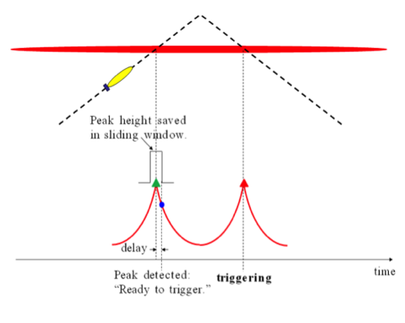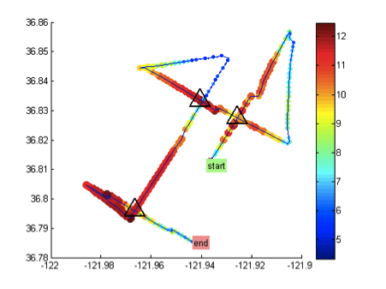CytoAUV's software enables autonomous adaptive sampling. This sampling software 1) determines the optimal AUV survey strategy (e.g. speed, horizontal and vertical trajectory) to focus on areas of scientific value, and 2) powers on the cytometer and collects data within these regions of interest. Data from the cytometer and other onboard sensors will be used to autonomously adjust the sampling strategy, focusing survey efforts on regions of high cell abundance, high cytometric diversity, and/or steep gradients in nutrient concentrations or salinity. Development of CytoAUV’s adaptive sampling algorithm will draw upon a suite of adaptive sampling algorithms we developed, exemplified by two algorithms: AUV peak-capture and AUV patch-tracking.
Fig. 6. Left panel: As the AUV’s sawtooth trajectory carries it through a phytoplankton patch, the vehicle detects the fluorescence peak on the first crossing, with a delay. It captures the peak on the second crossing with no delay (from Zhang et al. 2010). Right panel: On 24 April 2011, Tethys ran the algorithm to find and track the center of a moving phytoplankton patch. Triangles correspond to successively updated patch center estimates (from Godin et al. 2011).

AUV peak-capture algorithm: MBARI’s Dorado AUV is equipped with ten fast water samplers (called “gulpers”), each of which takes in a 1.8-L water sample in 1~2 sec. The problem for the Gulper is similar to that of the cytometer: how to obtain representative samples of organisms, especially when organisms often aggregated in very thin layers? For Gulper, the limited resource is number of samples, for the cytometer, the resource is energy. We have developed an adaptive triggering algorithm for the AUV's gulpers to autonomously trigger the gulpers at fluorescence peaks characteristic of high phytoplankton abundance (Zhang et al. 2010a). The principle of the method takes advantage of the AUV's sawtooth (yo-yo) trajectory. In one yo-yo cycle, a descent leg followed by an ascent leg, the vehicle crosses the phytoplankton bloom twice. On the vehicle's first crossing (descent leg), the peak detection (by tracking the fluorescence signal's slope) comes with a delay, but the vehicle remembers the peak value. On the second crossing (ascent leg), as soon as the fluorescence signal reaches the saved peak value, a sampling is triggered. This way, the sampling is right on the peak. This algorithm has been successfully used by the Dorado AUV in numerous field programs for studying phytoplankton thin layers and intermediate nepheloid layers (Zhang et al. 2010b), and for capturing water samples in a deep hydrocarbon plume in the Gulf of Mexico (Zhang et al. 2011). Cell-rich layers and convective brine plumes can be expected in the under-ice and ice-edge regions accessible from Nuuk, facilitating first-time tests of this approach in ice-covered waters.
AUV patch-tracking algorithm: Biological processes such as phytoplankton blooms appear in patches that evolve from initiation to decline. A challenge is to detect and track these features in real time. We have developed an algorithm for an AUV to autonomously localize and track the center of a phytoplankton bloom patch based on in vivo chlorophyll a fluorescence. The algorithm takes advantage of the responsiveness of the AUV platform to minimize the chance of losing track of the patch and maximize the rate at which the patch center is revisited. The field performance of patch tracking by the MBARI Tethys AUV is shown in Fig. 6. Importantly, Tethys currently responds to bulk fluorescence properties that result from mixed populations; it cannot discriminate between different populations of phytoplankton despite their different ecosystem roles. CytoAUV will distinguish between different types of cells based on differences in cell size and pigment content.

Vehicle modifications: While CytoAUV's core vehicle and software will be identical to existing Tethys vehicles, certain characteristics will be modified to accommodate the cytometer. The cytometer will be housed in the payload portion of the vehicle, which is the most forward section. This portion will be completely customized for CytoAUV. Externally the vehicle will look like a slightly longer version of the existing Tethys. In addition to the cytometer, sensors will also be integrated to provide physical (temperature, salinity, current), optical (scattering, fluorescence) and chemical (nitrate and dissolved oxygen) context for the flow cytometer measurements. These sensors are currently installed on the Tethys, and are well understood. Other modifications include possible power system upgrades to support higher peak loads and increasing the variable buoyancy system's maximum displacement.

Publications (from other projects over the last 5 years)

[Click here to enter text]

  - Continuing Projects

If the proposed project includes multiple individual projects, please list each of these projects as a subheading in the proposal. For each subheading, please address the following:

Current status of project and results to date

[Click here to enter text]

Significant changes from previous project proposal

[Click here to enter text]

Publications based on the results of this project only

[Click here to enter text]

- New and Continuing Projects: Plans for 2013

Research Activities

[Click here to enter text]

Engineering/technology development

Year 1:
Build SeaFlow or SeaLabel cytometer from component parts
Design and test flow cell, prototype other high-risk components. Hold review at end of year, recommend Go/No-go for years 2 and 3, preliminary design review.

Year 2:
Develop science requirements, concept of operations. Refine CytoAUV instrument design. Select embedded computer. Hold critical design review. Implement software. Build and test instrument on the bench; verify data against BD Influx cytometer. Make required modifications to LRAUV for CytoAUV vehicle.

Year 3:
Integrate instrument with vehicle, test in tank and at sea. Conduct science missions.

Field programs (detail ship requirements/deployments/diver requirements)

[Click here to enter text]

Specific deliverables

[Click here to enter text]

Milestones (see last page for personnel classification list)

[Click here to enter text]

 | Milestone 1 | Milestone 2 | Milestone 3 | Milestone 4 | Milestone 5 | Total Resources for each resource category for all milestones listed here
Milestone Date
Milestone Description
EE
SE
ME
EE Tech
SE Tech
ME Tech
Machine Shop
Divers

Budget justification

[Click here to enter text]

Project team

Alexandra Z Worden - Principle Investigator, Chief Scientist
James G Bellingham - Chief Engineer
Thomas C O'Reilly - Project Manager, embedded computing system
Mark Chaffey - Systems Engineer
Denis Klimov - Optics, electrical, fluid management
Michael Risi - Embedded computing system

Project lab space

[Click here to enter text]

Data availability outside project team, uniqueness

[Click here to enter text]

Export Regulation
Does the project team anticipate any foreign collaborations or international travel? If so, please identify collaborators by name, institution, and country.

[Click here to enter text]

Does the project team plan or anticipate export controlled purchases, shipments, or transfers of items (e.g., research instruments, proprietary data, hand-carried tools or samples) outside the U.S. temporarily or permanently? If yes, please identify country or countries and indicate whether these items will remain under MBARI control while abroad or controlled by others. Will the items be exported to more than one country? Please include foreign collaborator information as described above.

[Click here to enter text]

Risk matrix (development and infrastructure projects only)

 | Technical Risk | Organizational Risk | Tech Transfer Risk | Labor Estimate Risk
High | Optics  Fluid handling
Medium |  | IP agreement
Low

Personnel Classifications

Engineer -  Mechanical Engineer | Engineer -  Electrical Engineer | Engineer -  Software Engineer | Engineer -  Mechanical Tech | Engineer -  Electrical Tech | Engineer -  Software Tech | Observ Support Technician | Science –  Software Engineer
(Reg) | (Reg) | (Reg) | (Reg) | (Reg) | (Reg) | (Reg) | (Reg)
Jim Birch (2/3) | Mark Chaffey | Dave Caress | John Ferreira | Paul Coenen | Karen S | Mike Kelley | Mike Godin
Larry Bird | Scott Jensen | Danelle Cline | Frank Flores | Tom Marion |  | Jared Figurski | Frederic Py
Francois Cazenave | Chad Kecy | Duane Edgington(2/3) | Mike Parker | Jim Montgomery
Jon Erickson | Denis Klimov | Kevin Gomes (2/3) | Jim Schofield | Jose Rosal
Dale Graves (2/3) | Paul McGill | Kent Headley (2/3)
Andy Hamilton (2/3) | Ed Mellinger | Rich Henthorn |  |  |  |  | Science –  Mechanical Engineer
Brett Hobson | Craig Okuda | Bob Herlien |  |  |  |  | (Reg)
Bill Kirkwood | Alana Sherman | Brian Kieft |  |  |  |  | Gene Massion
Doug Pargett |  | Thom Maughan
Farley Shane |  | Mike McCann
 |  | Rob McEwen
 |  | Tom O’Reilly
 |  | Wayne Radochonski
 |  | Mike Risi
 |  | Brent Roman
 |  | Carlos Rueda-Velasquez
 |  | Brian Schlining
 |  | Rich Schramm

Development and infrastructure projects must complete the risk matrix (see item #5 at the end of the proposal form).
Not all projects will require all four titles to be filled in. Please indicate individuals only for those titles that are appropriate for your project.
This number should be the same number you entered on the resource requests for this particular resource.

