Subconn Pin # |  | Colour Code |  | Ethernet (TIA 568B) |  | 1000Base-T Signal ID |  | Power
1 |  | Black |  |  |  |  |  | Not Used
2 |  | Orange |  |  |  |  |  | Not Used
3 |  | White |  |  |  |  |  | +12V
4 |  | Brown |  | 8 |  | DD-
5 |  | Brown/White |  | 7 |  | DD+
6 |  | Blue |  | 4 |  | DC+
7 |  | Blue/White |  | 5 |  | DC-
8 |  | Orange |  | 2 |  | DA-
9 |  | Orange/White |  | 1 |  | DA+
10 |  | Green |  | 6 |  | DB-
11 |  | Green/White |  | 3 |  | DB+
12 |  | Red |  |  |  |  |  | Not Used
13 |  | Green |  |  |  |  |  | GND

From: <william@4-deep.com>
Subject: RE: Microscope evaluation: ideas?
Date: March 15, 2016 6:13:16 AM PDT
To: "'Tom O'Reilly'" <oreilly@mbari.org>
Cc: "'John Samson'" <john@4-deep.com>, "'Stephen Jones'" <stephen@4-deep.com>

Hi Tom,
Please see attached file for cable pinout. To interface with the submersible you will need a Subconn 13 pin Ethernet connector and locking ring. (male connector ‘DBH13M’ – ring ‘DLSA-M’) Note that we use Ethernet wiring scheme TIA568B and that +12V is fed to the unit via the white (+12V) and green (GND) 18 AWG wires. Since this connector is not mated to a cable you will need to mount it to a bulkhead. The threads on the connector are ½-20 UNF. There is another Subconn connector type you could use but you will need to mate it to a cable. The part number is: DOM13M
We do have a flow chamber you may use. John has it with the demonstration unit now.

If you have any other questions, please let me know.
Tks
Bill
OPERATIONS MANAGER
William MacLean
www.4-deep.com
T +1 (902) 444 4449
william@4-deep.com
6589 Chebucto Road
Halifax, Nova Scotia
Canada B3L 1L9

From: Tom O'Reilly [mailto:oreilly@mbari.org]
Sent: March 14, 2016 8:32 PM
To: John Samson <john@4-deep.com>
Cc: Bill Mclean <william@4-deep.com>; Denis Klimov <klimov@mbari.org>
Subject: Re: Microscope evaluation: ideas?

Also, we plan to evaluate the instrument in the lab as well as at sea.
Does 4Deep have a 'flow chamber' that we can use in the lab? (Otherwise we can build our own)
Thanks!
Tom

On Mar 14, 2016, at 3:58 PM, Tom O'Reilly <oreilly@mbari.org> wrote:
Hi Bill
Can you please send specification/drawing/pinout for the cable?
We will likely lower the instrument from a boat to about 50-100 meters depth.

Thanks
Tom

On Mar 14, 2016, at 11:02 AM, John Samson <john@4-deep.com> wrote:

I do not see this as a problem, except that we have only 5 m of cable for the demo sub. If you are to deploy to an ROV, you will want to build your own comm/power cable. I include Bill, our operational manager, to confer with you on this, as he can make suggestions about the cable system for an ROV.

Thanks,
John

<image003.jpg>
Research Scientist
John Samson
www.4-deep.com
T +1 (902) 444 4449
john@4-deep.com
6589 Chebucto Road
Halifax, Nova Scotia
Canada B3L 1L9

On Mon, Mar 14, 2016 at 2:39 PM, Tom O'Reilly <oreilly@mbari.org> wrote:
Thanks for that info John.

We are meeting with MBARI scientists to discuss an evaluation plan - are we allowed to test the loaner instrument at sea, e.g. lowered from a cable or mounted on an ROV?

Thanks,
Tom

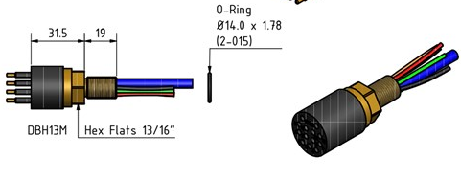

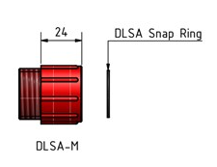

3/16/2016 call to Bill (William MacLean) www.4-deep.com T +1 (902) 444 4449
McCartney
They build cable, they mold Subconn, mount RG45 connector,
4-deep add power
D-p4tp2#4c18

3/16/2016 email from Brock.
Hi Dennis:
Here are two cables that Falmat has in stock:
FMXCAT51205K24 = 164 ft @ $11.84/ft. 5 #12 awg
FMXCAT51806K12 = 164 ft @ $8.35/ft. 6 # 18awg
See attached specifications.
The DOM13M is $150.00.
Regards,
Brock Rosenthal
Ocean Innovations
brock@o-vations.com
(858) 454-4044
www.o-vations.com

3/17/2016
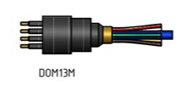

3/17/2016 10:40 call to Brock 858-454-4044
DOM13M is $150.00
DLSA-M $6
Boot mold $13
Fedex from Houston TX 77043 to 95039
Has one in stock in San Diego
$9 ground shipping
4808 0190 0255 210, 05/18, Denis Klimov, 711

