Launch Procedure
  - Wave Glider SV3 with Extreme Sea State Modifications

Revision A
Item Number: 09774

©2018 Liquid Robotics
Confidential computer software. Valid license from Liquid Robotics, Inc. required for possession, use or copying. Consistent with FAR 12.211 and 12.212, Commercial Computer Software, Computer Software Documentation, and Technical Data for Commercial Items are licensed to the U.S. Government under vendor's standard commercial license.
Trademarks
Liquid Robotics®, Wave Glider®, Wave Glider Management System, WGMS, and SHARC® are worldwide trademarks of Liquid Robotics. Other products and company names mentioned herein may be the trademarks of their respective owners.
Patents
The Wave Glider mechanism is patented under US Patent Number 7,371,136 and other patents pending. All aspects of the Wave Glider product have been developed at private expense by Liquid Robotics.
Warranty
The information contained herein is subject to change without notice. The only warranties for Liquid Robotics products and services are set forth in the express warranty statements accompanying such products and services. Nothing herein should be construed as a warranty. Liquid Robotics is not liable for technical or editorial errors or omissions contained herein.

Contact

Liquid Robotics
1329 Moffett Park Drive
Sunnyvale, CA 94089
Phone: +1 408 636 4200
Customer Support: +1 888-574-4574
Fax: +1 408 747 1923

Contents
Contact 2
Launch Procedures for Extreme Sea State Modifications 4
Launch Operations 4
Launch - Required Personnel and Equipment 4
Launch Procedure 4

Launch Procedures for Extreme Sea State Modifications
The following procedure shall be used with the Wave Glider SV3 Launch and Recovery Guide, Chapter 8. Wave Glider SV3 Launch Operations, and Appendix 1: Towfish Launch and Recovery Procedures

Launch Operations
Estimated Duration: 20 minutes

Launch - Required Personnel and Equipment
- 3 Deckhands
- 1 Lead Technician (may also be Deck Boss)
- 1 Hoist Operator
- 1 Captain/Vessel Operator
- PPE
- Bundling Strap and release line
- SeaCatch with pin and release line
- 2 x tag lines (10-15m)
- Large tub or plastic garbage can full of water for purging air in towfish on deck (optional)
- Cardboard wedge and double-sided tape

Launch Procedure
- Notify piloting operations center of deployment plan and coordinate task sequence
- Toolkit (Job Safety Analysis (JSA)) review: discuss launch process with all participating crew. Ensure safety briefing covers the tasks expected of each crew, PPE, hoisting safety, exclusion zones, no-touch, and emergency response. Ensure clear and effective crane operator communications.
- Prep vehicle for launch:
  - Move vehicle to hoisting location on deck
  - Insure transit tie down straps are removed so as not to hoist the Stand during launch
  - Attach crane hoisting line to center Lifting Bail with a SeaCatch, oriented with release line running aft of the vehicle masts
  - Place tag lines on bow and stern Float handles (slipped, no knots or hardware)
  - Attach and check Bundling Strap is tight, tethered to the saddle u-bolt, and that the ratchet is fully locked
  - Ensure release line lengths are ample to trip the Sea Catch and Bundling Strap once the vehicle is in the water
  - Insert cardboard wedge under the fifth wing aft of the Wave Glider sub nose with double-sided tape as depicted in Figures 1-3.
  - Notify Wave Glider Ops Center or pilot in charge to prepare to pilot
  - Set rudder center (through WGMS or the Vehicle Web Page)
  - Request Captain orient vessel for best control of swinging loads; once oriented, confirm all deck personnel and the vessel Captain are ready to proceed with launch.
  - Two Deckhands place towfish, tail fins down, in large tub or plastic garbage can full of sea water to purge air from the nose of the towfish and increase weight of towfish followed by over the side hand deployment; OR carefully hand deploy towfish from the vessel into the water, fins first, gently dunking below the surface to purge air from the towfish (until sinking of towfish is observed), while tending the towcable. One Deckhand shall continue to feed towcable into the water and will tend the towcable upon Wave Glider hoisting to keep it clear of entanglements releasing the towcable when the sub reaches the water.
- Proceed with hoisting of vehicle from center Lifting Bail; requires 3 trained personnel, one Deckhand for each tag line and one Lead Tech for the SeaCatch and Bundling Strap release lines. Lift vehicle off the deck and into the water keeping control of fore and aft tag lines, never using the release lines for the SeaCatch or Bundling Strap as tag lines
- Vehicle shall be oriented with the bow of the Wave Glider at a 45-90 degree angle away from vessel
- Deckhands: point the bow of the Wave Glider away from vessel, and slip the bow line as the vehicle is set into the water
- Lead Tech: pulls SeaCatch pin and release-line, continuing to pull the winch hoisting line clear of vehicle masts before the hoisting line goes slack
- Lead Tech: pulls Bundling Strap release-line (releasing Sub to dive 8m)
- Deckhand: slips the stern tag line
- Lead Tech: retrieves Saddle back to vessel
- Notify Wave Glider Ops Center or pilot in charge to confirm vehicle is in water for piloting
- Secure launch equipment on deck
- WGOC performs remote testing and confirms successful launch and releases vessel to next tasking

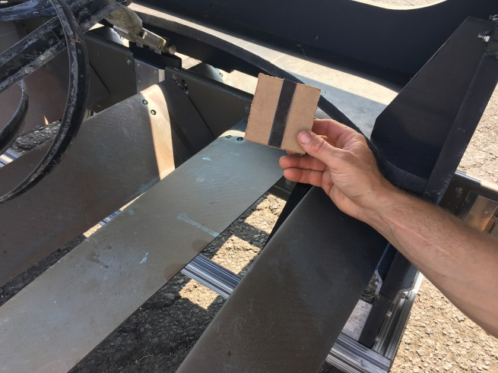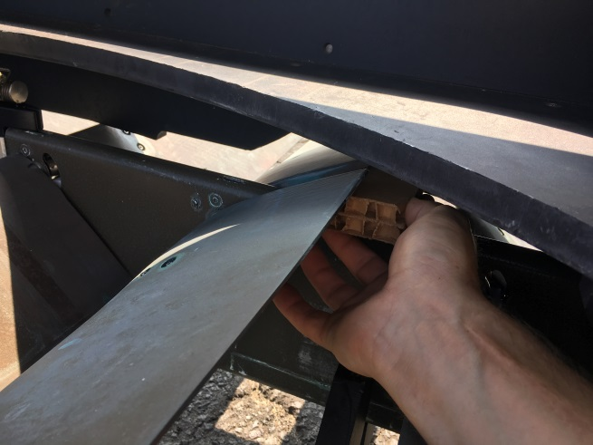
Figure 1. Doublesided tape on cardboard wedge Figure 2. Insert wedge under the fifth wings
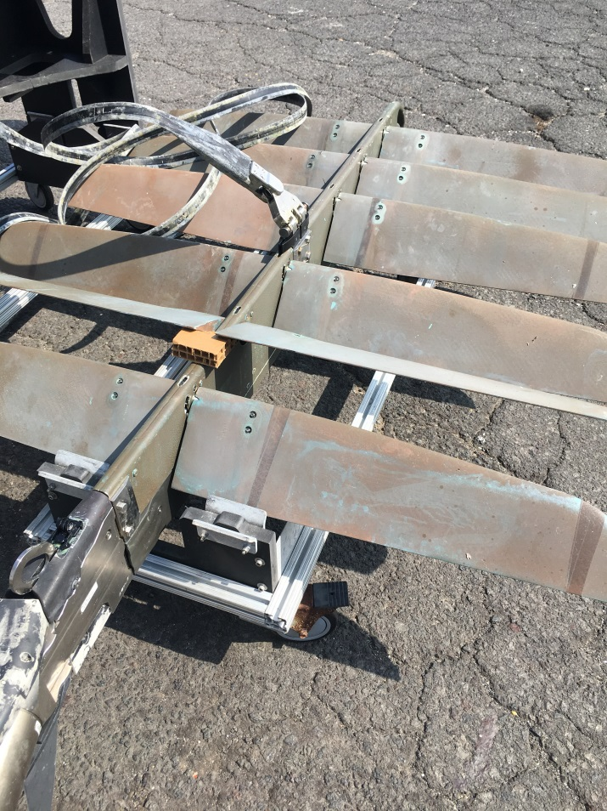
Figure 3. View of the cardboard wedge under the fifth wing (without saddle installed)

