Sea-Gird Electronics Glider Payload CTD

SENSOR GUIDE

First Revision Second Draft February 2012
Liquid Robotics Part Number: xxx-xxxxx



Liquid Robotics Sensor Guide for the Sea-Bird Electronics Glider Payload CTD
Copyright © 2012 Liquid Robotics, Inc. All rights reserved. Printed in the United States of America.

Trademarks
Liquid Robotics®, LRI, Wave Glider, Wave Glider Management System, and WGMS are worldwide trade- marks of Liquid Robotics, Incorporated. Other products and company names mentioned herein may be the trademarks of their respective owners.

Patents & Inventions
The Wave Glider mechanism is patented under US Patent Number 7,371,136 and other patents pending. All aspects of the Wave Glider product have been developed at private expense by Liquid Robotics, Inc.

Table of Contents

Preface

Introduction

System Overview..........................................................................................2
Mechanical Design ........................................................................................3
Electronics ...................................................................................................4
Software Components ...................................................................................5
Software System Overview ............................................................................6

Collecting Data

Data Collection Process Overview....................................................................8
Plan for Data Collection .................................................................................9
Configure the GPCTD................................................................................... 10
Collect Data ............................................................................................... 10
Retrieve Data for Further Analysis ................................................................. 10

Commands

Commands Overview................................................................................... 12

GPCTD Commands ......................................................................................12
GPCTD Command Acknowledgements ............................................................19

Data Formats

Data Format Overview .................................................................................22
Payload Telemetry Message Format ...............................................................22

Launch, Recovery, and Storage

Launch, Recovery, and Storage Overview .......................................................26
GPCTD Accessories Kit ............................................................................26
Glider Payload GPCTD Precautions ............................................................26
Pre-Launch Checkout ...................................................................................27

Troubleshooting

Troubleshooting Overview ............................................................................30
Liquid Robotics Customer Support .................................................................31

Maintenance

Maintenance Overview .................................................................................34

Replacement

Replacement Overview.................................................................................36
Removal and Installation Process - Float Hull ..................................................37
Removal and Installation Process - Glider .......................................................37
Placing the Float on the Float-Glider Saddle ....................................................38
Removing the Turtle Deck ............................................................................39
Removing the Solar Panel.............................................................................40
Disconnecting and Removing the Payload Drybox ............................................43
Removing the Payload Drybox Lid Assembly ...................................................44
Removing the GPCTD Assembly.....................................................................45
Installing the GPCTD Assembly .....................................................................47
Installing the Payload DryBox Lid Assembly ....................................................49
Connecting and Installing the Payload Drybox .................................................51
Installing the Solar Panel..............................................................................52
Installing the Turtle Deck .............................................................................54
Placing the Glider on the Glider Support Stand ................................................55
Disconnecting the GPCTD Assembly from the Glider .........................................56
Removing the GPCTD from the Glider Frame ...................................................57
Installing the GPCTD on the Glider Frame .......................................................59
Connecting the GPCTD Assembly to the Glider.................................................62

Appendix A Glossary

Preface

This guide provides information for operating the Wave Glider with one or more Sea-Bird Electronics Glider Payload CTDs installed. It provides an overview of the mechanical, electronic, and software aspects of the GPCTD integrated in the Wave Glider. The guide includes specific considerations for the GPCTD during operational planning, pre-launch, launch, recovery, storage, troubleshooting, and maintenance. It also includes descriptions of the command structure and data formats supported by the Wave Glider when operating the GPCTD.

This document assumes a working familiarity with the Liquid Robotics Wave Glider and the Sea-Bird Electronics family of GPCTDs. It focuses primarily on the information unique to GPCTD integration with the Wave Glider. This manual also assumes that the GPCTD has been tested according to the Sea-Bird GPCTD User’s Manual. Listed below are additional documents that the user should have available while working with the Wave Glider and GPCTD. Appendix A provides a glossary of terms used in this manual.

Related Documents

• Sea-Bird Electronics GPCTD User’s Manual
• Sea-Bird Electronics GPCTD Specifications Sheet
• Sea-Bird Electronics GPCTD Support and Training, http://www.seabird.com
• Liquid Robotics Interface Control Description, version 2.00, P/N 030-00026-02
• Liquid Robotics Wave Glider User Manual, P/N 030-00025-02
• Mobile Operations Kit Operator’s Guide, Liquid Robotics P/N 030-00799

Chapter 1

Introduction

The Liquid Robotics integration of the Sea-Bird Electronics Glider Payload CTD pro- vides a mobile, long endurance platform for collecting conductivity, temperature, and pressure data, and (optionally) dissolved oxygen data. This chapter provides an overview of the GPCTD as integrated into the Wave Glider. See Appendix A for a glossary of terms used in this manual.

System Overview

The Sea-Bird Electronics family of Glider Payload CTD sensors can be integrated into the hull of the float, a glider payload, or a towbody of the Liquid Robotics Wave Glider. More than one GPCTD can be installed in the Wave Glider. If the GPCTD has the optional dissolved oxygen sensor, it must also have the pump when integrated into the Wave Glider. If the GPCTD does not have the dissolved oxygen sensor, the pump is optional when integrated into the Wave Glider. The operation of the GPCTD as described in this manual is independent of the inclusion of the pump.

The GPCTD is powered by the Wave Glider's electrical system, which uses photovoltaic solar cells. The GPCTD is controlled by the Liquid Robotics Wave Glider Management System (WGMS). Data generated by the GPCTD can be sent to WGMS using standard Wave Glider communications channels via the Iridium satellite The GPCTD may be commanded dynamically from shore during deployment to reflect changing mission objectives and constraints.

Data is returned from the GPCTD to WGMS. A key feature of the data generated by the Sea-Bird Electronics-Liquid Robotics combination is that it can be extended with Wave Glider GPS tags for latitude, longitude, date, and time for each sample.

Mechanical Design

The Sea-Bird Electronics GPCTD can be integrated into the hull of the float, a glider payload, or a towbody of the Liquid Robotics Wave Glider. Typical float hull and glider installations are shown below. Contact Liquid Robotics for more information about the GPCTD integrated into a towbody.

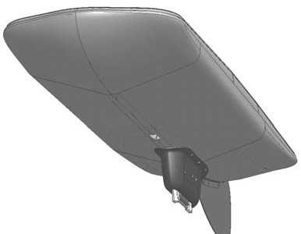
Figure 1: GPCTD Mounted in Float Hull

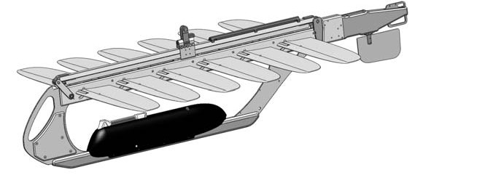
Figure 2: GPCTD Mounted On Glider

Electronics

The payload drybox contains a Payload Interface Board (PIB). A Personality/ Communications (P-Comm) board for the GPCTD plugs into one of the personality modules of the PIB. The GPCTD is powered by and communicates through the P- Comm and PIB to the Command and Control (C&C) module on the Wave Glider. The payload drybox may also contain additional electronics for other sensors and monitors in the payload in addition to the GPCTD.

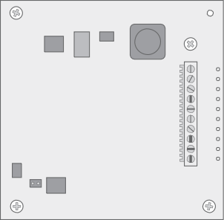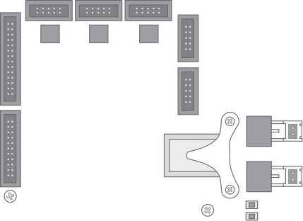The illustration below is an example of how the electronics may be arranged. The electronics boards may be stacked in different arrangements depending on space requirements for other payload electronics.

Figure 3: PIB with P-Comm

Software Components

The Wave Glider and GPCTD use the following software systems and applications. Their purpose and use are described in greater detail in the following section.

• Sea-Bird Electronics SEASOFT Software Package

The Sea-Bird Electronics SEASOFT Software Package can be used to configure the GPCTD prior to integration into the Wave Glider, and for post-processing data.

• Wave Glider Management System (WGMS)

The Liquid Robotics WGMS is a shore-based service used to pilot the Wave Glider. It communicates to the Wave Glider via an Iridium modem. Commands are sent to the GPCTD using the WGMS Write Console Script command.

Software System Overview

GPS Commands
Data

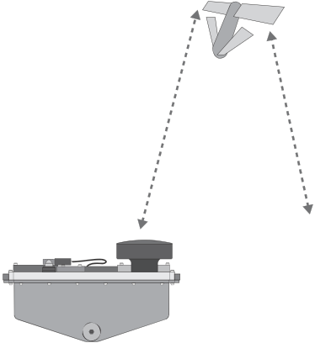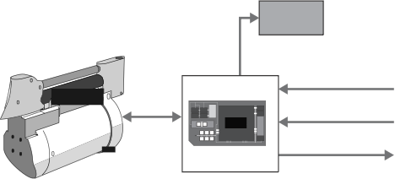1 | GPCTD 2 | PIB | 3 | C&C 4 | WGMS 5 | User computer

Figure 4: GPCTD Control and Data Flow

The user plans his use of the GPCTD using appropriate resources, such as the Sea- Bird Electronics documentation, Wave Glider documentation, and considerations discussed in this manual. See "Chapter 2, Plan for Data Collection".

The GPCTD is configured including parameters such as baud rate and output format. (6). The GPCTD must be configured prior to integration into the Wave Glider.

During deployment, WGMS (5) is used to send commands to the GPCTD via the
Iridium satellite.

The GPCTD streams data to the PIB (2), which returns it through WGMS. GPCTD data is returned with tags for latitude, longitude, datestamp, and timestamp for each sample.

Chapter 2

Collecting Data

This chapter describes configuring GPCTD data collection parameters using Liquid Robotics and Sea-Bird Electronics tools. The flexibility of the Sea-Bird Electronics and Liquid Robotics systems allow for any number of additional ways to configure and perform data collection with equally successful results.

Data Collection Process Overview

Collecting data from an GPCTD and returning it to shore involves four operations. This section provides an overview of the entire process. Each step is described in more detail in the following sections of this chapter.

Step 1: Plan for Data Collection

The GPCTD can be configured to take samples at specific intervals and report blocks of samples. The principal constraints on your choices are environmental – primarily communications bandwidth and power consumption – and post-processing requirements.

Step 2: Configure the GPCTD

You must configure the GPCTD prior to integration in the Wave Glider.

Step 4: Collect data

The GPCTD starts streaming data to the PIB when the it receives the GPCTD -run command according to the default configuration parameters or the parameters sent with commands through WGMS.

Step 5: Store and Retrieve Data

The PIB returns the data to WGMS. If the GPCTD includes a datalogger option, data can be retrieved directly from the GPCTD while on-shore.

Plan for Data Collection

The combination of the Wave Glider sensor management system with the Sea-Bird Electronics GPCTD supports a large number of possible applications. The planner must balance collection objectives and environmental constraints when developing the detailed collection plan.

One of the key advantages of the Liquid Robotics integration is that it is easy to change the GPCTD collection program at any time, including after launch.

Considerations for the GPCTD

Communications Bandwidth

It is possible to configure the GPCTD to generate more raw data than the Iridium communications channel can transport to shore. If the GPCTD samples less than once every 30 seconds, it is recommended that the duty cycle option be used to reduce the required communications bandwidth.

Power Budget

The GPCTD subsystem is a relatively low power sensor. However, its power consumption must be included when assessing the total power budget for the Wave Glider. Using the duty cycle option can reduce the power consumption of the GPCTD. Communications requirements for the GPCTD must also be included when assessing the total power budget for the Wave Glider.

Configure the GPCTD

The GPCTD must be configured before integration in the Wave Glider using Sea-Bird Electronics tools or a PC with a serial terminal program. See the Glider Payload GPCTD User’s Manual for more information.

When configuring the GPCTD for use in a Wave Glider, the following parameters must be set.

WARNING: If the configuration parameters are not set correctly, the
GPCTD may not return data.

serial port: 9600 baud, 8 data bits, 1 stop bit, no parity

OutputExecutedTag: NO

OutputFormat: 0

AutoRun: OFF

Note: This is the autorun feature implemented in the GPCTD, not the autorun feature implemented in the PIB and controlled by the GPCTD --autorun command.

Clock: Correct time (UTC recommended)

Collect Data

The command

GPCTD -run

causes the GPCTD to start to collect data and return it to the PIB. The GPCTD returns samples in Sea-Bird Electronics-native format. The PIB appends GPS date, time, latitude, and longitude. before returning the data to WGMS via the Iridium satellite.

Retrieve Data for Further Analysis

The GPCTD data is returned from a Wave Glider through WGMS using the Iridium satellite or Xbee radio. If the GPCTD includes a datalogger option, data can be retrieved directly from the GPCTD on-shore using Sea-Bird Electronics tools or a PC with a serial terminal program.

Chapter 3

Commands

This chapter describes the commands and command formats used to control the
GPCTD.

Commands Overview

The GPCTD is controlled by the commands described in this chapter. Commands are sent to the GPCTD through the PIB from WGMS using the Write Console Script command. Responses are returned in the Write Console ACK.

Note: The Wave Glider does not support the full command set of the Sea-Bird Elec- tronics Glider Payload CTD. Unsupported commands can be implemented using the CTD -c command. However, some GPCTD commands can make the GPCTD inoperable.

GPCTD Commands

Synopsis

CTD -o | --on

CTD -f | --off

CTD -a | --autorun

CTD -r | --run [period] [report block size] [destination] CTD -x | -stop
CTD -p | --period [period]

CTD -z | --size [report block size] CTD -d | --dest [destination]
CTD –y | --cycle [sensor off time] CTD -s | --status
CTD -i |--id

CTD -c | --cmd [GPCTD command string from GPCTD documentation]

CTD ON

Syntax

CTD -o | --on

Summary

Directs the PIB to power on the GPCTD.

Semantics

This will apply power to the GPCTD. The return data will include the serial number of the GPCTD and the default sampling parameters (sample interval, report block size, and destination address).

Notes

This command will not start the GPCTD sampling.

CTD OFF

Syntax

CTD -f | --off

Summary

Directs the PIB to power off the GPCTD.

Semantics

This will power off the GPCTD.

Notes

If the GPCTD was currently sampling data, the last packet will be sent with whatever data has been collected at this point, regardless of whether or not the number of samples specified in the report block size has been reached.

CTD AUTORUN

Syntax

CTD -a | --autorun [mode]

Summary

This command sets the PIB-based Autorun mode.

Semantics

This command will turn the PIB-based Autorun feature On or Off. When Autorun is On, the personality module, and therefore the GPCTD, will be powered on when the PIB starts up. When Autorun is Off, the personality module and the GPCTD will not be powered on when the PIB starts. After the PIB is running, the power state can always be changed by sending a CTD ‐o or CTD ‐f. Valid parameters for the CTD ‐a command are On/Yes/1 or Off/No/0.

Note: This is the autorun feature implemented in the PIB, not the autorun feature implemented in the GPCTD and controlled by setting AutoRun during configuration.

CTD RUN [period][report block size][destination]

Syntax

CTD -r | --run [period][report block size][destination]

Summary

Directs PIB to start the GPCTD sampling with either default settings or the given parameters.

Semantics

Sends the start command to the GPCTD in order to begin autonomous sampling of the GPCTD. The return will include serial number and the parameters used for the sampling. The parameters are as follows:

Period: This is the time between successive samples in seconds. The value must be between 1 and 3600 (1 second up to 1 hour). If a sample rate faster than 30 seconds is required, it is recommended to implement the duty cycle option to avoid saturating the Iridium SBD bandwidth. Initial default value is 1 minute. The value is stored in the PIB EEPROM and will be maintained through power cycles/reboots of the system and/or PIB.

Report Block Size: This is the number of samples that are packed into a single data report. The value must be between 1 and 10. Initial default value is 1. The value is stored in the PIB EEPROM and will be maintained through power cycles/reboots of the system and/or PIB.

Destination: This is a 2-byte hex address indicating where the data should be sent (shore, another payload, payload resident modem, etc. This uses the standard BoardID-TaskID nomenclature where address 0x0000 is sent to shore via the default communication channel. The value is stored in the PIB EEPROM and will be maintained through power cycles/reboots of the system and/or PIB.

Note: Destination is not currently supported. Including a destination in the com- mand will have no impact on the GPCTD.

Notes

All parameters are optional, but if they are entered, they must be entered in the order specified. If you want to specify destination address, you must also specify period and block size. If only the period needs to be specified, the block size and destination do not need to be sent in the command. If the GPCTD is currently off when this command is sent, it will power on the GPCTD and then start sampling. If the GPCTD is currently sampling data when this message is received and the parameters are different from the current sampling mode, the data collected up to this point will be transmitted and the GPCTD will be reset to use the new parameters for sampling, otherwise a “Sampling in progress” message will be returned in the ACK/NACK.

CTD STOP

Syntax

CTD -x | --stop

Summary

Directs PIB to stop the GPCTD sampling but leave the GPCTD powered on.

Semantics

Sends the stop command to the GPCTD in order to end autonomous sampling on the GPCTD. The data collected since the last report will be transmitted back to the desired destination at this point, regardless of whether the report block size has been reached.

CTD PERIOD

Syntax

CTD -p | --period [period]

Summary

Directs the PIB to set the default sample period (in seconds) for use when the next
ctd -r command is received.

Semantics

Sets the default sample period of time between successive samples in seconds. he value must be between 1 and 3600 (1 second up to 1 hour). If a sample rate faster than 30 seconds is required, it is recommended to implement the duty cycle option

to avoid saturating the Iridium SBD bandwidth. Initial default value is 1 minute. The value is stored in the PIB EEPROM and will be maintained through power cycles/ reboots of the system and/or PIB.

Notes

This will not change the current sample interval if sampling is already in progress when the command is received, but will set the new default for the next time sampling is started. This value is stored in the PIB EEPROM and will be maintained through power cycles/reboots of the system.

CTD REPORT BLOCK SIZE

Syntax

CTD -z | --size [report block size]

Summary

Sets the default report block size (the number of samples that are sent in a single data report packet).

Semantics

Sets the default report block size. Valid values range from 1 to 10 and the initial default value is 10.

Notes

This will not change the current block size if sampling is already in progress when the command is received, but will set the new default for the next time sampling is started. This value is stored in the PIB EEPROM and will be maintained through power cycles/reboots of the system.

CTD DESTINATION

Syntax

CTD -d | --dest [destination]

Summary

Sets the default destination where the data reports are sent.

Semantics

Sets the default destination where the data reports are sent. The destination is specified in the standard 2 byte BoardID-TaskID nomenclature where address
0x0000 is the default communication channel to shore. Values must be specified as a HEX value. The initial default value is 0x0000 (i.e. send data to shore via default communication channel).

Note: Destination is not currently supported. Sending a GPCTD --destination com- mand will have no impact on the GPCTD.

CTD DUTY CYCLE

Syntax

CTD –y | ‐‐cycle [sensor off time]

Summary

This command sets up a duty cycle for the GPCTD. When told to start sampling, the firmware will collect one full packet of samples (as specified by the sample period and report block size parameters). Once a full packet of data has been collected, the sensor will stop sampling for the amount of time specified by this command. After the wait period has elapsed, the sequence will repeat.

Example

If you want the CTD to sample at a 10 second interval, put 10 samples into a packet, and get one packet every 10 minutes (600 seconds), the sample period would be set to 10 seconds, the report block size would be set to 10 samples per packet (10 samples * 10 seconds per sample = 100 seconds to get one packet’s worth of data) and this parameter would need to be set at 500 seconds (100 seconds for the sampling time and 500 seconds off = 600 seconds (or 10 minutes) for the whole duty cycle).

Semantics

Sets the amount of time the sensor will wait between blocks of samples (1 block of samples is specified by the report block size parameter). Valid values range from 0 seconds to 43200 seconds (12 hours)

Notes

This will not change the current duty cycle time if sampling is already in progress when the command is received, but will set the new default for the next time sampling is started. This value is stored in the PIB EEPROM and will be maintained through power cycles/reboots of the system.

The GPCTD enters a low-power mode between sample cycles and the pump is powered-off. This can reduce the total power requirement of the GPCTD.

CTD STATUS

Syntax

CTD -s | --status

Summary

Directs PIB to return the current state of the GPCTD.

Semantics

This command will generate a response from the PIB indicating the current state of the GPCTD. This will include power on/off, sampling in progress or not, and the parameters that are used for sampling (period, report block size, and destination).

CTD ID

Syntax

CTD -i | --id

Summary

Directs PIB to return serial number and version information for the GPCTD.

CTD COMMAND [command]

Syntax

CTD -c | --command [command]

Summary

This will send a user-generated command string replicating a Sea-Bird Electronics
GPCTD command.

Semantics

This command will send a user-generated command to the GPCTD. Commands must be formatted appropriately for the GPCTD as specified in the GPCTD documentation. Data will be returned as best as possible from the GPCTD, truncated

to 256 bytes. The WGMS will not process the data; the user must process the data returned by these commands.

WARNING: Some configuration commands may put the GPCTD in a state where it will stop returning data or the PIB will not be able to communicate with the GPCTD. Examples are changing the baud rate or setting the
auto-run to “yes”. The GPCTD can not be reconfigured while deployed. If the GPCTD becomes inoperable, it can not be restored until the Wave Glider is recovered and the GPCTD is reconfigured.

GPCTD Command Acknowledgements

All acknowledgements to commands are sent as a text block in the ACK to the Write Console Script command and can be viewed in WGMS. If the destination is unable to process the command, it will send a NACK back instead of the ACK with text.

Command Acknowledgment for All Commands except CTD -id and
CTD -command

All commands except CTD -id and CDT -cmd return the following status string as an acknowledgement:

OK/FAIL Pwr=On/Off Smpl=On/Off Intrvl=#### sec Size=## smpl/pkt
Off-T=#### Slp=On/Off Dest=0x####/SHORE Oxygen=Yes/No Autorun=Yes/No

where OK/FAIL indicates the success or failure of the command and the remainder of the string returns the current status information of the GPCTD.

Command Acknowledgement for CTD -id

CTD -id returns the one of following acknowledgments:

SBE Glider Payload CTD 1.0A SERIAL NO. 0024 (serial number and firmware version will vary)

or

CTD Version and Serial Number is not available

Command Acknowledgment for CTD -cmd

The PIB returns up to the first 256 characters returned from the GPCTD as a response to the CTD -cmd command.

Chapter 4

Data Formats

The Wave Glider returns GPCTD data in Sea-Bird Electronics-native formats with GPS date, time, latitude, and longitude appended. This chapter provides details on the available GPCTD data formats.

Data Format Overview

Data returned by the GPCTD is a fairly compact ASCII string. The data can be reported back by the GPCTD in three different formats. See the Sea-Bird Electronics Glider Payload CTD User’s Manual for more information about the data formats.

Note: The Wave Glider currently only supports Format 0. Output must be set to “0”
during configuration of the GPCTD prior to integration in the Wave Glider.

Format 0 is Engineering Units in Hex. This format returns the data for each measurement as a 5 byte Hex value (00000 -> FFFFF). The data can then be converted to real values with a very simple algorithm. When using this format, the sensor will return either a 15 byte or 20 byte string (the 20 byte string is used when the oxygen sensor is installed) which the PIB will parse and pack as three 4-byte integer values, or as four 4-byte integer values if the oxygen sensor is installed. Data conversions are as follows:

Pressure in decibars = (Value/100) – 10

Temperature in degrees Celsius = (Value/10,000) – 5

Conductivity in Siemens/meter = (Value/100,000) – 0.05

Oxygen in Hertz = (Value/10)

Format 1 is Engineering Units returned in Decimal (no end user conversion necessary, but more difficult to parse and pack up efficiently for transmission).

Note: Format 1 is not currently supported by the Wave Glider. If the GPCTD is con- figured for Format 1, the PIB will not return any data.

Format 2 is Raw Data returned in Decimal format (requires the calibration information in order to convert to engineering units).

Note: Format 2 is not currently supported by the Wave Glider. If the GPCTD is con- figured for Format 2, the PIB will not return any data.

Payload Telemetry Message Format

The GPCTD data is returned to WGMS as a type 0x91 structure as shown in Table 1. See the Sea-Bird Electronics documentation for definitions of the sensor specific values. Where appropriate, the text strings are converted to binary to save space.

Table 1: Payload Telemetry Message Format 0x91

Field Name Bytes
Used

Byte # Format

PayloadType 4 0-3 Unsigned 32-bit integer:
0x00000070

Board ID 1 4 Unsigned 8-bit integer Task Id 1 5 Unsigned 8-bit integer Sensor Data Format 1 6 (bits 0-3) Unsigned 4-bit integer Default Parser 1 6 (bit 4) 0=binary/1=ASCII Delivery Priority 1 6 (bits 5-7) Signed 3-bit integer
Repeat Count 1 7 Unsigned 8-bit integer

Sensor Data Format:

0: Sensor Identification – serial number and version (ASCII) (not currently supported)

1: Sensor Status/Configuration -- on/off/sampling/parame- ters (ASCII) (not currently supported)

8: GPCTD Data without Oxygen Sensor – Sensor Data For- mat 0 (Engineering Units in Hex, PIB packs as binary to save space)

9: Note: GPCTD with Oxygen Sensor – Sensor Data Format
0 (Engineering Units in Hex, PIB packs as binary to save space)

Table 2: GPCTD Sensor Data Format

Field Name Bytes
Used

Byte # Format

GPS Latitude 4 0-3 Signed 32-bit integer

GPS Longitude 4 4-7 Signed 32-bit integer

GPS Date and Time 4 8-11 Unix time_t as read on the SMC Pressure 4 12-15 Unsigned 32-bit integer Temperature 4 16-19 Unsigned 32-bit integer Conductivity 4 20-23 Unsigned 32-bit integer
Oxygen 4 24-27 Unsigned 32-bit integer

Latitude and longitude are 1/10,000 of a minute. Pressure P (in decibars) = (Value/100) - 10

Temperature T(in deg C) = (Value/10,000) – 5

Conductivity C (in S/m) = (Value/100,000) – 0.05

Oxygen O (in Hz) = (Value/10)

Below is the GPCTD data as returned in WGMS

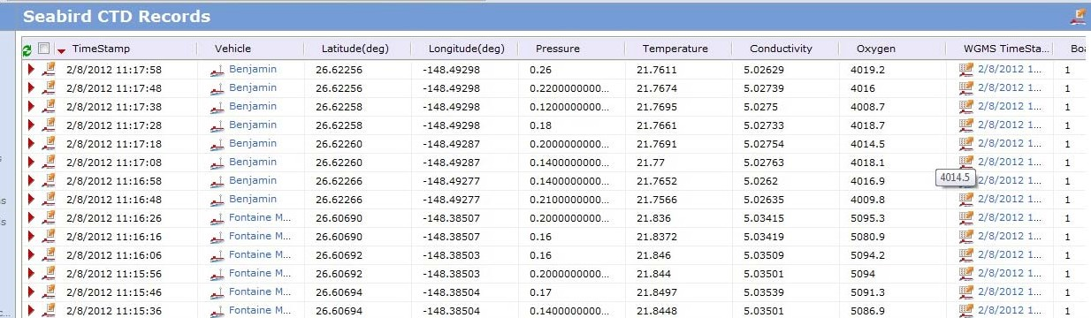
Figure 5: GPCTD data in WGMS

Chapter 5

Launch, Recovery, and Storage

Detailed instructions for launch, recovery, and storage are found in the Wave Glider User Manual and Mobile Operations Kit Operator’s Guide. This chapter provides spe- cific instructions and considerations for when the Glider Payload GPCTD is installed.

Launch, Recovery, and Storage Overview

GPCTD Accessories Kit

A Wave Glider with the GPCTD installed ships with a GPCTD accessory kit. The kit and its contents must be stored by the user. Some items may be needed for troubleshooting or to return the GPCTD.

ADCP Accessories Kit

Sea-Bird Electronics Manuals and
Software

Custom Foam (save for reshipping)

Glider Payload GPCTD Precautions

In order to minimize contamination of the conductivity cell and the oxygen sensor membrane with surface oils as it enters/exits the water, it is critical that the proper deployment and recovery techniques be used. See the Sea-Bird Electronics Glider Payload GPCTD User’s Manual for detailed information.

Pressure housings in the GPCTD may flood under pressure due to dirty or damaged o-rings, or other failed seals. When a sealed pressure housing floods at great depths and is subsequently raised to the surface, water may be trapped at the pressure at which it entered the housing, presenting a danger if the housing is opened before relieving the internal pressure.

If you suspect the GPCTD is flooded during recovery, point it in a safe direction away from people, and loosen the 4 screws on the sensor end cap about ½ turn. If there is internal pressure, the end cap will follow the screws out, and the screws will not become easier to turn. In this event, loosen the bulkhead connector (on the other end cap) very slowly, at least 1 turn. This opens an o-ring seal under the connector. Look for signs of internal pressure (hissing or water leak). If internal pressure is detected, let it bleed off slowly past the connector o-ring. Then, you can safely remove the sensor end cap.

If the GPCTD includes the pump, the GPCTD should only operate if it is fully submerged or totally dry.

Pre-Launch Checkout

The Glider Payload GPCTD should undergo a final pre-launch test, as part of the overall test of the Wave Glider. Add the following to the checklist to confirm Glider Payload GPCTD functionality:

Status Checks

Calibrate and characterize the Glider Payload GPCTD, if necessary. See the Sea-Bird
Electronics Glider Payload CTD User’s Guide.

Functionality Checks

WARNING: If the GPCTD includes a pump, the GPCTD should only oper- ate if it is fully submerged or totally dry.

Confirm that the GPCTD is powered on by issuing the ctd -o command using the WGMS Write Console Script command. The GPCTD should return the following acknowledgement:

OK/FAIL Pwr=On/Off Smpl=On/Off Intrvl=#### sec Size=## smpl/pkt Off-T=#### Slp=On/Off Dest=0x####/SHORE Oxygen=Yes/No Autorun=Yes/ No

where OK/FAIL indicates the success or failure of the command and the remainder of the string returns the current status information of the GPCTD.

Confirm the status of the GPCTD by issuing the ctd -i command. The GPCTD
should return the following acknowledgement:

SBE Glider Payload CTD 1.0A SERIAL NO. 0024 (serial number and firmware version will vary)

Confirm that the GPCTD is returning data by issuing the ctd -r command. The
GPCTD should return the following acknowledgement:

OK/FAIL Pwr=On/Off Smpl=On/Off Intrvl=#### sec Size=## smpl/pkt Off-T=#### Slp=On/Off Dest=0x####/SHORE Oxygen=Yes/No Autorun=Yes/ No

Data should be visible in WGMS as shown below. If the data is older than the sample rate/block report size period, the GPCTD may not be returning data correctly.

Figure 6: GPCTD data in WGMS

Stop the GPCTD by issuing the ctd -x command. If needed, power the GPCTD off by issuing the ctd -f command. For each command the GPCTD should return the following acknowledgement:

OK/FAIL Pwr=On/Off Smpl=On/Off Intrvl=#### sec Size=## smpl/pkt Off-T=#### Slp=On/Off Dest=0x####/SHORE Oxygen=Yes/No Autorun=Yes/ No

If the GPCTD does not return acknowledgements or data as expected, go to
"Chapter 6, Troubleshooting".

Chapter 6

Troubleshooting

Testing and troubleshooting of the standalone GPCTD must be completed according to the Sea-Bird Electronics Glider Payload GPCTD User’s Guide prior to its integra- tion into the Wave Glider. This chapter provides instructions for troubleshooting after integration.

Troubleshooting Overview

There are three situations where you may become aware that the GPCTD is not operating properly:

• During on-shore checkout
• During pre-launch checkout
• During normal operations at sea

If you become aware of a possible problem with the GPCTD, follow the steps below to isolate the problem.

Note: The Wave Glider with the GPCTD installed shipped with an GPCTD accessory kit. The kit contains items needed for troubleshooting. "Chapter 5, GPCTD Accesso- ries Kit".

1. Confirm that the GPCTD is working by performing the functionality checks. See
"Chapter 5, Pre-Launch Checkout".

2. If the GPCTD does not return acknowledgements or data as expected, consult the Troubleshooting chapter of the Wave Glider User Manual to ensure that there are no problems with the Wave Glider power or communications systems.

3. If the GPCTD continues to fail, see "Liquid Robotics Customer Support" below to contact Liquid Robotics.

Liquid Robotics Customer Support

Customer support is available during regular business hours: Monday - Friday, 8:00
AM to 5:00 PM (PST). Outside of regular business hours, support will be provided within 2 (two) business days.

Telephone (888) 574-4574 or
(408) 636-4200

Email support@liquidr.com Before You Contact Us
Before contacting Liquid Robotics support, please have the following information ready:

• Your support contract number
• Serial number of the vehicle(s) or part(s) affected

Chapter 7

Maintenance

Maintenance instructions for the Wave Glider unit are provided in Wave Glider Mobile Operations Kit Operator’s Guide. Maintenance instructions for the GPCTD are provided in the Sea-Bird Electronics Glider Payload GPCTD User’s Guide. This chap- ter provides additional instructions for maintenance of the GPCTD installed in the Wave Glider.

Maintenance Overview

There are no special maintenance procedures for the GPCTD integrated into the Wave Glider. See the Sea-Bird Electronics GPCTD User’s Guide for standard GPCTD maintenance procedures.

If the GPCTD needs to be removed from the Wave Glider to perform maintenance, see “"Chapter 8, Replacement".” If the GPCTD is re-installed following maintenance, be sure to complete checkout of the GPCTD before installation. Follow the testing and troubleshooting instructions in the Sea-Bird Electronics GPCTD User’s Guide.

The GPCTD includes an anti-foulant device that contains bis(tributyltin) oxide, a corrosive agent. Wear rubber or latex gloves and eye protection when handling the devices. See the MSDS for more information.

Chapter 8

Replacement

The GPCTD may need to be disconnected or removed from the Wave Glider for trou- bleshooting. This chapter provides detailed instruction for disconnecting, removing, and installing the GPCTD in the Wave Glider.

Replacement Overview

This chapter provides detailed instruction for disconnecting, removing, and installing the GPCTD in the Wave Glider hull and in a glider payload. Contact Liquid Robotics for replacement information for a GPCTD installed in the towbody.

The GPCTD includes an anti-foulant device that contains bis(tributyltin) oxide, a corrosive agent. Wear rubber or latex gloves and eye protection when handling the devices. See the MSDS for more information.

Before installing the GPCTD, be sure to first complete checkout of the GPCTD. Follow the testing and troubleshooting instructions in the Sea-Bird Electronics GPCTD User’s Manual. The GPCTD should only operate when it is not flooded with water. Take care not to power-on the GPCTD if it is not flooded with water.

The installation and removal procedures require the following tools and equipment. Have the necessary tools and equipment ready before beginning the disconnection, removal, or installation procedures.

Tools and Equipment Required for Removal and Installation
Tool/Part Qty Part #
Mobile Operations Tool Kit
Float-glider saddle 1 00231
#2 Phillips head screwdriver 1 N/A
6mm hex head wrench 1 N/A
4mm hex head wrench 1 N/A
3M silicone spray lubricant 1 N/A
Loctite 242 (blue) 1 N/A
Cable ties 4 N/A
Cable cutter (for cable ties) 1 N/A

Removal and Installation Process - Float
Hull

Removing the GPCTD from the float hull

1. “Removing the Turtle Deck” on page 39

2. “Removing the Solar Panel” on page 40

3. “Disconnecting and Removing the Payload Drybox” on page 43

4. “Removing the Payload Drybox Lid Assembly” on page 44

5. “Removing the GPCTD Assembly” on page 45

Installing the GPCTD in the float hull

1. “Removing the Turtle Deck” on page 39

1. “Removing the Solar Panel” on page 40

2. “Installing the GPCTD Assembly” on page 47

3. “Installing the Payload DryBox Lid Assembly” on page 49

4. “Connecting and Installing the Payload Drybox” on page 51

5. “Installing the Solar Panel” on page 52

6. “Installing the Turtle Deck” on page 54

Removal and Installation Process - Glider

Removing the GPCTD from the glider

1. “Disconnecting the GPCTD Assembly from the Glider” on page 56

2. “Removing the GPCTD from the Glider Frame” on page 57

Installing the GPCTD in the glider

1. “Installing the GPCTD on the Glider Frame” on page 59

2. “Connecting the GPCTD Assembly to the Glider” on page 62

Placing the Float on the Float-Glider
Saddle

Before You Begin

Before removing the GPCTD from the float hull, the float must be installed on the float-glider saddle which ships with the Wave Glider.

Description of Work

1. Place the glider on the support stand as instructed in the Liquid Robotics Wave
Glider Mobile Operations Kit User’s Guide.

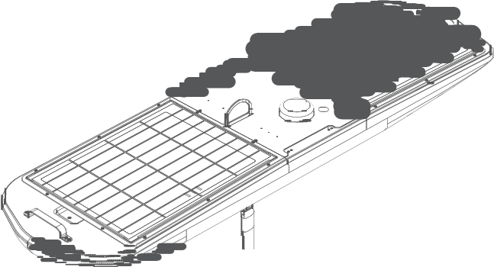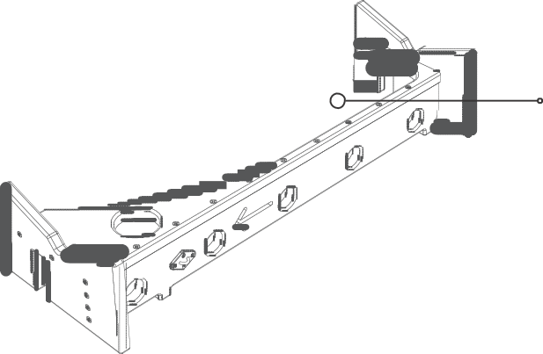Cutout to accommodate ADCP

Drainage hole

Forward end

Figure 7: Float on the float-glider saddle

2. Place the float on the float-glider saddle, following the instructions in the Liquid
Robotics Wave Glider Mobile Operations Kit User’s Guide.

This completes the procedure for using the float-glider saddle.

Removing the Turtle Deck

Before You Begin

Note: Before removing the turtle deck, the float must be installed on the float- glider saddle which ships with the Wave Glider.

Note: For detailed instructions, see “Placing the Float on the Float-Glider Saddle” on page 38.

WARNING: Before working on the Wave Glider, make sure that you have powered off the vehicle by disconnecting the shorting plug from the bat- tery switch on the C&C dry box.

Description of Work

1. Remove the six (6) screws securing the turtledeck.

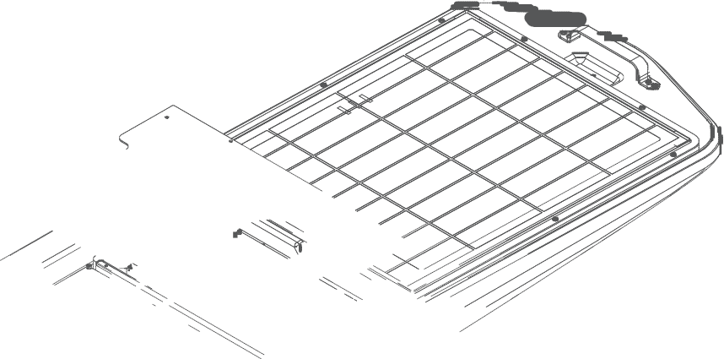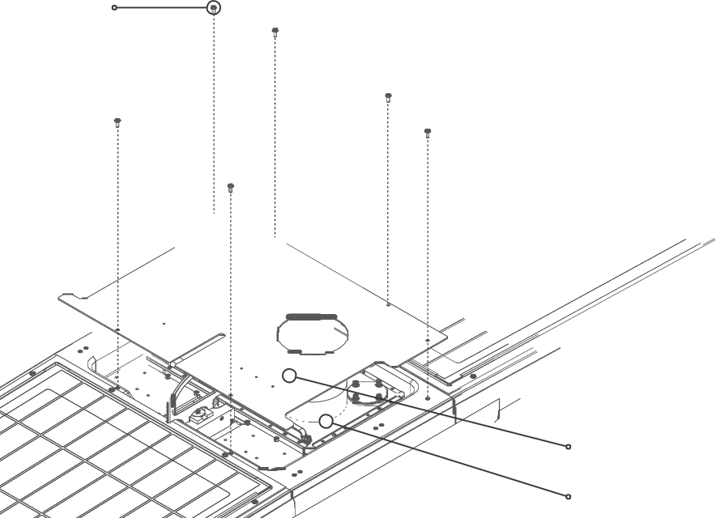Phillips Head
Screw 12mm

Turtle Deck

C&C Dry Box

Figure 8: Removing the Turtle Deck

2. Remove the turtledeck to expose the C&C dry box.

This completes the procedure for removing the turtle deck.

Removing the Solar Panel

Before You Begin

To remove the solar panel, the turtle deck must be removed so that you can access the C&C dry box.

Note: For detailed instructions, see “Removing the Turtle Deck” on page 39.

Description of Work

1. Remove the three (3) screws securing the left side connector cover to the C&C dry box, and remove the cover to access the solar panel cable connector.

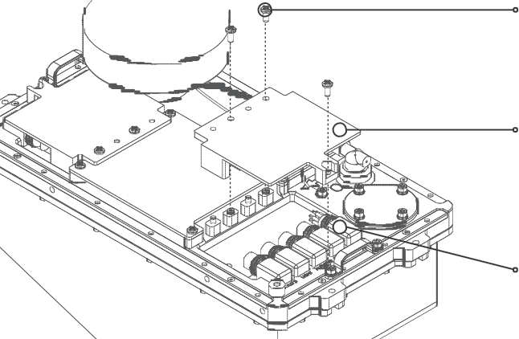Phillips Head Screw (12mm)

Connector Cover

Aft Solar Panel Connector

Figure 9: Removing the Connector Cover from the C&C Dry Box

2. Remove the six (6) screws securing the center cable routing cover to the dry box, and remove the cover.

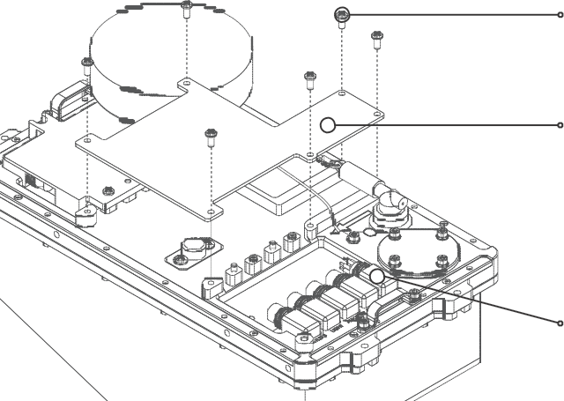Phillips Head Screw (12mm)

Cable Routing Cover

Aft Solar Panel Connector

Figure 10: Removing the Cable Routing Cover from the C&C Dry Box

3. Disconnect the aft solar panel cable from the SOLAR 1 AFT connector on the C&C
dry box.

4. Remove the eight (8) screws securing the aft solar panel.

Phillips Head
Screw 12mm

Aft Solar Panel

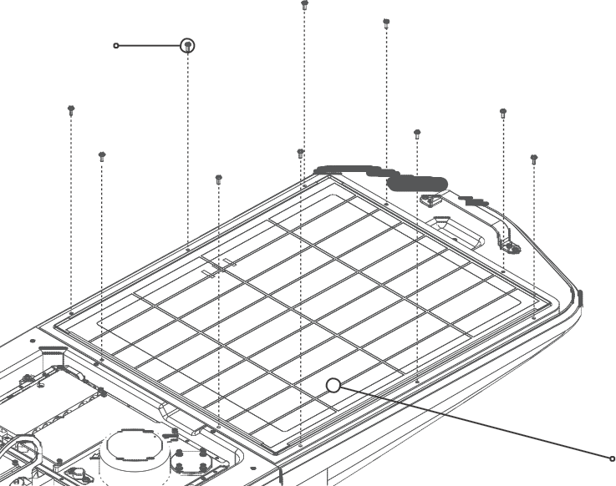Figure 11: Removing the Aft Solar Panel Screws

WARNING: Handle the solar panel with care. Bending a solar panel dur- ing removal or installation can cause damage.

5. Grasping the assembly from both ends, gently lift the solar panel out of the float and place it on a smooth, level surface where it will not get damaged.

Note: There are cutouts in the float at the front and back of the solar panel which allow you to access the panel for easy removal.

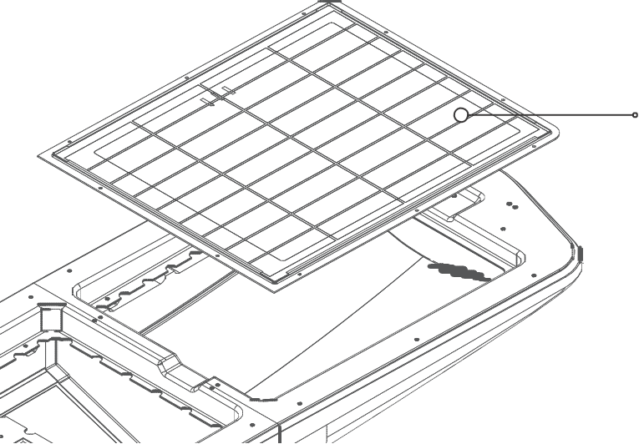Aft Solar Panel

Solar Panel Access Cutout

Figure 12: Removing the Aft Solar Panel

This completes the procedure for removing the aft solar panel.

Disconnecting and Removing the Payload
Drybox

Before You Begin

To disconnect and remove the payload drybox, the turtle deck must be removed so that you can access the C&C dry box and the aft solar panel must be removed so you can access the aft payload bay.

Note: For detailed instructions, see “Removing the Turtle Deck” on page 39 and
“Removing the Solar Panel” on page 40.

The payload drybox is connected to the C&C via a cable. The cable must be disconnected prior to removing the payload.

Description of Work

1. Disconnect the C&C cable.

2. Lift the payload drybox out of the payload bay.

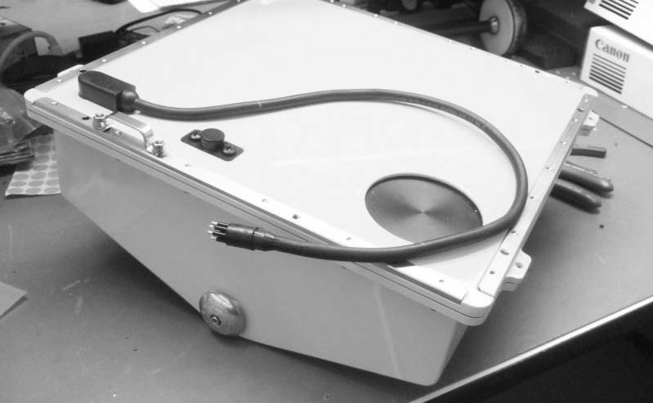
Figure 13: Payload Drybox and C&C connection cable

This completes the procedure for disconnecting and removing the payload drybox.

Removing the Payload Drybox Lid
Assembly

Before You Begin

To remove the payload dry box lid assembly, the payload must be disconnected.

Note: For detailed instructions, see “Disconnecting and Removing the Payload Dry- box” on page 43.

Description of Work

1. Lift the payload drybox out of the hull.

2. Place the payload drybox lid side down on a work surface.

3. Remove the 26 screws attaching the lid assembly to the payload dry box.

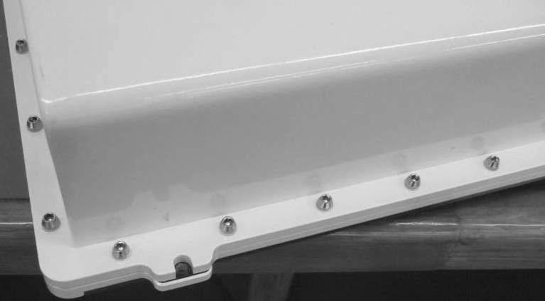
Figure 14: Removing the Payload Drybox Cover attachment screws

4. Lift the payload drybox away from the lid assembly.

The payload drybox lid assembly is now removed.

Removing the GPCTD Assembly

Before You Begin

To disconnect the GPCTD assembly, the payload drybox lid assembly must be removed.

For detailed instructions, see “Removing the Payload Drybox Lid Assembly” on page 44.

Description of Work

1. Place the payload drybox cover lid side down on a work surface.

2. Disconnect the GPCTD subconn from the P-Comm on the PIB.

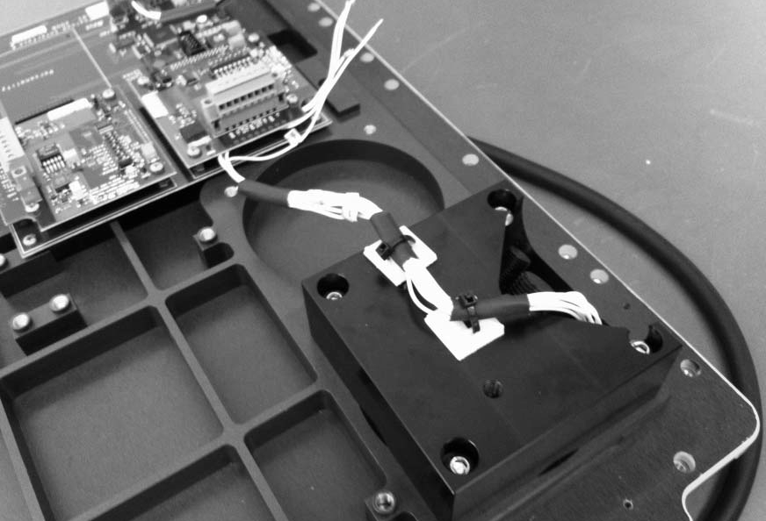
Figure 15: Disconnecting the GPCTD from the P-Comm

3. Feed the GPCTD subconn out of the foam and out of the grommet in the hull of the float.

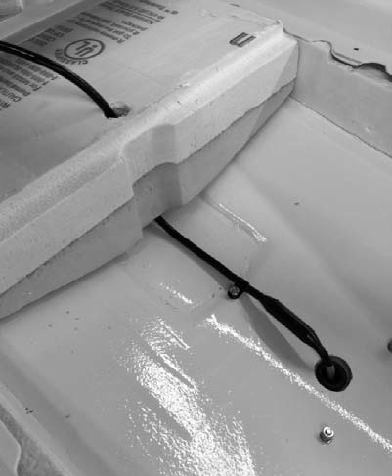
4. Removing the GPCTD cable
5. Remove attachment screws that hold the GPCTD and housing to the hull of the float.

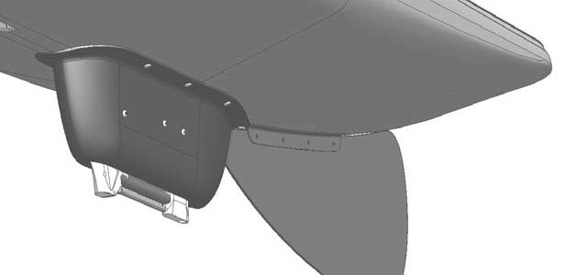
6. Removing the GPCTD housing attachment screws
7. Lift the GPCTD, housing, and cable away from the float.

This completes the procedure for removing the GPCTD assembly.

Installing the GPCTD Assembly

Before You Begin

To install the GPCTD assembly, the float must be installed on the float-glider saddle which ships with the Wave Glider.

Note: For detailed instructions, see “Placing the Float on the Float-Glider Saddle” on page 38.

WARNING: Before working on the Wave Glider, make sure that you have powered off the vehicle by disconnecting the shorting plug from the bat- tery switch on the C&C dry box.

Description of Work

1. Align the GPCTD and housing to the holes in hull of the float.

2. Attach the GPCTD housing to the hull using the attachment screws.

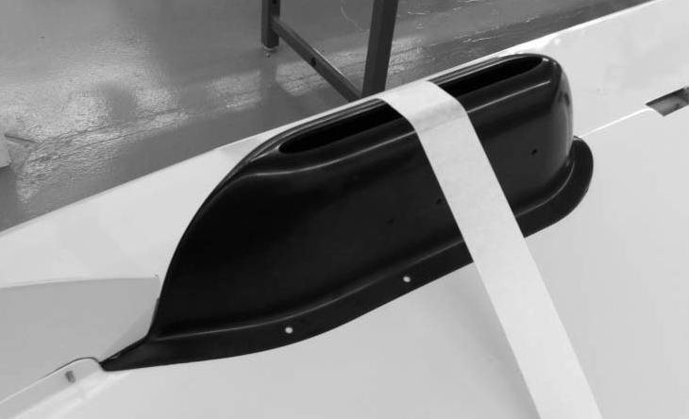
3. Attaching the GPCTD housing screws

4. Feed the GPCTD subconn through grommet in the hull of the float and through the foam.

Figure 16: Installing the GPCTD cable

5. Plug the subconn into the P-Comm on the PIB.

Figure 17: Plugging the GPCTD subconn into the P-Comm

This completes the procedure for installing the GPCTD assembly.

Installing the Payload DryBox Lid
Assembly

Before You Begin

The GPCTD must be properly installed and connected to the payload drybox lid assembly prior to performing this procedure.

Note: For detailed information, see “Installing the GPCTD Assembly” on page 47.

All other sensors and applications resident in the payload pay must be properly installed prior to performing this procedure. See the appropriate sensor guide for detailed information.

Description of Work

1. Orient the payload drybox lid assembly over the housing so that the alignment pin on the lid assembly can be mated to the alignment hole on the housing. Place the lid assembly on the payload drybox.

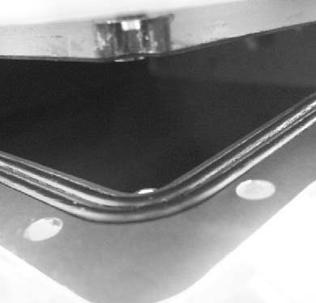
Figure 18: Payload drybox lid assembly alignment hole

2. Keeping the payload drybox and lid together, flip them over and place on the work surface.

3. Attach the 26 screws attaching the lid assembly to the payload dry box.

Figure 19: Installing the Payload Drybox Lid Assembly attachment screws

This completes the procedure for installing payload drybox lid assembly.

Connecting and Installing the Payload
Drybox

Before You Begin

To connect and install the payload drybox, the payload drybox lid assembly must be completed.

Note: For detailed instructions, see “Installing the Payload DryBox Lid Assembly” on page 49.

The payload is connected to the C&C via a cable. The cable must be connected prior to installing the payload drybox.

Description of Work

1. Place the payload drybox in the payload bay of the hull. <<need image; alignment?
attachment screws?>>

1. Connect the payload cable to the C&C.

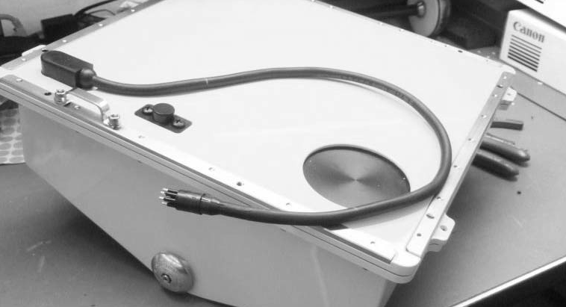
Figure 20: Connecting the payload cable to the C&C.

<<need image of cable connection to C&C>>

This completes the procedure for connecting the payload.

Installing the Solar Panel

Before You Begin

To install the solar panel, the payload drybox must be installed and connected.

Note: For detailed instructions, see “Connecting and Installing the Payload Drybox”
on page 51.

Description of Work

1. Connect the aft solar panel cable to the SOLAR 1 AFT connector on the C&C dry box.

2. Install the center cable routing cover and secure it with the six 12mm phillips head screws.

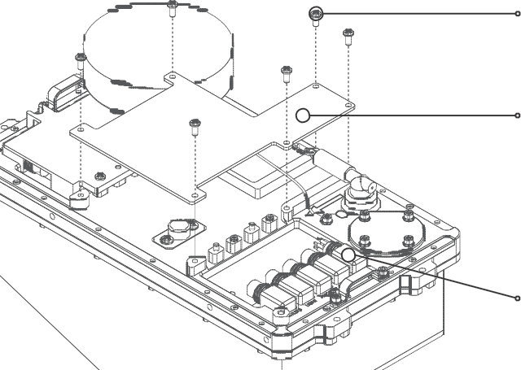Phillips Head Screw (12mm)

Cable Routing Cover

Aft Solar Panel Connector

Figure 21: Installing the Cable Routing Cover on the C&C Dry Box

3. Install the left side connector cover on the C&C dry box and secure it with three
12mm phillips head screws.

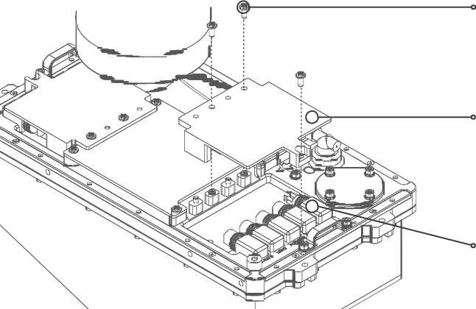Phillips Head Screw (12mm)

Connector Cover

Aft Solar Panel Connector

Figure 22: Installing the Connector Cover on the C&C Dry Box

WARNING: Handle the solar panel with care. Bending a solar panel dur- ing removal or installation can cause damage.

4. Gently lower the solar panel in place, making sure not to pinch the solar panel cable in the process. The cable must be routed through the cutout at the forward end of the aft payload bay.

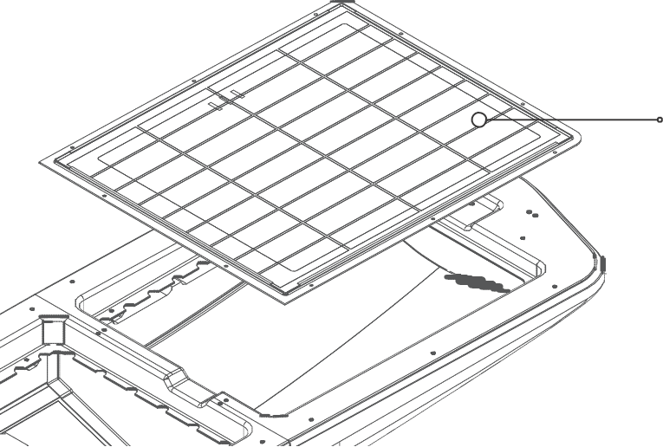Aft Solar Panel

Solar Panel Access Cutout

Figure 23: Installing the Aft Solar Panel

5. Secure the solar panel with eight 12mm phillips head screws.

This completes the procedure for installing the solar panel.

Installing the Turtle Deck

Before You Begin

To install the turtle deck, the solar panel must be installed.

Note: For detailed instructions, see “Installing the Solar Panel” on page 52.

Description of Work

1. Install the turtle deck and secure it with six 12 mm phillips head screws.

Note: Depending upon your vehicle configuration, you may have to uninstall anten- nas or other components in order to install the turtle deck.

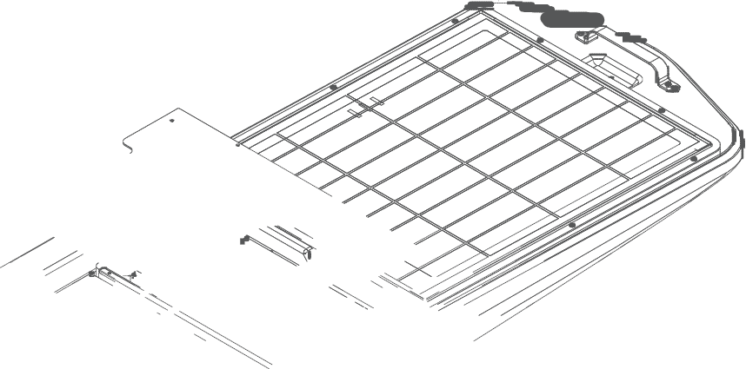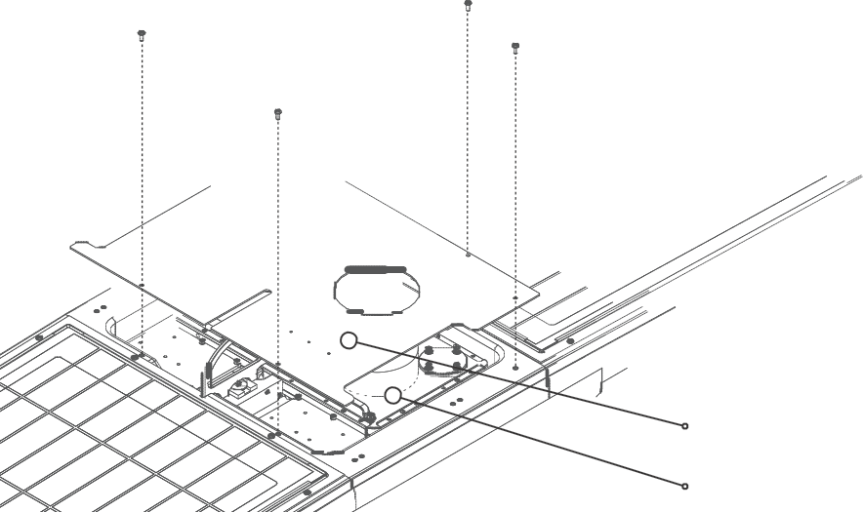Phillips Head
Screw 12mm

Turtle Deck

C&C Dry Box

Figure 24: Removing the Turtle Deck Screws

This completes the procedure for installing the turtle deck.

Placing the Glider on the Glider Support
Stand

Before You Begin

Before removing the GPCTD from the glider, the glider must be installed on the glider support stand which ships with the Wave Glider.

Description of Work

1. Place the glider on the support stand as instructed in the Liquid Robotics Wave
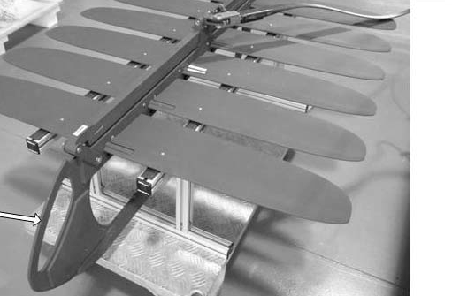Glider Mobile Operations Kit User’s Guide.

Figure 25: Glider on support stand

This completes the procedure for placing the glider on the support stand

Disconnecting the GPCTD Assembly from the Glider

Before You Begin

To disconnect the GPCTD, the glider must be placed on the glider support stand.

Note: For detailed instructions, see “Placing the Glider on the Glider Support Stand”
on page 55.

WARNING: Before working on the Wave Glider, make sure that you have powered off the vehicle by disconnecting the shorting plug from the bat- tery switch on the C&C dry box.

Description of Work

1. Disconnect the cable clamp and remove the screws.

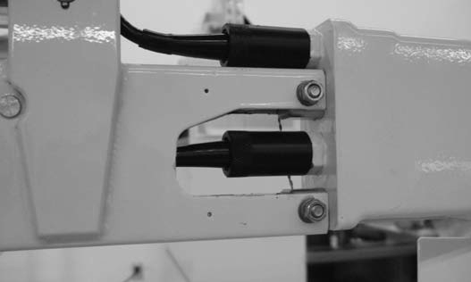2. Unscrew the locking sleeve and unplug the GPCTD subconn from the glider.

Figure 26: GPCTD subconn connector to glider with cable clamp

3. Remove the cable from the cable frame.

This completes the procedure for disconnecting the GPCTD assembly.

Removing the GPCTD from the Glider
Frame

Before You Begin

To remove the GPCTD from the glider frame, the GPCTD must be disconnected from the glider.

Note: For detailed instructions, see “Disconnecting the GPCTD Assembly from the
Glider” on page 56.

Description of Work

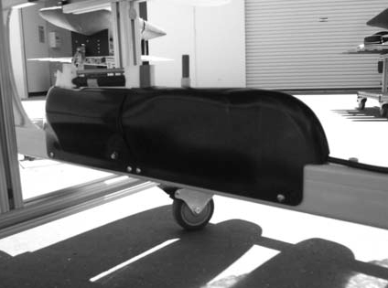1. Remove the screws attaching the front and rear fairings to the glider frame.

Figure 27: GPCTD front and back fairings

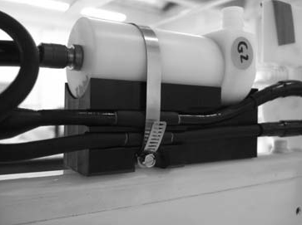2. If the optional pump is installed, remove the clamp attaching the pump to the pump bracket.

Figure 28: Optional pump with clamp.

3. Remove the clamp attaching the GPCTD to glider frame.

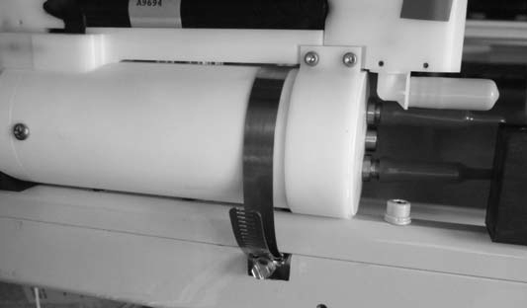
Figure 29: GPCTD with clamp

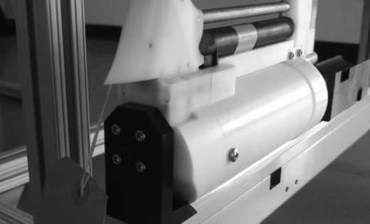4. Remove the four screws attaching the GPCTD to the GPCTD bracket.

Figure 30: GPCTD bracket and attachment screws

5. Remove the GPCTD from the bracket.

This completes the procedure for removing the GPCTD from the glider frame.

Installing the GPCTD on the Glider Frame

Before You Begin

To remove the GPCTD from the glider frame, the glider must be placed on the glider support stand.

Note: For detailed instructions, see “Placing the Glider on the Glider Support Stand”
on page 55.

WARNING: Before working on the Wave Glider, make sure that you have powered off the vehicle by disconnecting the shorting plug from the bat- tery switch on the C&C dry box.

Description of Work

1. Place the GPCTD on the GPCTD bracket.

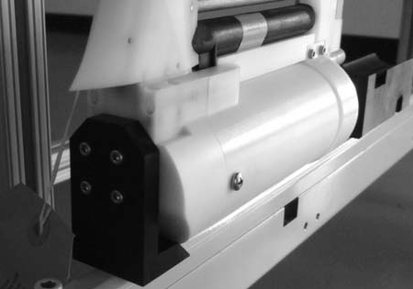2. Install the four screws attaching the GPCTD to the bracket. Make sure the GPCTD is aligned with the glider frame.

Figure 31: GPCTD bracket and attachment screws

3. Install the clamp attaching the GPCTD to glider frame. Make sure screw head on hose clamp is on the port side of glider. Tighten firmly.

Figure 32: GPCTD with clamp

4. If the optional pump is included, place the pump on the pump bracket.

5. Install the clamp attaching the pump to the pump bracket.

Figure 33: Optional pump with clamp.

6. Place the front and rear fairings over the GPCTD.

7. Adjust pump (using the outlet), such that the pump does not interfere with the back fairing.

8. Install the screws attaching the front and rear fairings to the glider frame using blue
Loctite.

Figure 34: GPCTD front and back fairings

This completes the procedure for installing the GPCTD on the glider frame.

Connecting the GPCTD Assembly to the
Glider

Before You Begin

To connect the GPCTD, the GPCTD must be installed on the glider frame.

Note: For detailed instructions, see “Installing the GPCTD on the Glider Frame” on page 59.

Description of Work

1. Attach the locking sleeve to the subconn cable.

2. Spray the GPCTD subconn cable and the female connector on the glider with 3M sil- icone lubricant spray.

3. Feed the cable through the glider frame.

4. Plug the GPCTD subconn cable into the female connector on the glider.

5. Secure the locking sleeve.

Figure 35: GPCTD subconn connector to glider with cable clamp.

6. Clamp the GPCTD subconn cable using cable clamp. Pull any slack out of cable between clamp and connection to glider (so that the self-fusing tape and heat shrink is sitting on the edge of the slot the cable passes through).

7. Insert clamp screws using blue Loctite.

8. Push clamp up, firmly securing cable.

9. Tighten screws with 14 in-lbs torque.

This completes the procedure for connecting the GPCTD assembly.

Appendix A

Glossary

This appendix provides a glossary of terms and definitions related to the Wave
Glider and GPCTD which are used in this manual.

C&C Command and Control module: The C&C is located in the center dry box, which also houses the primary control electronics. The C&C transfers information between the SMC to the WGMS.

GPCTD Sea-Bird Electronics Glider Payload GPCTD which collects con- ductivity, temperature, and pressure data, and (option- ally) dissolved oxygen data.

Iridium modem Modem communicating with the Iridium satellite constellation.

Wave Glider A marine robot developed by Liquid Robotics.

WGMS Wave Glider Management System: WGMS provides the applica- tions and programming interfaces for users to send commands to, and receive data from, the Wave Glider and its payloads.

Glossary | 65

