Client: | MBARI
Region: | Monterey_Bay_CA
Requestor: | Ryan Carlon
Pre-Mission Checklist No.: | NA
Sales Order No.: | NA
Program Phase: | Pre-Proposal Proposal/Quote Mission Planning

Mission Parameters
Mission Start/End Date: | 20160523 - 20160610
Mission Duration: | 18 Days
Op Area: | Monterey Bay

Wave Glider Configuration
Model
SV2 | SV3
Standard Options
Custom Configuration | 8.0 Meter Umbilical  Additional devices
Custom Configuration
- CTD+DO

Risk Assessment Summary
One SV3 wave glider will be deployed in Monterey Bay for a shakedown cruise. The vehicle will also gather data on some of the historic Monterey Bay Aquarium Research Institute (MBARI) experiment lines. If possible, operations should not occur within the 100 fathom isobaths in Monterey Bay, so as to avoid non-AIS equipped vessels and crab pots. The assessment is:
Green = Nominal risk Yellow = Moderate risk Red = High risk
Risk Mitigation
- Bathymetry =
- Navigational Authority =
- Power Margin =
- Vessel Traffic = Fishing, non-AIS
- Hazards to Navigation = Tidal currents, crab pots
- Political Interests =
Bathymetry
The safe operating depth for a Wave Glider in this configuration is 15 meters. Depths throughout the entire specified operation area are well beyond this limitation and are safe for wave glider operations. MBARI has ocean observation moorings M1 and M46044 (36.70lat/ -122.378 lon and 36.75 lat/ -122.03 lon) that should be avoided during normal operations. In the proposed operation area in Monterey Bay during this time of year, it is imperative that the wave glider remains beyond the 100ftm isobaths to avoid scattered crab pots. Pot density in the area during this time of year poses a great hazard to wave glider operations.
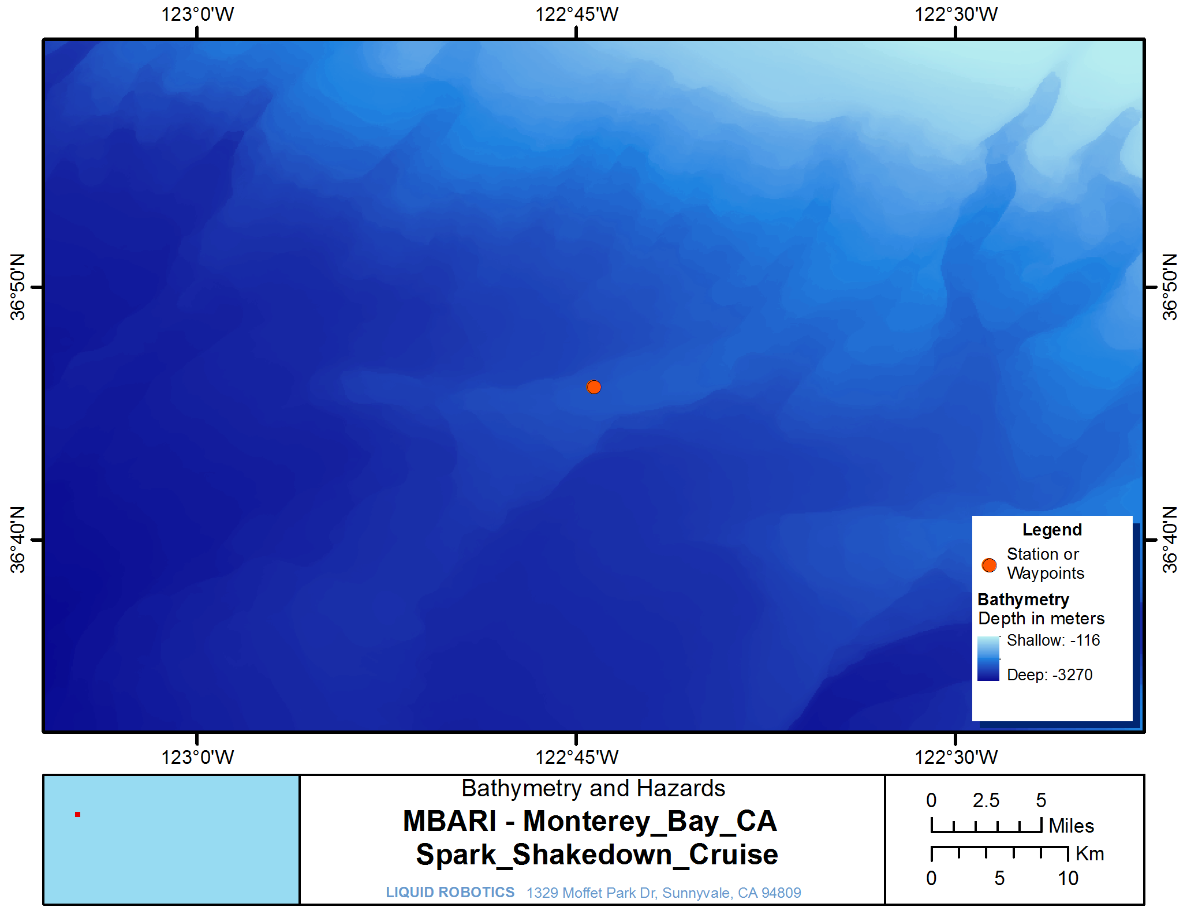

Surface Currents
Surface currents in Monterey Bay are light and variable. Currents will be slightly stronger closer to shore, and should be avoided.
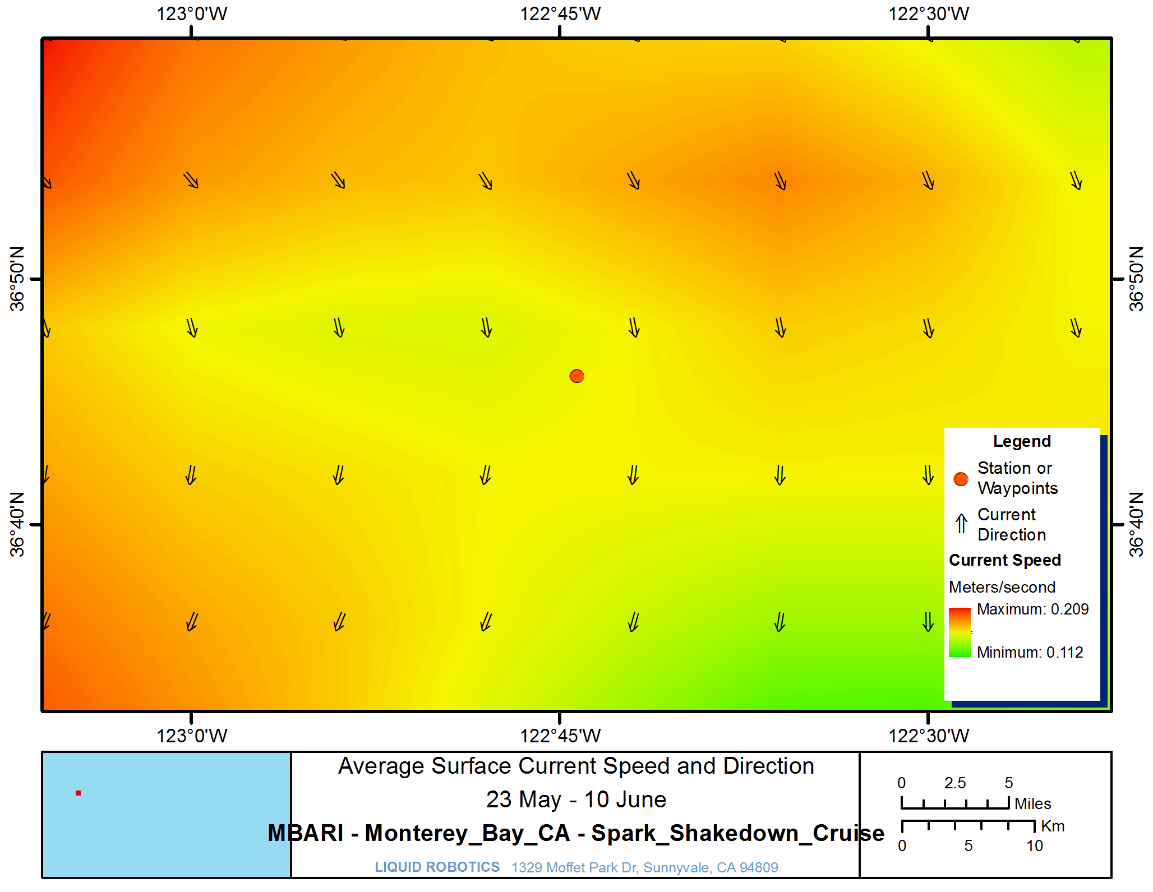

Hindcast models indicate currents in the area of interest are moderate. Surface currents magnitudes range from 0.02 to 0.50 m/s, with an average of 0.19 m/s. Currents exhibit moderate variability, with a standard deviation of 0.05 m/s.

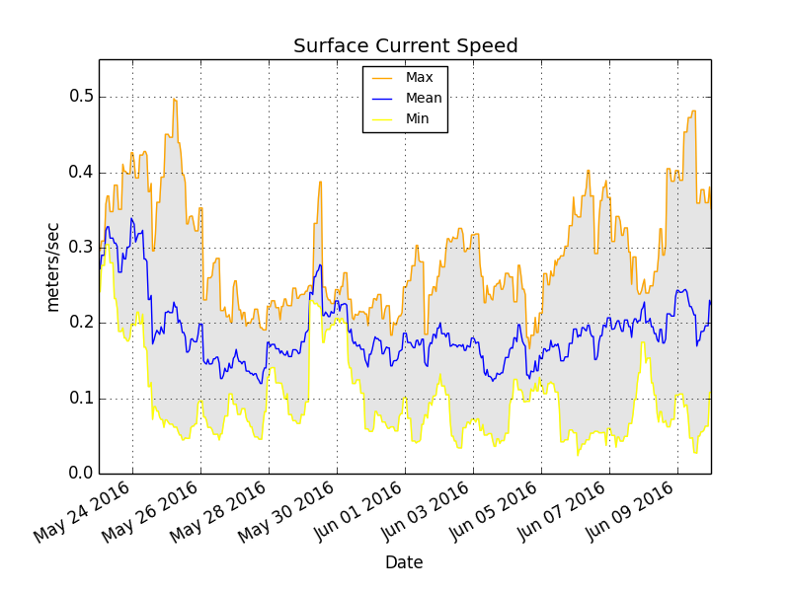
Waves
Models predict seas in the area of interest will be energetic. Significant wave heights (Hs) range from 1.12 to 4.10 m, with an average of 2.03 m. Significant waves heights exhibit low variability, with a standard deviation of 0.272 m.

Wave average periods (Tav) range from 5.0 to 15.6 sec, with a mean of 9.2 sec. Average periods exhibit a standard deviation of 0.91 sec.

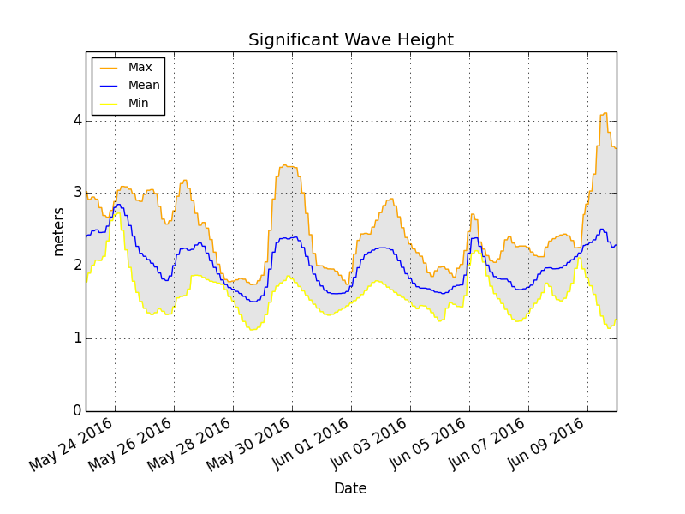 | 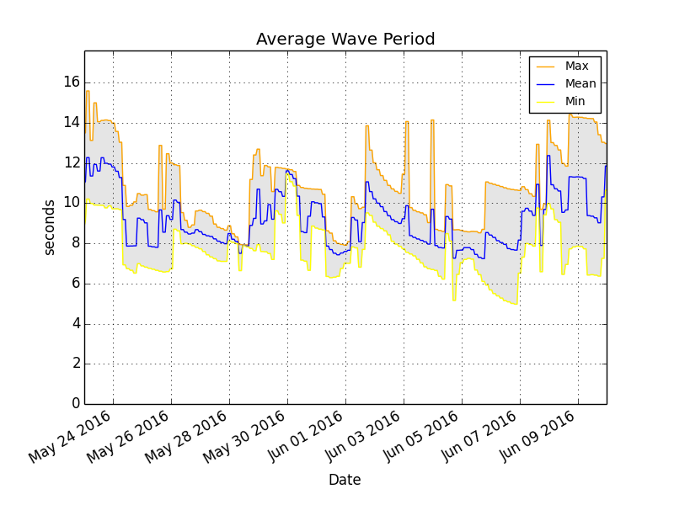

Wind
Models suggest winds in the area of interest are moderate. Wind speeds range from 0.7 to 15.7 m/s, with an average of 6.3 m/s. Winds exhibit low variability, with a standard deviation of 1.37 m/s.

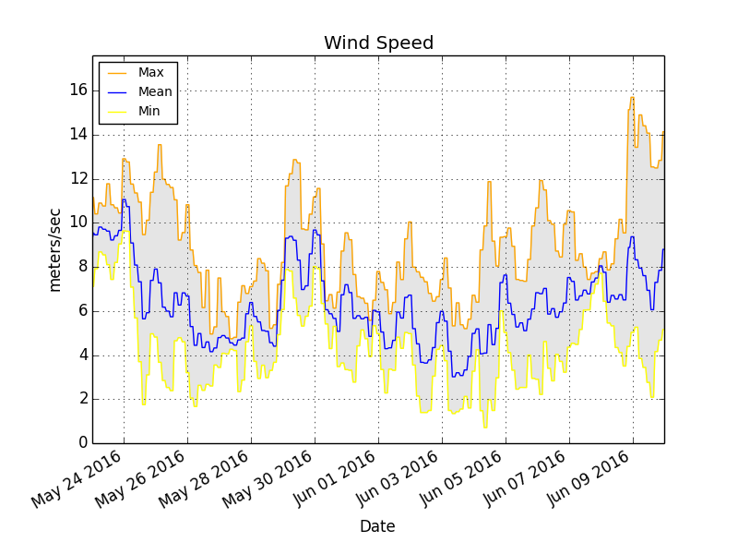

Solar Insolation
Historical data shows that solar energy in the area of interest is moderate. Peak irradiance is 934.00 W/m^2, with an average of 292.00 W/m^2.

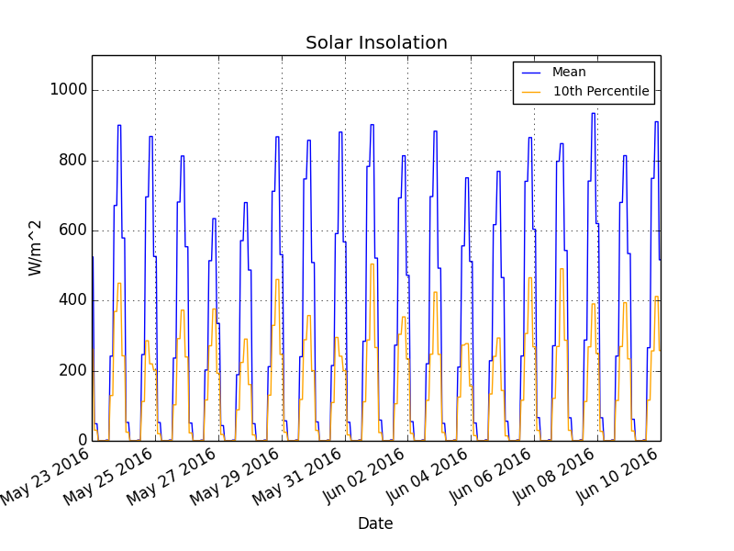

Navigational Authority
Simulations predict that vehicle navigation will be nominal. Navigational authority is primarily a function of vehicle speed through water and surface currents. Wave Glider speed through water can be derived from sea state and wind speed. Given the environmental conditions detailed above, it is expected that an SV3 configured with the METOC+ payload will average 0.6 m/s speed through water. Speeds range from 0.2 to 1.0 m/s.
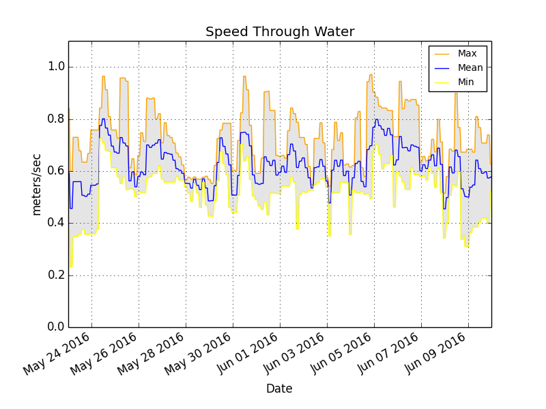

When surface currents speeds approach or exceed vehicle speed through water, the vehicle will be subject to slow speed over ground or drift. Simulations predict that the system will navigate at-will 92 percent of the time. Metrics used to assess navigational authority are 1. speed through water vs. surface currents magnitude (speed delta) and 2. the progress to target over ground. Both metrics are based on the most conservative simulation results, and may not reflect mean values of speed through water and surface currents.

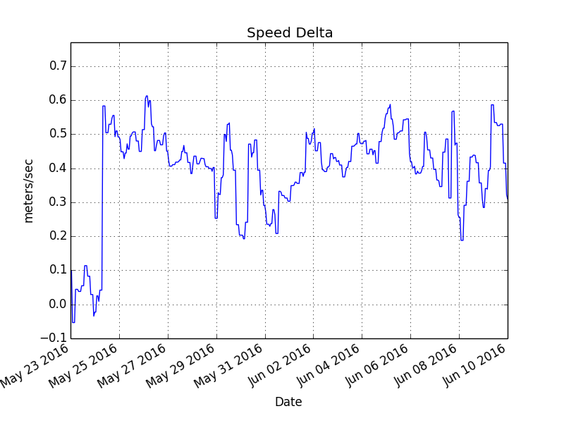 | 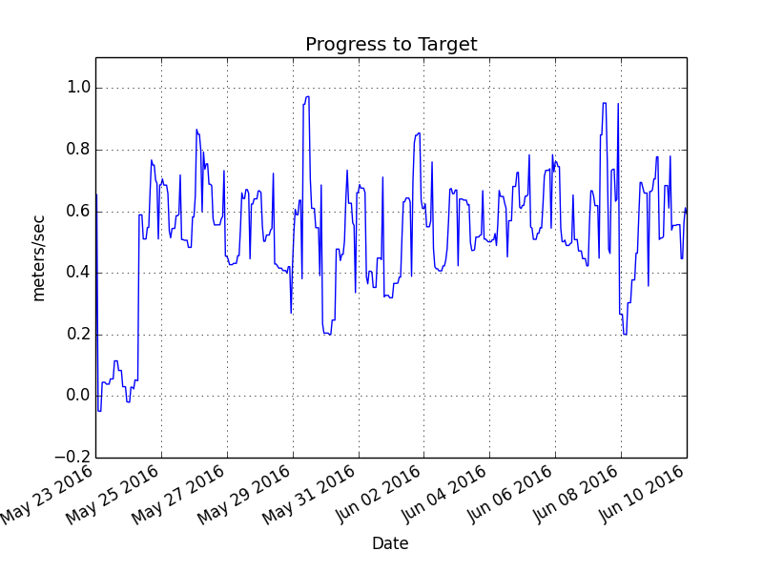

The course for this assessment has been defined as hold station.

Power Margin
Given the solar conditions in the area of operation, a Wave Glider SV3 will generate an average continuous 30 W. This is the average sustainable power consumption for the system. Peak power is expected to be 97 W.

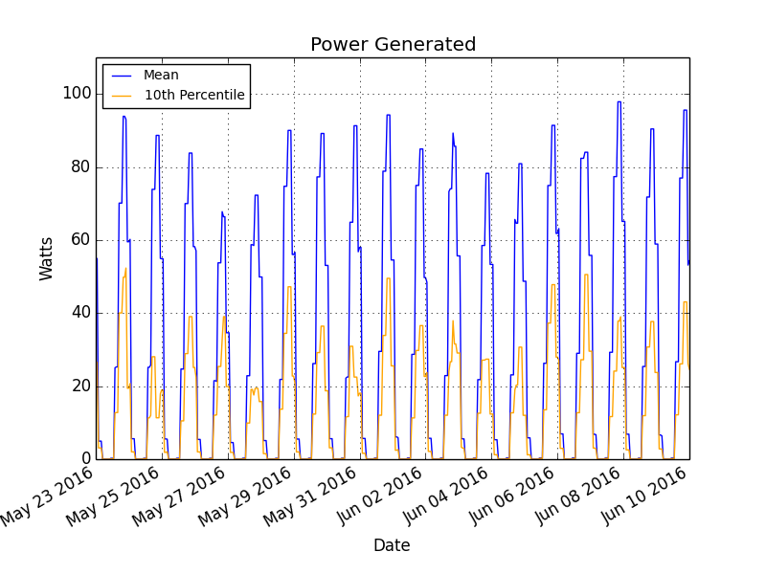

For the proposed mission, the standard power configuration is to be modified. Under the modified configuration, the system will consume 12.6 W. The modified configuration is:

Component Type | Priority | Duty Cycle (%) | Power Consumption | Subsystem
AMPS | NaN | 100 | 0.25 | Core
Iridium Modem - SBD | NaN | 100 | 0.5 | Core
Thrudder | NaN | 100 | 0.5 | Core
GPS 2 | NaN | 100 | 0.0 | Core
GPS 1 | NaN | 100 | 0.2 | Core
Vehicle Management Computer | NaN | 100 | 2.25 | Core
Weather Station 200WX | 4 | 100 | 1.8 | Core Payload
Water Speed Sensor | 5 | 100 | 1.4 | Core Payload
Ethernet Switch | 2 | 100 | 2.5 | Core Payload
CTD & Dissolved Oxygen | 5 | 10 | 0.28 | Payload
AIS Receiver | 1 | 100 | 1.35 | Core Payload
Sensor Management Computer | 1 | 100 | 0.9 | Payload
Sub_CTD/DO | 5 | 10 | 0.28 | Payload

For this mission, the auxiliary thruster is to be used only to overcome currents and when power allows. It is expected that the thruster will be used up to 0.0 percent of the time.

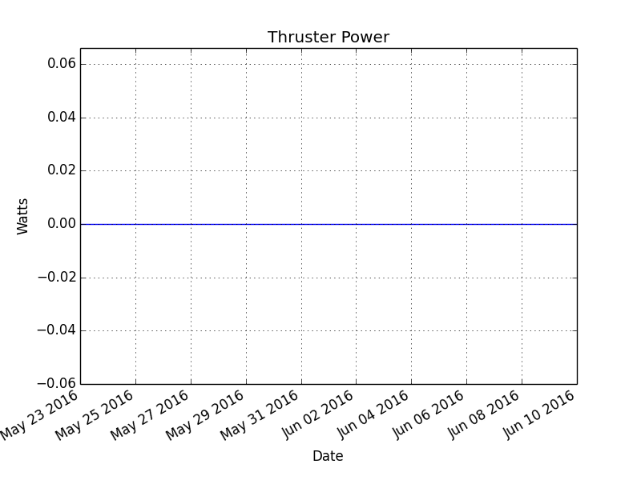

Accounting for all power consumers, the average continuous draw is 12.6 W. Under this configuration, with a launch date of May 23, 2016 it is expected that there will be sufficient power to sustain operations throughout the deployment.

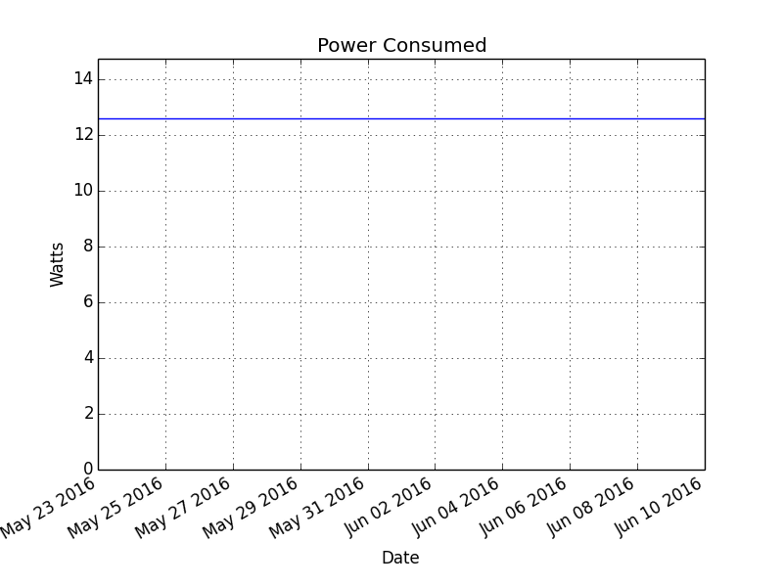 | 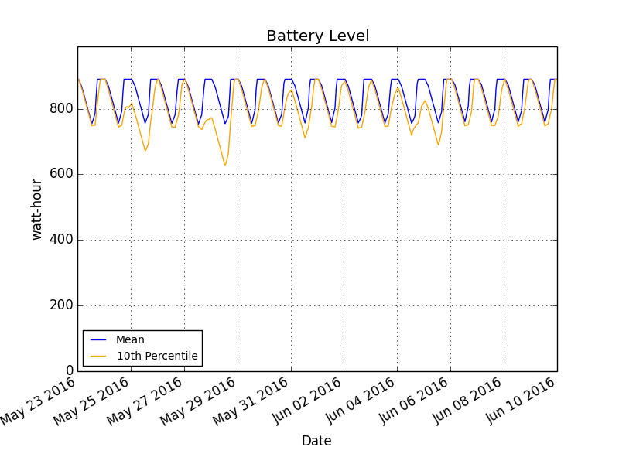

The assessment assumes that the communications path is Iridium satcomm. It does not account for additional power draw due to cellular communications (typically 5W for cell and ethernet).

Vessel Traffic
Monterey Bay has moderate volumes of both commercial and recreational vessel traffic. It is expected that traffic during the upcoming mission will be consistent with what has been observed during previous deployments. The associated level of risk is deemed acceptable.

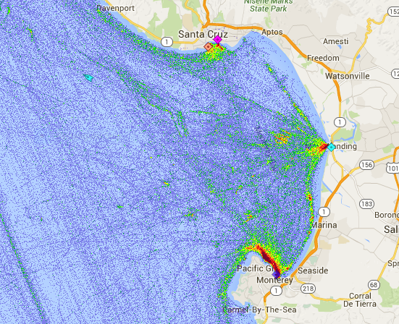
Political Interests
Operations will be within California waters. Local authority approval and appropriate permitting will be required prior to mission start date.

