Customer: | MBARI
Region: | Central California Coast
Requestor: | Thom Maughan Jamie Griffith
Pre-Mission Checklist No.: | 140122
Sales Order No.:
Program Phase: | Pre-Proposal Proposal/Quote Mission Planning

Mission Parameters
Mission Start/End Date: | 2014-02-05 to 2014-02-20
Mission Duration: | 20 days
Op Area: | 35.1185, -122.9752

Wave Glider Configuration
Model
SV2 | SV3
Standard Options
METOC (600hz)  METOC+ (300 or 600hz)  Hydrocarbon  Gateway  Custom Configuration [explain below] | 5.8 Meter Umbilical  4.0 Meter Umbilical  Tow Body  Additional devices [explain below]
Custom Configuration
- Using Wave Glider ‘Tex’ to communicate with a Benthic Rover

Risk Assessment Summary
The assessment is:
- Bathymetry = Green Light
- Navigational Authority = Green Light
- Power Margin
  - February = Yellow Light
- Vessel Traffic = Green Light
- Hazards to Navigation = Green Light
- Political Interests = Green Light

Bathymetry
The op area is waters with depths well over 1000 fathoms, bathymetry will not be an issue for this mission.

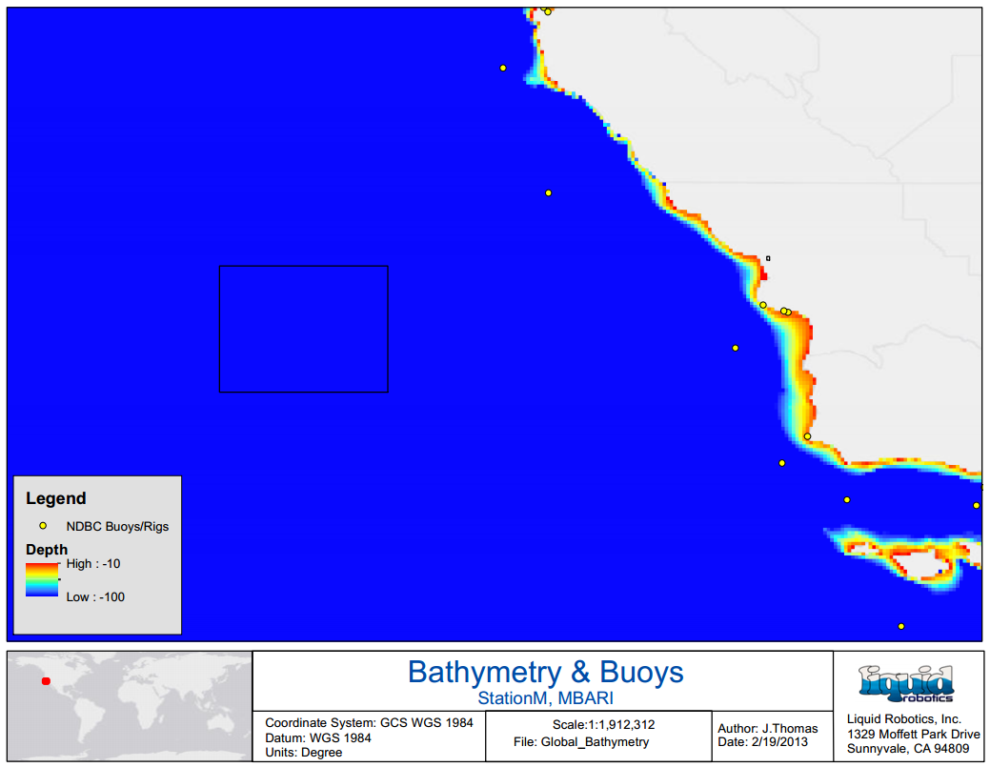

Navigational Authority
Navigational authority in this area should not be a problem for the duration of this mission. The vehicle is expected to be able to hold station for approximately 90% of the time or greater. Tidal currents should not have any affect on the vehicle this far offshore. The southward flowing California current dominates this area. Significant wave heights in this area will average about 3.1 meters with periods between seven to ten seconds. Average surface currents for this area are expected to be less than 0.5 knots.

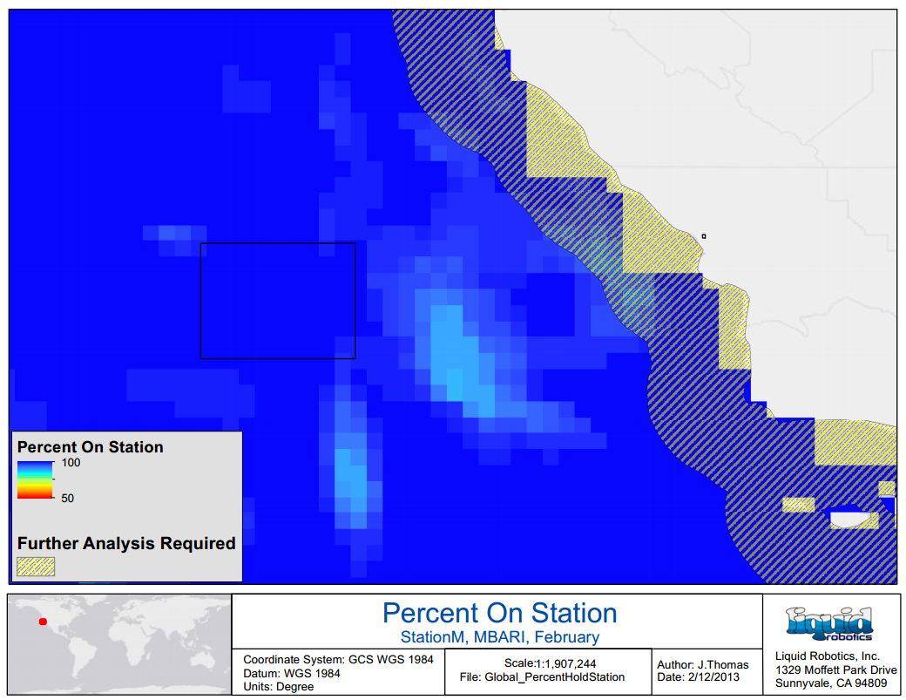

Power Margin
Power is the highest environmental risk factor for the proposed mission. At the latitudes of interest, there is limited solar energy available. For a February deployment, battery life is expected to last about two weeks with a 7W payload. If the payload draw is increased to 10W continuous, battery life may be depleted in as little as one week. Core payload requirements for an SV2 will draw about 5W. Due to the unique nature of this payload, continuous operation may not be necessary for mission success.

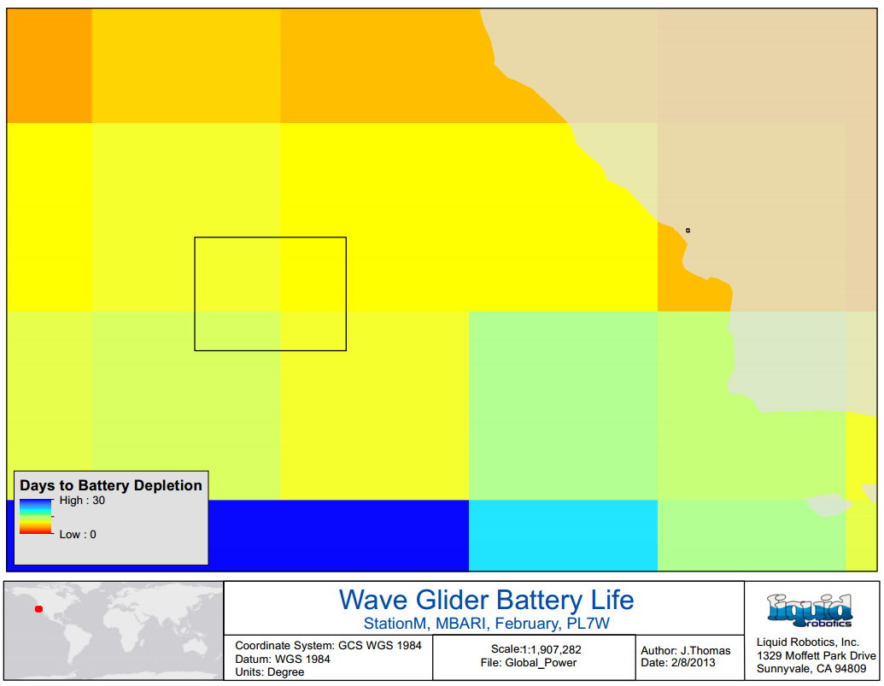

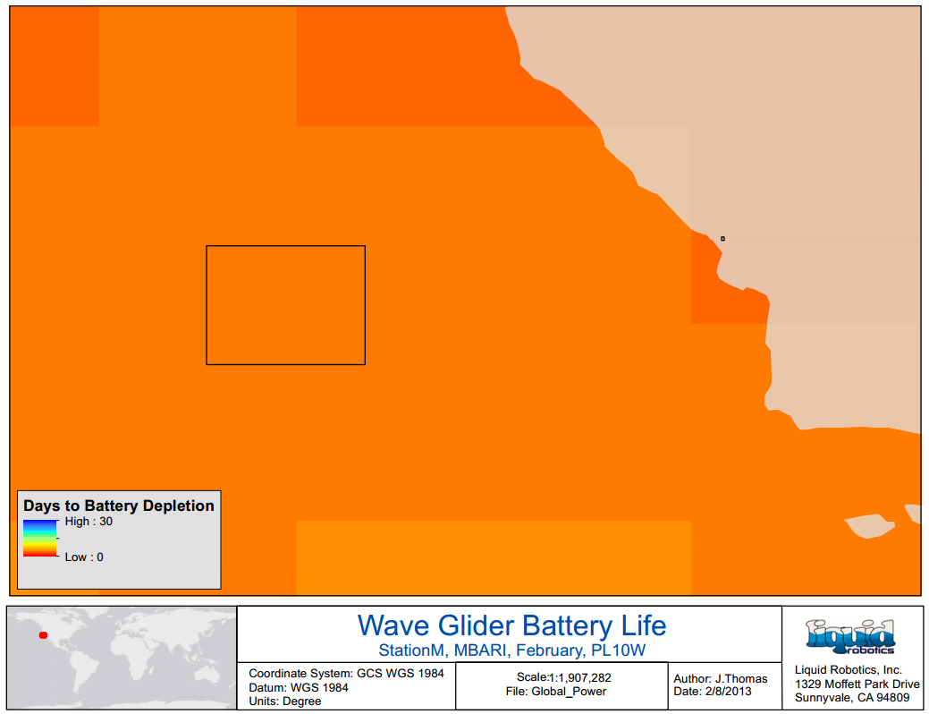

Vessel Traffic
Minimal vessel traffic can be expected, however commercial shipping traffic travelling south to Long Beach is likely.

Hazards to Navigation
Although unlikely this far out, kelp patties are a possible encounter and may encumber the vehicle.

Political Interests
Operations will be within US waters, as such proper permits and notices with the US Coast Guard are required.

