In May 2016 we began a collaboration with Joaquin Del Rio Fernandez and his doctoral student Ivan Masmitja from the Polytechnic University of Catalunya Spain (UPC). The goal was to improve the accuracy of acoustic geolocation techniques used on the Waveglider both for USBL fixes as well as the addition of a range only autonomous geolocation feature. In addition the collaboration anticipated a publication at IEEE Oceans in October of 2016. Unfortunately this agreement prevented Ivan from being able to participate in the annual intern program at MBARI but the engineering department kindly funded Ivan’s stay over the summer of 2016. During his time here, Ivan worked with the hotspot team to develop and test the onboard range only geolocation feature. He also began work on the publication “Range-Only Underwater Target Localization: Path Characterization” which was published and presented at IEEE Oceans Monterey as planned.
Ironically, one week after the presentation of Ivan’s work the hotspot team was asked to locate the coastal profiling float (CPF) which had been overdue. The CPF contained no location acoustics – just a single medium frequency modem was onboard. The location was also out of cell phone range and the algorithm was started three separate times via satellite with circles of varying radius. The results from the three runs were within approximately 3m of each other and the runs were conducted on different days over the course of about 2 weeks. The final run was conducted just prior to the ROV Ventana dive on October 11.
Upon diving at the location, the CPF was easily found visually in the location calculated (see fig 1). Due to error in the positioning of the ROV, it’s not possible to know the error of the algorithm to less than 10m, though it’s calculated to be accurate to about 2m.
Clearly any surface vessel with the ability to collect acoustic ranges and GPS locations could apply a least squares fit to the ranges and compute the location just as the hotspot does. However, this is quite time consuming and error prone with a human in the loop. The loss of the CPF occurred during the fall CANON field campaign and the ability of the hotspot to provide range only geolocation allowed the Westren Flyer to continue on with its science mission rather than manually attempting to range to the missing instrument. In this case, the incident also occurred in an offshore environment (23 km S of Ano Nuevo) where boat operations can be limited due to weather. In this isolated case, the cost savings provided by this new feature greatly exceeded the cost of hosting our collaborator (~$5k) this summer and proved the range only geolocation method is a reliable way of accurately locating an asset without a USBL solution. While we never want to search for missing assets, we hope that this tool can be used in the future alongside the suite of capabilities of our autonomous fleets currently provide.

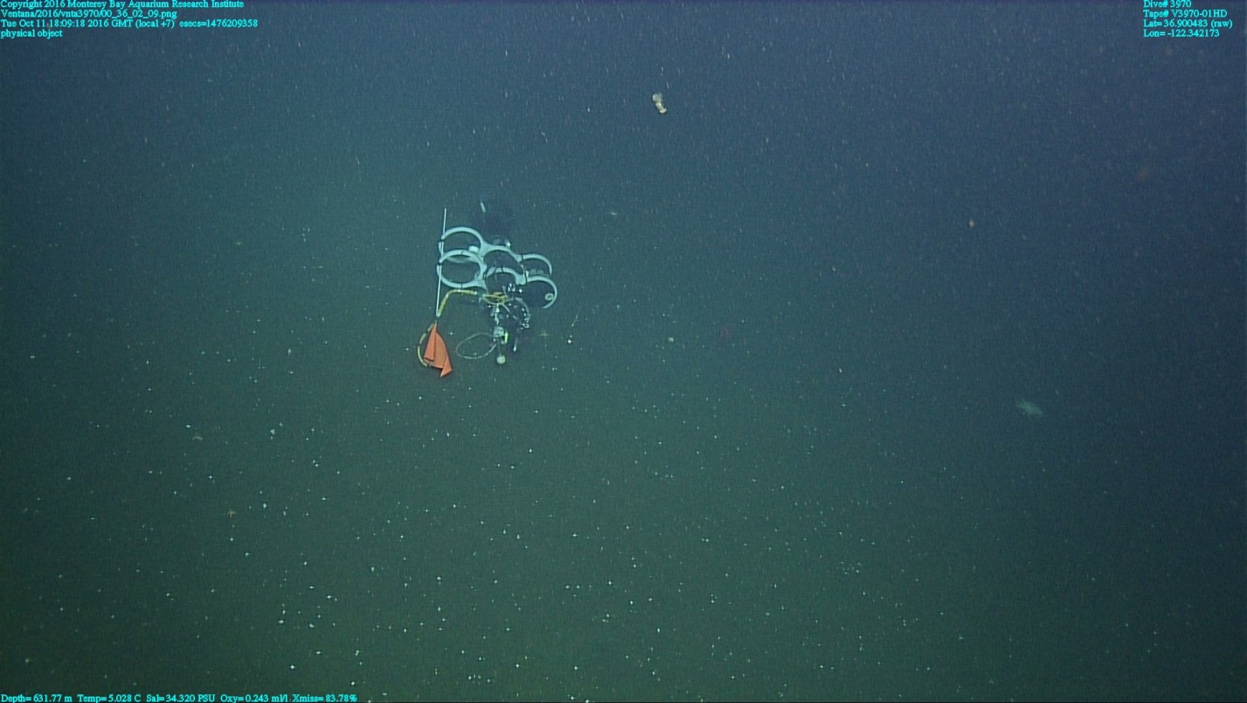
Fig 1.) The first sighting of the CPF on the bottom from ROV Ventana on the recovery dive.

Fig 2.) The navigated (USBL) positions of the ROV Ventana and the calculated positions of the CPF from the Waveglider. 10m yellow bar for scale.

