Project Number: | 901411

Project Start: Jan. 1, | 2014 | Project Duration (in years): | 2 ¹

Please indicate what type of project is being proposed (mark only one).

 |  |  |  | X
Feasibility/Scoping  [Less than 100 days effort] |  |  | Development |  |  | Research |  |  | Infrastructure² |  |  | Education
 |  |  | Time Series |  |  | Institute Initiative

Project Manager: Brian Kieft
Principal Investigator: Kanna Rajan, Mark Chaffey
Lead Scientist:
Lead Engineer: Tom O'Reilly

Project Title: Wave Glider-based Communications Hot Spot

- ABSTRACT (new projects only)

The Wave Glider communication “Hot Spot" developed under the 901010 Distributed Autonomy project is responding to a need for rapid transfer of large data sets from at-sea assets to shore. In 2013 we demonstrated transfer of telemetry at sea from the Dorado AUV to the Hot Spot via FreeWave radio at a range of up to 480 meters. We propose to extend the Hot Spot capability to enable intercommunication with other MBARI assets such as LRAUV and BEDS, via both surface RF and underwater acoustics. We will leverage progress made by the BEDS and LRAUV projects to add acoustic hardware to Hot Spot that enables low bandwidth communication with underwater assets, geolocation of deployed systems, and navigation assistance, e.g. for WG-asset rendezvous. We plan to integrate a Globalstar satellite modem, 802.11 Wi-Fi, implement robust power management, and automate configuration procedures. All processes and software will be documented with the goal of transitioning the Hot Spot to operational asset status. These activities are fully aligned with the aims and needs of the 2014 CANON proposal and anticipate future needs for that project as well as others like 901010 for multi-vehicle coordination.

- PROPOSAL

  - New Projects

Statement of the problem, why it is important
One of the major themes of MBARI’s current research is the increasing dependence on real-time data for informed decision-making during the course of field experiments. To this end MBARI has invested considerable resources in related projects such as the Ocean Decision Support System (ODSS) for coordinated mission planning and data visualization, highly agile sampling platforms such as the LRAUV family of vehicles, and the development of sophisticated sampling algorithms for applications such as patch tracking. Adequate real-time data is the raw material for ODSS’s visualization and decision-making tools for managing these types of missions and yet due to design constraints many of our mobile assets have a very limited ability to bring back real time data.
Experiments using AUV’s that do push limits on data return quickly run into difficulties with too much AUV time spent on the surface and a large dollar cost for data return. A major reason for this is our historical reliance on the Iridium Satellite constellation for over-the-horizon communications. While the AUV Iridium satellite systems are required for command and status updates, are reliable and provide worldwide coverage, they have a very limited data transfer rate and a large cost per byte; see figure 1.
We propose to upgrade and operate the Wave Glider mobile communications Hot Spot to directly support two MBARI field objectives in 2014, one an experiment that would benefit from high bandwidth communications relay from the LRAUV to ODSS on shore, the second an experiment that would benefit from an acoustic communications relay that can pass data to shore. The specific experiment to be targeted in each case has not been selected but we anticipate supporting CANON and/or ECOHAB.

How does it relate/contribute to MBARI’s mission and strategic plan?
How does it relate/contribute to the Packard Foundation’s Ocean Visions Grantmaking policies? (See http://mww.mbari.org/oed/OED_Documents3.htm#Packard for documents.)

Utilizing the Wave Glider as a Hot Spot “adapts innovative technologies” per the strategic plan. Moreover Hot Spot will be a basic at-sea communications infrastructure component, and can benefit any research activity that relies on near-real-time return of large data volumes from untethered underwater assets. Hot Spot can also telemeter data from science instruments on the Wave Glider itself, with higher bandwidth and lower cost than the Iridium channel provided by Liquid Robotics. Thus Hot Spot is relevant to science problems within all four research themes in the technology roadmap, as well as marine conservation projects sponsored by the Packard Foundation's Ocean Grantmaking process.

Approach to the problem

Hot Spot is a store-and-forward system on the sea surface that relays data files between "end points" such as ships, shore, and AUVs, using RF line-of-sight, satellite, and acoustic communication links. Each end point can both send and receive data to and from any other end point. Command files as well as telemetry files can thus be exchanged between end points through the Hot Spot. Shore will be a common end point, but Hot Spot also facilitates exchange between autonomous platforms. An AUV can quickly exchange data with the Hot Spot via high-speed line-of-sight radio then dive to continue its mission, avoiding lengthy surface dwell time and dollar cost associated with satellite communications. If shore is the destination end point, Hot Spot then transfers the data via cell modem or satellite link, using optimal antenna designs to increase throughput and reliability. Multiple end points can use Hot Spot simultaneously. Hot Spot will emphasize functionality with existing MBARI assets, especially Dorado, LRAUV, and BEDS acoustic platforms. Hot Spot will include wireless protocols including 802.11 to support other CANON collaborators such as USC and the University of Porto. Considerable development and test of Hot Spot has already occurred under the 2012 DTN Feasibility Study and 901010 Distributed Autonomy project. A preliminary design review for Hot Spot was held in April 2013, focusing on Radio Frequency links, and acoustic functionality was specified later in the year. Hot Spot is designed to work autonomously, with emphasis on minimal required configuration steps. In 2014, we will focus on the Wave Glider Sensor Management Computer (SMC) as a Hot Spot host, but the Hot Spot functionality could be located aboard any ship or other surface platform that can host a Linux computer system and required communication links. The system will utilize very mature off-the-shelf software technology components, including the widely-used 'rsync' protocol for data file transfer. Supported RF communication links include 802.11, 900 MHz FreeWave, Globalstar satellite and CDMA or GSM cell. We will also provide acoustic communications utilizing a Benthos acoustic modem.

Preliminary experiments performed during 2013 Distributed Autonomy demonstrated the feasibility of Hot Spot to Dorado FreeWave communication link and rsync protocol as a file transfer mechanism. As shown in Figure 2, 1.34 MByte of data was transferred from Dorado to Wave Glider at ranges exceeding 400 meters; transfer time varied from 3.8 to 13 minutes, with a mean transfer time of 4.6 minutes. Note that rsync protocol errors due to intermittent radio signal occurred several times during the transfers, but the rsync protocol was able to successfully retry the link and recover the data. We will also characterize Hot Spot connectivity with University of Porto "SeaCon" vehicles using 802.11 radios in October 2013.

Why the MBARI Hot Spot is Unique
The use of a Wave Glider as a communications link has been previously experimented with by our Porto collaborators and is even advertised as a feature on the SV3 by Liquid Robotics. MBARI’s contribution is this area is that our work is directed specifically at developing an operational system that supports our unique mobile assets, for example the Dorado and the LRAUV classes of AUV’s. The radio technology we use and the file transfer methods are tailored to our application. While we are leveraging extensively from commercial products for the hardware we use, for example the use of the Wave Glider as a platform, using the Liquid Robotics SMC processor as our current host, and with each of the individual radio modems, the system created by the aggregation of these products, the unique mix of radio telemetry, the network configuration and the software scripts that effect the file transfers are very unique to MBARI’s problem space are and not available on any commercial product.

Intellectual Property Protection
The work on the mobile Hot Spot at MBARI to date has been assembling a unique mix of commercial radio products and writing application scripts that use standard Linux utilities and therefore does not appear at this time to constitute intellectual property of commercial interest. This may change in the future however and we propose to require a non-disclosure agreement to release any unique work generated by this project to outside entities until such time as other arrangements are made through the ITD department.

Note that Hot Spot focuses on the communication links between end points using the Wave Glider (WG) as a platform, but does not itself address how to achieve a physical rendezvous between platforms. Thus participating platforms are required to arrange to be within communication range with Hot Spot. The control and coordination of the WG is a separate but connected effort in the 2014 901010 Distributed Autonomy proposal. Rajan is PI or co-PI on both proposals.

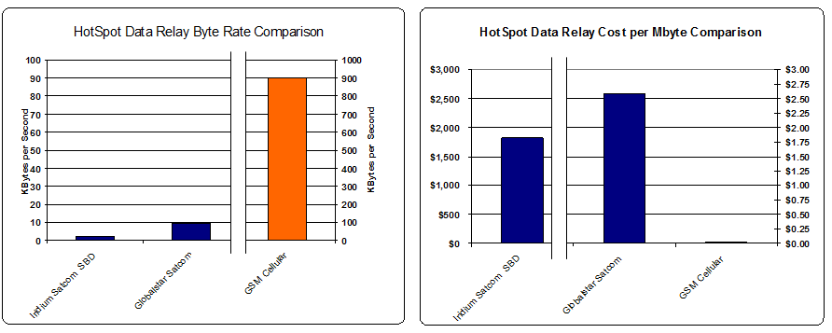
Figure 1: Relative data rate and cost of radio telemetry methods. Note scale change between GSM cellular and other services.
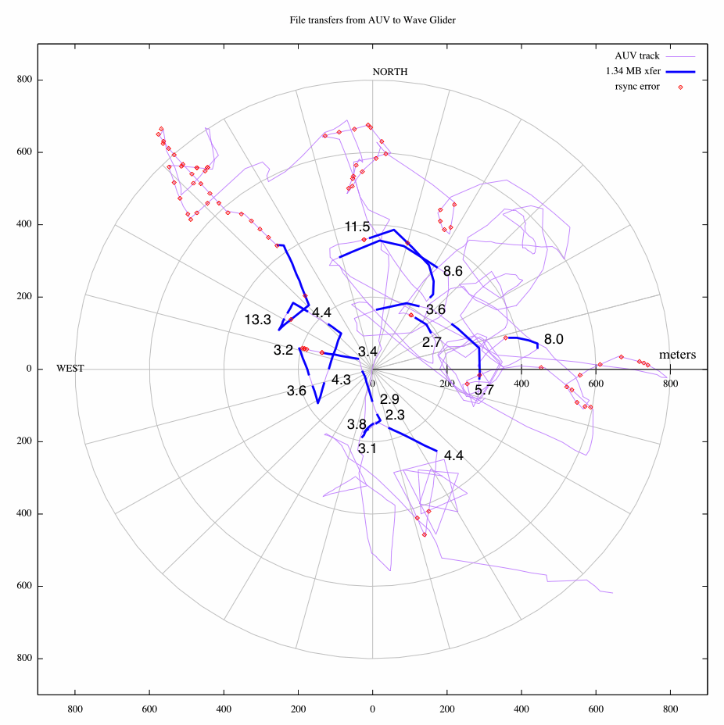
Figure 2: Dorado AUV bearing and range from Wave Glider, showing results of 1.34 MByte file transfer via rsync protocol over Freewave radio. Blue segments show successful transfers of 1.34 MByte test file set. Numbers next to the blue segments show total duration of the transfer, in minutes. Red dots show location of rsync errors. Rsync timeout was set to 60 seconds for these tests. Significant wave height ranged between 1.7 and 2.7 meters during these tests - see test report in the project folder for more detail.

Publications (from other projects over the last 5 years)
R. Henthorn, D.W. Caress, M.R. Chaffey, P.R. McGill, W.J. Kirkwood, , MBARI, Moss Landing, CA; W.C. Burgess, , Greeneridge Sciences, Santa Barbara, CA; “Development of a High-Resolution Shallow Seismic Refraction Tomography System at the Monterey Bay Aquarium Research Institute”. (2009) Eos Trans. AGU, Ocean Sci. Meet. Suppl., Abstract OS21A-1148

Current status of project and results to date

While this is the first year of a standalone HotSpot proposal, initial work on this problem was done under the 901224 (2012) DTN Feasibility Study and 901010 (2013) Distributed Autonomy projects. The results of this previous work are referenced in the “approach to the problem” section above.
Significant changes from previous project proposal
none
Publications based on the results of this project only
none

  - New and Continuing Projects: Plans for 2014

Research Activities
Facilitate ongoing efforts of MBARI researchers by providing higher quality data in a timely manner. See field programs for more specific details.

Engineering/technology development
Development effort will focus on implementation of features described during the 2013 preliminary design review, as well an acoustic modem interface. Specific development tasks are detailed in Table 1.

Table 1: Hot Spot software tasks
Task | Description
HS-LRAUV RF link characterization | Measure range, connectivity of HS-to-LRAUV Freewave link; includes at-sea characterization
Auto shore link selection | dynamically determine optimal shore link (e.g. based on signal strength, distance from shore, fail-over...)
Shore link scheduling | When to establish shore connection? Periodically? Immediately after AUV connection?
Link detection | HS detects, responds to endpoint link active (ppp or SLIP)
Link duration management | How long should HS and endpoint keep link connected?
Link power management | Power link radio/modem only when needed
Endpoint naming conventions | Must associate endpoint IP address with directory names
HS-acoustic adapter | Access to acoustic endpoints; file transfer via acoustic protocol
Benthos acoustic modem driver | Operate Benthos acoustic modem for synchronous data transmission and retrieval
Acoustic GPS | Transmit Hot Spot location via acoustic modem
HS log | Log connections, errors. Provide retrieval-to-shore method
Interface to WG communication infrastructure | Control some HS functions through WGMS (e.g. turn on cell modem, retrieve HS logs through WG Iridium)
User interface | Enable user to configure Hotspot (schedules, etc)
External interface | Provide API to applications, e.g. autonomy
HS console gateway | HS enables shore-to-endpoint ssh
Kite-balloon experiment | Demonstrate relay through kite-balloon over 802.11 link

Field programs (detail ship requirements/deployments/diver requirements)

We propose three specific applications that require ship time The following applications will make use of the R/V Paragon for deployment and recovery of the Wave Glider, LRAUV and Aerostat. We request a total of 11 ship days for the following applications.

LRAUV data transfer via RF: Large amounts of ADCP data are generated when full water column sampling is activated for organism tracking. This full data set cannot be transferred to shore via the usual Iridium SBD messages due to its size. This application will demonstrate full water column data transfer back to shore via the Hot Spot, preferably in support of the fall CANON experiment. See LRAUV proposal 901110 for further details on this effort.

BEDS data transfer via acoustics: Benthic Event Detectors are deployed on or are buried in the seabed and record the motion of sediment debris flows when they occur. The data is transferred back to the surface via an acoustic modem and the bandwidth can be quite low. Since transferring single events can take hours, an autonomous vehicle like the Wave Glider is a good candidate for reducing the workload on human resources. This application will focus on the data transfer aspect of the BEDs platform and will rely on an operator manually directing the Wave Glider to the general location of the BED. See BEDs proposal 901006 for further details on this effort.

Hot Spot to Aerostat relay to shore: We will demonstrate Hot Spot access to shore via the Aerostat's 802.11 access point. This application might utilize an AUV endpoint as well, although for simplicity it may instead transfer data directly from the Hot Spot.

Specific deliverables

We will deliver a Wave Glider Sensor Manager Computer (SMC) payload box with Hot Spot hardware and software that implements the functionality described in this proposal. Communication links will include CDMA cell, Globalstar satellite, FreeWave 900 MHz radio, 802.11 radio, and Benthos acoustic modem. Payload will be compatible with SV2 and SV3 Wave Glider platforms.

Milestones (see personnel classification list)

[Click here to enter text]

2014 Project Start Date:  01/01/2014 | Milestone 1 | Milestone 2 | Milestone 3 | Milestone 4 | Total Resources for each resource category for all milestones listed here
Milestone Date | Q1 | Q2 | Q3 | Q4
Milestone Description | Support Dorado telemetry transfer to shore during Spring CANON | BED data acquisition via acoustic link | Aerostat relay demonstration | LRAUV high data volume transfer to support CANON
EE | 67 |  | 5 | 72 | 144
SE | 192 | 248 | 112 | 96 | 648*
ME |  | 96 (Bird) |  |  | 96
EE Tech |  | 72 |  |  | 72
SE Tech
ME Tech
Machine Shop
Divers |  |  |  |  | * O’Reilly 496  Kieft 152

Budget justification
We request $9000 in funds for a low frequency acoustic modem for supporting underwater communications and $2000 in funds for miscellaneous wiring and cabling. We also request $300 for cellular airtime and $4800 for Globalstar satellite airtime.

Project team
Mark Chaffey
Kanna Rajan
Brian Kieft
Tom O'Reilly

Project lab space

None needed beyond individual offices.

Data availability outside project team, uniqueness

Data generated from this project will be available to all CANON PIs, their groups and our collaborators. Access for other groups will be conformant to CANON's and MBARI's data sharing policies.

Export Regulation
Does the project team anticipate any foreign collaborations or international travel? If so, please identify collaborators by name, institution, and country.
None.

Does the project team plan or anticipate export controlled purchases, shipments, or transfers of items (e.g., research instruments, proprietary data, hand-carried tools or samples) outside the U.S. temporarily or permanently? If yes, please identify country or countries and indicate whether these items will remain under MBARI control while abroad or controlled by others. Will the items be exported to more than one country? Please include foreign collaborator information as described above.
None.

Monterey Bay National Marine Sanctuary SESAs (General map)
Projects will need to indicate whether or not work will be conducted within one of the Monterey Bay National Marine Sanctuary's Ecologically Significant Areas (SESAs). An interactive map can be found on the Sanctuary's SIMoN webpages at http://sanctuarysimon.org/maps/sesa/. (Note: It may take a moment for the page to load, so please be patient.) To determine if your work will occur in a SESA, specific coordinates can be entered using the locator function (click on the red "target" button in the toolbar at the top of the map). If your work will be conducted in one of these areas, please indicate which area, by number.
None.

Risk matrix (development and infrastructure projects only)

 | Technical Risk | Organizational Risk | Tech Transfer Risk | Labor Estimate Risk
High
Medium |  |  | X
Low | X | X |  | X

This date and number should remain the same for the duration of the project. If your project start date for 2014 is not January 1, please indicate the start date in the first cell of the milestone chart.
Development and infrastructure projects must complete the risk matrix (see item #5 at the end of the proposal form).
Not all projects will require all four titles to be filled in. Please indicate individuals only for those titles that are appropriate for your project.
See atlas project folder: 901411.HotSpot\ReleasedReports\MBARIMobilePlatformCommsFinal.pdf
See atlas project folder: 901411.HotSpot\Presentations\MobilHotspotDesignReview.pptx
This number should be the same number you entered on the resource requests for this particular resource.

