Project update: Wave Glider Hot Spot

Since our last report, the Hot Spot has been deployed multiple times to provide acoustic communication in support of Charlie Paull’s Coordinated Canyon Experiment. The Hot Spot retrieved in situ science telemetry from Benthic Event Detectors on the Monterey Canyon floor, providing timely characterization of several turbidity events. The CCE team also used the Hot Spot to monitor and maintain the CCE Benthic Instrument Node (BIN), and it was utilized to make in situ software repairs that will prevent the multiple disruptive BIN reboots seen during previous BIN deployments.

The team began exporting the Hot Spot software, hardware and electrical design to the DeLong lab at the University of Hawaii (who will use Hot Spot to coordinate their MBARI-built MiVEGAS LRAUVs), and to the National Oceanography Centre in the UK.

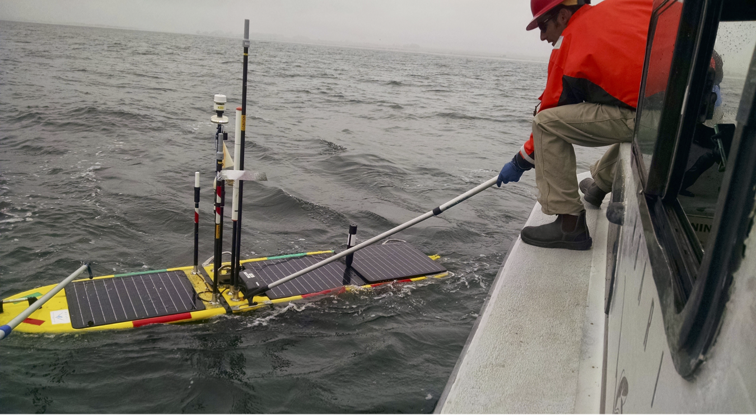

Figure 1: MBARI's SV3 Wave Glider with Hot Spot payload being deployed from RV Paragon. Note multiple Hot Spot radio and satellite antennae.

Steering Committee/Working Group Participation

Coordinating onboard GPU processing working group (formed during 2016 Mobile cytometer-microscope workshop at MBARI)
Collaborations
P Dias, J Pinto and J Sousa of the University of Porto, to integrate MBARI's LRAUV into thr Neptus vehicle planning software

Coordinated Canyon Experiment team (National Oceanography Center Southampton, University of Hull, Ocean University of China and US Geological Survey), to monitor Benthic Instrument Node status, archive and process CCE data
Jupiter Research Foundation (H Schmitz, L Ziccarelli, R Dellor), advising on calibration/validation procedures for the JRF Autonomous Microscope

MiVEGAS team from University of Hawaii, exporting Hot Spot technology

National Oceanography Centre UK, exporting Hot Spot technology

Ken Foote of IEEE/WHOI, collaborating on the IEEE Oceanic Engineering Society's Standards Initiative

Jay Pearlman of IEEE, coauthoring book chapter "Challenges and approaches to system integration"
Conferences/Workshops/Symposiums attended
A Connected Ocean 2016, October 11-13, Brest, France

American Geophysical Union Fall 2016 Meeting, December 12-14, San Francisco
Deployment Cruises
Coordinated Canyon Experiment BIN-3 deployment, October 18-21
Project Highlights
CANON: Hosted Paulo Dias of the University of Porto for five days at MBARI, where we integrated MBARI's LRAUV into UPorto's Neptus vehicle command software. CANON is evaluating Neptus as a potential operational tool.

CCE: Attended Charlie Paull's presentation at AGU Fall 2016 meeting (O'Reilly is a coauthor). Determined cause of repeated BIN cpu reboots; developed, tested and deployed (using the Hot Spot acoustic link) procedures to prevent future reboots.

Invited Lectures

Plenary lecture: "Some standards for interoperable marine instruments", at ACO 2016, October 11-13, Brest, France

Coauthor on Paull, et al: "Most detailed direct measurements yet of turbidity currents in the deep ocean: Monterey Coordinated Canyon Experiment", AGU Fall 2016, San Francisco

Other Activities
Session chair for "Interoperability standards for the marine environment", at ACO 2016, October 11-13, Brest, France

Peer Reviewed Publications
Masmitjà Rusiñol, Ivan, Spartacus Gomáriz Castro, Joaquín del Río Fernandez, B. Kieft, and Thomas C. O'Reilly. "Range-only benthic rover localization off the central California coast." Instrumentation viewpoint (electrònic) 19 (2016): 86-87.

Masmitjà Rusiñol, Ivan, Oriol Pallarés Valls, Spartacus Gomáriz Castro, Joaquín del Río Fernandez, T. O’Reilly, and B. Kieft. "Range-only underwater target localization: error characterization." In 21st IMEKO TC4 International Symposium and 19th International Workshop on ADC Modelling and Testing Understanding the World through Electrical and Electronic Measurement, pp. 267-271. 2016.

