Project Highlights

Waveglider Hotspot 901411

The final deployment for our SV2 Waveglider “Tex” occurred in February and was a 115 nautical mile trip to Station M to check on Ken Smith’s Benthic Rover via the Hotspot acoustic link. This was an exciting deployment as it included the newly integrated acoustic channel as well as an over the horizon Iridium link to allow direct human interaction to an asset on the seafloor. In this case, 6000 meters beneath the surface. This initial test focuses on ranging to the Benthic Rover and the team was pleased with the results, both acoustically and via the Iridium link. Further deployments are scheduled this fall that will incorporate querying the Rover for health and status.

Following the Station M deployment, the hotspot was integrated into the new SV3 vehicle “Tiny”. The first extended deployment of the vehicle occurred in March in preparation for the spring EcoHAB experiment off Newport Beach. This deployment focused on high bandwidth RF communication between the Hotspot and the Long Range AUV Daphne. After a successful test in Monterey Bay, the SV3 was loaded in a pickup truck and delivered to Newport Beach.

The second deployment of the SV3 occurred from the R/V Nerissa in Newport Beach, CA. This mission lasted 3 weeks and provided RF communication between LRAUV Daphne and the Hotspot. The Hotspot also proved very valuable as a debugging tool allowing a high speed and direct connection to the LRAUV when needed.

The next deployment is scheduled for mid-May to support Benthic Event Detector acoustic data download. This Hotspot functionality greatly reduces human load by allowing the relatively slow acoustic data transfer to occur without a boat on station. It was first demonstrated in March of 2014 and refinements are being made to increase efficiency of the data transfer.

Finally, Tom O’Reilly has a collaboration agreement with Christoph Waldmann of MARUM to further develop the communications "Hotspot" system and applications for Wave Glider platforms

Images:

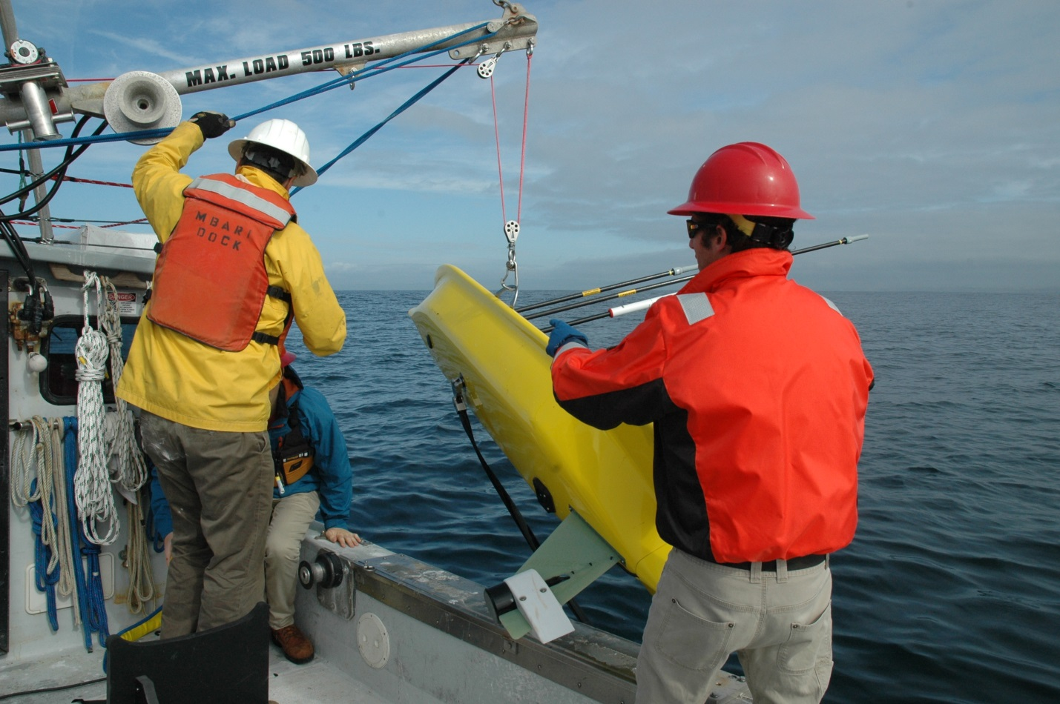
Figure 1 – Recovery of the SV3 onto the R/V Paragon following a successful first deployment in Monterey Bay.

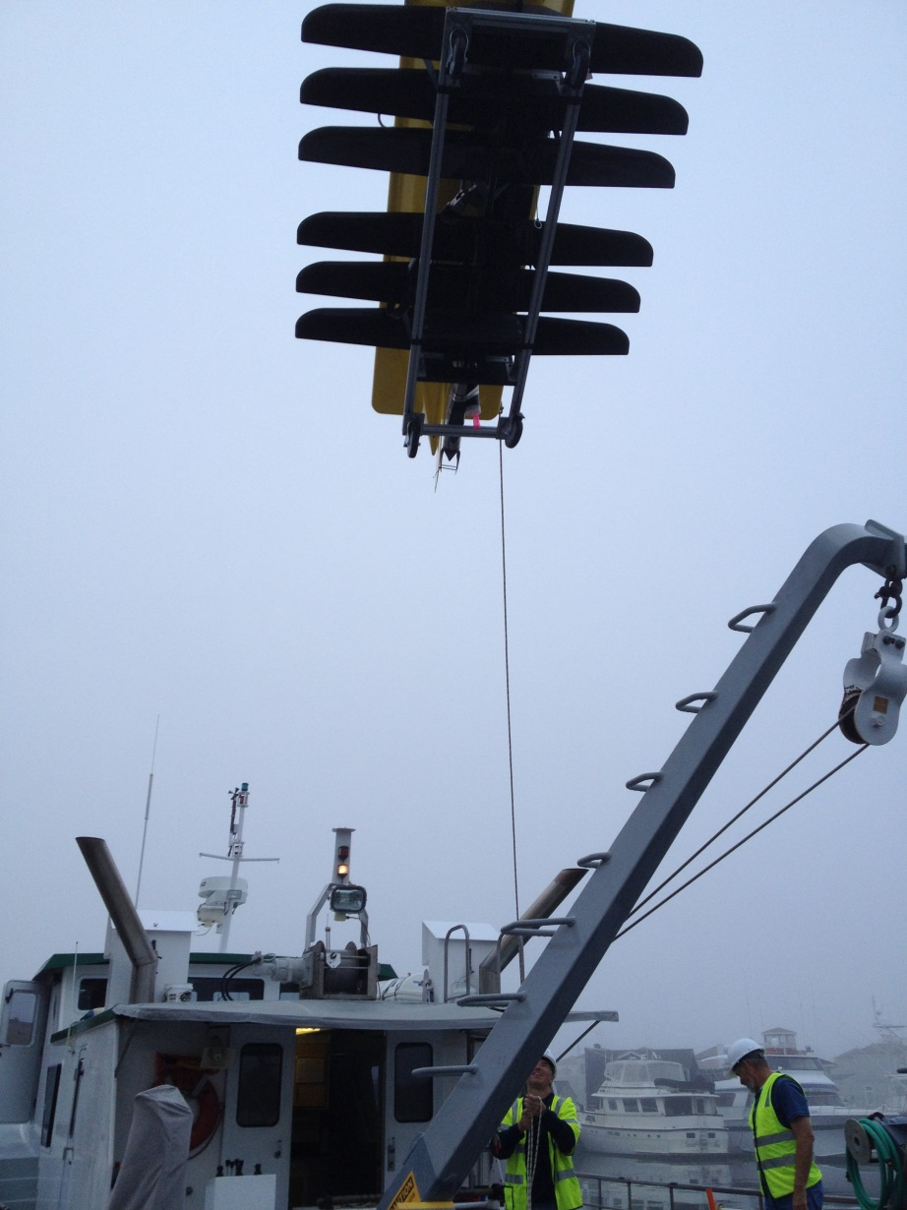
Figure 2 – SV3 “Tiny” being loaded onto the R/V Nerissa in Newport Beach, CA. to support the EcoHAB experiment.

