Project Highlights

Waveglider Hotspot 901411

In June the Hotspot was integrated with the new SV3 Waveglider. The system was deployed to Smooth Ridge to test over-the-horizon acoustic communication with the Benthic Rover in preparation for the Hotspot cruises to Station M. Further refinements of our process and shore-side Iridium setup were established and the Hotspot is well- positioned to support the Station M efforts.

A new acoustic instrument was added to the Hotspot suite in the form of a Benthos Directional Acoustic Transducer (DAT). Essentially an iUSBL, the DAT can track underwater assets (e.g. AUVs, gliders) that are equipped with a Benthos MF modem. Software onboard the Hotspot determines asset latitude and longitude based on acoustic range, azimuth and elevation, and sends the position to MBARI's shore-side tracking database via satellite or cell modem. The positions can then be displayed by our ODSS in near-realtime. In addition, we wrote software that allows the Waveglider to autonomously follow a tracked asset, allowing the Waveglider to remain within acoustic and RF range of the asset, without human intervention. These new features have proven particularly useful during the fall CANON experiment, where the Waveglider Hotspot autonomously tracked LRAUVs drifting underwater in Lagrangian mode for long periods.

Images:
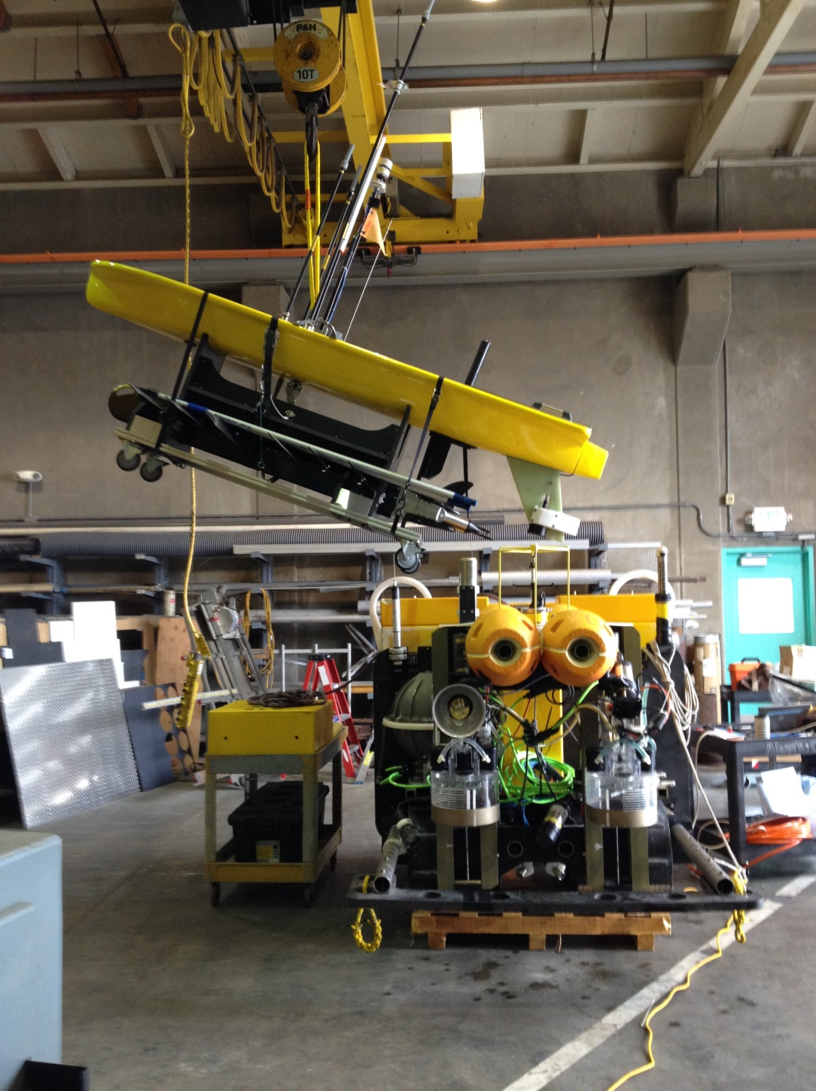
Figure 1 – A brief acoustic communications test between the SV3 Waveglider and the Benthic Rover just prior to the Rover being loaded on the ship for the Smooth Ridge cruise.

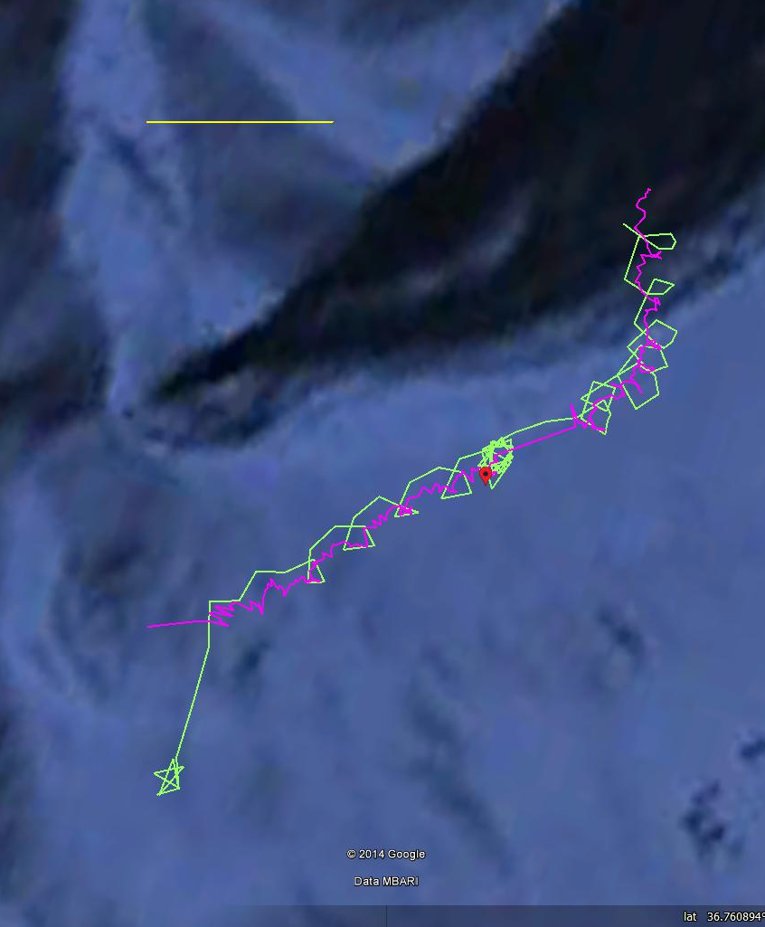
Figure 2 – SV3 “Tiny” (green) following LRAUV Makai (magenta) which is underwater. The yellow line is 500m for scale.

