MBARI Mobile Marine Research Platform Communications Functional Requirements and the role of Delay Tolerant Networking –a feasibility study
Rev. 7 08AUG12 Final

Contributors
Mark Chaffey
Kanna Rajan
Tom O’Reilly
Brent Roman
Frederic Py
Hans Thomas

Introduction
MBARI is actively developing new methods of ocean sampling using multiple marine vehicles in a complimentary, collaborative network. The sampling network includes Autonomous Underwater Vehicles (AUV’s), autonomous gliders, surface and subsurface drifters, ships etc., all referred to generically as “platforms”. This work is occurring under the major project initiative CANON. A major theme of the initiative is to track and sample the chemical and biological evolution of specific water masses over time.

The coordination of daily CANON sampling strategies and the tasking or re-tasking of platform assets often depends on interpreting the results of data from individual platforms while they are still operating in the field. On shore or on ship, the management task of assimilating data from current assets, making it accessible to interested parties, and providing the tools for planning new missions is performed with the assistance of the Operational Decision Support System (ODSS), a software application currently in development under the umbrella of the CANON initiative.

A limitation in the ability ODSS to assimilate data and plan new missions has been the difficulty of getting near real-time data with sufficient resolution from mobile field assets. The dominant cause of this communications bottleneck has been that most of the platforms currently used by CANON have not been configured to return large amounts of data from the field in real time and depend on the Short Burst Data (SBD) message service of the Iridium satellite system in order to provide reliable long distance over-the-horizon connectivity as shown in figure 1. SBD messages are a maximum of 1960 bytes in length and the uplink data rate of 2.4kbs requires that vehicles such as AUV’s can uplink only heavily decimated data sets and are required to spend a long interval on the surface to download any significant amount of data. The cost of SBD data return is also significant, at about $1820 per megabyte. In contrast, vehicle line-of-sight radios are capable of much greater bandwidth but typically have maximum practical ranges at sea of only about 1-2 km and are therefore useful for local communications only.

The concept of a communications gateway is to use high bandwidth radios for local communications to a data relay platform that then uses the most appropriate link to shore, either satellite or GSM cellular modem. Because the gateway remains at the ocean surface, it can have a larger power budget, higher and larger antennas and a larger radio volume than the AUV’s it supports. The communications gateway creates a cost efficient large volume data pipeline connecting remote mobile assets with ODSS.

The goal of this document is to investigate the technical options and overall architecture for installing a communications network gateway for the mobile platforms used in MBARI field research. It is hoped that the recommendations of this document will provide a template to encourage and guide compatible communications protocol selection and equipment purchases for MBARI’s mobile assets that need to return data to shore in near real time for the CANON initiative experiments as well as other users. This document examines three questions:
- What are the appropriate data transport technologies and is the best architecture to provide bidirectional communications to shore for the highly mobile platforms used for CANON-like field experiments, now and in the foreseeable future?
- Is the Delay Tolerant Network (DTN) software application, designed for infrequent and disrupted communication channels such as space and oceanographic exploration, the appropriate service to run on platforms that need to communicate in our domain?
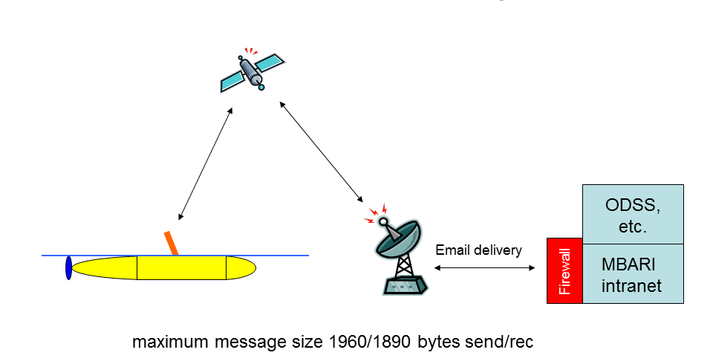
- What other software applications should be considered as the data transfer service in this application.
Figure 1. Illustration of the current Dorado and LRAUV Iridium based SBD message communications to shore.

Executive summary of the results
Laboratory and field tests were conducted with the current Delay Tolerant Networking reference design (DTN2) software. We also tested a Linux/Windows file synchronization utility application called rsync under similar conditions. Field testing was conducted with the Dorado AUV utilizing a line-of-sight FreeWave 900 MHz Internet Protocol radio link as the local RF connection between the AUV and the Gateway. The Gateway element was a single board computer running the Linux operating system that was borrowed from the Underwater Systems Laboratory at the University of Porto, Portugal. The research vessel R/V Zephyr was used as a Gateway platform and the ships KVH miniVsat satellite modem Internet connection was used as the communications link from the Gateway to shore and the ODSS server. An illustration of the network configuration as tested is shown in figure 5.

The testing was conducted in an entirely TCP/IP protocol environment and showed very similar performance for the DTN2 application and the rsync file transfer protocols. DTN2 required a significant investment in the configuration of the software that was not necessary for one-off implementations utilizing rsync, however DTN may offer advantages in non-IP environments. The development of DTN also appears to be the only standards based effort for true network connectivity in difficult environments. We therefore concluded that the Gateway hardware design should be required to be capable of supporting both DTN and the rsync utility. The specific protocol should be specified between these two alternatives at the implementation stage and in fact different applications may choose to implement either or both of the alternatives. For example an implementation that takes place in an entirely TCP/IP environment may choose to initially use rsync for simplicity, while an application that includes links that are not TCP compliant but are currently supported by DTN, such as acoustic modems, may choose to use DTN.

The conclusion of the study is that the Gateway concept is entirely technically feasible with currently available off-the-shelf hardware and software. The integration of the described Gateway data return capabilities into MBARI’s science missions is therefore a matter strictly of scientific need and MBARI’s development priorities. We believe that there is substantial value in MBARI developing this infrastructure, initially to support ODSS and the CANON field programs and subsequently for continuing to develop a strong position in long endurance scientist-in-the-loop over–the-horizon oceanography based on robotic platforms.

Sources of the requirements
The proposed mobile platform ship and shoreside communications requirements described later in this document are drawn from the following example use cases that were developed based on input from the following sources:
  - The CANON 2011 June experiment plan and discussions of future CANON requirements.
  - The plans of the MBARI Autonomy project and the associated Oceanographic Decision Support System (ODSS) supporting CANON initiatives.
  - The plans of the Tethys LRAUV project.

Example use cases for mobile platform communications
  - Human interactive AUV survey and coordinated sampling missions with Tethys and Dorado using a Gateway.
In this scenario an AUV is launched on a mission to identify and map a feature of interest such as an ocean frontal system. During the course of the mission the AUV surfaces periodically to establish a position fix from GPS (30-60 seconds for a hot fix). During the execution of the mission the AUV navigates to less than 1.5 kilometers to a pre-programmed rendezvous waypoint or to a waypoint that is down-linked via SBD message using the Iridium satellite link. At the waypoint the AUV establishes a high bandwidth connection using either a FreeWave Ethernet radio connection (current) or an 802.11 Wi-Fi connection (not currently installed on MBARI vehicles) to a network “Gateway” that acts as a relay to shore. The Gateway can be carried by a buoy, a ship, or a Wave Glider. With a connection made to the Gateway the AUV can upload large data sets (>1mByte in a 4 minute surface session with current radios. This would be ~10% of the total data volume collected by Tethys per hour) that would be rapidly assimilated and displayed by ODSS. New mission tasking commands from the ODSS mission planning application would also be downloaded through the Gateway. The near real time availability of high resolution data allows scenarios where for example Tethys AUV survey data would be used to rapidly create sampling mission tasking commands for Dorado for high resolution water sampling or other missions that are rapidly transmitted to the AUV through either a support vessel Gateway or a field Gateway. This scenario can also be extended to include non-MBARI vehicles from outside collaborators participating in the experiment.

The Gateway and the resulting data pipeline between distant mobile field platforms that is providing the ODSS application with high resolution data sets fully supports scientist-in-the-loop operations. Working with layered visualizations of AUV sampling data, remote sensing imagery and other data sets allows for near real-time interpretation and re-tasking of the field experiment as oceanic conditions evolve. The Gateway concept specifically supports the CANON long term vision of conducting ecological process driven field experiments with intensive deployment of multiple platforms for carrying out analysis in situ.

Contrast the above scenario with the current method of operation for an AUV reporting health and status and optionally small subsets of the data to the operator using the SBD message service of the Iridium satellite link. An AUV typically produces data sets of about 7 to 10 mega-bytes per hour of operation but only a very small subset of data, typically several kilo-bytes, is telemetered during the mission execution. At the completion of (and during) the mission the AUV sends brief messages notifying the operator of status via the Iridium satellite link. The vast majority of the data set from the mission is not available until downloaded post AUV recovery. In the case of an extended long range AUV mission, this could be several weeks.
  - Surface ship-of-opportunity sampling mission
In this mission a surface vessel, for example the John Martin, performs a sampling mission and the data is linked back to the Shoreside ODSS or other application in real time or near real time. The ship does not have intrinsic communications connectivity. Mission data is transferred via portable Gateway and an Ethernet connection to MBARI from the ship via the public internet and VPN using G3 cellular or satellite modem connections.
  - Platform to platform direct communications (coordinated sampling).
In this mission sampling results data or the results of on-board data processing and/or commands would be passed between several AUV’s collecting data in a coordinated mission. The communications connection would be through a surface loitering buoy, Wave Glider or ship based Gateway connection or directly from AUV to AUV using the radio or acoustic links.

Summary of investigation of candidates for MBARI field networking standards.
The project spent the most time configuring and testing the DTN2 release of the delay tolerant networking protocol, initially in the lab, then in one field trial. Similar tests were also conducted on the file synchronization utility rsync.
  - The DTN networking protocol.
Delay tolerant networking is an active area of academic and applied research. Numerous examples exist in the literature of interesting and relevant experimental applications of various DTN variants, however no cases could be found of the routine use of the reference DTN implementation in current permanently operational systems.
The laboratory and field tests of the DTN protocol at MBARI were successful, however three weeks of software effort were required to install and configure the DTN application. Most of this effort was due to the complexity of the software configuration and the inadequacy of the available documentation.

DTN operates on top of other networking protocols such as TCP/IP, Ethernet, 802.11, and acoustic transport layers. DTN is connected to the lower level protocols through a convergence layer adapter (CLA). Our study utilized the TCP/IP CLA exclusively (with underlying Freewave and VSAT 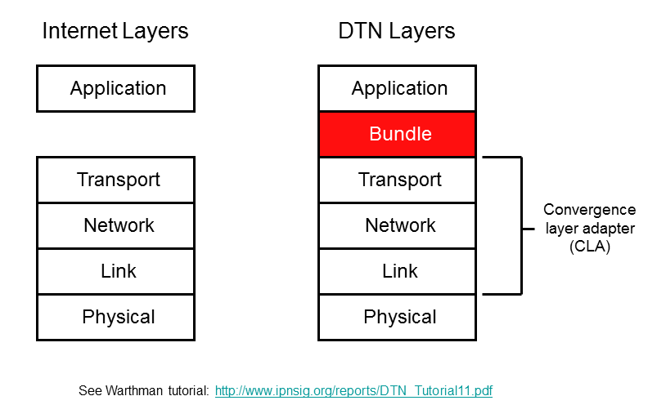
Figure 2. Comparison of the Internet and DTN protocol stacks.
satellite links). We believe that DTN is much more compelling in heterogeneous networks that include multiple protocols, such as Iridium SBD, acoustic, and GSM/CDMA, and recommend that a heterogeneous DTN testbed be developed and evaluated. The current release of DTN is referred to as DTN2 and the available software includes the DTN2 distribution and the DTN2-compatible Underwater acoustic modem CLA developed by the University of Porto that supports the WHOI acoustic MicroModem, and the Evologics acoustic modem. All communications links that support TCP/IP, such as Wifi and Ethernet radios, GSM cellular modems, etc. are also supported by this software distribution.

Our study did not explore many available DTN2 configuration options, due to time constraints and lack of adequate documentation. E.g. our test network was configured for static “always on” IP addresses throughout, which led to system fragility when the static ship address provided by satellite provider KVH changed unexpectedly. It should be noted that DTN2 includes configuration options which invoke network functions that would eliminate some of the problems we experienced such as invoking limits on connection “time to live” and forcing the dynamic discovery of DTN peers, however we did not have the resources in this study to investigate these functions.
  - Sendmail or POSTIX email services.
Sendmail, and POSTIX are applications that support the Simple Mail Transfer Protocol (SMTP) and are standard email transfer applications that have been ported to most operating systems including Linux. They operate in a store and forward mode and therefore appear to be suitable for applications such as this one where end-to-end network connectivity may not be available. Each communications link must support TCP/IP and each node in an email network hop must run an email server application known as a Mail Transfer Agent (MTA). An MTA continues to attempt delivery until a message is rejected or the timeout value is reached. Limitations include the complexity of attaching files, unknowable file size limitations on intermediate MTA servers and timeouts on the connections to destination servers. For this report we did not experiment with mail server protocols.
  - Linux command-line utilities that can transfer files over intermittent TCP/IP links.
rsync remote-update protocol transfers just the differences between two sets of files across a TCP/IP network connection. The source machine must run the ssh daemon. rsync's is a very efficient algorithm that can transfer a single file or an entire directory tree. rsync works over intermittent connections; the partial option will preserve partially-retrieved files, so the next rsync session will pick up where it left off.
wget is a utility for non-interactive download of files from the Web. It supports http, https, and ftp protocols (i.e. the file source machine must run an http server or ftp daemon). wget is designed for slow or intermittent TCP/IP links; if a download fails due to a network problem, wget will keep retrying until the whole file has been retrieved. If the server supports regetting, wget will instruct the server to continue the download from where it left off.
The use of one or both these utilities in a Gateway application would require some software effort to write a routine to periodically look for IP connections to targeted nodes and invoke the applications.
Testing showed rsync performed similarly to DTN in an all TCP/IP network environment and was easier to configure.
  - ESP remote communications method.
GSM cell phone data service requires a specialized account for machine-to-machine (M2M) communications. For the AT&T network M2M GSM service requires special “blue SIM” service to be able to have “mobile terminated” connections. In regular phone data service no traffic is accepted that is “mobile terminated” or addressed to the GSM modem. ESP works around this by opening a connection from the mobile site into MBARI and running an application that sets up a VPN connection. Once the VPN connection is established the remote computer appears on the internal MBARI network and is accessible to network services (including FTP and the DTN application). An additional trick is that it appears impossible for the VPN server at MBARI to support static IP addresses on the outside trying to establish a VPN connection with the server. The workaround an application that registers the VPN server assigned DNS address with a Dynamic DNS update service (DDNS) under a hostname of choice (i.e.www.Brentx.org) This creates a routable address on the WWW and can be then reached (only from the MBARI internal net because of the VPN) by any IP process addressed to that host. The cost of maintaining the open VPN connection is minimal because it takes very little bandwidth to keep it open. The VPN connection sits on top of the normal TCP/IP transport layer connection and appears as a separate network.
No experiments were conducted using this communication method however it appears to work well for ESP. The recommendation however is to use an M2M contracted account with a routable address.

Recommendations and conclusions.
The design and deployment of a communications Gateway that provides the capability to transfer large data sets from AUV’s is technically achievable with current technology and a reasonable amount of development effort. The system hardware design should be required to be capable of supporting both the standard DTN networking application and simple rsync software utilities for data and missions tasking information transfer. The specific communication protocol should be specified between these two alternatives at the implementation stage and different applications may choose to implement either or both of the alternatives. For example an implementation that takes place in an entirely TCP/IP environment may choose to use rync for simplicity and low initial development effort, while an application that includes multiple links that are not TCP compliant but are currently supported by DTN – such as the WHOI acoustic micro modem- may choose to use DTN. MBARI should monitor the progress of DTN development and participate in the work of the Delay-Tolerant Networking Research Group (DTNRG) where appropriate with the goal of moving toward a consistent standard for networking field platforms over intermittent communications links. Concurrently, the use of simple file synchronization utilities for data transfer should not be overlooked as an initial step in implementing a successful gateway function and developing a user base for near-real-time over-the-horizon oceanography.
  - Proposed system architecture and requirements.
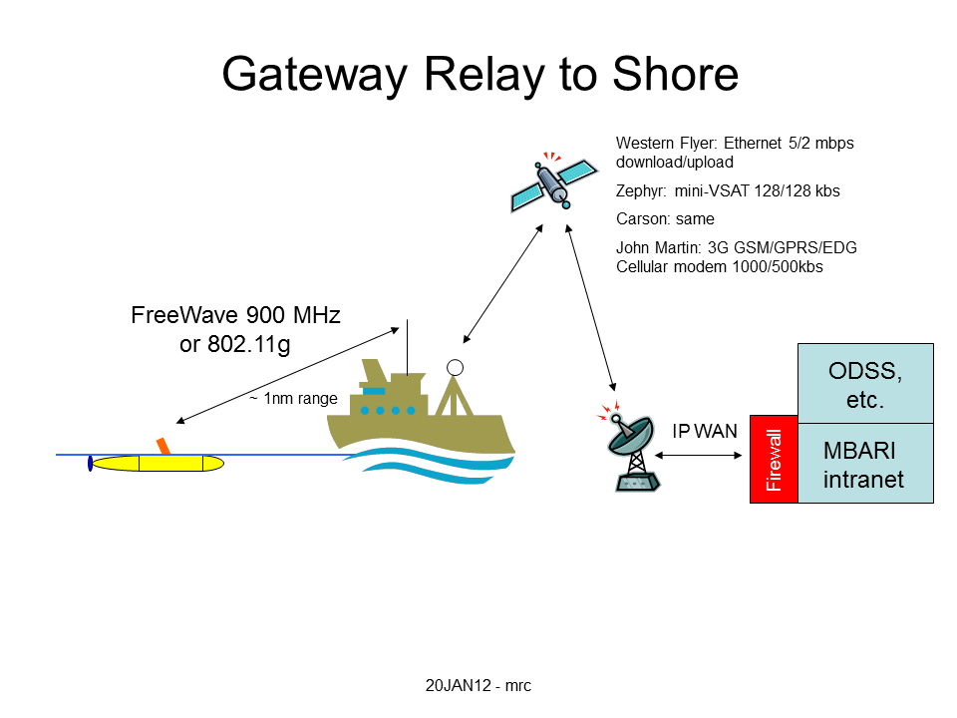
The proposed system architecture consists of three major elements: First there are the highly mobile remote data collection platforms. The best examples of these are the Tethys long range AUV and Dorado. The second element is the mobile communications Gateway. This system consist of a minimum of hardware for handing communications processing and radios for communicating locally with platforms through short range, line-of-sight (LOS) radio communications and back to shore either through the cellular phone network (if within cellular range), or through satellite communications. The Gateway is a small portable system-in-a-box that can be temporarily installed on ships of opportunity, a small buoy, or ideally on a non-moored platform such as the Liquid Robotics “Wave Glider”. The final element in the architecture is the shoreside or ship based “Operational Decision Support System” or ODSS software application and the data serving computers that support it.
Figure 3. Example of a ship based Gateway relay to shore.

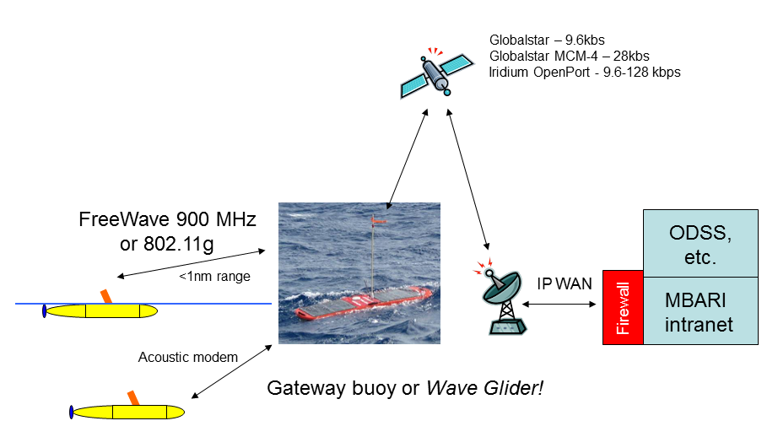
Figure 4. Wave Glider Gateway relay to shore.

  - Mobile research platform (AUV) recommended design requirements.
    - Software.
- Communications application capable of supporting automatic data transfer, DTN network stack running on the platform processor that handles communications.
- Convergence layer adapter (CLA) for 802.11b WiFi radio if DTN is used. Note: the standard DTN release includes a CLA for TCP/IP networks.
Or, depending on implementation chosen,
- Software application utilizing rsync for file transfer that synchronizes files between the mobile platform and the Gateway and the Gateway and shore.
    - Hardware.
- 802.11b Wi-Fi radio modem with a 2.4 GHz antenna able to provide signal connectivity to reciprocal radio modem and 2 meter high antenna at 1nm range while platform is on the water surface. Maximum sea state TBD.
- As an alternate to upgrading to a high speed Wi-Fi modem, the existing 900mHz Freewave radios and antennas can be used, but with longer data transfer and AUV on the surface times.
- Acoustic modem. There is an existing DTN convergence layer adapter for the WHOI micro-modem that is designed for the low overhead. Other acoustic modems could also be specified. (optional)
  - Field Gateway recommended design requirements.
The field Gateway is a proposed platform that would act as a communication hub for field assets. It can be an existing asset such as a ship with Internet connectivity and a Gateway or it can be a stand alone platform such as a buoy or Wave Glider with a Gateway. The function of the field Gateway is to act as a bridge between the approximately 1nm range of the AUV (or other power and height limited surface platforms) line-of-site radio systems and the public Internet and VPN connection to MBARI. The connection to the public Internet can be via G3 cellular phone, satellite modem such as Globalstar, or FreeWave radio connection to shore.
    - Software
- DTN application and network stack running on the platform processor that handles communications.
- For DTN implementation:
  - TCP/IP Convergence layer adapter (CLA) for 802.11b WiFi radio.
  - TCP/IP CLA for G3 or G4 cellular phone modem.
  - TCP/IP CLA for Globalstar MCM-4 or similar satellite modem (for outer Monterey Bay and California coastal operations).
- Note: the standard DTN release includes a CLA for TCP/IP networks.

Or, depending on implementation chosen,
- Software application utilizing rsync for file transfer that synchronizes files between the mobile platform and the Gateway and the Gateway and shore utilizing the TCP/IP over the above physical communications links.
    - Hardware
- 802.11b WiFi radio modem with a 2.4 GHz antenna able to provide signal connectivity to reciprocal radio modem and antenna at 1nm range while platform is on the water surface. Maximum sea state TBD.
- Globalstar MCM-4 or similar satellite modem (for outer Monterey Bay and California coastal operations). 19.2 kbs.
- Iridium Open Port 128 kbs.
- G3 or G4 cellular modem. These modems offer data rates of 500kbs or greater at a cost of around $99 for 3 gigabytes per month (100 megabytes per day).
- Acoustic modem. (optional)
  - Shipboard design requirements
A shipboard based Gateway would include the equipment of a Gateway above with the option of substituting existing shipboard Internet access for the Gateway satellite or G3 cellular modem.

  - Additional general requirements and recommendations.
    - Packaging.
The field Gateway system must be stand-alone and portable. It must be capable of installation on a buoy, ship-of-opportunity, or other robotic assets such as the Wave Glider.
    - Installation of 802.11b/g radio communications.
It is recommended that Wifi 802.11b/g/n compatible antennas be designed for installation on the Dorado and LRAUV class vehicles and the appropriate radios installed. This will significantly decrease the download time for large data sets. The goal is to reduce the data download time to the GPS fix acquisition time. To accomplish this task a new AUV antenna must be designed and tested for 2.4 GHz.
    - AUV systems known to be currently using 802.11b/g radio communications when on the surface.

GAVIA - Teledyne Gavia ehf

REMUS – Hydroid Inc.

Iver – OceanServer Technology Inc.

HUGIN - Kongsberg Maritime

Appendix 1. DTN References
  - DTN Research Group References and DTN2 implementations
http://sourceforge.net/projects/dtn/files/ Source for the DTN2 ver. 2.8.0 application files used for MBARI’s laboratory and field testing.
http://www.dtnrg.org/docs/code/DTN2/doc/manual/ Detailed information on DTN2, the current reference implementation of DTN. The section on the DTN2 API details all of the functions needed to code an application which interfaces to the DTN2 protocol at a fairly low level.
http://www.rfc-editor.org/rfc/rfc5050.txt reference for DTN2 message (bundle) specifications.
http://ieeexplore.ieee.org/xpls/abs_all.jsp?arnumber=5733227&tag=1 Porto Group paper on implementing DTN2 and developing Convergence Layer Adapter (CLA) for the WHOI MicroModem.
  - Trinity College Dublin DTN implementation
http://www.n4c.eu/Download/n4c-tcd-007-d4_1-FINAL.pdf Description of installing and configuring a DTN node with some good examples of how to use DTN2 without modifying the underlying code.
  - IBR-DTN implementation
http://www.ibr.cs.tu-bs.de/projects/ibr-dtn/
Website of the German Institut für Betriebssysteme und Rechnerverbund (IBR) DTN implementation.
http://journal.ub.tu-berlin.de/eceasst/article/view/512 Detailed paper describing the IBR-DTN implementation designed for embedded systems.
http://tools.ietf.org/html/draft-irtf-dtnrg-tcp-clayer-02 This document describes the protocol for the TCP-based Convergence Layer Adapter (CLA) for Delay Tolerant Networking (DTN).
  - Postellation implementation
http://www.ietf.org/proceedings/79/slides/DTNRG-3.pdf
  - General
http://www.ipnsig.org/reports/DTN_Tutorial11.pdf

http://csd.xen.ssvl.kth.se/csdlive/sites/default/files/projects/Condroid%20Final%20Report%20V1.0_0.pdf This is a well documented experiment that included construction and verification of a DTN Gateway and has useful details on the implementation and testing.
  - Some interesting DTN based field trials
http://www.cse.iitk.ac.in/users/braman/dgp.html Low cost networking in India experiment.
http://www.snc.sapmi.net/ Internet connectivity using opportunistic relays through reindeer herds.
http://www.princeton.edu/~mrm/zebranet.html Tracking animal migration using tracking collars and DTN connections.

Appendix 2. Acronyms and other definitions
Broadband – Vague marketing term for high speed, usually refers to Internet access.
CANON - Controlled, Agile and Novel Observing Network project, F. Chavez PI
CLA – Convergence Layer Adapter. A DTN software module that adapts the DTN application to a specific data transport and physical layer. The current DTN release includes a CLA for TCP/IP networks.
DHCP – Dynamic Host Configuration Protocol (Ethernet)
DNS – Domain Name Server (Ethernet)
DTN – Delay Tolerant Networking. A software application that is designed for intermittent communications networks with long latencies.
Globalstar satellite link – Low earth orbit satellite constellation that provides “bent pipe” 4800 bps communications to coverage areas around the major continents.
Globalstar MCM-4, four channel binding of up to 28kbs
GSM - Groupe Spécial Mobile, a collection of cellular phone protocols.
3G – Shorthand for third generation celluar phone service. First phone protocol with sufficent bandwidth to support broadband connectivity from mobile devices.
4G – Latest generation broadband cell service, over 1Mbs possible.
GPRS/EDGE – General Packet Data Service on cell phone networks. Typical speeds of approximately 70 to 135 kbps.
Hotfix – GPS position calculation where the local receiver satellite ephemeris table is current. Usually takes less than 20-30 seconds after seeing the sky or power up. Some receivers can forward calculate the table and maintain short times to first fix (TTFF). Without this feature an ephemeris table over 4 hours old can take several minutes to get a position.
HSDPA - High-Speed Downlink Packet Access is a 3G mobile telephony protocol in the HSPA family with down-link speeds between 1.8 and 14 Mbit/s
HSUPA - High-Speed Uplink Packet Access is a 3G mobile telephony protocol in the HSPA family with up-link speeds up to 5.76 Mbit/s
IPsec VPN – IP protocol for providing end-to-end security of content message.
Iridium satellite link – Low earth orbit satellite that provides world wide low power communications at 2.4 kbits per second.
Iridium open port (9.6-128 kbps with per-MB pricing for airtime)
KVH VSAT link (TracPhone V7) commercial satcom system providing internet connectivity for marine vessels.
MMS messages – Standard protocol for sending messages from mobile phones.
ODSS – Operational Decision Support System project.
rsync Unix/Linux/windows utility that is designed for efficient file synchronization across TCP/IP networks.
SBD – Short Burst Data, an Iridium radio service that forwards messages of up to 1960 bytes each when a satellite connection is available.
TCP/IP – Transmission Control and Internet Protocol, the two initial specifications for defining Internet communications and the protocol that underlies almost all internet communications.
T-Rex – Autonomy application running on the Dorado AUV.
802.11 - Ethernet radio standard commonly called WiFi (2.4 GHz, up to 10Mbs). Different modulation schemes are 802.11b, 802.11g, etc.
UAV – Unmanned Aerial Vehicle
VSIP – Virtual Static IP addressing. Can also be used with VPN.
VSAT – Very Small Aperture Terminal (antenna diameter less than three meters).

Appendix 3. DTN and Gateway laboratory and field tests.
  - Experiment description.
In order to test the suitability of DTN and the rsync applications for networking MBARI’s mobile platforms laboratory and field tests were conducted that were designed to resemble the operating environment of a field Gateway.
In the field test files were transferred from the MBARI CTD AUV to shore and simultaneously transferred a mission tasking file from shore to the AUV. The DTN application was utilized to automatically dispatch the files when the AUV surfaced to aquire a GPS navigational fix at the end of a run. For convienince, the vessel Zephyr was used as the communications relay (Gateway) between the relatively short range AUV Ethernet radio and the long range communications link to shore.The ship to shore link utilized the ship resources of the KVH mini-VSat terminal that provides IP connectivity to the WWW at 128kbs uplink and downlink. The Gateway function could also have been provided by a temporary buoy, or any other platform of convienience with an GSM cell phone or satellite connection to shore.
  - DTN laboratory testing.
The test configuration used a Ubiquiti Bullet radio link between trex3 and vesuvio (no Manta, no Leviton router) to simulate the Freewave connection between the Gateway and the AUV.
Test file: test.tar.gz: 133188678 bytes (133 MB)
from vesuvio: scp ~/mydtn/test.tar.gz dorado1@dtn-trex3:mydtn/.
195 sec
205 sec
140 sec
140 sec
135 sec
135 sec
(less 3 sec for password entry)

from trex3 to vesuvio: scp ~/mydtn/test.tar.gz oreilly@dtn-vesuvio:mydtn/incoming/scp/.
64 sec
65 sec
64 sec
65 sec

File transfer times, dtncp: from trex3 to vesuvio:

    - Uninterrupted case
 | trial 1 | trial 2 | trial 3 | trial 4
Start dtncp on trex3 | 09:13:03 | 09:28:05 | 09:30:50 | 09:33:25
dtncp complete on trex3: | 09:14:30 | 09:29:31 | 09:32:16 | 09:34:51
complete file recvd on vesuvio | 09:15:13 | 09:30:10 | 09:32:51 | 09:35:29
total xfer time | 130 | 125 | 121 | 125

    - Interrupted case, disconnect vesuvio cable for 120 sec after dtncp complete on trex3
 | trial 1 | trial 2 | trial 3 | trial 4
start dtncp on trex3 | 09:42:12 | 09:47:51 | 09:54:15 | 10:01:41
dtncp complete on trex3: | 09:43:38 | 09:50:40 | 09:57:12 | 10:04:06
reconnect after 120 sec | 09:45:38 | 09:52:40 | 09:59:12 | 10:06:06
complete file recvd on vesuvio | 09:46:34 | 09:53:29 | 10:00:08 | 10:06:56
total xfer time | 142 | 218 | 233 | 195

  - Rsync laboratory testing.
The rsync utility tests were conducted in a similar configuration to the DTN laboratory tests described above.
rsync: from trex3 to vesuvio (rsync -P --partial-dir=partial-dir ~/mydtn/test.tar.gz oreilly@dtn-vesuvio:mydtn/incoming/rsync/.) (NO TIMEOUT) (about 3 sec to input password)
    - Uninterrupted case:
 | trial 1 | trial 2 | trial 3 | trial 4
start rsync on trex3 | 11:32:39 | 11:34:35 | 11:36:24 | 11:38:16
complete file recvd on vesuvio | 11:33:53 | 11:35:53 | 11:37:38 | 11:39:35
total xfer time | 74 | 78 | 74 | 78

    - Interrupted case, Disconnect vesuvio cable for 120 sec, 30 sec into transfer.
 | trial 1 | trial 2 | trial 3 | trial 4
start rsync on trex3 | 08:58:15 | 09:06:00 | 09:19:30 | 09:31:00
reconnect after 120 sec | 09:00:45 | 09:08:30 | 09:22:00 | 09:33:30
complete file recvd on vesuvio | 09:03:07 | 09:10:48 | 09:24:34 | 09:35:52
total xfer time-120 seconds | 172 | 168 | 183 | 171
Note: In trial 2, rsync resumed transfer ~90 sec after reconnect. Trial 3 resumed ~111 sec after reconnect. Trial 4 resumed ~92 sec after reconnect.
    - Interrupted case with retry. Set rsync timeout = 90 sec, and keep trying rsync in a loop, with 5 sec sleep between each loop. Disconnect vesuvio cable for 120 sec, 30 sec into transfer:
 | trial 1 | trial 2 | trial 3 | trial 4
start rsync on trex3 | 11:33:30 | 11:40:00 | 11:46:30 | 11:52:00
reconnect after 120 sec | 11:36:00 | 11:42:30 | 11:49:00 | 11:54:30
complete file recvd on vesuvio | 11:38:03 | 11:44:33 | 11:51:03 | 11:56:48
total xfer time-120 seconds | 153 | 153 | 153 | 168

The above tests were conducted with the following c-shell script running on trex3:
#!/bin/csh
# Continually synchronize test file between trex and vesuvio with rsync.
# Use this script to measure throughput across an intermittent link.
# To avoid password input on each invocation of rsync, source machine's
# public rsa key should be included in target machine's .ssh/authorized_hosts
# file (see https://blogs.oracle.com/jkini/entry/how_to_scp_scp_and)
#
while (1)
date
rsync --timeout 90 -P --partial-dir=partial-dir ~/mydtn/test.tar.gz oreilly@dtn-vesuvio:mydtn/incoming/rsync/.
echo rsync status: $status
sleep 5
end
  - Field test architecture.
The DTN application open source software dtn 2.8.0 was installed on three nodes, the trex2 processor on the Dorado CTD AUV, the “Manta” processor used as an intermediate node on the Zephyr, and on the MBARI server odss-staging.shore.mbari.org. In order for DTN to route traffic a static “routeable” address was required for the ship based DTN node. The KVH miniVSat V7 terminal was configured to provide a single routeable static IP address. A small Internet Gateway/router was installed to provide “NAT translation” based on the port address to allow connection to several hosts behind the single static IP address (see figure 2 for details).
The MBARI internet firewall was configured to allow IP traffic from the Zephyr installed Gateway/router IP address to the DTN port on odss-staging.

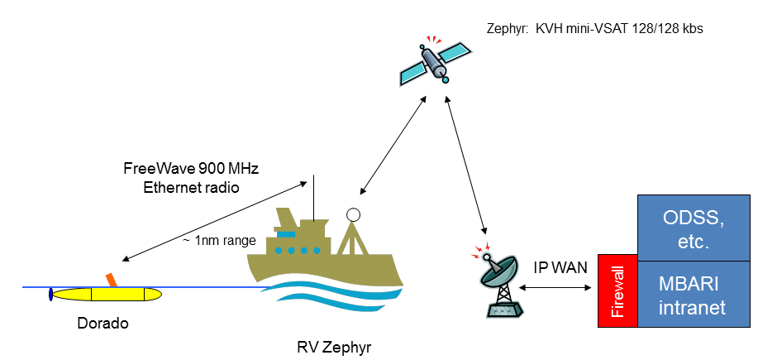
Figure 5. Simplified communications architecture as field tested.
  - DTN Field test operations.
The plan of the field test was to conduct four AUV runs in a yo-yo profile, have the surface to acquire a GPS fix, then return to a waypoint approximately 400 meters from the Zephyr and surface. On the return journey a dummy data file is loaded in the DTN send directory for automatic transfer to the shoreside ODSS server when the AUV establishes radio connection to the Zephyr. Simultaneously a dummy mission re-tasking file is queued up on the shoreside server in the odss-staging DTN send directory and this file is automatically downloaded to the AUV. Each run would generate a 2x larger data file. At the end of the run the amount of time required for the download would be measured. Then the AUV would be manually commanded to begin the next run.
The first AUV test run aborted spontaneously shortly after it began due to a power cycle of the trex2 processor for unknown reasons.
The second run was a repeat of the first run and successfully generated a 573440 byte data file on the return leg and this was automatically transferred to the MBARI shore-odss data server in less than two minutes after the AUV surfaced. The mission re-tasking file was not sent to the AUV due to a configuration error.
The third run did not generate an AUV data file due to an operational bug related to Gulper Sampling. The mission tasking file was successfully sent from odss-staging to the AUV when the AUV surfaces.
The fourth AUV run successfully generated a 1146880 byte data file. When the AUV surfaced at the end of the mission the data file was automatically transferred to the Zephyr “Manta” Gateway in less than four minutes, and end-to-end to the odss-staging server directory in a total of 7 minutes from when the AUV first made a radio connection. Simultaneously a new mission tasking file was successfully sent from odss-staging to the AUV.
  - Field test conclusions.
End-to-end data transfers utilizing the DTN application successfully transferred data files up to 1.1MByte from the AUV Dorado trex2 autonomy processor in less than four minutes and to a file directory in the MBARI shoreside server odss-staging under typical at operational conditions. Simultaneously a mission tasking file of typical length was sent from odss-staging to the AUV. These transfers occurred automatically when the AUV surfaced and was able to connect to the Zephyr Gateway using the AUV Freewave Ethernet radio. The data transfer rate and therefore the AUV surface time for transfer appears to be currently limited by the radio bit rate, however under actual field conditions we were able to achieve about a 50% utilization of the theoretical maximum bit rate, which is very good.
Tests under similar conditions using the utility rsync were also successful in transferring data files over intermittent IP links. Rync was easier to configure and transferred the large data files slightly faster.
The conclusion is that in an all TCP/IP environment either DTN or rsync are both efficient at transferring large data files over intermittent or long delay network links and large AUV data sets can be automatically sent to shore using a Gateway with minimal time on the surface.
  - Additional recommendations and observations based on the laboratory and field tests.
Networking skills:
We have found DTN configuration to be a challenging task, especially in light of incomplete documentation. In this study, we used only very basic DTN configuration options, which may have resulted in an overly “fragile” network. In future, the engineer or technician charged with DTN configuration and operation should have sufficient background in IP networking, and must be allocated adequate time to determine how to more effectively configure DTN.

Software engineering resources: If we decide to pursue DTN as an operational element, additional MBARI software engineering resources must be allocated. Due to limited time in the feasibility study, we did not become familiar with DTN source code yet we’ve identified serious reliability issues that require debugging at the C++ source code level. Inspection of DTN source code could also help to understand otherwise poorly documented configuration options. Moreover we only utilized the basic existing applications included with the DTN2 distribution (dtnping, dtncp, etc), but these basic utilities may not be optimal for operational use in a project such as CANON. Instead we may want to develop our own application code using the DTN C++ API.

Documentation: DTN2 documentation is fairly sparse, sometimes out-dated, and organisation could be improved. Building and installing the software can be especially challenging. DTN2 relies on several third-party packages, and is only compatible with certain versions of those. Yet the documentation doesn’t specify all of these dependencies, which are apparent only after perusing various online forums. We built DTN2 for Linux and MacOS, and encountered subtle but poorly documented procedural differences between these platforms that required several hours to debug.
The DTN2 distribution includes a very basic tutorial which deals with the trivial case of a single-node DTN “network”, but very little detail for the more realistic multi-node case. The documentation includes a description of the numerous DTN configuration options, but much of this is vague and makes references to undefined terms. In the absence of good documentation, configuration is a very time-consuming process, including much trial-and-error to determine the right combination of parameters across multiple DTN nodes. We eventually arrived at a configuration which works well for our testbed, but which proves to be rather fragile in the event of slight changes to the physical network. E.g. we specify all IP addresses statically, but in the real world these may change, leading to lengthy reconfiguration and testing. There appear to be DTN options that enable dynamic addressing and routing, but these are not well-documented. In general the organisation of documents at the DTN2 website could be improved. For example, the N4C Functional Specification for DTN Infrastructure is an extremely useful document, yet it doesn’t appear on the main DTN2 documentation page; we only learned of this document rather late in the project.

DTN daemon reliability: The most critical issue we’ve identified is that of DTN2 daemon reliability. Each node in a DTN network hosts a DTN daemon (aka “dtnd”), which performs critical networking functions. We have encountered occasional dtnd crashes on all of our DTN nodes (Manta, Linux, MacOS). We have seen dtnd crashes in two circumstances: (1) The DTN daemon sometimes crashes immediately after starting the DTN “copy daemon” (dtncpd). (2) We have observed dtnd crash on the Manta when attempting transfer of a large 1.3 GByte file. When dtnd crashes, a very brief cryptic series of hex digits is written to the DTN log. Simply restarting the daemon manually almost always results in another crash within seconds. Re-initializing the daemon with the --init-db flag often but not always clears the error state. In some cases, the DTN bundle database must be manually removed before restarting. We haven’t determined how to reliability reproduce these crashes, and have no hard statistics on how often they occur, but estimate very roughly that 5% of dtnd instances will crash. If we decide to pursue operational use of DTN, we will certainly need to debug these problems at the C++ source code level.

Clock synchronization: DTN works properly only when clocks on all DTN nodes are well-synchronized. If clock differences exceed the bundle expiration time (typically 60 seconds), we observe dtnd cpu usage exceeding 10% and a general degradation in performance - e.g. bundles are not successfully transported in a reasonable amount of time. Since erroneous timestamps due to a faulty clock are propagated throughout the DTN network, DTN daemons on many or all of the nodes must be reinitialized in addition to fixing the faulty clock.

Manta Gateway: Several DTN2 applications (e.g. dtnping) are not included with the Manta Gateway loaned to us by Porto. Porto engineer Ricardo Martins indicates that these could be added relatively easily.

Appendix 4. Current MBARI AUV and shipboard communications assets
  - Dorado
- Iridium satellite modem, T-Rex processor A3LA modem maximum SBD size 1960/1860 bytes, vehicle processor 9601 maximum SBD size 340/270 byes upload/download, latency 5-20 seconds (may be updated to 9602 in future)
- Line-of-site radio, MicroBee Ethernet radio PN PCFW-104-ETH PC/104 FreeWave FGRM Series embedded radio, at-sea range about 1 -1.5 nm, 57.6kb. Maximum 96kbs.
  - Tethys
- Iridium 9601 satellite modem with SBD messaging, maximum size 340/270 byes, latency 5-20 seconds.
- Missions generate – 13 mega-bytes per hour of raw data. Compressed data sets of between 3-10 kbytes are sent back nominally every hour in 9 to 30 messages of 340 bytes each. The smaller sets take about 5 minutes to upload and larger data sets about 15 minutes. Longer upload times cause greater exposure of the vehicle to surface ship interference.
- Line-of-site radio, FreeWave MM2 900MHz 115.2-153.6 kbps (may be updated to 802.11b WiFi link in the future).
- Note that mission tasking script files are around 10-20kB each although short waypoint lists and selection of preloaded scripts takes much less space and communications bandwidth.
  - Zephyr
- KVH Trac-Phone V7 mini-VSAT broadband satellite link providing Ethernet connectivity. Service plan F1 128/128 kbs. Cost is flat rate, unmetered. Eastern Pacific coverage.
  - Western Flyer
- Broadband Ku band VSAT system carried on satellite Galaxy 18. Ethernet 5/2 mbps download/upload to users on request. Cost is $0.010/mbyte to limit then $0.15/mbyte. Eastern Pacific coverage. 84cm dish provides coverage over the northeastern pacific.
  - Rachel Carson
- The Current plan is to move over the KVH Trac-Phone V7 mini-VSAT broadband satellite link from the Zephyr. Eastern Pacific coverage. The microwave system to Mt. Toro will also be installed. The system currently is configured for DNS/DHCP routing although there is discussion of changing the service to provide a routable static address in the future.
  - John Martin
- 3G GSM/GPRS/EDG Cellular modem. No data limit. Coverage approximately 10nm from shore. Data transfer rates can be as high as 500kb up and 1000kb down.
  - Pt. Sur
- Broadband 1 meter dish unlimited access Ethernet. Eastern Pacific coverage.

Appendix 5. Comparison costs of data transfer

Note the extremely low cost of cellular (GSM/GPRS) data transfer compared to satellite airtime. Also interesting to note the high cost of Iridium SBD message service compared to Iridium RUDICS packet data service. For satellite communications systems that utilize a small omnidirectional antenna and therefore are suitable for a buoy or Wave Glider based Gateway the Globalstar network is the most cost efficient and covers within 300 kilometers of shore.

Small Platform Communications Links to Shore Comparative costs
 | Service Provider | Service /Plan Name | Current Signal Coverage | Antenna | Uplink /downlink Raw Data Rate | Estimate of uplink kbps | Maximum Feasible Data per Day | Power required when trans. Watts | Airtime cost per Mbyte | Joules per Kbyte | Cost per year for 22MB/day
Nearshore | Industrial G3 modem GSM/GPRS/EDG | Verizon wireless $50/5Gb | Monterey Bay within 10nm of shore (raised antenna) | omni-directional | 500/1000 kbs | tbd | tbd | tbd | $0.008 | tbd | $600 (1)
Offshore | KVH mini-Vsat | TracPhone V3 | Global | stabilized, 14" dia. | 128k/2mbs | 128k/2mbs | tbd | tbd | $0.99 (2) | tbd | $6,000
Offshore | KVH mini-Vsat | TracPhone V7 | Global | stabilized, 24" dia. | 1/2 mbs | 128/128 kbs (3) | tbd | tbd | $0.99 | tbd | $17,940
Offshore | Globalstar | Liberty 48000 dial-up | Coastal regions to 200 miles from shore | teacup size, omni-directional | to 9.6/9.6 kbit per second | 7.8 | 30 MB (4) | 8 | $2.58 | 8.2 | $20,717
Offshore | Globalstar | MCM-4 channel bonding modem | Coastal regions to 200 miles from shore | omni-directional | to 28/28 kbit per second | 22.75 | 120 MB | 24 | $2.58 | 8.2 | $20,717
Offshore | INMARSAT | F-33, MPDS (5) | Spot beam, most of americas | stabilized, 14" dia. | 28/64 kbit per second | 28 | 68 MB + | 60 | $30.00 | 17.1 | $240,900
Offshore | Iridium | PPP or RUDICS (6) | Global | small, omni-directional | to 2.4/2.4 kbit per second | 2.4 | 15MB (7) | 2.5 | $37.68 | 8.3 | $302,570
Offshore | Iridium | Open Port channel bonding modem | Global | small, omni-directional | to 128/128 kbit per second | 128 | ? | ? | $10.25 | ? | $82,308
Offshore | Iridium | SBD | Global | small, omni-directional | to 2.4/2.4 kbit per second | 2.4 | ? | 2.5 | $1820 (8) | 8.3 | $14.6M
 | KB= Kilobyte; MB= Megabytes; GB= Gigabytes; 1 GB = 1,024 Megabytes; 1 MB = 1024 Kilobytes; 1 Kilobyte =8 Kilobits
 | (1) - 5Gb per month @ $50 plan.
 | (2) - Plan is M500. Maximum usage 500Mbyte per month then cost is 2x.
 | (3) - Data rate depends on the plan. Current plan on Zephyr is 128kb unmetered. Cost per Mbyte is estimate. Maximum daily cap unknown. MBARI ship plan is 128/128 kbs. Cost per Mbyte is estimate.
 | (4) - Actual science data return at 40% satellite availability (data compression was used). Airtime is pre-purchased.
 | (5) - MPDS = Mobile Packet Data Service.
 | (6) - RUDICS = Router Based UDI Connectivity Solution, an Iridium packet data service.
 | (7) - Calculated data return at 95% satellite availability, assuming simillar compression efficiency as achieved in Globalstar testing.
 | (8) - Based on $0.0018 per byte + 19.95 month. First 30 bytes $1.62.

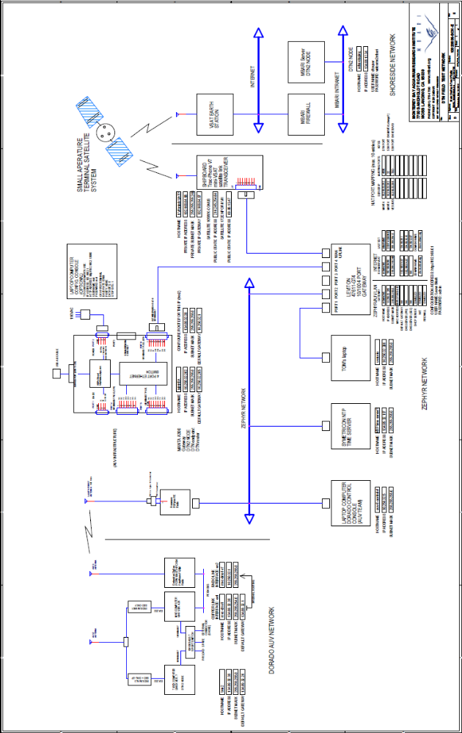
Figure 6. Detail of DTN field test hardware architecture.

Controlled, Agile, and Novel Observing Network - CANON
The current 9601 Iridium satellite radio modem on Tethys supports 340 Byte maximum SBD messages. Upgrading to the A3LA or 9522 modem allows 1960 Bytes per message.
See appendix 5 for satcom comparative cost details.
DTN2 is the designation of the current release of the Delay Tolerant Network (DTN) software application. The location http://sourceforge.net/projects/dtn/files/ is the source for the DTN2 ver. 2.8.0 application files used for MBARI’s laboratory and field testing.
TCP/IP or Transmission Control and Internet Protocol, the two fundamental specifications for defining Internet communications.
Wave Glider is a commercial product, an autonomous wave and solar powered surface platform. The advantage of a Wave Glider is that it can be remotely commanded to loiter in the area of study or follow a continuously changing AUV sampling area. With transit speeds between 1.5 -2 kts in the first month of deployment, a Wave Glider can easily follow a study site that is drifting 40 km per day. For long endurance LRAUV missions, the Wave Glider as a Gateway platform could take the place of a research vessel.
Tethys is an AUV developed at MBARI optimized for extremely long range and long endurance, also referred to as the long range AUV (LRAUV).
Dorado is an MBARI AUV with a large payload that is capable of collecting water samples.
See the Delay-Tolerant Networking Research Group (DTNRG) at http://www.dtnrg.org and the DTN reference section in this document.
In static addressing the DTN application on each node in the system is assigned a specific Internet (IP) address for traffic routing. In dynamic routing a hostname is assigned and a Domain Name System (DNS) server dynamically maps the hostname to the currently assigned IP address. Dynamic addressing automatically modifies IP packet routing as the assigned IP address’s change.
The Globalstar LEO satellite constellation is the enabling technology for cost efficient high volume data return from small platforms within 300-500 kilometers of the coast. For example the Globalstar cost is $2.58 per MB vs $1,820 for Iridium SBD. In previous work with Globalstar MBARI has returned 20-30 MB per day very reliably. Also see appendix 5.
Note that NATO NURC, La Speizia has already demonstrated this concept of a Wave Glider DTN Gateway in collaboration with the University of Porto.
See pricing at http://m2m.sprint.com/engage-with-us/m2m-pricing.aspx
“dtn 2.8.0”, from sourceforge here: http://sourceforge.net/projects/dtn/files/
The Manta Gateway is a ruggedized single board computer and power supply running Linux and the DTN application. It can act as a router between a local network (copper or RF) and a WAN using a GSM modem or other medium for transport. It also can provide a DTN network-like interface to the WHOI micro-modem. The unit used for the test was built by Ricardo Martins of the Underwater Systems and Technology Laboratory Universidade do Porto, Faculdade de Engenhariaand and was on loan to Kanna Rajan.

