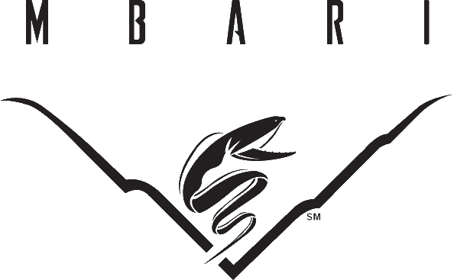

Ventana Upgrade
Design Specification

Revision 1.0

Monterey Bay Aquarium Research Institute
7700 Sandholdt Rd.
Moss Landing, CA 95039
Table of Contents
1 Introduction 4
1.1 General Description 4
1.2 Purpose of Document 4
2 Equipment Specification 5
2.1 Mechanical 5
2.1.1 System of Units 5
2.1.2 Operating Depth 5
2.1.2.1 Variable Buoyancy System: 5
2.1.3 Hydraulics 6
2.1.3.1 Vehicle Power 6
2.1.3.2 Hydraulic System & Components 6
2.1.3.3 Thruster Placement & Capabilities 6
2.1.3.3.1 Thruster Placement 6
2.1.3.3.2 Thrust Capabilities 7
2.2 Electrical / Optical 7
2.2.1 Electrical Assemblies 7
2.2.2 Sub-Sea Control Pod 7
2.2.2.1 Connectors & Cables 8
2.2.2.2 FOCAL 903 Video/Data Multiplexer 8
2.2.3 Main Junction Box 8
2.2.3.1 Ground Fault Monitoring 9
2.2.4 Auxiliary Interface Junction Box 9
2.2.4.1 Auxiliary Power Requirements 9
2.2.4.2 Auxiliary Data Requirements 9
2.2.4.3 Connectors & Ports 10
2.2.4.4 Ground Fault Monitoring 10
2.2.5 Lighting Junction Box 10
2.2.6 Umbilical Termination / Transformer Junction Box 10
2.2.7 Core Instruments (MBARI Provided) 11
2.2.7.1 Navigation 11
2.2.7.2 Cameras & Viewing 11
2.2.7.3 Science Tools 12
2.2.7.3.1 Tool Sleds 13
2.3 Surface Control Equipment and Power Distribution 13
2.3.1 Control Room 13
2.3.2 Control System 14
2.3.2.1 Software 14
2.3.2.1.1 Redundant Device Selection 14
2.3.2.1.2 Graphical User Interface (GUI) 14
2.3.2.1.3 Joy Stick Integration 14
2.3.2.1.4 Focal Video Switcher 15
2.3.2.1.5 Advance Navigation Controls (MBARI R&D) 15
2.3.2.1.6 Navigation Processor 16
2.3.2.1.7 Video Overlay 17
2.3.2.1.8 Integrated Viewing System 18
2.3.2.2 Control System Hardware 18
2.3.2.2.1 Top Side Hardware 18
2.3.2.2.2 Sub Sea Hardware 19
2.3.2.2.3 Video Equipment 19
2.3.2.2.4 MBARI Core Instrumentation 19
2.3.3 ROV Auto Functions 19
2.4 Deployment System 20
2.4.1 Umbilical Handling System (UHS) 20
2.4.1.1 Remote Belly Pack 20
3 Documentation 21
4 Spares 21
5 Design Review and Acceptance Testing 21
6 MBARI Project Team Contact Information 21

Introduction

General Description
The ROV Tiburon, designed and developed by MBARI, is an outstanding science and engineering platform that has completed over 1100 dives since 1997, supporting a wide variety of science and engineering activities. Tiburon is now poised for replacement to update obsolete systems, improve reliability, reduce maintenance requirements, and upgrade science capabilities.

During the past 10 to 20 years, the technical and operational requirement to support deep-submergence science activities at MBARI and in the broader sense the ocean science community have become increasingly more complex as new sensors, instruments, and ocean observing systems are developed. Tiburon was originally designed to serve primarily as a highly technical ocean observing and exploration tool, with high-quality imaging capabilities in a maneuverable vehicle, incorporating a broad suite of sensors and samplers that could be configured quickly for various science and engineering missions. Since Tiburon’s development, the priorities for ROV capabilities have evolved from that of a sophisticated exploratory tool well equipped with sensors, to highly capable submersible platform that is easily configurable to support a broad spectrum of activities. Priorities for future MBARI ROV operations include Ocean Exploration (Gulf of California, Juan de Fuca Ridge, Hawaii, and eastern Pacific sites), Ocean Observatory Support (benthic node connection, subsea fiber-optic cable installation, instrument & sensor installation & recovery, ROV support for AUV docking stations), Ocean Experimentation & Sampling (instrument deployment, sample collection in mid-water and benthic habitats), and Ocean Education & Outreach (high quality imagery for collaboration with MBA, BBC, NOVA, etc.). The need for sophisticated imaging & sensing remains, but new requirements for heavy payload capabilities, seamless sensor & instrument integration and data management, and complex manipulations, sample collection, instrument servicing, and seafloor cable-laying have become high priorities for ROV operations, and will likely dominate MBARI’s future ROV requirements. The obsolescence of some of Tiburon’s systems, coupled with the growing technical demands of MBARI’s expeditionary ROV science and the forthcoming requirements to support MOOS and MARS ocean observing systems, has created a juncture for review of Tiburon’s operational capabilities.

Purpose of Document
This document represents MBARI’s requirements for it’s new science class ROV and will be used in conjunction with SMDH’s system specification/quote as the “Scope of Work/Technical Specification” for SECTION B of the contract.

Equipment Specification

Mechanical

System of Units
System of units shall be metric

Operating Depth
All systems and sub-systems shall be rated to an operational depth of 4000 MSW.

Variable Buoyancy System:
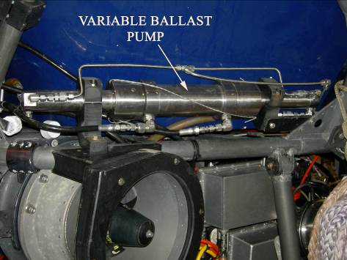
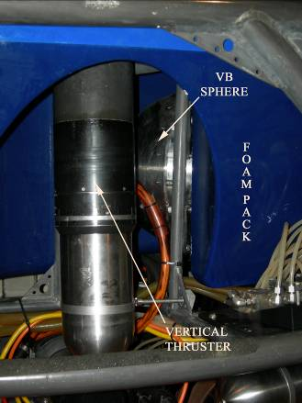
MBARI designed and developed a Variable Buoyancy (VB) control system for assisting in the operational control of Tiburon. The VB system is used primarily to keep the vehicle neutrally buoyant with a secondary function of assisting in the dynamically changing payload to assist in the deployment and recovery of science equipment during a dive without compromising ROV operations. The VB system is not intended to be used for vertical positioning. The VB system uses seawater as the medium for adjusting buoyancy. This is accomplished by opening a valve to flood the buoyancy spheres and lose buoyancy. Gaining buoyancy is accomplished by pumping the entrained seawater out of the spheres. The MBARI provided VB system will be incorporated into the design of the new vehicle. Voids in the syntactic foam module will be provided to accommodate the VB spheres (4) so as not to clutter the open frame of the vehicle. General specifications are listed below in Table 1:

Table 1
VB SYSTEM WEIGHTS (kg)
Device | Qty. | In air wt | Air total | In H20 wt. | H20 total
Pump | 1 | 13.18 | 13.18 | 9.17 | 9.17
Sphere (dry) | 4 | 17.39 | 69.56 | -3.68 | -14.72
Directional control valve | 1 | 1.36 | 1.36 | 1.36 | 1.36
Flood valve | 1 | 1.5 | 1.5 | 1.5 | 1.5
Plumbing | 1 | 6.82 | 6.82 | 5.97 | 5.97
Total: |  |  | 92.42 |  | 3.28

The Flood Valve is a specially designed solenoid valve that operates on 24 VDC @ 1A.
The VB system can be removed from Tiburon in the first quarter of 2007 and shipped to SMDH’s facility for integration.

Hydraulics
Hydraulics will be used for propulsion of the vehicle, compensation and the operation of hydraulic tools such as manipulators, vibracoring, dredge pump, cable laying tool sled, collection tools, etc. Refer to Appendix A - Hydraulic block diagram.

Vehicle Power
The vehicle shall be a 75 SHP, 3kV, 60Hz system. No umbilical cooling system shall be required.

Hydraulic System & Components
The hydraulic system will provide a flow up to 136 lpm at a nominal pressure of 210 bar. The system will include the following:
- Curvetech Hydraulic Power Unit (HPU) –75 shp, 3000vac, 4 pole motor with a 100cc/rev on demand pump. Temperature sensors for monitoring motor winding temperature.
- Curvetech Thruster Control Unit (iTCU) for operation of the thrusters and a spare valve to provide a high flow tooling port. Integral pump load valve, PRV, pressure, temperature, and moisture monitoring.
- Curvetech Intelligent 12 function valve pack (iHCU) for operation of MBARI core and mission specific equipment. The valve pack will be outfitted with (4) 8 lpm proportional valves which permit the remote control of flow for each valve and (8) 15 lpm solenoid valves. Equipped with moisture sensor.
- (4) Curvetech Hydraulic Pressure Compensators – 2.75L rolling diaphragm construction with analog linear level sensors for real time feedback.
- Curvetech Compensator Reservoirs – 10 L with integral 6.3 L compensator with level alarm and oil temperature sensor.
- (7) Curvetech HTE380BA-32 Thruster
- (1) Quark dual tool manifold for operation of the variable ballast system (up to ~30 lpm) and spare tooling port.
- Tool sled supply (up to ~30 lpm) with quick disconnects (type to be determined).
- Schilling T2 supply.
- High and Low pressure filters
SAE ports are preferred over BSPP where ever possible.

Thruster Placement & Capabilities

Thruster Placement
3 vertical thrusters will be positioned one port and one starboard about 25% back from the front of the vehicle and the third thruster mounted aft central. The MBARI tool sleds when mounted on the vehicle, will not provide an unobstructed path for the vertical down thrust, therefore, the verticals must be angled out sufficiently to provide a clear path for thrust. The horizontal thrusters will be in a conventional vectored configuration, but when performing scientific observations a special thrust control algorithm (Observation Mode) will be selected to minimize the disturbance of the viewing area from thruster wash. When in the Observation Mode, only the rear thrusters will perform fore/aft propulsion and only one set of fore aft thrusters will be used to move the ROV laterally. Details of the algorithm shall be agreed upon by SMDH and MBARI.

Thrust Capabilities
Power sharing algorithms will be developed to provide a mode of operation that gives priority to vertical or horizontal thrust depending upon the operation at hand. The horizontal thrusters will provide a minimum of 600kg of thrust in both fore/aft and lateral directions. The vertical thrusters will provide a minimum of 500 kg of vertical thrust. Maximum horizontal thrust assumes no vertical thrust and the maximum vertical thrust assumes no horizontal thrust.

Electrical / Optical
Refer to Appendix A – Electrical / Optical block diagram.

Electrical Assemblies
In addition to SMDH’s ground fault detection for the three and single phase AC systems, MBARI will require a ground fault detection scheme to detect and isolate faults on individual DC buses. The system must be able to detect current leakage to sea-water down to approximately 10 micro amps. GFM alarms will be able to be displayed on the GUI and thresholds will be field configurable. MBARI has designed and implemented a ground fault monitoring board to work with the WAGO 750-477 differential analog input module. The circuit is used to scan the high and low outputs of Vicor DC/DC converters that supply the various regulated DC voltages on the vehicle and detects leakage to sea-water. MBARI will provide it’s GFM board as describe above for the DC ground fault detection system.

MBARI is performing pressure tests on the MBARI GFM board, VICOR modules and WAGO 750-477 to see if they are suitable for operation in oil to a pressure of 6000 psi. Results of these tests will be provided to SMDH as soon as possible and prior to the preliminary design review. If any of the items fail testing, it will be SMDH’s responsibility to come up with an alternate method to meet the design requirement. SMDH will be responsible for the overall design of the DC power system.

Sub-Sea Control Pod
The Sub-Sea Control Pod will be a one atmosphere pressure vessel containing the MBARI provided FOCAL multiplexer, various DC supplies and110vac protection and switching. The Sub-Sea Control Pod will provide independent power switching, GFM and isolation for all connected instruments. In addition, mechanical isolation relays will be provided for all serial data lines to assist with fault detection. The Sub-Sea Control Pod will have environmental sensors for temperature, humidity and water intrusion feedback. 10 to 15% of the total internal volume of the control pod will be uncommitted space for future additions.

Connectors & Cables
Seacon MINI-CON series connectors will be used for all camera, data and fiber optic ports coming from the Sub-Sea Control Pod. MBARI will provide the cables for all of the MBARI associated equipment and the 4 pass fiber optic connector . SMDH will be responsible for all other connectors on the Sub-Sea Control Pod and any cables that provide connection to other SMDH equipment. Connector material shall be stainless steel type 316 equivalent or better.

FOCAL 903 Video/Data Multiplexer
MBARI will provide a FOCAL 903 for the core vehicle with the specifications listed below in Table 2. This system can be provided to SMDH at any time.

Table 2
FOCAL 903 Remote Configuration
Item |  | RS-232 | RS-485 | VIDEO | 100BT
VIB-TX, REMOTE VIDEO CARD |  |  |  | 4
VIB-TX-8, REMOTE VIDEO CARD (8X4) |  |  |  | 8
FMB (1310/1550)
EIB-10/100-1470 (1470/1490) |  |  |  |  | 1
8 CH 485, 907-485 |  |  | 8
8 CH 485, 907-485 |  |  | 8
DIB-232-16 |  | 16
CBP-241-HR-24V (CHASSIS)
Totals: |  | 16 | 16 | 12 | 1

Main Junction Box
The Main Junction box will be an oiled filled, pressure compensated enclosure which permits switching, control, isolation and ground fault monitoring of the core vehicle and MBARI provided instrumentation. In lieu of connectors for each device controlled from the main j-box, MBARI requests that cable compression gland fittings be used to reduce the number of possible connector failure points. MBARI has designed a fitting that has been in use on both of our vehicles for several years with success and can provide these to SMDH. 10-15% of the internal volume shall be uncommitted for future expansion.

Ground Fault Monitoring
If the required DC power for the instrumentation originates from the Main Junction Box, then ground fault monitoring (GFM) will be performed on both the high and low sides of the main DC power buses (24vdc and 12vdc) and the 110vac input.

Auxiliary Interface Junction Box
The Auxiliary (Science) Interface Junction box will be an oil filled, pressure compensated enclosure that provides a flexible interface for mission specific instrumentation. This junction box must provide a wide range of power buses and data protocols to meet the present and future needs of the science and engineering research and development activities. The control of the Auxiliary J-box will be handled through the core vehicle control software and MBARI must be able to easily configure the GUI to accommodate future analog and digital I/O requirements. The junction box will have a water intrusion detection circuit. Refer to Appendix A – Auxiliary (Science) Junction Box block diagram for more details.

Auxiliary Power Requirements
The total auxiliary power requirement for the vehicle is 3000 watts. The J-box will have inputs providing 110vac limited at 1000 watts and 240vdc limited at 2000 watts. These main inputs will have some sort of remote or thermal reset current limit device to provide overload protection. The 240vdc will provide power to Vicor DC/DC converters that provide regulated 48vdc @ 150watts, 24vdc @250w and 12vdc @ 150w. 10-15% of the internal volume shall be uncommitted for future expansion. The individual bus voltages will have switched (high and low isolated) outputs and power ratings as listed below in Table 3.

Table 3
Bus Voltage Outputs and Power Ratings
Bus | Number of Outputs | Switch Rating (watts)
110vac | 2 | 1000
240vdc | 2 | 1000
48vdc | 1 | 600
24vdc | 8 | 12
12vdc | 4 | 6

Auxiliary Data Requirements
MBARI will provide a Prizm Mini Mux II fiber optic video and data multiplexer to meet the Auxiliary J-box data requirements. A minimum of (2) RS-232 channels will have relays to allow for remote mechanical isolation of the data and ground lines from the multiplexer port. The MiniMux II is pressure tolerant to 4000 meters and has data I/O as listed below in Table 4. This unit can be supplied to SMDH at any time.

Table 4
PRIZM MINI MUX II Configuration
Item |  | RS-232 | RS-485 | VIDEO | 10BT
Mother board |  | 2 | 1 | 2
Ethernet daughter board |  | 4 |  |  | 1
Total: |  | 6 | 1 | 2 | 1

Connectors & Ports
The J-box will have a minimum of (12) ports for instrumentation, (1) RS-485 data port for control of the J-Box I/O, (1) fiber port for the MINI MUX and (1 to 2) ports for the incoming power buses. MBARI can provide in-house designed and fabricated gland fittings for the power and data ports.

Ground Fault Monitoring
Ground fault monitoring (GFM) will be performed on both the high and low sides of the Auxiliary J-box’s four main DC power buses (240vdc, 48vdc, 24vdc and 12vdc) and the 110vac input. Two spare GFM channels are required for future expansion.

Lighting Junction Box
The lighting junction box will be an oiled filled, pressure compensated enclosure that supports the operation of (6) DeepSea Power & Light, 400 watt SeaArc 2 HMI/MSR lamps and (4) 250 watt incandescent lights provided by MBARI. Three dual ballasts which are housed in 1 atm housing will be provided for the operation of the SeaArc HMI lights. The junction box will provide on/off control of all the light circuits and dimming capability for the incandescent lights. In addition, the Lighting Junction box will provide ground fault monitoring for each light circuit and the capability to isolate the fault. The junction box will have a water intrusion detection circuit.

MBARI can provide compression gland fittings for the Junction box and all the cables required for the operation of the lights.

Umbilical Termination / Transformer Junction Box
The Umbilical Termination / Transformer Junction box will be an oiled filled, pressure compensated enclosure. The 10.5 kVA instrument power transformers will be housed in the Umbilical Termination J-Box. The j-box shall provide an easy method to disconnect the umbilical from the ROV (details to be agreed between both parties during the preliminary design review). Burton HV connectors will be used to distribute the HPU and ROV instrument power. A Seacon MINP-4FO-FCRL-RL-TI, 4 pass single mode fiber connector and MINP-4FO-CCPL-TI cable will be provided by MBARI for connection of the fibers to the sub-sea control pod. In addition, MBARI will also provide a Seacon MINF-1FOSM-BCRL-TI connector and associated cable for direct connection of the HDTV camera. The junction box will have a water intrusion detection circuit.

Core Instruments (MBARI Provided)
Tiburon II core instrumentation and associated cables as listed below will be provided by MBARI. Since the equipment is being transferred from the original Tiburon to Tiburon II and Tiburon will remain operational until May of 2008, it won’t be possible to provide all of this equipment for test and integration at SMDH’s facility.

Navigation
Table 5
NAVIGATION SYSTEMS
Device | 232 | 485 | 422 | TTL | 10BT | 100BT | Vid | 110vac | 240v | 48v | 24v | 12v | 5v | Watts
usbl |  |  |  | 1 |  |  |  |  |  |  | 1 |  |  | 30
gyro | 1 |  |  |  |  |  |  |  |  |  | 1 |  |  | 12
sonar | 1 |  |  |  |  |  |  |  |  |  | 1 |  |  | 24
homer | 1 |  |  |  |  |  |  |  |  |  | 1 |  |  | 12
dvl | 1 |  |  |  |  |  |  |  |  | 1 |  |  |  | 5
depth | 1 |  |  |  |  |  |  |  |  |  | 1 |  |  | 0.5
altimeter | 1 |  |  |  |  |  |  |  |  |  | 1 |  |  | 6
Total: | 6 | 0 | 0 | 1 | 0 | 0 | 0 | 0 | 0 | 1 | 6 | 0 | 0 | 89.5

Table 6
NAVIGATION WEIGHTS (kg)
Device | Qty. | In air wt | Air total | In H20 wt. | H20 total
DVL | 1 | 18 | 18 | 12.1 | 12.1
Octans | 1 | 18 | 18 | 9 | 9
Altimeter | 1 | 5 | 5 | 2.7 | 2.7
Depth sensor | 1 | 1.33 | 1.33 | 1.33 | 1.33
Homer | 1 | 2.1 | 2.1 | 1.3 | 1.3
Responder | 1 | 4.5 | 4.5 | 2.5 | 2.5
VHF radio beacon | 1 | 1.6 | 1.6 | 0.95 | 0.95
Xenon strobe | 1 | 1.7 | 1.7 | 1 | 1
Sonar | 1 | 6.4 | 6.4 | 3.3 | 3.3
Total: |  |  | 58.63 |  | 34.18

Cameras & Viewing
Table 7
CAMERA & VIEWING
Device | 232 | 485 | 422 | TTL | 10BT | 100BT | Vid | 110vac | 240v | 48v | 24v | 12v | 5v | Watts
HDTV |  |  |  |  |  |  |  |  |  |  | 1 |  |  | 53
pilots cam | 1 |  |  |  |  |  | 3 |  |  |  |  | 1 |  | 6
digital still |  | 1 |  |  |  |  | 1 |  |  |  |  | 1 |  | 6
digital strobe |  |  |  |  |  |  |  |  |  |  |  |  | 1 | 100
down cam | 1 |  |  |  |  |  | 1 |  |  |  |  | 1 |  | 6
umbilical cam |  |  |  |  |  |  | 1 |  |  |  | 1 |  |  | 5
aux cameras |  |  |  |  |  |  | 4 |  |  |  | 4 |  |  | 20
pan & tilts |  | 1 |  |  |  |  |  |  |  |  | 4 |  |  | 75
Total: | 2 | 2 | 0 | 0 | 0 | 0 | 10 | 0 | 0 | 0 | 10 | 3 | 1 | 271

Table 8
CAMERA AND VIEWING WEIGHTS (kg)
Device | Qty. | In air wt | Air total | In H20 wt. | H20 total
HDTV | 1 | 36.7 | 36.7 | 16.8 | 16.8
Pilot camera | 1 | 5.67 | 5.67 | 2.95 | 2.95
Still camera | 1 | 5.67 | 5.67 | 2.95 | 2.95
Strobe | 1 | 5.67 | 5.67 | 2.95 | 2.95
Internal P&T camera | 1 | 11.8 | 11.8 | 6.4 | 6.4
Aux camera | 4 | 0.4 | 1.6 | 0.28 | 1.12
PT-10 | 2 | 4.4 | 8.8 | 4.2 | 8.4
PT-25 | 2 | 9.8 | 19.6 | 5.7 | 11.4
HMI Ballast | 3 | 15.56 | 46.68 | 9.29 | 27.87
HMI Light | 6 | 3.67 | 22.02 | 1.8 | 10.8
Incandescent Light | 4 | 1.25 | 5 | 0.57 | 2.28
Total: |  |  | 169.21 |  | 93.92
TOOL SYSTEMS
Device | 232 | 485 | 422 | TTL | 10BT | 100BT | Vid | 110vac | 240v | 48v | 24v | 12v | 5v | Watts
ctd | 1 |  |  |  |  |  |  |  |  |  | 1 |  |  | 5
toolsled intfc | 1 |  |  |  |  |  | 2 |  | 1 | 1 |  |  |  | 1200
vb valve |  |  |  |  |  |  |  |  |  |  | 1 |  |  | 50
modem | 1 |  |  |  |  |  |  |  |  |  | 1 |  |  | 30
schilling | 1 |  |  |  |  |  |  |  |  | 1 |  |  |  | 72
Total: | 4 | 0 | 0 | 0 | 0 | 0 | 2 | 0 | 1 | 2 | 3 | 0 | 0 | 1357

Science Tools
Table 9

Table 10
TOOL WEIGHTS (kg)
Device | Qty. | In air wt | Air total | In H20 wt. | H20 total
Schilling | 1 | 90.9 | 90.9 |  | 0
CTD | 1 | 13.7 | 13.7 | 8.6 | 8.6
Clump weight latch | 1 | 6.81 | 6.81 | 5.75 | 5.75
Acoustic modem | 1 | 2.75 | 2.75 | 2.1 | 2.1
Emergency cutter | 1 | 2.27 | 2.27 | 1.81 | 1.81
Tool Sled | 1 | 613.81 | 613.81 | 235.172 | 235.172
Total: |  |  | 730.24 |  | 253.432

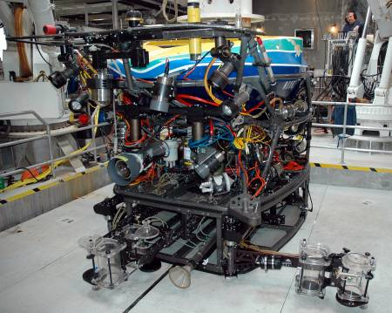
Tool Sleds
In addition to the core vehicle, MBARI has individual tool sled packages designed for specific science missions that are always coupled to the vehicle. MBARI will design and build the tool sleds to bolt on to the bottom of the core vehicle. MBARI will provide the tool sled hardware (guide cones) required for the attachment of the sleds. The weight of each Tool sled will not exceed 613 kg. in air and 236 kg. in water. The 273 kg payload requirement is in addition to the weight of the tool sled. The Kraft manipulator is part of the tool sled and therefore the weight is included in the tool sled total weight. Interconnect requirements are as follows:

- RS-232 data channel for operation of the tool sled controller.
- RS-422 data channel for operation of the Kraft manipulator.
- 48 vdc @ 5 amps (unregulated) for tool sled controller power
- 240 vdc @ 4 amps (unregulated) for tool sled tools.
- Two video channels for tool sled cameras.
- Hydraulics requirement, >= 8 gpm @ 3000 psi. (quick disconnects TBD)

Surface Control Equipment and Power Distribution
Refer to Appendix A – Surface Block Diagram for MBARI’s interpretation of the configuration of the top side hardware.

Control Room
The panoramic view of Tiburon’s control room is shown below. Starting at the far left is the Co-pilots station. The co-pilot is responsible for manipulator, sonar and other instrument operations, umbilical haul in / pay out and alarm & data monitoring. The pilots station is next and the then the chief scientist and co-scientist. MBARI will utilize as much of the control room equipment as possible. MBARI shall provide a drawing showing available rack / panel space for SMDH hardware.

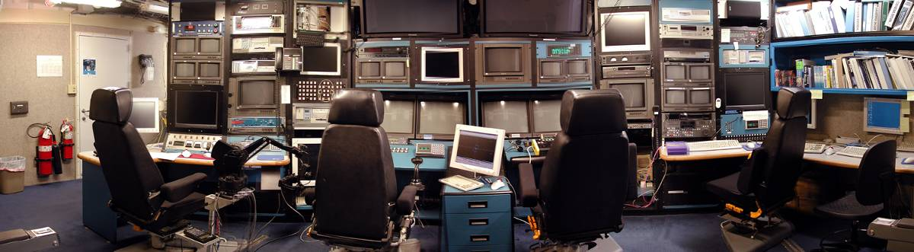

Control System
The Control system must provide interfaces that are designed to be flexible and configurable to allow easy integration of third party systems into the control system.

Software

Redundant Device Selection
The system shall provide a method for selection of primary and secondary instruments for redundant devices to provide input for control or display of information. An example would be the option to select the Altimeter or DVL for input into the Auto-Altitude function or display onto the GUI. Other redundant devices would include heading sensors.

Graphical User Interface (GUI)
The system must provide at a minimum, 3 work stations with Graphical User Interfaces (GUI) for control and monitoring of vehicle systems. The individual GUI screen layouts must be able to be expanded or modified by MBARI when required. The GUI’s must support touch screens. An example of MBARI required graphical, in addition to numeric displays are as follows:
- Graphic display of vehicle thrusters and level of thrust commands
- Pitch & Roll (some type of artificial horizon)
- Pan & Tilt feedback (x, y graph type display)
- Turns counter history with set point (compass rose showing set point and vehicle heading history).
Numeric displays are required for the following MBARI items:
- HDTV camera lens feedback (focus, zoom and Iris)
- Umbilical out (Delta)
A list of standard GUI items will be finalized during the preliminary design review.

Joy Stick Integration
Tiburon’s existing joysticks shall be incorporated into the new vehicle system. MBARI can provide Tiburon’s spare joysticks to SMDH for integration and testing when required.
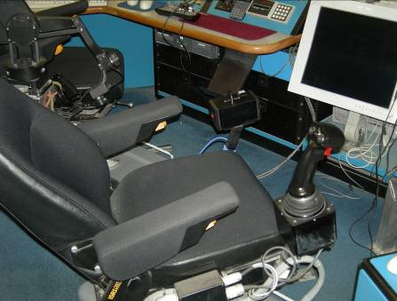
Some operational tasks require the ROV to track very delicate animals in the mid-water column. MBARI has utilized the capability to reduce the thruster output by scaling the joystick command output to allow for finer control of the vehicle during these maneuvers. MBARI will require this capability to be incorporated into the new vehicle.

During sample collection activities, the pilot is sometimes required to precisely position the vehicle to place a specimen in a sampler and then quickly close the door to that sampler to capture the animal. The pilot can’t afford to let go of the joystick to activate the hydraulic valve through the GUI, so we currently provide the capability to map a particular valve in advance to a button on the joystick. This allows the pilot to never have to take his eyes off the screen nor hands off the joystick. A summary of the integration of control system items with the joy sticks are as follows:
- Button on main joystick for enable/disable of MBARI observation mode. When the observation mode is enabled by the joy stick, the joy stick command is scaled to the percentage that is selected on the GUI. When the observation mode is disabled, the joy stick command is set back to 100%
- (2) Buttons on vertical joystick for enable/disable of vertical and main joy stick lock. The vertical or main joy stick command value is locked, when the joystick lock button is activated. After the joystick value is set and the input from the joystick is returned to zero, if a new joystick value of 50% or greater is detected, the joystick lock is disabled. The joystick lock is also disabled when the button is pressed again after lock condition is set.
- Switch on main joystick for operation of mapped valve from GUI.
- Trigger on main joystick for enable/disable of AutoROV Heading function.

The specifications for the joy sticks are as follows:
- Vertical axis: (Measurement Systems, Inc. P/N = 523U).
- Horizontal axis: (Measurement Systems, Inc. P/N = 547 – 3 axis)

Focal Video Switcher
The MBARI provided Focal 903 multiplexer has one 8x4 video card (8 switched to 4) which can take 8 input channels of video and via the FOCAL console, select 4 channels for output. The control of the video switcher is performed through the FOCAL console mux by providing +5vdc to 4 channels to select Video input A or B. The control of the FOCAL video switcher shall be incorporated in to the control system and the switcher operated through the GUI.

Advance Navigation Controls (MBARI R&D)
Tiburon currently supports an interface that allows an external controller to receive real-time ROV telemetry. The interface also executes ROV thrust commands sent by the external controller. The ROV telemetry data and thrust commands are sent and received by the Tiburon control system over a serial port. The Tiburon control system sums the received thrust commands with the pilot joystick commands to allow the pilot to assist or disturb the external controller. The Tiburon control system also monitors a digital input, the closure of which disables the external controller interface. An emergency cutoff button is attached to this digital input to allow the pilot to immediately disable external control.

Tiburon II shall support a similar advanced controls interface to allow for the control of the ROV by an external controller. The data in table 11 shall be sent to the advanced controls interface from the Main Control Computer via a serial connection. The data is required to have a latency of no more than 20 ms. The data string shall be sufficiently flexible as to allow for the addition of future data items with minimal configuration changes. The format of the data string as well as the serial port configuration shall be agreed upon by MBARI and SMDH.

The Main Control Computer shall also receive thrust commands as shown in table 12 from the advanced controls interface and sum those commands with the pilot commands in real-time. The format of the command string shall be agreed upon by MBARI and SMD.

Table 11
SMD control system data to be sent to Advanced Controls Interface
data | type | units
Heading | float | degrees
Pitch | float | degrees
Roll | float | degrees
Depth | float | meters
Altitude | float | meters
AutoHead state | boolean | N/A
Emergency Cutoff state | boolean | N/A
Observation Mode state | boolean | N/A
Bypass Mode state | boolean | N/A
Heading Thrust | float | TBD
Lateral Thrust | float | TBD
Axial Thrust | float | TBD
Vertical Thrust | float | TBD

Table 12
Advanced Controls Interface commands sent to SMD control system
data | type | units
Heading Thrust | float | TBD
Lateral Thrust | float | TBD
Axial Thrust | float | TBD
Vertical Thurst | float | TBD

Navigation Processor
The MBARI Navigation Processor or NavProc is a computer that interfaces various ship and ROV navigations systems together. NavProc can send and receive data over serial ports or via a proprietary publish/subscribe data distribution system know as Datamanager. Once data has been published to Datamanager any other Datamanager node on the network can subscribe to that piece of data.

The data in Table 13 shall be sent to the NavProc computer from the Main Control Computer via a serial connection. The data is required to have a latency of no more than 100 ms. The data string shall be sufficiently flexible as to allow for the addition of future data items with minimal configuration changes. The format of the data string as well as the serial port configuration shall be agreed upon by MBARI and SMD.

The Main Control Computer shall also receive MBARI system variables as shown in table 14 to be displayed on the GUI. The format of the data string shall be agreed upon by MBARI and SMD.

Table 13
SMD control system data to be sent to NavProc
data | type | units
Vehicle in water | boolean | N/A
Heading | float | degrees
Pitch | float | degrees
Roll | float | degrees
Altitude | float | meters
Depth | float | meters

Table 14
NavProc System Data sent to SMD control system
data | type | units
Umbilical payout | float | meters
Umbilical delta | float | meters
HDTV humidity | float | percentage
HDTV leak detect | boolean | N/A
HDTV zoom position | float | TBD
HDTV focus position | float | TBD
HDTV iris position | float | TBD

Video Overlay
Tiburon II will use the Options VIGRA video overlay to display vehicle information on the pilots video display. The VIGRA overlay system can receive this data via a serial or TCP connection.

The data in table 15 shall be sent to the VIGRA overlay unit from the Main Control Computer via a serial or TCP connection. The data is required to have a latency of no more than 100 ms. The data string shall be sufficiently flexible as to allow for the addition of future data items with minimal configuration changes. The format of the data string as well as the serial port configuration shall be agreed upon by MBARI and SMD.

Table 15
SMD control system data to be sent to VIGRA overlay Unit
data | type | units
Heading | float | degrees
Hydraulic Pressure | float | PSI
Depth | float | meters
AutoHead state | boolean | N/A
Altitude | float | meters
Divenumber | integer | N/A
Date | string | date string

Integrated Viewing System
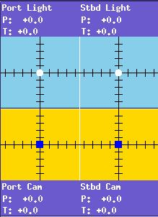
Tiburon currently uses an integrated viewing system or IView to control the camera and light pan and tilts. This system allows the control of the cameras to be shared between the pilots and scientists. The IView system also supports special viewing modes that have proven useful in different observation scenarios.

Though the pan and tilts will be controlled via the IView controller it is necessary to have the pan and tilt positions displayed both graphically and numerically on the pilot GUI for diagnostic purposes. In order to display the pan and tilt positions on the pilot GUI the Main Control Computer shall receive pan and tilt data as shown in table 16 via a serial string. The format of the serial string shall be agreed upon by MBARI and SMD. The data shall be displayed on the pilot GUI both graphically and numerically in a similar fashion as shown in figure to the right. The layout of the pan and tilt portion of the GUI shall be agreed upon by MBARI and SMD.

Table 16
IView pan and tilt data sent to SMD control system
data | type | units
Port light pan | float | degrees
Port light tilt | float | degrees
Starboard light pan | float | degrees
Starboard light tilt | float | degrees
Port camera pan | float | degrees
Port camera tilt | float | degrees
Starboard camera pan | float | degrees
Starboard camera tilt | float | degrees

Control System Hardware

Top Side Hardware
All SMDH control system hardware such as PC’s, monitors, etc. must run on 110VAC/60Hz.

Sub Sea Hardware
SMDH will provide a Tritech IGC gyro compass and IFG fiber optic gyro as backup for MBARI’s Octans 6000 FOG.

Video Equipment
MBARI will provide all the associated equipment such as monitors, recording decks, video overlay, control room video switcher, video distribution and conversion equipment.

MBARI Core Instrumentation
MBARI will provide all the associated equipment required to support MBARI core instrumentation such as PC’s, cabling and deck boxes.

ROV Auto Functions
The vehicle will have the following suite of automatic control routines:
- Auto Depth. ROV automatically remains at a constant water depth (+/- .02% at 4000m). This function will incorporate a nudge feature to modify the current set point. MBARI will provide a Digiquartz depth sensor with .01% resolution as the vehicle’s depth sensor.
- Auto Altitude. ROV automatically remains at constant distance from the seabed. Feedback will be provided from an altimeter or DVL. This function will incorporate a nudge feature to modify the current set point. A provision shall be provided to enter an offset value for altimeter data to compensate for the location of the altimeter or DVL on the vehicle. MBARI will provide a Simrad model 1007 altimeter and a RDI 1.2 mHz “Workhorse Navigator” DVL as the altimeter sensors.
- Auto Heading. ROV automatically maintains a constant heading (+/- 2 deg.?). Feedback will be provided by the vehicle’s FOG. This function will incorporate a nudge feature to modify the current set point. MBARI will provide an Octans 6000 FOG as the primary heading sensor.
- Auto Hold. ROV maintains current position in X and Y. Feedback will be provided by the DVL when bottom lock is available and by the Sonardyne fusion system when bottom lock is not available. This function will incorporate a nudge feature to modify the current set point.
- Auto Step. ROV moves a user input distance in X and/or Y direction. Feedback will be provided by the DVL. This function will incorporate a nudge feature to modify the current set point.
- Auto Home. ROV automatically returns to a preset “home” position. Feedback will be provided by the DVL.
- Auto Track. ROV automatically follows pipe / cable using TSS or equivalent tracking device. SMDH will provide description of input protocol for Auto Track.
- Auto Route. ROV automatically follows a pre-programmed route of waypoints.
- Thruster Plane Priority. Vertical or horizontal thrusters are selected to take priority.
- Control Reversal. Joystick commands are reversed for moon pool launch & recovery operations.
- Lost Thruster Compensation. If a thruster fails, it can be isolated and the control system will modify control algorithms to compensate.
- Pitch, Roll, Horizontal and Vertical Trims.

As a goal, Auto Altitude, Hold, Step and Home shall move or maintain the position of the vehicle to better than +/-10 cm in all 3 dimensions (vertical, fore/aft, athwarthsips). As a minimum, Auto functions shall move or maintain the position of the vehicle to better than 1 meter in all 3 dimensions (vertical, fore/aft, athwarthsips ) If the 10 cm goal can not be achieved with the standard SMD system, SMD shall provide the ability for a MBARI developed servo loop to be used in place of the standard SMD control loop. The implementation details of a MBARI developed control loop will be agreed upon by MBARI and SMD, this capability may be included in the existing MBARI "advanced navigation" hooks requirement.

The tolerances specified above for the auto functions are for a controlled environment such as a test tank and the auto function accuracy will be limited by the resolution and quality of the sensors data used for the test. Procedures for verification and testing will be agreed upon by MBARI and SMDH during the initial kick off meeting.

Deployment System

Umbilical Handling System (UHS)
The UHS is designed to deploy, tend, recover and store 5000 meters of 0.68 inch diameter armored umbilical. The ROV & UHS consists of a traction winch, storage drum, motion-compensated crane and ROV launch & recovery crane. The system was designed and built by Dynacon Inc.

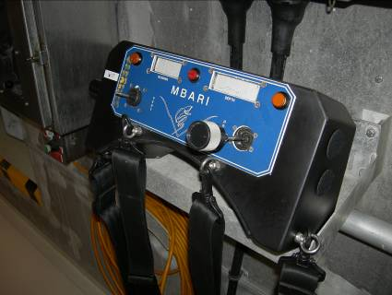
Remote Belly Pack
A belly pack is required for control of the vehicle during launch and recovery of the vehicle as it transits through the moon pool interface. SMDH shall provide a new belly pack with joysticks for thruster control, a display for depth and the capability to enable/disable auto heading. The Belly Pack shall be splash proof. Figure 3 shows the Tiburon Belly Pack located in the Moon Pool area.

Documentation
A complete documentation set for the operation and maintenance of the ROV system will be provided, comprising of the following:
- Equipment specifications and description
- Equipment operating procedures
- Maintenance procedures
- Relevant assembly drawings
- Electrical and hydraulic circuit diagrams
- Parts lists
- Software description and user interface instructions
- Proprietary equipment manuals
- Equipment interface documents
Three paper copies of the above documentation will be provided along with three electronic copies stored in Adobe Acrobat format on CD. Electrical and hydraulic circuit diagrams will be provided as a separate document in electronic DXF or DWG format to allow MBARI to update the documents as hardware is changed or upgraded.

Spares
A final list of spares shall be agreed between both parties after the completion of CDR.

Design Review and Acceptance Testing
As part of the design process, MBARI will participate in a minimum of a preliminary and critical design review at the offices of SMDH. MBARI will witness the FAT and will sign off against each of the agreed tests during the FAT. FAT test will be agreed upon by SMDH and MBARI during the PDR.

MBARI Project Team Contact Information

Program Manager: Dale Graves, Ext. 1913 grda@mbari.org
Program/Software Engineer: Mike Risi 1834 mrisi@mbari.org
Program Scientist: Jim Barry 1726 barry@mbari.org
Mechanical Engineer: Brett Hobson 1941 hobson@mbari.org
Mechanical Engineer: Mark Brown 1939 mob@mbari.org
Appendix A

Block Diagrams

Electrical / Optical Block Diagram
Surface Block Diagram
Hydraulic Block Diagram
Auxiliary (Science) Interface J-Box Block Diagram
ROV Power Distribution Block Diagram
TRELLEBORG TG-28A Syntactic Foam

