Ventana Control System Upgrade
Ventana is a work class remotely operated vehicle (ROV) that has been enhanced to conduct scientific and engineering research studies in the ocean. The current control system is a Linux based system that utilizes as many of the existing peripherals both on the surface and subsea as is possible. It was last upgraded in 2002. Maintaining the existing system becomes more and more difficult as components age and become obsolete or unsupported. This proposal would seek to follow that same scenario to the greatest extent possible and only replace items that are incompatible with new hardware/software.
The vehicles current capabilities include:
40hp propulsion system
1850m depth rating
900lb fixed payload system which incorporates a 300lb variable ballast system
Power
Lighting: 3.4 kW
Hotel: 1.1 kW
Science: 3.5 kW
Ventana also has multiple tool-sleds that are dedicated to various tasks and that can be reconfigured offline to facilitate quick turnaround between different users and research programs. As part of this upgrade hooks should be established to allow control of these three tool-sleds. The control interface and the subsea controllers would become “nodes” on the new control system rather than individual software packages/controllers.

In the past an upgrade has been a complete rebuild of the subsea control housing (replaced with new) and a replacement of the control room computer hardware. The peripherals both subsea and in the control room will be cross-decked where possible. The requirements for this control upgrade are; replacement of all control room electronics (computer, interface cards (analog IO, digital IO, multi serial input, multi-display controller), touch screens, touch pads and keyboard, (signal interface tray has traditionally been replaced but retasking is preferred). The existing pilot chair and interface could remain as pure analog devices or preferably become a node (micro) to enhance the system with more capability and simplify the wiring/configuration. The existing subsea “Gespac” housing would be replaced with new electronic hardware (Wago), new penetrator end bell, new connectors and new software to run on the new hardware platform. Replacing the subsea electronics with smart IO (Wago, in use throughout the institute) and close the control loops on the surface make very good sense. There is a high level of knowledge at the institute with this product and spares could be common with other projects at MBARI. High speed telemetry systems make this possible. The components required for control are much less costly. Current ground fault detection circuits and water/moisture detection either need to be cross decked or another solution needs to be found. These could be existing in house products, new build or possibly third party.

Current features of the control system include:
Two touch screen monitors for control input and informational/status/alarm displays (4ch video card)
Video overlay output (3rd ch of 4ch video card)
Touchpad/mouse input (PS2)
Keyboard input (PS2)
32 analog inputs (2x 16ch ADC cards)
96 ch digital IO
2 native serial ports (Com1-2)
8 port Rocket port serial card (Com 3-10)
The current configuration takes input from the Pilot Station through a hardwired interface (not a comms link It would be a relatively simple task to convert this to a micro or “wago” type modules). These signals include:
Joystick analogs (6)
For/Aft cmd
Turns cmd
Lat cmd
Main Camera Pan cmd
Main Camera Tilt cmd
Main Camera Shld cmd
Joystick digitals (5)
Trigger open/close
Rocker deploy/retract
Still camera trigger
Pilot Left Pedestal Analogs (4)
Vertical cmd
Variable Buoyancy (VB) pump cmd
Spare 3000psi servo cmd
Spare analog cmd
Pilot Left Pedestal Digital (13)
Auto depth- initiates a servo loop around the current depth reading
Auto altitude- (cross linked with auto depth to prevent simultaneous activation) initiates servo loop around the current altitude.
Cruise- (causes a write of current joystick thrust commands to be written to the output and held, any additional command input from joystick is additive)
Auto Heading- initiates a servo loop around the current heading value.
Bypass/Bypass Interlock (2)- commands system to initiate a low pressure mode of operation usually around 600-800psi hydraulic pressure. Interlock prevents the ROV Motor from starting in High Pressure/loaded.
Jog up/Jog down- jogs the Auto depth/altitude set point
Upper Cam pan left/right
Upper Cam tilt up/down
Spare digital input
DTEC tool enable (output from controller to pedestal)
DTEC D enable. (output from controller to pedestal)
The following inputs connect to a software program via DGH modules that communicates to Insite and MBARI camera packages. In addition to taking input from the Pilot’s station the software sends setup information, WB cmds, BlkB cmds, auto focus, gain etc, a complete listing of the functionality will follow.
Insite Camera Select (1 of 8 inputs)
Camera Focus Near
Camera Focus Far
Camera Zoom In
Camera Zoom Wide (total 12 dig inputs)

Remote Valve pack controller (18) (would probably be reassigned to a rate manipulator)
VALVE PACK #3 VLV 1A
VALVE PACK #3 VLV 1B
VALVE PACK #3 VLV 2A
VALVE PACK #3 VLV 2B
VALVE PACK #3 VLV 3A
VALVE PACK #3 VLV 3B
VALVE PACK #3 VLV 4A
VALVE PACK #3 VLV 4B
VALVE PACK #3 VLV 5A
VALVE PACK #3 VLV 5B
VALVE PACK #3 VLV 6A
VALVE PACK #3 VLV 6B
VALVE PACK #3 VLV 7A
VALVE PACK #3 VLV 7B
VALVE PACK #3 VLV 8A
VALVE PACK #3 VLV 8B
Swing-arm Brake On/Off (2)
Pilot Foot Pedals (“ORed” with Upper Pan and tilt commands)
ISE 7 function Manipulator Master
SWING 0-5vdc analog (5) connected to PID control loops to control
SHOULDER “ motion of the subsea slave which provides
ELBOW “ position feedback via sin/cos sensors. Out-
PITCH “ put of PID drives jet pipe servo valves via
YAW “ DAC (+/- 5vdc)
Jaw Open Dig input (5)
Jaw Close
Wrist Rotate CW
Wrist Rotate CCW
Arm Enable
Three Motor Starter ccts that are interlocked with each other and the ROV Motor is also interlocked with the Bypass Interlock cmd above, see below for more details.

The remainder of the surface input commands is done through the touch screen controller or mouse/touchpad device. The individual hardware items (digital/analogs) are map-able to the subsea electronics using built in menus. The software “widgets” buttons, slide bars, bar graphs compass rose etc are map-able to the GUI and to an output. The hardware inputs from the ROV are map-able to GUI widgets or output hardware (digitals). This is a very useful tool when needing to make changes to the system either to add new functionality or when changes are required because something has failed.

Each analog input from the subsea controller or from the console controls has the ability to be scaled into user friendly values ie: feedback (digitized hall effects Sin/Cos) from the Pan&Tilts can be converted into absolute angles then off set to reflect the real values. The same is true for surface analog inputs (potentiometers) from the joystick or pilot panel. These can be scaled and biased to show real voltage values or % or angles (manipulator).

Power Interface Station
Main Console On/Off (Motor Starter style)
ROV Hotel On/Off (Motor Starter Style interlocked with above)
ROV Motor On/Off (Motor Starter Style interlocked with above and the Bypass switch on the console, prevents hydraulics from being started in high pressure mode.)
Console Ground Fault Monitor (This monitor is separate from the systems used subsea and is interlocked with the three motor starter ccts above. Ie: if a ground fault occurs on any of the primary ROV power systems, the associated cct is interrupted via a dry contact relay and the cct is shut off.)
Main 480vac Input Power (not interlocked, ship power system is lossy)
Console 120vac
ROV Hotel Power 2300vac
ROV Motor Power 2300vac 3ph
Ground Fault Analog Panel Meter (ADC to GUI, displayed as 4 separate values)
Ground Fault Analog Panel Meter Channel Selector Switch (2 Dig outputs to select analog channel ie: 00 = 110 VAC gndflt
01 = 480 VAC gndflt
10 = 2300 ROV Hotel gndflt
11 = 2300 ROV Hydraulic gndflt)
Ground Fault Acknowledge
Ground Fault Reset
Ground Fault Alarm Silence
Ground Fault Sonic Alarm

Other features of the control system include:
Tether management system data input, speed, tension cable out. (serial input)
This is an informational data and is displayed on the user interface as a block of data in text boxes.
Ship’s gyro input (required for turns counter) (serial input)
This data is used to show ship heading to the ROV pilots and also used to calculate turns for the ship and ROV.
Logging output, (11 integer values, 11 float values see IO listing for details) this is serial data to the MBARI data logging system PL Logger.
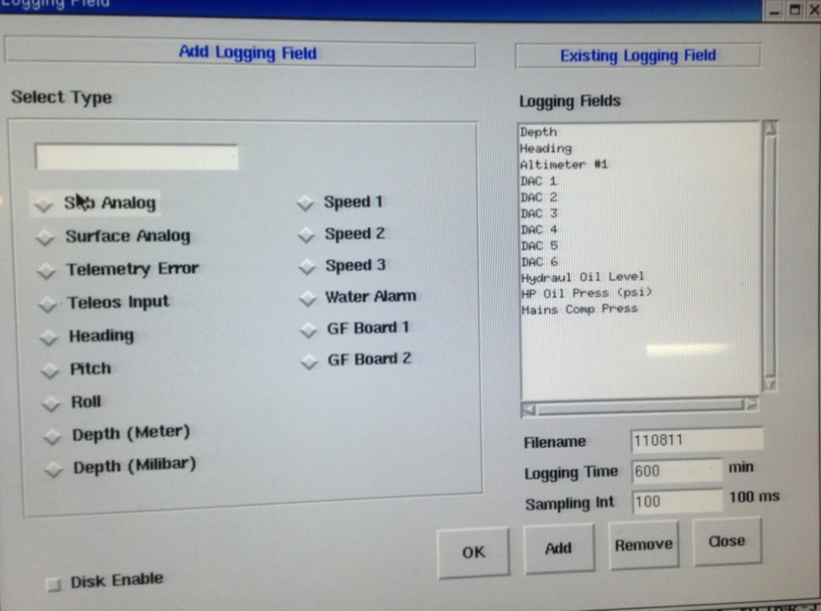
Disk logging (all data used by the control system can be logged to disk, this is selectable via a GUI window) the files are logged to the local disk as CSV files. As shown below, predefined items (teloeos, Heading pitch etc) and user selectable items can be logged. The frequency, duration and filename are settable by the user.

“Teleos” Data (mis-labeled should be “Stanford Control Telemetry”. This serial string exports vehicle status, see IO listing for details. This string also inputs thruster command data from Stanford which is added to the thrust commands and is enabled via pilot input on the touch screen. This is one form of Station Keeping it utilizes DVL input and Vision Input (Stanford). It is planned to integrate this feature into the control system rather than an external device with communications.

Auto functions:
Auto heading: On activation takes the current compass/gyro input as a set point and holds the vehicle on that heading. “jogging” of the heading set point is achieved by applying a “turns” command to the joystick while in auto.
Auto Depth: On activation takes the current depth reading as a set point and holds the vehicle at that depth. Adjusting or “jogging” the set point is achieved through digital inputs on the pilots station.
Auto Altitutde: On activation takes the current altimeter value as a set point and holds the vehicle at that altitude. Jogging the set point for this function utilizes the same digital inputs as the Depth function. The depth and altitude functions are mutually exclusive via hardware interlock on the pilots console.
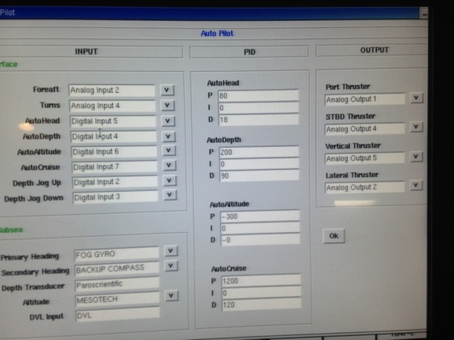
Cruise: Holds the current value of thrust commands as a set point. Allows additive commands from the pilot joystick (fore/aft, lateral port/stbd). If any of the auto function are engaged the thrust command comes from the appropriate loop and any noise or offset from the pilot’s joystick is ignored.

Each of the auto functions has an associated PID loop that allows the operator to select an input and tune the variables that control the performance. This is accomplished through menu pages on the interface. Analog output driving each of the four thruster groups is also selectable. The sensor used for loop control is also selectable. This is to allow for failure of a given sensor.

Toolsled “Nodes”

Benthic (Kevins Ctr)
Touch Screen/mouse interface, no other Control Room hardware
Serial data to dedicated uCtr
4 x analog outputs
High Flow Suction Sampler (minarek pwr controller) 0-10vdc
DSSI Pump (SemiPower Block) 0-10vdc
Peristaltic sampler (minarek pwr controller) 0-10vdc
Spare
6 digital outputs
Toolsled power 110/220 VAC (leitch relay)
Tool-sled Cameras (2x 12vdc)
DSSI reverse (linked to DSSI analog, speed set to zero prior to reversing)
Index Fwd
Index Rev
Index stop
1 x digital input
Index read (auto stop of index sampler, reed switch closure)
Mid-Water DGH Controller
Hardware interface to Pilots controls, Joystick
Rocker (tool deploy/retract)
Trigger (open/close)
Trigger Selected (Requires digital input to determine which “node”, pilot or tool- sled accepts the command, mutually exclusive. 5 X digital input
Hardware interface to science control box, suction sampler
HFSS/DSSI Speed 1 X analog input
HFSS Carousel Fwd
HFSS Carousel Rev
HFSS Carousel Stop 3 x digital input
TouchScreen/GUI interface
Valve select
D5 – D8 open
D5 – D8 close
Port Swing Deploy
Port Swing Retract
Nozzle Deploy
Nozzle Retract
Spare Valve A
Spare Valve B 16 x digital output
Port Light on/off
Port Light pan port
Port Light pan stbd
Port Light tilt up
Port Light tilt down
Stbd Light on/off
Stbd Light pan port
Stbd Light pan stbd
Stbd Light tilt up
Stbd Light tilt down 10 X digital output (AC)
Science 12vdc on/off
Science 24vdc on/off
Camera One on/off
Camera Two on/off
Ground fault Ch select bit 1
Ground fault Ch select bit 2
HFSS Enable
DSSI Enable
Toosled 120 VAC On/Off (HFSS)
Toolsled 240 On/Off (DSSI) 10 X digital output (DC)
Water Alarm ch 1
Water Alarm ch 2
Water Alarm ch 3
Water Alarm ch 4
HFSS Index read 5 X digital input

Manipulator Control
Ventana incorporates a seven (7) function manipulator that is integrated into the control system. It consists of the master controller on the surface, the slave and a hydraulic servo valve pack subsea. It also utilizes two solenoid valves from the vehicle. Analog (potentiometer) set point values are read by the control system and fed in to the software components that allow scale and biasing. The values generated reflect the range of motion of the master in real degrees. The angles are then fed to a software component that does PID control as in the auto functions. Feedback from the manipulator is in the form of Sin/Cos values (hall effects) and is scaled to reflect real world angles through first a scale and bias component which is calibrated to give real Sin/ Cos values then to arcsin/arcos components to determine the appropriate angle and quadrant. The feedback is applied to the PID and a control or motion command is output to the servo valves. Interlocks also exist in software (enable button on GUI) and hardware flow control solenoid to prevent unintended motion. The manipulator also has a “deadband” feature that prevents a joint from initially being commanded until the master and slave are within five (5) degrees of each other. This is called “picking up a joint”. Once picked up, the slave joint will follow motions made with the master controller.

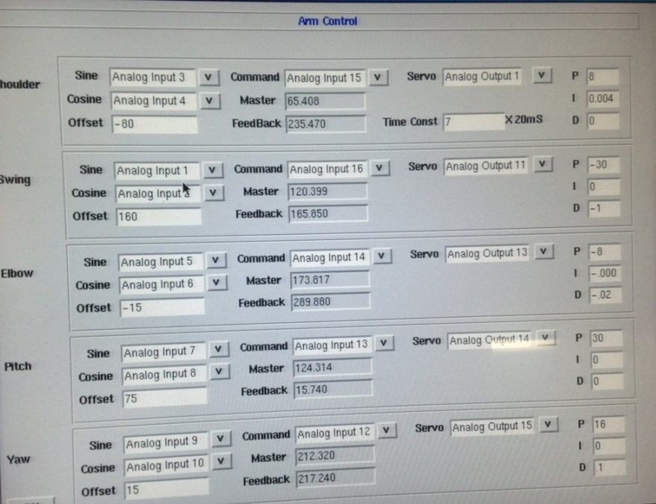

Subsea Electronics
6 x 400w HMI/HID lamps with dry contact isolation (12 digital cmds)
2 x 250w incandescent lamps with dry contact isolation (4 digital output cmds)
1x 5 station servo valve (10gpm) pack (5 analog output cmds DAC)
thruster control/spare
1 x 5 station servo (3gpm) pack (5 analog output cmds DAC)
Camera and tool control
1x6 station servo valve pack (6 analog output cmds DAC, 1 digital output cmd ) manipulator control/ enable
2 x 8 station 4way 3 position hydraulic solenoid valves (32 digital output cmds)
1 x 8 station auxiliary 4way 3 position hydraulic solenoid valves (16 digital output cmds)
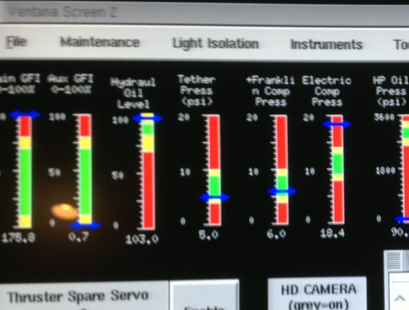
2 ground-fault detection systems
Critical monitoring
- Fog Gyro GFI
- Valves GFI
- Instrument Bus GFI
- Logic Bus GFI
- Lights GFI
- Toolsled 120/220 GFI
- Core 120 GFI
- Main 120 GFI
The above are monitored using both an analog and digital value. The choice of analog input value (1) from the GFI circuit is selected via 3 digital output bits from the control system. The selection is automatic via control system and the resulting analog value is continuously updated and displayed in a bar graph at the operator’s station. When a ground fault alarm event occurs, a digital input (8) to the control system is triggered and a graphic with the name of the fault along with an “alarm” information window is displayed on the operator station. The operator has the option to try to clear the event and the GUI item. If the event clears all returns to normal if not the information window will hide under an “Alarms” task bar item and keep track of the event until it is corrected. The “Alarm” task bar item will turn RED indicating and event is pending or unresolved.

Non critical monitoring
This is an auxiliary system that monitors 16 separate channels for ground faults.
- Arm FB Power GFI
- Cam FB Power GFI
- Depth Sensor Power GFI
- DVL Power GFI
- Altimeter Power GFI
- Oil Pressure Power GFI
- 10 spare
It uses 4 digital output bits from the control system to select which channel to monitor. The value generated is transmitted to the surface control system via an analog input (1) (ADC). The analog values are displayed on the pilot station as Bar graphs above. If a preset value is exceeded an alarm graphic is generated with the same features as those of the critical alarms above.
This board also monitors eight water alarm sensors. The outputs from the alarm circuit are connected to eight (8) digital inputs. These are:
Thruster servo water
Altimeter #1 water
Altimeter #2 water
Doppler Velocity Log water
Pan&tilt servo water
Aux heading water
Port manip FB water
Spare.
A water alarm event generates the same response as above. “a graphic with the name of the fault along with an “alarm” information window is displayed on the operator station. The operator has the option to try to clear the event and the GUI item. If the event clears all returns to normal if not the information window will hide under an “Alarms” task bar item and keep track of the event until it is corrected. The “Alarm” task bar item will turn RED indicating and event is pending or unresolved.”

Water Alarm Board
This board monitors water ingression status in the primary atmospheric housings on the vehicle:
Fiber Optic water
GESPAC water
Transformer water
Core water
4 spare
This board monitors sensors placed in the above housings to detect water ingression. An alarm event will trigger one of eight (8) digital inputs to the control system which will in turn initiate the above response for alarm events.
Digital Output
2x 32 digital outputs (64 digital output bits)
3x 16 dry contact relays NC/NO contacts available (48 digital output bits)
Digital Inputs
1x 32 digital inputs (32 digital input bits)
Serial Interface Card
8x RS232 DB-9 ports
These ports are in addition to the native serial ports on the Gespac Processor. These are used to import data and export control to items such as the DVL, Octans FOG, Altimeter, back up Compass, etc. They are bidirectional and capable of speeds to 38.4 kbaud.

Options:
#1 Full up replacement of both Surface and Subsea control electronics. This is the most desirable option as it updates all components and builds a new subsea penetrator and supplies new connectors. This means a complete system can be tested on the bench before any actual replacement work is undertaken. Down time is minimized and the troubleshooting phase is mostly complete off line. Sub options during this phase include what approach to use regarding IO:
The Ricketts model uses intelligent modules ie: Wago, DGH, Seimens etc to generate the IO subsea. This has the advantage of reducing hardware cost, the modules are usually less expensive than comparable “bussed” io cards like Gespac G96, PCI or PC104. It may also reduce the overall size of the housing required for the IO. Software development is reduced by only having one node to develop. All the intelligence would reside in the control room processor. This is achievable because of the high speed data links. An issue that may be problematic is being able to get the existing serial data connected to the subsea processor to the surface. Some additions/modifications may be required to the data scheme.

The Ventana model uses “bussed” IO. Some of this hardware is very old but has proven to be extremely reliable and robust. If a suitable current generation processor could be secured, it may behoove the project to use that and modify/recompile the existing code. However, news from Gespac Inc. indicates that the G96 bus is very near end of life. Other options using newer bussed hardware such as PCI are also available. PC104 is not a great option due to the cumbersome nature of working on the “stack”.

Subsea Components
Main electronics housing
Penetrator head Connectors
25 x MINK $13500
1 x MINO $1400

New IO
64 current drivers to 1.5 amp
48 dry contact relays
32 digital inputs
64 analog inputs (ADC)
16 analog outputs (DAC)
Serial solution
Serial term server

Surface inputs
Pilot Station Micro
Lateral Command
Fore/aft Command
Vertical Command
Turns Command
Main Camera Pan
Main Camera Tilt
Main Camera Shoulder
VB Pump Control Pot #1
Spare Servo Valve Pot #2
Spare Analog Input Pot #3
Belly Pack Micro (RF?)
Bellypack Port
Bellypack Starboard
Bellypack Lateral
Bellypack Vertical
Bypass New features
Auto head
Lcd heading display
ISE Manipulator Micro
Port Manip Swing
Port Manip Shoulder
Port Manip Elbow
Port Manip Pitch
Port Manip Yaw
Wrist rotate cw
Wrist rotate ccw
Jaw open
Jaw close
Toolsled Remote Control Micro
Sampler Speed control
Index fwd
Index rev
Index stop

