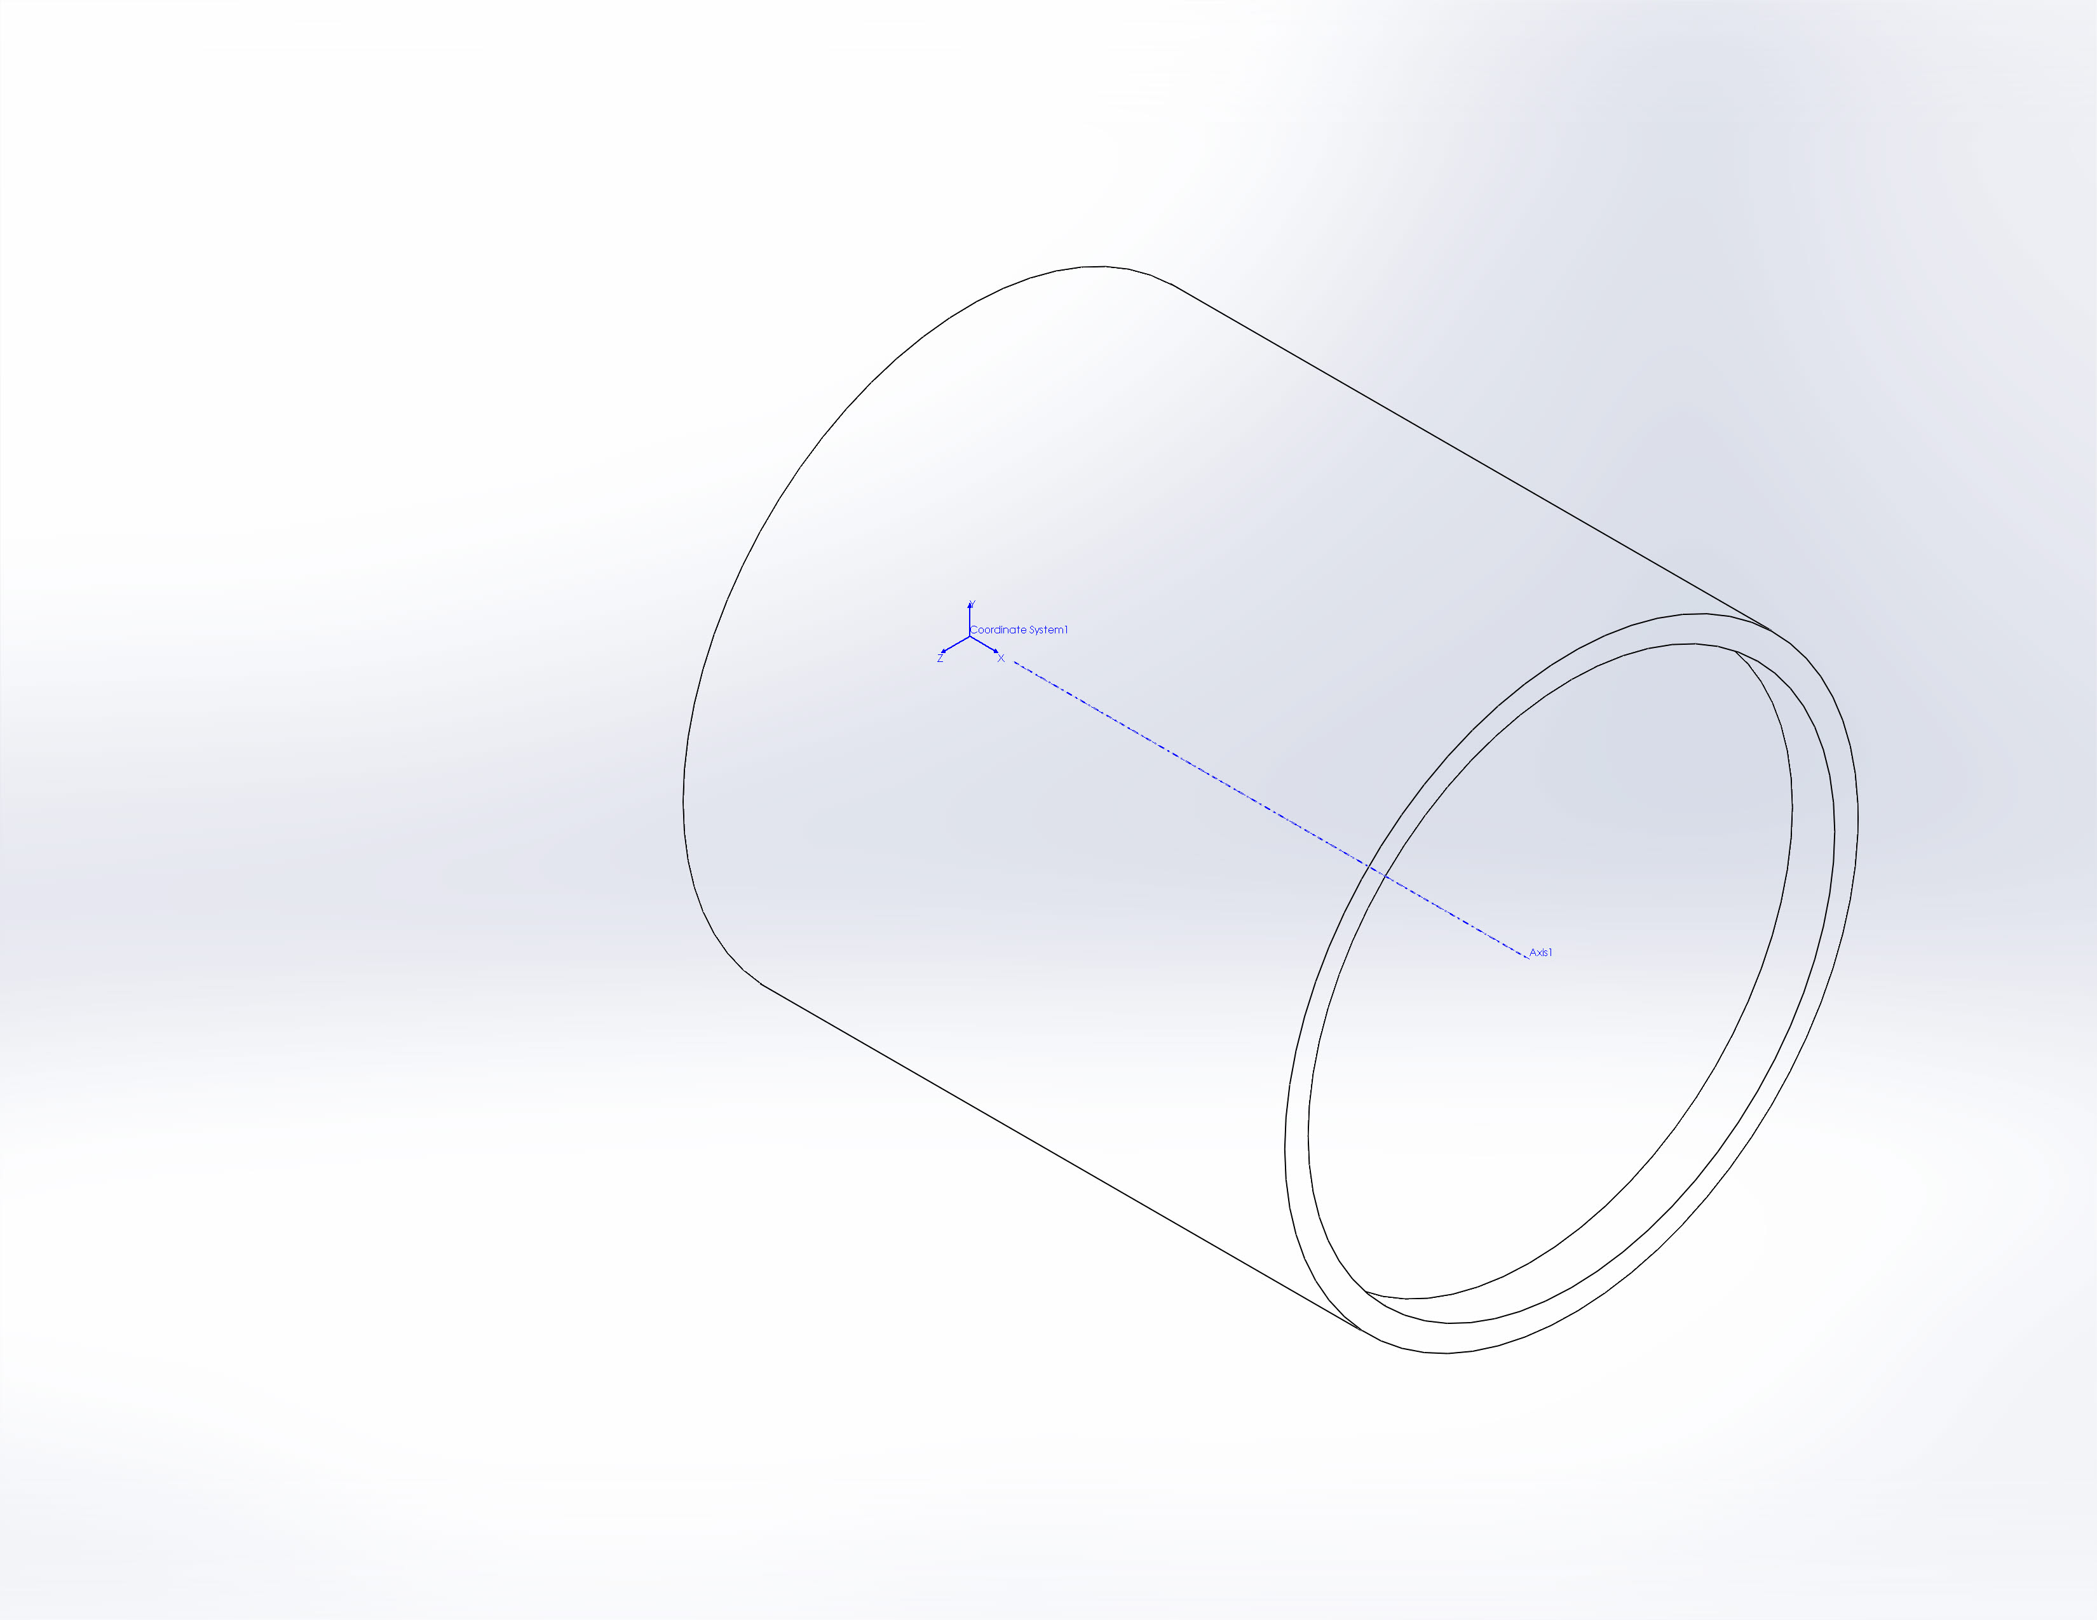
  Simulation of P-201367-12_BEDSTube
  Date: Wednesday, November 28, 2012
  Designer: Solidworks
  Study name: Buckling
  Analysis type: Buckling
  Table of Contents
  Description 1
  Assumptions 2
  Model Information 2
  Study Properties 4
  Units 4
  Material Properties 5
  Loads and Fixtures 6
  Connector Definitions 7
  Contact Information 7
  Mesh Information 8
  Sensor Details 9
  Study Results 10
  Conclusion 13

Description
No Data

Assumptions

Model Information

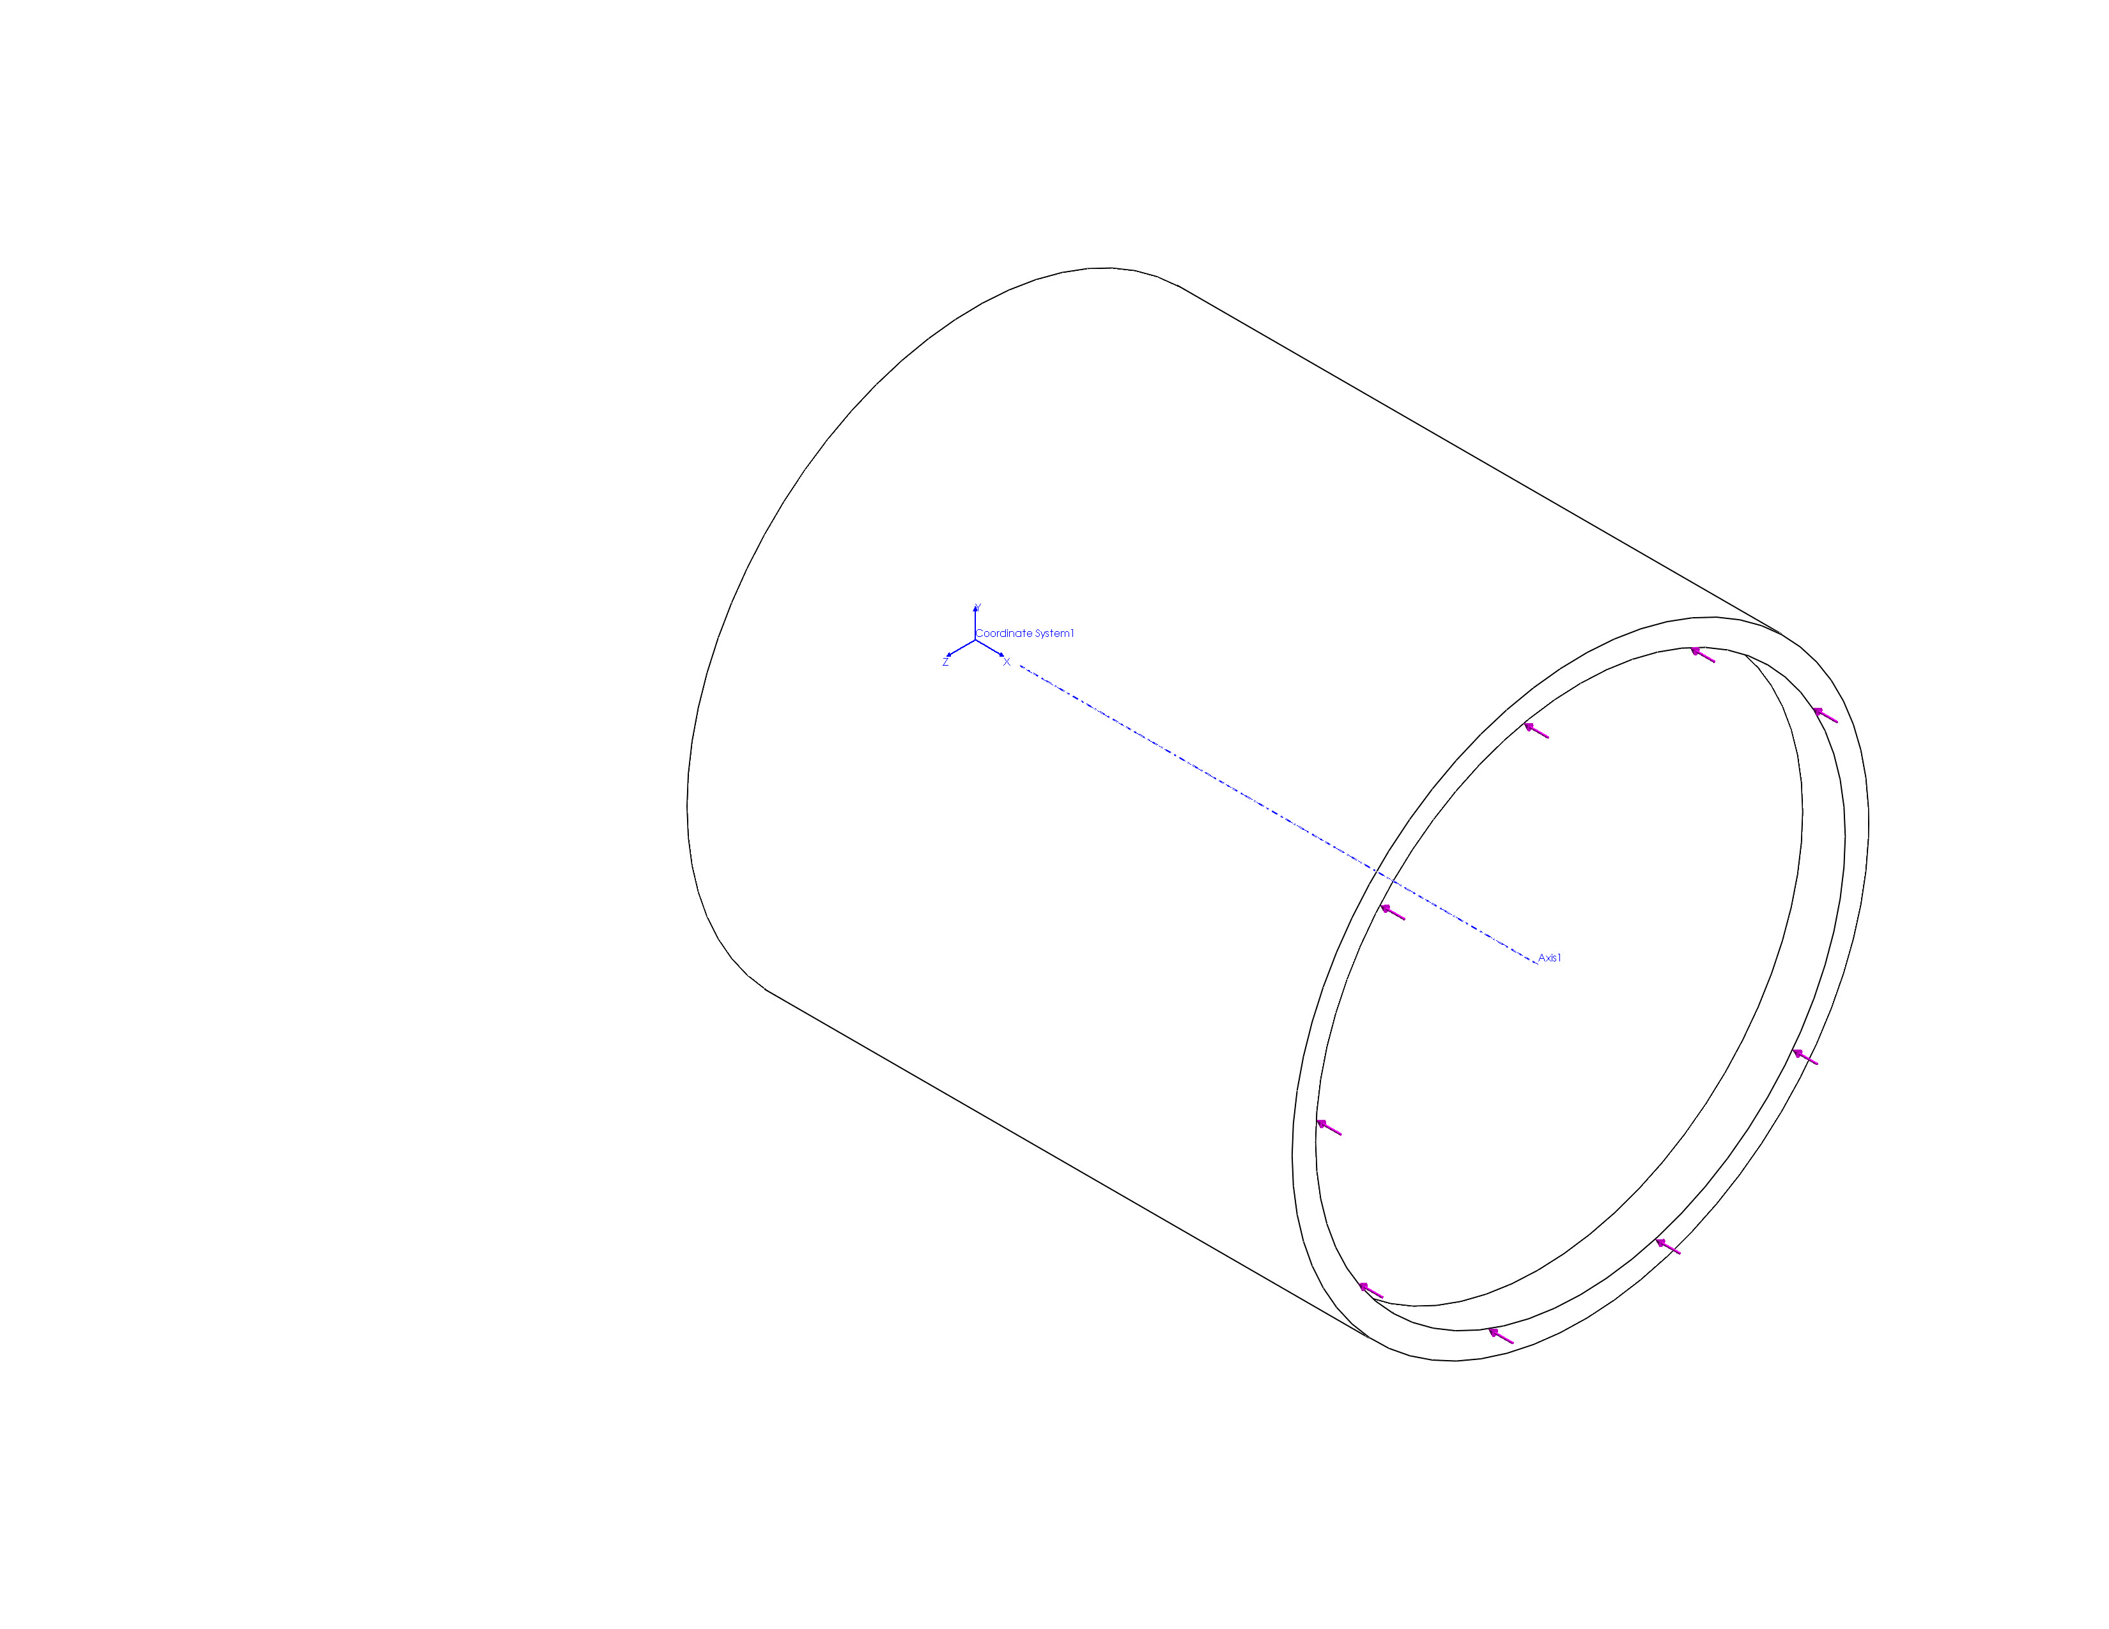
Model name: P-201367-12_BEDSTube
Current Configuration: Default
Composite Bodies
Document Name and Reference | Properties
Shell-2  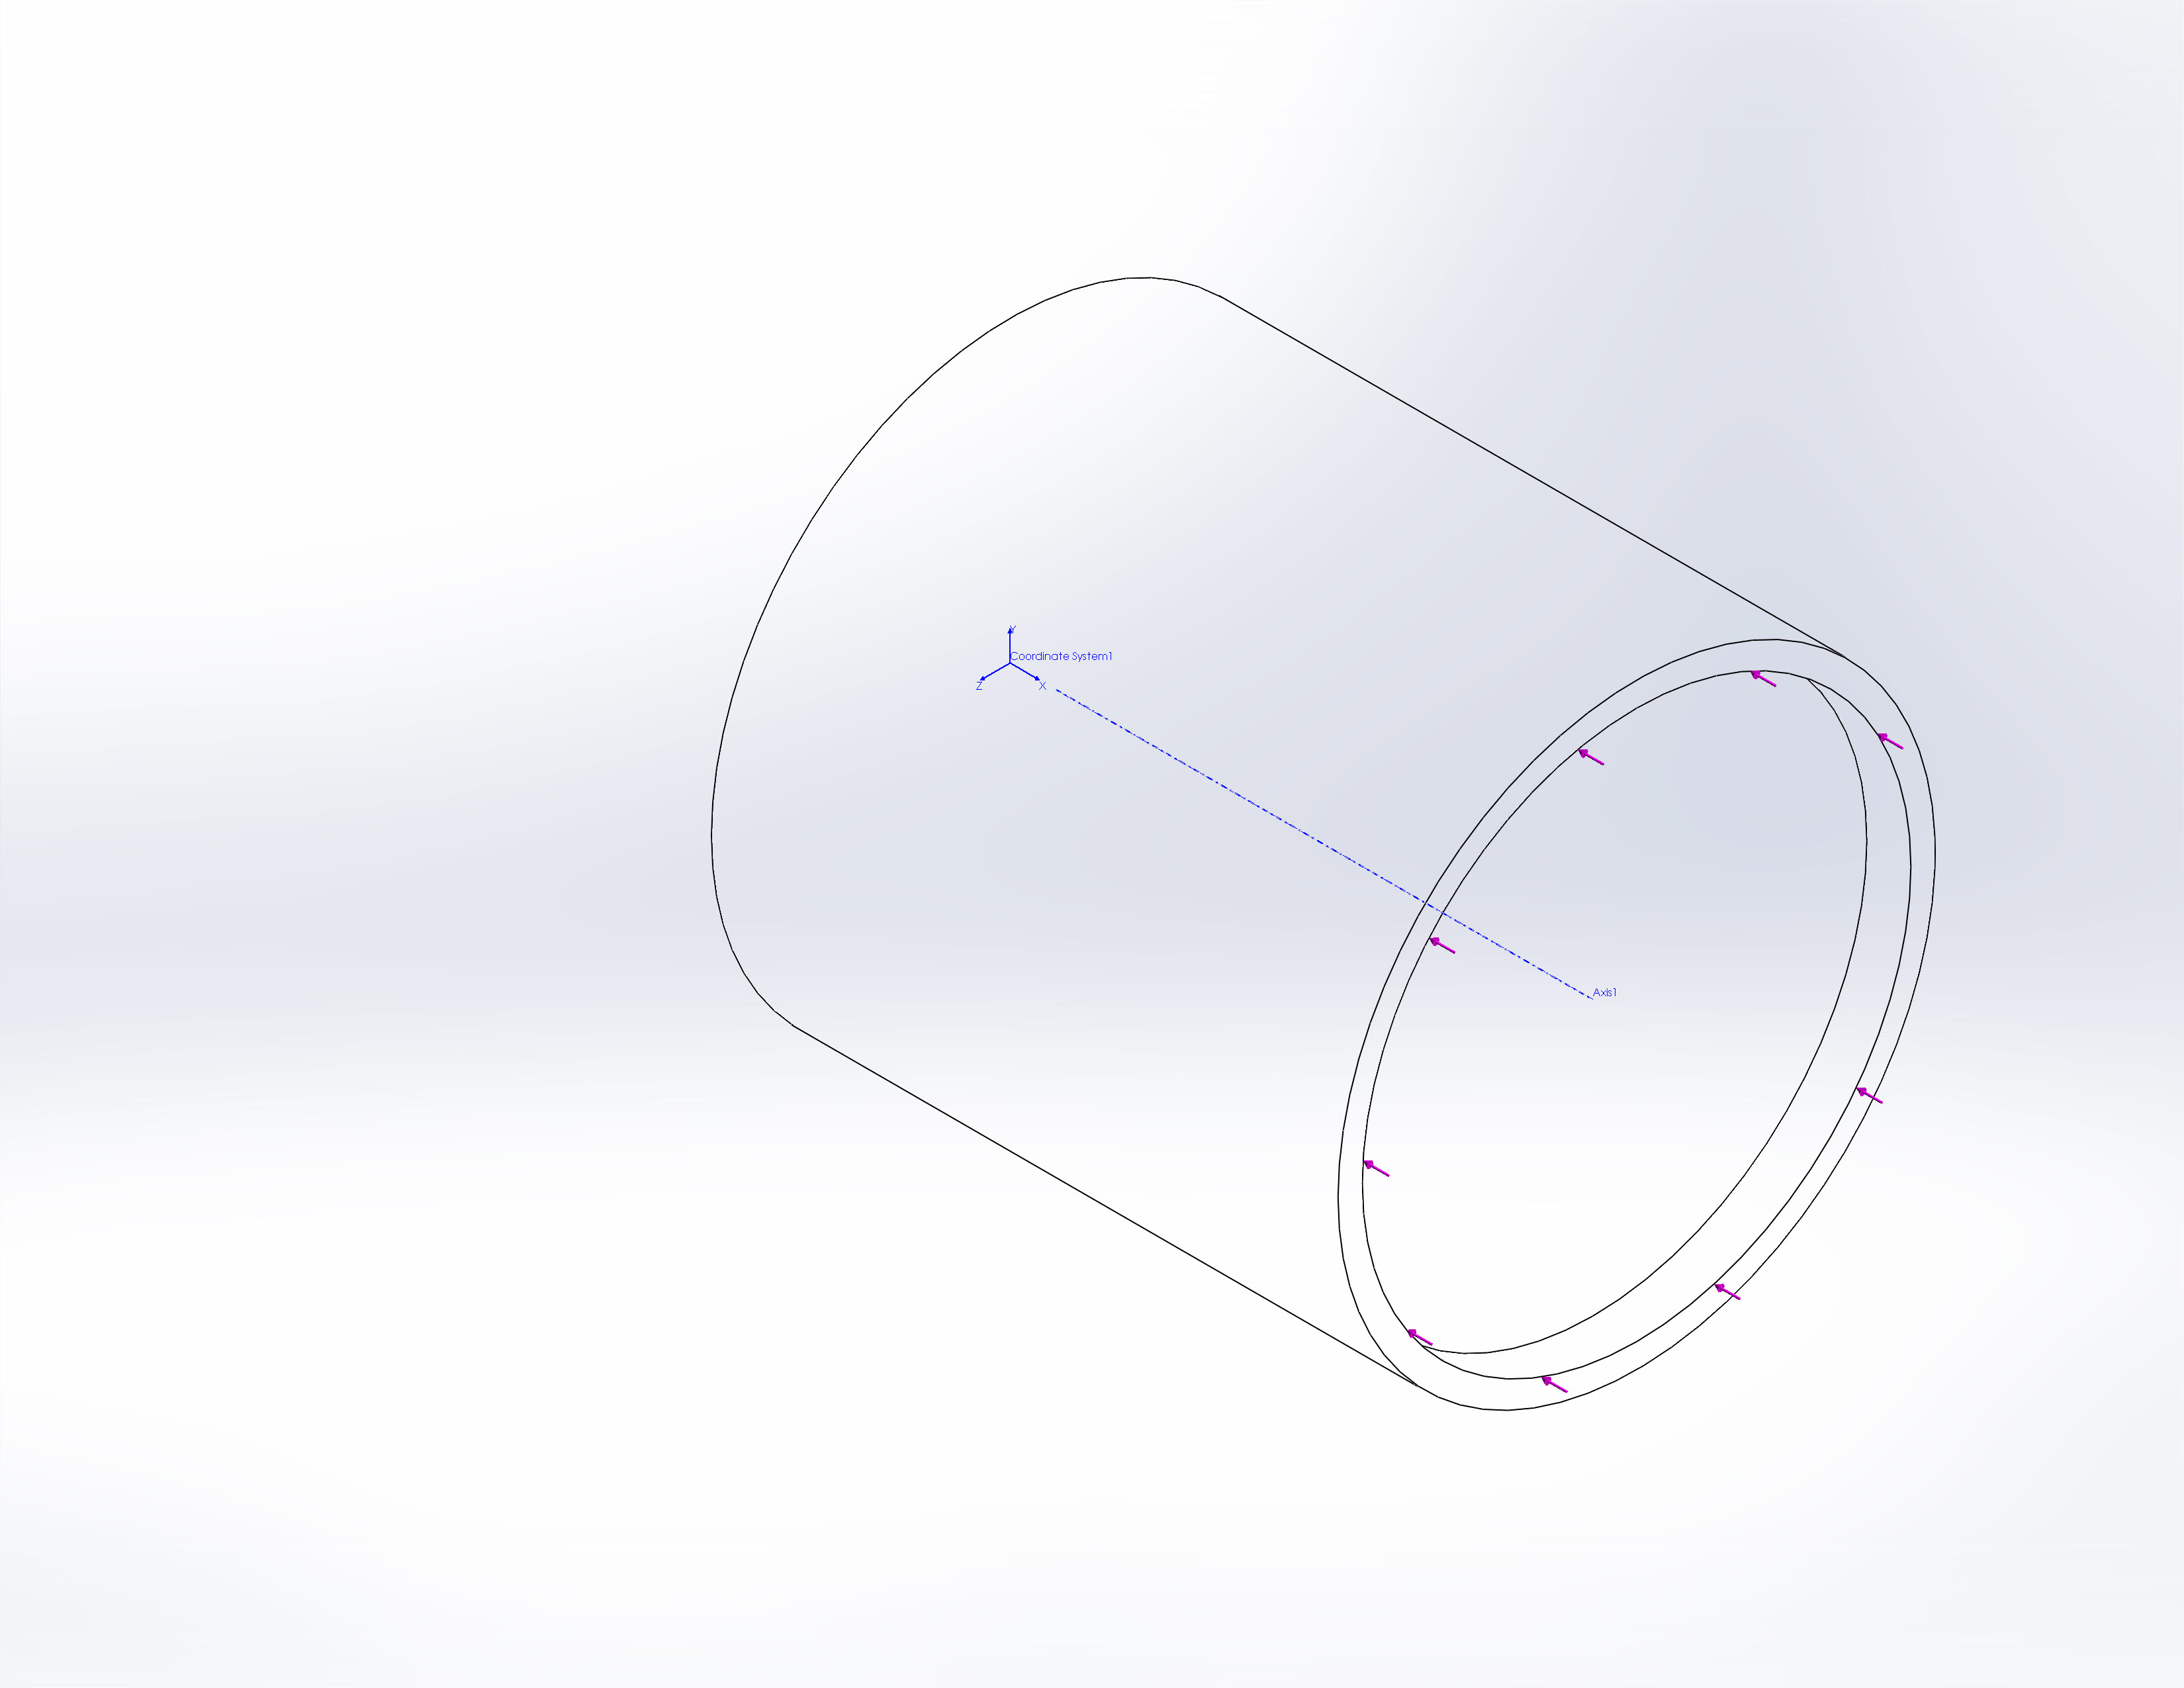 | Total number of Plies: 10  Symmetric: No  Document Name: C:\Users\jon\Desktop\BEDS_Case\P-201367-12_BEDSTube.sldprt  Date Modified: Nov 28 09:58:35 2012
  Ply | Thickness(mm) | Angle(deg) | Area(mm^2) | Volume(in^3) | Density(kg/m^3) | Mass(kg) | Weight(N)
  1 | 0.254 | -80 | 7985.2 | 97596.9 | 7985.2 | 2028.24 | 1000
  2.02824e+006 | 1.98768e+007 | 2 | 0.254 | 80 | 7985.2 | 97596.9 | 7985.2
  2028.24 | 1000 | 2.02824e+006 | 1.98768e+007 | 3 | 0.254 | -80 | 7985.2
  97596.9 | 7985.2 | 2028.24 | 1000 | 2.02824e+006 | 1.98768e+007 | 4 | 0.254
  80 | 7985.2 | 97596.9 | 7985.2 | 2028.24 | 1000 | 2.02824e+006 | 1.98768e+007
  5 | 0.254 | -80 | 7985.2 | 97596.9 | 7985.2 | 2028.24 | 1000
  2.02824e+006 | 1.98768e+007 | 6 | 0.254 | 80 | 7985.2 | 97596.9 | 7985.2
  2028.24 | 1000 | 2.02824e+006 | 1.98768e+007 | 7 | 0.254 | -80 | 7985.2
  97596.9 | 7985.2 | 2028.24 | 1000 | 2.02824e+006 | 1.98768e+007 | 8 | 0.254
  80 | 7985.2 | 97596.9 | 7985.2 | 2028.24 | 1000 | 2.02824e+006 | 1.98768e+007

Study Properties
Study name | Buckling
Analysis type | Buckling
Mesh type | Shell Mesh Using Surfaces
Number of modes | 5
Solver type | FFEPlus
Incompatible bonding options | Automatic
Thermal Effect: | On
Thermal option | Include temperature loads
Zero strain temperature | 298 Kelvin
Include fluid pressure effects from SolidWorks Flow Simulation | Off
Soft Spring: | Off
Result folder | SolidWorks document (C:\Users\jon\Desktop\BEDS_Case)

Units
Unit system: | SI (MKS)
Length/Displacement | mm
Temperature | Kelvin
Angular velocity | Rad/sec
Pressure/Stress | N/m^2

Material Properties
Model Reference | Properties | Components
 |  | SolidBody 1(Split Line1)(P-201367-12_BEDSTube),  Shell-2(SolidBody 1(Split Line1))(P-201367-12_BEDSTube)
  Name: | CarbonEpoxy_ortho
  Model type: | Linear Elastic Orthotropic
  Default failure criterion: | Max von Mises Stress
  Mass density: | 0.0570002 lb/in^3
  Elastic modulus in x: | 2.1e+007 psi
  Elastic modulus in y: | 1.4e+006 psi
  Elastic modulus in z: | 1.4e+006 psi
  Poisson's ratio in xy: | 0.25
  Poisson's ratio in yz: | 0.4065
  Poisson's ratio in xz: | 0.25
  Thermal expansion coef in x: | -4.4e-008 /Fahrenheit
  Thermal expansion coef in y: | 1.2e-005 /Fahrenheit
  Thermal expansion coef in z: | 1.2e-005 /Fahrenheit
  Shear modulus in xy: | 850000 psi
  Shear modulus in yz: | 502000 psi
  Shear modulus in xz: | 850000 psi
Curve Data:N/A

Loads and Fixtures
Fixture name | Fixture Image | Fixture Details
Immovable-1 | 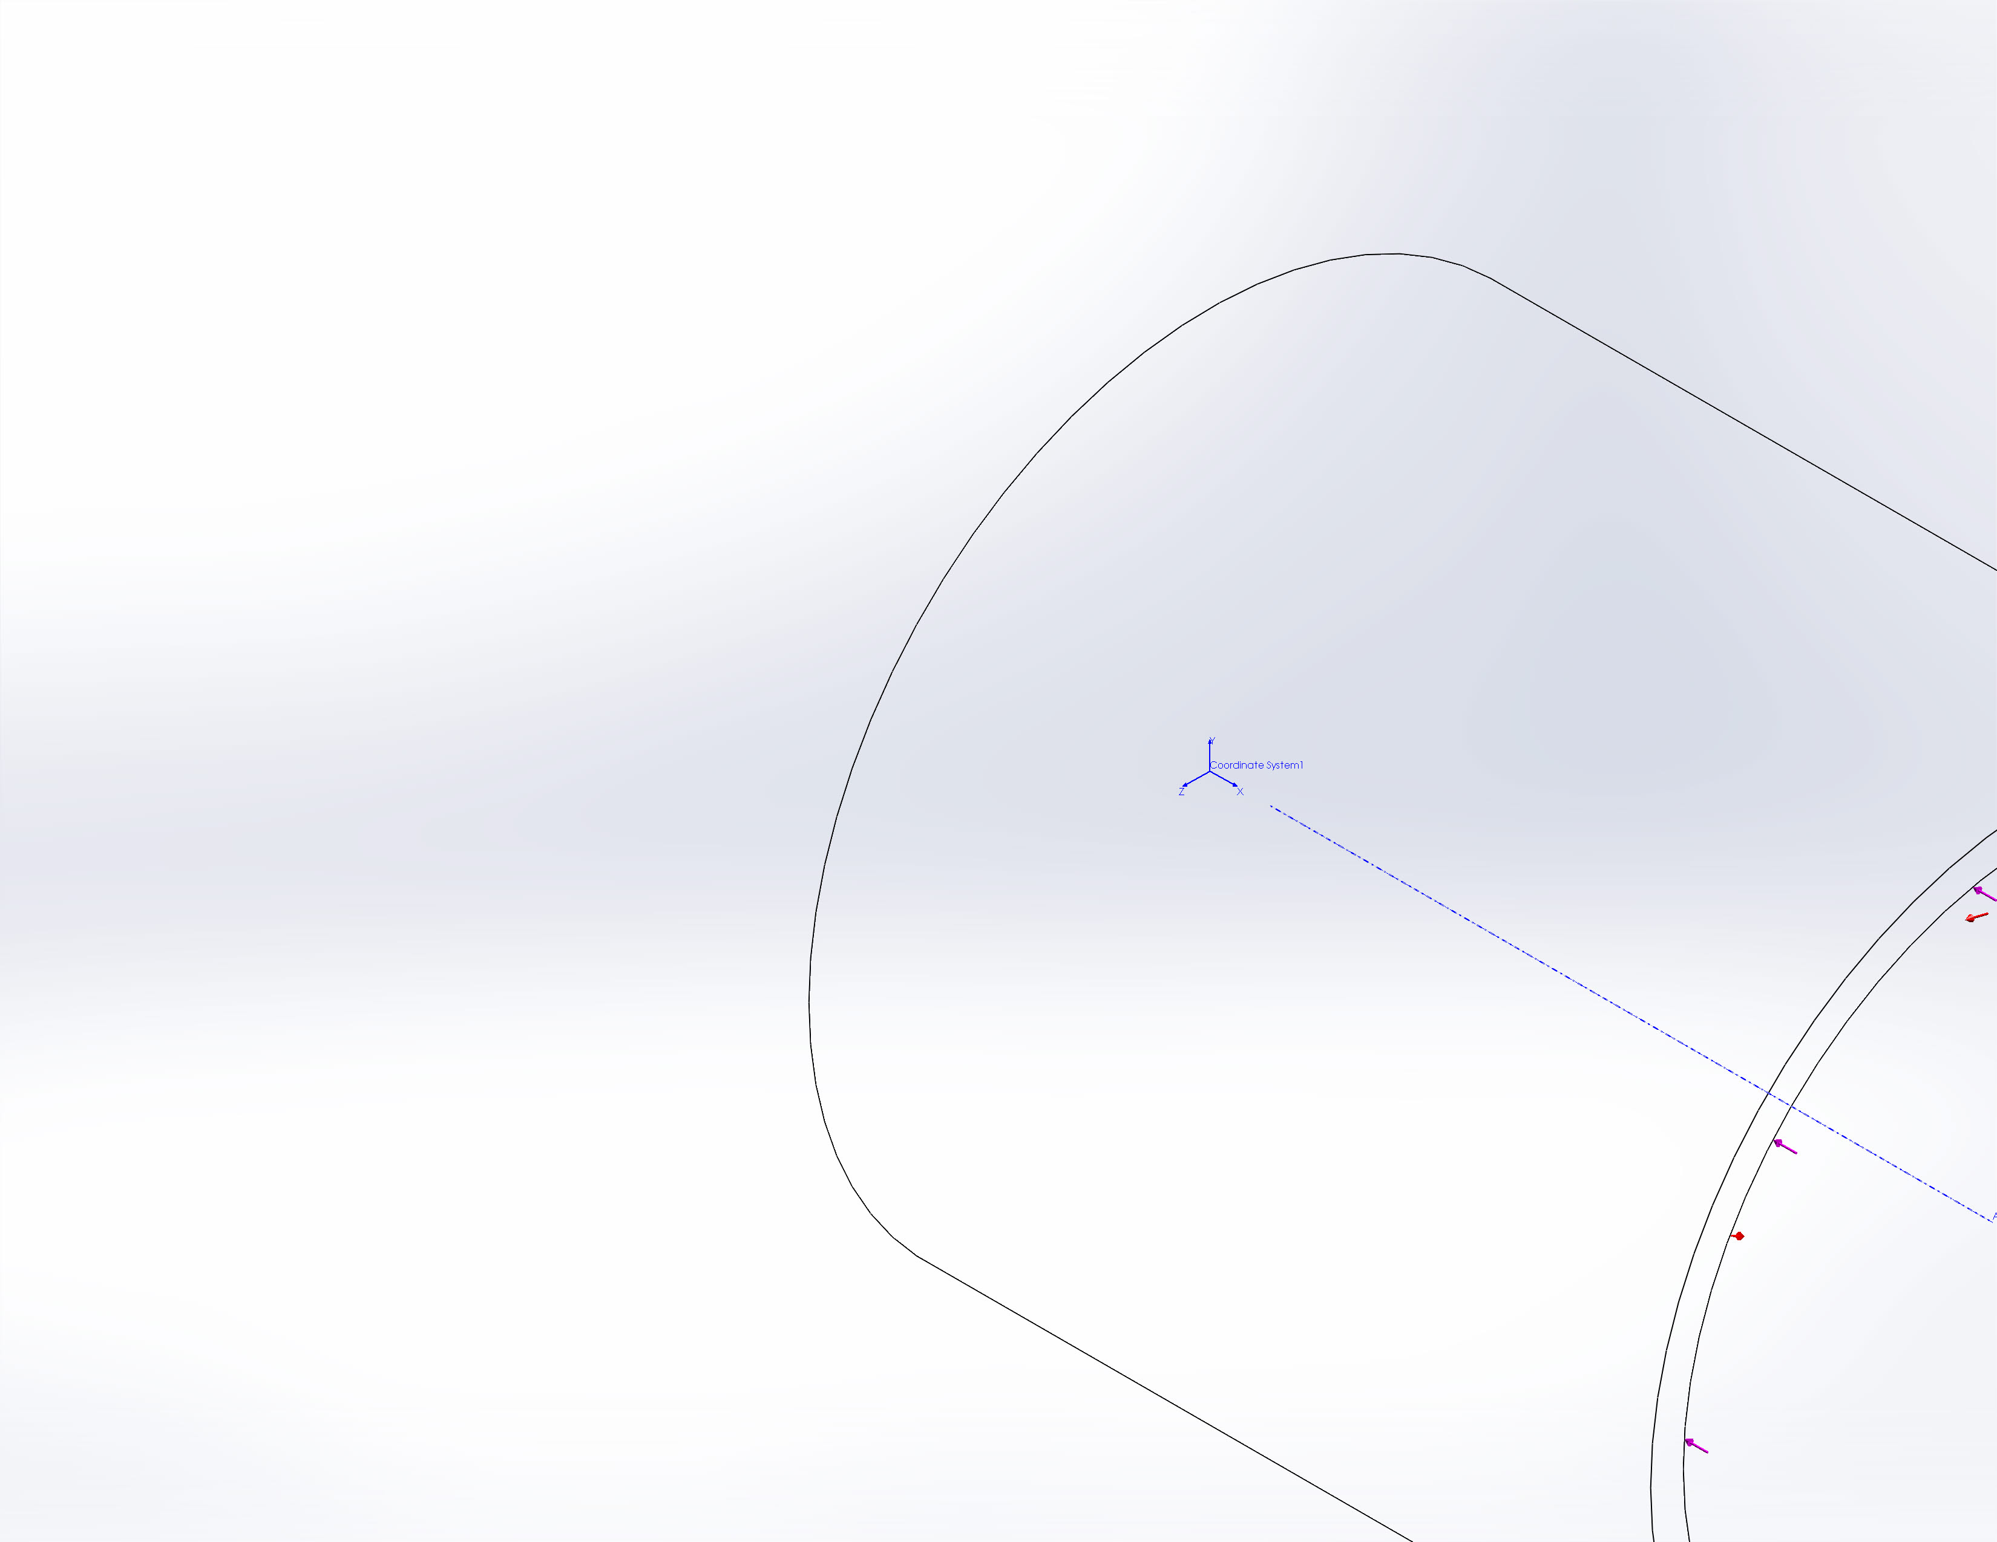
  Entities: | 1 edge(s)
  Type: | Immovable (No translation)
On Cylindrical Faces-1 | 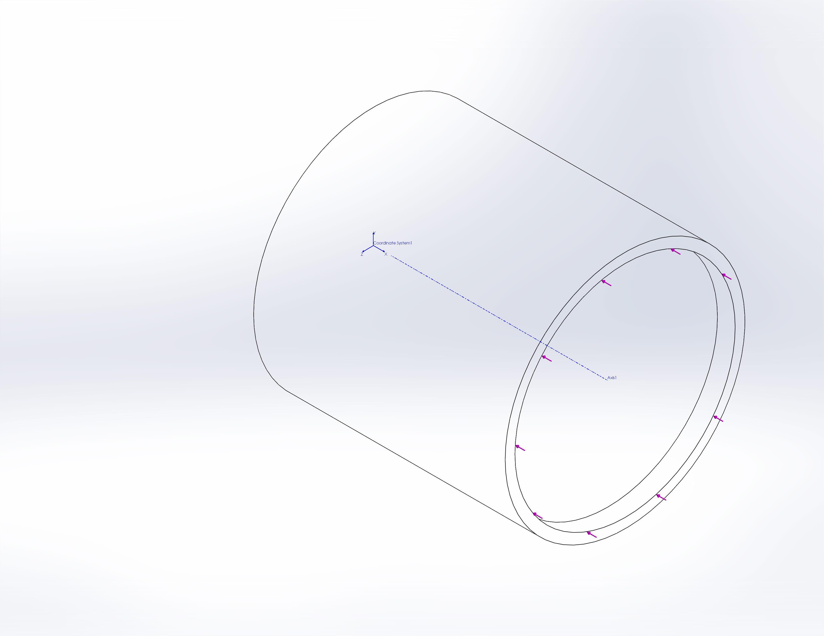
  Entities: | 2 face(s)
  Type: | On Cylindrical Faces
  Translation: | 0, ---, ---
  Rotation: | ---, ---, ---
  Units: | in, rad

Load name | Load Image | Load Details
Pressure-1
  Entities: | 3 face(s)
  Type: | Normal to selected face
  Value: | -7259
  Units: | psi
Force-1 | 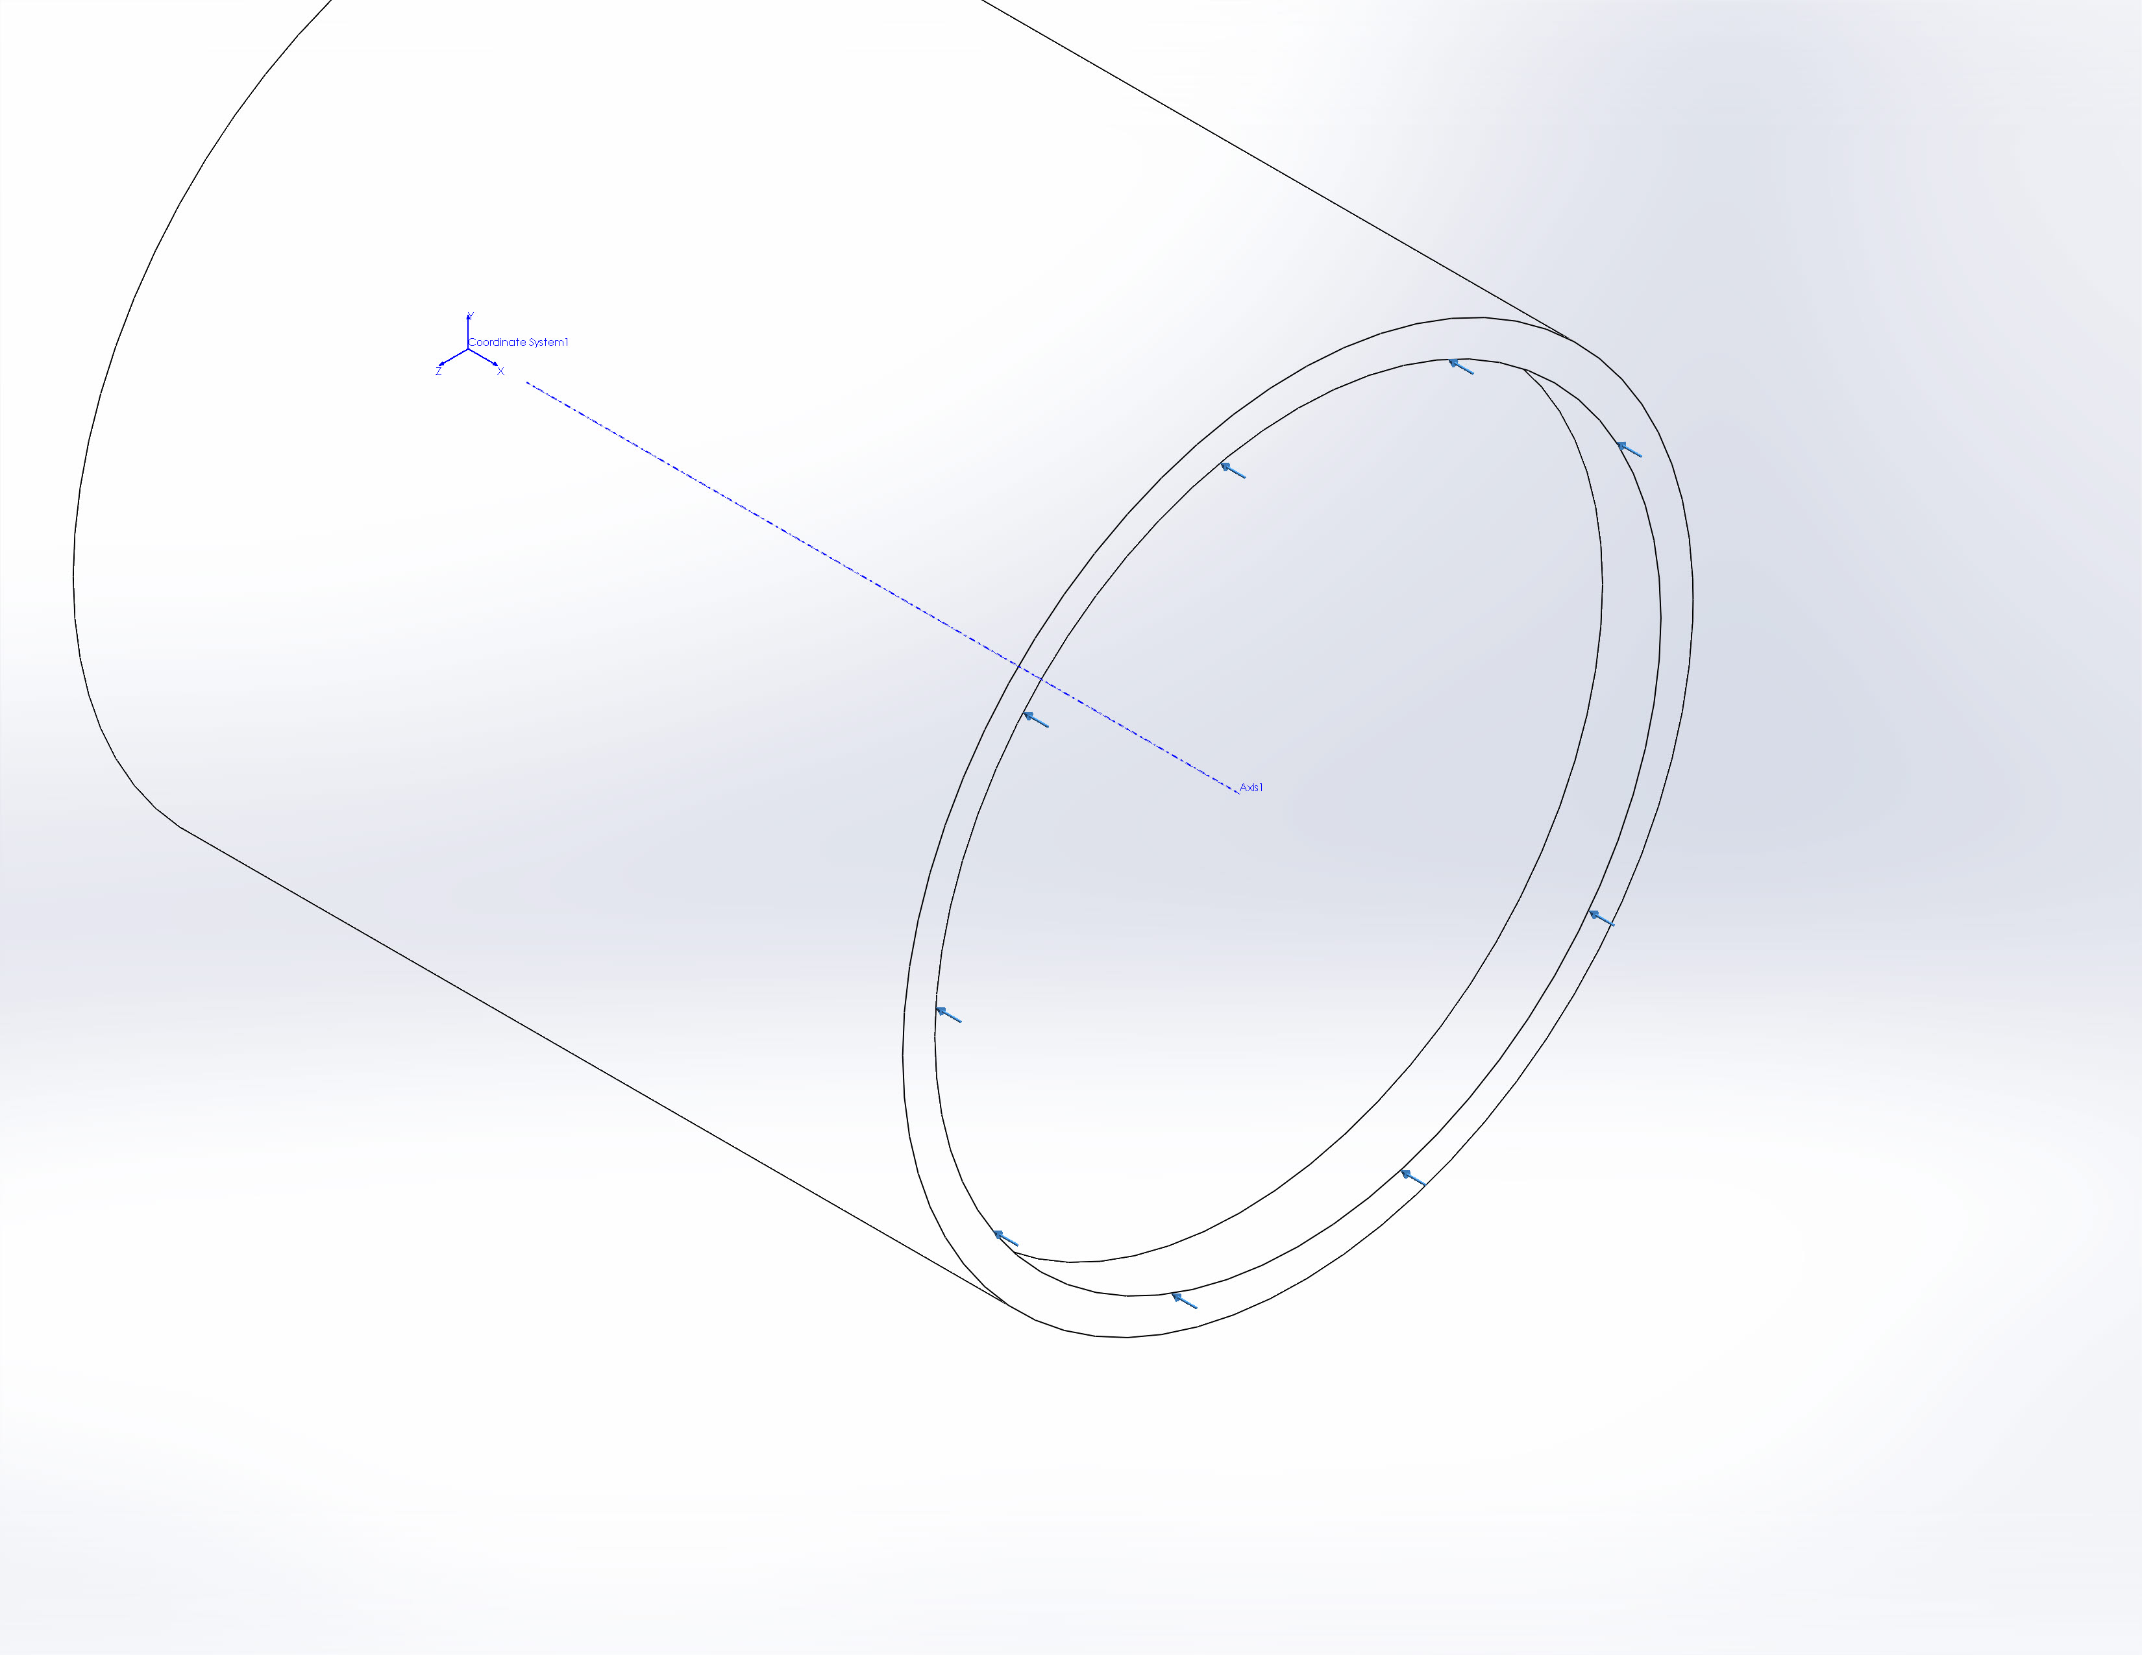
  Entities: | 1 edge(s)
  Reference: | Face< 1 >
  Type: | Apply force
  Values: | ---, ---, -331018 lbf
  Moments: | ---, ---, --- lbf-in

Connector Definitions
No Data

Contact Information
No Data

Mesh Information
Mesh type | Shell Mesh Using Surfaces
Mesher Used: | Standard mesh
Automatic Transition: | Off
Include Mesh Auto Loops: | Off
Jacobian check for shell | On
Element Size | 0.125 in
Tolerance | 0.00625 in
Mesh Quality | High

Mesh Information - Details
Total Nodes | 44958
Total Elements | 22302
Time to complete mesh(hh;mm;ss): | 00:00:06
Computer name: | WOPR
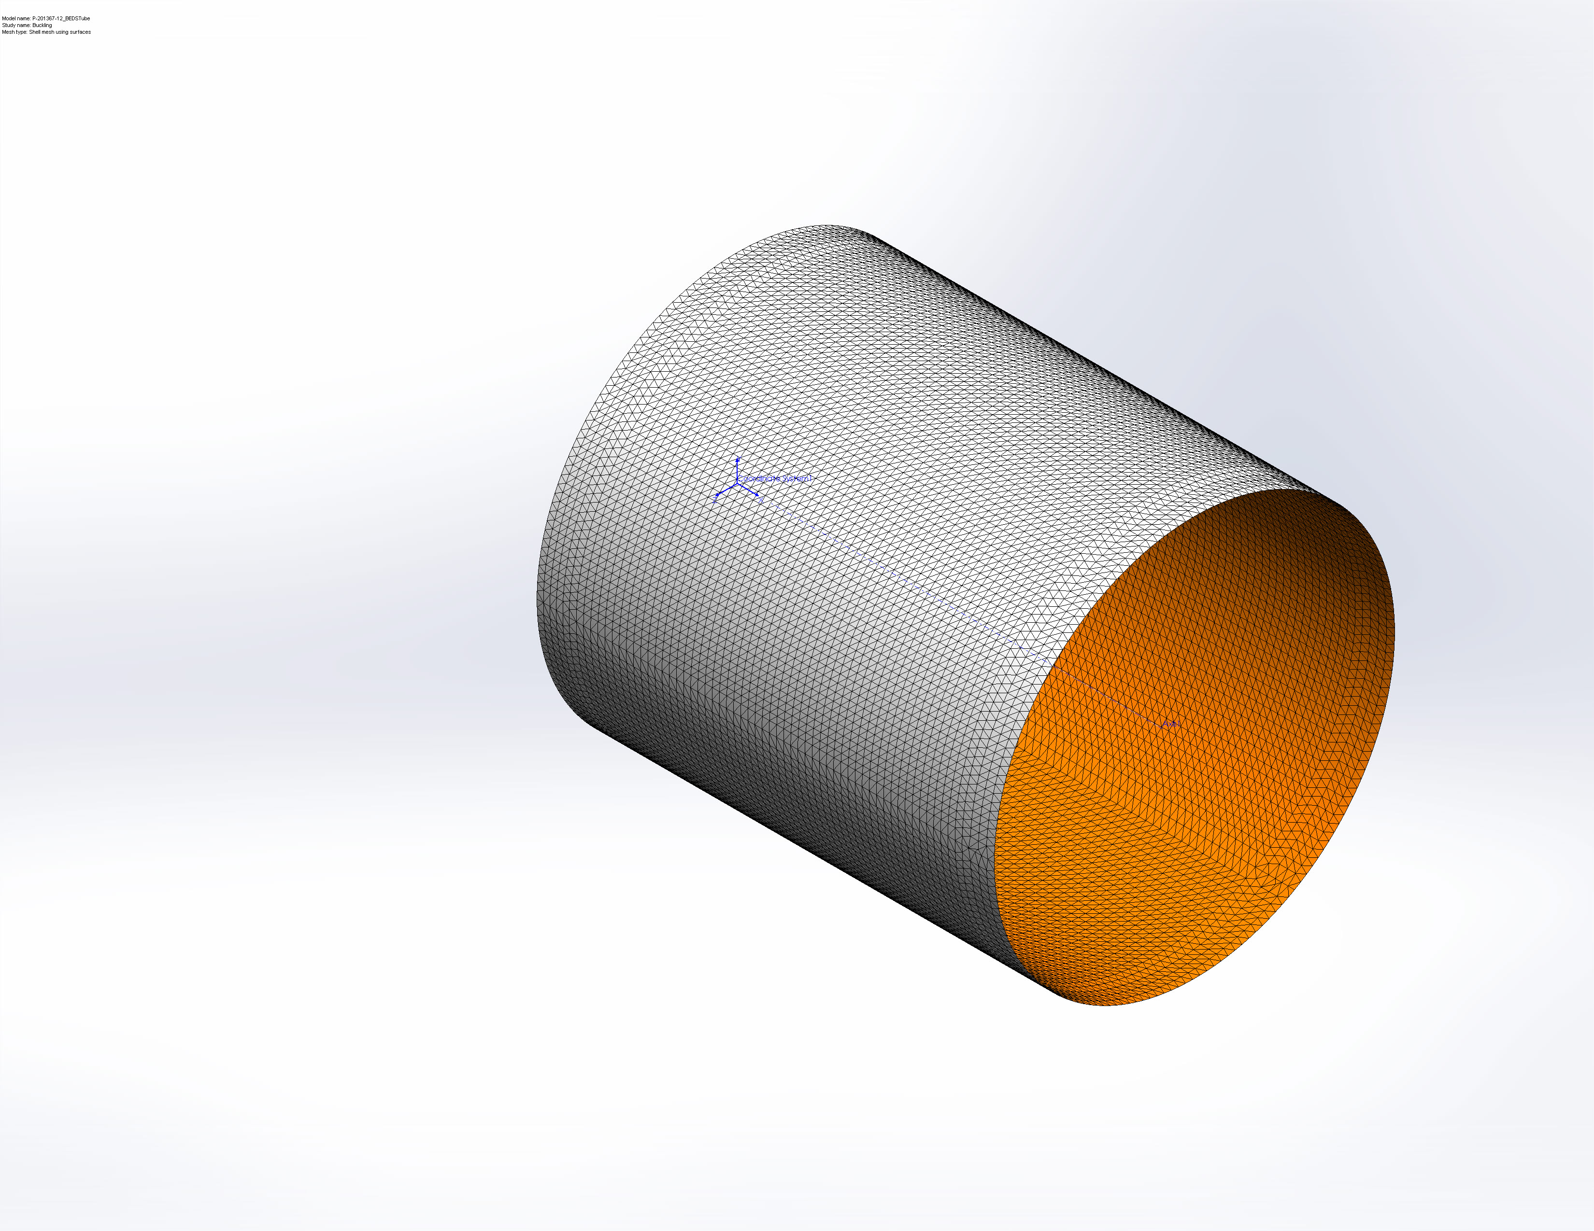

Sensor Details
No Data

Study Results

Name | Type | Min | Max
Displacement1 | URES: Resultant Displacement Plot for Mode Shape: 5(Load Factor = 0.127423) | 0 in  Node: 65 | 0.00228668 in  Node: 17210
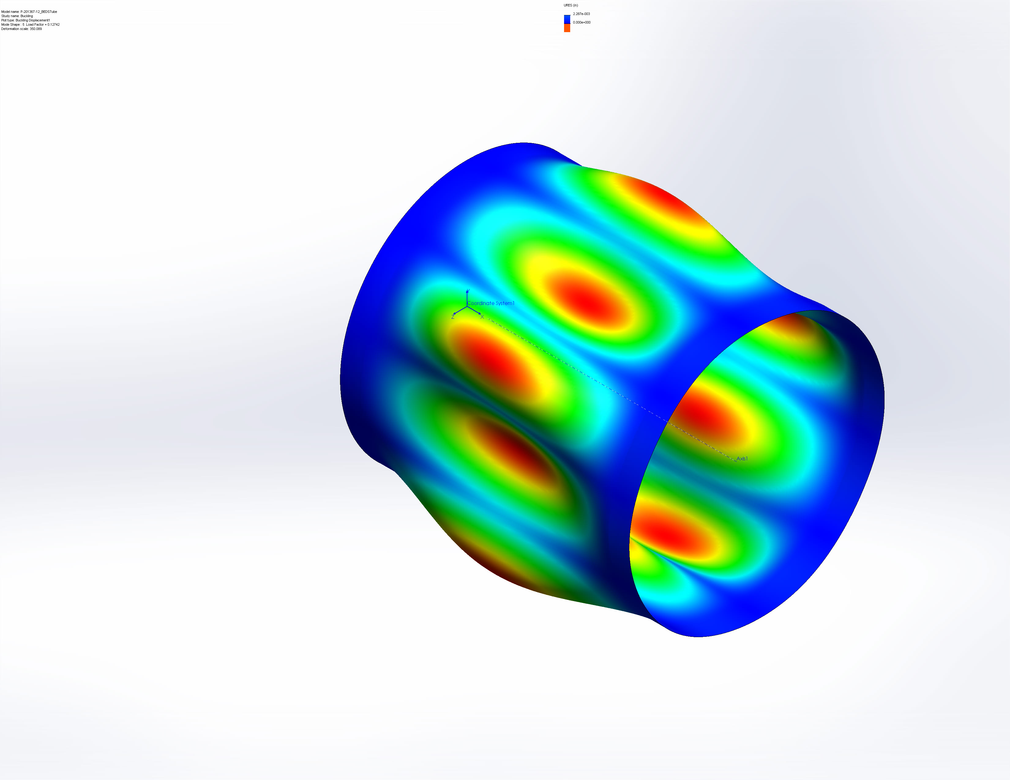
P-201367-12_BEDSTube-Buckling-Displacement-Displacement1

Mode List
Mode Number | Load Factor
1 | 0.094327
2 | 0.094332
3 | 0.1075
4 | 0.10751
5 | 0.12742

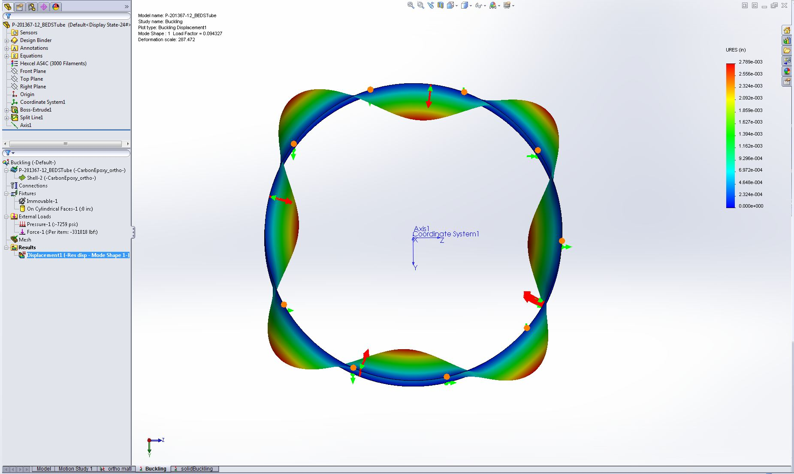
Image-1

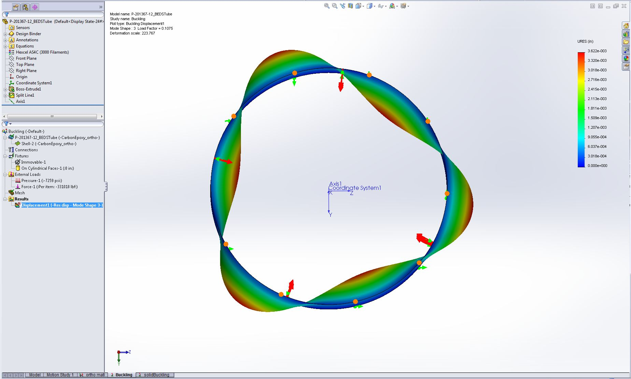
Image-2

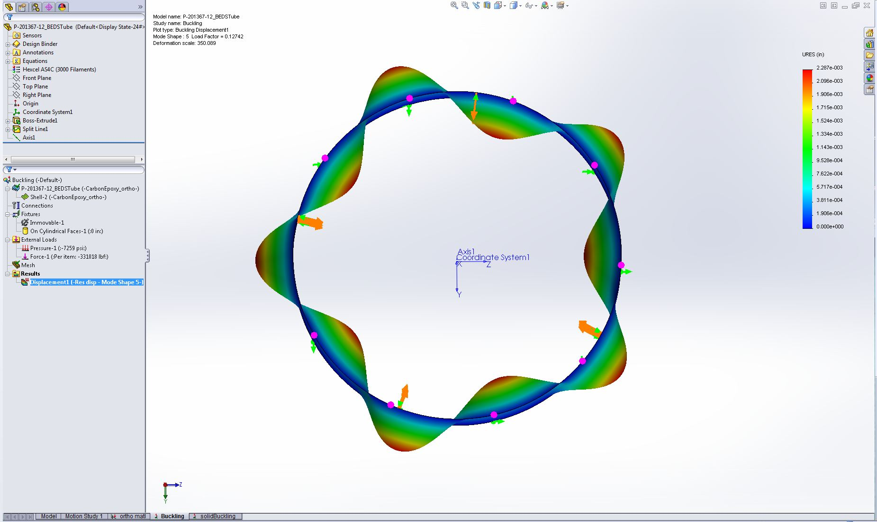
Image-3

Conclusion

