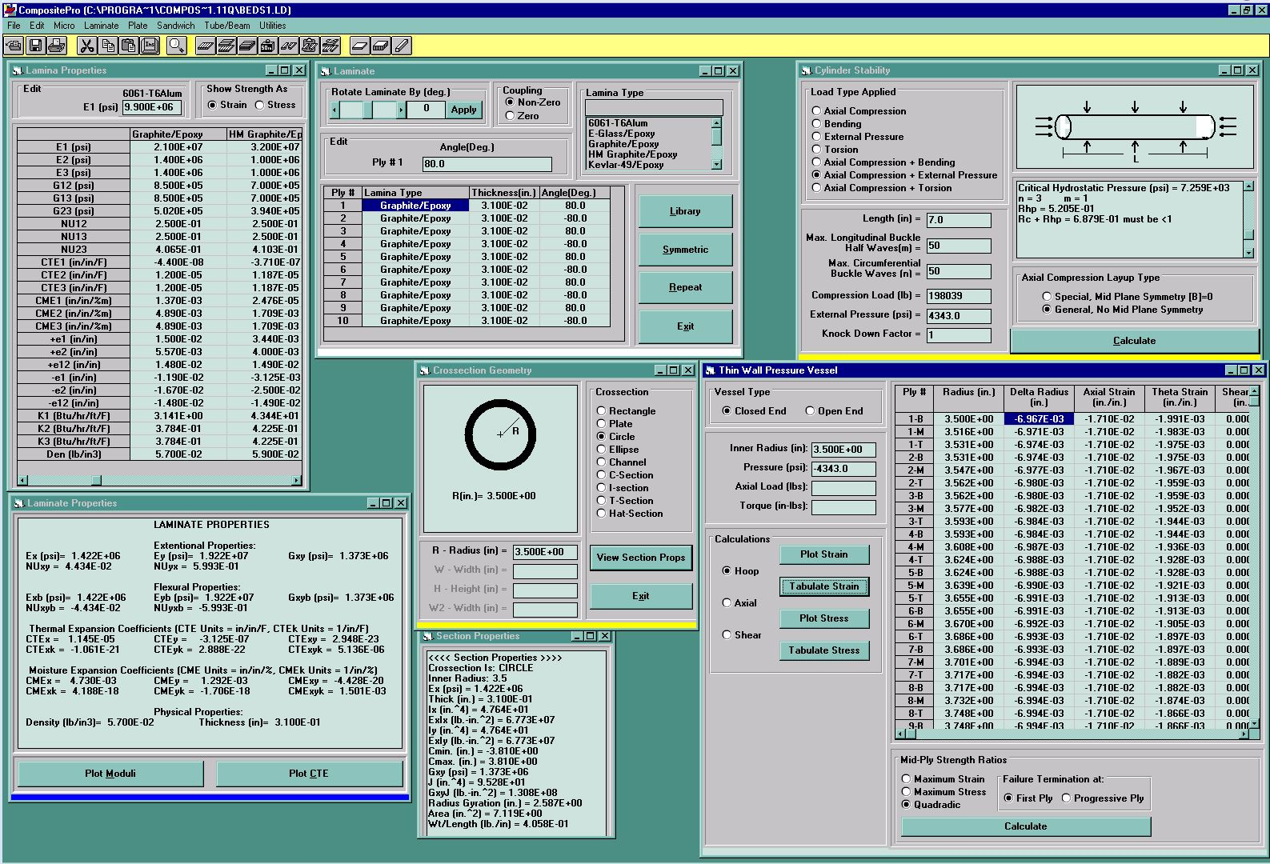
Figure 1 Test10_7x7.0_strain

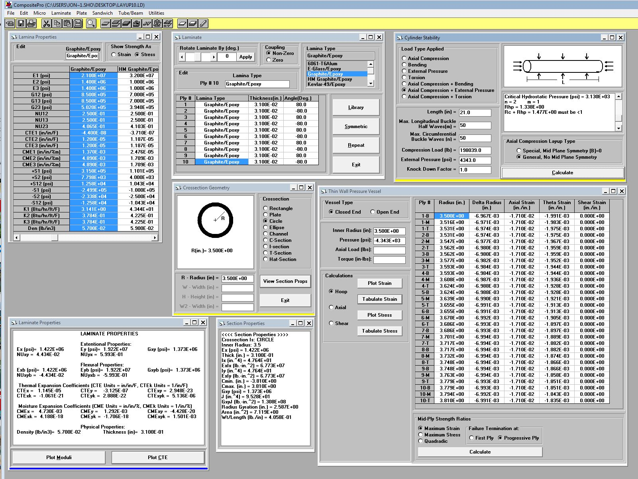
Figure 2 Test10_7x21.0_strain

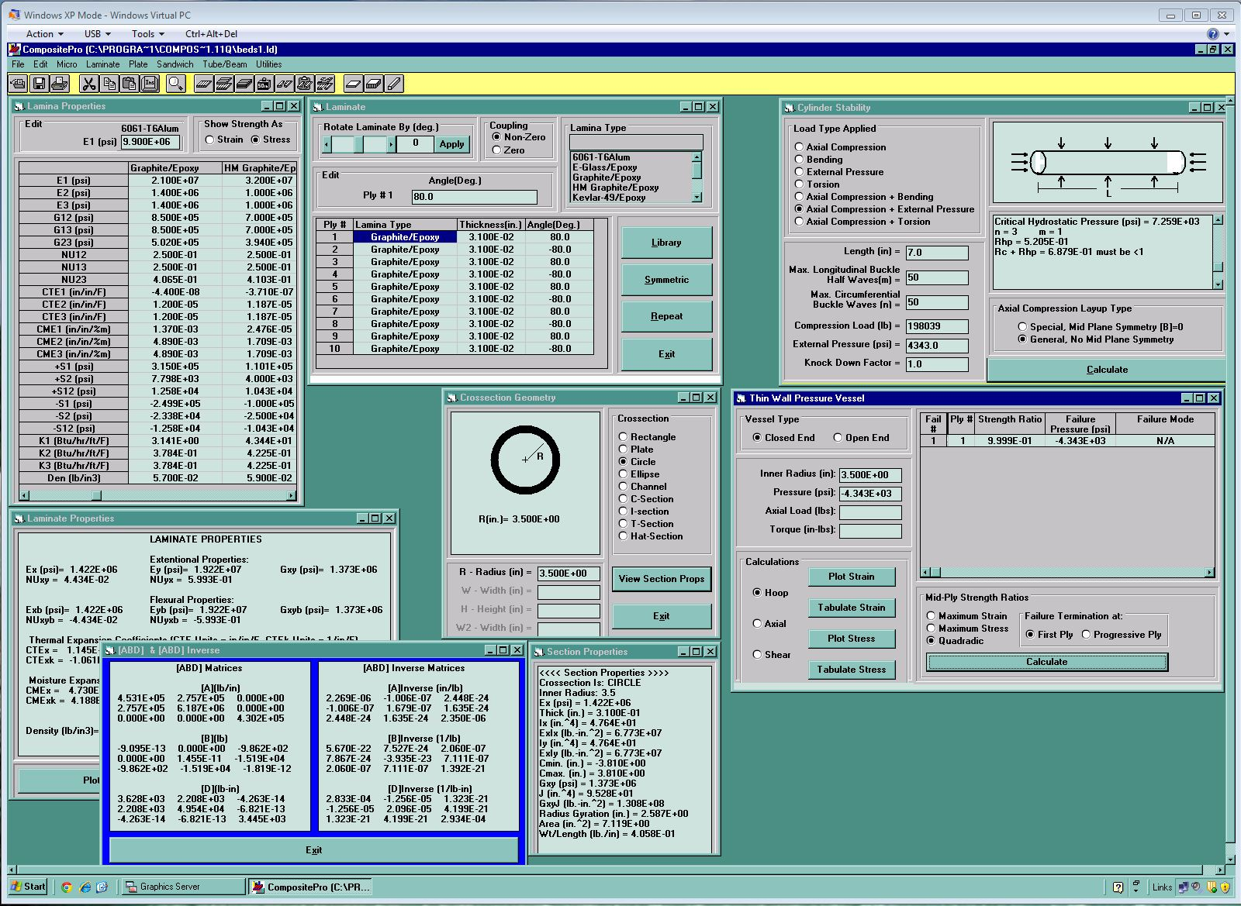
Figure 3 Test10_7x7.0-1

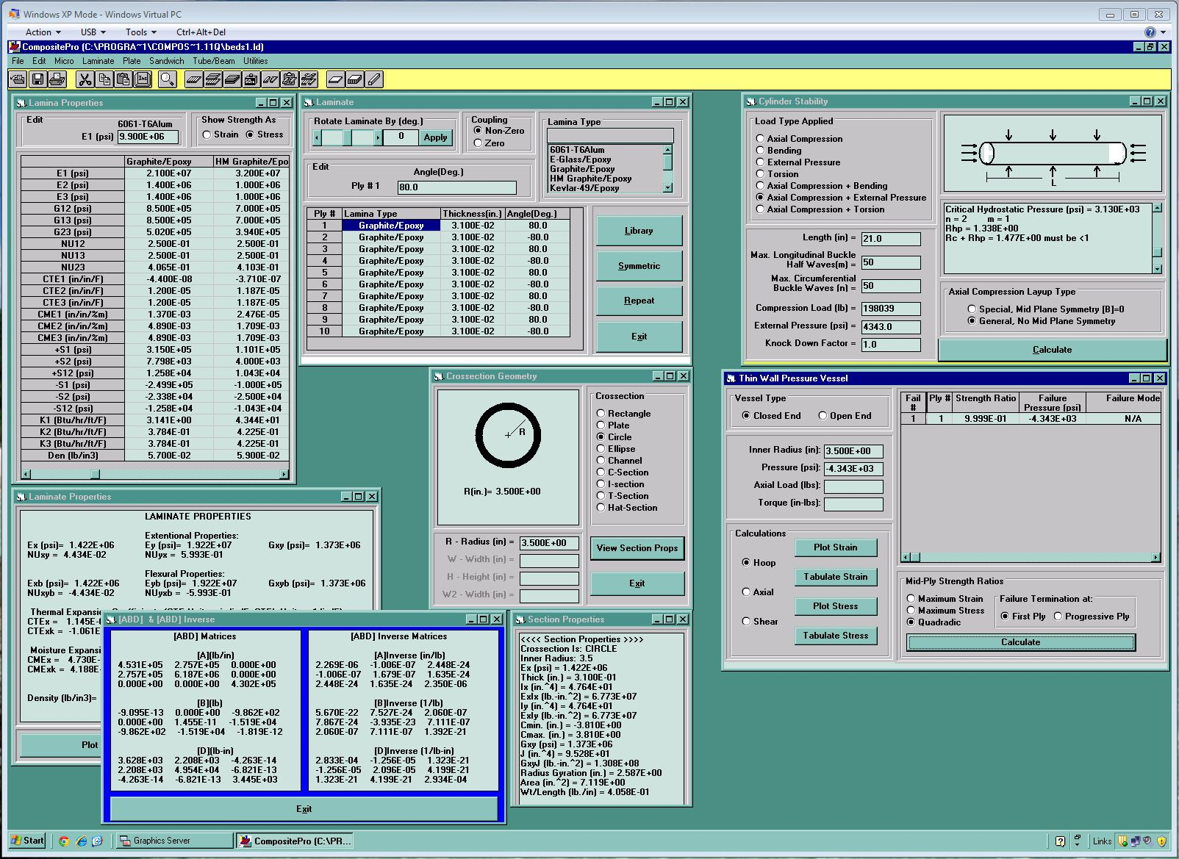
Figure 4 Test10_7x21.0

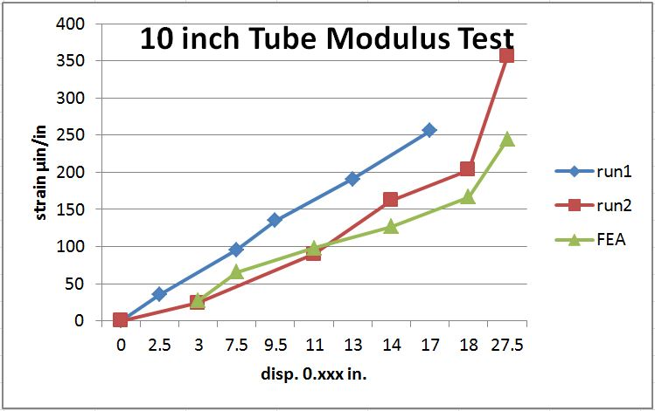
Figure 5 Disp. vs Strain-1

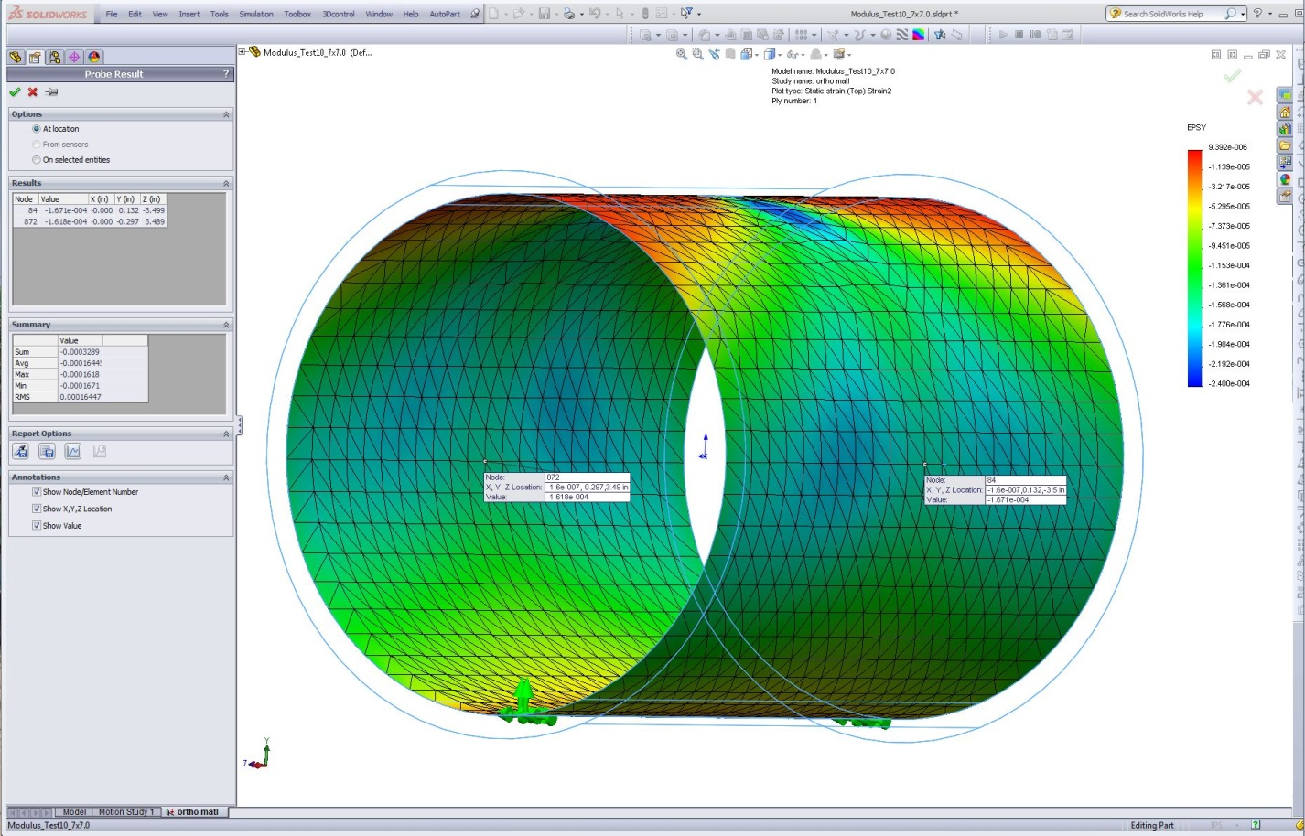
Figure 6 Modulus_Test10_7x10.0-Y-Dir_Strain

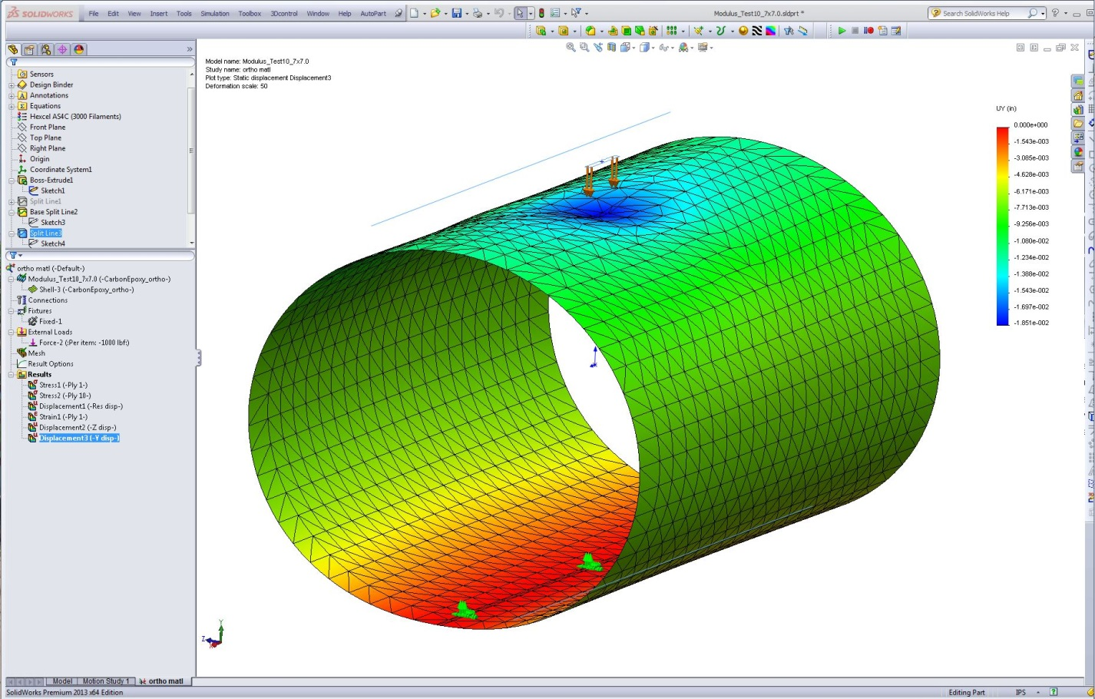
Figure 7 Modulus_Test10_7x10.0-Disp-Y

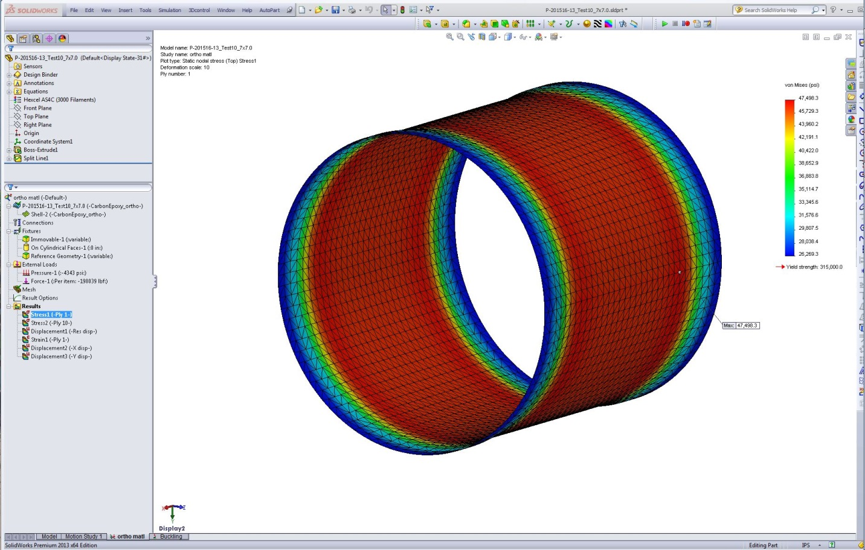
Figure 8 Test10_7x7.0-StressPly1

