RP Cases
Traditionally Rapid Proto-type parts have been used as models for design concepts or at most models for test fit. At MBARI is using a ProJet 3500 to produce parts to actually be used in mechanical assemblies and in some instances are used in submerged applications at sea. Usually this is done for non-stressed parts, or parts that have such complex geometry they cannot be machined in a traditional manner.
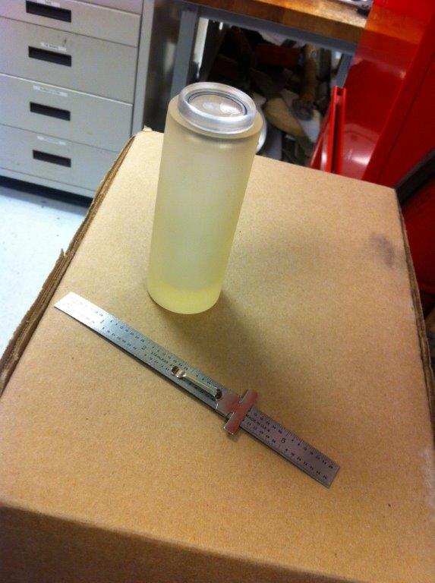
The CAMTAG / SharkTag project produced an underwater pressure case using this ProJet machine in VisiJet M3 Crystal material. This case was pressure tested to failure at approximately 3350 psi., at which point it collapsed with a loud bang. In reverse engineering this case, the math indicates it should have collapsed at 1,965 psi. based on the advertised mechanical properties for the material of a Tensile Modulus of 1463 MPa (2.12189E5 psi), and Tensile Strength of 42.4 MPa (6121 psi.). The actual test pressure at failure (3350 psi.) should produce a VonMises stress on the inner surface of the tube of 10,420 psi. This is obviously in excess of the Tensile strength of 6121 psi., and yields a Hoop Stress of -12,040 psi.
If in subsequent tests, this test pressure continues, it would indicate that we should be using a compressive stress at yield for calculation.

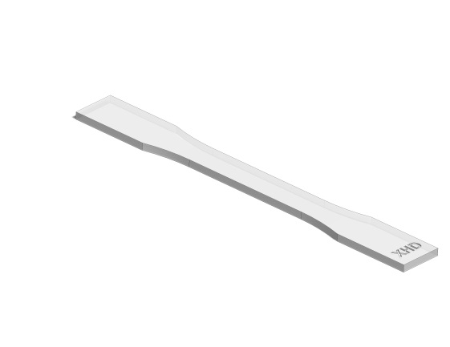
In an attempt to characterize the VisiJet material, a series of “DogBone “ tensile tests on coupons built in several directions and two different build resolutions (UHD, & XHD). The coupons were constructed to ASTM 638-10 standard dimensions. With the build directions controlled by the machine to be horizontal and vertical to the length of the coupon.
The graphs are stress/strain curves for the coupons response to axial tensile loading.
ASTM_D638-10_UHD Vertical Build, 3,492 psi.
ASTM_D638-10_UHD Horizontal build, 4,343 psi.
ASTM_D638-10_XHD Horizontal build, 5,375 psi.

The adjacent graph is the machine ouput for the last run #5 of the XHD coupons.

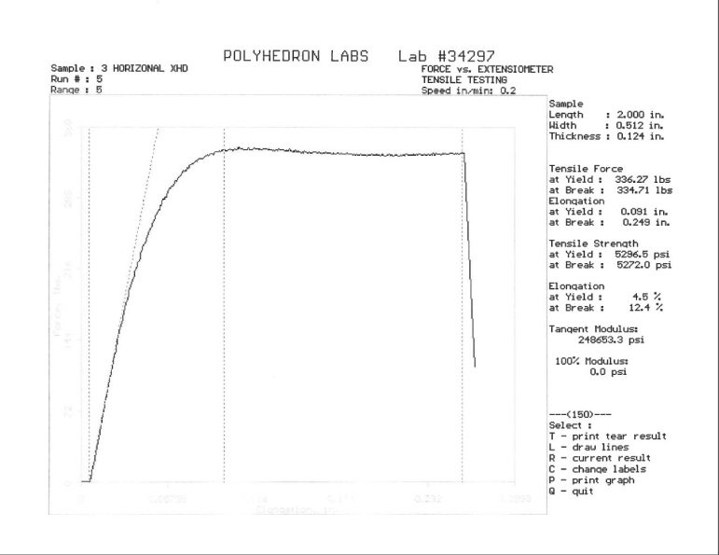

SolidWorks Simulation Non-linear solution using a complete compressive-tensile stress-strain curve.

ProJet 3500 HD, UHD, XHD resolution
VisiaJet M3 Crystal Tensile strength = 42.4 MPa (6121 psi) Tensile Modulus = 1463 MPa (2.12189E5 psi)

CAMTAG
cylindrical housing. .25 wall - Loud failure occurred ~3350 psi.

DOGBONE Tests
ASTM_D638-10_UHD Horizontal build, 4,343 psi.
ASTM_D638-10_UHD Vertical Build, 3,492 psi.
ASTM_D638-10_XHD Horizontal build, 5,375 psi.

