BIC America F12 12-Inch 475-Watt Front Firing Powered Subwoofer

Price: | $212.00
What's included
- Powered subwoofer with 12-inch injection molded long throw woofer; BASH designed amp
- Patented BIC "Venturi" vent eliminates port noise
- Adjustable crossover, adjustable volume control, automatic signal sensing
- Inputs for both Dolby Pro Logic and Dolby Digital/DTS
- Backed by 5-year warranty

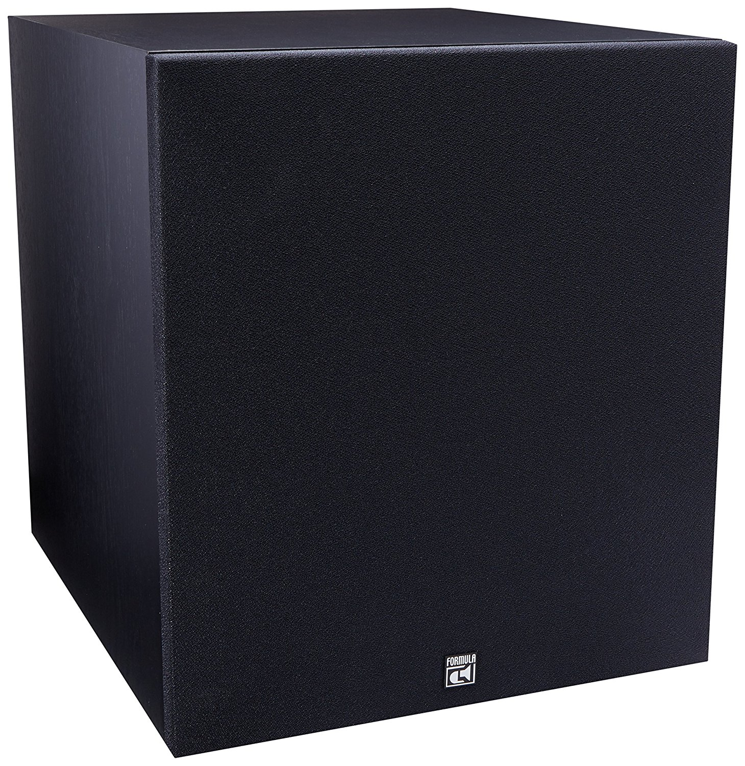

Miscellaneous Cables - $80.00

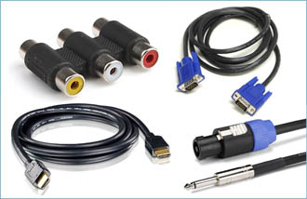

Illuminated Pushbutton Switch, 22mm, SPDT, Momentary Spring Return, 5 A, 250 V, Blue

82-6151.1123 - $20.00 x 8 = $160

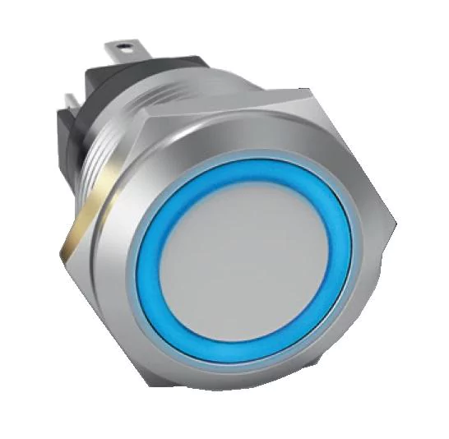

CanaKit Raspberry Pi 3 Complete Starter Kit - Includes 32 GB Samsung EVO+
Price: $69.99

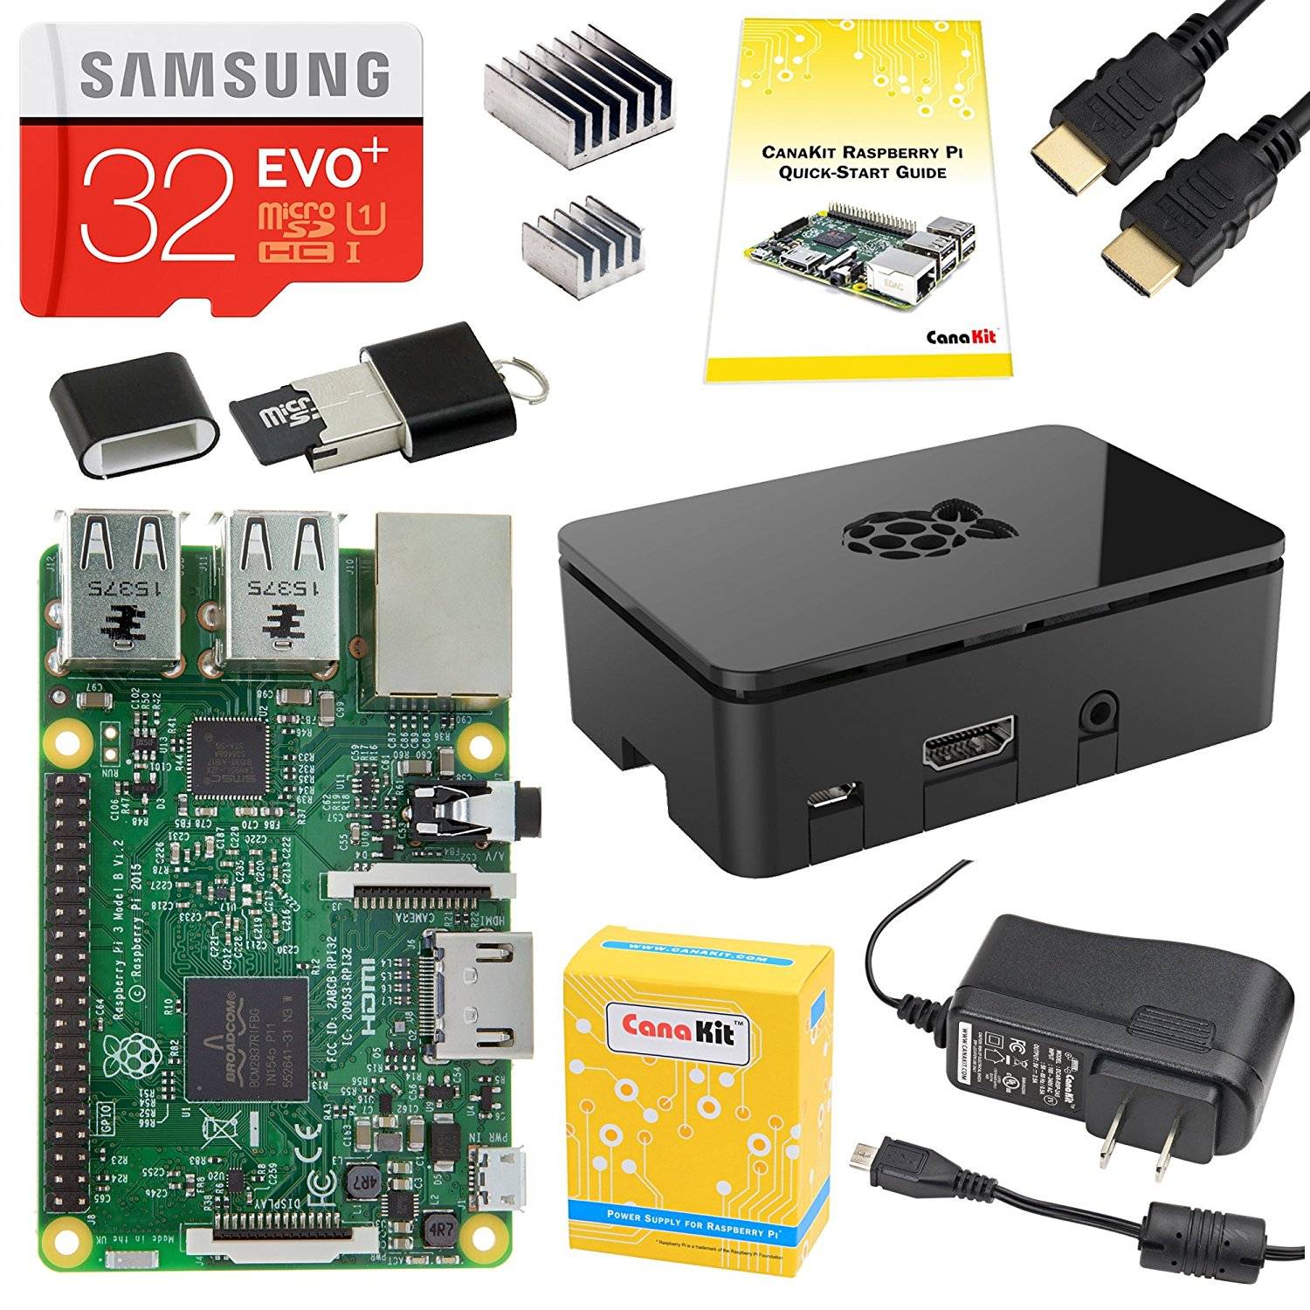

SMSL SA50 50Wx2 TDA7492 Class D Amplifier + Power Adapter
Price: $65.00
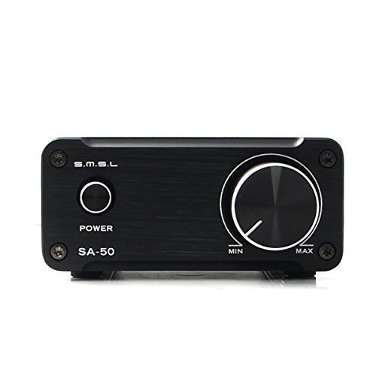

Total $587 + tax & shipping

