Building the sound exhibit on Raspberry Pi 4 JAN24

What we are building:

cat /etc/debian_version returns 11.8
bjones@brentypi:~ $ cat /etc/os-release
PRETTY_NAME="Raspbian GNU/Linux 11 (bullseye)"
NAME="Raspbian GNU/Linux"
VERSION_ID="11"
VERSION="11 (bullseye)"
VERSION_CODENAME=bullseye
ID=raspbian
ID_LIKE=debian
HOME_URL="http://www.raspbian.org/"
SUPPORT_URL="http://www.raspbian.org/RaspbianForums"
BUG_REPORT_URL=http://www.raspbian.org/RaspbianBugs

bjones@brentypi:~ $ uname -a
Linux brentypi 6.1.21-v8+ #1642 SMP PREEMPT Mon Apr 3 17:24:16 BST 2023 aarch64 GNU/Linux

Cana Pi starter kit pro with RP model 4 B

From raspberry pi imager from https://www.raspberrypi.com/software/
Choose Raspberry Pi 4 and Raspberry Pi Os (Legacy, 32-bit Debian bullseye)
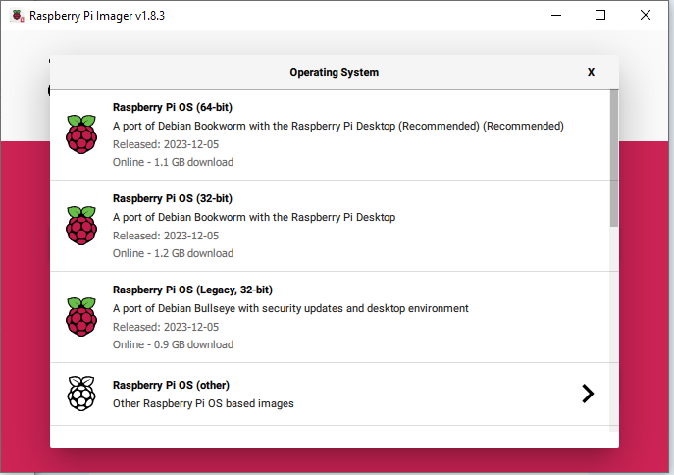

Choose button to customize op system

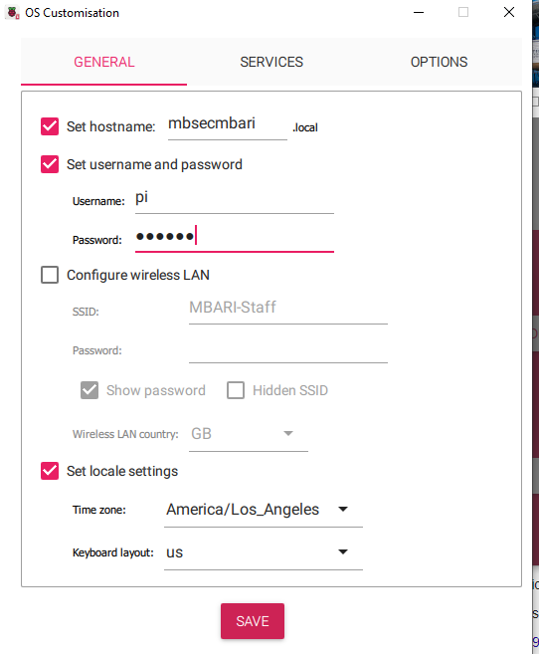

Set RP4B name to mbsecmbari. Set username to pi and password to MBARI1!

Save and then select use settings to let imager flash uSD card. Install in RP4B and boot

Now you should be able to install pipresents. Go to https://github.com/KenT2/pipresents-kms and follow the installation steps.

Copy the pp_deepsound_1p3 project to the ~/pp_home/pp_profiles directory. Copy the splashscreen.jpg and SECfiles dir to the /pp_home/media directory.

