2016 Annual Report

- For projects that will have longer write-ups this year (you will be contacted by Chris, Connor, or Nancy): Please follow the instructions below. Target length: 1,000 words.
- For new projects, or projects that had long write-ups last year but will be brief this year: Please provide a paragraph or two based on the instructions below.
~~~~~~~~~~~~~~~~~~~~~~~~~~~~~~~~~~~~~~~~~~~~~~~~~~~~~~~~~~~~~~~~~~~~~~~~~~~~~~~~~~~
Project title: A high-resolution bio-sensor to simultaneously measure the behavior, vital rates, and environment of key marine taxa
Project leads: Kakani Katija
Project manager: Kakani Katija
Collaborators: Tom Hurst and T. Aran Mooney (Woods Hole Oceanographic Institution), Kenneth Alex Shorter (University of Michigan), David Mann (Loggerhead Instruments)
Funding source: National Science Foundation, Instrument Development for Biological Research

Project summary
To address questions regarding marine animal behavior, physiology, and ecology, NSF funded the research team to develop innovative bio-sensor technology (the invertebrate tag, or ITAG) for keystone, soft-bodied invertebrates, such as squids and jellies. The ITAG simultaneously measures fine-scale animal behaviors and samples high-resolution physical-biogeochemical environmental data. Importantly, these data are sampled affixed to the organism across temporal and spatial scales relevant to the animal, providing vital information about their basic biology and community interactions. The team initially integrated light, external temperature, and additional pressure sensors with accelerometers and magnetometers in a tagging package to study and characterize squid behavior in the laboratory (Fig. 1a). In addition, engineers on the team are currently miniaturizing and testing sensors for dissolved oxygen and salinity, which will be integrated into the new tagging package in early 2017. We have also tested deployment methods and collected behavioral data of swimming jellyfish at the Monterey Bay Aquarium (Fig. 1b). Our first squid field deployments are planned in Spring of 2017 in Azores, Portugal, with jellyfish deployments planned for Monterey Bay in the Fall. The eventual ability to link behavioral and environmental data from free-ranging soft-bodied invertebrates will enable the study of baseline animal activity and climate-related environmental changes—such as ocean acidification and the ocean carbon cycle—which have the potential to significantly affect the health of the ocean.

Figures
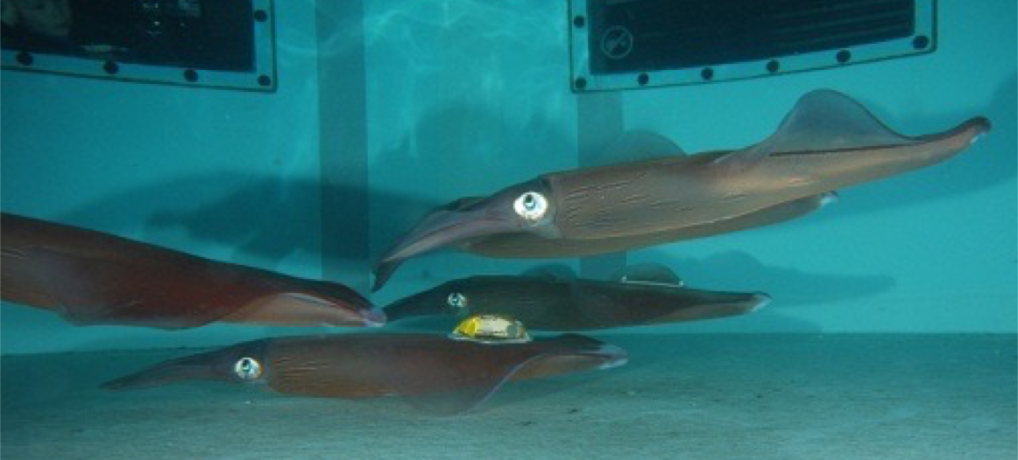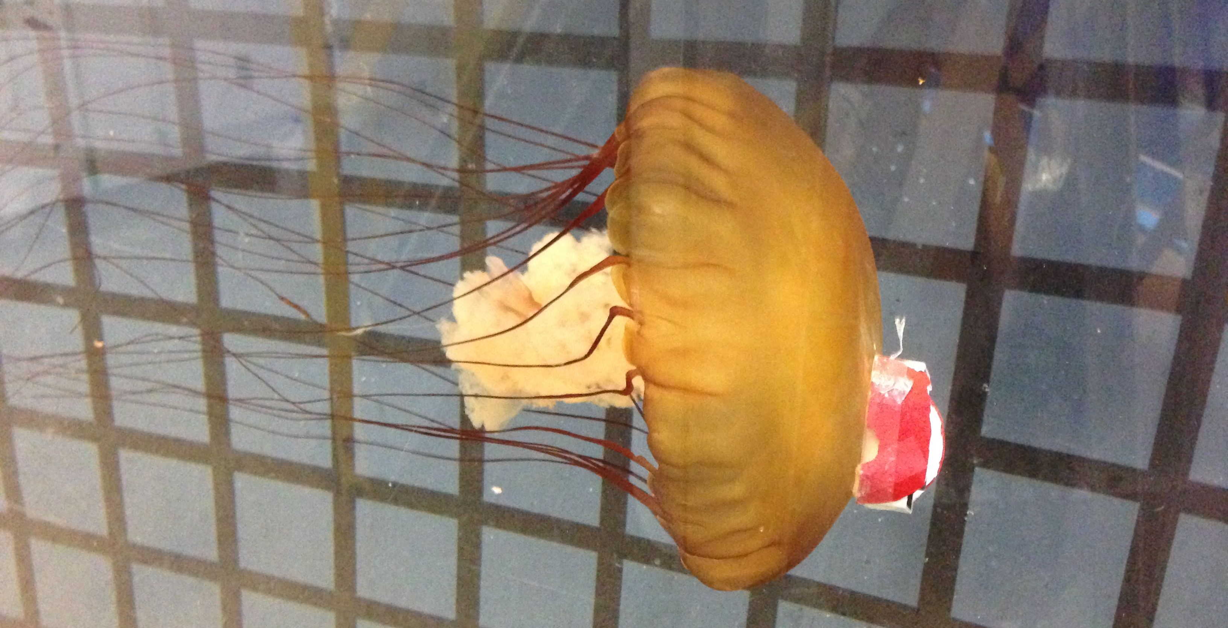
A B
Figure 1. The invertebrate tagging package or (ITAG) affixed to (A) squid (Loligo forbesi) and (B) jellyfish (Chrysaora fuscescens) maintained in the laboratory. Photo credits: Jorge Fontes and Kakani Katija.
~~~~~~~~~~~~~~~~~~~~~~~~~~~~~~~~~~~~~~~~~~~~~~~~~~~~~~~~~~~~~~~~~~~~~~~~~~~~~~~~~~~
Project title: DeepPIV: Measuring fluid motion in the deep sea
Project leads: Alana Sherman
Project manager: Kakani Katija
Project team: Dale Graves, Chad Kecy, Denis Klimov, Jon Erickson
Collaborators: Bruce Robison and Jim Barry (MBARI)

Project summary

Marine organisms feed, avoid predation, and reproduce under ever-changing conditions in the ocean environment. While undergoing these functions, organisms are generating a variety of signals that are observed by other predators and prey. In addition to chemical, visual, acoustic, and electromagnetic signals, organisms create and detect hydromechanical cues in the water column that elicit a variety of ecologically beneficial behaviors. However, studies of hydromechanical cues in the ocean are lacking due to our inability to measure those processes at size and time scales experienced and elicited by marine organisms in the ocean. To address this need, we have been developing DeepPIV, an instrument that enables fine temporal and spatial scale measurements of fluid motion in situ. In 2016, DeepPIV was successfully integrated on all of MBARI’s ROV assets, and was used during midwater and benthic cruises with Bruce Robison and Jim Barry. These efforts resulted in expanding the utility of DeepPIV, while addressing several science questions related to the ecomechanics of larvaceans and deep sea corals sand sponges.

Using DeepPIV, we were able to measure the filtration rates of two species of giant larvacean (genus Bathochordaeus), with values up to 80 L/hr (Fig. 2A). To determine whether larvacean houses passively select and concentrate particles of a given size range, we modified DeepPIV’s dye injector to use microplastic particles. In situ feeding experiments, where microplastics were injected into the water column and later filtered, ingested, and packaged into fecal pellets, revealed a novel mechanism for microplastic transport from the surface to the benthos (Fig. 2B). Finally, efforts with Jim Barry during the Benthic Ecology cruise at Sur Ridge yielded dye visualizations of sponges pumping (Fig. 2C), and the first-ever DeepPIV measurements of flow produced by sponges and coral in situ (Fig. 2D). We also collected deep-sea sponges and conducted on-ship laboratory measurements of flows, where sponges were actively pumping and extracting particles from fluid in the tank (Fig. 2E). Future DeepPIV efforts involve partnering with scientists at other oceanographic institutions to further expand its utility

Figures
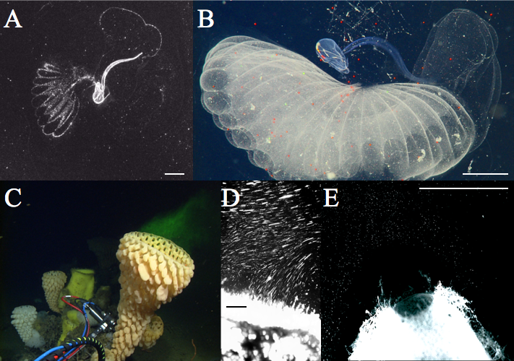
Figure 2. (A) DeepPIV reveals flow inside the mucus house of a giant larvacean, (B) in situ feeding studies using microplastics, (C) DeepPIV dye injections reveal sponge pumping dynamics, (D) in situ and (E) laboratory flow measurements of sponges from Sur Ridge. Scale bars indicate 2 cm.
~~~~~~~~~~~~~~~~~~~~~~~~~~~~~~~~~~~~~~~~~~~~~~~~~~~~~~~~~~~~~~~~~~~~~~~~~~~~~~~~~~~

Addenda
Include the accomplishments of all members of your group who are MBARI employees.
- Awards
NSF-OTIC, Mesobot funding award with WHOI, Univ. Texas, MBARI and Stanford

- Degrees awarded
N/A

- Patents issued
N/A

- Invited lectures
Hopkins Marine Station of Stanford University, Pacific Grove, California
California State University, Monterey Bay, Seaside, CA
American Physical Society, Division of Fluid Dynamics Meeting, Portland, OR
American Society of Limnology and Oceanography: Ocean Sciences Meeting, New Orleans, LA
Society of Integrative and Comparative Biology Meeting, Portland OR
Department of Ocean Resources Engineering, University of Hawaii, Manoa, HI
Department of Mechanical and Biomedical Engineering, Boise State University, Boise, ID
Department of Biology, Occidental College, Los Angeles, CA
Department of Zoology, University of British Columbia, Vancouver, Canada
Department of Integrative Biology, University of California, Berkeley

- Mentorships
Diana Li, Biology Graduate Student, Hopkins Marine Station, Stanford University
Nadege Aoki, Biology Undergraduate Student, Cornell University
Natalia Mushegian, Molecular and Envir. Biology Undergraduate Student, Univ. of Calif., Berkeley

- Publications
Fossette S, Katija K, Goldbogen JA, Bograd S, Patry W, Howard MJ, Knowles T, Haddock SHD, Bedell L, Hazen EL, Robison BH, Mooney TA, Shorter KA, Bastian T, Gleiss AC (2016). “How to tag a jellyfish? A methodological review and guidelines to successful jellyfish tagging.” Journal of Plankton Research, doi:10.1093/plankt/fbw073.

- Other
Katija K, Sherman AD, Robison BH (2016). “DeepPIV: Fluid visulizations from the ocean surface to the seafloor.” APS-DFD Gallery of Fluid Motion, doi:10.1103/APS.DFD.2016.GFM.V0085.

Place text and figures in \\atlas\tempbox\barr\2016AnnualReport
>> Deadline: Noon, January 13, 2017 <<

