Plastic waste can be found in nearly all marine environments, and ecosystem impacts from this widespread contamination range from physical and biological, to chemical effects. The distribution and fate of plastics in open ocean ecosystems are poorly known even though these offshore waters comprise the largest living space on the planet. Communities of deep-sea animals form complex food webs from which humans harvest and consume a variety of species, making it important to understand the patterns and processes by which these pollutants are distributed. Within the open ocean, plastics have been globally documented in the surface water and in seafloor sediments of the deepest ocean basins. The mechanisms through which these plastics are transported from the surface to the seafloor, and the interactions with animals living throughout the water column are virtually unknown.

Microplastics (defined as < 5 mm in diameter) are the most numerically abundant types of plastic within the marine plastic debris field, and may exert the largest ecosystem-scale effects due to their extremely small sizes and potential for ingestion by pelagic organisms, ranging from zooplankton to large predatory fishes. However, the biological impacts on organismal feeding, growth, reproduction, and mortality are poorly known, in part because there is a lack of in situ data on the ingestion and fate of microplastics. To better understand the ability of midwater organisms to ingest and process microplastics, in situ feeding experiments were conducted with abundant filter-feeding larvaceans in Monterey Bay, which were enabled by the concurrent instrument development of DeepPIV at MBARI.

Larvaceans, or appendicularians, are highly abundant filter feeders that can be found throughout the ocean. Larvaceans build complex mucus filters that form a “house” in which the animal lives and filters food particles from the water column. Giant larvaceans of the genus Bathochordaeus are generally an order of magnitude larger than most other larvacean species, constructing mucus houses that can reach 1 m in diameter. Once clogged, giant larvaceans abandon their houses and then construct new mucus structures on a daily cycle. Past work by MBARI scientists has shown that discarded Bathochordaeus houses sink rapidly to the seafloor and contribute significantly to the vertical transport of carbon to the deep sea. Recent efforts using DeepPIV at MBARI have measured filtration rates as high as 80 L/hr for giant larvaceans, which comprise the highest reported rates of filtering by midwater organisms. When extending the filtration impact to the population level, giant larvaceans have the potential to filter all of the seawater within their principal depth range in Monterey Bay, in as little as two weeks. Due to this extremely high filtering capacity and the similarity in size of microplastics and their principal food particles, giant larvaceans may be significantly concentrating, ingesting, and transporting these pollutants through the water column.

In order to evaluate whether larvaceans ingest microplastics, and to determine the size range of ingested particles, additional instrumentation was required. Since early 2015, engineers and scientists (led by Electrical Engineering Lead Alana Sherman and Postdoctoral Fellow Kakani Katija) have been developing DeepPIV, an instrument that allows for the visualization and quantification of small-scale fluid motion (Fig. 1). In 2015, DeepPIV was built and integrated on MBARI’s MiniROV. By the end of 2016, DeepPIV was integrated on all of MBARI’s ROVs (Fig. 1). In addition to camera and laser housings, DeepPIV was originally equipped with a dye injector, which was used to release fluorescent dyes to qualitatively visualize in situ fluid motion. The dye injector was modified to allow for the passage of microplastic particles for particle injection studies. This modification enabled in situ feeding experiments of filter-feeding organisms, like larvaceans, during subsequent midwater cruises.

In 2016 MBARI scientists injected microplastic particles into the houses of actively feeding giant larvaceans (specifically Bathochordaeus stygius) during Midwater Ecology Cruises with Senior Scientist Bruce Robison and Postdoctoral Fellow Anela Choy. Microplastics were observed to enter the inner filters; the particles that did not attach to the mucus house were ingested (Fig. 2) and later processed into fecal pellets (Fig. 3). Unlike microplastics in the water column, microplastic particles trapped within the collapsed filters of discarded Bathochordaeus houses and their fecal pellets would travel quickly to the seafloor. These relatively fast sinking rates (~500 m/day) would reduce the likelihood of interception, consumption or degradation during their descent.

Results from this work present a novel biological transport mechanism that could move large amounts of microplastics rapidly from shallow waters into the deep sea. Since discarded houses and fecal pellets of giant larvaceans (in addition to the larvaceans themselves) are widely consumed by other pelagic, midwater, and benthic animals, microplastics could be easily transported through marine food webs. Understanding the rates at which microplastics are concentrated by larvaceans and other pelagic filter-feeders and then sink into deep water, will be needed to evaluate the overall impact of microplastics on marine food webs and nutrient cycling in the ocean. Fortunately, with technological developments at MBARI that include instrumentation like DeepPIV, these topics can be directly addressed in the near future.

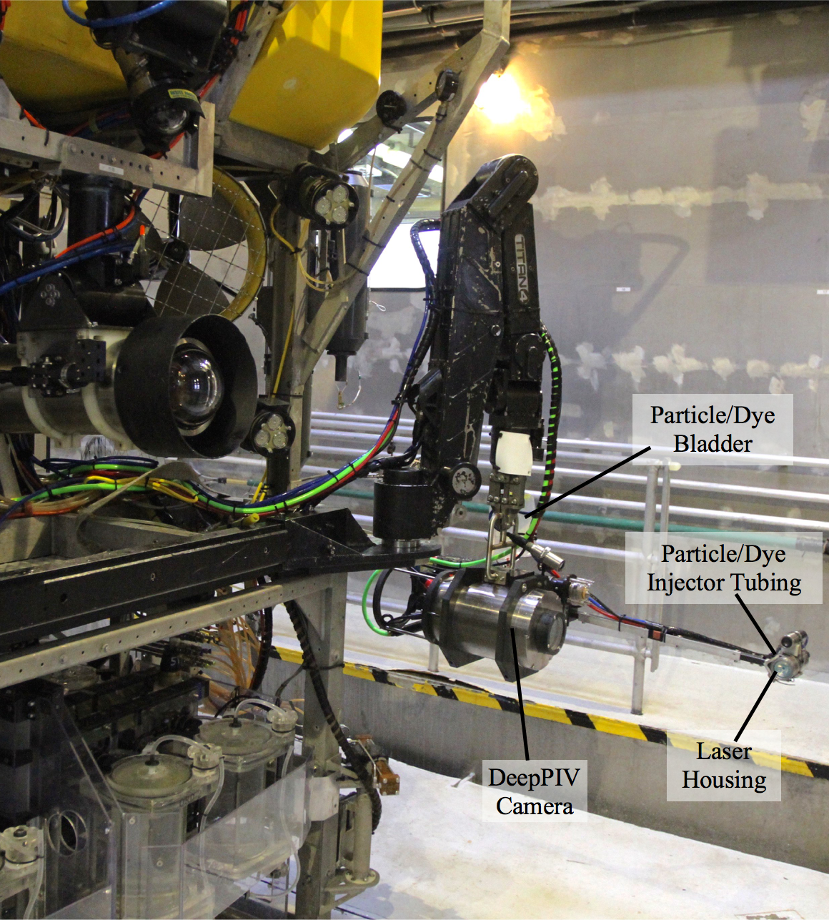
Fig. 1. Experiments were conducted on board R/V Western Flyer using DeepPIV’s particle injector deployed from ROV Doc Ricketts.

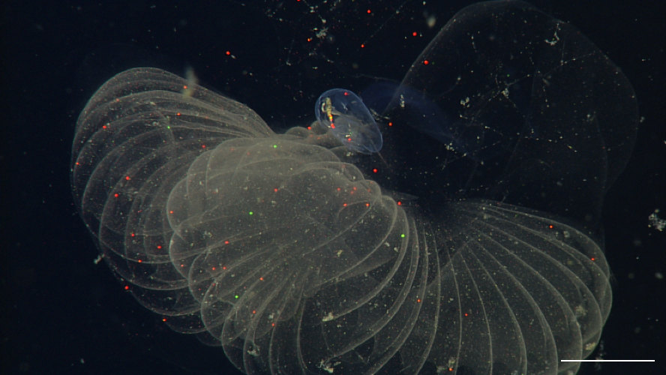
Fig. 2. During feeding experiments, microplastics were observed inside and attached to the inner house, and inside the gut of giant larvaceans. Microplastic particles are represented by different colors (e.g., red, yellow, green, orange). Scale bar corresponds to 2 cm.

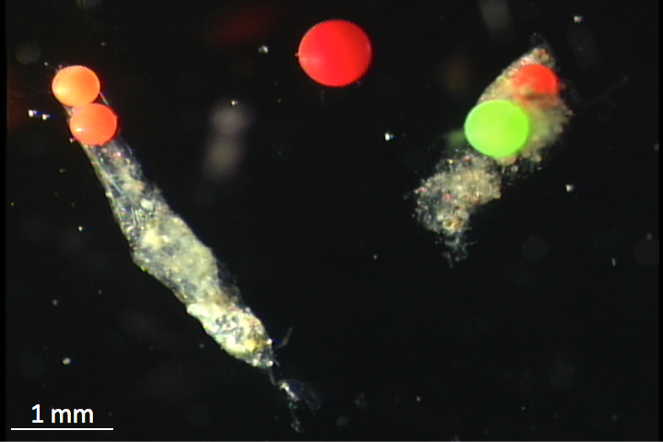
Fig. 3. Collected giant larvaceans were maintained in a cold room, and fecal pellets contained microplastics.

