Kakani Katija and Alana Sherman
DeepPIV: From the surface to the benthos
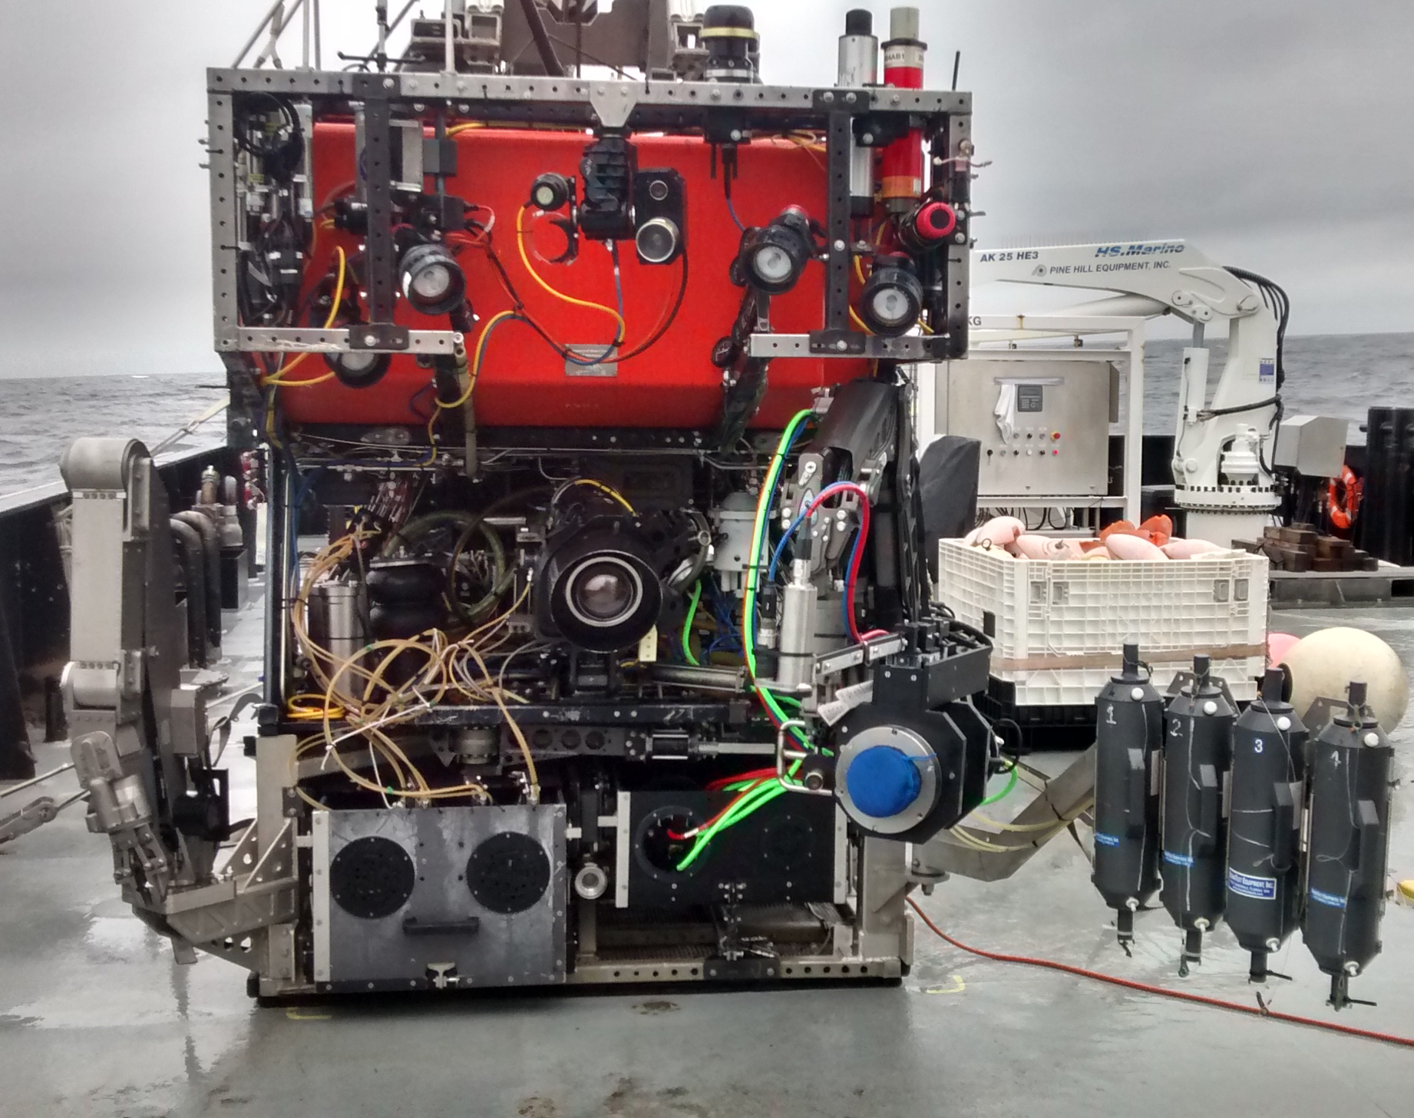 Figure 1. DeepPIV integrated on Rachel Carson’s port manipulator during a test cruise (for benthic operations) in October 2016.
Since the start of 2015, we have been developing DeepPIV, an instrument that enables fine temporal and spatial scale measurements of fluid motion in situ. Since then, we have built and integrated DeepPIV on all of MBARI’s ROVs. In the fall and winter of 2016, DeepPIV was used during both midwater (with Bruce Robison and Postdoctoral Fellow Anela Choy) and benthic (with Jim Barry and Postdoctoral Fellow Joshua Lord) cruises along with dedicated DeepPIV cruise days on R/V Rachel Carson. These efforts resulted in expanding the utility of DeepPIV, while addressing several science questions including the following:
- What are the structures and mechanisms that describe the function of larvacean houses? How does that affect their ability to feed on a range of particle sizes and compositions?
- How do benthic organisms survive in a highly variable, dynamic environment? How is feeding of benthic organisms (including deep sea corals and sponges) linked to environmental flows, and do feeding mechanisms change in response to their environment?
- What are the distributions of microplastics between the surface and the benthos? How do we conduct vertical transect sampling routines that are robust and repeatable during midwater cruises to most accurately quantify environmental microplastics?
We have continued our efforts to measure and describe larvacean mucus houses in situ using DeepPIV’s scanning capabilities. These efforts have culminated in scans of four different larvacean species’ houses (including Bathochordaeus stygius; image A and B), which are currently being prepared for a publication. Working closely with Postdoctoral Fellow Joshua Lord and Jim Barry, we have made headway in developing tools and techniques for simultaneously sampling fluid adjacent to and filtered by deep-sea sponges while also measuring organism filtration rates using DeepPIV (see Figure 1). These investigations will yield vital information in our understanding of deep-sea sponge ecology and the feeding impact of these communities on larger scale processes in the ocean. Finally, DeepPIV is being used to quantify the Doc Rickett’s suction sampler volumetric flow rate during microplastic sampling (image C and D) to determine the presence, type, distributions, and/or densities of environmental microplastics. Future DeepPIV efforts involve partnering with scientists at other oceanographic institutions to further expand its utility.
Publications and Presentations (* - shared first authorship)
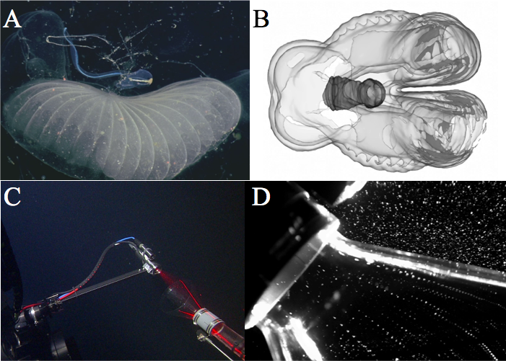Figure 2. (A) Giant larvacean Bathochordaeus stygius in house using white-light illumination. (B) DeepPIV scans yield three-dimensional reconstructions of the larvacean house structure. (C) DeepPIV has also been used to quantify volumetric flow rates into the suction sampler, streaklines of incoming particles shown in (D), for determining environmental concentrations of plastics in midwater.

- Katija K., Sherlock R.E., Sherman A.D., Robison B.H. (2017), New technology reveals role of giant larvaceans in oceanic carbon cycling. Conditionally accepted by Science Advances.
- Katija* K., Choy* C.A., Sherlock R.E., Sherman A.D., Robison B.H. (2017). From the surface to the seafloor: How giant larvaceans can move microplastics into the deep sea. Submitted.

