Kakani Katija
Deep Sea Bioinspiration
Since the summer of 2017, we have been establishing the Bioinspiration Lab at MBARI, whose core team members are involved in developing tools, deploying instrumentation, and conducting laboratory studies of midwater and benthic organismal ecomechanics for bioinspired engineering design applications. These efforts involve engineering, scientific, and administrative tasks, which include the following:
Engineering activities:
- Integrating a new laser on DeepPIV that will double the illumination power output from the current version (Figure 1A). We acquired two Coherent, 2 W, 639 nm continuous DPSS lasers in the Fall of 2017, and are testing both systems with planned integration for June 2018 deployments.
- Conducted a feasibility study to conduct 3D measurements using plenoptic imaging hardware called EyeRIS. We are in the process of testing similar hardware on loan to use from NOAA, and working with partners at NOC and Henry Ruhl (CenCOOS) to fund the initial acquisition of hardware.
Scientific activities:
- The DeepPIV instrument has been deployed on nearly 80 ROV dives since Summer of 2015. These efforts have largely been conducted during midwater dives, with deployments during benthic dives planned with Senior Scientist Jim Barry in Summer 2018.
- During our last midwater cruise with Senior Scientist Bruce Robison, we successfully conducted 3D reconstructions of mucus houses of a relatively rare larvacean, Mesochordaeus. This effort was especially challenging due to the fragile mucus house, and could not have been accomplished without the masterful skills of MBARI’s ROV pilots.
- We are working closely with the Video Lab to streamline the annotation and analysis of DeepPIV data, and the subsequent integration of the data in VARS.
Administrative activities:
- Establishing the Laser Lab, a shared-use space that will enable safe operation of lasers at MBARI (Figure 1B).
- Assisting with LRAUV lab and cubicle renovations to enable more effective use of shared space over multiple engineering development projects (Figure 1C and D).
- Hiring (1) an NSF-funded Research Assistant as part of a collaboration with MBA and Hopkins Marine Station, to study jellyfish movement ecology by deploying animal-borne sensor packages; (2) searching for a Research Engineering Technician who will support all activities of the Bioinspiration Lab; and (3) NSF-funded Machine Learning Postdoctoral Researcher as part of a collaboration with Steve Rock (Stanford) to enable robust, automated tracking algorithms of state-changing midwater targets on autonomous vehicles.
- Establishing the Deep Ocean Inspiration Group. External members of the working group come from diverse backgrounds (e.g., optical physics, materials science, computational physics, mathematics, experimental fluid mechanics, and organismal biologists), whose shared interests stem from bio-inspired engineering design. Members will participate in the Bioinspiration Lab’s planned research cruises in 2018.
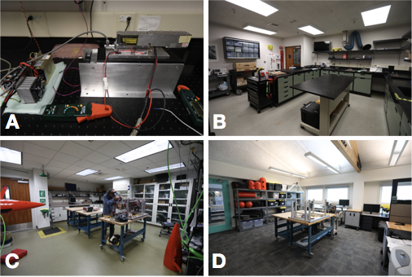
Figure 1. Activities of the Bioinspiration Lab include (A) testing and integration of a new laser, establishing the (B) Laser Lab, (C) reorganizing the LRAUV lab space and (D) cubicle area for more effective use of shared space.
Publications and Presentations (* - invited talk, underline – advised student)
- Yoerger D, Breier JA, Curran M, Fujii J, German CR, Gomez-Ibanez D, Govindarajan A, Hobson B, Howland J, Katija K, Llopiz J, Pontbriand C, Risi M, Robison BH, Rock S, Wiebe PH (2018). “Mesobot: An autonomous underwater vehicle for tracking and sampling midwater targets.” ASLO Ocean Sciences Meeting, February 11-16, Portland, OR.
- Mooney TA, Flaspohler GE, Caruso F, Katija K, Fontes F, Afonso P, Shorter KA (2018). “Fine-scale locomotion patterns of the veined squid, Loligo forbesi, measured using a novel bio-logging tag.” ASLO Ocean Sciences Meeting, February 11-16, Portland, OR.
- Katija K, Sherman AD, Sherlock RE, Robison BH (2018). “DeepPIV: Elucidating small-scale zooplankton-particle interactions in the deep sea.” ASLO Ocean Sciences Meeting, February 11-16, Portland, OR.
- Katija K, Sherlock RE, Sherman AD, Robison BH (2018). “DeepPIV reveals how mucus houses of deep sea, giant larvaceans are built.” Society of Integrative and Comparative Biology Annual Meeting, January 3-7, San Francisco, CA.
- Katija K* (2017). “DeepPIV: Measuring carbon fluxes in the mesopelagic using particle image velocimetry.” Pump It Up Workshop, September 28-29, Woods Hole, MA.
- “From outer to inner space: How exploration leads to inspiration.” Stanford Women’s Perspectives Seminar, Stanford University, January 25th, 2018. Palo Alto, CA.
- “DeepPIV: Measuring small-scale fluid motion in the deep sea.” Stanford Fluid Mechanics Seminar Series, Stanford University, November 28th, 2017. Palo Alto, CA.
- “New technology enables the study of biomechanics, functional morphology, and ecology of giant larvaceans in the deep sea.” Ocean Sciences Seminar Series, University of California, Santa Cruz, October 13th, 2017. Santa Cruz, CA.
- “New technology enables the study of biomechanics, functional morphology, and ecology of giant larvaceans in the deep sea.” Joint Biology and Physics Seminar Series, Bates College, September 26th, 2017. Lewiston, ME.

