Fiber Optic MinCon Seal
Jim Scholfield 6/27/18

This adaptor is used to secure and seal 1 or more fiber optic lines in a mincon compatible bulkhead connection. Typically oil filled on the wet (pressure) side. Original design came out of Laser Ramon 2004.
2 sealing materials are required. The primary water and pressure seal needs to be a hard epoxy. The second sealing material could be a softer epoxy or an oil tolerant polyurethane. This 2nd material acts as a strain relief for the fiber where it enters the adaptor.
Materials Required-
Hard Epoxy such as LocTite E-60NC, low viscosity, hard, Shore 80D, non corrosive. Only problem with 60NC is the 60 min work time combined with low viscosity which allows a little too much dripthru the holes the fibers pass thru. A near equivalent with a 10-20 min work time would work much better and simplify the process. I strongly Suggest LocTite E-30CL, excellent with fiber optics, very strong, medium viscosity, 30 min worklife.
Flexible epoxy such as 3M DP 105, or Loctite E-05CL, or even ScotchCast 2123, a very soft reenterable sealant, can be used as the additional sealant/strain relief on the oil filled side. It is not a urethane so is oil tolerant.
Flexible Urethane adhesives such as Loctite U-09FL can be used on the dry side but are incompatible with oil.
Large work surface to properly lay out exposed fiber optic tubing without kinks or otherwise jeopardizing the fibers
Stands stable enough to hold the Tubing ass’ys esp. if SS as shown.
Enough clamps to hold and align the adaptors and tubing vertically
Acetone for cleaning surfaces
Wipes, small cotton tipped swabs, proper applicator guns for epoxy and sealants used
Rubber gloves

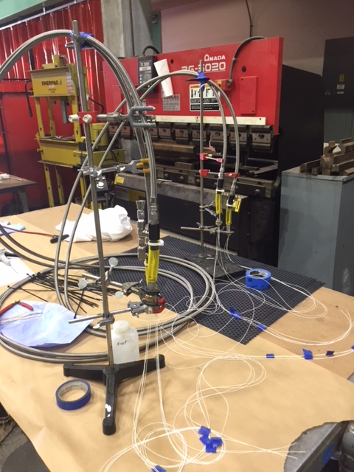

PROCEDURE—
Good idea to have end to end light check on fibers so know OK to connectorize ends
The 1st step is carefully cleaning the inside of the connector/adaptor, both ends, with acetone using a cotton swab. Careful of fibers.
Carefully set up similar to above being especially careful of fibers
The process requires the connector to be separated from the clear tubing by a ½” or so. When epoxy is set the fibers will have to be pushed back into the hose 1” or more to allow a clamp on the hose. Make sure the fibers have enough slack to move back without kinking.
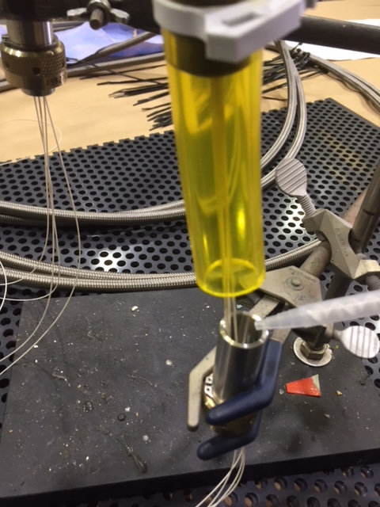

Use the hard epoxy on the backside(pressurized) to effect a pressure seal . fill about 2/3 full. (I did a small amount to start knowing some would drip thru, when that had set I poured the remainder. A thicker faster epoxy would not require this.)
In either case, slide the fibers carefully up and down a few times for ½” or so to pull epoxy into the holes the fibers pass thru. Some small amount of drip thru is OK.
Notice the dripthru and straightness of fibers above and below the connector. If possible wipe excess away, a smear is OK. Important to keep fibers from adhering to each other or the connector inner wall. This is a difficult and time consuming task but well worth it in finished product.

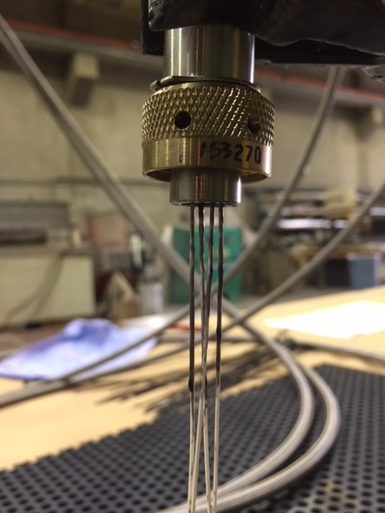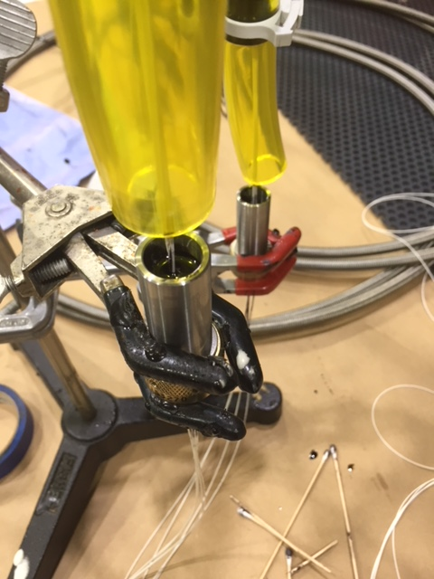

At this point the softer sealing material can be used to fully fill the back of the connector.
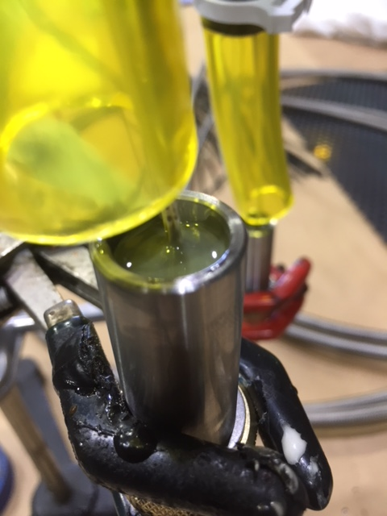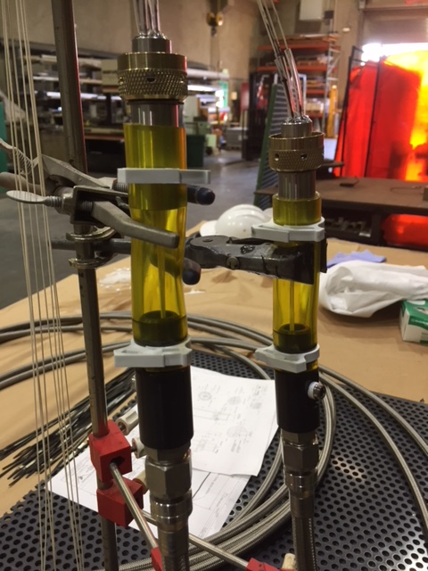

Slide the clear tubing over the connector, carefully to allow the fibers to slide and not kink. Clamp.
Carefully demount then remount the connector and hoses so the dry side is uppermost. Be especially careful of the loose unsupported fibers.

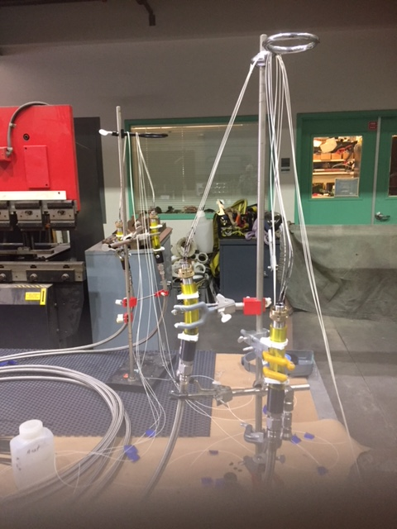

Basic set up for filling front(dry) side. Note keeping fibers organized.
Carefully clean blobs or joined fibers close to the connector to allow the small tygon tubing to slide into the connector. This proved to be a daunting and perilous task on fragile fiber optics. I opted to leave fibers adhered to the inner connector wall and not risk damage to the fiber.

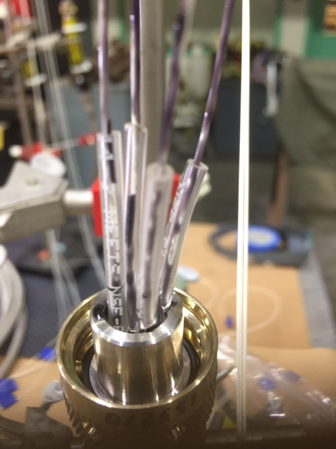

Carefully slide tygon into position ~3/8” into connector.
Backfill this ass’y with a soft epoxy or urethane. U-09FL worked very well here

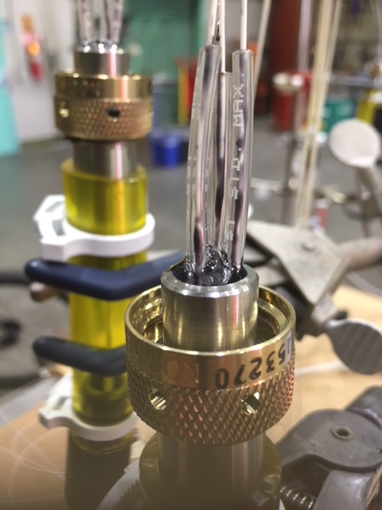
Recheck entire ass’y for integrity of fibers.

kkkkkk
Notice

