Project Number: | 901506

Project Start: Jan. 1, | 2015 | Project Duration (in years): | 2 ¹

Please indicate if proposal includes requests for any of the following (mark all that apply).

 | x |  |  | x |  |  |  |  |  |  |  |  | x
Ship Time |  |  | ROV |  |  | AUV |  |  | Wave Glider |  |  | Mini-ROV

Please indicate what type of project is being proposed (mark only one).

 |  |  |  | x
Feasibility/Scoping  [Less than 100 days effort] |  |  | Development |  |  | Research |  |  | Infrastructure² |  |  | Education
 |  |  | Time Series |  |  | Institute Initiative
Project Manager: Kakani Katija
Principal Investigator: Alana Sherman
Lead Scientist: Kakani Katija
Lead Engineer: Alana Sherman

Project Title: Measuring in situ fluid motions using ROV-deployed particle image velocimetry (DeepPIV)

- ABSTRACT (new projects only)

Project Description:
Marine organisms feed, avoid predation, and reproduce under ever-changing conditions in the ocean environment. While undergoing these functions, organisms are generating a variety of signals that are observed by other predators and prey. In addition to chemical, visual, acoustic, and electromagnetic signals, organisms create and detect hydromechanical cues in the water column that elicit a variety of ecologically beneficial behaviors. However, studies of hydromechanical cues in the ocean are lacking due to our inability to measure those processes at size and time scales experienced and elicited by marine organisms in the ocean.
Here we propose to develop DeepPIV, an instrument that will optically capture the motion of suspended ambient particles using a laser sheet and high-resolution camera. This instrument is loosely based on a self-contained underwater velocimetry apparatus (SCUVA; Fig. 1), which is used in near-surface waters and is operated by a SCUBA diver. To conduct measurements of fluid velocity in midwater and deep-sea environments, we will deploy a commercially available laser and optics to interface with MBARI’s ROVs, illuminating a sheet of fluid perpendicular to the science camera. The ROV’s main science camera will capture the motion of the laser-illuminated particle field over time, and post-processing algorithms will quantify fluid velocity. DeepPIV will provide us with the tools necessary to explore a variety of topics including siphonophore (an effective predator of forage species in Monterey Bay) ecology and larvacean house flows (filtration rates are important to nutrient cycling). In addition, DeepPIV can be used to elucidate many other ocean processes (e.g., benthic fluid exchange) and inform engineering studies on propulsion and bio-inspired design.
This project is intended to be a two-year effort with very specific goals:
2015 | - Acquire a 1 W, continuous, 671 nm laser with optics providing a spread angle of 90 degrees  - House laser (head and power supply) and optics in 4000 m housing featuring a flat-port optical window  - Interface (electrical, mechanical, and communications) the housing with MBARI’s ROVs  - Calibrate and utilize the on-board, high-definition, science camera to capture suspended particulate motion  - Deploy the laser housing during midwater cruises and analyze/evaluate resultant images
2016 | - Conduct a feasibility study to determine whether a separate camera and housing should be used for remote deployments  - Acquire camera and interface new camera with existing system  - Publish and present results and instrument development

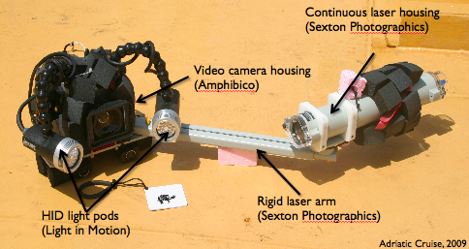
Figure 1. The components of a self-contained underwater velocimetry apparatus. For scale, the video camera housing is used underwater by a single scuba diver.
- PROPOSAL

  - New Projects

Statement of the problem, why it is important

The ability to directly measure velocity fields in a fluid environment is necessary to provide empirical data for studies in fields as diverse as oceanography, ecology, biology, and fluid mechanics. Field measurements introduce practical challenges such as environmental conditions, animal availability, and the need for field-compatible measurement techniques. To avoid these challenges, scientists typically use controlled laboratory environments to study animal-fluid interactions (see Fig. 2 for examples of data using the particle image velocimetry or PIV technique). However, it is reasonable to question whether one can extrapolate natural behavior (i.e., that which occurs in the field) from laboratory measurements. Therefore, in situ quantitative flow measurements are needed to accurately describe animal swimming in their natural environment.
In prior work, we designed a self-contained, portable device that operates independent of any connection to the surface, and can provide quantitative measurements of the flow field surrounding an animal. This apparatus, a self-contained underwater velocimetry apparatus (SCUVA; Fig. 1), can be operated by a single scuba diver in depths up to 40 m. However, SCUVA is limited by the technology it employed: 1) measurements are limited to depths of 40 m; 2) the laser power is limited due to the use of battery-powered laser technology, thereby limiting the size of science targets; 3) the measurements are limited to 30 Hz, thereby limiting the flow rates that can be accurately resolve. Here, we will address these limitations by the development and deployment of DeepPIV, an ROV-deployable instrument that quantifies in situ fluid motions in near-surface, midwater, and benthic deep-sea environments.

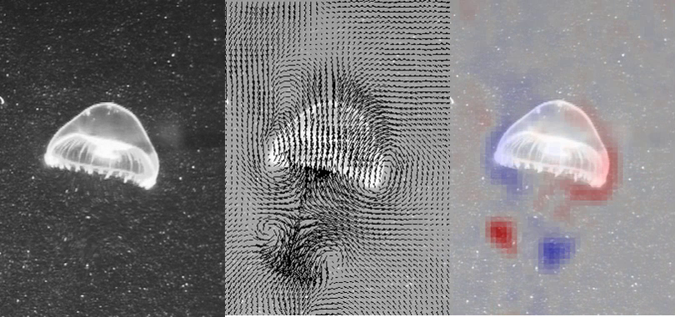
Figure 2. (Left) Raw particle field images, (center) resultant velocity fields, and (right) vorticity (measure of fluid rotation) fields induced by swimming Aequorea victoria.

How does it relate/contribute to MBARI’s mission and strategic plan?

The development and future deployment of DeepPIV contributes to MBARI’s mission and strategic plan in many different ways. We plan to develop and adapt innovative technologies that are traditionally reserved for laboratory environments to allow researchers to identify and resolve important questions related to fluid mechanics and transport that will advance our understanding of the ocean. Since the engineering development and deployment of DeepPIV are inherently linked to the science questions, we will explore how natural ocean systems (a fluid environment) operate and respond to change. Importantly, we hope to transfer the knowledge gained and technology developed by DeepPIV to communities outside MBARI by making video and data available through MBARI, by publishing our methods and solutions in peer-reviewed journals, and presenting our work at national and international engineering and science conferences. In addition, we hope to make the DeepPIV technology available to other academic and research institutions by providing expertise and assistance in adding our advanced capability to other ROVs.

If successful, DeepPIV will directly contribute to three separate research themes at MBARI. DeepPIV will assist with the Exploration and Discovery theme by providing a new framework to understand how the environment and biology are intricately linked in the world ocean and in Monterey Bay. DeepPIV will leverage and hopefully later contribute to advanced imaging technologies at MBARI to create detailed fluid visualizations of the water column and benthic environments, which are important goals in the Ocean Visualization theme. Finally, DeepPIV will contribute to our knowledge of Ecosystem Dynamics, where the transfer of matter and life between the ocean surface and deep sea operates within physical limits that are constrained by fluid mechanics. DeepPIV will provide the ability to understand these important processes and themes at the size and time scales relevant to biology in the ocean and Monterey Bay.

How does it relate/contribute to the Packard Foundation’s Ocean Visions Grantmaking policies? (See http://mww.mbari.org/oed/OED_Documents3.htm#Packard for documents.)

The development and future deployment of DeepPIV will contribute to the Packard Foundation’s Ocean Visions Grantmaking policies by enhancing our scientific understanding of how marine ecosystems function, which will contribute to the Foundation’s long-term goal of restoring health and productivity of the world’s oceans and coasts. DeepPIV will first be engineered for deployment on MBARI’s ROVs (Doc Ricketts, Ventana, and Mini-ROV), with the long-term goal of being deployable on most commercially-available ROVs. This will allow us to expand our research focus from Monterey Bay and Gulf of California to other locations that the Packard Foundation is focused on, which may include the Western Pacific.

Does it relate to the Technology Roadmap? If so, please describe how.
(See http://www.mbari.org/about/TechnologyRoadmap.pdf.)

DeepPIV relates to the Technology Roadmap by taking the laboratory into the ocean. The development of DeepPIV will provide novel instrumentation and framework to understand the determinants of organism survival by elucidating the physical constraints imposed on biology by their fluid environment. By taking a measurement technique that is normally limited to the laboratory and deploying it in near-surface, midwater, and benthic environments, DeepPIV will enable new ways for conducting experiments on feeding and predation of animals under ambient conditions. In addition, DeepPIV instrumentation and deployment protocols can be modified to enable identification and quantification of biomass and particulate concentrations in the oceans. Future deployments of DeepPIV could be AUV-borne, which will then advance MBARI’s persistent presence and can be used to characterize inhomogeneous flow conditions during AUV sampling.

The development and deployment of DeepPIV can be used to address topics within Ecosystem Processes, Ocean Visualization, and Exploration and Discovery. The data collected by DeepPIV can answer key questions about the biological pump, and contribute quantitative information about the flux of material generated at the sea surface and its transport to the seafloor. To understand the fate of forage species, DeepPIV can provide necessary inputs to coupled physical-biological models by quantifying the mechanics of feeding and predator avoidance. The fluid dynamics of the environment has been shown to affect the distribution and alter behavior of marine organisms. Hence, it’s important to study these physical processes at scales on the same order of organisms. Therefore, visualizing the ocean from the perspective of fluid motion will allow us to relate water column conditions to the activity and range of organisms. Finally, DeepPIV will enable us to conduct experiments to provide understanding of our future ocean.

Approach to the problem

Our approach to the development and deployment of DeepPIV is to minimize the acquisition of new resources, reuse existing hardware at MBARI, and minimize the labor requirements by careful and thorough definition of requirements and engineering design. These considerations are especially important given the limited time frame (2 years) for development, deployment, and science of the DeepPIV project. Careful definition of requirements and subsequent engineering design will minimize errors later on in the development process. We are planning on using Ken Smith’s 6000 m, titanium housing for the deployment of DeepPIV’s laser; we are also using the ROV’s science camera to minimize costs. DeepPIV deployment is designed around the goal of being able to piggy-back on other cruises without the need for specialized ROV tool sleds; this design consideration will allow all Scientists at MBARI to use the instrumentation when the swing arm is not in use. We are also considering changes in DeepPIV components, configuration, and modification of requirements to enable successful deployment of the device in case the preliminary design does not fulfill all requirements.

Publications (from other projects over the last 5 years)

Katija K, Dabiri JO (2008) “Real-time field measurements of aquatic animal-fluid interactions using a self-contained underwater velocimetry apparatus (SCUVA).” Limnology and Oceanography: Methods, vol. 6, pp. 162-171.
Katija K, Dabiri JO (2009). “A viscosity-enhanced mechanism for biogenic ocean mixing.” Nature, vol. 460, pp. 624-626.
Katija K, Colin SP, Dabiri JO, Costello JH (2011). “Comparison of flows generated by Aequorea victoria: A coherent structure analysis.” Marine Ecological Progress Series, vol. 435, pp. 111-123.
Katija K, Colin SP, Dabiri JO, Costello JH (2011). “Quantitatively measuring in situ flows using a self-contained underwater velocimetry apparatus (SCUVA).” Journal of Visualized Experiments, vol. 56, e2615.
Sutherland KR, Dabiri JO, Koehl MAR (2012). “Simultaneous field measurements of ostracod swimming behavior and background flow.” Limnology and Oceanography: Fluids and Environments, vol. 1, pp. 135-146.
Katija K (2012). “Biogenic inputs to ocean mixing.” Journal of Experimental Biology, vol. 215, pp. 1040-1049.
Sutherland KR, Costello JH, Colin SP, Dabiri JO (2014). “Ambient fluid motions influence swimming and feeding by the ctenophore Mnemiopsis leidyi.” Journal of Plankton Research, vol 0, 1-13.

  - Continuing Projects

If the proposed project includes multiple individual projects, please list each of these projects as a subheading in the proposal. For each subheading, please address the following:

Current status of project and results to date

[Click here to enter text]

Does it relate to the Technology Roadmap? If so, please describe how.
(See http://www.mbari.org/about/TechnologyRoadmap.pdf.)

[Click here to enter text]

Significant changes from previous project proposal

[Click here to enter text]

Publications based on the results of this project only

[Click here to enter text]

  - New and Continuing Projects: Plans for 2015

Research Activities

This project is primarily focused on the engineering and technology developments described in detail in the following section. In year one, we will develop and deploy a laser and components in housings that will enable fluid visualization measurements. The laser housing(s) will be designed to interface (i.e., communications, electrical, and mechanical) with MBARI’s ROVs Ventana, Doc Ricketts, and MiniROV. Initial field deployments (e.g., Gulf of California or using MiniROV) will provide data on DeepPIVs design and inform any design changes to be made before field deployments in Monterey Bay commence in Fall of 2015. We will also evaluate and select a high-speed camera to be used for future DeepPIV deployments in 2016.

The successful deployment of DeepPIV has the potential to contribute to many different science questions in near-surface, midwater, and benthic environments. Here, we discuss science questions that pertain to an important gelatinous zooplankton group, larvaceans. Due to their gelatinous tissue and stationary filter-feeding behavior, larvaceans provide targets for DeepPIV with a high probability for success. Gelatinous zooplankton grazers, including larvaceans, salps, and doliolids, can ingest particulate and phytoplankton by filtering fluid through a feeding mesh. The feeding of some gelatinous zooplankton, such as salps and doliolids, are directly coupled to their locomotion. Salps and doliolids have internal feeding meshes, and the synchronous contraction and relaxation of muscles that provide locomotion serve to create a feeding current that drives flow and suspended food through their feeding mesh. Other gelatinous zooplankton (e.g. larvaceans) have external feeding meshes, and locomotion of the animal’s body is not coupled to feeding. When larvaceans beat their swimming appendage while inside their feeding mesh (or house), they create a current that forces food and particulate through a mesh. Although the relationship between feeding and locomotion for these groups of gelatinous zooplankton are different, feeding and generation of currents by moving appendages are inherently linked. Interestingly, larvacean mucus houses begin to collapse soon after appendage motion ceases.

Larvacean houses are extremely important to nutrient cycling in Monterey Bay. Based on estimates of mucus production, houses can be occupied and utilized by larvaceans for up to 30 days. It is not clear how much fluid these organisms filter during feeding, and an estimate can provide measures of feeding impact by larvaceans. Once larvaceans are disturbed or their feeding mesh becomes clogged, they abandon their mucus house. Once abandoned, the house sinks rapidly (800 m/day) to the seafloor, transporting nutrients. Science questions that DeepPIV can address include:

- What is the flow structure in larvacean houses?
- What is the volume flux of fluid, particulate, and food through the filter apparatus? This can provide information on ecological impacts of feeding by larvaceans.
- How does flow contribute to the structural integrity of larvacean mucus houses and maintenance of their vertical position in the water column?
- Can flow dynamics explain the vertical distribution and abundance of larvaceans?

Additional science targets can include (but are not limited to) the stationary feeding currents of pasiphaeid shrimp, volume flux of nutrients and flow induced by filter feeding of benthic organisms, and boundary layer interactions between currents over seamounts and soft coral filtering appendages. Science targets are related not only to key questions about biology but also bio-inspired design of engineered systems including: jellyfish-inspired underwater vehicle design, salp-inspired design of heart valves, and passive morphology of organisms for drag reduction and fuel efficient transportation.

Engineering/technology development

The engineering and technology development of DeepPIV will address the following primary and secondary (i.e., contingent) requirements:

Primary Requirements
- Frequency of laser light shall minimize changes in organismal behavior and response
- Laser and optics shall generate a sheet of light 1 mm thick
- Science camera shall be used to capture particulate motion in laser sheet
- Science camera and laser settings shall be selected so as to minimize particle streaking and maximize particle concentrations and resolution
- Laser housing(s) shall be rated for depths up to 4000 m
- Laser housing(s) shall deploy and interface (i.e., communications, electrical, and mechanical) with ROVs Doc Ricketts, Ventana, and MiniROV
- Laser power shall be controllable during ROV deployments
- Laser, optics, and relative positioning of laser housing(s) from the science camera shall yield illuminated field of views at least 1 m²
- Mount laser housing(s) and control vehicle so as to minimize hydrodynamic disturbance of ROV
- Maintain position of laser sheet on target of interest for 5 sec durations

Secondary Requirements
- Laser, optics, additional components, and relative positioning of laser housing(s) from the science camera will yield illuminated field of views at least 0.25 m²
- High-speed camera (minimum 1000 fps at maximum resolution) shall capture motion of particles in the laser sheet
- Maintain position of laser sheet on target of interest for 2 sec durations

Selection of laser and optics

We selected a 1 W, continuous, 671 nm DPSS laser (LaserGlow Technologies) to be used as the DeepPIV illumination source. The laser beam output has a beam diameter of 1 mm, and has a 5% stability rating after 4 hours of continuous testing. Coupled with optics ranging in beam spread angles of 30 deg to 90 deg (ThorLabs), the laser and optical components can generate a sheet of light 1 mm thick. The laser can be customized to include a built-in temperature sensor and cut-off when ambient temperatures exceed an allowable temperature level. This temperature cut-off will ensure safe operation of the laser in case temperatures exceed the operating temperature range.

Laser housing(s) and components

To minimize costs, we are pursuing two different, parallel designs to achieve a single optimal configuration that can be deployed on all of MBARI’s ROVs. The first design involves using a single laser housing, where we are planning on using Ken Smith’s 6000 m, titanium, flat-port housing for the laser and electronics. The second design involves machining two separate housings (to be made in-house); one housing will contain electronic components and the second housing will utilize Ken Smith’s housing’s flat port with the laser and optical components. A flat port housing is vital to minimizing optical distortion of the laser sheet and maximizing spread angle to illuminate larger fields of view. Fig. 3 shows the relative placement of components and wiring for a single-housing DeepPIV design. A Vicor unit will be used to condition the ROV power output to an allowable input for the laser controller and power supply. The laser optics will be affixed to the front of the laser to ensure proper alignment between the beam and optics. Currently, we are uncertain as to whether the laser controller and power supply (with cabling and adapters) will fit in the lengthwise dimension of the titanium housing. Therefore, we have budgeted for a longer titanium endcap (materials and machine shop time) to be made pending evaluation of laser controller and power supply internal dimensions. However, if we decide to pursue a double housing configuration, a longer titanium endcap will not be needed. The justification for the double housing configuration is that deployments of a single, large housing on the MiniROV may detrimentally affect stability and control of the vehicle. Our cost and labor budget was calculated to cover either a one or two housing solution.

Depending on laboratory experiments and initial field trials, we may require additional components (i.e., galvanometer and servo motor; accounted for in the budget) and laser functionality (i.e., pulsed laser operation mode; requires an additional analog input) to achieve high-quality DeepPIV data (see appendix for more detail). Based on the preliminary layout of components (Fig. 3), we have sufficient space in Ken Smith’s housing for these improvements. Transitioning to a two-housing design will provide more space for additional components.
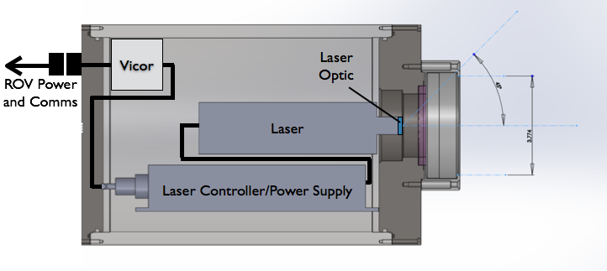
Figure 3. Preliminary layout of components (i.e., laser, power supply, optics, and Vicor) in K. Smith's 6000 m, titanium, flat-port housing.

ROV deployment of laser housing

To enable measurements of fluid motion independent of the hydrodynamic signature created by the deployment platform, the laser housing needs to be deployed sufficiently far enough away from the vehicle. Preliminary estimates made on a Midwater Time Series cruise in April (based on input from ROV pilots Mark Talkovic and Knute Brekke) indicate that the bow wave on the ROV Doc Ricketts can extend 25 to 50 cm in front of the science camera dome depending on approach speed of the vehicle. These estimates are similar to the conditions found in May using ROV Ventana; the bow wave of MiniROV is smaller than the other vehicles. Therefore, to ensure that the measurement region is unaffected by the ROV bow wave, the laser sheet should be deployed approximately 1 m in front of the science camera dome. In addition, the method of deployment should be consistent across platforms (on ROVs Doc Ricketts, Ventana, and MiniROV), and minimizes use of tool sleds so as to be deployable on midwater and benthic cruises. Therefore, the laser housing will be mounted to the port side swing arm on the ROVs (Fig. 4). If we employ a two-housing design, the laser housing will be placed on the swing arm and the electronics housing will be secured in the payload bay of the vehicle.

To ensure a stable connection between the laser housing and science camera, a variety of methods will be concurrently employed. First, the swing arm joints will be tightened up and secured to minimize motion in the swing arm. In addition, a flange will be attached to the ROV such that the swing arm will lock into place on the flange during DeepPIV deployments. Finally, the port manipulator will hold the laser housing and swing arm configuration into place on the flange. Minimization of motion between the laser sheet and camera are essential to fluid measurements, and we feel these techniques will sufficiently address this issue.
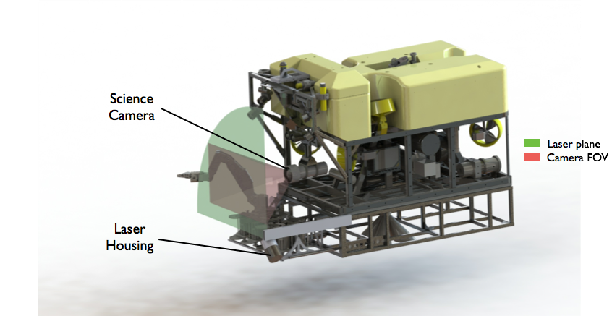
Figure 4. Preliminary design of DeepPIV deployed on ROV Doc Ricketts. The laser sheet is 1 mm in front of the science camera and illuminates approximately 1.5 m² field of view using a 90 deg spread angle optic.

ROV control during DeepPIV operations

In order to measure fluid motion, the PIV technique uses consecutive particle fields and cross-correlation algorithms to compute velocity fields. Since PIV uses particle fields as tracers in the flow of interest, particles must remain in the laser sheet as long as possible. Field deployments of SCUVA, a scuba-based device for in situ PIV measurements, have indicated that manual control of the device provides sufficient control and stability of SCUVA. Therefore, initial deployments of DeepPIV will rely on ROV pilots to position the vehicle and laser sheet with respect to the science target of interest. In collaboration with Steve Rock and Mike Risi (Precision Control), later deployments of DeepPIV will utilize a modified JellyTrack (in conjunction with MBARI mode) control algorithm to follow and maintain vehicle position with respect to an object in midwater. Since DeepPIV will be built to interface with the MiniROV as well, initial tests and integration of control with DeepPIV hardware can be conducted in the MBARI test tank with neutrally buoyant objects. Initial DeepPIV deployments with control will focus on stationary targets. If successful, further development of JellyTrack in 2016 (with Precision Control) will enable maintenance of vehicle position with respect to a motile science target.

Secondary requirements

The two biggest challenges we face in the design and deployment of DeepPIV is whether our current camera, laser, and optics configuration will allow for visualization of particles sufficiently fast enough to minimize particle streaking with a large enough field of view area (requirements call for 1 m²), and whether control of the ROV can achieve stationary positioning with respect to a science target for durations greater than 5 sec. Preliminary calculations (see appendix) show that the current configuration (θ is 90 deg, field of view is 1.44 m²) generates laser illumination levels that are less than SCUVA. Although we need to confirm these estimates by experimenting with the configuration in the laboratory, we have already considered (and accounted for them in the budget) adjustments that can be made to the configuration to ensure successful deployment of DeepPIV (see appendix for recommendations). These modifications include using a galvanometer in the laser housing, operating the laser in pulsed mode, selecting an optic with a spread angle less than 90 deg, and zooming in the science camera. In addition, we can modify our requirements and define secondary requirements where measurement area and duration are reduced, and a high-speed camera is utilized instead of the science camera.

Field programs (detail ship requirements/deployments/diver requirements)

If space is available, we will be joining Bruce Robison or Steven Haddock on MBARI’s Gulf of California cruise in early 2015 for the first deployment of DeepPIV. These field deployments will rely on pilot control to position the ROV and DeepPIV laser sheet on an object of interest (i.e., larvacean houses and jellyfish). Two separate ship days on R/V Rachel Carson using ROV Ventana are requested (August and September 2015) to integrate improvements to DeepPIV hardware (based on field trials in the Gulf of California; see Milestone 6) and ROV control (using MBARI mode and JellyTrack algorithms as per Steve Rock’s internal proposal, Precision Control; see Milestone 5). Additional testing and integration of control and DeepPIV hardware can be conducted in MBARI’s test tank using MiniROV. In addition, we will conduct more DeepPIV field deployments in conjunction with the Midwater Time Series project.

However, if space is not available on the Gulf of California cruise, we will request one day on R/V Rachel Carson using ROV Ventana as soon as the ship is available (presumably April 2015). We will then request two ship days later in 2015 (August and September) for integration of DeepPIV hardware improvements and vehicle control. If, however, R/V Rachel Carson is not available in 2015, we can also conduct testing, integration, and deployment of DeepPIV using MiniROV.

Specific deliverables

- ROV-compatible laser housing(s) (components: laser, power supply, Vicor, optics, and galvanometer (if required)), deployable to 4000 m and operates in pulsed or continuous modes
- ROV midwater DeepPIV data (from Gulf of California) for evaluation
- Requirements and selection of high-speed camera for future DeepPIV development
- JellyTrack for ROV control during Deep PIV deployment (as part of a collaboration with Steve Rock and Mike Risi; see Precision Control)
- ROV midwater DeepPIV data (from Monterey Bay) for evaluation and publication
- Evaluation of DeepPIV and plans for further development
- Publication and conference presentation of DeepPIV methods

Milestones (see personnel classification list)

- Integration of laser housing(s) (power and communications) with MBARI’s ROVs.
- Support and deployment of DeepPIV during MBARI’s Gulf of California cruise.
- Analysis of DeepPIV data from MBARI’s Gulf of California cruise.
- Evaluation of available high-speed cameras to be used for future development of DeepPIV.
- Modify DeepPIV illumination by adding pulsed and/or galvanometer functionality for the laser configuration.
- Redeploy DeepPIV in Monterey Bay with Steve Rock and Mike Risi’s implementation of JellyTrack control.
- Analysis of DeepPIV data from Monterey Bay.
- Publication of DeepPIV methods and conference presentations.

2015 Project Start Date:  01/01/2015 | Milestone 1 | Milestone 2 | Milestone 3 | Milestone 4 | Milestone 5 | Milestone 6 | Milestone 7 | Milestone 8 | Total Resources for each resource category for all milestones listed here
Milestone Date | January 2015 | February-March 2015 | March-April 2015 | April-June 2015 | May-July 2015 | August-October 2015 | October-November 2015 | October-December 2015
Milestone Description | DeepPIV integration with MBARI’s ROVs | Deploy DeepPIV without control in Gulf of California | Analyze DeepPIV data from Gulf of California | Evaluation of high-speed cameras for DeepPIV | Modify DeepPIV laser configuration | Deploy DeepPIV with control in Monterey Bay | Analyze DeepPIV data from Monterey Bay | Publish and present data and DeepPIV methods
EE | 80 (Sherman) | 20 (Sherman) |  | 40 (Sherman) | 80 (Sherman) | 40 (Sherman) |  |  | 260
SE
ME | 180 (Graves) | 40 (Graves) |  |  |  | 40 (Graves) |  |  | 260
EE Tech
SE Tech
ME Tech
Machine Shop | 40 |  |  |  |  |  |  |  | 40
Divers

Budget justification

Cost | Type | Description
$15,000 | DeepPIV Capital Equipment | Laser and power supply/controller; laser optics and mount; titanium housing end cap (if required); galvanometer and servo motor (if required); laser housing connectors and cabling
$1,000 | Supplies | Materials and hardware for DeepPIV attachment to ROVs
$1,000 | Supplies | Miscellaneous supplies for new high-speed camera testing
$2,000 | Supplies | Hard drives for recording of DeepPIV data
$1,100 | Travel | Travel expenses for Katija to Gulf of California
$2,700 | Travel | Travel and conference expenses for Katija (APS-DFD)
$22,800 | Total

Project team

Alana Sherman, Principal Investigator (260 hrs requested)
Alana will oversee the development of the electronics and communications systems for DeepPIV to MBARI’s ROVs. In addition, she will review the capabilities of DeepPIV to determine whether we are meeting engineering and science requirements, and will assist with publication and presentation of DeepPIV work.

Kakani Katija, Project Manager (300 hrs requested)
Kakani will manage project time and resources, help develop science and engineering requirements, work with the engineering team to facilitate testing and deployments, will analyze Deep PIV data from deployments, and will assist with publication and presentation of DeepPIV work.

Bruce Robison, Senior Scientist
Bruce will oversee the development of science and engineering requirements and will review the capabilities of DeepPIV to meet those requirements. In addition, he will assist with publication and presentation of DeepPIV work.

Doug Au, Software Engineer
Doug will review the capabilities of DeepPIV to meet science and engineering requirements.

Dale Graves, Mechanical Engineer (260 hrs requested)
Dale will oversee the mechanical design and integration of DeepPIV with MBARI’s ROVs, as well as support the deployments of DeepPIV in the Gulf of California and Monterey Bay.

Project lab space

Since we will be testing and deploying a high-powered (1 W, continuous) laser, we will need a lab space where we can safely operate the laser. See https://www.osha.gov/dts/osta/otm/otm_iii/otm_iii_6.html for information and OSHA guidelines. There does exist MBARI lab space that has been previously used for laser equipment in the electronics lab that would be suitable for this project.

Data availability outside project team, uniqueness

The data extracted from video produced by DeepPIV will be added to MBARI’s video collections and will be available to MBARI researchers and collaborators. In addition, any publications that result from this work will be available to all. Engineering methods and products developed as a result of this work will be shared via publications, presentations, and hopefully other institutions to facilitate small-scale, in situ fluid mechanics measurements during ROV deployments.

Export Regulation
Does the project team anticipate any foreign collaborations or international travel? If so, please identify collaborators by name, institution, and country.

Yes. We anticipate deploying DeepPIV during MBARI’s Gulf of California Cruise (Mexico) during either Bruce Robison or Steven Haddock’s legs, depending on space availability.

Does the project team plan or anticipate export controlled purchases, shipments, or transfers of items (e.g., research instruments, proprietary data, hand-carried tools or samples) outside the U.S. temporarily or permanently? If yes, please identify country or countries and indicate whether these items will remain under MBARI control while abroad or controlled by others. Will the items be exported to more than one country? Please include foreign collaborator information as described above.

Yes. Since we anticipate deploying DeepPIV during the Gulf of California Cruise, we plan to hand carry all components of DeepPIV to Mexico.

Monterey Bay National Marine Sanctuary SESAs (General map)
Projects will need to indicate whether or not work will be conducted within one of the Monterey Bay National Marine Sanctuary's Ecologically Significant Areas (SESAs). An interactive map can be found on the Sanctuary's SIMoN webpages at http://sanctuarysimon.org/maps/sesa/. (Note: It may take a moment for the page to load, so please be patient.) To determine if your work will occur in a SESA, specific coordinates can be entered using the locator function (click on the red "target" button in the toolbar at the top of the map). If your work will be conducted in one of these areas, please indicate which area, by number.

None at this time.

Risk matrix (development and infrastructure projects only)

 | Technical Risk | Organizational Risk | Tech Transfer Risk | Labor Estimate Risk
High
Medium | x |  |  | x
Low |  | x | x
  - Appendix: Laser, optics, and camera configuration calculations

Using the SCUVA configuration for reference, we can compare the proposed DeepPIV laser, optics, and camera configurations to determine whether our component arrangement and selection will fulfill DeepPIV requirements. Since we have had success conducting in situ measurements using SCUVA in the past, these results will provide a baseline with which to compare the preliminary DeepPIV configuration. Here we present rough estimates based on several assumptions. We will assume that the position of the laser and camera are fixed over time; this is a necessary condition for these measurements. Since we have not generated ray-tracing diagrams, we will estimate the effective beam spread angle given the air-water optical interface from a sample SCUVA dataset. Further, we will assume that the effective beam spread angle change for DeepPIV is the same for SCUVA. In addition, our estimates will not address light attenuation, which is a function of turbidity in the natural environment and changes depending on the oceanic conditions. To be sure, increases in turbidity will negatively impact the effective illumination from the laser, and field experiments that compare laser sheet intensity with fluid turbidity will be beneficial for further development of DeepPIV.

Fig. 5 shows the layout of SCUVA’s camera and laser housings and the distances between them. The distances in the x and z directions (both equal to 45 cm) correspond to the lateral and forward separation between the laser and camera housings. All distances are measured with respect to the front face of the camera and laser housing, and on the central axis of the camera. The side view shows the laser housing only, where the optics generates a green laser sheet with a beam spread angle of θ. The optics used for SCUVA has a beam spread angle θ = 20 deg. Taking a snapshot of the laser sheet from a SCUVA dataset, we can measure the actual or effective beam spread angle (θ_{E}), which was found to be 15 deg. Therefore, due to the air-water optical interface, the beam spread angle of the laser sheet (θ) is reduced to an effective angle (θ_{E}) by 25%. For clarity, we will use θ_{E} to replace θ in all of our calculations below.

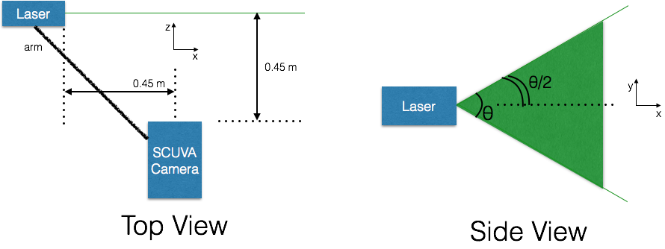
Figure 5. SCUVA components and relative distances. Green indicates the laser sheet location. θ is the laser sheet beam spread angle.

To compare SCUVA and the preliminary DeepPIV configuration, we will define and compare the power density (PD) of the laser,

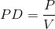,
where P is the (nominal) power rating of the laser used and V is the volume of fluid illuminated by the laser and optic combination. From the diagram in Fig. 5, we see that the laser sheet’s vertical extent (y) can be expressed as a function of the lateral extent (x) and the beam spread angle (θ):
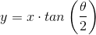.
To compute the volume of fluid illuminated by the laser sheet of constant thickness t in the z-dimension, we will integrate the above function with respect to x (refer to Fig. 5 for coordinate reference),
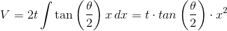,
where x is the distance from the laser housing to the central axis of the camera. The thickness of the laser sheet t for both configurations is approximately 0.01 m.

Table 1 summarizes the parameters that will be used to compute PD for both SCUVA and DeepPIV. In addition, Table 1 shows the value of PD for both cases. Based on the preliminary configuration of DeepPIV with a 90 deg optic, 1 W laser, and a 1.44 m² field of view (FOV), DeepPIV’s laser sheet has a power density that is an order of magnitude less than SCUVA. Although the preliminary DeepPIV configuration may result in a significant power density deficit when compared with SCUVA, there are some minor modifications that can be made simultaneously or inclusion of additional components alone that will yield sufficient illumination levels. The following summarizes how changes to the configuration will affect the power density, and we suggest changes that can be made to DeepPIV’s design once these estimates are verified in the laboratory.

Table 1. Summary of parameters used to compute power density using a reference SCUVA configuration and DeepPIV's preliminary design.
Configuration | θ () | θ_{Ε} () | x (m) | FOV (m²) | P (W) | PD (W/m³)
SCUVA | 20 | 15 | 0.45 | 0.02 | 0.3 | 1.1E3
DeepPIV | 90 | 67.5 | 1 | 1.44 | 1.0 | 1.5E2

Modifying science camera settings

To increase the available light on the camera sensor, the gain can be increased. An increase in gain by 3 dB will result in a doubling of available light on the sensor. Therefore, increasing the gain by 9 dB will increase the effective power density of the image by a factor of 2³ or 8, alone making up for the PD deficit between DeepPIV and SCUVA’s configurations. For reference, the gain of the science camera used for ROVs Ventana and Doc Ricketts can be increased by 18 dB. However, increasing gain alone is not the most attractive option since it results in an increase in image noise. To be sure, since the PIV algorithm does not track individual particles but instead cross-correlates regions in a field of view, the algorithm is not as sensitive to increases in image noise as one would suspect.

Reducing the FOV size

To reduce the illuminated field of view size, we can adjust relative placement of the laser from the camera or change the optic used. Since we want to minimize hydrodynamic disturbance in the laser sheet induced by motion or presence of the vehicle, the position of the laser housing is more fixed than the optics employed. By using a 60 deg rather than a 90 deg optic, the effective FOV size will be 1 m² and the power density will be 2.4E2 W/m³. Further reducing the optical beam spread angle to 30 deg will decrease the effective FOV to 0.2 m² and increase the power density to 5.0E2 W/m³. Unfortunately, changing the optics alone will not make up the power density deficit we are estimating, however when combined with the other method we discuss above, it will be more than sufficient.

Incorporating a galvanometer in the laser housing

Galvanometers are used in medical to scan a beam of light through an angle specified by the rotation of a mirror. Unlike a laser optic, which spreads the available laser light from a beam with 1 mm diameter to a volume with 1 mm thickness, a galvanometer sweeps the laser beam through a specified angle. If the galvanometer and camera are synced such that a laser is swept through an angle θ (equivalent to the beam spread angle) with every camera frame, a sheet of light is created in each frame. Therefore, assuming a spread angle of 60 deg, which generates an effective FOV of 1 m², the power density of the laser sheet increases to 3.2E3 W/m³. Therefore, using a galvanometer alone will provide us with nearly three times the power density of SCUVA. However, incorporating a galvanometer and driver in a laser housing is not trivial due to space considerations and syncing between the science camera and driver. We have budgeted both labor and materials to incorporate these changes in DeepPIV’s design.

Recommendation for DeepPIV design

Based on these estimates, there appears to be three different solutions that can be employed to ensure that DeepPIV illumination has the equivalent or higher power density than SCUVA’s configuration. These solutions include:

- Decreasing the optical beam spread angle and increasing the camera gain will result in an increase in effective power density of the laser illumination. For example, using an optic with a 30 deg beam spread angle and an increase in camera gain by 3 dB will increase the power density by an order of magnitude, thereby making up the power density deficit. This is a straightforward improvement that minimizes increases in image noise. However, this optical configuration will illuminate an area of 0.2 m² (or 45 cm x 45 cm) instead of 1 m² (or 1 m x 1 m), which is still an order of magnitude improvement over SCUVA’s capabilities.
- Utilizing a galvanometer and servo motor to drive the rotation of a mirror in the laser housing will result in an effective power density (assuming the scanning angle is 60 deg) nearly three times that of SCUVA. Using any option with a galvanometer will not require a lens optic to control the spread angle of the laser sheet, and the effective spread angle of the scan can be adjusted depending on the waveform input provided.
- By using a galvanometer in conjunction with changes in camera gain, we can achieve between 3 and 12 times the effective power density illumination of SCUVA without adding significant image noise.

We are currently evaluating all of these solutions. Option 3 is preferred based on our initial analyses.

This date and number should remain the same for the duration of the project. If your project start date for 2015 is not January 1, please indicate the start date in the first cell of the milestone chart.
Development and infrastructure projects must complete the risk matrix (see item #5 at the end of the proposal form).
Not all projects will require all four titles to be filled in. Please indicate individuals only for those titles that are appropriate for your project.
This number should be the same number you entered on the resource requests for this particular resource.

