Project Number: | 901506

Project Start: Jan. 1, | 2016 | Project Duration (in years): | 2 ¹

Please indicate if proposal includes requests for any of the following (mark all that apply).

 | X |  |  | X |  |  |  |  |  |  |  |  | X
Ship Time |  |  | ROV |  |  | AUV |  |  | Wave Glider |  |  | Mini ROV

Please indicate what type of project is being proposed (mark only one).

 |  |  |  | X
Feasibility/Scoping  [Less than 100 days effort] |  |  | Development |  |  | Research |  |  | Infrastructure² |  |  | Education
 |  |  | Time Series |  |  | Institute Initiative
Project Manager: Kakani Katija
Principal Investigator: Alana Sherman
Lead Scientist: Kakani Katija
Lead Engineer: Dale Graves

Project Title: DeepPIV (Particle Image Velocimetry)

- ABSTRACT (new projects only)

- PROPOSAL

  - New Projects

  - Continuing Projects

If the proposed project includes multiple individual projects, please list each of these projects as a subheading in the proposal. For each subheading, please address the following:

Current status of project and results to date

The DeepPIV project has been very successful in achieving our proposed objectives for 2015. As of July 2015 we have completed the following goals:

- Acquired a 1 W, continuous, 671 nm laser with optics providing a spread angle of 60 degrees in-water
- Housed laser head and controller in 4000 m housing featuring a flat-port optical window
- Interfaced instrument(electrical, mechanical, and communications) with Mini-ROV
- Calibrated and utilized the on-board, high-definition, 60 fps, science camera to capture suspended particulate motion
- Deployed instrument during two midwater cruises (Mini-ROV/Rachel Carson) and collected PIV data of flow fields surrounding biological targets (see Figure 1)
- Collected images to create 3D reconstruction of biological targets (see Figure 2)
- Evaluated high-speed camera options for PIV

We are currently working on the following tasks:
- Collaborating with Precision Controls team on the blob tracking algorithm (JellyTrack)
- Calibrating and verifying in situ 3D reconstruction and PIV techniques

By the end of 2015, we expect to complete the following:
Development
- Develop concept to deploy stand alone camera and laser for larger ROV deployments
- Collect data in the lab for 3D reconstruction of known acrylic targets for method verification
- Collect data in the field for PIV using a known flow field (vortex generator)
- Integrate GigE on Mini-ROV to facilitate using an upgraded camera system
Deployments
- One more deployment using the Mini-ROV on the Rachel Carson
- Deployments using the Mini-ROV on the R/V Western Flyer as part of Bruce Robison’s midwater cruise in August
- Potential use of the system on the Mini-ROV as part of a two-week jelly tagging field program in Monterey Bay
Dissemination
- Katija has been invited to give a conference talk about DeepPIV at AGU in San Francisco (December 2015)
- Katija will be submitting an abstract as part of the APS Division of Fluid Dynamics meeting in Boston (November 2015) and the Society of Integrative and Comparative Biology meeting in Portland, OR (January 2016).

In summary, we have made excellent progress on this project and are currently on or ahead of our projected schedule. Furthermore, we have the potential to collect a great deal of science data over the next several months.

Significant changes from previous project proposal

No significant changes.

Publications based on the results of this project only

We have no publications on this work at this point, however parts of this work have been presented at various events and venues:
- MBARI board presentation for March meeting – DeepPIV: Measuring fine-scale fluid motion at depth
- MBARI board demonstration for DOEST – DeepPIV: Measuring fine-scale fluid motion at depth
- Talk at MBARI Science Educators Meeting – Surviving in the oceans: Elucidating in situ animal-fluid interactions
- Invited seminar at Fluid dynamics of Living Systems, hosted by NSF in Arlington, VA – Surviving in the oceans: Elucidating in situ animal-fluid interactions
- Invited seminar for UCLA Biology Seminar Series – Jet or die: Ontogeny and swimming by ambush-feeding medusae
- Invited talk at TEDYouth in New York – Finding the footprints of marine organisms
- Invited talk at TEDWomen in Montery – Revealing the footprints of marine organisms

  - New and Continuing Projects: Plans for 2016

Research Activities

Planned research activities for 2016 include the following:
- Continued deployments using MBARI’s ROVs to evaluate shallow water larvacean (e.g. Bathychordaeus) house structure and measure interior mucus house flow rates to estimate feeding impact and carbon flux.
- Integration of DeepPIV on larger/deeper depth-rated ROVs will allow for internal filter structure comparisons between deeper larvacean species (e.g., Mesochordaeus and fritillariids)
- Once the JellyTrack algorithm is online, we will be able to measure flows generated by motile targets. This will enable comparison of filter feeding abilities and impact on carbon flux across taxa (e.g., salps, doliolids, and appendicularians).
- The higher sensitivity, high-speed camera will allow us to build on work conducted in 2005 (see “Eye on the Sea Study”; Widder et al, Deep Sea Res., 2005): evaluating the effect of white and red lights on escape, swimming, and feeding behaviors across taxa in benthic and midwater communities. This work will also contribute to efforts on the pending NSF-OTIC Mesobot proposal with Bruce Robison, Brett Hobson, and Kakani Katija as Co-PIs in collaboration with Dana Yoerger at WHOI.
- Data collected during all of our cruises will contribute to future publications, however data are currently being analyzed. We expect to publish and present our work (both science and engineering developments) at multiple venues.

Potential research activities for 2016 include the following:
- Contributing to SESA Sur Ridge monitoring efforts to evaluate how boundary layer fluid motion affects feeding ability of soft coral in the Monterey Bay National Marine Sanctuary.
- Evaluate the potential for DeepPIV to address science targets and questions related to the bottom boundary layer and feeding performance of benthic communities in the Monterey Canyon.

Engineering/technology development

In 2016, the goals of this project will be to:
- Acquire a new, stand-alone camera to be used with our existing laser in a self-contained DeepPIV package.
Our experience in 2015 has made it clear that using the main ROV camera for DeepPIV is challenging due to the positional accuracy required and poor sensitivity of these cameras to read or near-IR illumination. In addition, the main ROV cameras for the larger ROVs lack precise control to return to a calibrated position, which is required for DeepPIV measurements. While using the main science camera on Mini-ROV has facilitated rapid data collection for this project, a more robust solution for all ROVs is a separate camera system that is optimized for this type of work. We want to emphasize that this is not a “camera development project” that requires advanced optics for wide-angle correction, a large development effort, and great cost. We are proposing to buy an off-the-shelf camera to place in a simple, flat-port housing that is sufficient for the narrow fields of view preferred for DeepPIV. A stand-alone frame (with secured laser and camera housings) can be calibrated and tested without an ROV, and can be deployed on all ROVs without requiring significant real estate that can limit science tasks during a dive.
An optimal camera for our application would be very sensitive to red/near-IR light, would have high resolution, and a high frame rate. We are using red/near-IR illumination so as to minimize behavioral responses of target organisms to light. The use of a high-speed camera allows us to accurately measure fluid motion and organismal behavior since both requires high temporal resolution. For example, particle motions in high-speed flows (> 5 cm/s) are currently not captured due to limited frame rates and subsequent particle streaking. These flow speeds are common across taxa especially during feeding, swimming, and escape behavior. A high-speed, near-IR-sensitive camera will also allow for evaluation of organism behavioral response to white and red lights, using near-IR lighting to illuminate the behavior. This effort would build on work conducted in 2005 during the “Eye on the Sea Study” (see Widder et al, Deep Sea Res., 2005) by Bruce Robison and others.

Below we have listed three options for a stand-alone camera that vary by cost and features. All cameras use GigE (which will be available on all ROVs in 2016) and have some local storage for short video clips:
  - Photron Mini AX50 ($26,000): this combines great sensitivity in low light conditions and near-IR and shoots 2000 frames per second (fps) at 1K resolution. There is 4 GB of on-board memory. This is the highest quality camera and the most expensive.
  - Photron Mini UX50 ($19,000): this camera is similar in frame rate and resolution to the AX50; the big difference is that the AX50 sensor is more sensitive. The AX50 has a monochrome ISO of 40,000 versus the UX50 that has an ISO of 6,400. For this application, light sensitivity of the camera is crucial, however either camera represents a significant improvement. There is 4 GB of on-board memory
  - Prosilica GT2000 NIR ($2100): this is a machine vision camera optimized for near-IR applications, with 1K resolution at 58 fps. This camera will not facilitate high-speed work, but will still be an improvement over using the main ROV camera. There is only 128 MB of on-board memory. We have had significant experience with Prosilica cameras at the institute (Ocean Imaging, Benthic Rover), and the price is very reasonable.
We have entered the most expensive option in our budget, however we wanted to present approximate costs of less expensive alternatives so the Management Team can provide informed guidance.

- Acquire both a prime lens and a zoom lens for the selected camera.
We will select and purchase a prime lens (fixed focal length) compatible with our selected camera for initial deployments. Once we have evaluated and refined the system, we will then use a motorized zoom lens that can be remotely controlled using analog inputs. The ability to zoom is very important for using DeepPIV on organisms, as zoom will provide fine-scale detail of fluid/particle motion adjacent to biological targets. We will build a housing that can accommodate either lens so that there will be limited mechanical integration of the new, controllable zoom lens. We have identified two suitable lenses for this application:
  - Prime lens: Canon EF 85mm f/1.2L USM lens ($2000)
  - Zoom lens: Kowa LMZ16160M3P-IR ($2820)

- Design and build housing for the new camera, lens, and any interface electronics.
We propose to build a simple, anodized aluminum cylindrical housing with a flat glass port for the camera and other required components. The housing will be designed with a depth rating of 4000 m, so the camera can be used during deep dives on the Doc Ricketts.

- Design and build new laser housing that accommodates a galvanometer (purchased in 2015).
We will reuse the existing endcaps of our laser housing, and design and build a larger tube that provides clearance for a galvanometer. A galvanometer is an electromechanical device that controls and rotates a mirror at high frequencies, whose rates are synchronized to a camera shutter. This will be used to redirect the laser beam to illuminate a sheet of fluid, thereby increasing the optical power of the laser sheet. Synchronization is not possible using the main science camera on the ROVs, but will be achievable with the proposed DeepPIV camera.

- Design and build a frame that is mountable on the swing arms of ROVs, which will keep the camera and laser alignment fixed throughout DeepPIV deployments.

- Integrate the stand-alone DeepPIV system with MBARI’s three ROVs (Mini-ROV, Doc Ricketts, and Ventana). This integration involves designing and building wet cables to supply ROV power and vehicle communications (GigE and serial) to the DeepPIV package.

Field programs (detail ship requirements/deployments/diver requirements)

Number of Days | Ship | Vehicle needs | Requested dates | Deployment objectives
2 | R/V Rachel Carson | ROV Mini-ROV | March | Integrate improvements to DeepPIV hardware, design, and JellyTrack based on field trials from 2015
2 | R/V Rachel Carson | ROV Ventana | October | Integrate new DeepPIV hardware and JellyTrack on MBARI’s larger ROVs

Specific deliverables

- High-speed camera for DeepPIV
- ROV-compatible (ROV Doc Ricketts and Ventana) laser housing (components: laser, power supply, Vicor, optics, galvanometer, humidity sensor) and camera housing (components: high-speed camera, lens), deployable to 4000 m
- JellyTrack for ROV control during DeepPIV deployment (as part of a collaboration with Steve Rock and Mike Risi; see Precision Control)
- ROV DeepPIV data (from Monterey Bay) for evaluation
- Publication and conference presentations of DeepPIV methods

Milestones (see personnel classification list)

- Acquire separate high-speed camera and components for DeepPIV.
- Build DeepPIV system: interface camera and laser components (e.g., camera, lens, galvanometer), housings, and rigid frame.
- Integrate DeepPIV housings and frame (power, mechanical, and communications) with ROVs Doc Ricketts and Ventana.
- Deploy DeepPIV in Monterey Bay with Steve Rock and Mike Risi’s implementation of JellyTrack control.
- Analysis of DeepPIV data from Monterey Bay.
- Publication of DeepPIV methods and science results and conference presentations.

2016 Project Start Date:  01/01/2016 | Milestone 1 | Milestone 2 | Milestone 3 | Milestone 4 | Milestone 5 | Milestone 6 | Total Resources for each resource category for all milestones listed here
Milestone Date | January 2016 | February-March 2016 | April 2016 | May-October 2016 | October-November 2016 | October-December 2016
Milestone Description | Acquire high-speed camera | Build DeepPIV system with separate camera and laser housings | Integrate DeepPIV system with other ROVs | Deploy DeepPIV with JellyTrack in Monterey Bay | Analyze DeepPIV data from Monterey Bay | Publish and present data and DeepPIV methods
EE | 20 (Klimov)  50 (Sherman) | 100 (Klimov)  50 (Kecy)  50 (Sherman) | 50 (Sherman)  100 (Kecy) | 50 (Sherman)  50 (Kecy) |  | 40 (Sherman) | 120 (Klimov)  240 (Sherman)  200 (Kecy)
SE |  |  |  | 40 (Risi) |  |  | 40 (Risi)
ME | 20 (Graves) | 180 (Graves) | 100 (Graves) | 80 (Graves) |  |  | 380 (Graves)
EE Tech |  | 40 (Marion) | 20 (Marion) |  |  |  | 60 (Marion)
SE Tech
ME Tech |  | 40 (Flores) |  |  |  |  | 40 (Flores)
Machine Shop |  | 80 |  |  |  |  | 80
Divers

Budget justification

DeepPIV Camera Costs:
1. Camera housing:
a. 4” housing | $1,000
b. flat port | $900
c. Seacon* bulkhead/cable connectors | $4,000
d. wet cables (GigE compatible) | $1,000
e. internal chassis | $500
2. Camera | $26,000
3. Lenses + controller | $6,000
Laser housing (to incorporate galvanometer) | $1,000
ROV frame for DeepPIV | $500
Supplies for engineering | $1,000
RAID drives for data | $2,000
Lab supplies for bench testing | $1,000
PIV software | **$10,000
Ocean Sciences Meeting in New Orleans, LA (5 nights x $240 lodging, $800 transportation, 6 days x $70 per diem) for Katija | $2,420
Total | $57,320

*Seacon connectors have been shown to work reliably with GigE data streams.
**We would prioritize purchasing a high-speed camera over PIV software.

Project team

Position | Participant | Hours requested | Specific roles and responsibilities
Principal Investigator | Alana Sherman | 240 | Oversee development of electronics and communication systems for DeepPIV; review capabilities of DeepPIV to meet requirements; assist with publications/presentations
Project Manager | Kakani Katija | 1200 | Manage project time and resources; develop requirements; facilitate testing and deployments; analyze data; write publications/presentations
Mechanical Engineer | Dale Graves | 380 | Oversee mechanical design and integration of DeepPIV with ROVs; support deployments in Monterey Bay
Electrical Engineer | Chad Kecy | 200 | Assist with electronics and comms systems; support deployments in Monterey Bay
Electrical Engineer | Denis Klimov | 120 | Assist with optical system design for DeepPIV
Software Engineer | Mike Risi | 40 | Assist with deployments in Monterey Bay using JellyTrack algorithm (see Steve Rock & Precision Control)
Senior Scientist | Bruce Robison |  | Oversee development and review capabilities of DeepPIV; assist with publications
Mechanical Technician | Frank Flores | 40 | Construction of frame and assistance with deployments
Electrical Technician | Tom Marion | 60 | Wiring of camera housing, interface cabling between housings and ROVs

Project lab and office space requirements

Currently we are using the lab space on the north wall of the LRAUV lab; no additional lab or office space for this project is requested.

Data storage requirements (see Todd Ruston for assistance)

15 TB assuming 4 DeepPIV dive days (at 2 TB per day) and 6 shared dive days (on vehicles/ships of opportunity at 1 TB per day).

Data availability outside project team, uniqueness

Raw video collected by DeepPIV has been uploaded to MBARI’s video collections (see cifs://atlas.shore.mbari.org/DeepPIV) and is available to MBARI researchers and collaborators by request. Engineering methods and products developed as a result of this effort will be shared via publications, presentations, and with other institutions to facilitate small-scale, in situ fluid mechanics measurements during ROV deployments. Data will be made available to the broader oceanographic community once results are published.

Export Regulation
Does the project team anticipate any foreign collaborations or international travel? If so, please identify collaborators by name, institution, and country.

Not at this time. All DeepPIV deployments in 2016 are expected to take place in Monterey Bay.

Does the project team plan or anticipate export controlled purchases, shipments, or transfers of items (e.g., research instruments, proprietary data, hand-carried tools or samples) outside the U.S. temporarily or permanently? If yes, please identify country or countries and indicate whether these items will remain under MBARI control while abroad or controlled by others. Will the items be exported to more than one country? Please include foreign collaborator information as described above.

Not at this time.

Monterey Bay National Marine Sanctuary SESAs (General map)
Projects will need to indicate whether or not work will be conducted within one of the Monterey Bay National Marine Sanctuary's Ecologically Significant Areas (SESAs). An interactive map can be found on the Sanctuary's SIMoN webpages at http://sanctuarysimon.org/maps/sesa/. (Note: It may take a moment for the page to load, so please be patient. Also, if prompted for a login, hit “Cancel” and then you will be able to access page.) To determine if your work will occur in a SESA, specific coordinates can be entered using the locator function (click on the red "target" button in the toolbar at the top of the map). If your work will be conducted in one of these areas, please indicate which area, by number.

We do not have any immediate plans to conduct research at a Monterey Bay National Marine Sanctuary SESA. However, DeepPIV instrumentation can provide insight on biological interactions with the fluid environment (e.g., boundary layer flow over soft coral and how fluid interactions affect feeding of soft coral in SESAs) during research efforts at Sur Ridge, and we are more than willing to assist in those efforts.

Risk matrix (development and infrastructure projects only)

 | Technical Risk | Organizational Risk | Tech Transfer Risk | Labor Estimate Risk
High
Medium | X |  |  | X
Low |  | X | X

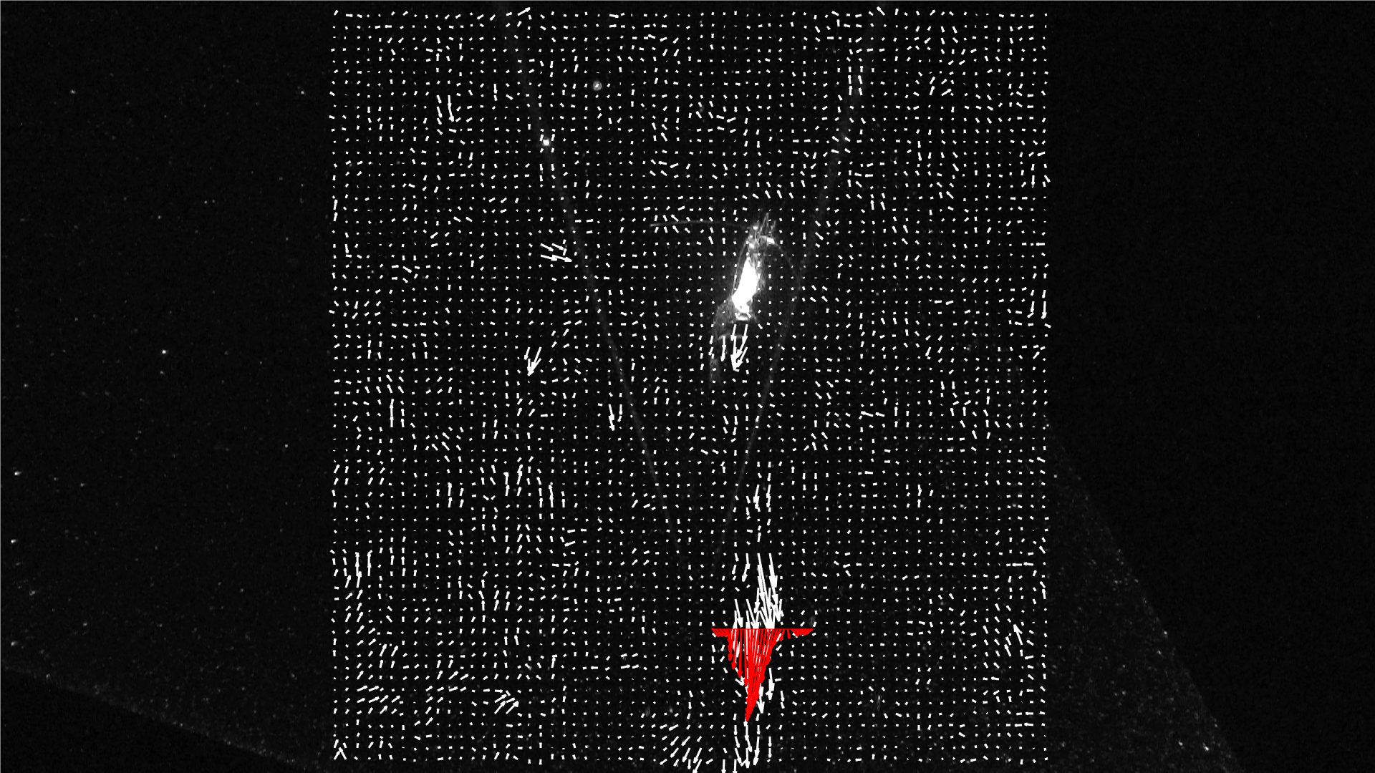
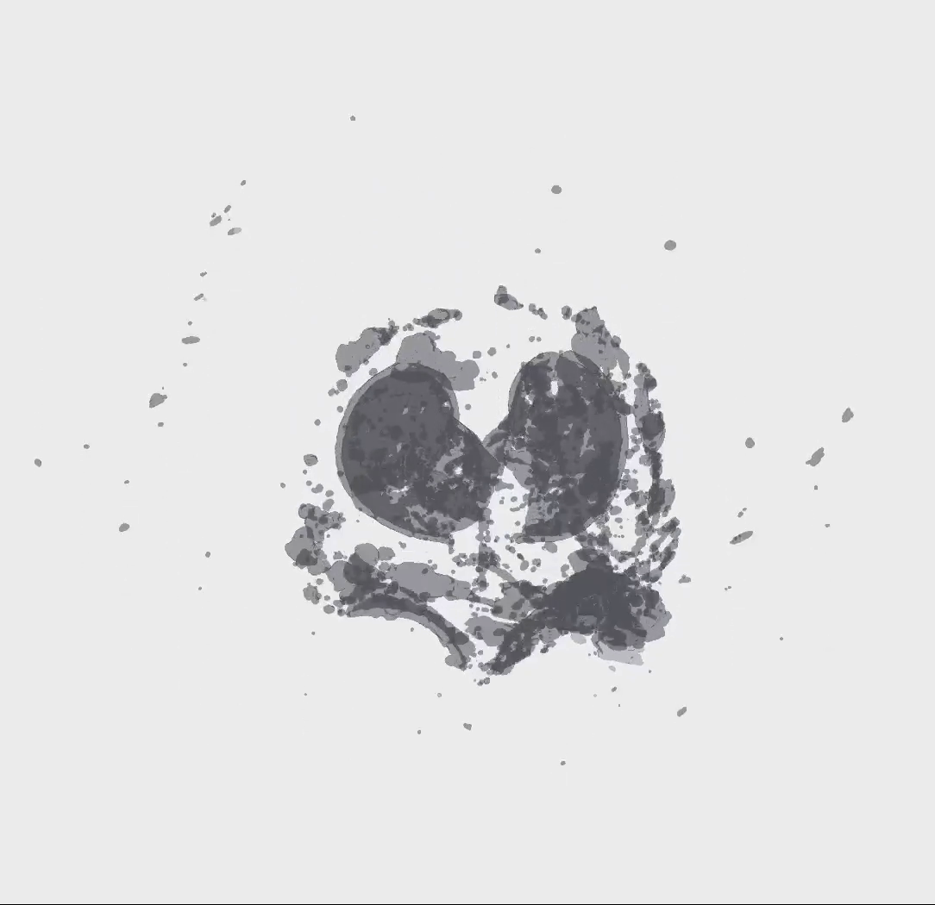
Pasiphaeid shrimp
Feeding current
Swimming appendages
5 cm
Figure 1. Preliminary results using DeepPIV to quantify the feeding current of a pasiphaeid shrimp. The red arrows indicate the flow speed across a line downstream from the feeding organism. Preliminary results indicate that a single, 5 cm long pasiphaeid filters 17.5 cm³/hr.
Figure 2. Preliminary results using DeepPIV to reconstruct the inner and outer filter of a juvenile Bathychordaeus sp.
Inner filter
Remnants of outer filter
Larvacean located here
1 cm

This date and number should remain the same for the duration of the project. If your project start date for 2016 is not January 1, please indicate the start date in the first cell of the milestone chart.
Development and infrastructure projects must complete the risk matrix (see item #5 at the end of the proposal form).
Not all projects will require all four titles to be filled in. Please indicate individuals only for those titles that are appropriate for your project.
This number should be the same number you entered on the resource requests for this particular resource.

